SUPPLEMENTARY APPENDIX
Figure 1. showing multiple bright echogenic masses on fetal echocardiography
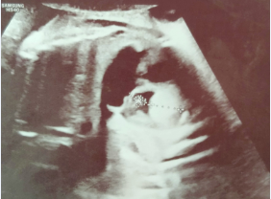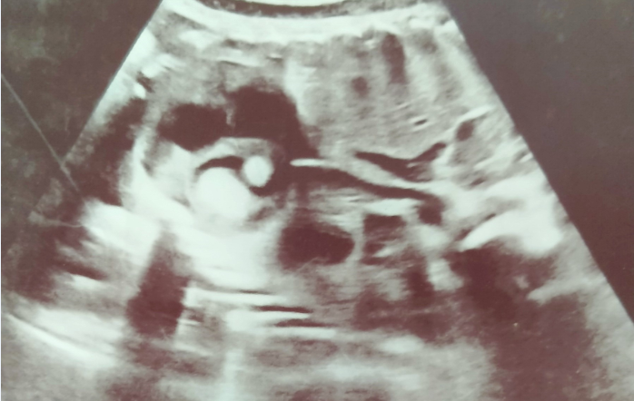

Figure 2. Hypopigmented ash leaf macules seen at the groin
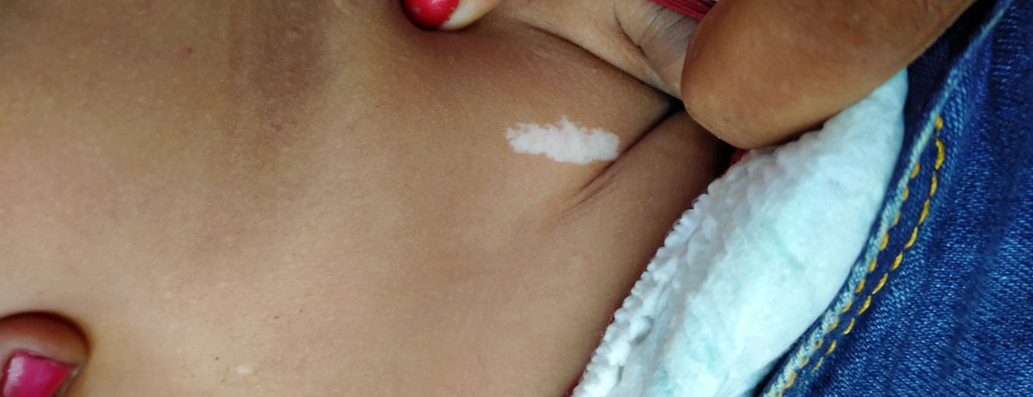

Figure 3. Skin pigmentation, indented and thickened skin noted at the nape of neck and back
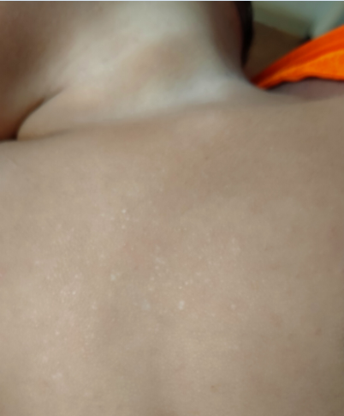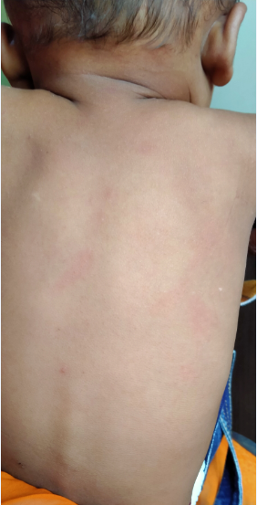

Figure 4. Echocardiography showing multiple cardiac masses s/o rhabdomyomas
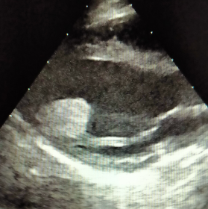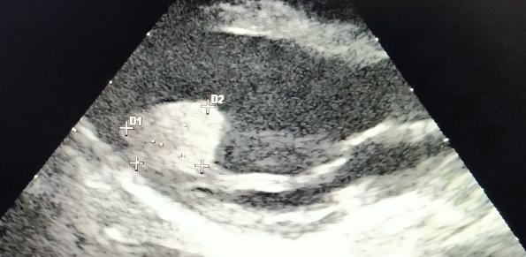
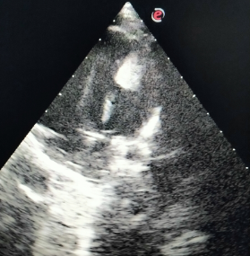
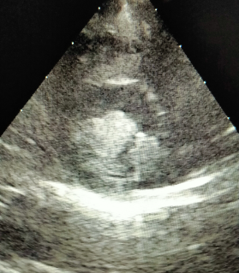

Table 1. Diagnostic criteria of tuberous sclerosis
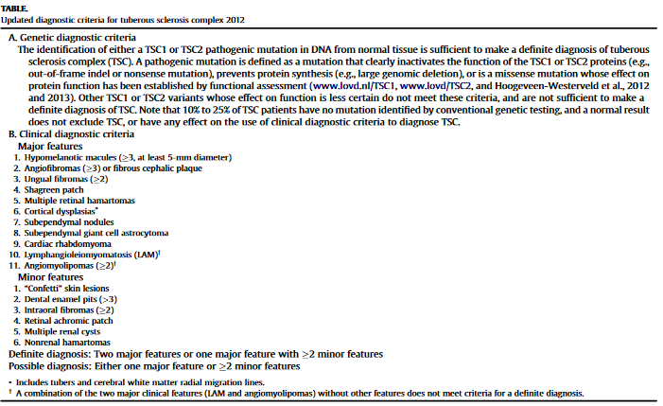
Available at https://www.tscalliance.org/healthcare-professionals/key-medical-publications/

