Supplementary information

Comprehensive Effects of Interdecadal Change of Sea-surface Temperature Increase in the Indo-Pacific Ocean on the “Warming-Wetting” of the Qinghai–Tibet Plateau
Na Dong ^{1,2}, Xiangde Xu ^{2,*} , Wenyue Cai ^{2,*}, Tianliang Zhao ³&Chan Sun ⁴

¹ Department of Atmospheric and Oceanic Sciences & Institute of Atmospheric Sciences, Fudan University, Shanghai, China
² State Key Laboratory of Severe Weather, Chinese Academy of Meteorological Sciences, Beijing 100081, China
³ Nanjing University of Information Science & Technology, Nanjing 210044, China
⁴ National Satellite Meteorological Center, China Meteorological Administration, Beijing 100081, China

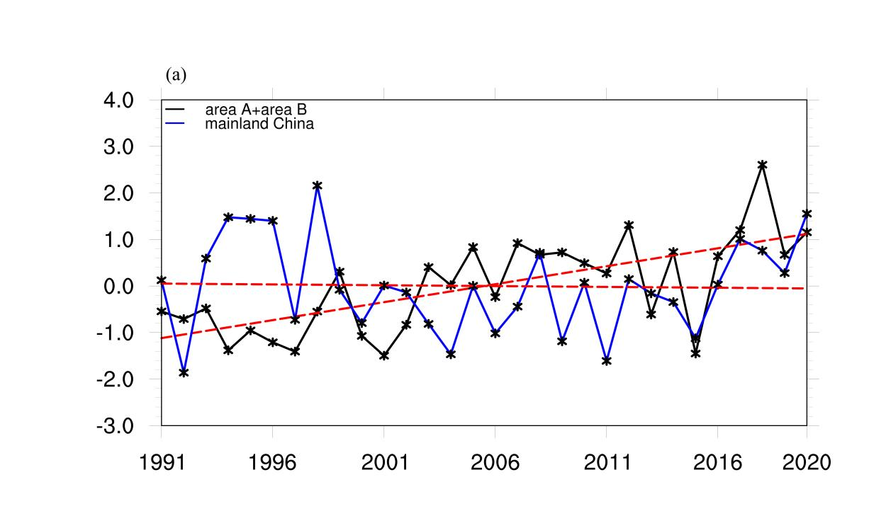
Figure S1: 1991–2020 summer (a) interannual variation curves of precipitation in the high-value A and B areas of precipitation variability and standardized precipitation of mainland China.
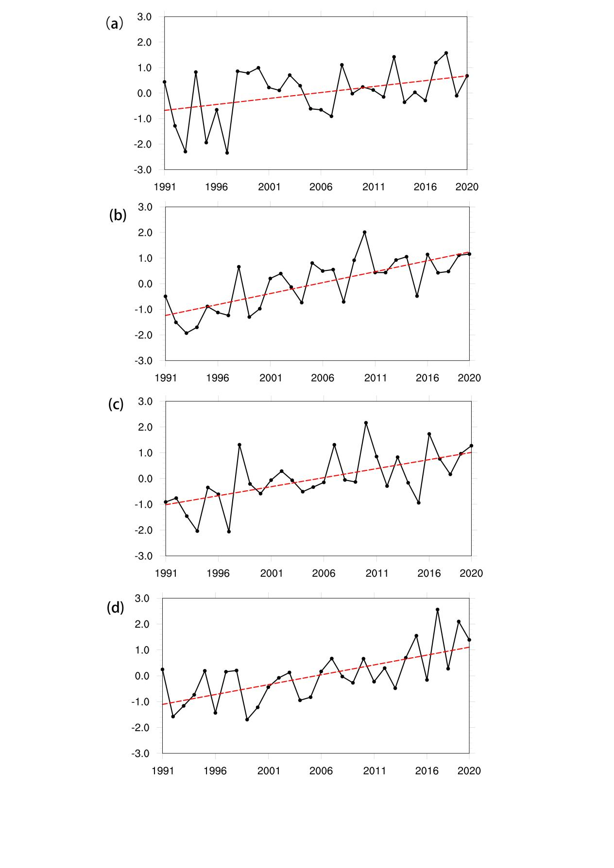
Figure S2: summer of 1991–2020: standardized interannual variation curves of specific humidity at 2 m in the SST high-impact areas (a) SST area 1, ( b) SST area 2, ( c) SST area 3, and (d) SST area 4.

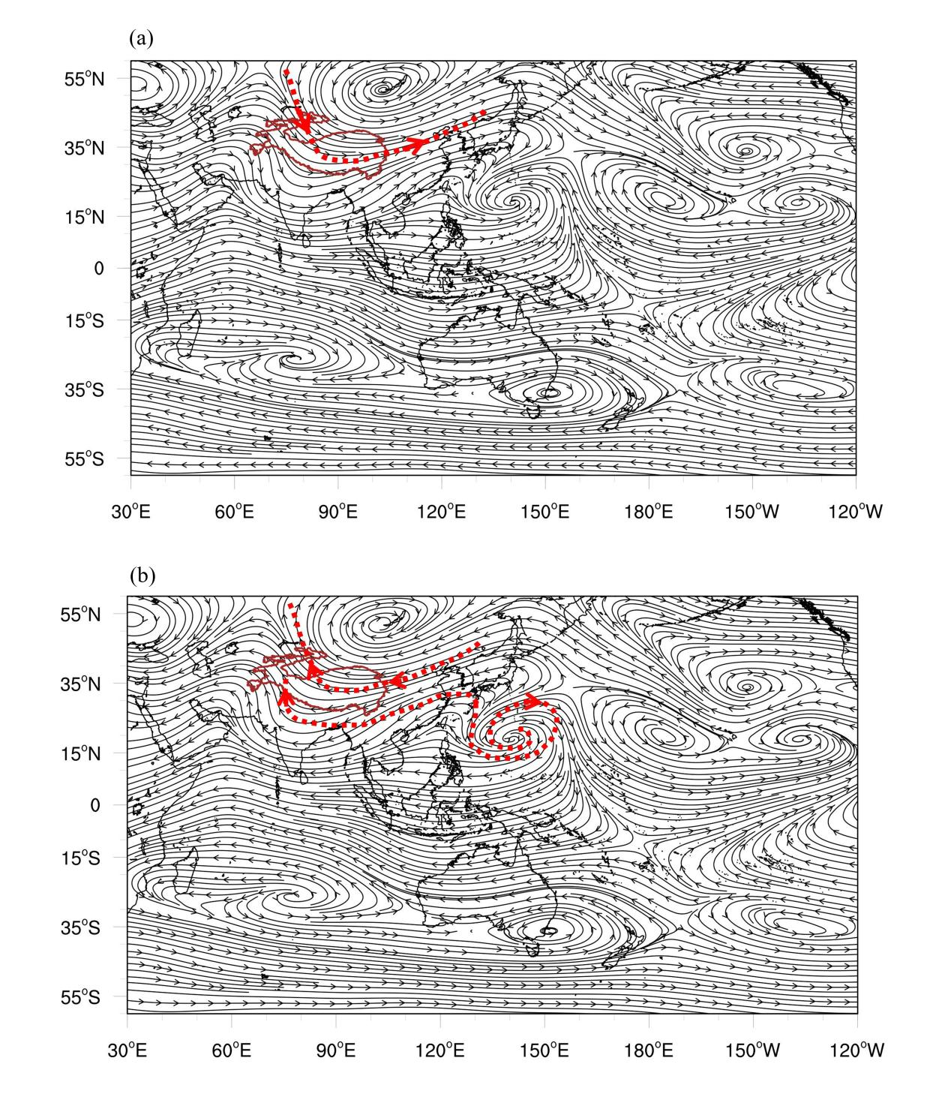
Figure S3: 500 hPa anomaly field of the whole-layer water vapor fluxes (a) for 1961–1990 and (b) for 1991–2020.

