Supplemental Data
Table 1: Brain exposure to ¹⁸F-baclofen raw data and ratios of exposure between the C1 and T10 conditions and coefficient of variance.
Group | Subject | Amygdala Uptake AUC (μCi min) | Anterior Caudate Nucleus Uptake AUC (μCi min) | Anterior Cingulate Cortex Uptake AUC (μCi min) | Anterior Putamen Uptake AUC (μCi min) | Brain Stem Uptake AUC (μCi min) | Cerebellar White Matter Uptake AUC (μCi min) | Cerebellum Uptake AUC (μCi min) | Dorsolateral Frontal Cortex Uptake AUC (μCi min) | Enthorinal Cortex Uptake AUC (μCi min) | External Pallidum Uptake AUC (μCi min) | Fusiform Gyrus Uptake AUC (μCi min) | Hippocampus Uptake AUC (μCi min) | Inferior Parietal Cortex Uptake AUC (μCi min) | Inferior Temporal Cortex Uptake AUC (μCi min)
IT C1 | A9401 | 40.97 | 4.31 | 20.31 | 6.17 | 201.76 | 41.45 | 116.53 | 2.38 | 4.70 | 1.25 | 6.49 | 12.40 | 18.95 | 5.24
IT C1 | A9402 | 5.41 | 0.62 | 2.57 | 0.86 | 29.90 | 6.14 | 18.38 | 0.52 | 0.85 | 0.23 | 1.21 | 1.62 | 2.99 | 1.34
IT C1 | A9404 | 17.24 | 1.61 | 2.49 | 4.02 | 106.20 | 18.89 | 98.57 | 1.63 | 3.13 | 0.91 | 4.38 | 5.23 | 13.08 | 3.95
IT T10 | A9401 | 0.66 | 0.13 | 0.26 | 0.20 | 1.84 | 0.35 | 2.18 | 0.40 | 0.24 | 0.06 | 0.51 | 0.36 | 1.03 | 0.74
IT T10 | A9402 | 0.18 | 0.04 | 0.09 | 0.04 | 0.99 | 0.24 | 0.98 | 0.09 | 0.05 | 0.03 | 0.14 | 0.13 | 0.40 | 0.19
IT T10 | A9404 | 1.62 | 0.26 | 0.29 | 0.44 | 13.03 | 1.80 | 11.00 | 0.24 | 0.26 | 0.12 | 2.32 | 1.99 | 1.39 | 0.81
Mean C1 |  | 21.21 | 2.18 | 8.46 | 3.68 | 112.62 | 22.16 | 77.83 | 1.51 | 2.89 | 0.80 | 4.03 | 6.42 | 11.67 | 3.51
SD C1 |  | 18.11 | 1.91 | 10.27 | 2.67 | 86.11 | 17.88 | 52.26 | 0.94 | 1.94 | 0.52 | 2.66 | 5.49 | 8.07 | 1.99
Coefficient of Variance C1 |  | 85.39 | 87.61 | 121.39 | 72.51 | 76.46 | 80.69 | 67.15 | 61.97 | 66.91 | 65.19 | 66.00 | 85.51 | 69.15 | 56.61
Mean T10 |  | 0.82 | 0.14 | 0.21 | 0.23 | 5.29 | 0.80 | 4.72 | 0.24 | 0.18 | 0.07 | 0.99 | 0.83 | 0.94 | 0.58
SD T10 |  | 0.73 | 0.11 | 0.11 | 0.20 | 6.72 | 0.87 | 5.47 | 0.16 | 0.12 | 0.05 | 1.17 | 1.01 | 0.50 | 0.34
Coefficient of Variance T10 |  | 89.42 | 77.17 | 50.56 | 88.82 | 127.10 | 109.29 | 115.92 | 63.71 | 63.22 | 65.47 | 117.84 | 122.66 | 53.31 | 58.54
Ratio C1/T10 |  | 25.86 | 15.21 | 39.64 | 16.25 | 21.30 | 27.82 | 16.49 | 6.21 | 15.78 | 11.38 | 4.07 | 7.76 | 12.42 | 6.05
Group | Subject | Insula Uptake AUC (μCi min) | Internal Pallidum Uptake AUC (μCi min) | Lateral Ventricle Uptake AUC (μCi min) | Limbic Cingulate Cortex Uptake AUC (μCi min) | Medial Frontal Cortex Uptake AUC (μCi min) | Medial Temporal Cortex Uptake AUC (μCi min) | Occipital Cortex Uptake AUC (μCi min) | Orbitofrontal Cortex Uptake AUC (μCi min) | Parahippocampal Gyrus Uptake AUC (μCi min) | Posterior Caudate Nucleus Uptake AUC (μCi min) | Posterior Cingulate Cortex Uptake AUC (μCi min) | Posterior Putamen Uptake AUC (μCi min) | Precuneus Uptake AUC (μCi min) | Premotor Cortex Uptake AUC (μCi min)
IT C1 | A9401 | 21.52 | 0.58 | 2.80 | 3.19 | 1.59 | 20.07 | 70.32 | 22.66 | 10.71 | 0.80 | 11.10 | 7.94 | 4.18 | 21.86
IT C1 | A9402 | 2.70 | 0.11 | 0.56 | 0.55 | 0.19 | 3.23 | 10.30 | 2.98 | 1.82 | 0.18 | 1.52 | 1.01 | 0.78 | 3.62
IT C1 | A9404 | 18.61 | 0.36 | 1.22 | 1.09 | 0.33 | 10.13 | 38.89 | 12.56 | 6.65 | 0.44 | 4.48 | 4.46 | 2.40 | 13.97
IT T10 | A9401 | 0.25 | 0.02 | 0.15 | 0.03 | 0.13 | 1.45 | 3.25 | 1.40 | 0.22 | 0.07 | 0.28 | 0.21 | 0.22 | 1.45
IT T10 | A9402 | 0.07 | 0.01 | 0.04 | 0.01 | 0.03 | 0.42 | 1.20 | 0.30 | 0.08 | 0.01 | 0.10 | 0.06 | 0.08 | 0.39
IT T10 | A9404 | 0.81 | 0.06 | 0.36 | 0.05 | 0.05 | 1.79 | 8.05 | 1.13 | 1.14 | 0.10 | 0.65 | 0.37 | 0.49 | 2.43
Mean C1 |  | 14.28 | 0.35 | 1.53 | 1.61 | 0.70 | 11.14 | 39.84 | 12.73 | 6.39 | 0.47 | 5.70 | 4.47 | 2.45 | 13.15
SD C1 |  | 10.13 | 0.24 | 1.15 | 1.39 | 0.77 | 8.47 | 30.02 | 9.84 | 4.45 | 0.31 | 4.91 | 3.47 | 1.70 | 9.15
Coefficient of Variance C1 |  | 70.96 | 67.19 | 75.40 | 86.63 | 109.63 | 75.97 | 75.36 | 77.29 | 69.61 | 65.78 | 86.06 | 77.52 | 69.32 | 69.56
Mean T10 |  | 0.38 | 0.03 | 0.18 | 0.03 | 0.07 | 1.22 | 4.17 | 0.94 | 0.48 | 0.06 | 0.34 | 0.21 | 0.26 | 1.42
SD T10 |  | 0.39 | 0.03 | 0.16 | 0.02 | 0.05 | 0.71 | 3.52 | 0.57 | 0.58 | 0.05 | 0.28 | 0.16 | 0.21 | 1.02
Coefficient of Variance T10 |  | 102.46 | 88.19 | 88.68 | 66.67 | 75.59 | 58.47 | 84.38 | 60.77 | 119.97 | 76.38 | 81.67 | 72.67 | 79.14 | 71.68
Ratio C1/T10 |  | 37.90 | 11.67 | 8.33 | 53.67 | 10.05 | 9.13 | 9.56 | 13.50 | 13.32 | 7.89 | 16.60 | 20.95 | 9.32 | 9.24
Group | Subject | Primary Motor Cortex Uptake AUC (μCi min) | Primary Sensory Cortex Uptake AUC (μCi min) | Rest of Brain Uptake AUC (μCi min) | Substantia Nigra Uptake AUC (μCi min) | Superior Parietal Cortex Uptake AUC (μCi min) | Superior Temporal Cortex Uptake AUC (μCi min) | Thalamus Uptake AUC (μCi min) | Third and Fourth Ventricles Uptake AUC (μCi min) | Ventral Frontal Cortex Uptake AUC (μCi min) | Ventral Posterior Putamen Uptake AUC (μCi min) | Ventral Striatum Uptake AUC (μCi min) | Vermis Uptake AUC (μCi min)
IT C1 | A9401 | 5.05 | 12.30 | 245.57 | 2.32 | 4.14 | 62.56 | 3.21 | 3.10 | 2.56 | 2.06 | 6.99 | 19.06
IT C1 | A9402 | 0.99 | 2.14 | 39.01 | 0.29 | 1.00 | 6.87 | 0.73 | 0.66 | 0.49 | 0.15 | 0.58 | 4.49
IT C1 | A9404 | 2.49 | 10.26 | 175.72 | 0.94 | 2.92 | 32.24 | 1.96 | 1.67 | 2.68 | 0.43 | 1.52 | 19.12
IT T10 | A9401 | 0.46 | 0.74 | 9.00 | 0.04 | 0.41 | 1.86 | 0.24 | 0.09 | 0.44 | 0.05 | 0.14 | 0.58
IT T10 | A9402 | 0.15 | 0.24 | 2.71 | 0.01 | 0.15 | 0.55 | 0.08 | 0.05 | 0.09 | 0.01 | 0.02 | 0.30
IT T10 | A9404 | 0.46 | 1.63 | 21.95 | 0.24 | 0.57 | 3.89 | 0.42 | 0.34 | 0.41 | 0.23 | 0.26 | 3.19
Mean C1 |  | 2.84 | 8.23 | 153.43 | 1.18 | 2.69 | 33.89 | 1.97 | 1.81 | 1.91 | 0.88 | 3.03 | 14.22
SD C1 |  | 2.05 | 5.37 | 105.07 | 1.04 | 1.58 | 27.88 | 1.24 | 1.23 | 1.23 | 1.03 | 3.46 | 8.43
Coefficient of Variance C1 |  | 72.20 | 65.28 | 68.48 | 87.60 | 58.92 | 82.27 | 63.05 | 67.74 | 64.46 | 117.21 | 114.24 | 59.26
Mean T10 |  | 0.36 | 0.87 | 11.22 | 0.10 | 0.38 | 2.10 | 0.25 | 0.16 | 0.31 | 0.10 | 0.14 | 1.36
SD T10 |  | 0.18 | 0.70 | 9.81 | 0.13 | 0.21 | 1.68 | 0.17 | 0.16 | 0.19 | 0.12 | 0.12 | 1.59
Coefficient of Variance T10 |  | 50.18 | 80.93 | 87.44 | 129.34 | 56.28 | 80.14 | 68.96 | 98.23 | 61.91 | 121.23 | 85.71 | 117.48
Ratio C1/T10 |  | 7.97 | 9.46 | 13.67 | 12.24 | 7.13 | 16.14 | 7.97 | 11.31 | 6.10 | 9.10 | 21.64 | 10.48

Table 2: Spinal cord exposure to ¹⁸F-baclofen raw data and ratios of exposure between the C1 and T10 conditions and coefficient of variance.
Group | Subject | Cervical Spinal Cord Uptake AUC (μCi min) | Cervical Spinal Cord + CSF Uptake AUC (μCi min) | Upper Thoracic Spinal Cord Uptake AUC (μCi min) | Upper Thoracic Spinal Cord + CSF Uptake AUC (μCi min) | Lower Thoracic Spinal Cord Uptake AUC (μCi min) | Lower Thoracic Spinal Cord + CSF Uptake AUC (μCi min) | Lumbar Spinal Cord Uptake AUC (μCi min) | Lumbar Spinal Cord + CSF Uptake AUC (μCi min) | Whole Body Uptake AUC (μCi min)
IT C1 | A9401 | 70.58 | 276.24 | 10.72 | 131.27 | 109.44 | 220.56 | 60.49 | 110.24 | 52582.3
IT C1 | A9402 | 114.55 | 297.99 | 27.69 | 140.23 | 131.83 | 228.85 | 103.76 | 289 | 124073
IT C1 | A9404 | 67.01 | 181.96 | 12.13 | 48.71 | 23.67 | 87.42 | 50.31 | 99.12 | 36341.4
IT T10 | A9401 | 0.78 | 2.08 | 0.9 | 3.64 | 72.8 | 203.23 | 29.33 | 80.15 | 49278.5
IT T10 | A9402 | 0.95 | 2.28 | 1.64 | 4.93 | 83.96 | 167.49 | 83.4 | 179.06 | 63867.2
IT T10 | A9404 | 14.57 | 31.85 | 17.7 | 55.51 | 126.23 | 287.71 | 130.59 | 235.81 | 51497.7
Mean C1 |  | 84.04667 | 252.0633 | 16.84667 | 106.7367 | 88.31333 | 178.9433 | 71.52 | 166.12 | 70998.9
SD C1 |  | 26.4769 | 61.67758 | 9.417029 | 50.45187 | 57.09114 | 79.36984 | 28.38083 | 106.5623 | 46675.33
Coefficient of Variance C1 |  | 31.50262 | 24.46908 | 55.89847 | 47.26761 | 64.64612 | 44.35473 | 39.68236 | 64.14781 | 65.74093
Mean T10 |  | 5.433333 | 12.07 | 6.746667 | 21.36 | 94.33 | 219.4767 | 81.10667 | 165.0067 | 54881.13
SD T10 |  | 7.913042 | 17.13027 | 9.493078 | 29.5818 | 28.18411 | 61.73474 | 50.66894 | 78.77583 | 7860.869
Coefficient of Variance T10 |  | 145.6388 | 141.9244 | 140.7077 | 138.4916 | 29.8782 | 28.12815 | 62.47198 | 47.741 | 14.32344
Ratio C1/T10 |  | 15.46871 | 20.88346 | 2.497036 | 4.997035 | 0.936217 | 0.815318 | 0.881802 | 1.006747 | 1.293685

Table 3: Brain exposure to ¹⁸F-baclofen expressed as µg*min.
Group | Subject | Amygdala Uptake AUC (μg min) | Anterior Caudate Nucleus Uptake AUC (μg min) | Anterior Cingulate Cortex Uptake AUC (μg min) | Anterior Putamen Uptake AUC (μg min) | Brain Stem Uptake AUC (μg min) | Cerebellar White Matter Uptake AUC (μg min) | Cerebellum Uptake AUC (μg min) | Dorsolateral Frontal Cortex Uptake AUC (μg min) | Enthorinal Cortex Uptake AUC (μg min) | External Pallidum Uptake AUC (μg min) | Fusiform Gyrus Uptake AUC (μg min) | Hippocampus Uptake AUC (ug min) | Inferior Parietal Cortex Uptake AUC (μg min) | Inferior Temporal Cortex Uptake AUC (μg min)
IT C1 | A9401 | 0.15 | 0.02 | 0.07 | 0.02 | 0.72 | 0.15 | 0.42 | 0.01 | 0.02 | 0.00 | 0.02 | 0.04 | 0.07 | 0.02
IT C1 | A9402 | 0.79 | 0.09 | 0.37 | 0.13 | 4.35 | 0.89 | 2.68 | 0.08 | 0.12 | 0.03 | 0.18 | 0.24 | 0.44 | 0.20
IT C1 | A9404 | 1.84 | 0.17 | 0.27 | 0.43 | 11.31 | 2.01 | 10.50 | 0.17 | 0.33 | 0.10 | 0.47 | 0.56 | 1.39 | 0.42
IT T10 | A9401 | 0.02 | 0.00 | 0.01 | 0.01 | 0.06 | 0.01 | 0.08 | 0.01 | 0.01 | 0.00 | 0.02 | 0.01 | 0.04 | 0.03
IT T10 | A9402 | 0.00 | 0.00 | 0.00 | 0.00 | 0.02 | 0.00 | 0.02 | 0.00 | 0.00 | 0.00 | 0.00 | 0.00 | 0.01 | 0.00
IT T10 | A9404 | 0.03 | 0.00 | 0.00 | 0.01 | 0.22 | 0.03 | 0.19 | 0.00 | 0.00 | 0.00 | 0.04 | 0.03 | 0.02 | 0.01
Group | Subject | Insula Uptake AUC (μg min) | Internal Pallidum Uptake AUC (μg min) | Lateral Ventricle Uptake AUC (μg min) | Limbic Cingulate Cortex Uptake AUC (μg min) | Medial Frontal Cortex Uptake AUC (μg min) | Medial Temporal Cortex Uptake AUC (μg min) | Occipital Cortex Uptake AUC (μg min) | Orbitofrontal Cortex Uptake AUC (μg min) | Parahippocampal Gyrus Uptake AUC (μg min) | Posterior Caudate Nucleus Uptake AUC (μg min) | Posterior Cingulate Cortex Uptake AUC (μg min) | Posterior Putamen Uptake AUC (μg min) | Precuneus Uptake AUC (μg min) | Premotor Cortex Uptake AUC (μg min)
IT C1 | A9401 | 0.08 | 0.00 | 0.01 | 0.01 | 0.01 | 0.07 | 0.25 | 0.08 | 0.04 | 0.00 | 0.04 | 0.03 | 0.01 | 0.08
IT C1 | A9402 | 0.39 | 0.02 | 0.08 | 0.08 | 0.03 | 0.47 | 1.50 | 0.43 | 0.27 | 0.03 | 0.22 | 0.15 | 0.11 | 0.53
IT C1 | A9404 | 1.98 | 0.04 | 0.13 | 0.12 | 0.04 | 1.08 | 4.14 | 1.34 | 0.71 | 0.05 | 0.48 | 0.48 | 0.26 | 1.49
IT T10 | A9401 | 0.01 | 0.00 | 0.01 | 0.00 | 0.00 | 0.05 | 0.11 | 0.05 | 0.01 | 0.00 | 0.01 | 0.01 | 0.01 | 0.05
IT T10 | A9402 | 0.00 | 0.00 | 0.00 | 0.00 | 0.00 | 0.01 | 0.02 | 0.00 | 0.00 | 0.00 | 0.00 | 0.00 | 0.00 | 0.01
IT T10 | A9404 | 0.01 | 0.00 | 0.01 | 0.00 | 0.00 | 0.03 | 0.14 | 0.02 | 0.02 | 0.00 | 0.01 | 0.01 | 0.01 | 0.04
Group | Subject | Primary Motor Cortex Uptake AUC (μg min) | Primary Sensory Cortex Uptake AUC (μg min) | Rest of Brain Uptake AUC (μg min) | Substantia Nigra Uptake AUC (μg min) | Superior Parietal Cortex Uptake AUC (μg min) | Superior Temporal Cortex Uptake AUC (μg min) | Thalamus Uptake AUC (μg min) | Third and Fourth Ventricles Uptake AUC (μg min) | Ventral Frontal Cortex Uptake AUC (μg min) | Ventral Posterior Putamen Uptake AUC (μg min) | Ventral Striatum Uptake AUC (μg min) | Vermis Uptake AUC (μg min) | White Matter Anterior Uptake AUC (µg min) | White Matter Posterior Uptake AUC (µg min)
IT C1 | A9401 | 0.02 | 0.04 | 0.88 | 0.01 | 0.01 | 0.22 | 0.01 | 0.01 | 0.01 | 0.01 | 0.02 | 0.07 | 0.29 | 0.24
IT C1 | A9402 | 0.14 | 0.31 | 5.68 | 0.04 | 0.15 | 1.00 | 0.11 | 0.10 | 0.07 | 0.02 | 0.08 | 0.65 | 1.85 | 1.40
IT C1 | A9404 | 0.27 | 1.09 | 18.72 | 0.10 | 0.31 | 3.43 | 0.21 | 0.18 | 0.29 | 0.05 | 0.16 | 2.04 | 4.99 | 3.09
IT T10 | A9401 | 0.02 | 0.03 | 0.31 | 0.00 | 0.01 | 0.06 | 0.01 | 0.00 | 0.02 | 0.00 | 0.00 | 0.02 | 0.08 | 0.09
IT T10 | A9402 | 0.00 | 0.00 | 0.04 | 0.00 | 0.00 | 0.01 | 0.00 | 0.00 | 0.00 | 0.00 | 0.00 | 0.00 | 0.01 | 0.01
IT T10 | A9404 | 0.01 | 0.03 | 0.37 | 0.00 | 0.01 | 0.07 | 0.01 | 0.01 | 0.01 | 0.00 | 0.00 | 0.05 | 0.08 | 0.13

Table 4: Spine exposure to ¹⁸F-baclofen expressed as µg*min.
Group | Subject | Cervical Spinal Cord Uptake AUC (μg min) | Cervical Spinal Cord + CSF Uptake AUC (μg min) | Upper Thoracic Spinal Cord Uptake AUC (μg min) | Upper Thoracic Spinal Cord + CSF Uptake AUC (μg min) | Lower Thoracic Spinal Cord Uptake AUC (μg min) | Lower Thoracic Spinal Cord + CSF Uptake AUC (μCi min) | Lumbar Spinal Cord Uptake AUC (μg min) | Lumbar Spinal Cord + CSF Uptake AUC (μg min)
IT C1 | A9401 | 0.25 | 0.99 | 0.04 | 0.47 | 0.39 | 0.79 | 0.22 | 0.39
IT C1 | A9402 | 16.68 | 43.39 | 4.03 | 20.42 | 19.20 | 33.32 | 15.11 | 42.08
IT C1 | A9404 | 7.14 | 19.38 | 1.29 | 5.19 | 2.52 | 9.31 | 5.36 | 10.56
IT T10 | A9401 | 0.03 | 0.07 | 0.03 | 0.13 | 2.53 | 7.07 | 1.02 | 2.79
IT T10 | A9402 | 0.01 | 0.04 | 0.03 | 0.08 | 1.30 | 2.59 | 1.29 | 2.77
IT T10 | A9404 | 0.25 | 0.54 | 0.30 | 0.95 | 2.15 | 4.91 | 2.23 | 4.02

Figures 1-51 following present plots of the activity within each region, expressed as µCi, of the ¹⁸F-baclofen.

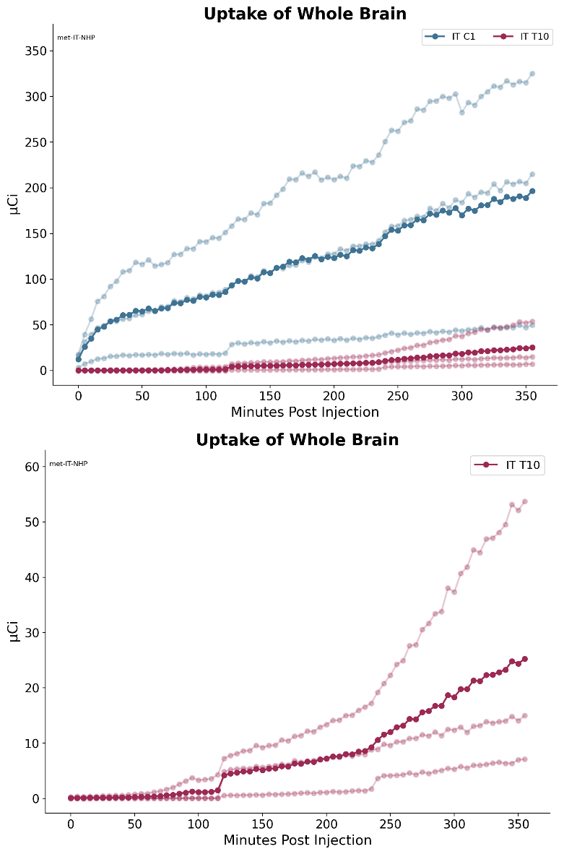
Figure 1: [¹⁸F]-Baclofen activity in monkey whole brain post IT administration.
Top: Group 1 with IT catheter tip placed at C1 and Group 2 with catheter tip placed at T10; dark blue and red lines represent the mean of the 3 individual animals shown in the muted blue and red lines
Bottom: Group 2 plotted alone with IT catheter tip placed at T10; dark red line represents the mean of the 3 individual animals shown in the lighter red lines.

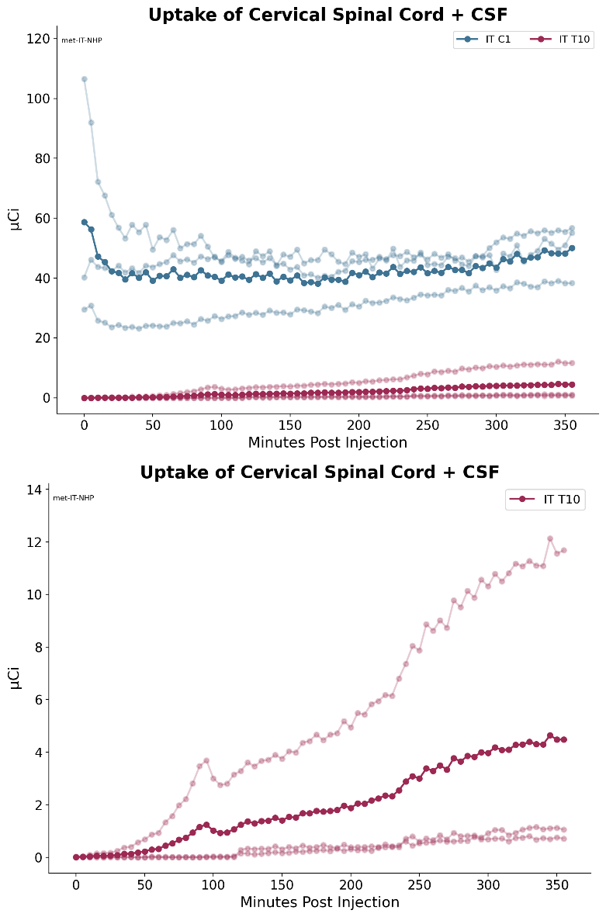
Figure 2: [¹⁸F]-Baclofen activity in monkey cervical spinal cord + CSF post IT administration.
Top: Group 1 with IT catheter tip placed at C1 and Group 2 with catheter tip placed at T10; dark blue and red lines represent the mean of the 3 individual animals shown in the muted blue and red lines
Bottom: Group 2 plotted alone with IT catheter tip placed at T10; dark red line represents the mean of the 3 individual animals shown in the lighter red lines.

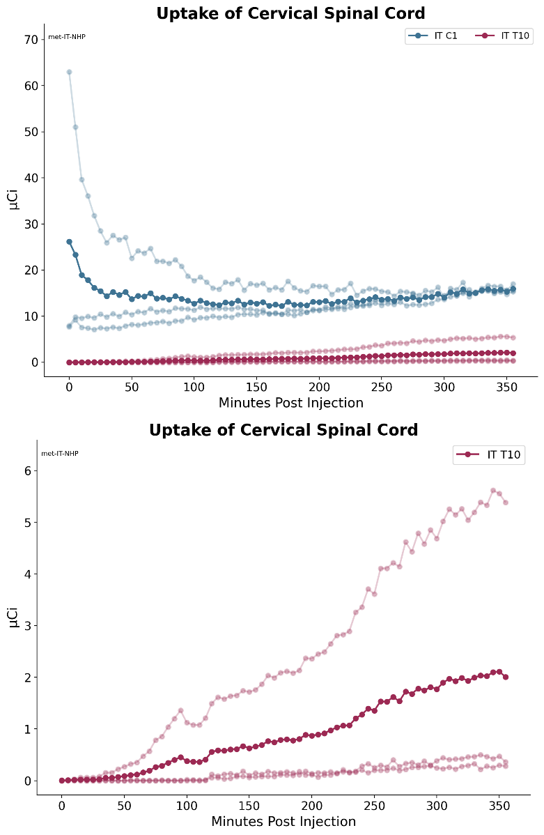
Figure 3: [¹⁸F]-Baclofen activity in monkey cervical spinal cord post IT administration.
Top: Group 1 with IT catheter tip placed at C1 and Group 2 with catheter tip placed at T10; dark blue and red lines represent the mean of the 3 individual animals shown in the muted blue and red lines
Bottom: Group 2 plotted alone with IT catheter tip placed at T10; dark red line represents the mean of the 3 individual animals shown in the lighter red lines.
\

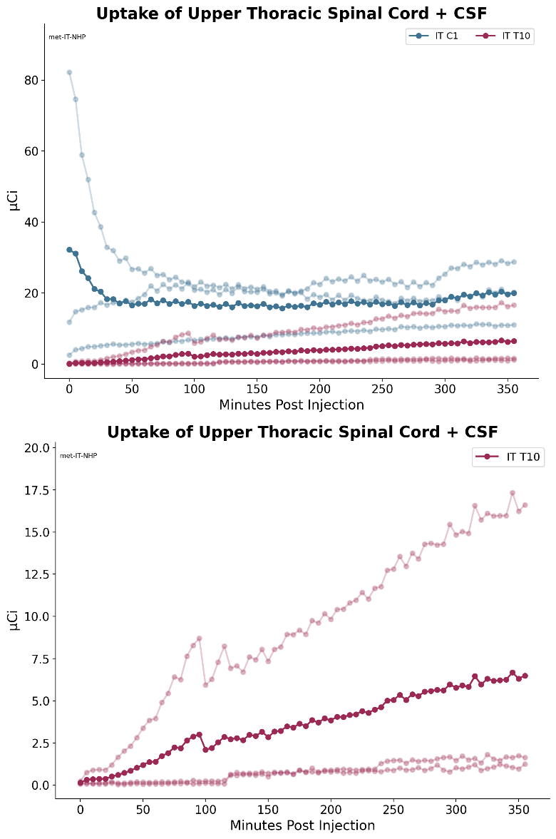
Figure 4: [¹⁸F]-Baclofen activity in monkey upper thoracic spinal cord + CSF post IT administration.
Top: Group 1 with IT catheter tip placed at C1 and Group 2 with catheter tip placed at T10; dark blue and red lines represent the mean of the 3 individual animals shown in the muted blue and red lines
Bottom: Group 2 plotted alone with IT catheter tip placed at T10; dark red line represents the mean of the 3 individual animals shown in the lighter red lines.

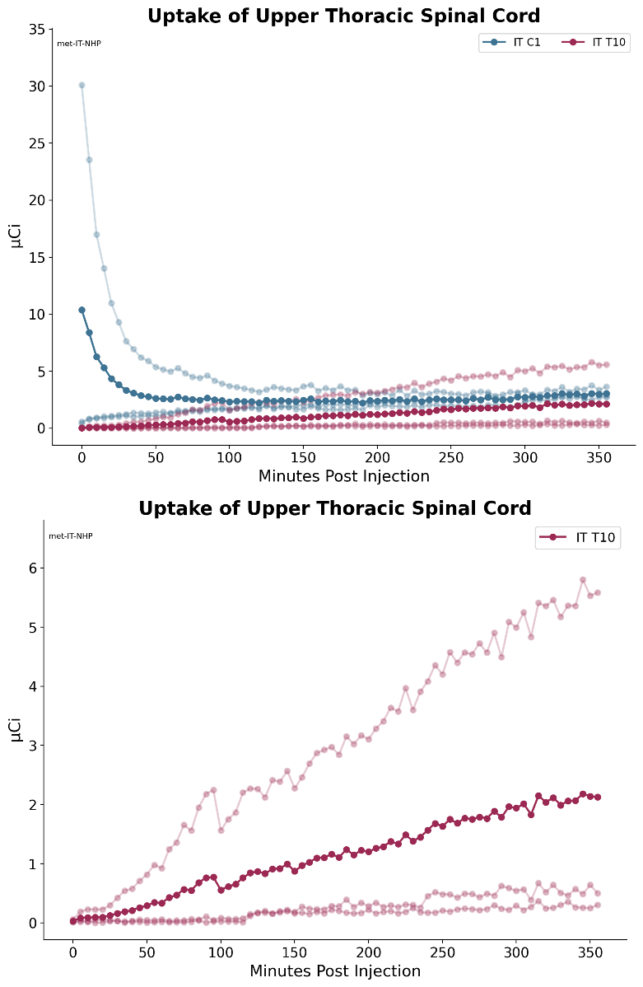
Figure 5: [¹⁸F]-Baclofen activity in monkey upper thoracic spinal cord post IT administration.
Top: Group 1 with IT catheter tip placed at C1 and Group 2 with catheter tip placed at T10; dark blue and red lines represent the mean of the 3 individual animals shown in the muted blue and red lines
Bottom: Group 2 plotted alone with IT catheter tip placed at T10; dark red line represents the mean of the 3 individual animals shown in the lighter red lines.

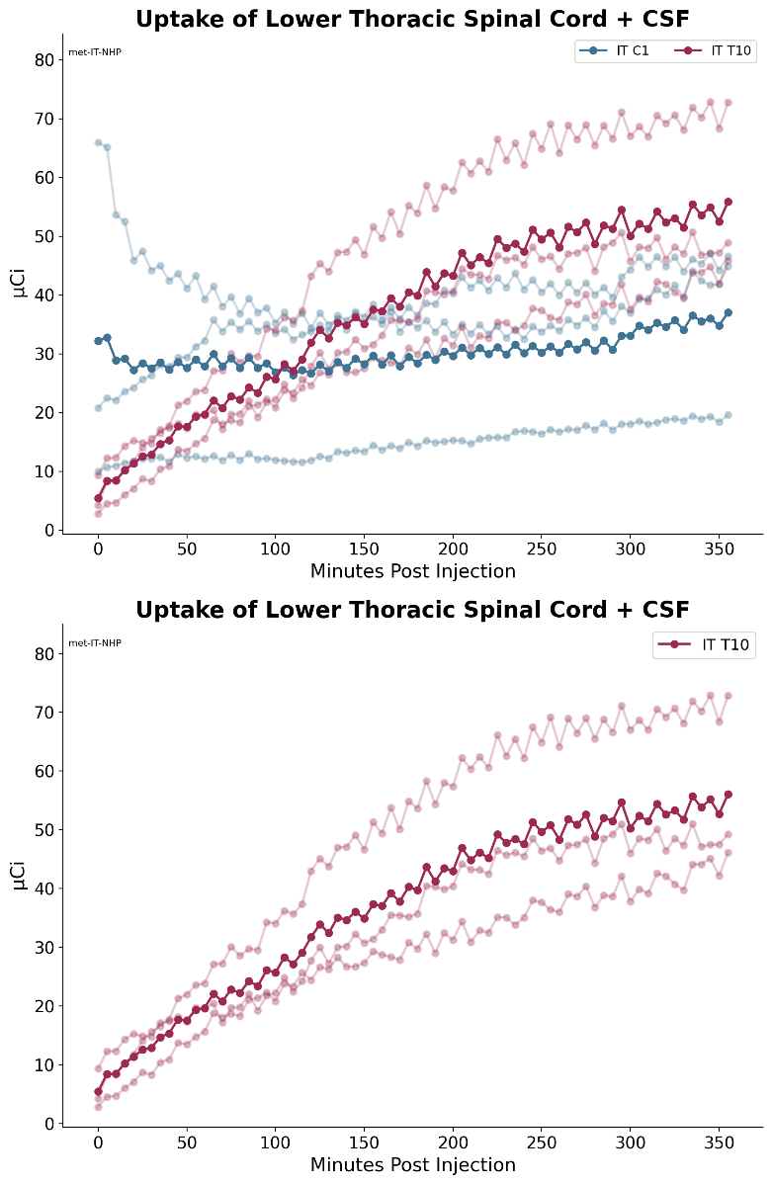
Figure 6: [¹⁸F]-Baclofen activity in monkey lower thoracic spinal cord + CSF post IT administration.
Top: Group 1 with IT catheter tip placed at C1 and Group 2 with catheter tip placed at T10; dark blue and red lines represent the mean of the 3 individual animals shown in the muted blue and red lines
Bottom: Group 2 plotted alone with IT catheter tip placed at T10; dark red line represents the mean of the 3 individual animals shown in the lighter red lines.

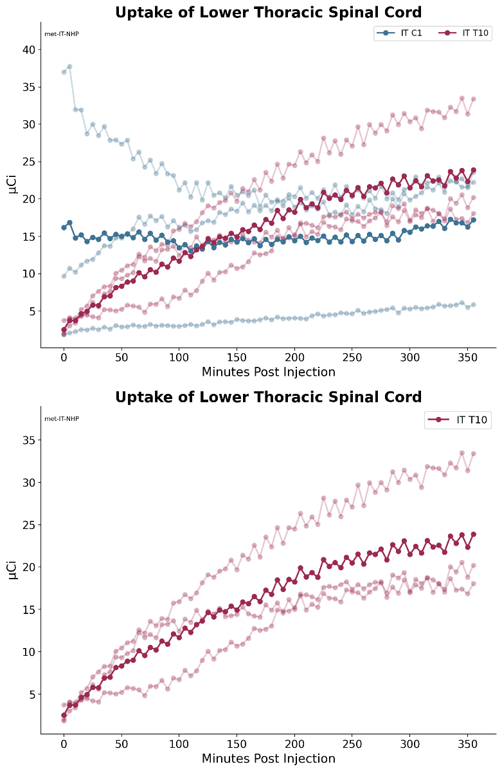
Figure 7: [¹⁸F]-Baclofen activity in monkey lower thoracic spinal cord post IT administration.
Top: Group 1 with IT catheter tip placed at C1 and Group 2 with catheter tip placed at T10; dark blue and red lines represent the mean of the 3 individual animals shown in the muted blue and red lines
Bottom: Group 2 plotted alone with IT catheter tip placed at T10; dark red line represents the mean of the 3 individual animals shown in the lighter red lines.

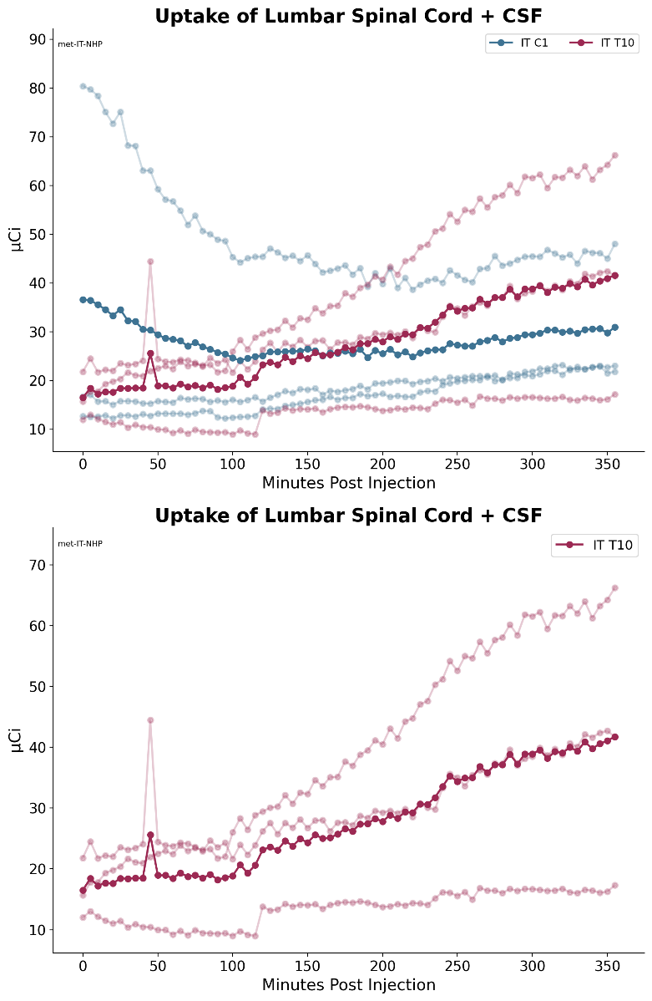
Figure 8: [¹⁸F]-Baclofen activity in monkey lumbar spinal cord + CSF post IT administration.
Top: Group 1 with IT catheter tip placed at C1 and Group 2 with catheter tip placed at T10; dark blue and red lines represent the mean of the 3 individual animals shown in the muted blue and red lines
Bottom: Group 2 plotted alone with IT catheter tip placed at T10; dark red line represents the mean of the 3 individual animals shown in the lighter red lines.

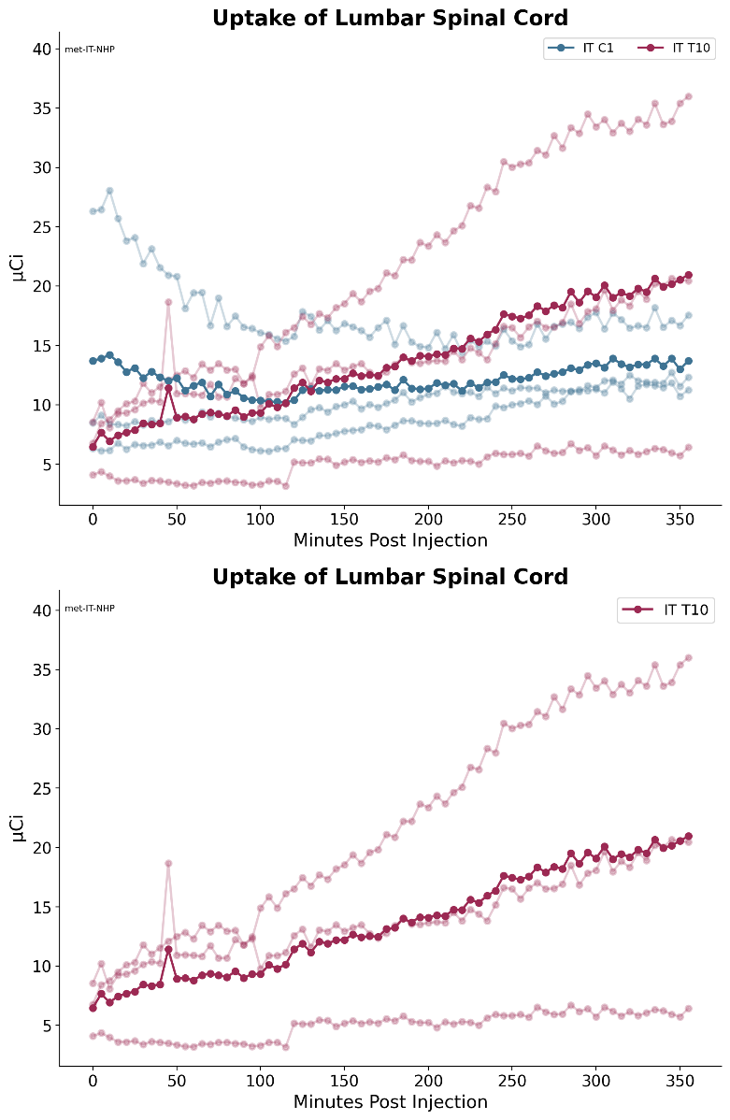
Figure 9: [¹⁸F]-Baclofen activity in monkey lumbar spinal cord post IT administration.
Top: Group 1 with IT catheter tip placed at C1 and Group 2 with catheter tip placed at T10; dark blue and red lines represent the mean of the 3 individual animals shown in the muted blue and red lines
Bottom: Group 2 plotted alone with IT catheter tip placed at T10; dark red line represents the mean of the 3 individual animals shown in the lighter red lines.

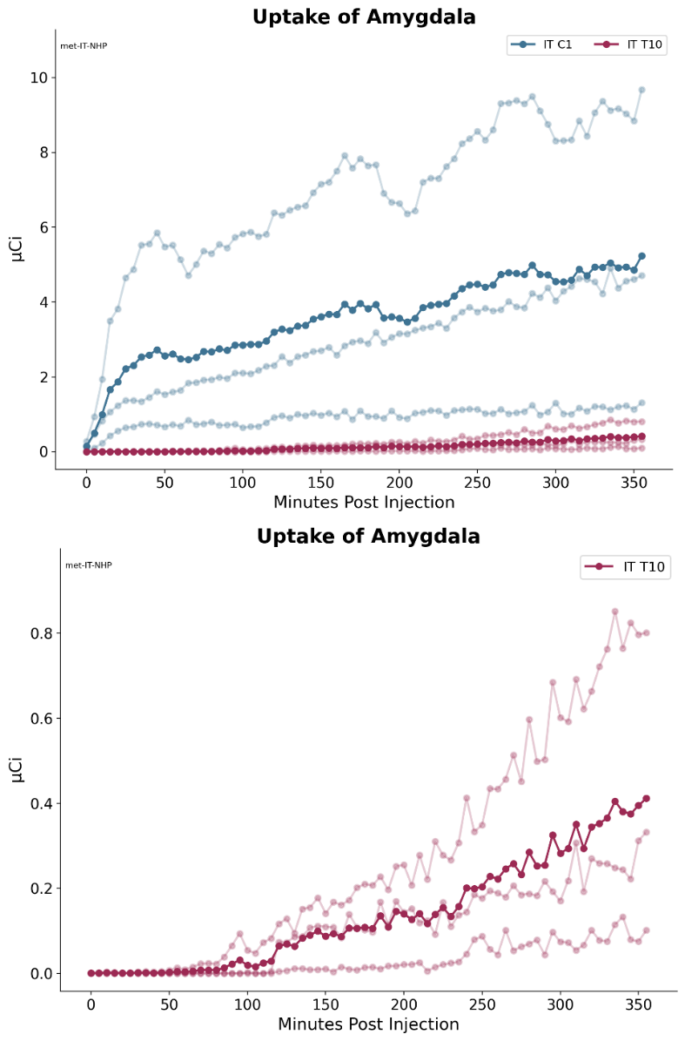

Figure 10: [¹⁸F]-Baclofen activity in monkey amygdala post IT administration.
Top: Group 1 with IT catheter tip placed at C1 and Group 2 with catheter tip placed at T10; dark blue and red lines represent the mean of the 3 individual animals shown in the muted blue and red lines
Bottom: Group 2 plotted alone with IT catheter tip placed at T10; dark red line represents the mean of the 3 individual animals shown in the lighter red lines.

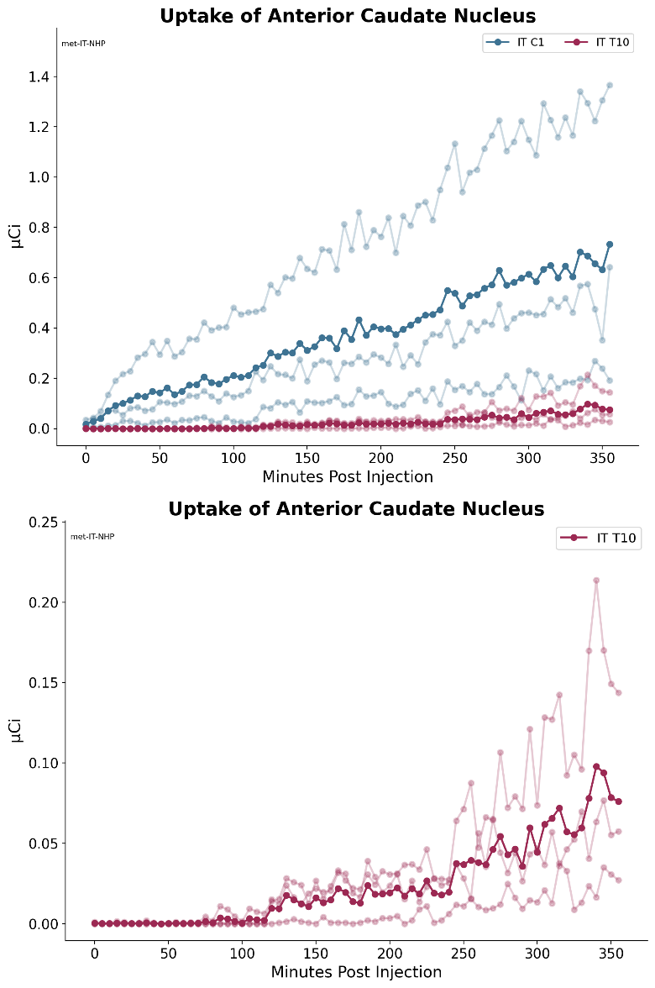

Figure 11: [¹⁸F]-Baclofen activity in monkey anterior caudate nucleus post IT administration.
Top: Group 1 with IT catheter tip placed at C1 and Group 2 with catheter tip placed at T10; dark blue and red lines represent the mean of the 3 individual animals shown in the muted blue and red lines
Bottom: Group 2 plotted alone with IT catheter tip placed at T10; dark red line represents the mean of the 3 individual animals shown in the lighter red lines.
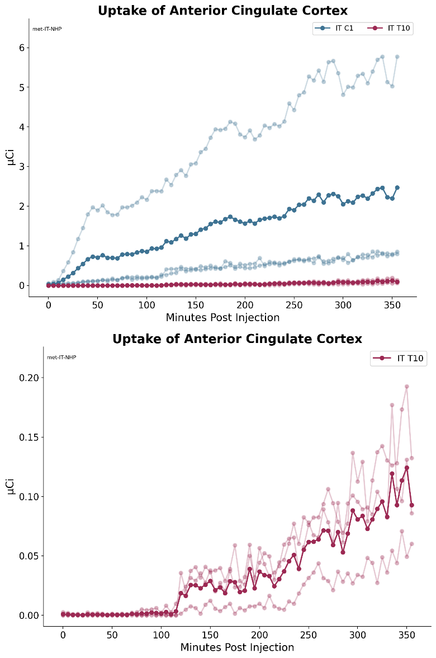
Figure 12: [¹⁸F]-Baclofen activity in monkey anterior cingulate nucleus post IT administration.
Top: Group 1 with IT catheter tip placed at C1 and Group 2 with catheter tip placed at T10; dark blue and red lines represent the mean of the 3 individual animals shown in the muted blue and red lines
Bottom: Group 2 plotted alone with IT catheter tip placed at T10; dark red line represents the mean of the 3 individual animals shown in the lighter red lines.
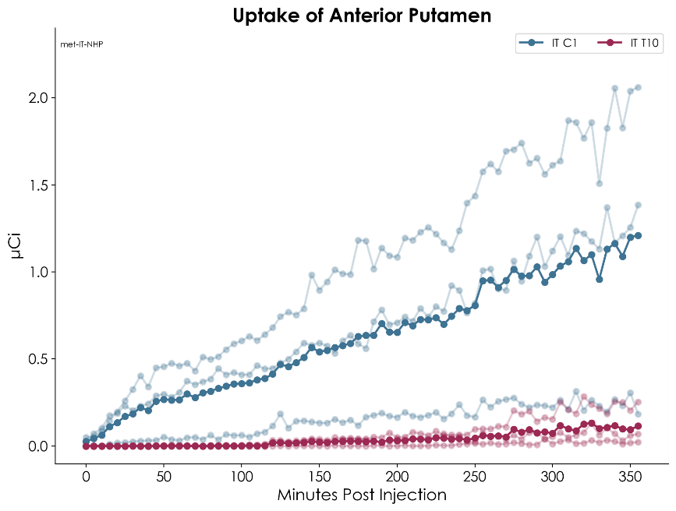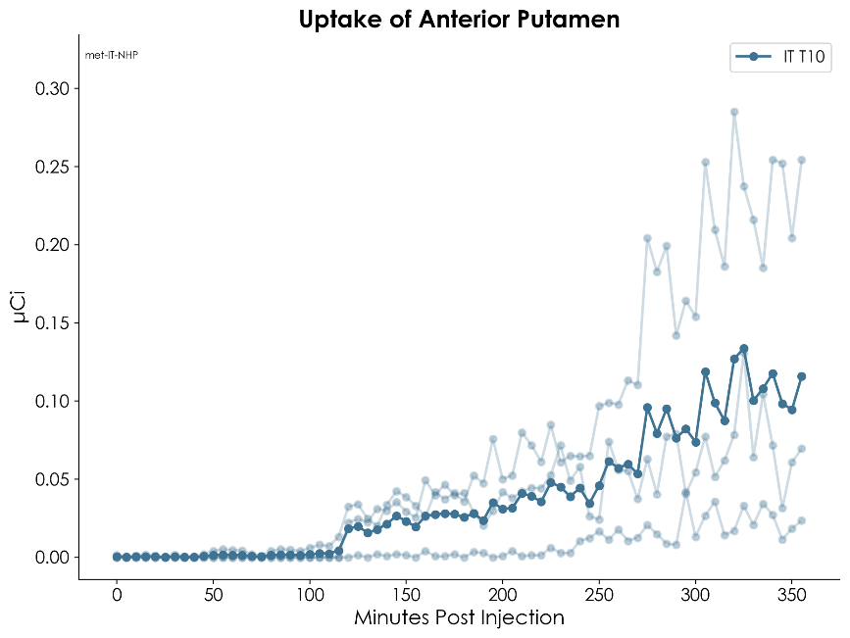

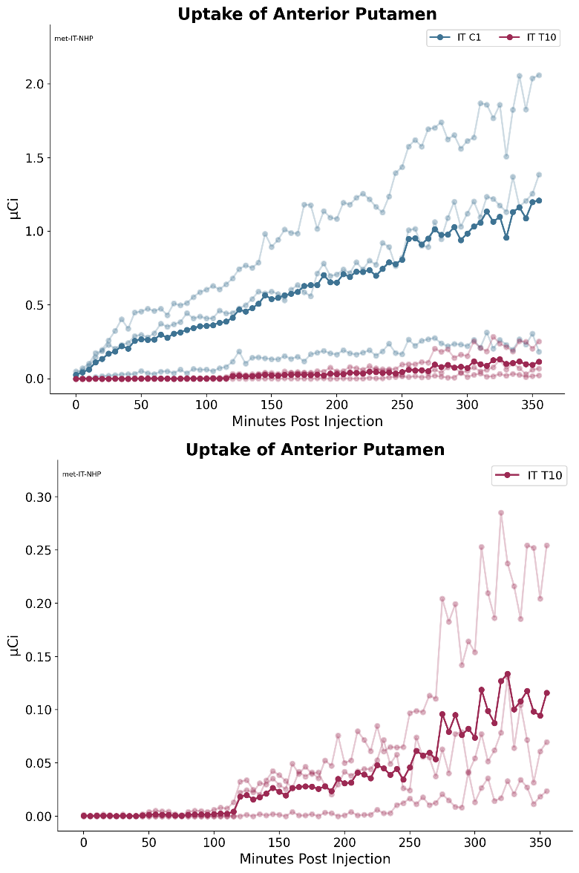

Figure 13: [¹⁸F]-Baclofen activity in monkey anterior putamen post IT administration.
Top: Group 1 with IT catheter tip placed at C1 and Group 2 with catheter tip placed at T10; dark blue and red lines represent the mean of the 3 individual animals shown in the muted blue and red lines
Bottom: Group 2 plotted alone with IT catheter tip placed at T10; dark red line represents the mean of the 3 individual animals shown in the lighter red lines.

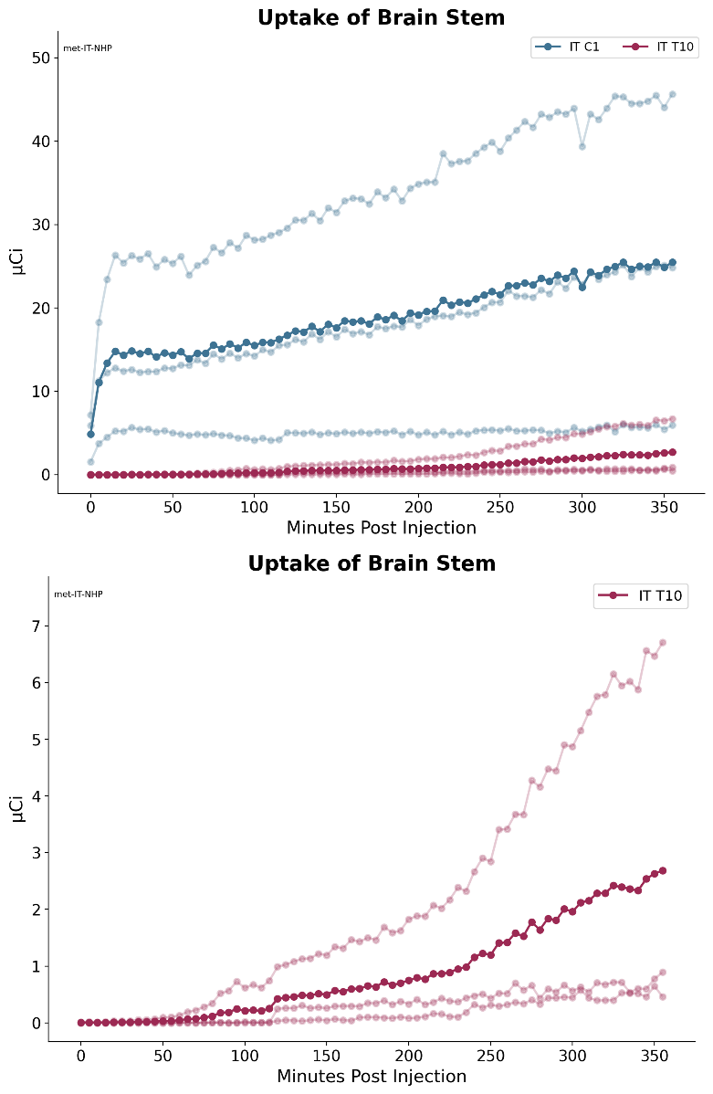

Figure 14: [¹⁸F]-Baclofen activity in monkey brain stem post IT administration.
Top: Group 1 with IT catheter tip placed at C1 and Group 2 with catheter tip placed at T10; dark blue and red lines represent the mean of the 3 individual animals shown in the muted blue and red lines
Bottom: Group 2 plotted alone with IT catheter tip placed at T10; dark red line represents the mean of the 3 individual animals shown in the lighter red lines.

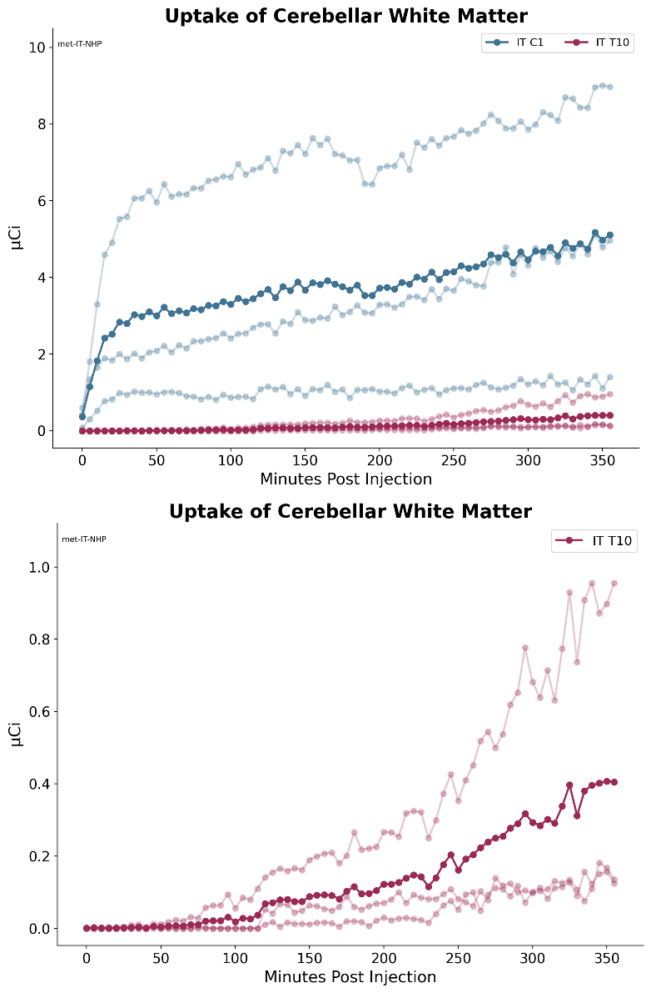
Figure 15: [¹⁸F]-Baclofen activity in monkey cerebellar white matter post IT administration.
Top: Group 1 with IT catheter tip placed at C1 and Group 2 with catheter tip placed at T10; dark blue and red lines represent the mean of the 3 individual animals shown in the muted blue and red lines
Bottom: Group 2 plotted alone with IT catheter tip placed at T10; dark red line represents the mean of the 3 individual animals shown in the lighter red lines.

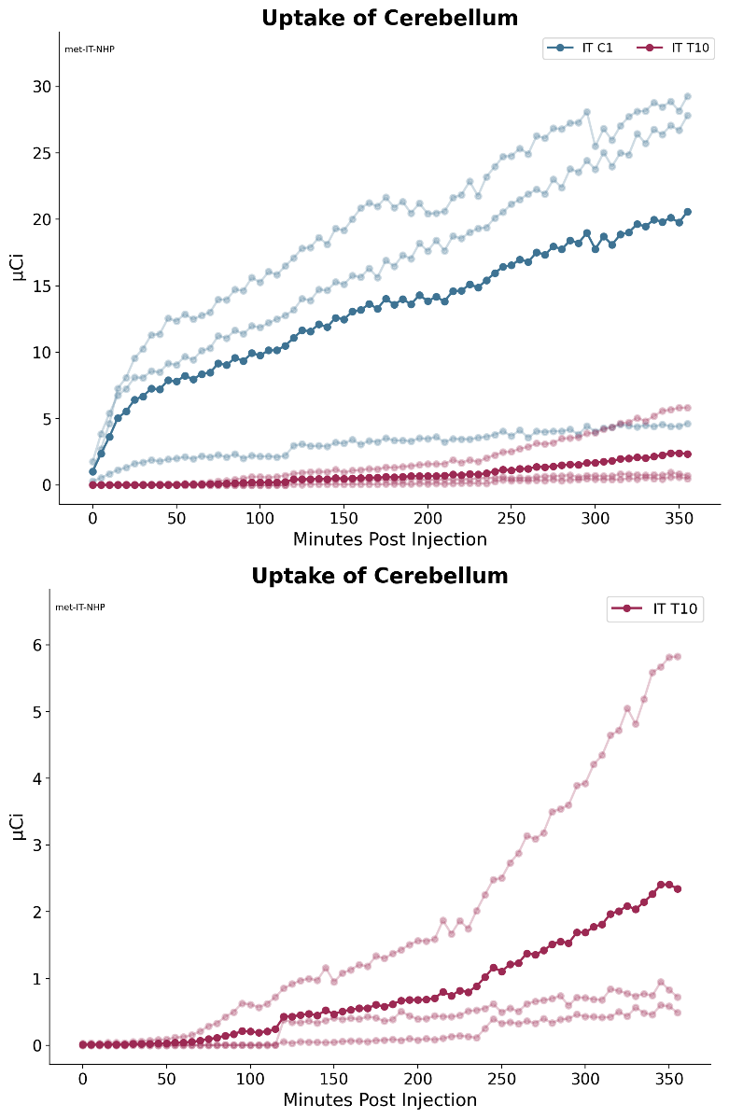

Figure 16: [¹⁸F]-Baclofen activity in monkey cerebellum post IT administration.
Top: Group 1 with IT catheter tip placed at C1 and Group 2 with catheter tip placed at T10; dark blue and red lines represent the mean of the 3 individual animals shown in the muted blue and red lines
Bottom: Group 2 plotted alone with IT catheter tip placed at T10; dark red line represents the mean of the 3 individual animals shown in the lighter red lines.

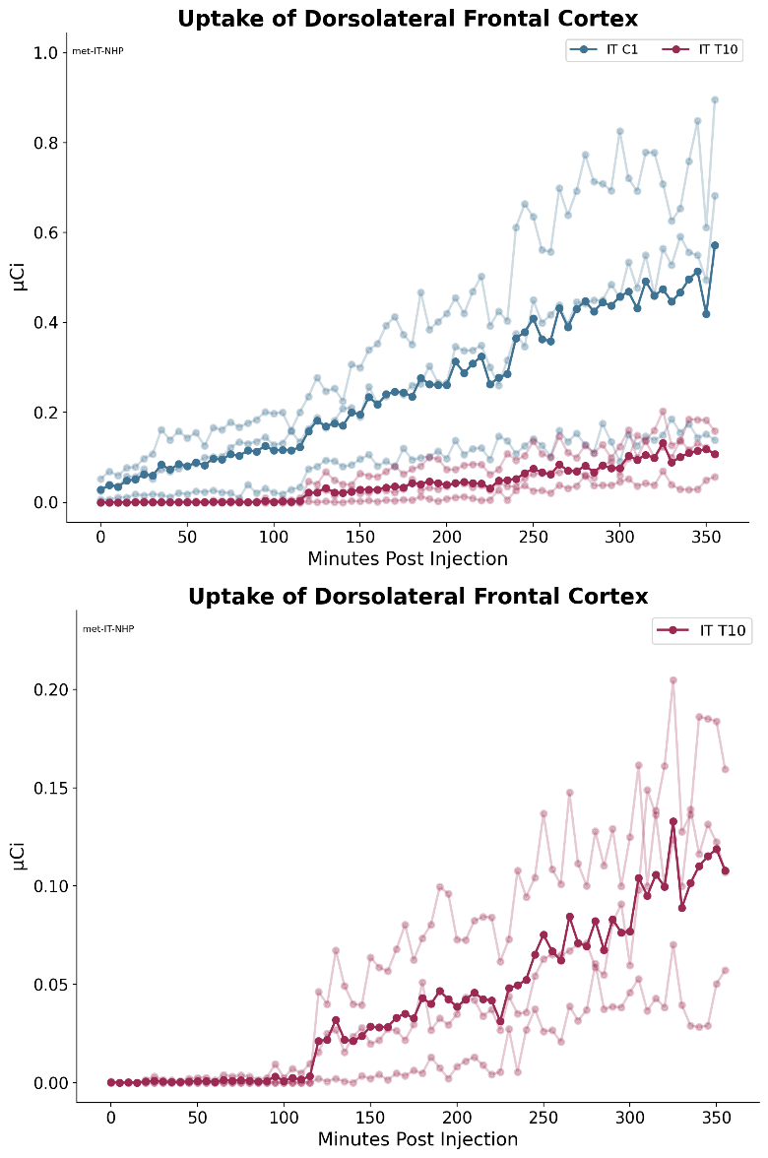
Figure 17: [¹⁸F]-Baclofen activity in monkey dorsolateral frontal cortex post IT administration.
Top: Group 1 with IT catheter tip placed at C1 and Group 2 with catheter tip placed at T10; dark blue and red lines represent the mean of the 3 individual animals shown in the muted blue and red lines
Bottom: Group 2 plotted alone with IT catheter tip placed at T10; dark red line represents the mean of the 3 individual animals shown in the lighter red lines.

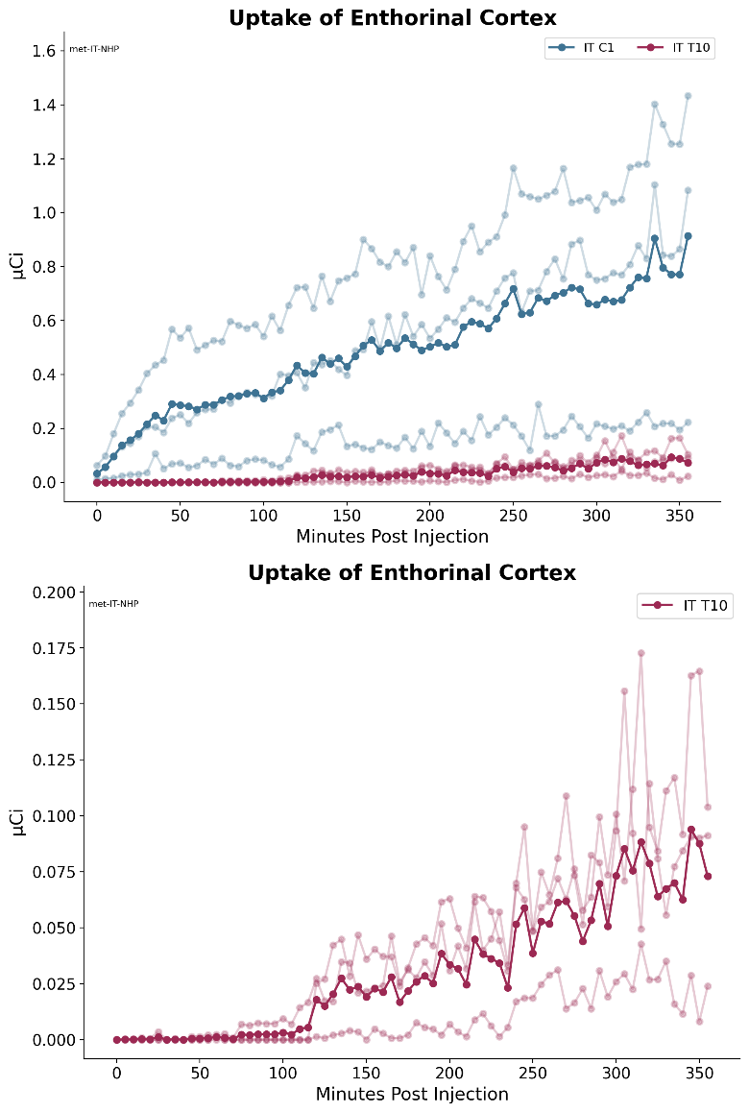

Figure 18: [¹⁸F]-Baclofen activity in monkey enthorinal cortex post IT administration.
Top: Group 1 with IT catheter tip placed at C1 and Group 2 with catheter tip placed at T10; dark blue and red lines represent the mean of the 3 individual animals shown in the muted blue and red lines
Bottom: Group 2 plotted alone with IT catheter tip placed at T10; dark red line represents the mean of the 3 individual animals shown in the lighter red lines.

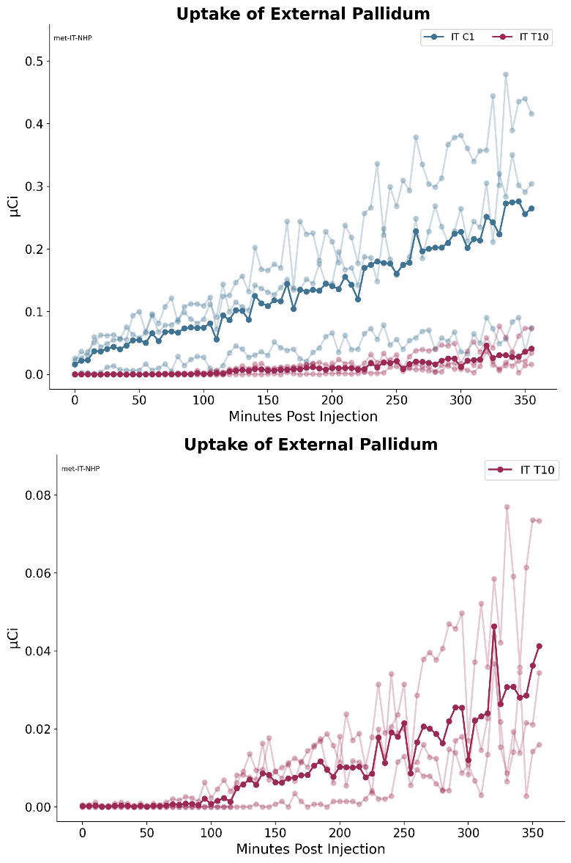

Figure 19: [¹⁸F]-Baclofen activity in monkey external pallidum post IT administration.
Top: Group 1 with IT catheter tip placed at C1 and Group 2 with catheter tip placed at T10; dark blue and red lines represent the mean of the 3 individual animals shown in the muted blue and red lines
Bottom: Group 2 plotted alone with IT catheter tip placed at T10; dark red line represents the mean of the 3 individual animals shown in the lighter red lines.

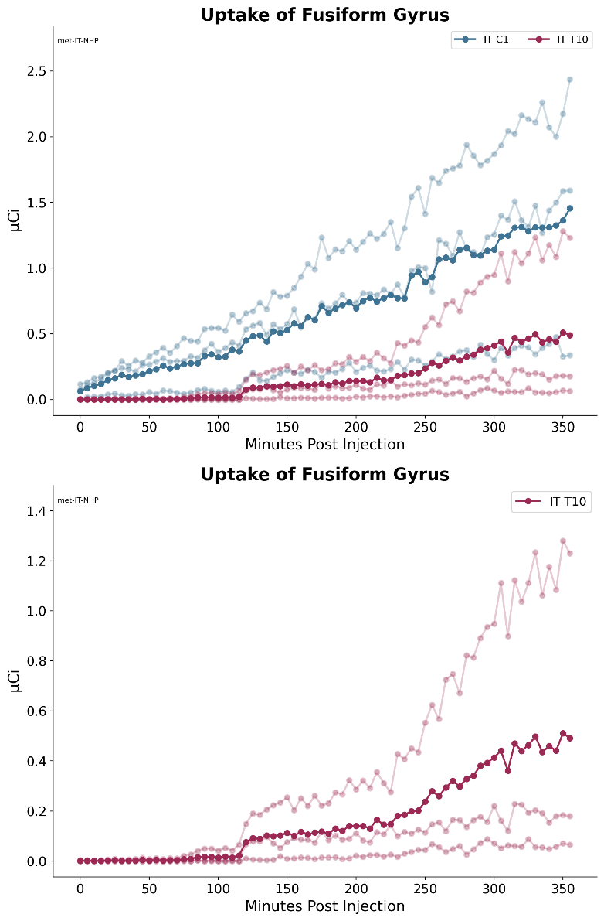
Figure 20: [¹⁸F]-Baclofen activity in monkey fusiform gyrus post IT administration.
Top: Group 1 with IT catheter tip placed at C1 and Group 2 with catheter tip placed at T10; dark blue and red lines represent the mean of the 3 individual animals shown in the muted blue and red lines
Bottom: Group 2 plotted alone with IT catheter tip placed at T10; dark red line represents the mean of the 3 individual animals shown in the lighter red lines.

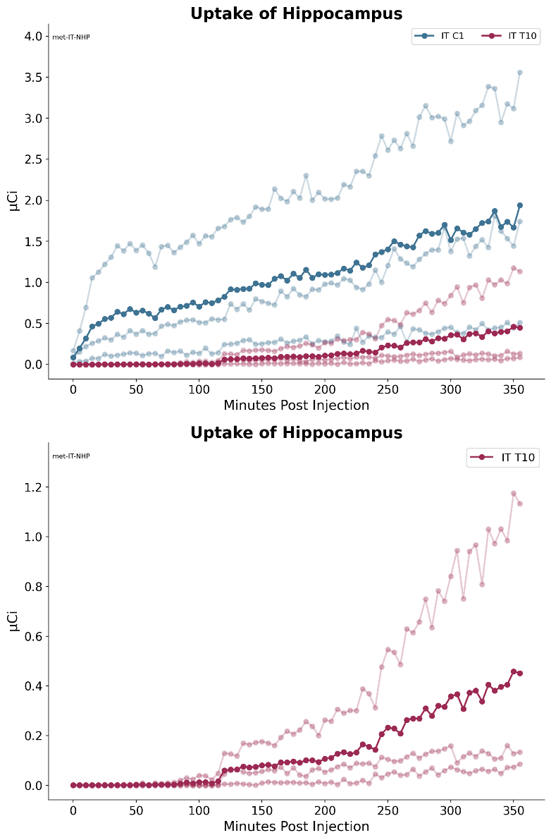
Figure 21: [¹⁸F]-Baclofen activity in monkey hippocampus post IT administration.
Top: Group 1 with IT catheter tip placed at C1 and Group 2 with catheter tip placed at T10; dark blue and red lines represent the mean of the 3 individual animals shown in the muted blue and red lines
Bottom: Group 2 plotted alone with IT catheter tip placed at T10; dark red line represents the mean of the 3 individual animals shown in the lighter red lines.

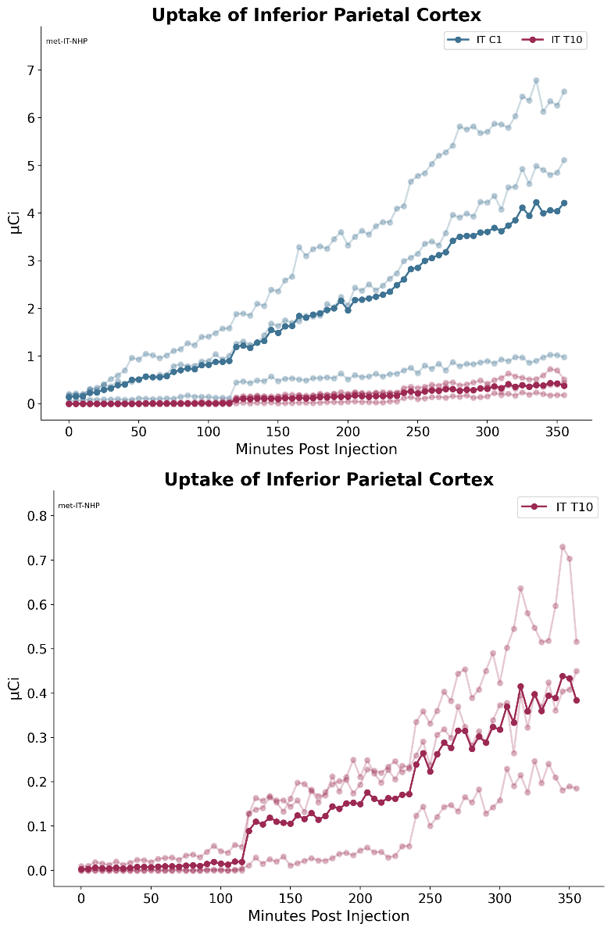
Figure 22: [¹⁸F]-Baclofen activity in monkey inferior parietal cortex post IT administration.
Top: Group 1 with IT catheter tip placed at C1 and Group 2 with catheter tip placed at T10; dark blue and red lines represent the mean of the 3 individual animals shown in the muted blue and red lines
Bottom: Group 2 plotted alone with IT catheter tip placed at T10; dark red line represents the mean of the 3 individual animals shown in the lighter red lines.

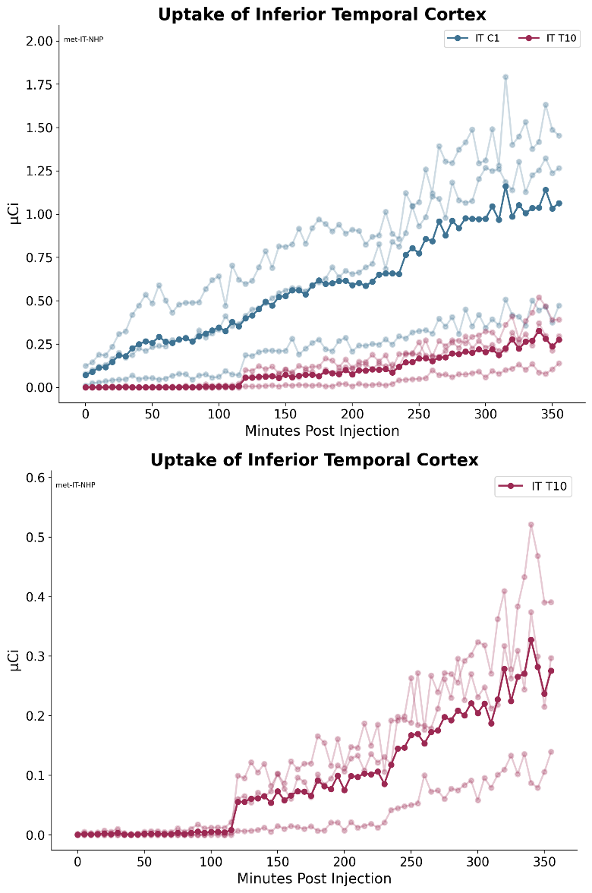
Figure 23: [¹⁸F]-Baclofen activity in monkey inferior temporal cortex post IT administration.
Top: Group 1 with IT catheter tip placed at C1 and Group 2 with catheter tip placed at T10; dark blue and red lines represent the mean of the 3 individual animals shown in the muted blue and red lines
Bottom: Group 2 plotted alone with IT catheter tip placed at T10; dark red line represents the mean of the 3 individual animals shown in the lighter red lines.

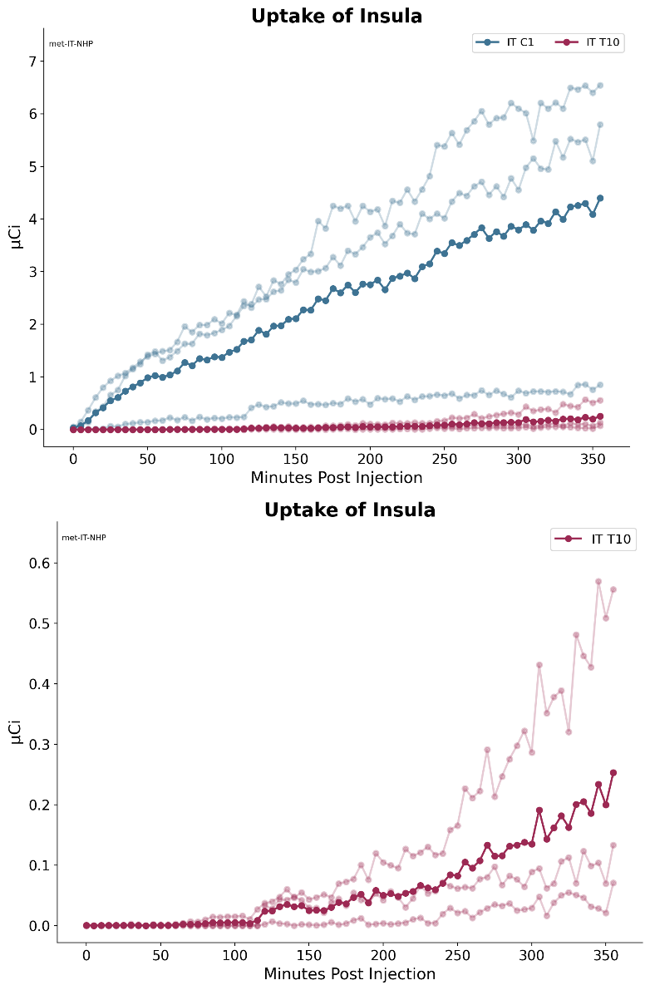
Figure 24: [¹⁸F]-Baclofen activity in monkey insula post IT administration.
Top: Group 1 with IT catheter tip placed at C1 and Group 2 with catheter tip placed at T10; dark blue and red lines represent the mean of the 3 individual animals shown in the muted blue and red lines
Bottom: Group 2 plotted alone with IT catheter tip placed at T10; dark red line represents the mean of the 3 individual animals shown in the lighter red lines.

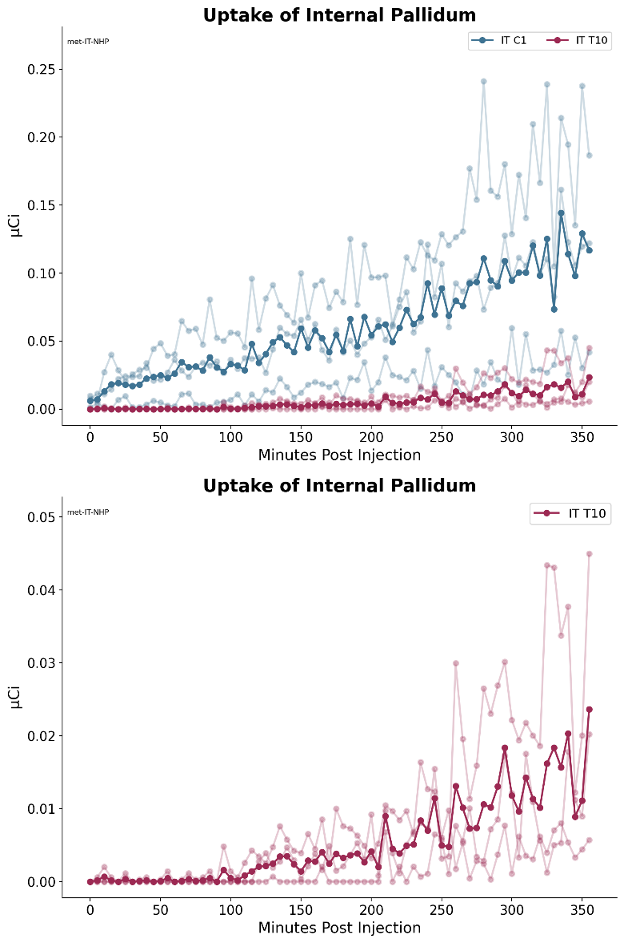
Figure 25: [¹⁸F]-Baclofen activity in monkey internal pallidum post IT administration.
Top: Group 1 with IT catheter tip placed at C1 and Group 2 with catheter tip placed at T10; dark blue and red lines represent the mean of the 3 individual animals shown in the muted blue and red lines
Bottom: Group 2 plotted alone with IT catheter tip placed at T10; dark red line represents the mean of the 3 individual animals shown in the lighter red lines.

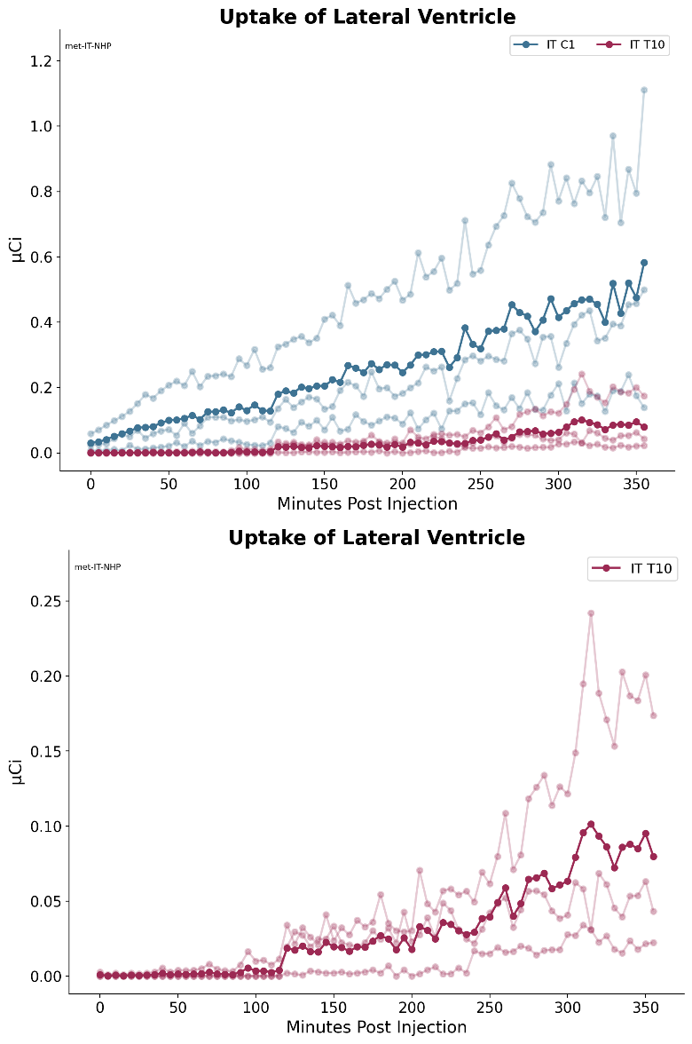
Figure 26: [¹⁸F]-Baclofen activity in monkey lateral ventricle post IT administration.
Top: Group 1 with IT catheter tip placed at C1 and Group 2 with catheter tip placed at T10; dark blue and red lines represent the mean of the 3 individual animals shown in the muted blue and red lines
Bottom: Group 2 plotted alone with IT catheter tip placed at T10; dark red line represents the mean of the 3 individual animals shown in the lighter red lines.

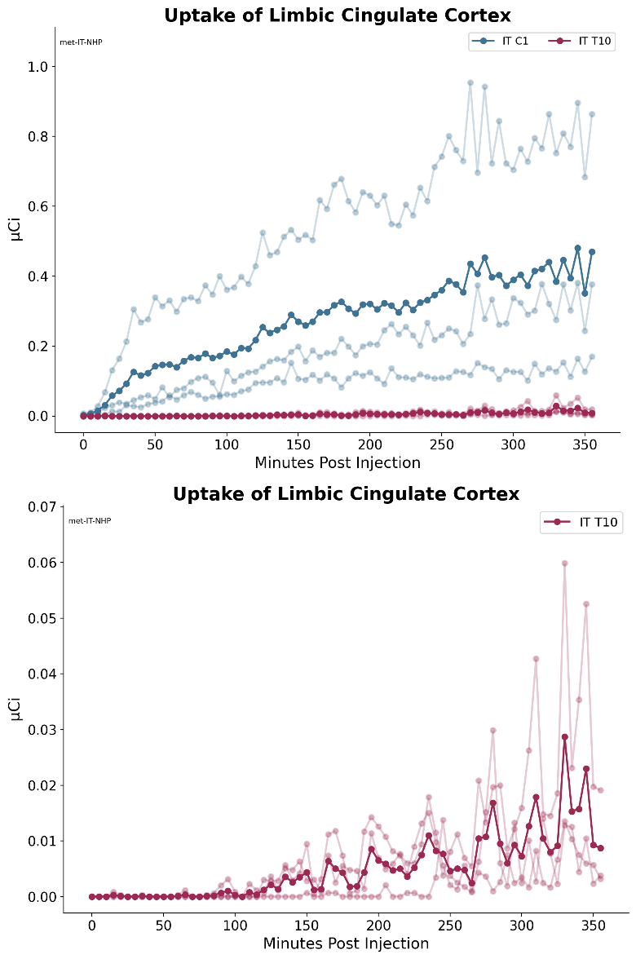
Figure 27: [¹⁸F]-Baclofen activity in monkey limbic cingulate cortex post IT administration.
Top: Group 1 with IT catheter tip placed at C1 and Group 2 with catheter tip placed at T10; dark blue and red lines represent the mean of the 3 individual animals shown in the muted blue and red lines
Bottom: Group 2 plotted alone with IT catheter tip placed at T10; dark red line represents the mean of the 3 individual animals shown in the lighter red lines.

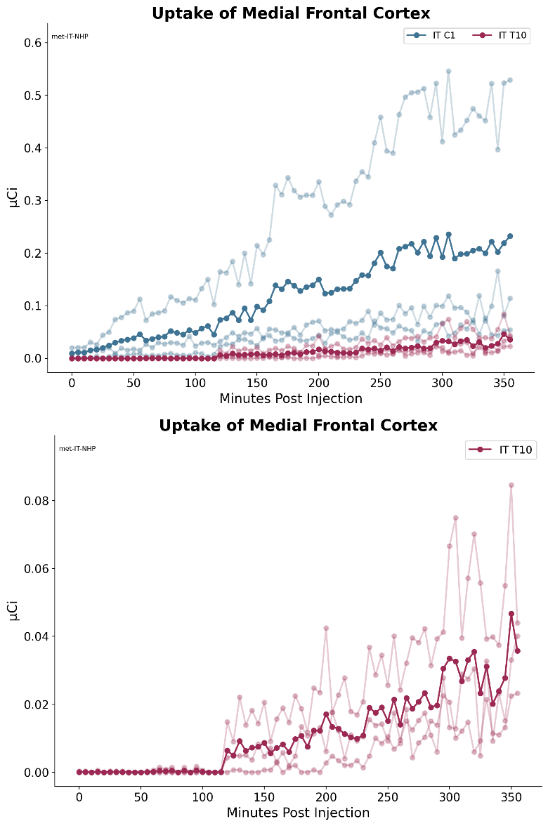
Figure 28: [¹⁸F]-Baclofen activity in monkey medial frontal cortex post IT administration.
Top: Group 1 with IT catheter tip placed at C1 and Group 2 with catheter tip placed at T10; dark blue and red lines represent the mean of the 3 individual animals shown in the muted blue and red lines
Bottom: Group 2 plotted alone with IT catheter tip placed at T10; dark red line represents the mean of the 3 individual animals shown in the lighter red lines.

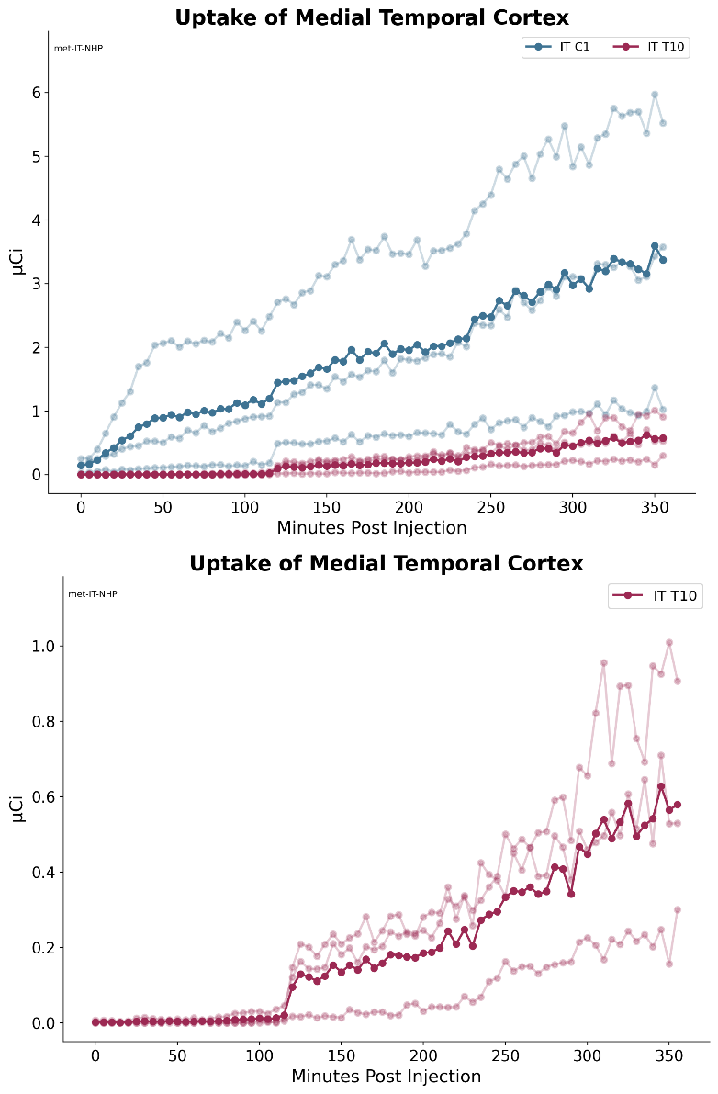
Figure 29: [¹⁸F]-Baclofen activity in monkey medial temporal cortex post IT administration.
Top: Group 1 with IT catheter tip placed at C1 and Group 2 with catheter tip placed at T10; dark blue and red lines represent the mean of the 3 individual animals shown in the muted blue and red lines
Bottom: Group 2 plotted alone with IT catheter tip placed at T10; dark red line represents the mean of the 3 individual animals shown in the lighter red lines.

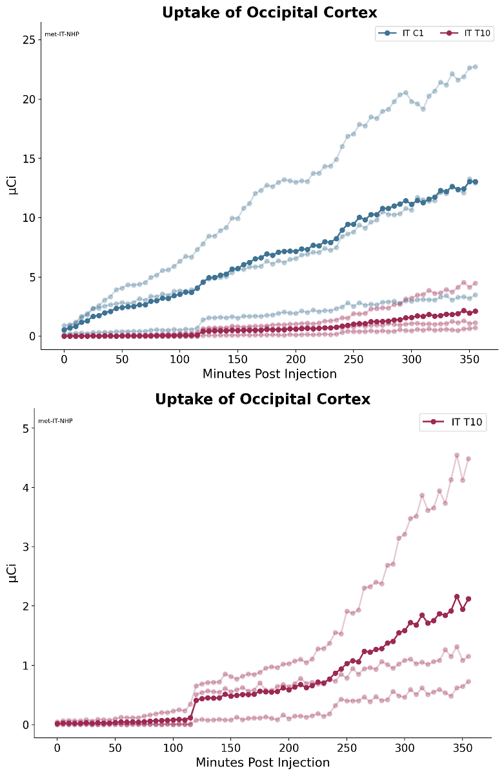
Figure 30: [¹⁸F]-Baclofen activity in monkey occipital cortex post IT administration.
Top: Group 1 with IT catheter tip placed at C1 and Group 2 with catheter tip placed at T10; dark blue and red lines represent the mean of the 3 individual animals shown in the muted blue and red lines
Bottom: Group 2 plotted alone with IT catheter tip placed at T10; dark red line represents the mean of the 3 individual animals shown in the lighter red lines.

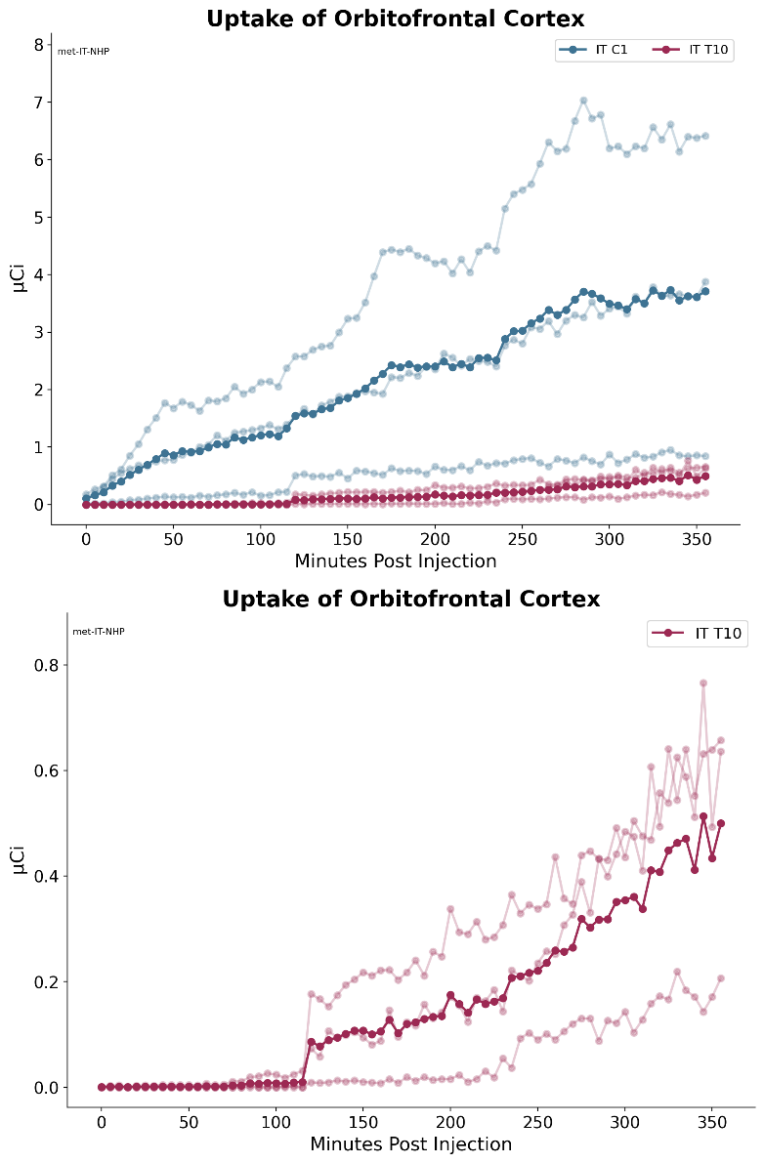
Figure 31: [¹⁸F]-Baclofen activity in monkey orbitofrontal cortex post IT administration.
Top: Group 1 with IT catheter tip placed at C1 and Group 2 with catheter tip placed at T10; dark blue and red lines represent the mean of the 3 individual animals shown in the muted blue and red lines
Bottom: Group 2 plotted alone with IT catheter tip placed at T10; dark red line represents the mean of the 3 individual animals shown in the lighter red lines.

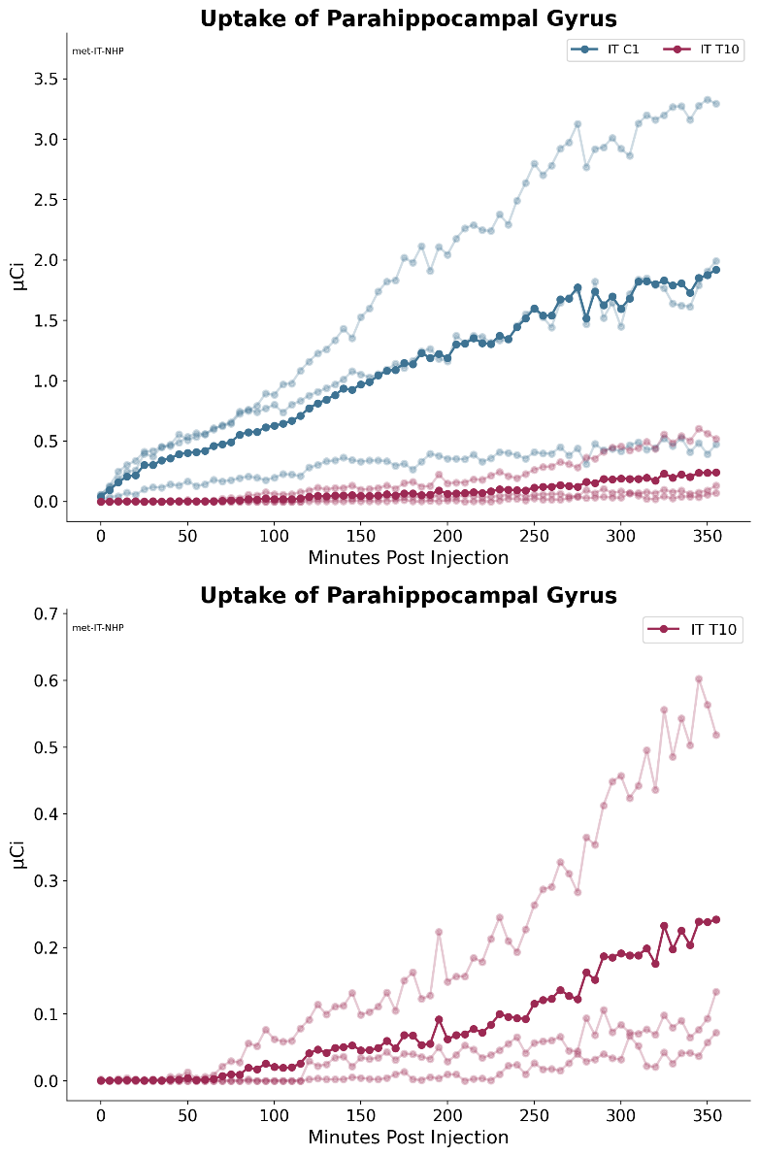
Figure 32: [¹⁸F]-Baclofen activity in monkey parahippocampal gyrus post IT administration.
Top: Group 1 with IT catheter tip placed at C1 and Group 2 with catheter tip placed at T10; dark blue and red lines represent the mean of the 3 individual animals shown in the muted blue and red lines
Bottom: Group 2 plotted alone with IT catheter tip placed at T10; dark red line represents the mean of the 3 individual animals shown in the lighter red lines.

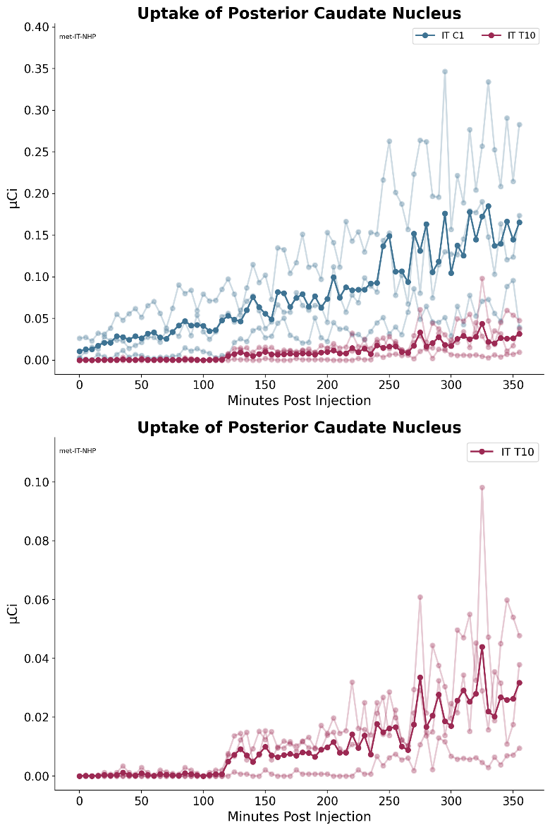
Figure 33: [¹⁸F]-Baclofen activity in monkey posterior caudate nucleus post IT administration.
Top: Group 1 with IT catheter tip placed at C1 and Group 2 with catheter tip placed at T10; dark blue and red lines represent the mean of the 3 individual animals shown in the muted blue and red lines
Bottom: Group 2 plotted alone with IT catheter tip placed at T10; dark red line represents the mean of the 3 individual animals shown in the lighter red lines.

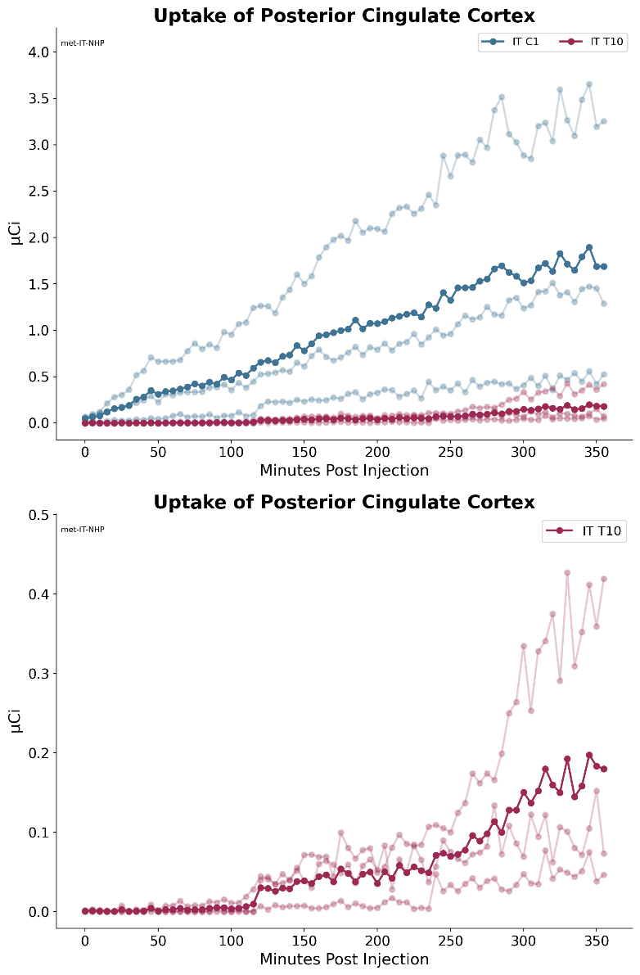
Figure 34: [¹⁸F]-Baclofen activity in monkey posterior cingulate cortex post IT administration.
Top: Group 1 with IT catheter tip placed at C1 and Group 2 with catheter tip placed at T10; dark blue and red lines represent the mean of the 3 individual animals shown in the muted blue and red lines
Bottom: Group 2 plotted alone with IT catheter tip placed at T10; dark red line represents the mean of the 3 individual animals shown in the lighter red lines.

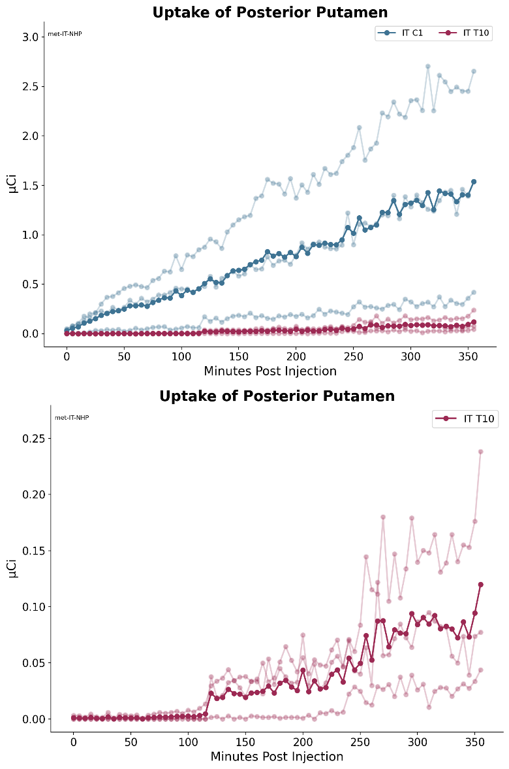
Figure 35: [¹⁸F]-Baclofen activity in monkey posterior putamen post IT administration.
Top: Group 1 with IT catheter tip placed at C1 and Group 2 with catheter tip placed at T10; dark blue and red lines represent the mean of the 3 individual animals shown in the muted blue and red lines
Bottom: Group 2 plotted alone with IT catheter tip placed at T10; dark red line represents the mean of the 3 individual animals shown in the lighter red lines.

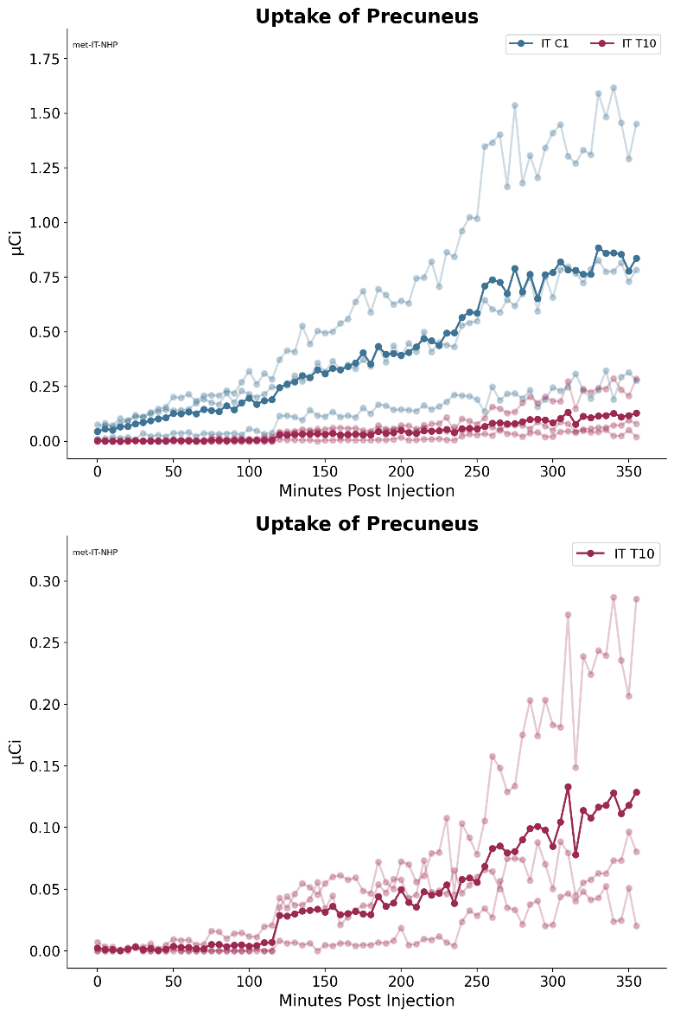
Figure 36: [¹⁸F]-Baclofen activity in monkey precuneus post IT administration.
Top: Group 1 with IT catheter tip placed at C1 and Group 2 with catheter tip placed at T10; dark blue and red lines represent the mean of the 3 individual animals shown in the muted blue and red lines
Bottom: Group 2 plotted alone with IT catheter tip placed at T10; dark red line represents the mean of the 3 individual animals shown in the lighter red lines.

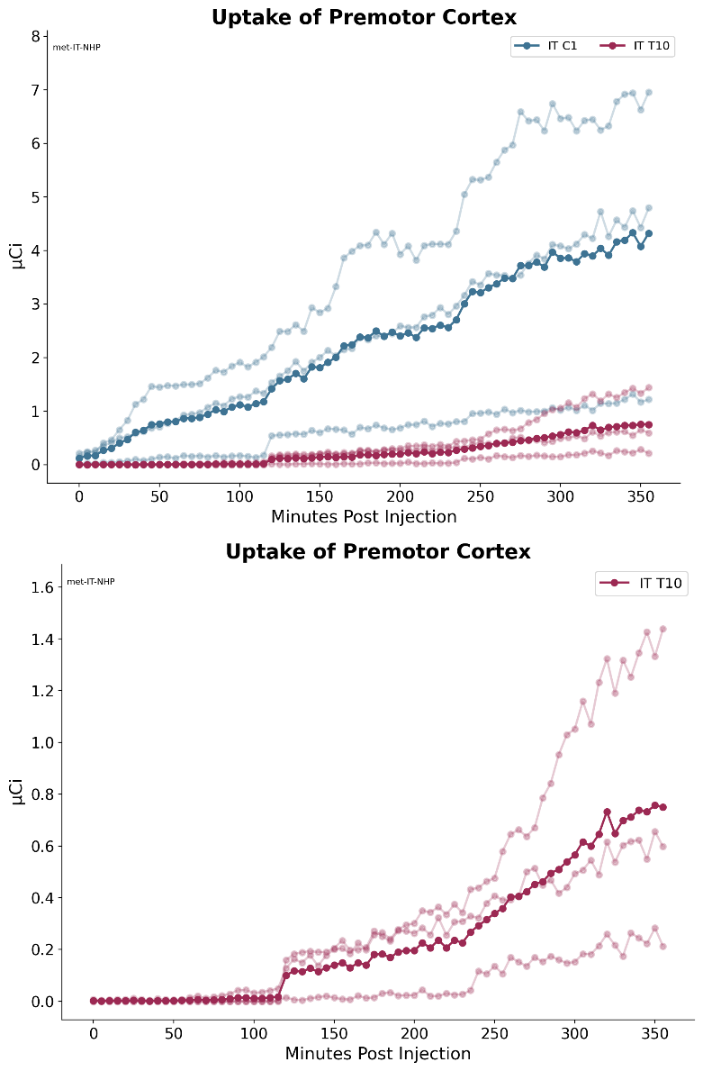
Figure 37: [¹⁸F]-Baclofen activity in monkey premotor cortex post IT administration.
Top: Group 1 with IT catheter tip placed at C1 and Group 2 with catheter tip placed at T10; dark blue and red lines represent the mean of the 3 individual animals shown in the muted blue and red lines
Bottom: Group 2 plotted alone with IT catheter tip placed at T10; dark red line represents the mean of the 3 individual animals shown in the lighter red lines.

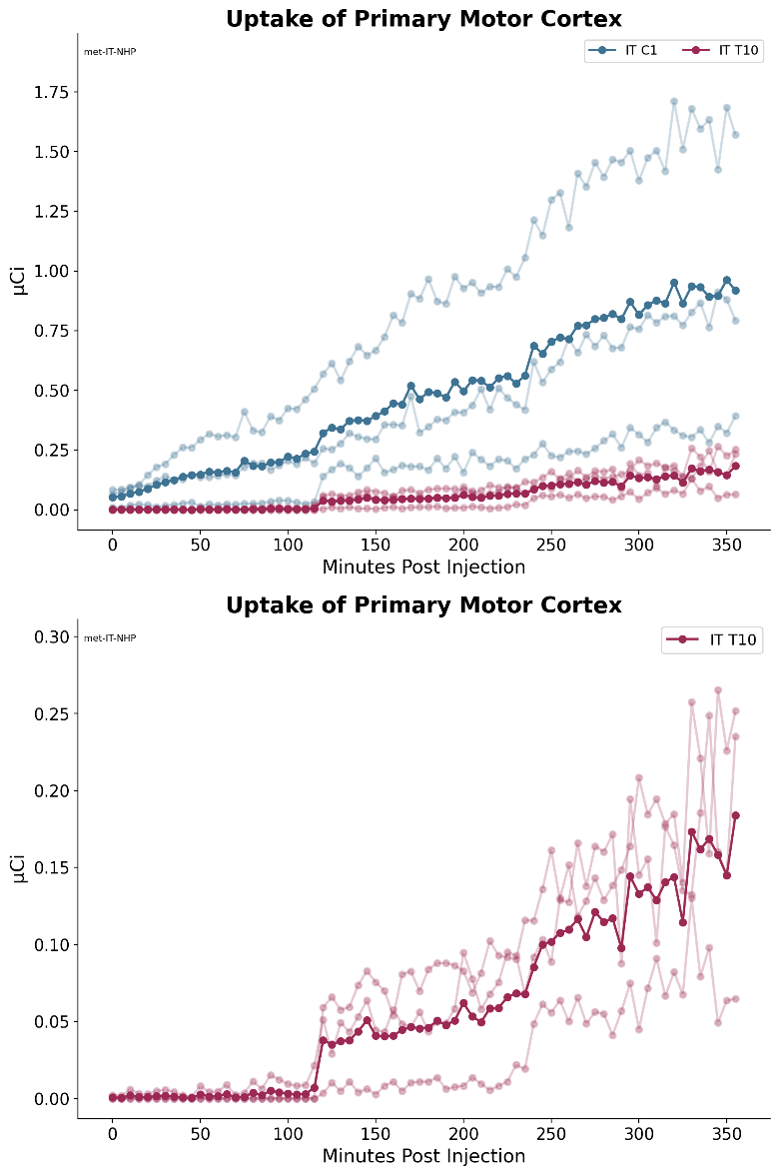

Figure 38: [¹⁸F]-Baclofen activity in monkey primary motor cortex post IT administration.
Top: Group 1 with IT catheter tip placed at C1 and Group 2 with catheter tip placed at T10; dark blue and red lines represent the mean of the 3 individual animals shown in the muted blue and red lines
Bottom: Group 2 plotted alone with IT catheter tip placed at T10; dark red line represents the mean of the 3 individual animals shown in the lighter red lines.

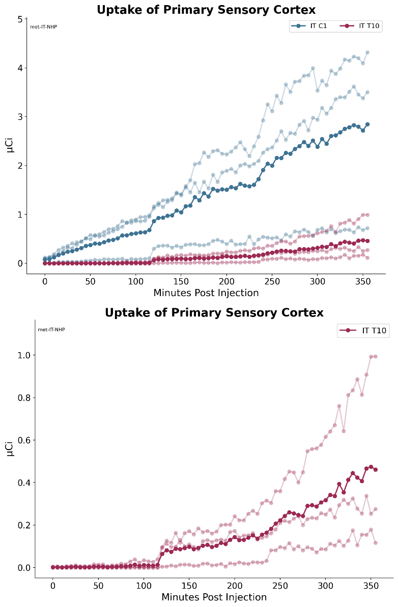
Figure 39: [¹⁸F]-Baclofen activity in monkey primary sensory cortex post IT administration.
Top: Group 1 with IT catheter tip placed at C1 and Group 2 with catheter tip placed at T10; dark blue and red lines represent the mean of the 3 individual animals shown in the muted blue and red lines
Bottom: Group 2 plotted alone with IT catheter tip placed at T10; dark red line represents the mean of the 3 individual animals shown in the lighter red lines.

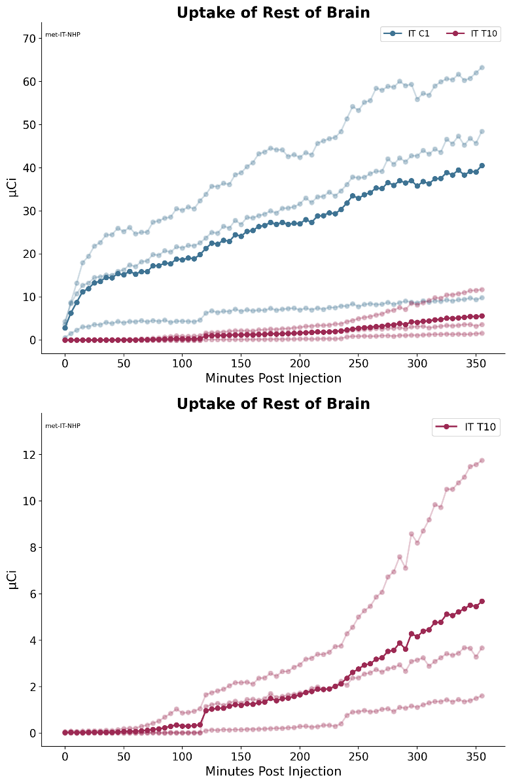
Figure 40: [¹⁸F]-Baclofen activity in monkey rest of brain post IT administration.
Top: Group 1 with IT catheter tip placed at C1 and Group 2 with catheter tip placed at T10; dark blue and red lines represent the mean of the 3 individual animals shown in the muted blue and red lines
Bottom: Group 2 plotted alone with IT catheter tip placed at T10; dark red line represents the mean of the 3 individual animals shown in the lighter red lines.

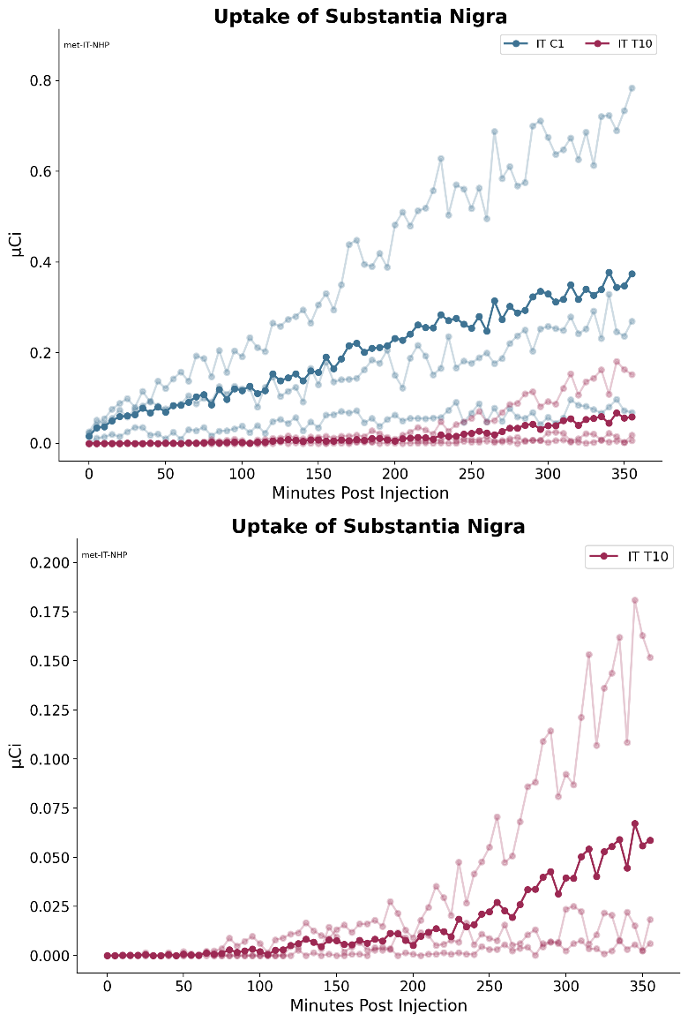
Figure 41: [¹⁸F]-Baclofen activity in monkey substantia nigra post IT administration.
Top: Group 1 with IT catheter tip placed at C1 and Group 2 with catheter tip placed at T10; dark blue and red lines represent the mean of the 3 individual animals shown in the muted blue and red lines
Bottom: Group 2 plotted alone with IT catheter tip placed at T10; dark red line represents the mean of the 3 individual animals shown in the lighter red lines.

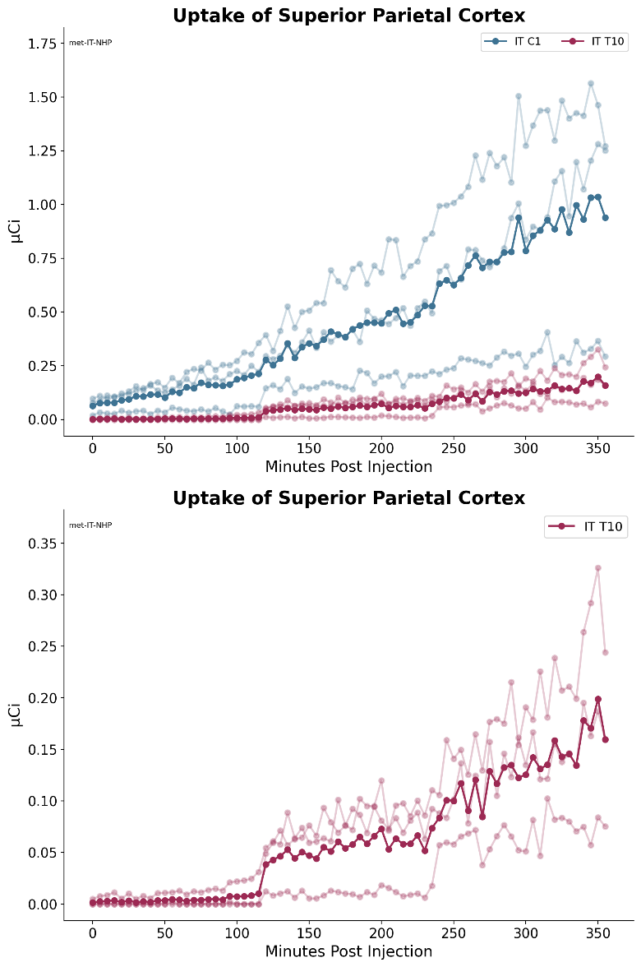
Figure 42: [¹⁸F]-Baclofen activity in monkey superior parietal cortex post IT administration.
Top: Group 1 with IT catheter tip placed at C1 and Group 2 with catheter tip placed at T10; dark blue and red lines represent the mean of the 3 individual animals shown in the muted blue and red lines
Bottom: Group 2 plotted alone with IT catheter tip placed at T10; dark red line represents the mean of the 3 individual animals shown in the lighter red lines.

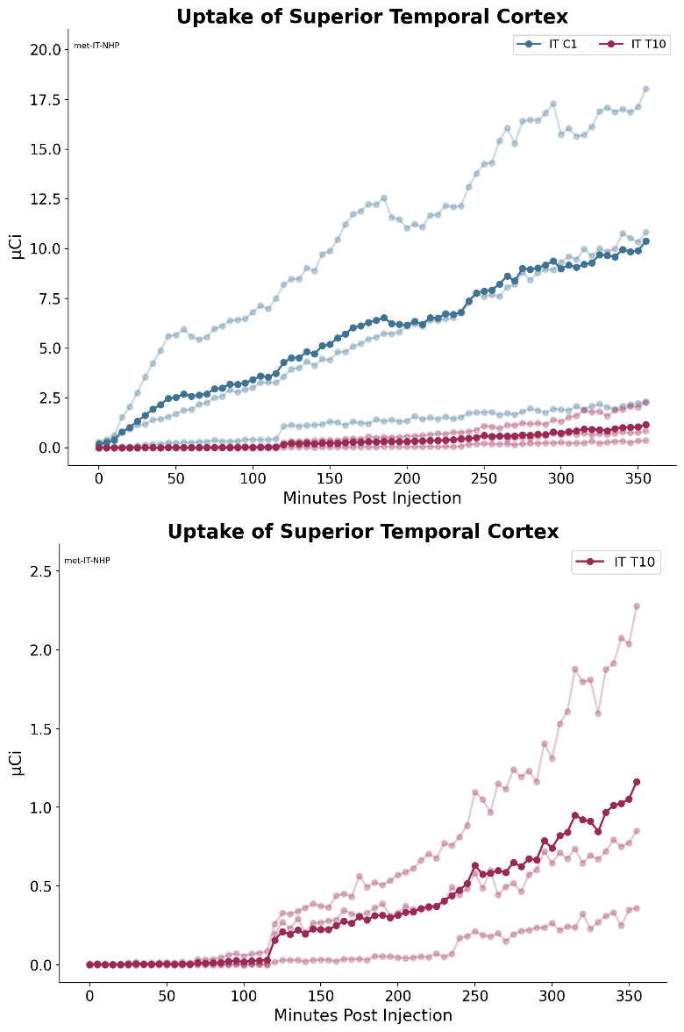
Figure 43: [¹⁸F]-Baclofen activity in monkey superior temporal cortex post IT administration.
Top: Group 1 with IT catheter tip placed at C1 and Group 2 with catheter tip placed at T10; dark blue and red lines represent the mean of the 3 individual animals shown in the muted blue and red lines
Bottom: Group 2 plotted alone with IT catheter tip placed at T10; dark red line represents the mean of the 3 individual animals shown in the lighter red lines.

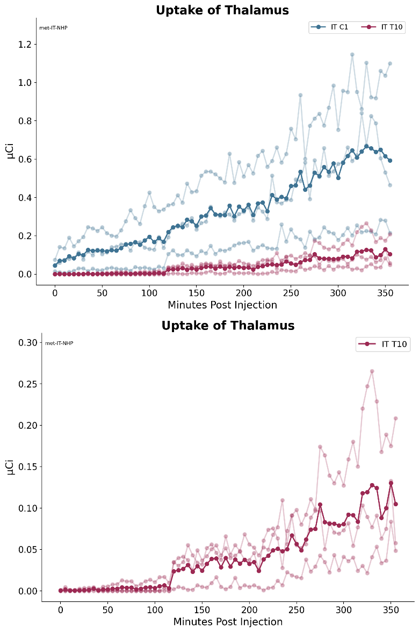
Figure 44: [¹⁸F]-Baclofen activity in monkey thalamus post IT administration.
Top: Group 1 with IT catheter tip placed at C1 and Group 2 with catheter tip placed at T10; dark blue and red lines represent the mean of the 3 individual animals shown in the muted blue and red lines
Bottom: Group 2 plotted alone with IT catheter tip placed at T10; dark red line represents the mean of the 3 individual animals shown in the lighter red lines.

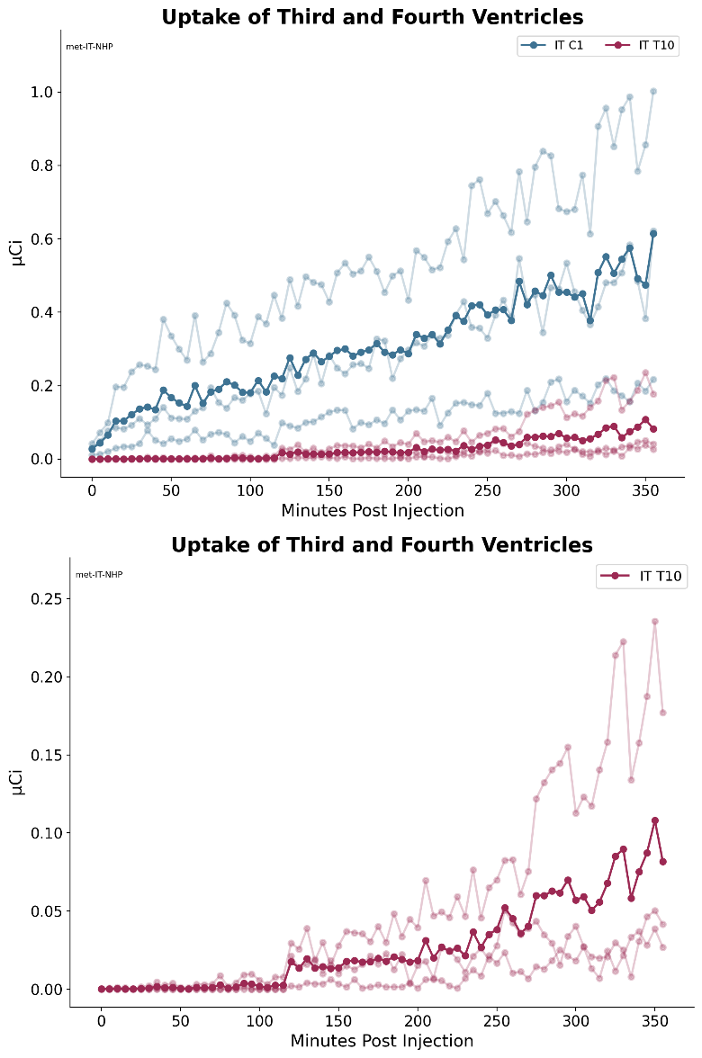
Figure 45: [¹⁸F]-Baclofen activity in monkey third and fourth ventricles post IT administration.
Top: Group 1 with IT catheter tip placed at C1 and Group 2 with catheter tip placed at T10; dark blue and red lines represent the mean of the 3 individual animals shown in the muted blue and red lines
Bottom: Group 2 plotted alone with IT catheter tip placed at T10; dark red line represents the mean of the 3 individual animals shown in the lighter red lines.

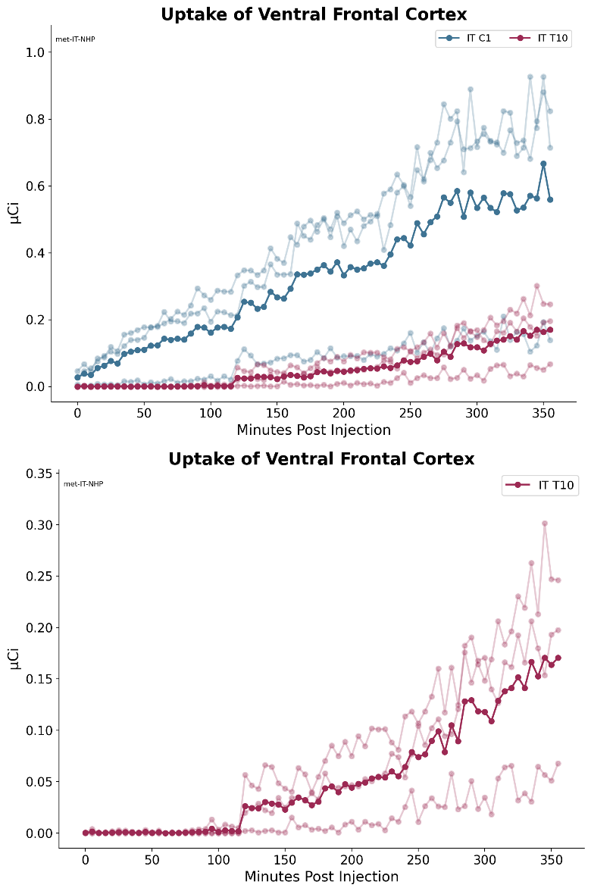
Figure 46: [¹⁸F]-Baclofen activity in monkey ventral frontal cortex post IT administration.
Top: Group 1 with IT catheter tip placed at C1 and Group 2 with catheter tip placed at T10; dark blue and red lines represent the mean of the 3 individual animals shown in the muted blue and red lines
Bottom: Group 2 plotted alone with IT catheter tip placed at T10; dark red line represents the mean of the 3 individual animals shown in the lighter red lines.

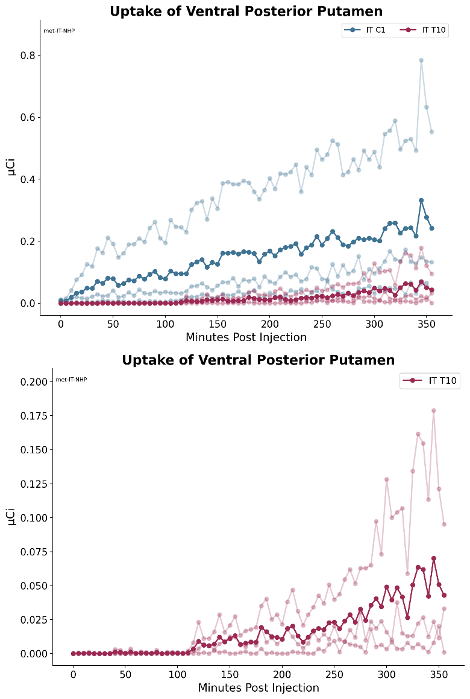
Figure 47: [¹⁸F]-Baclofen activity in monkey ventral posterior putamen post IT administration.
Top: Group 1 with IT catheter tip placed at C1 and Group 2 with catheter tip placed at T10; dark blue and red lines represent the mean of the 3 individual animals shown in the muted blue and red lines
Bottom: Group 2 plotted alone with IT catheter tip placed at T10; dark red line represents the mean of the 3 individual animals shown in the lighter red lines.

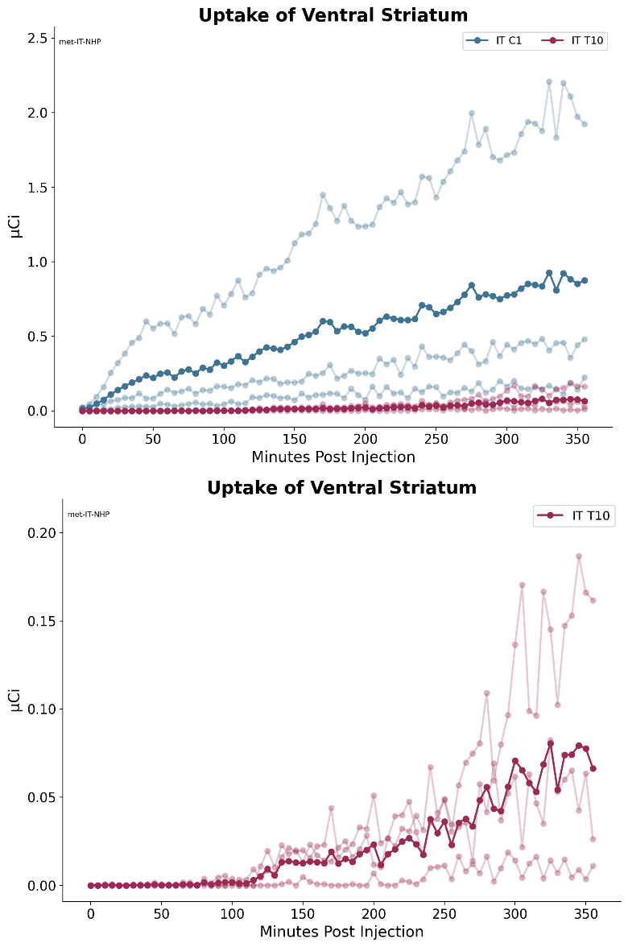
Figure 48: [¹⁸F]-Baclofen activity in monkey ventral striatum post IT administration.
Top: Group 1 with IT catheter tip placed at C1 and Group 2 with catheter tip placed at T10; dark blue and red lines represent the mean of the 3 individual animals shown in the muted blue and red lines
Bottom: Group 2 plotted alone with IT catheter tip placed at T10; dark red line represents the mean of the 3 individual animals shown in the lighter red lines.

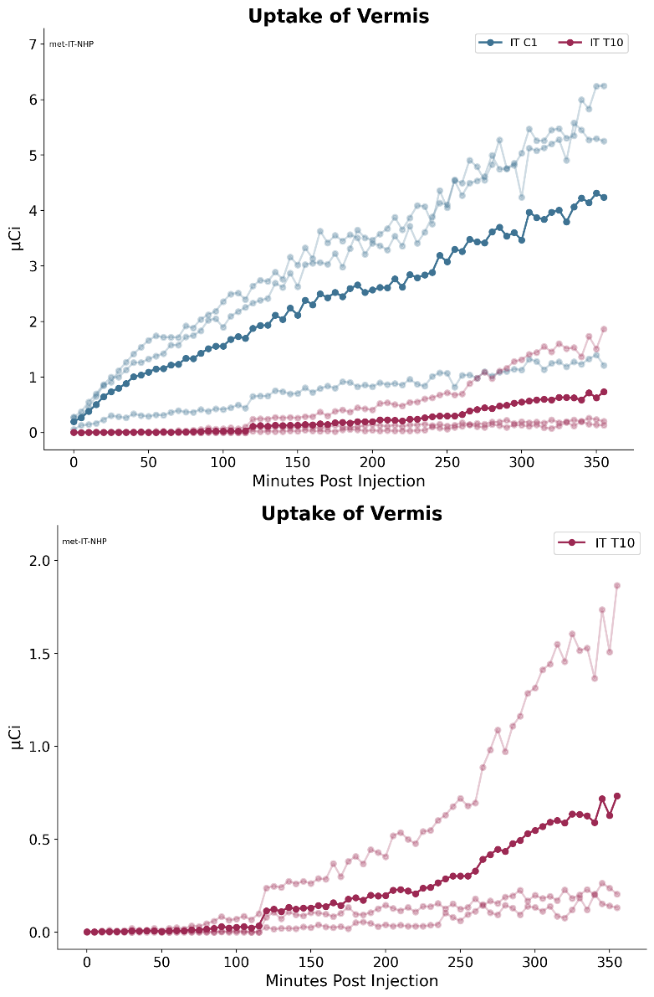
Figure 49: [¹⁸F]-Baclofen activity in monkey vermis post IT administration.
Top: Group 1 with IT catheter tip placed at C1 and Group 2 with catheter tip placed at T10; dark blue and red lines represent the mean of the 3 individual animals shown in the muted blue and red lines
Bottom: Group 2 plotted alone with IT catheter tip placed at T10; dark red line represents the mean of the 3 individual animals shown in the lighter red lines.

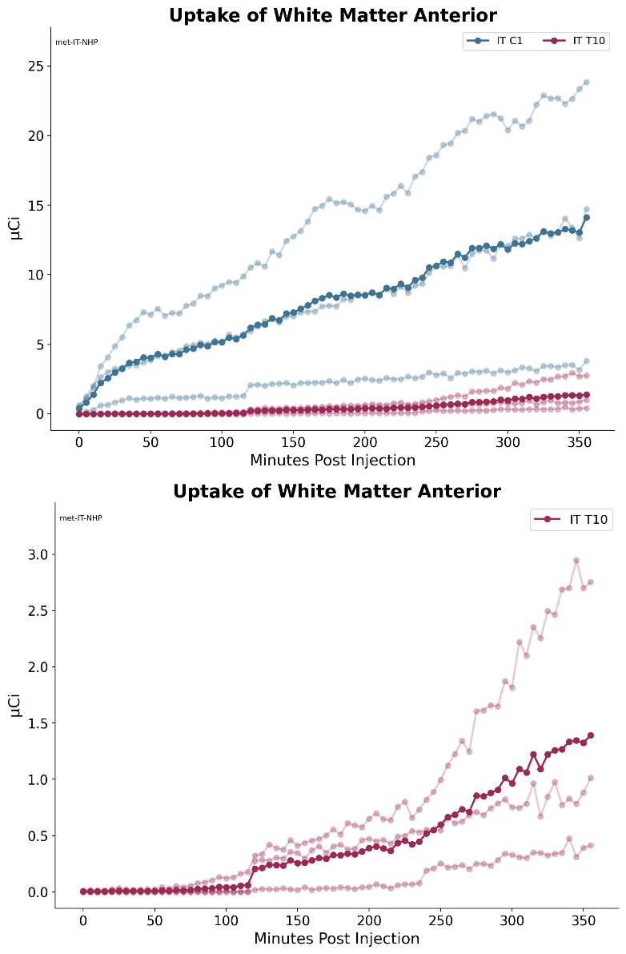
Figure 50: [¹⁸F]-Baclofen activity in monkey white matter anterior post IT administration.
Top: Group 1 with IT catheter tip placed at C1 and Group 2 with catheter tip placed at T10; dark blue and red lines represent the mean of the 3 individual animals shown in the muted blue and red lines
Bottom: Group 2 plotted alone with IT catheter tip placed at T10; dark red line represents the mean of the 3 individual animals shown in the lighter red lines.

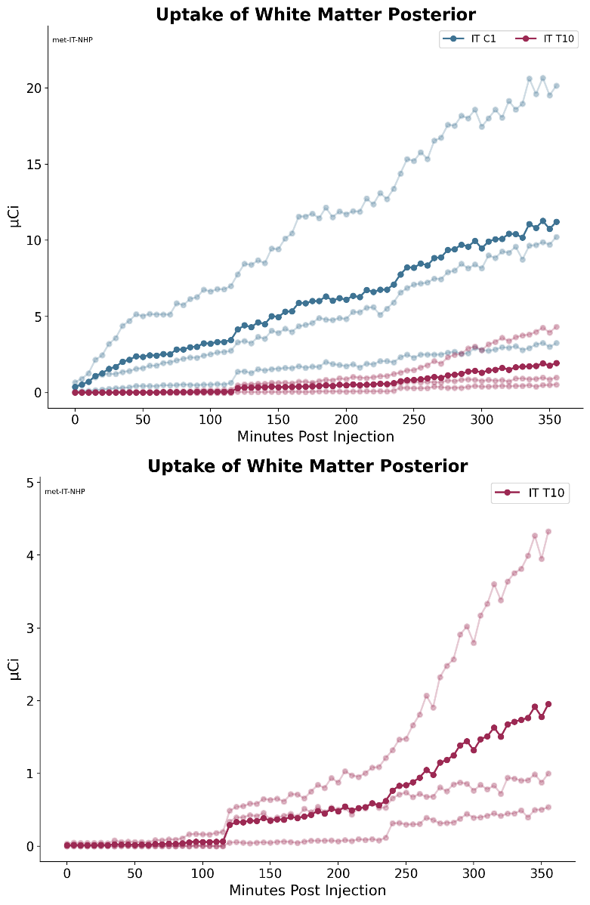

Figure 51: [¹⁸F]-Baclofen activity in monkey white matter posterior post IT administration.
Top: Group 1 with IT catheter tip placed at C1 and Group 2 with catheter tip placed at T10; dark blue and red lines represent the mean of the 3 individual animals shown in the muted blue and red lines
Bottom: Group 2 plotted alone with IT catheter tip placed at T10; dark red line represents the mean of the 3 individual animals shown in the lighter red lines.

