Factors Associated with Need for Intravenous Glucose Infusion for the Treatment of Early Neonatal Hypoglycemia in Late Preterm and Term infants

Luc P Brion, MD, Lisa Scheid, MD, L Steven Brown, MS,
Patti J. Burchfield, RN, Charles R. Rosenfeld, MD

Supplementary Material

Supplementary Figure 1. Institutional hypoglycemia algorithm *

Supplementary Table 1. Criteria for direct admission from the delivery room to the Mother-Baby Unit *

Supplementary Table 2. Demographics for neonates with a serum glucose <40 mg/dL (2.2 mmol/L) within the first 72h after birth (validation cohort).

Supplementary Table 2. Maternal characteristics for neonates with a serum glucose <40 mg/dL (2.2 mmol/L) within the first 72h after birth (validation cohort).

* modified from Sivarajan M, Schneider JH, Johnson KA, Bai S, ElHassan N, Kaiser JR, et al. Decreasing early hypoglycemia frequency in at-risk newborns after implementing a new hypoglycemia screening algorithm. J Perinatol 2021; 41:2840-2846.

Supplementary Figure 1. Institutional hypoglycemia algorithm

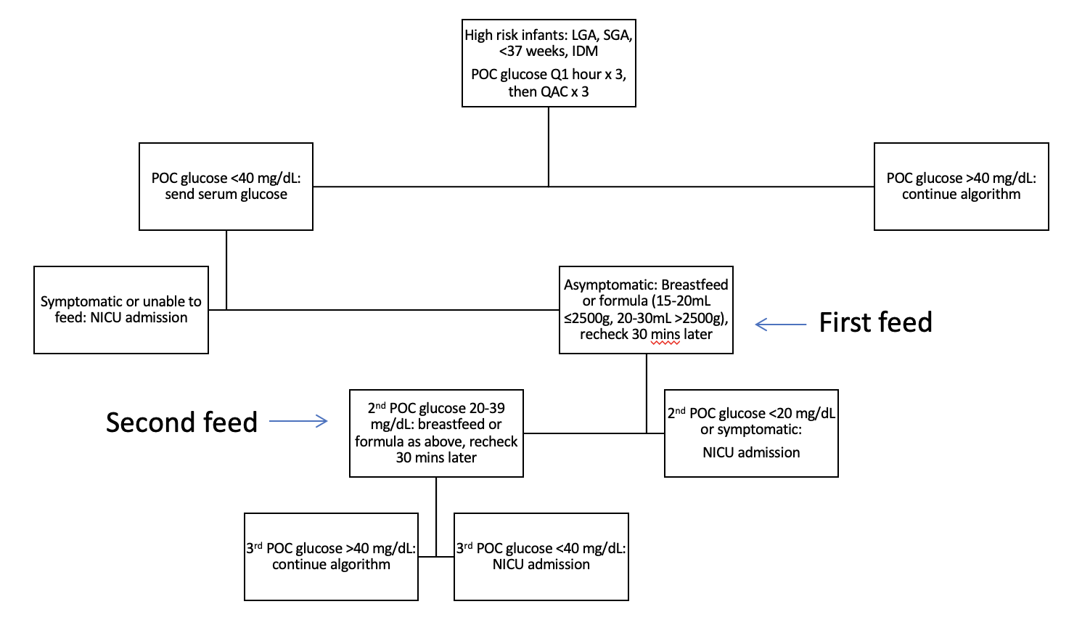

Supplementary Table 1. Criteria for direct admission from the delivery room to the Mother-Baby Unit

- Stable neonates with gestational age ≥35 weeks and birth weight ≥2100 grams
- Apgar score ≥7 at five minutes
- Positive pressure ventilation for less than 3 minutes in the delivery room
- Asymptomatic neonates at the time of leaving the delivery room (maximum 30 minutes of age)
- Neonates delivered of insulin-dependent diabetics (Class A1 or A2) not requiring intensive care
- Neonates with minor congenital anomalies not needing monitoring or surgery within 24 hours after birth
Supplementary Table 2. Demographics for neonates with a serum glucose <40 mg/dL (2.2 mmol/L) within the first 72h after birth (validation cohort).
Variables | Oral feeds only (n=1298) | Needed IV therapy (n=91) | P-value
Estimated gestational age (wk)* | 38.6 ± 1.8 | 38.4 ± 1.7 | 0.20
Male† | 698 (54) | 52 (57) | 0.53
Birth weight (gm)* | 3635 ± 714 | 3323 ± 755 | <0.01
Birth length (cm)* | 49.6 ± 3.0 | 48.9 ± 3.3 | 0.03
Head circumference (cm)* | 34.7 ± 1.7 | 33.9 ± 1.7 | <0.01
Fetal growth
Ponderal index* | 3.0 ± 1.2 | 2.8 ± 0.3 | 0.17
BMI (kg$·$m⁻²)* | 15 ± 3 | 14 ± 2 | <0.01
Size for gestational age |  |  | <0.01
Large for gestational age† | 394 (30) | 19 (22)
Appropriate for gestational age† | 835 (64) | 61 (67)
Small for gestational age† | 69 (5) | 11 (12)
Fetal growth restriction by ponderal  index† | 5 (<1) | 1 (1) | 0.34
Fetal growth restriction by BMI† | 21 (2) | 4 (4) | 0.08
Apgar scores
1-minute** | 8 (8, 9) | 8 (6, 8) | <0.01
5-minute** | 9 (9, 9) | 9 (8, 9) | <0.01
Multiple births† | 110 (9) | 4 (4) | 0.17
Umbilical arterial blood gas  Base excess*  HCO₃⁻ (mmol/L)*  pH_{a}*  P_{a}CO₂ (mm Hg)*  P_{a}O₂ (mm Hg)* | -5.8 ± 2.8  24.0 ± 2.2  7.25 ± 0.08  57.4 ± 11.5  26.7 ± 11.8 | -7.7 ± 4.3  24.0 ± 2.9  7.20 ± 0.10  64.9 ± 14.4  28.3 ± 43.0 | <0.01  0.92  <0.01  <0.01  0.80
Neonatal complications†
Preterm birth | 229 (18) | 16 (18) | 0.99
Infant of diabetic mother | 275 (21) | 28 (31) | 0.03
Fetal acidosis | 8 (<1) | 4 (4) | <0.01
Hypoxic-ischemic encephalopathy | 0 (0) | 1 (1) | 0.07
Early-onset sepsis | 3 (<1) | 7 (8) | <0.01
Congenital anomaly | 12 (1) | 8 (9) | <0.01
Chromosomal anomaly | 7 (<1) | 3 (3) | <0.01
Congenital infection | 24 (2) | 4 (4) | 0.11
Pulmonary hypertension | 0 (0) | 0 (0) | N/A
Persistent hypoglycemia† | 1 (<1) | 9 (10) | <0.01
Initial glucose (mg/dL)* | 31 ± 7 | 26 ± 9 | <0.01
Second glucose (mg/dL)* | 28 ± 7 | 24 ± 9 | <0.01
Change in glucose (mg/dL)* | -4.0 ± 8.4 | -2.5 ± 13.5 | 0.32
First spun hematocrit* | 58 ± 7 | 56 ± 8 | 0.03
Hematocrit > 65† | 166 (13) | 9 (10) | 0.43
Temperature (Fahrenheit)* | 98 ± 3 | 99 ± 5 | 0.17
*Data are means ± SD with T-test;**Data are medians (25th, 75th) with Mann-Whitney U-test; †n (%) with Chi-square test or Fisher's exact test.
Abbreviations: BMI, body mass index

Supplementary Table 3. Maternal characteristics for neonates with a serum glucose <40 mg/dL (2.2 mmol/L) within the first 72h after birth (validation cohort).
Variables | Oral feeds only (n=1268) | Needed IV therapy (n=90) | P-value
Age* | 29 ± 6 | 29 ± 6 | 0.91
Race and ethnicity†  White Hispanic  Hispanic  Black  Asian  Other | 51 (4)  1025 (81)  150 (12)  35 (3)  7 (<1) | 3 (3)  75 (83)  12 (13)  0 (0)  0 (0) | 0.51
Gravidity* | 3 ± 2 | 3 ± 2 | 0.11
Maternal anthropometrics
Admission height (cm)* | 159 ± 7 | 159 ± 6 | 0.93
Weight at 9 months before delivery (kg)* | 75 ± 18 | 76 ± 22 | 0.63
Admission weight (kg)* | 85 ± 21 | 84 ± 22 | 0.76
BMI (kg$·$m⁻²)* | 33 ± 7 | 33 ± 8 | 0.72
Weight change during pregnancy (kg)* | 9 ± 8 | 7 ± 7 | 0.10
Obesity† | 157 (12) | 15 (17) | 0.24
Pregnancy complications†
Gestational diabetes | 274 (22) | 22 (24) | 0.53
Pre-gestational diabetes | 11 (1) | 7 (8) | <0.01
Chronic hypertension | 60 (5) | 9 (10) | 0.04
Pre-eclampsia | 123 (10) | 17 (19) | <0.01
Eclampsia | 1 (<1) | 0 (0) | 1.00
Chorioamnionitis | 0 (0) | 0 (0) | N/A
Placental abruption | 10 (<1) | 1 (1) | 0.53
Diabetes
Random glucose during pregnancy  (mg/dL)* | 91 ± 27 | 101 ± 45 | 0.04
Glucose tolerance test (mg/dL)* | 191 ± 32 | 175 ± 42 | 0.05
Insulin order within 9 months prior | 106 (8) | 19 (21) | <0.01
EBG before birth (mg/dL)* | 101 ± 22 | 108 ± 26 | 0.12
*Data are means ± SD with T-test; ;**Data are medians (25th, 75th) with Mann-Whitney U-test; †n (%) with Chi-square test or Fisher's exact test.
Abbreviations: BMI, body mass index; N/A, not applicable; EBG, estimated blood glucose

