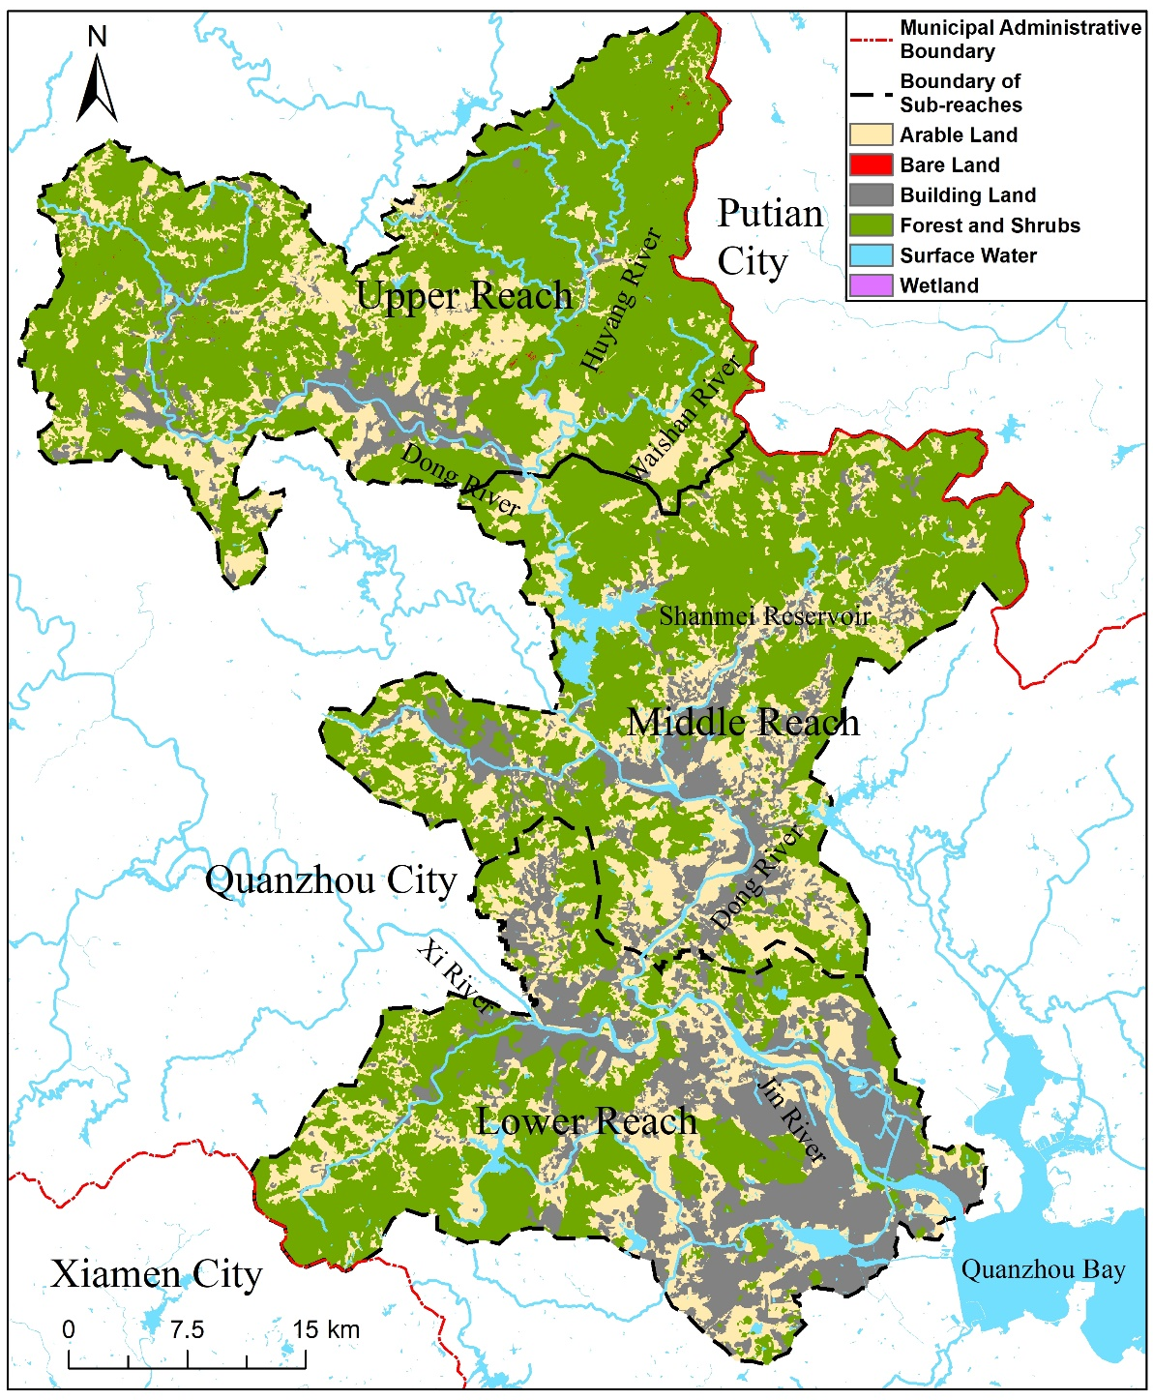
Figure S1 Land use map of the study area

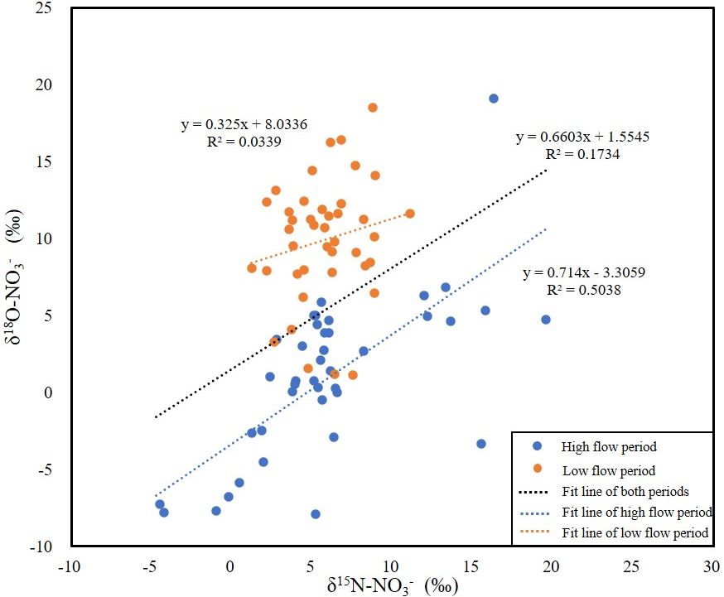
Figure S2 Variations of δ¹⁵N-NO₃⁻ versus δ¹⁸O-NO₃⁻ values in water samples in two sampling periods of upper reach of Jin River basin.

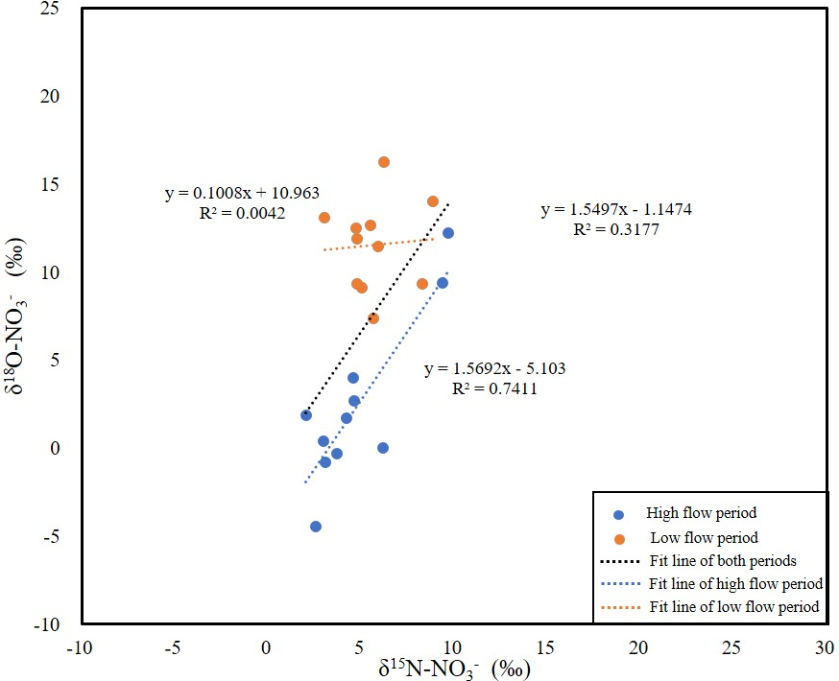

Figure S3 Variations of δ¹⁵N-NO₃⁻ versus δ¹⁸O-NO₃⁻ values in water samples in two sampling periods of middle reach of Jin River basin.
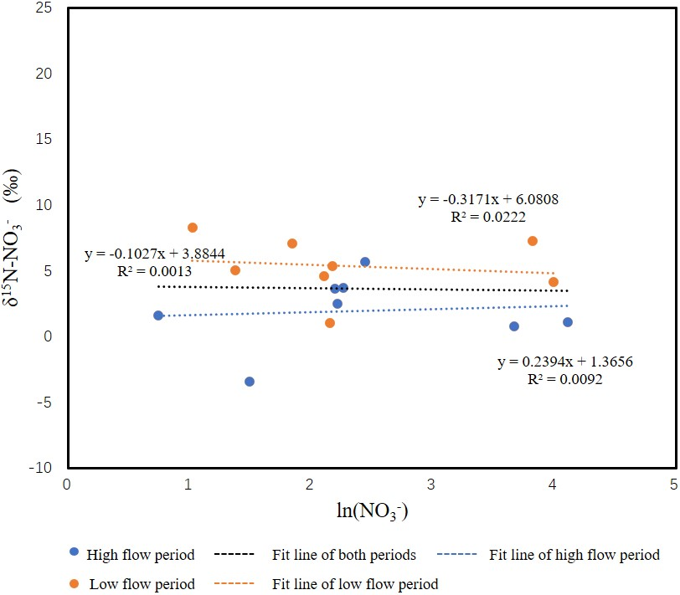
Figure S4 Variations of δ¹⁵N-NO₃⁻ versus ln (NO₃⁻) in water samples in two sampling periods of lower reach of Jin River basin.

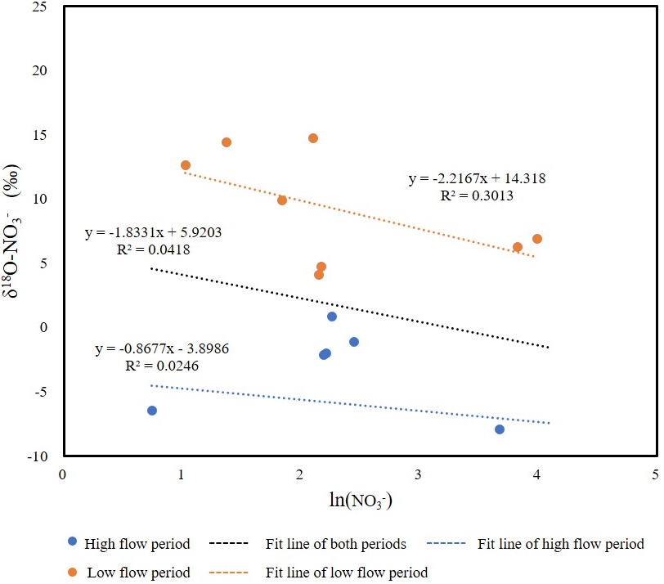
Figure S5 Variations of δ¹⁸O-NO₃⁻ versus ln (NO₃⁻) in water samples in two sampling periods of lower reach of Jin River basin.

