Submitted to Pure and Applied Geophysics

Appendix. Supplementary materials

Stress state inferred from b-value and focal mechanism distributions in the aftershock area of the 2005 West Off Fukuoka Prefecture earthquake

Keita Chiba^{1*}

Author#1: Keita Chiba, Institute of Seismology and Volcanology, Faculty of Science, Kyushu University, 744 Motooka, Nishi-Ku, Fukuoka, 819-0395 Japan, kchiba@sevo.kyushu-u.ac.jp, Tel: +81 92-802-4346,
ORCID: https://orcid.org/0000-0002-2841-3371

*Corresponding author: Keita Chiba

This file includes Figs. S1, S2, S3, and S4.

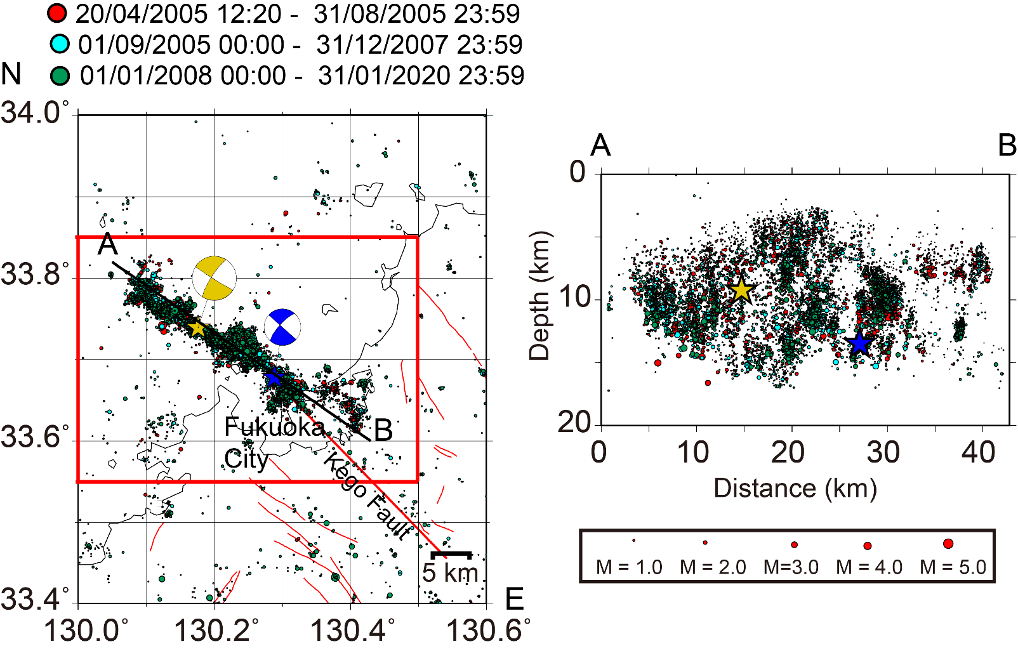

Figure S1

Left: Epicentral distribution of the $M≥0.5$ earthquakes. The red, right blue, and green circles represent the period a1 (12:20 JST on 20 April 2005 to 23:59 on 31 August 2005), period a2 (00:00 JST on 1 September 2005 to 23:59 on 31 December 2007), and period a3 (00:00 JST on 1 January 2008 to 23:59 on 31 January 2020) events, respectively. The events are scaled by their magnitudes. The yellow and blue stars represent the hypocenters of the mainshock and largest aftershock (M_{J} 5.8, 06:11 JST on 20 April 2005), respectively. Right: Cross-section of the hypocenters within 5 km of A–B. Other explanations are the same as in Fig. 1.

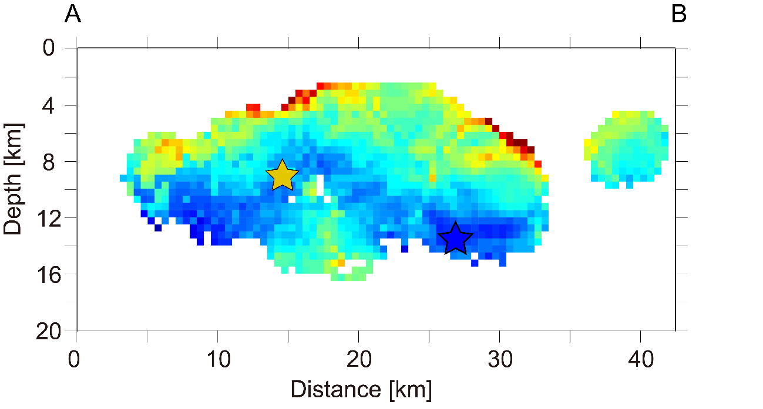
(a)

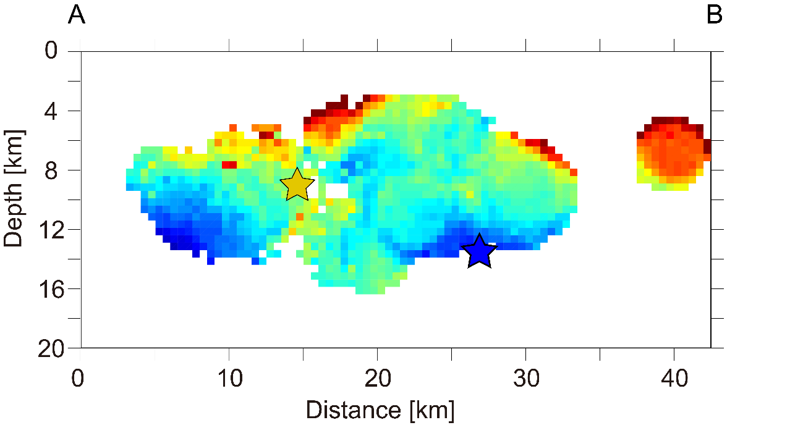
(b)

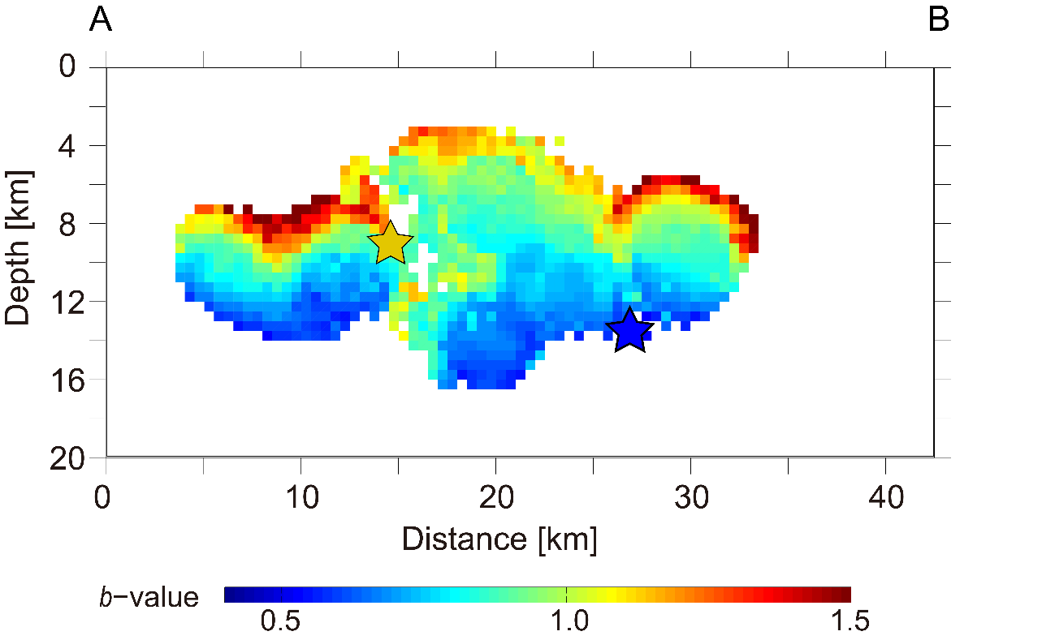
(c)

Figure S2
Cross-sections of the b-values in (a) period a1, (b) period a2, and (c) period a3. The yellow and blue stars
represent the mainshock and the largest aftershock, respectively.

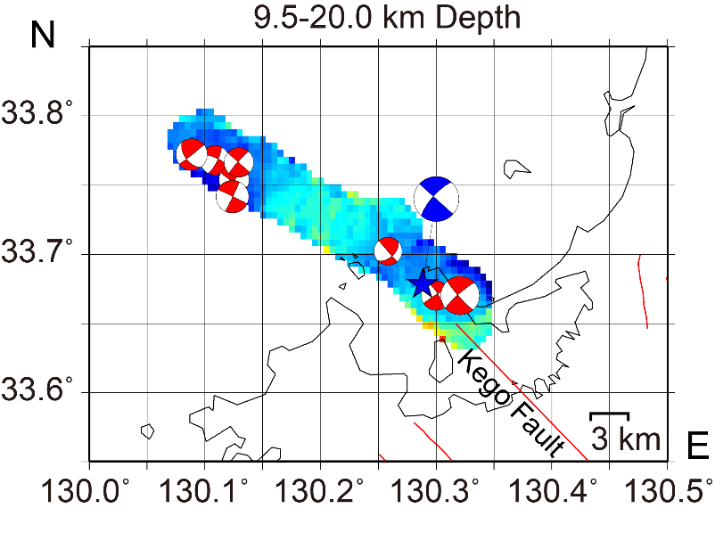
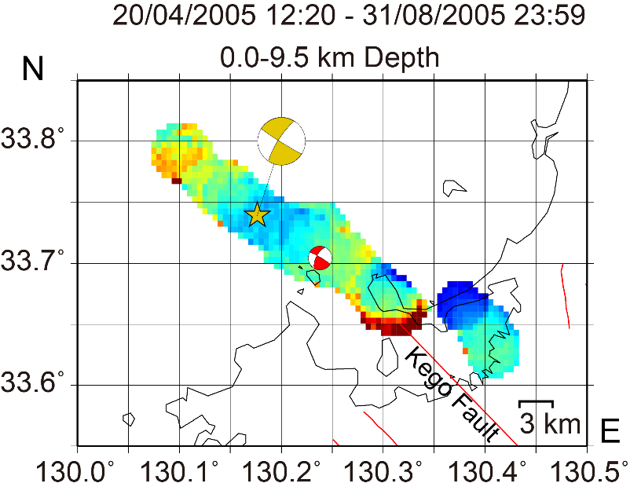
(a) (b)

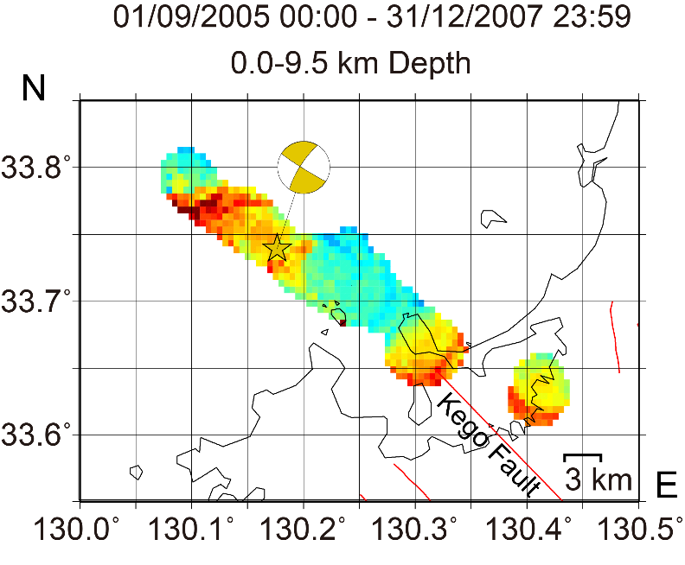
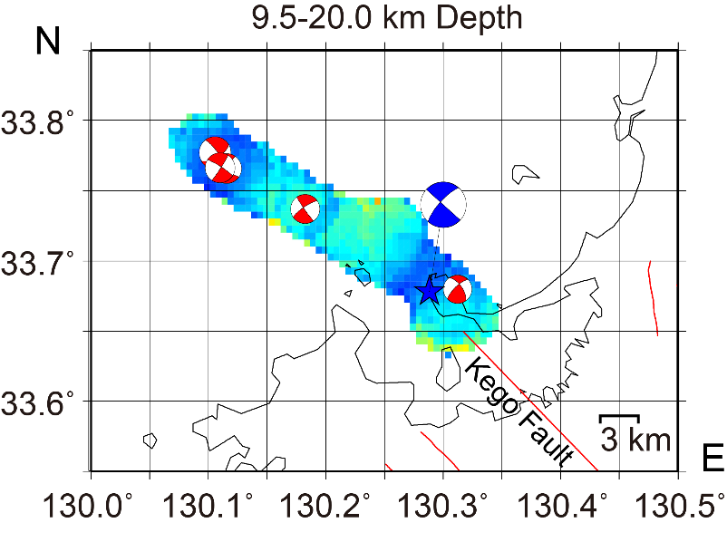
(c) (d)

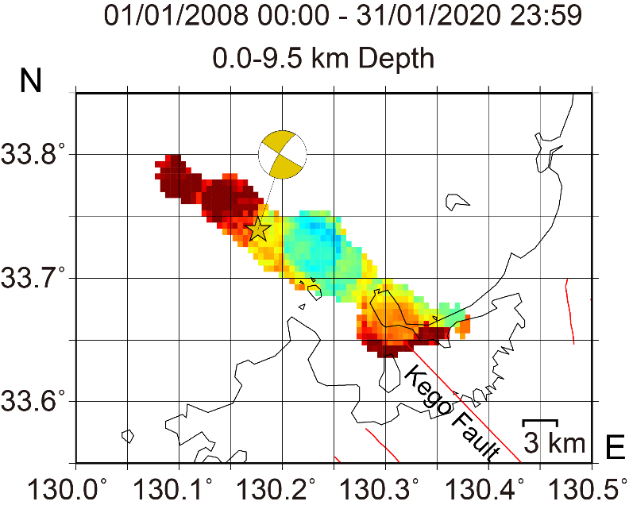
(e) (f)
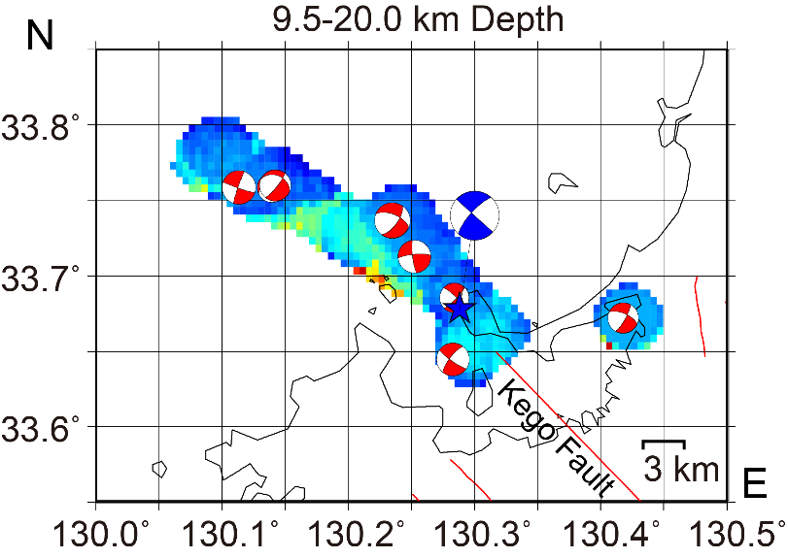

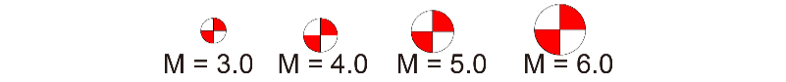
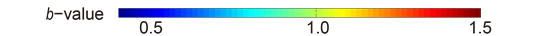
Figure S3
(a, b) Plan-view b-value maps of the shallow (0.0–9.5 km depth) and deep (9.5–20.0 km depth) regions during period a1. (c, d) Plan-view b-value maps of the shallow and deep regions during period a2. (e, f) Plan-view b-value maps of the shallow and deep regions during period a3. The focal mechanisms from the F-net data are superimposed on the b-value maps for the appropriate depth range and time window. Other explanations are the same as in Figs. 1 and 5.

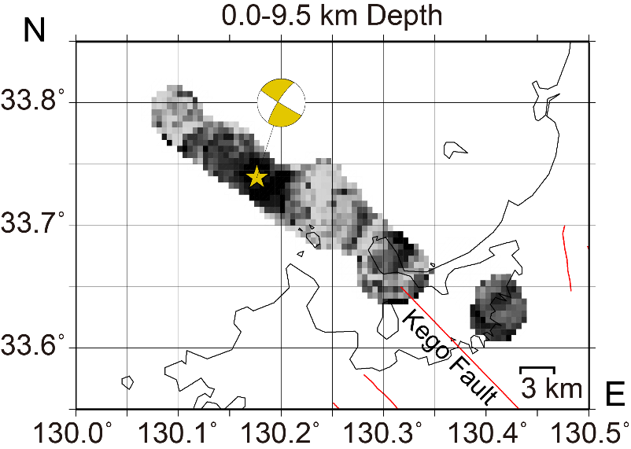
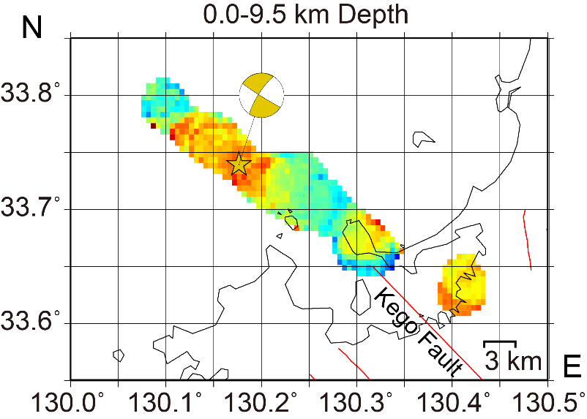
(a) (b)

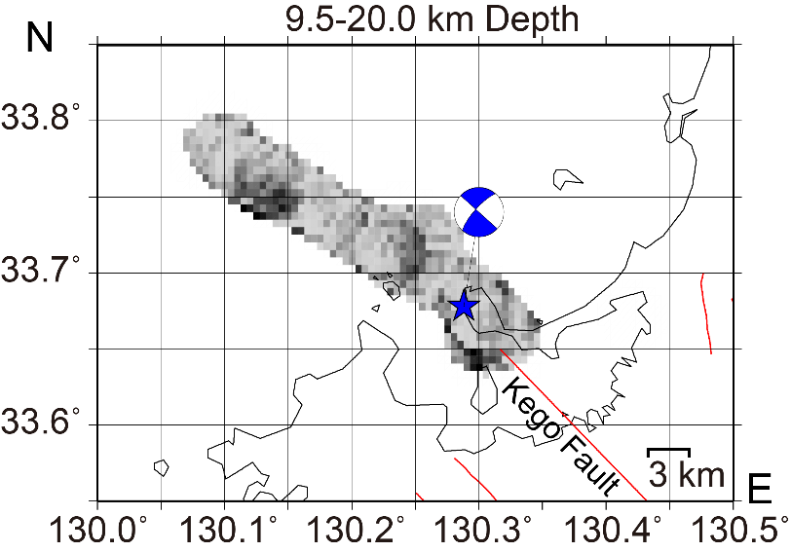
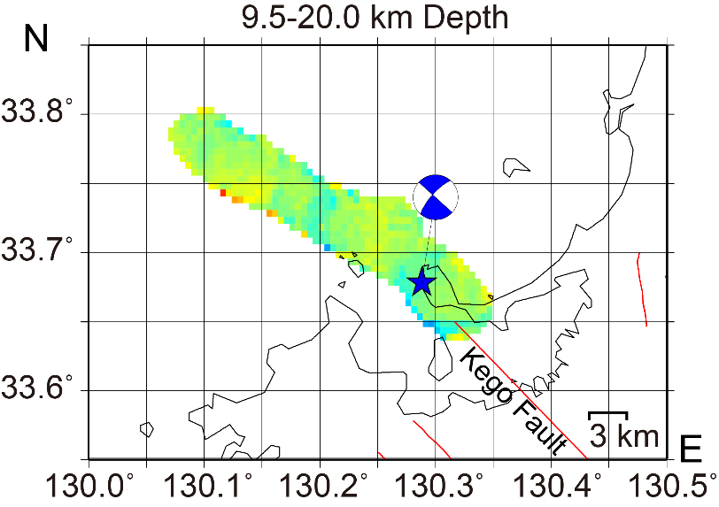
(c) (d)

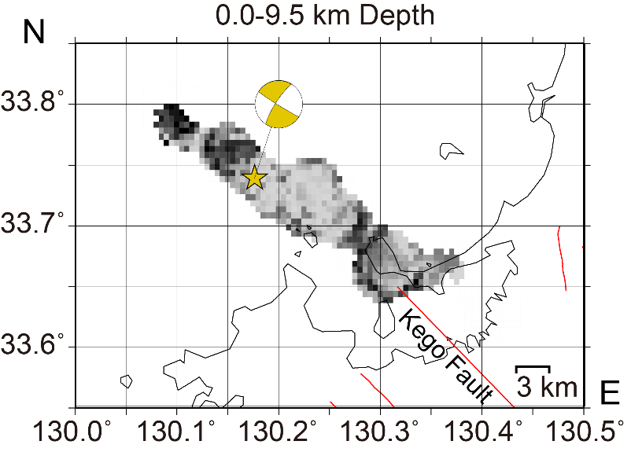
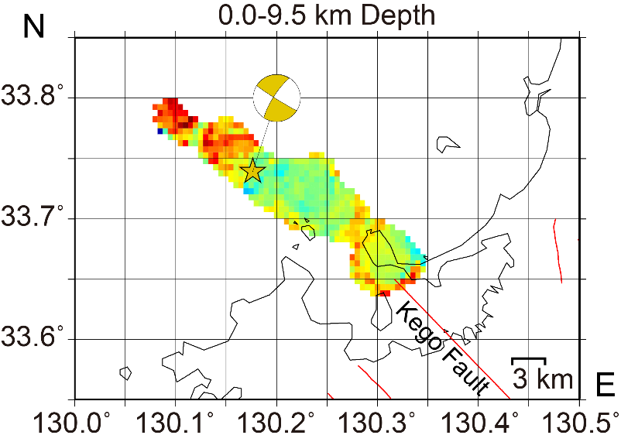
(e) (f)

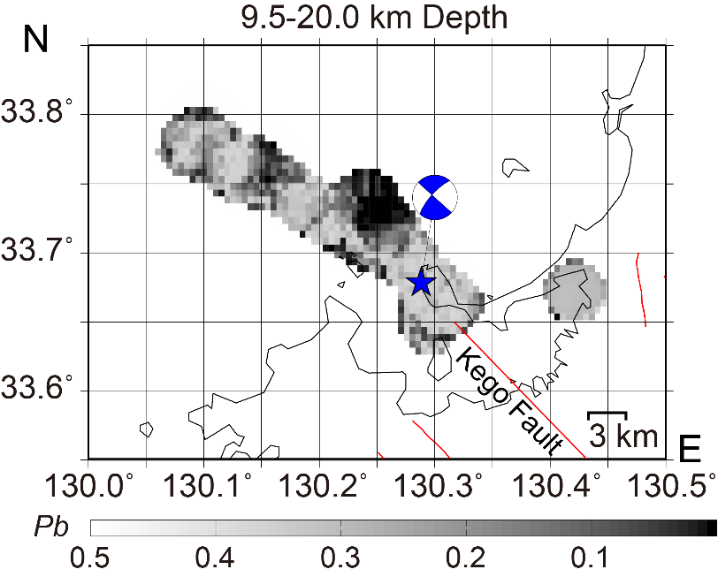
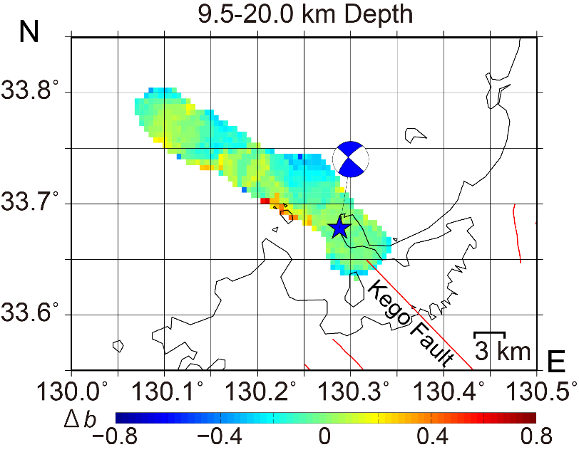
(g) (h)

Figure S4
a) Difference in b-values between periods a1 and a2 ($∆b= b_{period a2}-b_{period a1}$) in the shallow region. (b) p-values estimated from $∆b$ in (a). (c) Difference in b-values between periods a1 and a2 in the deep region. (d) p-values estimated from $∆b$ in (c). e) Difference in b-values between periods a2 and a3 ($∆b= b_{period a3}-b_{period a2}$) in the shallow region. (f) p-values estimated from $∆b$ in (e). (g) Difference in b-values between periods a2 and a3 in the deep region. (h) p-values estimated from $∆b$ in (g). The other symbols and meanings are the same as in Fig. 1.

