Supplementary information

Two Quasi-interfacial p-n Junctions Observed by a Dual-Irradiation System in Perovskite Solar Cells

Mohamed I. Omer^{1,3}†, Tao Ye^{1,4}†, Xianqiang Li^{1,3}, Shaoyang Ma³, Dan Wu³, Lei Wei³, Xiaohong Tang³, Seeram Ramakrishna², Qiang Zhu,¹ Shanxing, Xiong,⁶ Jianwei Xu^{1,5,7*}, Chellappan Vijila^{1*}, Xizu Wang^{1*}†

¹Institute of Materials Research and Engineering (IMRE), Agency for Science, Technology and Research (A*STAR), #08-03, 2 Fusionopolis Way, Innovis, 138634, Singapore
²Department of Mechanical Engineering, National University of Singapore, Singapore 117576, Singapore
³School of Electrical and Electronic Engineering, Nanyang Technological University, 50 Nanyang Avenue, Singapore 639798, Singapore
⁴Key laboratory of Micro/Nano Systems of Aerospace, Ministry of Education, Northwestern Polytechnical University, Xi’an 710072, China
⁵Department of Chemistry, National University of Singapore, 3 Science Drive 3, Singapore 117543
⁷Collegue of Chemistry and Chemical Engineering, Xi’an University of Science and Technology, Xi’an, 710054, PR China
⁷Institution of Sustainability for Chemical, Energy and Environment (ISCE2), 1 Pesek Road, Jurong Island, Singapore, 627833

This PDF file includes:

Figures S1 to S11 and Table S1.

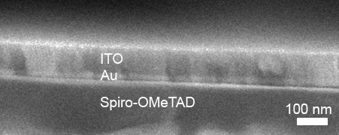

Fig. S1. The enlarged cross-section SEM image of the ITO/Au electrode.

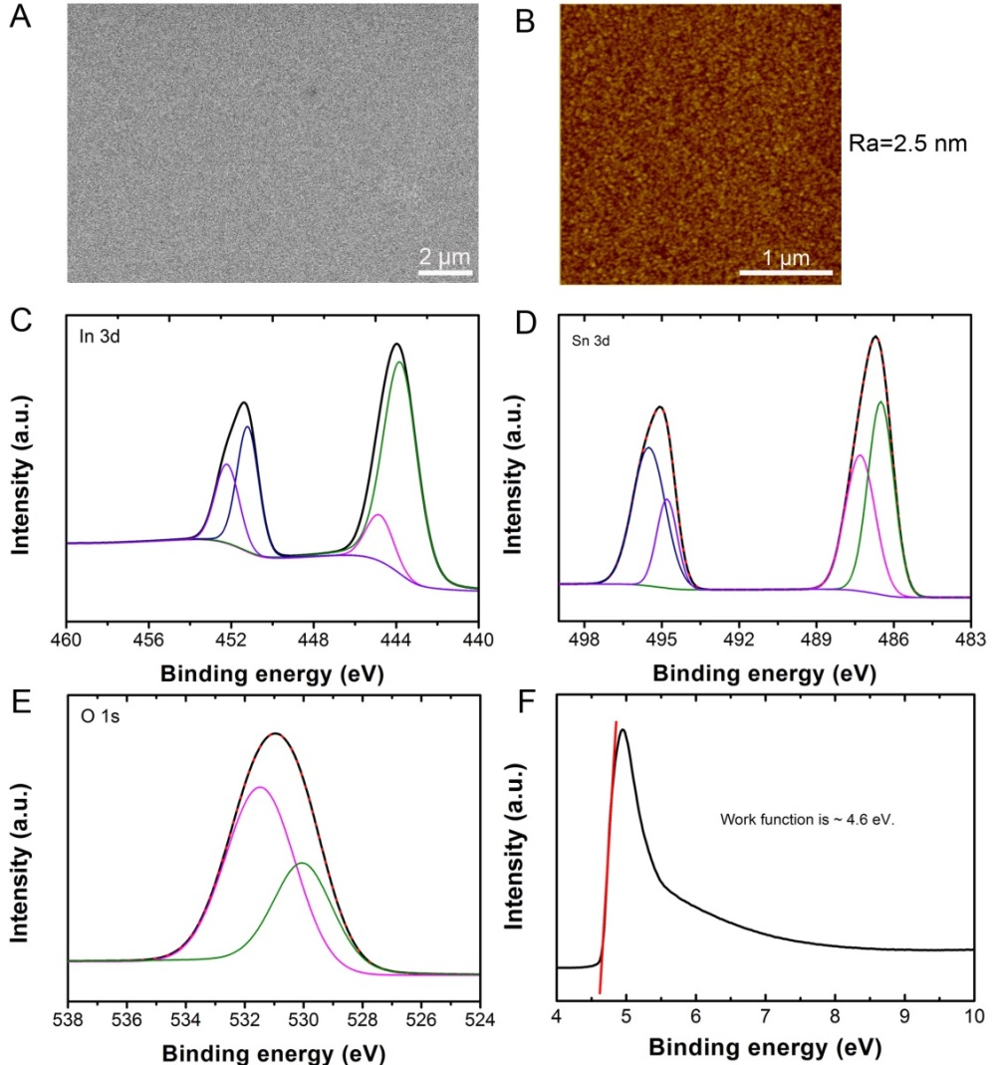
Fig. S2. Fundamentals of a prepared ITO layer. (A) Surface SEM image showing the smoothness and uniformity of a prepared ITO layer. (B) The AFM image of a prepared ITO layer. (C-E) XPS elemental spectra (In_{3d}, Sn_{3d} and O_{1s}) of the ITO sample. (F) UPS work function spectra of the fabricated ITO layer.

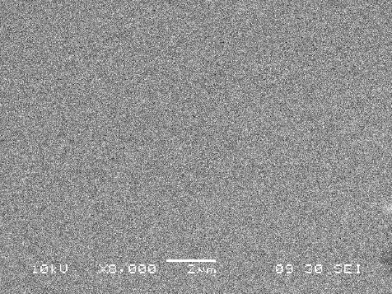

Fig. S3. The surface SEM image of a commercial ITO.

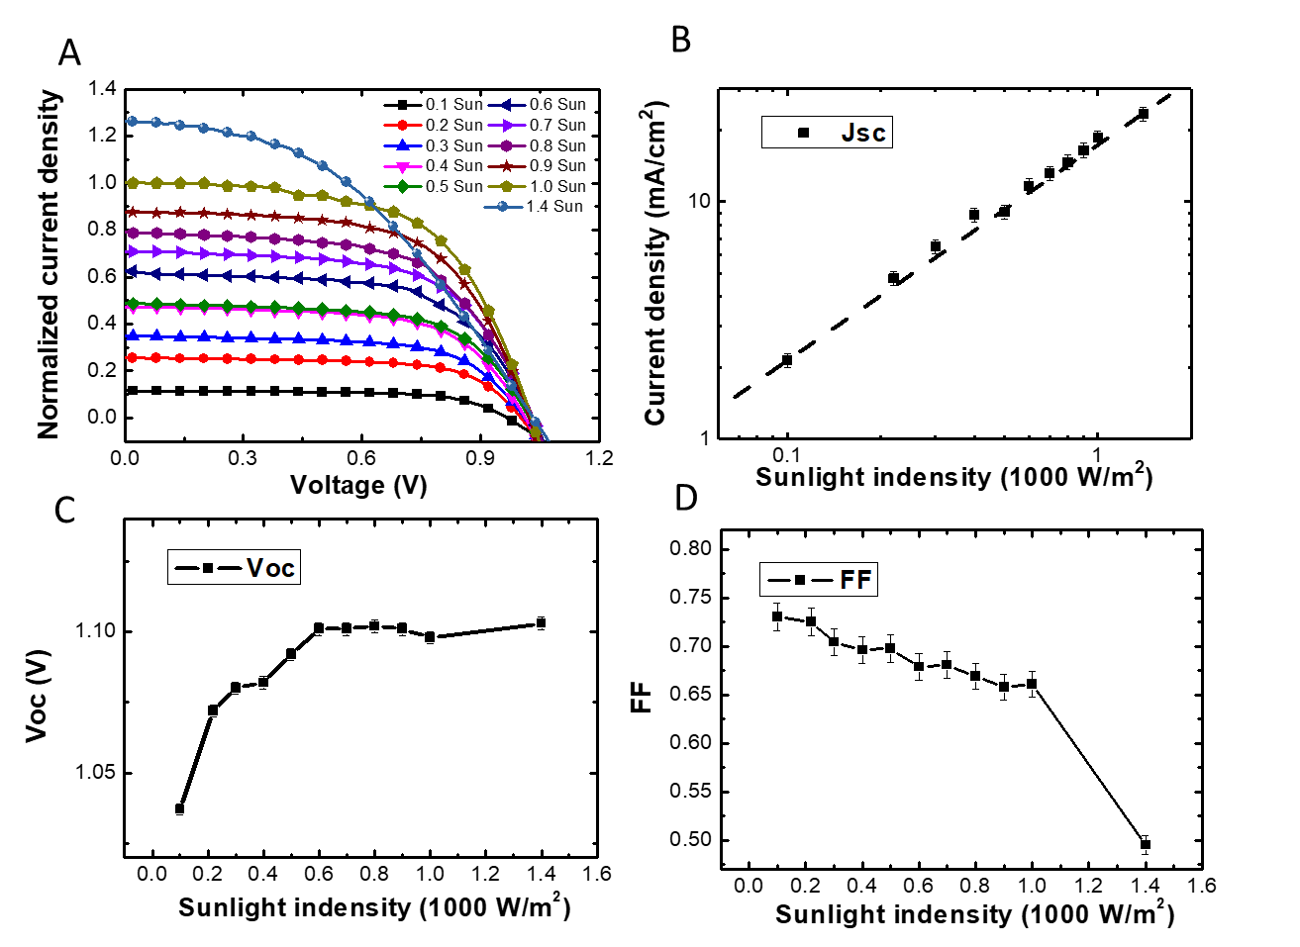
Fig. S4. (A) Light intensity response of the device performance for a Au-22.5 device when the light goes in from the FTO side; (B) the log-log plot of the J_{sc} against the light intensity; (C) the V_{oc} and (D) FF against the light intensity.
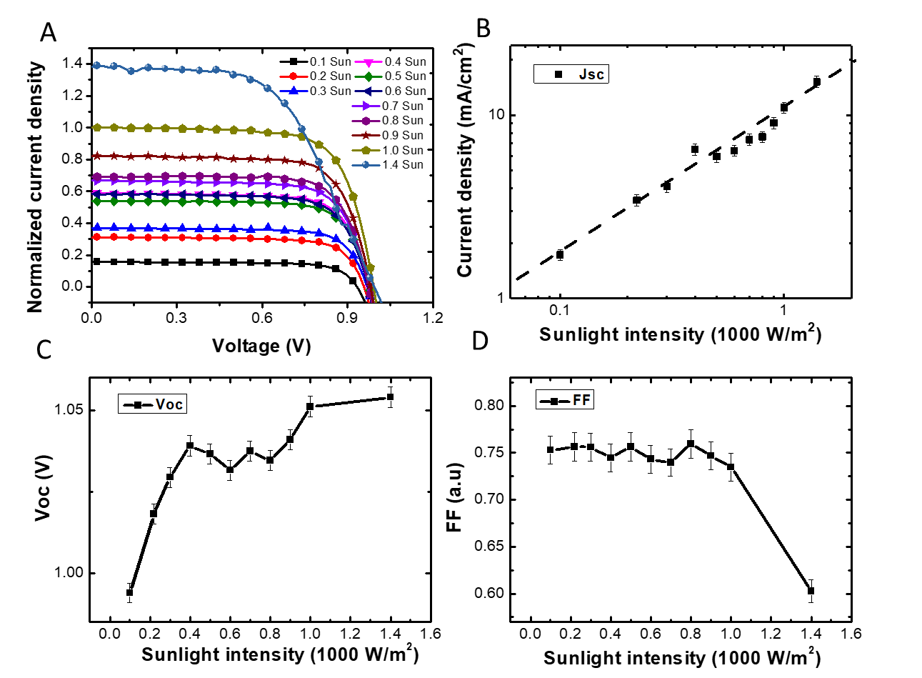
Fig. S5. (A) Light intensity response of the device performance for a Au-22.5 device when the light goes in from the ITO side; (B) the log-log plot of the J_{sc} against the light intensity; (C) the V_{oc} and (D) FF against the light intensity.

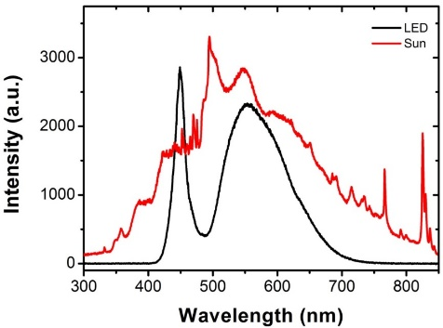
Fig. S6. The light spectra of a white LED and a simulated 1 sun light.

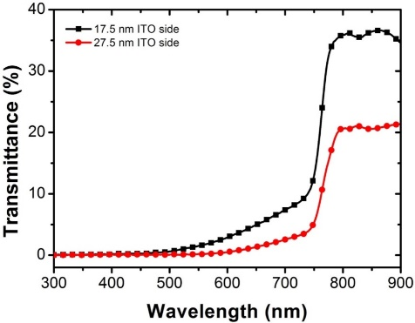
Fig. S7. Optical transmittance of the PSCs based on 17.5 and 27.5 nm Au electrodes: the light goes in from ITO side, showing the optical transmittance from ITO side decreases with the increase of the thickness of the Au layer due to the light attenuation of the Au electrode. The optical transmittance starts points are ~ 500 nm and ~600 nm for the 17.5 nm and 27.5 nm Au devices, respectively.

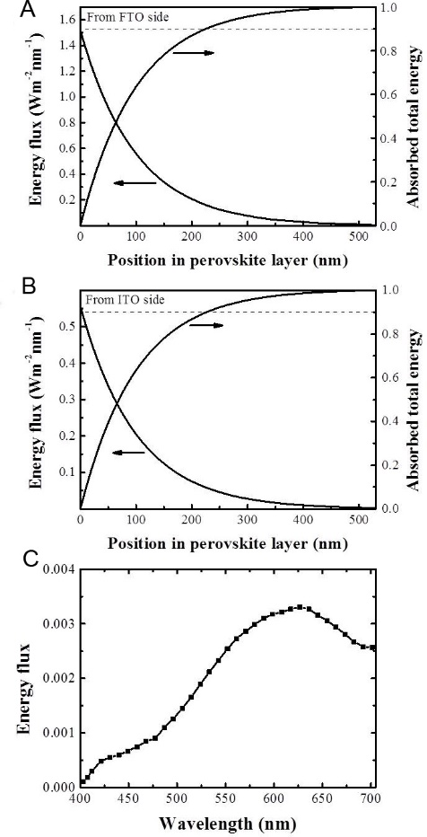
Fig. S8. Optical admittance analysis simulation: the energy flux decay and absorbed total energy within the perovskite layer of the Au-22.5 device when 532 nm incident light comes from (A) the FTO side and (B) the ITO side. (C) Energy flux at the interface between perovskite and spiro-OMeTAD layer under illumination at the ITO side as a function of the incident wavelength.

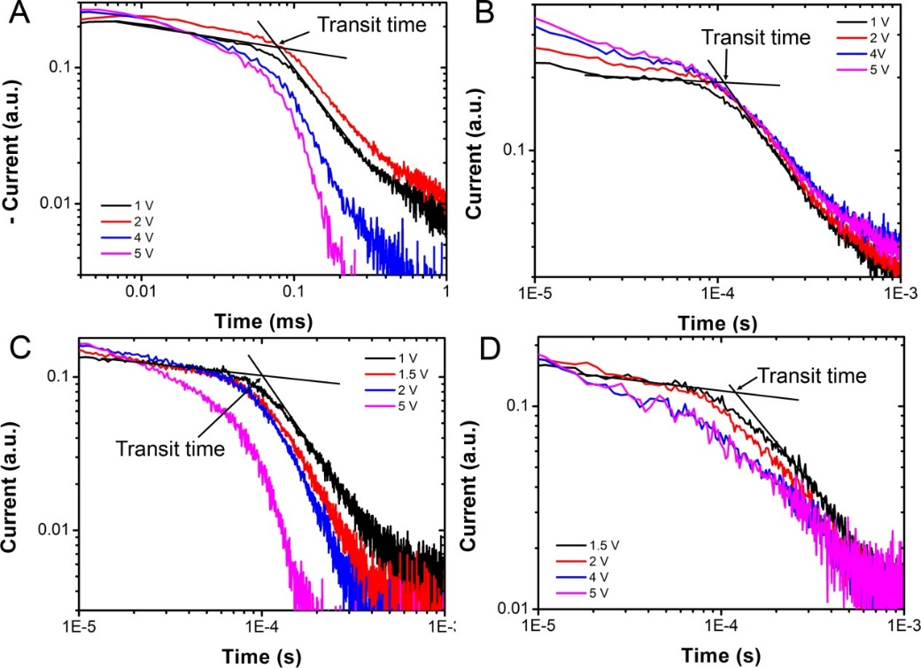
Fig. S9. TOF results of the device with a 22.5 nm Au electrode. Log-log plot of TOF spectra at different voltages for (A) electrons at the FTO side, (B) holes at the FTO side, (C) electrons at the ITO side and (D) hole at the ITO side.

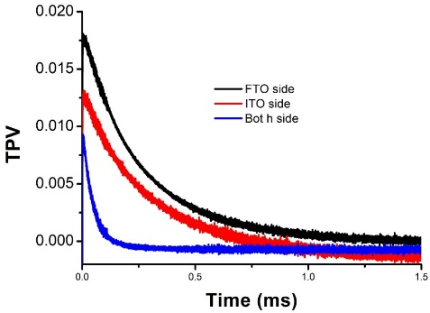
Fig. S10 Linear plot of the full spectra of the TPV experiments.
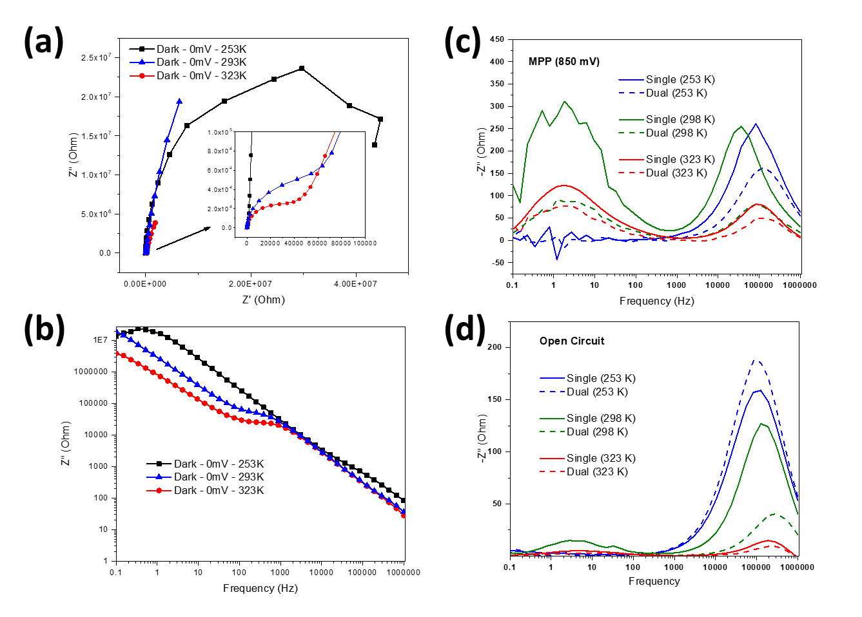
Fig. S11. Perovskite solar cell illumination-side-dependent impedance spectroscopy results: (a) Nyquist loci of –z'' vs z' at dark condition, (b) Nyquist loci of –z''vs frequency at dark condition. (c) Nyquist loci of –z''vs frequency at single and dual irradiation, (d) Nyquist loci of –z''vs frequency at single and dual irradiation at the open circuit condition.

Table S1. The fitting resistance and capacity obtained from dual ISD-IS spectra under single and dual illumination at the temperature from 253K to 323K.

MPP | Lighting | Rs | R_{hf} | C_{hf} | N_{hf} | R_{lf} | Cl_{lf} | N_{lf}
Low temp | Single | 49.04 | 599.7 | 15.24 | 0.879 | - | - | -
Low temp | Dual | 48.03 | 393.5 | 16.15 | 0.880 | - | - | -
Room temp | Single | 63.75 | 114 | 9.83 | 1 | 252.2 | 0.455 mF | 0.729
Room temp | Dual | 68.3 | 67.25 | 15.37 | 1 | 175.3 | 0.865 mF | 0.661
High  temp | Single | 52.52 | 162.1 | 10.26 | 1 | 375.9 | 0.395 mF | 0.702
High  temp | Dual | 53.77 | 102.1 | 11.74 | 1 | 207.2 | 0.610 mF | 0.735

