Appendix

Table A1: Results attribute non-attendance (A1.2) and scale heterogeneity analysis (A1.3)
 | (1) | (A1.2) | (A1.3)
 | Basic | Stated attribute non-attendance | Scale heterogeneity
Mean effects
Children | 0.022*** | 0.019*** | 0.024***
 | (0.004) | (0.005) | (0.005)
Education half | 1.716*** | 1.733*** | 1.820***
 | (0.060) | (0.064) | (0.071)
Education all | 2.927*** | 2.955*** | 3.111***
 | (0.073) | (0.077) | (0.112)
Health care medium | 0.679*** | 0.667*** | 0.726***
 | (0.042) | (0.044) | (0.047)
Health care high | 1.226*** | 1.183*** | 1.298***
 | (0.048) | (0.050) | (0.056)
Nutrition half | 1.634*** | 1.620*** | 1.746***
 | (0.054) | (0.057) | (0.083)
Nutrition all | 1.953*** | 1.913*** | 2.074***
 | (0.066) | (0.067) | (0.090)
Ignored number of children * Children |  | 0.034**
Ignored number of children * Children |  | (0.016)
Ignored number of children * Education half |  | 0.017
Ignored number of children * Education half |  | (0.183)
Ignored number of children * Education all |  | 0.034
Ignored number of children * Education all |  | (0.251)
Ignored number of children * Health care medium |  | 0.283
Ignored number of children * Health care medium |  | (0.192)
Ignored number of children * Health care high |  | 0.837***
Ignored number of children * Health care high |  | (0.215)
Ignored number of children * Nutrition half |  | 0.383*
Ignored number of children * Nutrition half |  | (0.202)
Ignored number of children * Nutrition all |  | 0.795***
Ignored number of children * Nutrition all |  | (0.239)
Standard deviation
Children | 0.053*** | 0.049*** | 0.042**
 | (0.009) | (0.010) | (0.020)
Education half | 0.625*** | -0.692*** | -0.722***
 | (0.084) | (0.082) | (0.087)
Education all | 1.290*** | 1.266*** | 1.298***
 | (0.060) | (0.052) | (0.059)
Health care medium | -0.074 | -0.076 | -0.067
 | (0.137) | (0.138) | (0.206)
Health care high | 0.732*** | 0.698*** | 0.765***
 | (0.055) | (0.054) | (0.064)
Nutrition half | 0.194 | 0.260** | 0.150
 | (0.235) | (0.103) | (0.229)
Nutrition all | 0.879*** | 0.869*** | 0.890***
 | (0.056) | (0.056) | (0.058)
Ignored number of children * Children |  | 0.018
 |  | (0.061)
Ignored number of children * Education half |  | 0.003
 |  | (0.127)
Ignored number of children * Education all |  | 0.009
 |  | (0.169)
Ignored number of children * Health care medium |  | 0.405***
 |  | (0.156)
Ignored number of children * Health care high |  | 1.054***
 |  | (0.256)
Ignored number of children * Nutrition half |  | -0.382
 |  | (0.258)
Ignored number of children * Nutrition all |  | -0.085
 |  | (0.457)
τ |  |  | -0.296***
 |  |  | (0.082)
N | 35994 | 35994 | 35994
AIC | 17198.441 | 17158.727 | 17182.781
BIC | 17317.316 | 17396.478 | 17310.148
Log likelihood | -8585.220 | -8551.364 | -8576.391
Notes: Standard errors are reported between parentheses. Significant coefficients are indicated with * p < 0.1, ** p < 0.05 or *** p < 0.01.

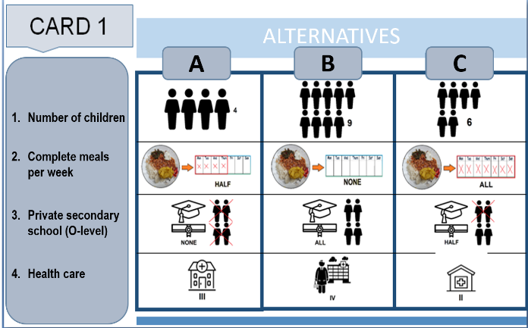

Figure A1: Examples of choice cards from the Senegalese (upper) and Ugandan (lower) experiment
