Supplementary Materials for

LC3-associated phagocytosis promotes glial degradation of axon debris after injury

Áron Szabó¹*, Virág Vincze¹, Sarolta Bognár¹, Katalin Eszter Varga¹, Poulami Banik¹, András Jipa¹, Lukas J. Neukomm² and Gábor Juhász^{1,3}*

*Corresponding author. Email: aszabo@brc.hu, juhasz.gabor@brc.hu

This file includes:

Figs. S1 to S5

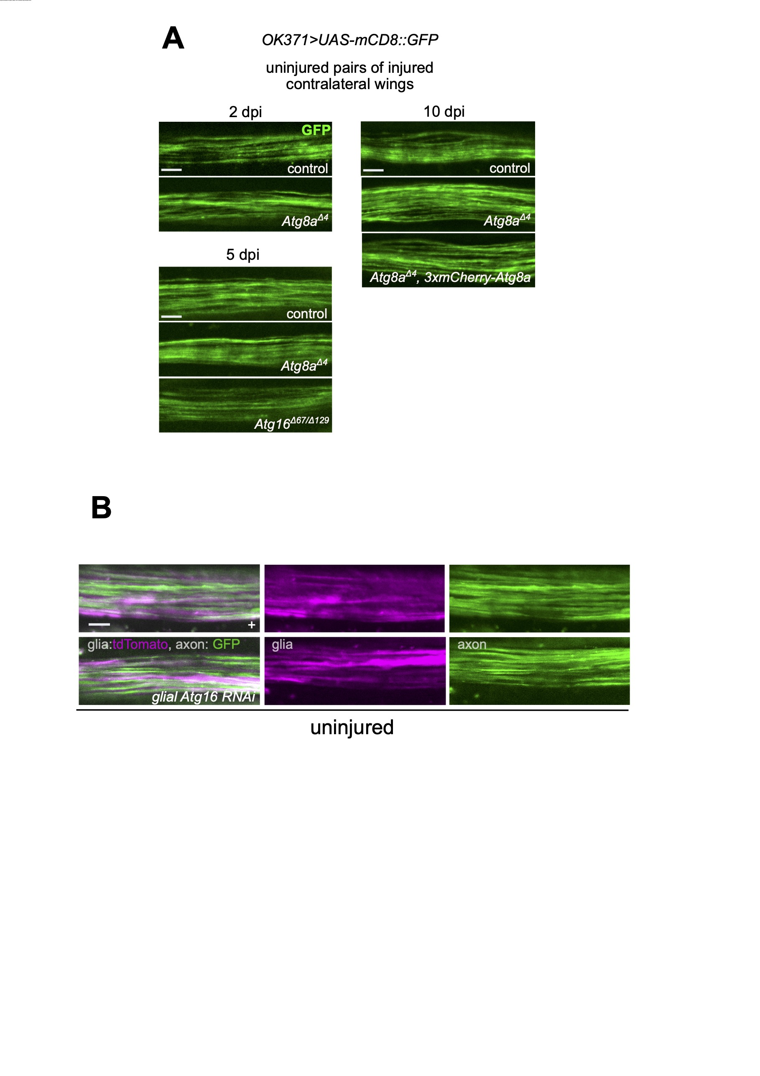
Figure S1. Atg8a and Atg16 mutations do not induce axon degeneration or glial abnormalities in the uninjured wing nerve
(A) z-projections of uninjured wing nerve segments (pairs of contralateral injured wings presented in Fig. 1) are shown for the indicated genotypes on OK371> UAS-mCD8::GFP/+ background at 2, 5 and 10 days post contralateral wing injury. (B) z-projected images of uninjured wing nerves expressing or not Atg16 RNAi KK in glia with repo-Gal4, axons labelled with mCD8::GFP, glia labelled with membrane-targeted tdTomato (VGlut> QUAS-mCD8::GFP, repo-Gal4>UAS-mtdTomato). Conclusions were drawn from the observation of n=18 independent animals from each genotype. Scale bar: 5 μm.
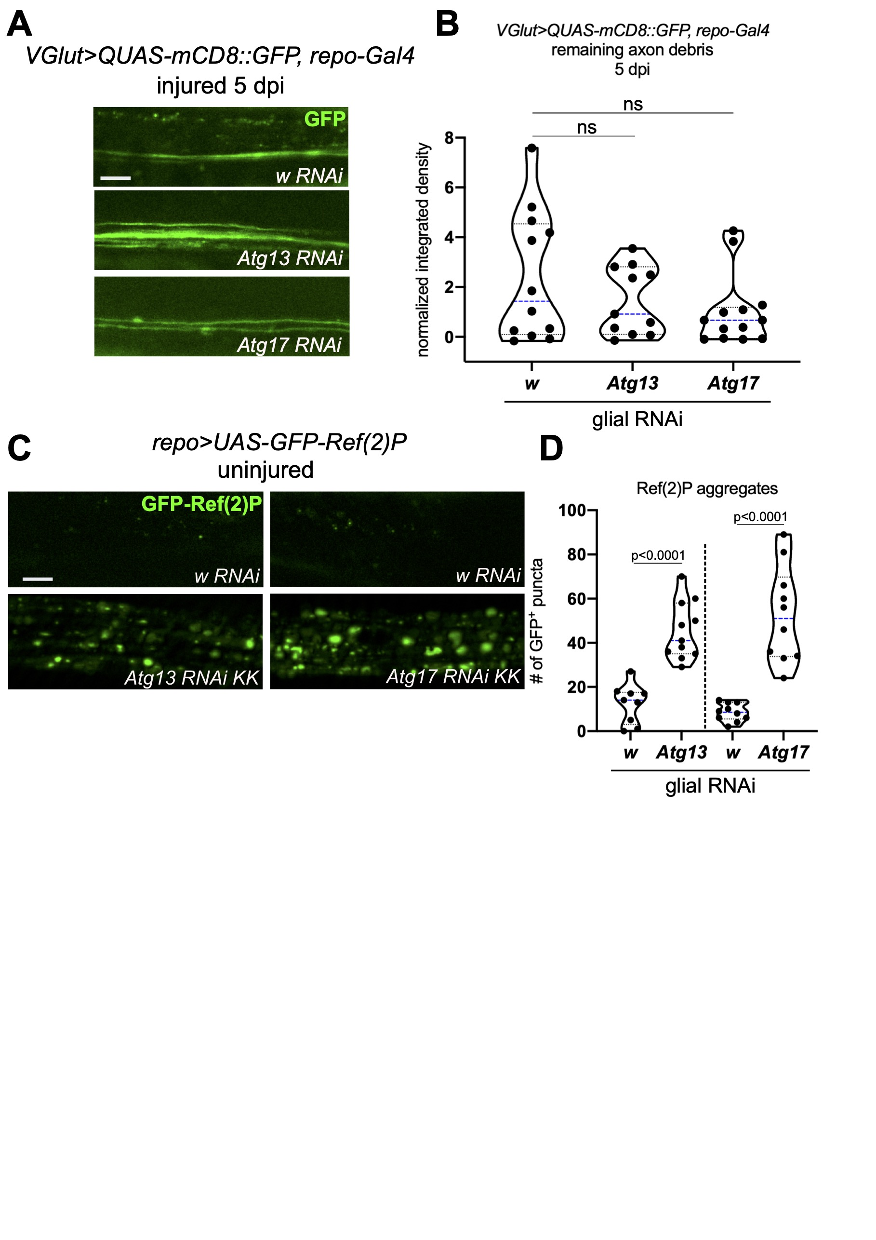
Figure S2. The Atg1 kinase complex in glia does not affect debris elimination
(A) z-projections of degenerating wing nerves expressing the indicated RNAi-s in glia, driven by repo-Gal4 on VGlut> QUAS-mCD8::GFP/+ background at 5 dpi. (B) Quantification of axon debris abundance in single-slice images of the indicated genotypes as in (A) at 5 dpi, Kruskal-Wallis test. n=12, 13 and 11. (C) Single-slice images of uninjured wing L1 vein glia expressing repo-Gal4-driven UAS-GFP-ref(2)P and co-expressing the indicated RNAi-s. (D) Quantification of the number of GFP-Ref(2)P puncta in single-slice images of genotypes in (C), unpaired, two-tailed t-test. n= 9, 11, 10 and 10. Independent experiments are separated by a dashed line. (B,D) Truncated violin plots with median and quartiles shown. w RNAi serves as a negative control. ns – not significant. Scale bar: 5 μm.
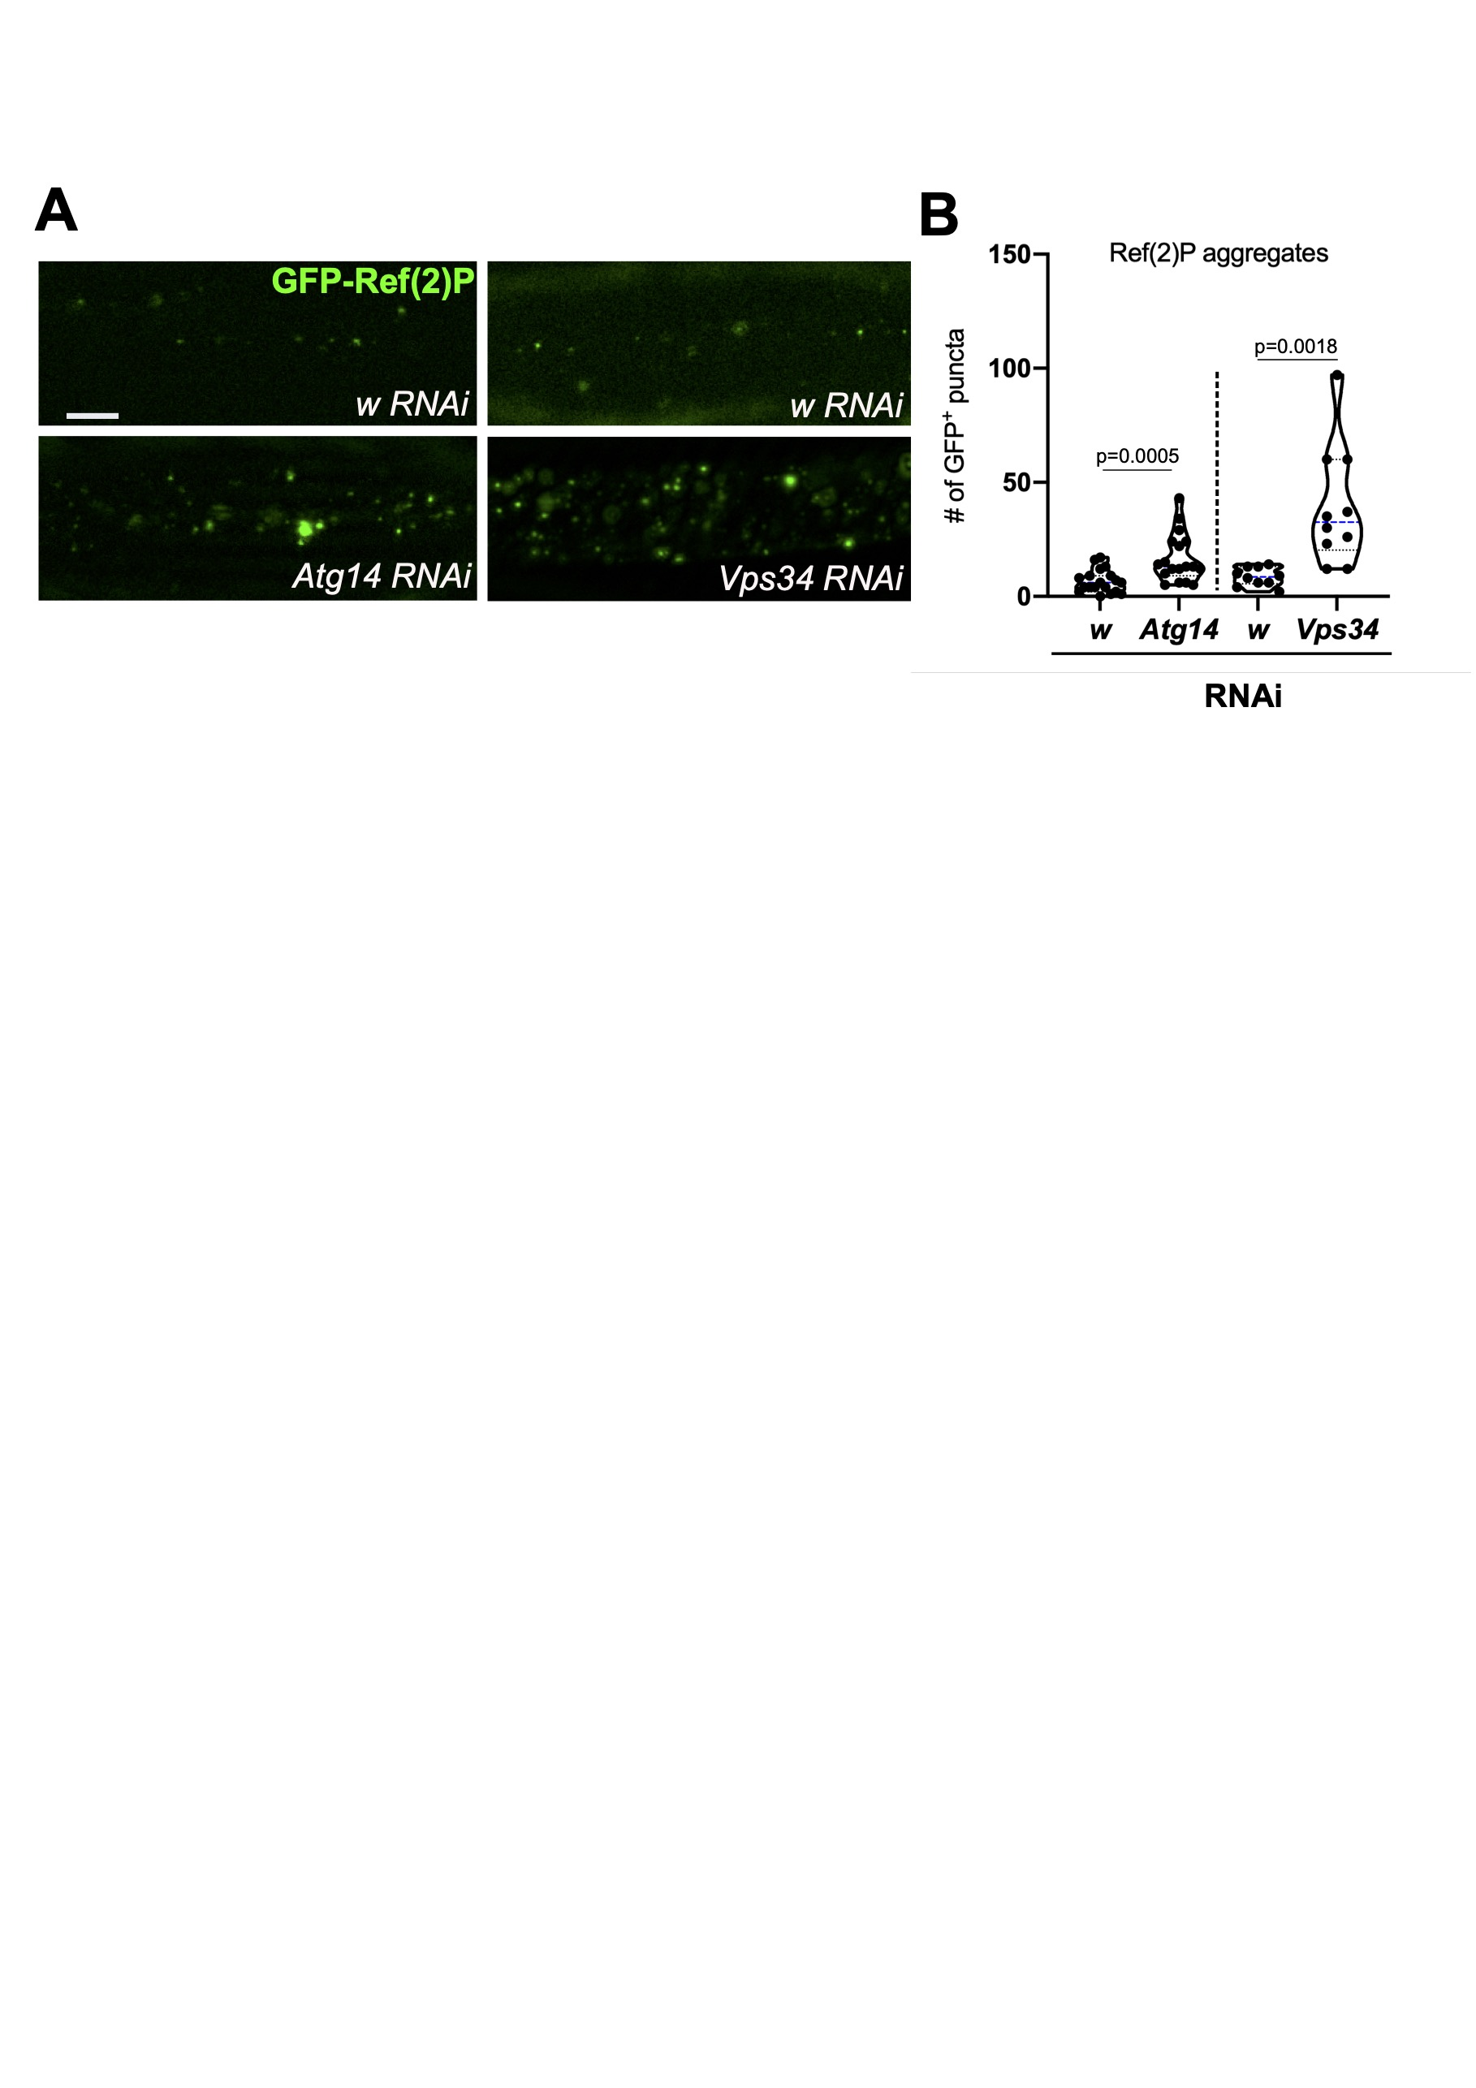
Figure S3. Loss of Atg14 or Vsp34 inhibits autophagy in glia
(A) Single-slice images of uninjured wing L1 vein glia expressing repo-Gal4-driven UAS-GFP-ref(2)P and co-expressing the indicated RNAi-s. Scale bar: 5 μm. (B) Quantification of the number of GFP-Ref(2)P puncta in single-slice images of genotypes in (B). Statistical analysis was performed with unpaired, two-tailed Mann-Whitney test (Atg14) or t-test (Vps34). ns – not significant. n=19, 18, 10 and 10. w RNAi serves as a negative control. Independent experiments are separated by a dashed line. Truncated violin plot with median and quartiles shown.
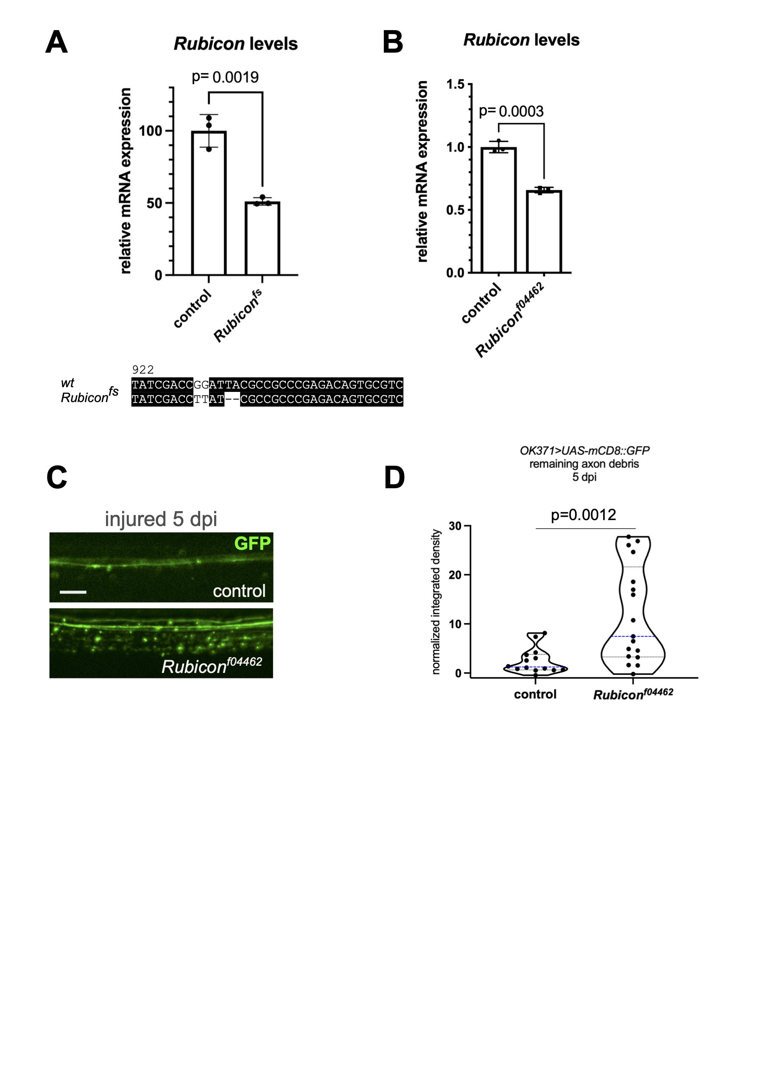
Figure S4. Characterization of Rubicon alleles and their effect on debris clearance
(A,B) Rubicon mRNA levels measured by quantitative reverse-transcription-coupled PCR (RT-qPCR) in the indicated genotypes. Statistics was performed with unpaired, two-tailed t-test, shown is the mean with standard deviation. n=3. Coding sequence change in Rubicon^{fs} is shown below the graph in (A). (C,D) z-projections of degenerating wing nerves at 5 dpi in the Rubicon^{f04462} mutant and quantification of axon debris abundance in single-slice images. Unpaired, two-tailed Mann-Whitney test was used for statistics. n=14 and 17. ns – not significant. Scale bar: 5 μm.
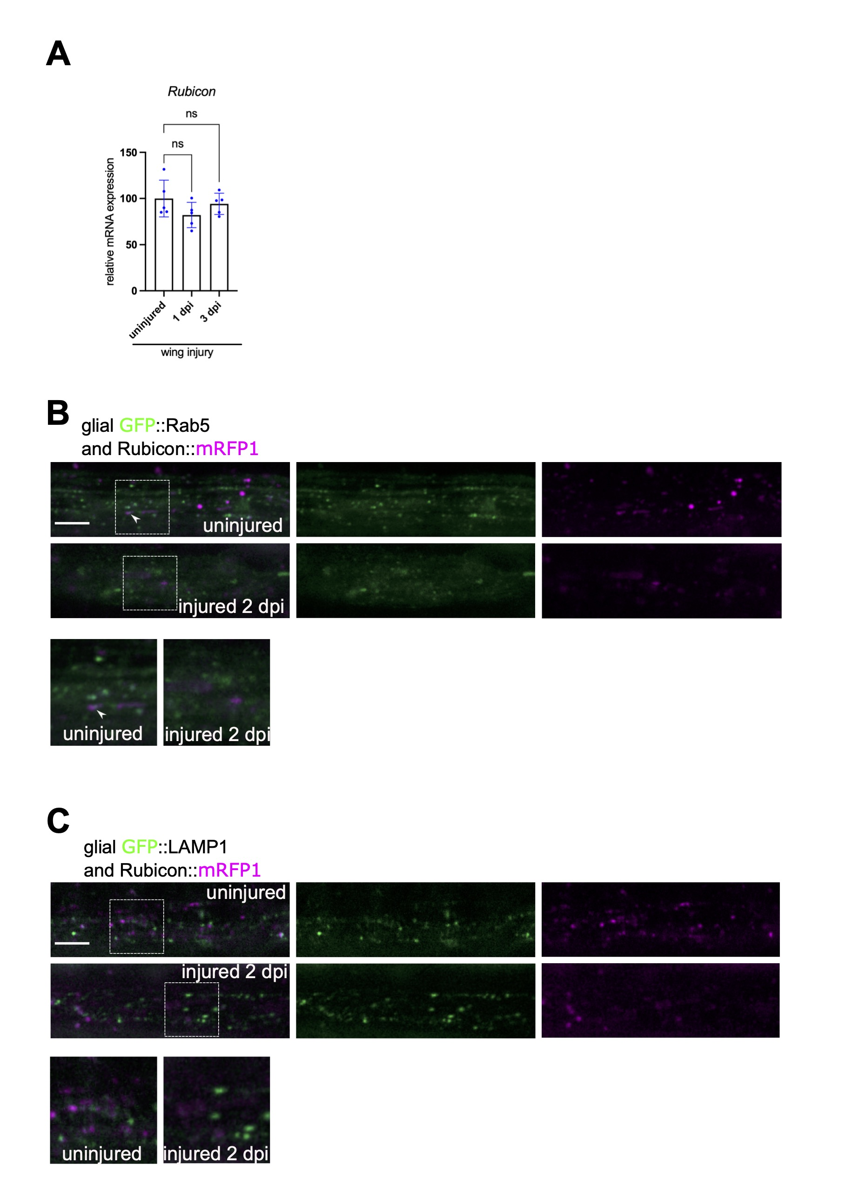
Figure S5. Rubicon expression does not change at the transcript level after injury and Rubicon scarcely colocalizes with Rab5 or LAMP1 in glia
(A) Rubicon transcript levels measured by RT-qPCR from intact or transected wings collected at the indicated time points. One-way ANOVA, ns- not significant. Shown is the mean with standard deviation. n=5. (B,C) Confocal single-slice images of uninjured and injured wing nerves at 2 dpi expressing in glia Rubicon::mRFP1 and GFP::Rab5 (repo-Gal4> UAS-Rubicon::mRFP1, >UAS- GFP::Rab5) (B) or Rubicon::mRFP1 and GFP::LAMP1 (repo-Gal4> UAS-Rubicon::mRFP1, >UAS- GFP::LAMP1) (C). Magnified images of the areas outlined by the dashed rectangles are shown below. Arrowheads point to co-localizing puncta. Scale bar: 5 μm.

