Supporting Information

Carbon-doped flower-like Bi₂WO₆ decorated carbon nanosphere nanocomposites with enhanced visible light photocatalytic degradation of tetracycline

Xiaona Jiang¹, Shuai Chen¹, Xinrui Zhang¹, Lanni Qu¹, Houjuan Qi¹, Bin Wang^{2,3}, Ben Bin Xu⁴, and Zhanhua Huang^{1,} *
¹ Key Laboratory of Bio-based Material Science and Technology, Ministry of Education, College of Material Science and Engineering, Northeast Forestry University, Harbin, 150040, China
² College of Materials Science and Engineering, Taiyuan University of Science and Technology, Taiyuan, 030024, China
³ Advanced Materials Division, Engineered Multifunctional Composites (EMC) Nanotech LLC, Knoxville, TN, 37934, USA
⁴ Mechanical and Construction Engineering, Faculty of Engineering and Environment, Northumbria University, Newcastle Upon Tyne, NE1 8ST, UK

*To whom correspondence can be made
E-mail: huangzh1975@163.com (Z. H.); bin_wang@scu.edu.cn (B. W.)

Chemicals
Bismuth nitrate pentahydrate (Bi (NO₃)₃•5H₂O), sodium tungstate dehydrates (Na₂WO₄•2H₂O), Ammonium oxalate (AMO), isopropyl alcohol (IPA) were procured from Tianjin BASF Chemicals Co. Ltd., China. D-(+)-Glucose (C₆H₁₂O₆, AR) and sodium sulfite (Na₂SO₄) were purchased from Tianjin Guangdu Technology Development Co., Ltd., China. 1,4-benzoquinone (BQ), and Rhodamine B (Rh B) were procured from Tianjin Kemiou Chemical Reagent Co. Ltd., China. Deionized water was made in our laboratory. All chemicals were analytically pure and brought from different companies without any further purification.

Characterization
The morphologies of photocatalysts were researched by transmission electron microscope (TEM) at 12.5 kV (Quanta200, FEI, Netherlands), high-resolution transmission electron microscope (HRTEM) at a 200 kV acceleration voltage (TEM-2100, LJEMOC, Japan). X-ray photoelectron spectroscopy (XPS) measurements were conducted on a K-Alpha. The non-monochromatic Al X-rays at 140 W was used as the primary excitation. The C1s peak at 284.6 eV as an internal standard was corrected the binding energy due to the relative surface charging. (PHI 5700, Thermo Electron Corporation, USA). X-ray diffraction (XRD) was performed under Cu-Kα irradiation (40 kV, 30 mA) with a scanning range of 5-80° at a speed of 5°/min (XRD-6100, Shimadzu, Japan). The specific surface areas and pore-size distributions were studied by the Brunauer-Emmett-Teller (BET) method on a nitrogen adsorption analyzer (ASAP 2020, Micromeritics, USA). UV-vis diffuse reflectance spectra (UV-vis DRS) were scanned in the range of 200-800 nm (TU-1900, Beijing Purkinje General Instrument Co., Ltd. China). Photoluminescence (PL, G9800A, Agilent, USA) spectra were measured with an excitation wavelength of 387 nm. The superoxide (‧O₂–) and hole (h⁺) were investigated using 5,5-dimethyl-1-pyrroline N-oxide (DMPO) and 2,2,6,6-tetramethylpiperidinyloxyl (TEMPO) spin-trapping agent respectively, by electron spin resonance (ESR) spectrometer (Bruker A300-9.5/12, Germany). The electrochemical measurements were performed by an electrochemical station (CHI660E Chenhua, China). The Ag/AgCl and Pt plate as reference and counter electrodes, respectively. The working electrode was obtained via the as-prepared samples slurry dropping on the FTO glass. The electrochemical performance of the electrodes was evaluated by the transient photocurrent response (i-t), Mott-Schottky, and electrochemical impedance spectroscopy (EIS) measurements in 0.25 M Na₂SO₄ solution.

Adsorption kinetics study
The adsorption experiments were carried out by used 50 mg adsorbent and 50mg/L of TC in 100mL of a vial in shaker (agitation speed 150 rpm) reaction at 293-313K. After the completion of the adsorption experiments, the absorbance of the supernatant dye solution was analyzed using the UV-vis spectrophotometer. The absorbance of TC was measured at the wavelength of 358nm, respectively. The removal efficiency (%) and adsorption capacity at equilibrium (q e) be calculated following Eq. (1) and Eq. (2) [1, 2]:
$$\operatorname{Re}{m}oval\left(\%\right)=\frac{\left(C_{0}-C_{e}\right)}{C_{0}}×100 (1)$$
$$q_{e}=\frac{(C_{0}-C_{e})×V}{M} (2)$$
where q _{e} and q _{t} (mg / g) is the adsorption capacity at equilibrium and t time respectively, m (g) the mass of samples, V (L) the volume of dye solution, C ₀ and C _{t} (mg·L⁻¹) the initial and t moment concentration of dye solution respectively and C _{e} the equilibrium concentration.

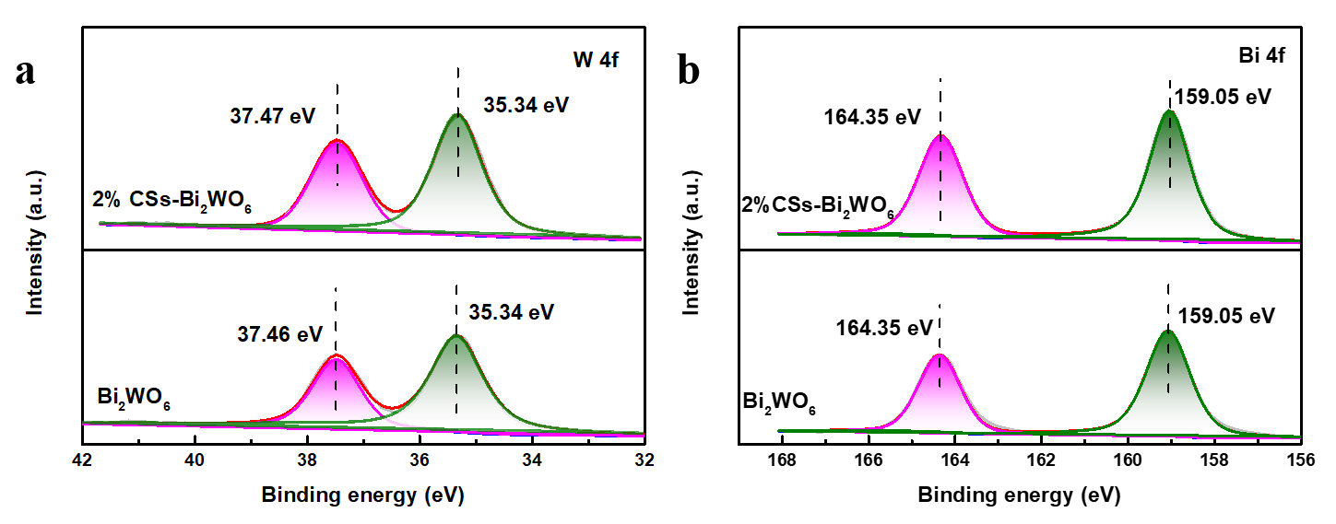
XPS
Fig. S1. XPS of Bi 4 f spectra (a), and W 4 f spectra (b).
The Bi 4 f XPS spectra were shown in Fig. S1a, and the Bi 4 f_{5/2} and Bi 4 f_{7/2} were at the binding energies of 164.42 eV and 159.05 eV (Bi₂WO₆), 164.42 eV and 159.05 eV (2% CSs-Bi₂WO₆), corresponding to Bi³⁺ in the Bi₂WO₆ crystal structure [3]. With the addition of CSs, no apparent change was observed, which revealed that the chemical states of Bi species were not changed.
From Fig. S1b, the W 4 f_{7/2} and W 4 f_{5/2} were at the binding energies of 35.34 eV, 37.46 eV (Bi₂WO₆), and 35.7 eV, 37.9 eV (2% CSs-Bi₂WO₆), respectively. Both values were almost identical and consistent with previous reports [4].

UV–vis DRS
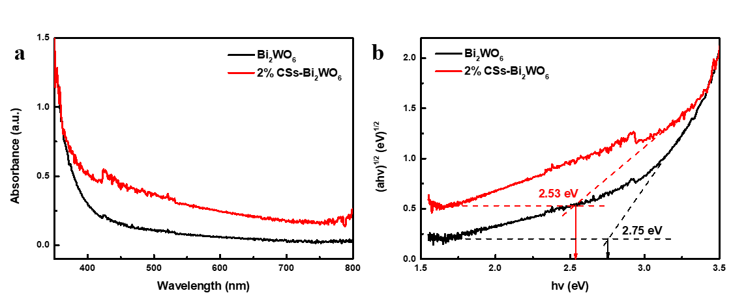
Generally speaking, the level of photocatalytic activity mainly depended on the energy band gap (E g) and the energy level of the oxide semiconductor. The ultraviolet-visible DRS absorption characteristics of pure Bi₂WO₆ and 2% CSs-Bi₂WO₆ were shown in Fig. S2.
Fig. S2 UV-vis absorption spectra of Bi₂WO₆ and 2% CSs-Bi₂WO₆ (a), plot of Kubelka - Munk transformation of Bi₂WO₆ and 2% CSs-Bi₂WO₆ (b).
Fig. S2a showed the comparison of the light absorption characteristics of pure Bi₂WO₆ and 2% CSs-Bi₂WO₆, using UV-Vis DRS. Pure Bi₂WO₆ exhibited a strong absorption response in the ultraviolet region below 430 nm. In addition, it can be seen that the visible-light absorption ability for the samples was improved in the range of 430-800 nm after Bi₂WO₆ was combined with the CSs. Whereas there was no shift of the absorption edge, which suggested that the improvement of photocatalytic performance was not related to CSs. The band gaps energies (E g) were calculated as the following formula [5]:
$$ahv=A(hv-Eg)^{\frac{n}{2}} (3)$$
where A represents a constant, and α, ν, and E g represent the adsorption coefficient, optical frequency, and bandgap, respectively [6]. The value of n depends on the type of electronic transition of a semiconductor (n = 1 for a direct transition, and n = 4 for an indirect transition) [7]. As previous literatures reported, Bi₂WO₆ was indirect band gap semiconductor and their values of n is 4 [8]. In Fig. S2b, the band gaps of the pure Bi₂WO₆ was estimated to be 2.75 eV, respectively, which was consistent with the reported experimental values [9]. And the 2% CSs-Bi₂WO₆ had close band gap values, and the band gap composite was about 2.53 eV.

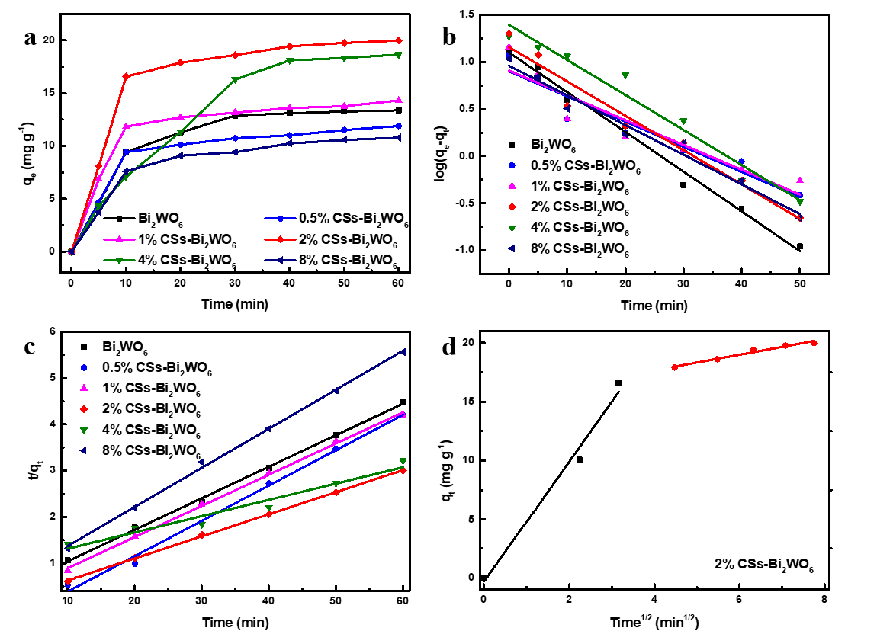
Adsorption kinetics
Fig. S3. Adsorption kinetics (a), pseudo-first-order kinetic plots(b), pseudo-second-order kinetic plots and (c), multilinear plots of intra-particle diffusion process of TC onto 2% CSs-Bi₂WO₆ (d).
Adsorption kinetics is often used to describe the adsorption rate and provide important information for the adsorption mechanism. As shown in Fig. S3a, when the adsorption time reaches 40 min, the catalyst adsorption reached equilibrium. With the increase of CSs, 8% CSs-Bi₂WO₆ showed weaker adsorbability than 2% CSs-Bi₂WO₆, which was mainly due to the agglomeration of excess carbon sphere and the decreased binding between Bi₂WO₆ and CSs. Therefore, 2% CSs-Bi₂WO₆ had the best ratio of Bi₂WO₆ and CSs, which showed the best photocatalytic performance and adsorption ability.
As we all know, the adsorption mechanism depended on the characteristics of adsorbent and mass transport process [10]. In Fig. S3b and Fig. S3c, a couple of adsorption kinetic models were employed to investigate the adsorption mechanism of TC over 2% CSs-Bi₂WO₆ and they were the pseudo-first-order and pseudo-second-order model, which were based on the difference in equilibrium adsorption capacity and adsorbed amount. The pseudo-first-order and pseudo-second-order models were shown in following formula (4) and (5) [11].
$$\text{log}\left(q_{e}-q_{t}\right)=\log{q_{e}}-\frac{k_{1}t}{2.303} (4)$$
$\frac{t}{q_{t}}=\frac{1}{k_{2}q_{e}^{2}}+\frac{t}{q_{e}} (5)$
In these two equations, q_{e} (mg·g⁻¹) means equilibrium adsorption capacity, q_{t} (mg·g⁻¹) the adsorption capacity at t moment, k₁ (min⁻¹) and k₂ (min⁻¹) the rate constant for pseudo-first-order kinetic model and pseudo-second-order kinetic model respectively. The value of R₂ for the pseudo-first-order model was ≤ 0.988 and the pseudo-second-order model was ≥ 0.996. The detailed data were shown in Table 1. Therefore, the adsorption process of 2% CSs-Bi₂WO₆ on TC was more in line with the pseudo-secondary model. Since the pseudo-second-order kinetic model assumes that the rate control step may be chemical adsorption, the adsorption process is mainly chemical adsorption.
Fig. S3d and table S1 display that the weber intraparticle diffusion model was used to study the adsorption process of 50 mg L⁻¹ TC by 2% CSs-Bi₂WO₆. The adsorption process is divided into two stages. The first stage is the slow diffusion of TC from the boundary layer to the adsorbent surface, and the second stage is the diffusion of pollutants into the porous structure of the photocatalyst until equilibrium. The k_{i1} > k_{i2}, indicated that this stage is a gradual.
Table S1. Adsorption kinetic equations and parameters of TC by CS-Bi₂WO₆

Kinetic models | Linear equations | parameters | Bi₂WO₆ | 0.5% CSs-Bi₂WO₆ | 1% CSs- Bi₂WO₆ | 2% CSs- Bi₂WO₆ | 4% CSs- Bi₂WO₆ | 8% CSs- Bi₂WO₆
Pseudo first order | Log(q_{e}-q_{t}) =logq_{e}-k₁t/2.303 | q_{e} (mg g⁻¹) | 13.38 | 11.89 | 14.31 | 18.66 | 19.98 | 10.78
Pseudo first order | Log(q_{e}-q_{t}) =logq_{e}-k₁t/2.303 | k₁(min⁻¹) | -0.042 | -0.027 | -0.026 | -0.037 | -0.036 | -0.0311
Pseudo first order | Log(q_{e}-q_{t}) =logq_{e}-k₁t/2.303 | R² | 0.988 | 0.907 | 0.861 | 0.959 | 0.951 | 0.969
Pseudo second order | t/q_{t}=1/k₂q_{e2}+t/q_{e} | q_{e}(mg g⁻¹) | 4.48 | 4.20 | 4.19 | 3.22 | 3.00 | 5.56
Pseudo second order | t/q_{t}=1/k₂q_{e2}+t/q_{e} | k₂(g mg⁻¹ min⁻¹) | 0.068 | 0.076 | 0.067 | 0.035 | 0.048 | 0.084
Pseudo second order | t/q_{t}=1/k₂q_{e2}+t/q_{e} | R² | 0.998 | 0.997 | 0.998 | 0.996 | 0.999 | 0.997
Pseudo third order | q_{t}=k₁t^{1/2}+c | k₁(g mg⁻¹ min^{1/2}) |  |  |  | 5.11
Pseudo third order | q_{t}=k₁t^{1/2}+c | c₁ |  |  |  | -0.300
Pseudo third order | q_{t}=k₁t^{1/2}+c | R |  |  |  | 0.976
Pseudo third order | q_{t}=k₁t^{1/2}+c | k₂(g mg⁻¹ min^{1/2}) |  |  |  | 0.664
Pseudo third order | q_{t}=k₁t^{1/2}+c | c₂ |  |  |  | 15.01
Pseudo third order | q_{t}=k₁t^{1/2}+c | R |  |  |  | 0.960

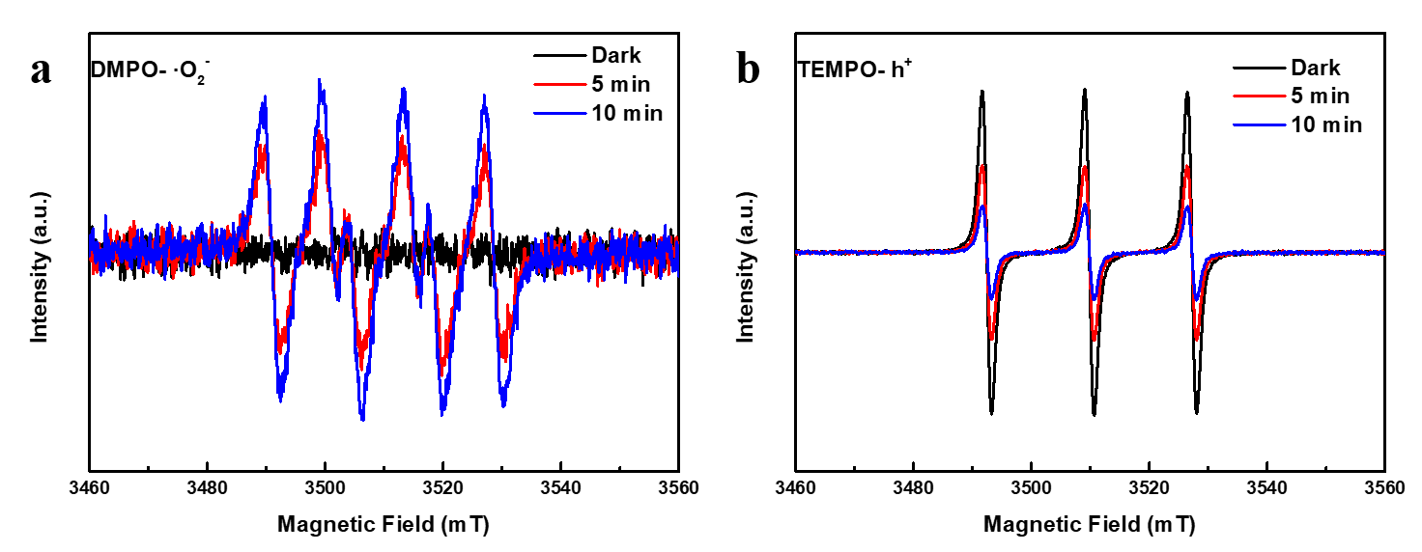
ESR spectrum
Fig. S4. The ESR spectrum of DMPO- ·O₂⁻ (a), and TEMPO- h⁺ (b), under both the dark and visible light irradiation.
In Fig. S4, ESR test identified the role of the active species in the reaction system by DMPO- ‧O₂– and TEMPO- h⁺ [12]. No ESR signal was observed in the absence of light in Fig. S4a. When 2% CSs-Bi₂WO₆ and DMPO were mixed in the presence of light for 5 and 10 min, a set of characteristic peaks attributed to ‧O₂⁻ was found. This indicated that in this catalytic system, ‧O₂⁻ were produced under light conditions. and that the signal intensities of ‧O₂⁻ increased with increasing light exposure time.
In addition, TEMPO- h⁺ tests were also carried out in Fig. S4b. The signal intensities of h⁺ decreased over the course of 5 to 10 min of light compared to dark conditions, indicating the involvement of h⁺ in the photocatalytic reaction. ESR demonstrated the production of large amounts of ‧O₂⁻ and h⁺ active substances during the photocatalytic reaction, in agreement with the results of radical capture experiments.

Table S2 Compared with the work reported in the literature on degradation of organic pollutants by carbon materials
Sample | Sample dose (mg) | Dye | Dye concentration  (mg L^{–1}) | Dye volume (mL) | Degradation rate (%) | Reference
MoS₂/SnO₂/CC | 100 | RhB | 15 | 50 | 95 | [13]
MIL-100(Fe)@Fe₃O₄/CA | 10 | TC | 10 | 50 | 85 | [14]
In₂S₃–8h | 60 | TC | 50 | 200 | 66 | [15]
FeNix-BDC | 100 | MB | 20 | 100 | 100 | [16]
CT-MI4 | 40 | CIP | 15 | 200 | 89 | [17]
CDs-ZnSnO₃ | 25 | TC | 10 | 100 | 82 | [18]
2% CSs-Bi₂WO₆ | 50 | TC | 50 | 100 | 84.6 | This work

References
[1] Li HJ, Miao QS, Chen YL, Yin MY, Qi H, Yang MC, Deng QL, Wang S (2020) Modified carbon spheres as universal materials for adsorption of cationic harmful substances (paraquat and dyes) in water. Micropor Mesopor Mat 297:110040.
https://doi.org/10.1016/j.micromeso.2020.110040
[2] Yang GR, Gao QZ, Yang SY, Yin SH, Cai XY, Yu XY, Zhang SS, Fang YP (2020) Strong adsorption of tetracycline hydrochloride on magnetic carbon-coated cobalt oxide nanoparticles. Chemosphere 239:124831.
https://doi:10.1016/j.chemosphere.2019.124831
[3] Yang F, Zhu XM, Fang JZ, Chen DD, Feng WH, Fang ZQ (2018) One step solvothermal synthesis of Bi/BiPO₄/Bi₂WO₆ heterostructure with oxygen vacancies for enhanced photocatalytic performance. Ceram Int 44:6918-6925.
https://doi.org/10.1016/j.ceramint.2018.01.119
[4] Li ML, Zhang LX, Fan XQ, Zhou YJ, Wu MY, Shi JL (2015) Highly selective CO₂ photoreduction to CO over g-C₃N₄/Bi₂WO₆ composites under visible light. J Mater Chem A 3:5189-5196. https://doi.org/10.1039/C4TA06295G
[5] Wang TY, Liu SX, Mao W, Bai YC, Chiang K, Shah K, Paz-Ferreiro J (2020) Novel Bi₂WO₆ loaded N-biochar composites with enhanced photocatalytic degradation of rhodamine B and Cr(VI). J Hazard Mater 389:121827.
https://doi.org/ 10.1016/j.jhazmat.2019.121827
[6] Chen SQ, Li F, Li TH, Cao W (2019) Loading AgCl@ Ag on phosphotungstic acid modified macrocyclic coordination compound: Z-scheme photocatalyst for persistent pollutant degradation and hydrogen evolution. J Colloid Interface Sci 547:50-59.
https://doi.org/10.1016/j.jcis.2019.03.092
[7] Wang WL, Zhao WL, Zhang HC, Dou XC, Shi HF (2020) 2D/2D step-scheme alpha-Fe₂O₃/Bi₂WO₆ photocatalyst with efficient charge transfer for enhanced photo-Fenton catalytic activity. Chinese J Catal 42:97-106. https://doi.org/10.1063/1.323948
[8] Meng XC, Zhang ZS (2015) Synthesis, analysis, and testing of BiOBr-Bi₂WO₆ photocatalytic heterojunction semiconductors. Int J Photoenergy 4:1-12.
https://doi.org/10.1155/2015/630476
[9] Qiang ZM, Liu XM, Li F, Li TH, Zhang M, Singh H, Huttula M, Cao W (2021) Iodine doped Z-scheme Bi₂O₂CO₃/Bi₂WO₆ photocatalysts: Facile synthesis, efficient visible light photocatalysis, and photocatalytic mechanism. Chem Eng J 403:126327. https://doi.org/10.1016/j.cej.2020.126327
[10] Qi HJ, Shi C, Jiang XN, Teng M, Sun Z, Huang ZH, Pan D, Liu SX, Guo ZH (2020) Constructing CeO₂/nitrogen-doped carbon quantum dot/g-C₃N₄ heterojunction photocatalysts for highly efficient visible light photocatalysis. Nanoscale 12:19112-19120. https://doi.org/10.1039/D0NR02965C
[11] Yin HF, Cao Y, Fan TL, Zhang M, Yao JC, Li PF, Chen SM, Liu XH (2021) In situ synthesis of Ag₃PO₄/C₃N₅ Z-scheme heterojunctions with enhanced visible-light-responsive photocatalytic performance for antibiotics removal. Sci Total Environ 754:141926. https://doi.org/10.1016/j.scitotenv.2020.141926
[12] Xie L, Yang Z, Xiong W, Zhou Y, Cao J, Peng Y, Li X, Zhou C, Xu R, Zhang Y (2019) Bi₂WO₆ nanocuboids: An. efficient visible light active photocatalyst for the degradation of levofloxacin drug in aqueous phase. Chem Eng J 302:194-203. https:/doi.org/10.1016/j.cej.2016.05.010
[13] Jia SL, Xu MZ, Chen SF, Yan JF, Yun JN, Deng ZH, Zhang ZY, Zhao W, Wang YN, Ma XL (2021) A hierarchical sandwich-structured MoS₂/SnO₂/CC heterostructure for high photocatalysis performance. Mater Lett 236: 697-701.
https://doi.org/10.1016/j.matlet.2018.11.026
[14] Rasheed HU, Lv X, Zhang S, Wei W, Ullah N, Xie J (2018) Ternary MIL-100(Fe)@Fe₃O₄/CA magnetic nano-photocatalysts (MNPCs): Magnetically separable and Fenton-like degradation of tetracycline hydrochloride. Adv Powder Technol 29: 3305-3314. http://dx.doi.org/10.1016/j.apt.2018.09.011
[15] Fang Y, Zhu SR, Wu MK, Zhao WN, Han L (2018) MOF-derived In₂S₃ nanorods for photocatalytic removal of dye and antibiotics. J Solid State Chem 266: 205-209. http://dx.doi.org/10.1016/j.jssc.2018.07.026
[16] Wu Q, Siddique M S, Yu W (2021) Iron-nickel bimetallic metal-organic frameworks as bifunctional Fenton-like catalysts for enhanced adsorption and degradation of organic contaminants under visible light: Kinetics and mechanistic studies. J Hazard Mater 401: 123261-123273.
http://dx.doi.org/10.1016/j.jhazmat.2020.123261
[17] Li LL, Zheng XY, Chi YH, Wang Y, Sun X, Yue QY, Gao BY, Xu SP (2019) Molecularly imprinted carbon nanosheets supported TiO₂: Strong selectivity and synergic adsorption-photocatalysis for antibiotics removal. J Hazard Mater 383:121211. https://doi.org/10.1016/j.jhazmat.2019.121211
[18] Guo F, Huang XL, Chen ZH, Sun HR Shi WL (2020). Investigation of visible-light-driven photocatalytic tetracycline degradation via carbon dots modified porous ZnSnO₃ cubes: mechanism and degradation pathway. Sep Purif Technol 117518.
https://doi.org/10.1016/j.seppur.2020.117518

