Table S1. Landsat 8 OLI band characteristics and products used in this study.
Band Number | Wavelength (µm) | Resolution
1 - Coastal aerosol | 0.433–0.453 | 30 m
2 - Blue | 0.450–0.515 | 30 m
3 - Green | 0.525–0.600 | 30 m
4 - Red | 0.630–0.680 | 30 m
5 - Near Infrared (NIR) | 0.845–0.885 | 30 m
6 - SWIR 1 | 1.560–1.660 | 30 m
7 - SWIR 2 | 2.100–2.300 | 30 m
8 - Panchromatic | 0.500–0.680 | 15 m
9 - Cirrus | 1.360–1.390 | 30 m
10 - Thermal Infrared (TIRS) 1 | 10.60-11.19 | 100 m
11 - Thermal Infrared (TIRS) 2 | 11.50-12.51 | 100 m
Year | ProductID
2018 | LC08_L2SP_160035_20180630_20200831_02_T1
2019 | LC08_L2SP_160035_20190703_20200827_02_T1
2020 | LC08_L2SP_160035_20200721_20200911_02_T1
2021 | LC08_L2SP_160035_20210825_20210901_02_T1

Table S2. Sentinel 2A MSI band characteristics and products used in the study.
Band Number | Central Wavelength (nm) | Bandwith  (nm) | Spatial  Resolution(m)
1-Coastal aerosol | 443.9 | 27 | 60
2-Blue | 496.6 | 98 | 10
3-Green | 560.0 | 45 | 10
4-Red | 664.5 | 38 | 10
5-Vegetation Red-edge | 703.9 | 19 | 20
6-Vegetation Red-edge | 740.2 | 18 | 20
7-Vegetation Red-edge | 782.5 | 28 | 20
8-Near infrared (NIR) | 835.1 | 145 | 10
8a-Vegetation Red-edge | 864.8 | 33 | 20
9-Water vapour | 945.0 | 26 | 60
10-Shortwave infrared (SWIR)-cirrus | 1373.5 | 75 | 60
11-Shortwave infrared (SWIR) | 1613.7 | 143 | 20
12-Shortwave infrared (SWIR) | 2202.4 | 242 | 20
Year | ProductID
2019 | S2A_MSIL2A_20190703T064631_  N0212_R020_T40SFF_20190703T112808
2020 | S2A_MSIL2A_20200707T064631_  N0214_R020_T40SFF_20200707T112619
2021 | S2A_MSIL2A_20210831T064631_  N0301_R020_T40SFF_20210831T094435

Table S3. Final environmental variables used in model construction for Cu.
Target soil property | RFE- Used environmental covariates | Training  set | Validation  set | Expert opinion- Used environmental covariates | Training  set | Validation  set
Copper  (Cu) | B2-Landsat | It consists of 47 observations. Each dataset contains 39 environmental variables, along with the target soil property (1 item). | It consists of 21 observations. Each dataset contains 39 environmental variables, along with the target soil property (1 item). | B5-Sentinel  NCI-Landsat  B8-Sentinel  GNDVI-Sentinel  SI-Sentinel  Flow Acc.  PlCu  PrCu  Slope  SPI  TWI  Elevation  Solar Rad.  BIO-15  BIO-12  BIO-1 | It consists of 47 observations. Each dataset contains 16 environmental variables, along with the target soil property (1 item). | It consists of 21 observations. Each dataset contains 16 environmental variables, along with the target soil property (1 item).
Copper  (Cu) | B3-Landsat
Copper  (Cu) | B4-Landsat
Copper  (Cu) | B5-Landsat
Copper  (Cu) | B6-Landsat
Copper  (Cu) | B7-Landsat
Copper  (Cu) | NCI-Landsat
Copper  (Cu) | GNDVI-Landsat
Copper  (Cu) | NDVI-Landsat
Copper  (Cu) | SI-Landsat
Copper  (Cu) | TopSGSI-Landsat
Copper  (Cu) | B2-Sentinel
Copper  (Cu) | B3-Sentinel
Copper  (Cu) | B5-Sentinel
Copper  (Cu) | B6-Sentinel
Copper  (Cu) | B7-Sentinel
Copper  (Cu) | B8-Sentinel
Copper  (Cu) | B8A-Sentinel
Copper  (Cu) | B11-Sentinel
Copper  (Cu) | B12-Sentinel
Copper  (Cu) | NCI-Sentinel
Copper  (Cu) | GNDVI-Sentinel
Copper  (Cu) | MSAVI2-Sentinel
Copper  (Cu) | NDVI-Sentinel
Copper  (Cu) | SI-Sentinel
Copper  (Cu) | TopSGSI-Sentinel
Copper  (Cu) | Flow Acc.
Copper  (Cu) | PlCu
Copper  (Cu) | PrCu
Copper  (Cu) | Slope
Copper  (Cu) | SPI
Copper  (Cu) | TWI
Copper  (Cu) | Elevation
Copper  (Cu) | BIO-15
Copper  (Cu) | BIO-12
Copper  (Cu) | BIO-1
Copper  (Cu) | Clay
Copper  (Cu) | pH
Copper  (Cu) | Sand

RFE----CU---b2_reflectance + b3_reflectance + b4_reflectance + b5_reflectance + b6_reflectance + b7_reflectance + ci_mean_kh + gndvi_mean_kh + ndvi_mean_kh + satind_mean_kh + sgsi_mean_kh + Sen_B02_30m_aoi + Sen_B03_Mean_30m_aoi + Sen_B05_Mean_30m_aoi + Sen_B06_Mean_30m_aoi + Sen_B07_Mean_30m_aoi + Sen_B08_Mean_30m_aoi + Sen_B08A_Mean_30m_aoi + Sen_B11_Mean_30m_aoi + Sen_B12_Mean_30m_aoi + ClayInd_Mean_Sentinel_khavr + GNDVI_Mean_Sentinel_khavr + MSAVI2_Mean_Sentinel_khavr + NDVI_Mean_Sentinel_khavr + Saturation_Mean_Sentinel_khavr + SGSI_Mean_Sentinel_khavr + FlowAcc_kh + PlanCur_kh + ProflCur_kh + slope_kh + spi_kh + Twi_kh + aoi_dem_clip_khavr + bio_15_khavr + bio_12_khavr + bio_1_khavr + Clay_khavr + pH_khavr + Sand_khavr
Expert opinion- CU----b5_reflectance + ci_mean_kh + Sen_B08_Mean_30m_aoi + GNDVI_Mean_Sentinel_khavr + Saturation_Mean_Sentinel_khavr + FlowAcc_kh + PlanCur_kh + ProflCur_kh + slope_kh + spi_kh + Twi_kh + aoi_dem_clip_khavr + srad_khavr + bio_15_khavr + bio_12_khavr + bio_1_khavr

Table S4. Final environmental variables used in model construction for Fe.
Target soil property | RFE- Used environmental covariates | Training  set | Validation  set | Expert opinion- Used environmental covariates | Training  set | Validation  set
Iron  (Fe) | B2-Landsat | It consists of 47 observations. Each dataset contains 40 environmental variables, along with the target soil property (1 item). | It consists of 21 observations. Each dataset contains 40 environmental variables, along with the target soil property (1 item). | B5-Sentinel  NCI-Landsat  B8-Sentinel  GNDVI-Sentinel  SI-Sentinel  Flow Acc.  PlCu  PrCu  Slope  SPI  TWI  Elevation  Solar Rad.  BIO-15  BIO-12  BIO-1 | It consists of 47 observations. Each dataset contains 16 environmental variables, along with the target soil property (1 item). | It consists of 21 observations. Each dataset contains 16 environmental variables, along with the target soil property (1 item).
Iron  (Fe) | B3-Landsat
Iron  (Fe) | B4-Landsat
Iron  (Fe) | B5-Landsat
Iron  (Fe) | B6-Landsat
Iron  (Fe) | B7-Landsat
Iron  (Fe) | NCI-Landsat
Iron  (Fe) | GNDVI-Landsat
Iron  (Fe) | NDVI-Landsat
Iron  (Fe) | SI-Landsat
Iron  (Fe) | TopSGSI-Landsat
Iron  (Fe) | B2-Landsat
Iron  (Fe) | B3-Sentinel
Iron  (Fe) | B4-Sentinel
Iron  (Fe) | B5-Sentinel
Iron  (Fe) | B6-Sentinel
Iron  (Fe) | B7-Sentinel
Iron  (Fe) | B8-Sentinel
Iron  (Fe) | B8A-Sentinel
Iron  (Fe) | B11-Sentinel
Iron  (Fe) | B12-Sentinel
Iron  (Fe) | NCI-Sentinel
Iron  (Fe) | GNDVI-Sentinel
Iron  (Fe) | MSAVI2-Sentinel
Iron  (Fe) | NDVI-Sentinel
Iron  (Fe) | SI-Sentinel
Iron  (Fe) | TopSGSI-Sentinel
Iron  (Fe) | Flow Acc.
Iron  (Fe) | PlCu
Iron  (Fe) | PrCu
Iron  (Fe) | Slope
Iron  (Fe) | SPI
Iron  (Fe) | TWI
Iron  (Fe) | Elevation
Iron  (Fe) | Solar Rad.
Iron  (Fe) | BIO-15
Iron  (Fe) | BIO-12
Iron  (Fe) | BIO-1
Iron  (Fe) | Clay
Iron  (Fe) | pH

RFE----FE---b2_reflectance + b3_reflectance + b4_reflectance + b5_reflectance + b6_reflectance + b7_reflectance + ci_mean_kh + gndvi_mean_kh + ndvi_mean_kh + satind_mean_kh + sgsi_mean_kh + Sen_B02_30m_aoi + Sen_B03_Mean_30m_aoi + Sen_B04_Mean_30m_aoi + Sen_B05_Mean_30m_aoi + Sen_B06_Mean_30m_aoi + Sen_B07_Mean_30m_aoi + Sen_B08_Mean_30m_aoi + Sen_B11_Mean_30m_aoi + Sen_B12_Mean_30m_aoi + ClayInd_Mean_Sentinel_khavr + GNDVI_Mean_Sentinel_khavr + MSAVI2_Mean_Sentinel_khavr + NDVI_Mean_Sentinel_khavr + Saturation_Mean_Sentinel_khavr + SGSI_Mean_Sentinel_khavr + FlowAcc_kh + PlanCur_kh + ProflCur_kh + slope_kh + spi_kh + Twi_kh + aoi_dem_clip_khavr + srad_khavr + bio_15_khavr + bio_12_khavr + bio_1_khavr + Clay_khavr + pH_khavr
Expert opinion- FE----b5_reflectance + ci_mean_kh + Sen_B08_Mean_30m_aoi + GNDVI_Mean_Sentinel_khavr + Saturation_Mean_Sentinel_khavr + FlowAcc_kh + PlanCur_kh + ProflCur_kh + slope_kh + spi_kh + Twi_kh + aoi_dem_clip_khavr + srad_khavr + bio_15_khavr + bio_12_khavr + bio_1_khavr

Table S5. Final environmental variables used in model construction for Mn.
Target soil property | RFE- Used environmental covariates | Training  set | Validation  set | Expert opinion- Used environmental covariates | Training  set | Validation  set
Manganese  (Mn) | B6-Landsat | It consists of 47 observations. Each dataset contains 9 environmental variables, along with the target soil property (1 item). | It consists of 21 observations. Each dataset contains 9 environmental variables, along with the target soil property (1 item). | B2-Sentinel  B5-Sentinel  NCI-Landsat  B8-Sentinel  GNDVI-Sentinel  SI-Sentinel  Flow Acc.  PlCu  PrCu  Slope  SPI  TWI  Elevation  Solar Rad.  BIO-15  BIO-12  BIO-1 | It consists of 47 observations. Each dataset contains 17 environmental variables, along with the target soil property (1 item). | It consists of 21 observations. Each dataset contains 17 environmental variables, along with the target soil property (1 item).
Manganese  (Mn) | NCI-Landsat
Manganese  (Mn) | NDVI-Landsat
Manganese  (Mn) | TopSGSI-Landsat
Manganese  (Mn) | B2-Landsat
Manganese  (Mn) | B8-Sentinel
Manganese  (Mn) | B12-Sentinel
Manganese  (Mn) | GNDVI-Sentinel
Manganese  (Mn) | pH

RFE----MN----b6_reflectance + ci_mean_kh + ndvi_mean_kh + sgsi_mean_kh + Twi_kh + Sen_B02_30m_aoi + Sen_B08_Mean_30m_aoi + Sen_B12_Mean_30m_aoi + GNDVI_Mean_Sentinel_khavr + pH_khavr

Expert opinion- MN--- b2_reflectance + b5_reflectance + ci_mean_kh + Sen_B08_Mean_30m_aoi + GNDVI_Mean_Sentinel_khavr + Saturation_Mean_Sentinel_khavr + FlowAcc_kh + PlanCur_kh + ProflCur_kh + slope_kh + spi_kh + Twi_kh + aoi_dem_clip_khavr + srad_khavr + bio_15_khavr + bio_12_khavr + bio_1_khavr

Table S6. Final environmental variables used in model construction for Zn.
Target soil property | RFE- Used environmental covariates | Training  set | Validation  set | Expert opinion- Used environmental covariates | Training  set | Validation  set
Zinc  (Zn) | Clay | It consists of 47 observations. Each dataset contains 2 environmental variables, along with the target soil property (1 item). | It consists of 21 observations. Each dataset contains 2 environmental variables, along with the target soil property (1 item). | B2-Sentinel  B5-Sentinel  NCI-Landsat  B8-Sentinel  GNDVI-Sentinel  SI-Sentinel  Flow Acc.  PlCu  PrCu  Slope  SPI  TWI  Elevation  Solar Rad.  BIO-15  BIO-12  BIO-1 | It consists of 47 observations. Each dataset contains 17 environmental variables, along with the target soil property (1 item). | It consists of 21 observations. Each dataset contains 17 environmental variables, along with the target soil property (1 item).
Zinc  (Zn) | Sand

RFE----ZN----Clay_khavr + Sand_khavr
Expert opinion- ZN--- b5_reflectance + ci_mean_kh + Sen_B08_Mean_30m_aoi + GNDVI_Mean_Sentinel_khavr + Saturation_Mean_Sentinel_khavr + FlowAcc_kh + PlanCur_kh + ProflCur_kh + slope_kh + spi_kh + Twi_kh + aoi_dem_clip_khavr + srad_khavr + bio_15_khavr + bio_12_khavr + bio_1_khavr

Variables abbreviations.
Normalized difference vegetation index (NDVI)
Normalized clay index (NCI)
Green Normalized Difference Vegetation Index [GNDVI)
Saturation index (SI)
Topsoil grain size index (TopSGSI)
Modified Soil Adjusted Vegetation Index (MSAVI2)
Topographic wetness index (TWI)
Stream Power Index (SPI)
Planform Curvature (PlCu)
Profile Curvature (PrCu)
BIO-1- Mean Annual Temperature (MAT) (°C)
BIO-12-Annual Precipitation (mm)
BIO-15- Precipitation Seasonality (CV)

Table S7. Confusion matrix results of land use classification using the random forest algorithm.
 | Training |  |  |  |  |  |  |  | Validation
 | Observed
 | Corine  Land  Cover  Class | Arable land¹ | Artificial Surfaces | Permanent crops | Water bodies | Sum | Users Accuracy | Corine  Land Cover Class |  | Arable land | Artificial Surfaces | Permanent crops | Water bodies | Sum | Users Accuracy
Predicted | Arable land | 316 | 0 | 0 | 0 | 316 | 100 | Arable land |  | 139 | 10 | 2 | 2 | 153 | 91
Predicted | Artificial Surfaces | 0 | 105 | 0 | 0 | 105 | 100 | Artificial Surfaces |  | 3 | 34 | 0 | 0 | 37 | 92
Predicted | Permanent crops | 0 | 0 | 453 | 0 | 453 | 100 | Permanent crops |  | 2 | 0 | 177 | 5 | 184 | 97
Predicted | Water bodies | 0 | 0 | 0 | 52 | 52 | 100 | Water bodies |  | 1 | 2 | 2 | 18 | 23 | 79
 | Sum | 316 | 105 | 453 | 52 | 926 |  | Sum |  | 145 | 46 | 181 | 25 | 397
 | Producers Accuracy | 100 | 100 | 100 | 100 |  | Acc:100%- Kappa:1.00 | Producers Accuracy |  | 96 | 74 | 98 | 72 |  | Acc:93%- Kappa:0.8846
^{[1]} The class refers to the land use types defined in Figure 4. Abbreviation. Acc.: Accuracy

Table S8. Random forest classification and model accuracy criteria in LOOCV (Leave-One-Out Cross-Validation) procedure for a given mtry value.
 | LOOCV-Classification
Variable | mtry | Accuracy | Kappa
Corine Land Cover Class | 2 | 0.9170 | 0.8668
Corine Land Cover Class | 4 | 0.9183 | 0.8690
Corine Land Cover Class | 6 | 0.9143 | 0.8626

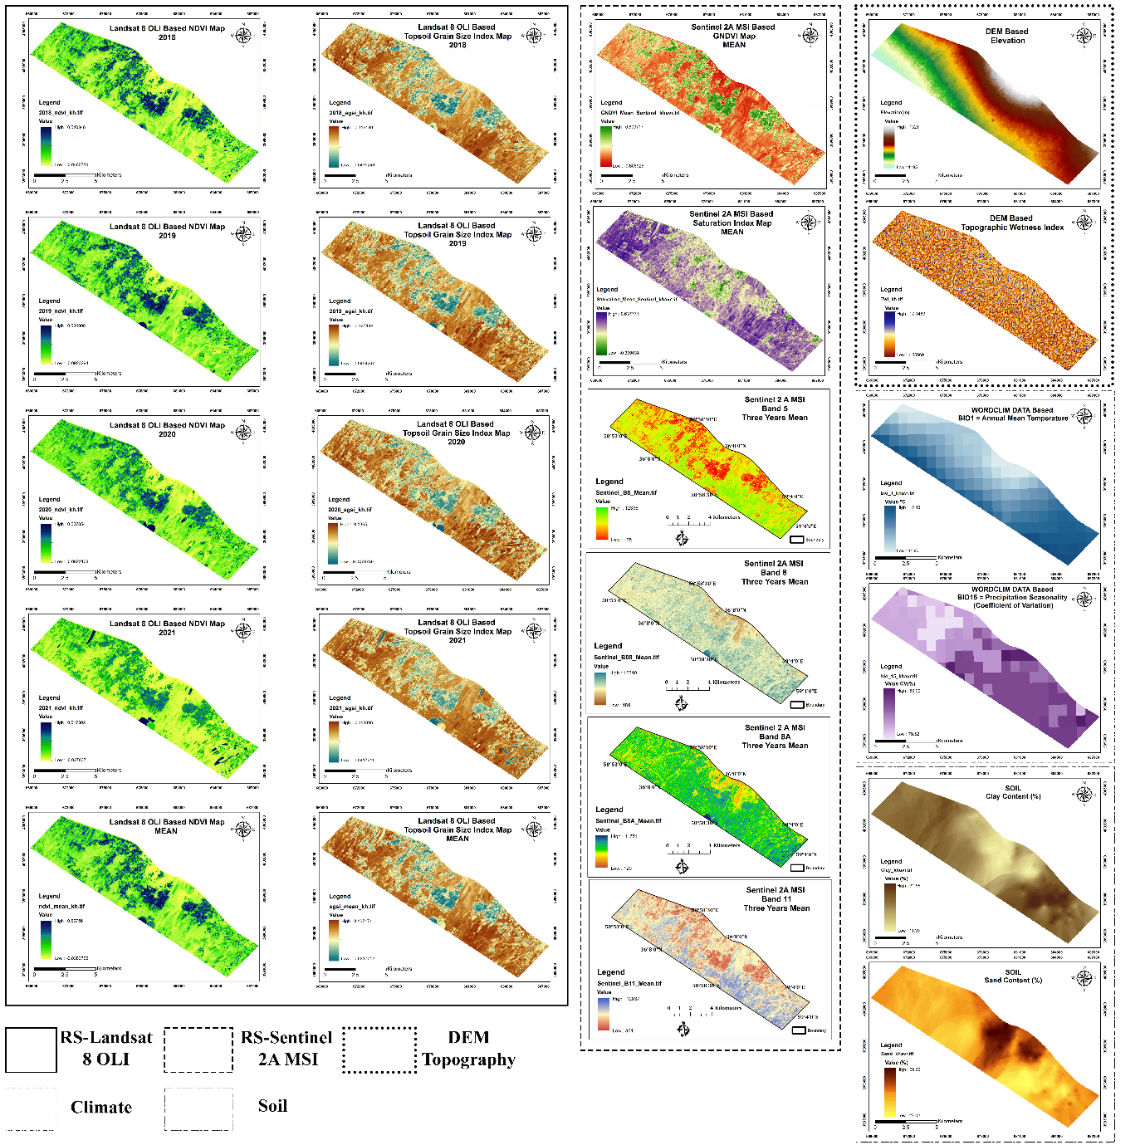
Figure S1. Some covariates used in the study.

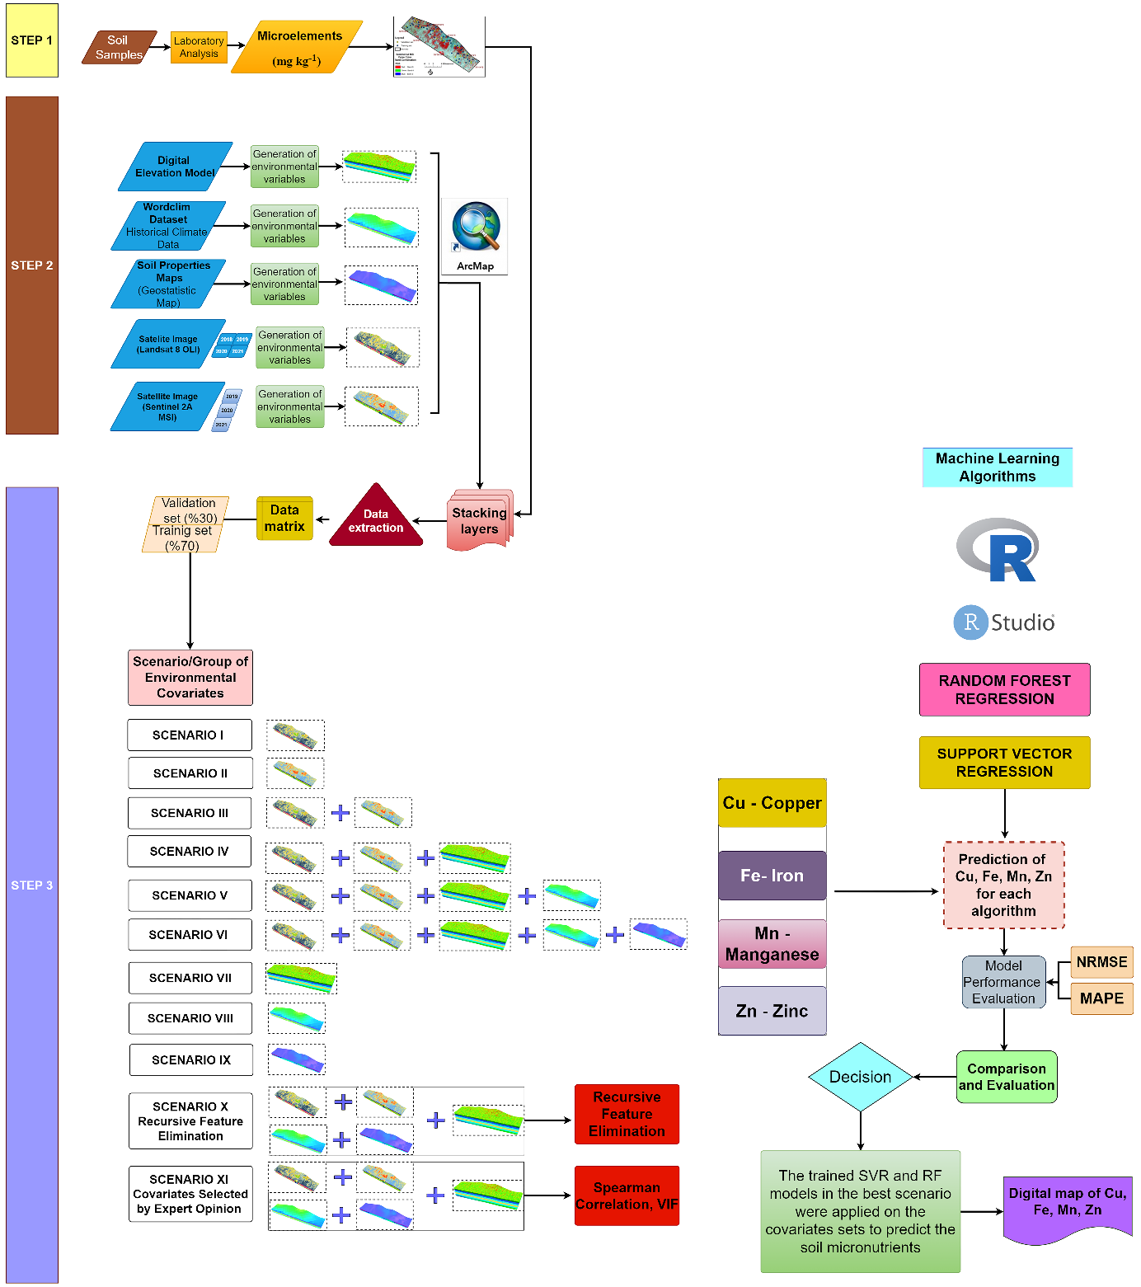
Figure S2. Grouping of the environmental variables to constitute the scenarios (I: RS-Landsat 8 OLI, II: RS-Sentinel 24 MSI, III: RS(All), IV: RS (All) + Topographic, V: RS (All) + Topographic+ Climate, VI: RS (All) + Topographic+ Climate + Soil, VII: Topographic, VIII: Climate, IX: Soil, X: Recursive Feature Elimination, XI: Covariates selection by expert opinion), and the modelling process workflow.

Figure S3. Distribution of the micronutrients of the samples for the training and validation datasets; a: Iron (Fe), b: Manganese (Mn), c: Copper (Cu), d: Zinc (Zn).

Figure S4. Land use types predicted by the random forest model.
Figure S5. Importance levels of the environmental variables used to predict the content of the soil micronutrients using the random forest algorithms: a) and b) copper, c) and d) iron, e) and f) manganese, g) and h) zinc.

Figure S6. Importance levels of the environmental variables used to predict the content of the soil micronutrients using the support vector regression algorithms: a) copper, b) iron, c) manganese, and d) zinc.

