In silico investigation of a series of D-A-D structured chain thiophene photosensitizers for photodynamic therapy
Zheng-Kun Qin,ª Xu-Hui Liu,ª Hai-Han Zhang,ª Xin Pu,^{b} Ye Ji,ª Jia-Yu Yang,ª Xi-Lian Guo,ª Jia Wang,ª Ming-Xing Song,ª* Fu-Quan Bai,^{b}**
ª College of Information Technology, Jilin Normal University, Siping 136000, People’s Republic of China.
^{b} International Joint Research Laboratory of Nano-Micro Architecture, Chemistry, Laboratory of Theoretical and Computational Chemistry, Institute of Theoretical Chemistry, Jilin University, Changchun, 130023, People's Republic of China
*Correspondence author: Ming-Xing Song (E-mail: mxsong@jlnu.edu.cn) Tel.: +86-434-3292050; Fax: +86-434-3292050.
** Also for correspondence: Fu-Quan Bai (E-mail: baifq@jlu.edu.cn)

Table of contents | Page no
Fig. S1 The obtained electron and hole diagrams for the work from (hcb)₂TD to (ppx)₂TDH in T₁ state | S3-S6
Fig. S2 The obtained electron and hole diagrams for the work from (hcb)2TD to (ppt)₂TDH in T₃ state | S7-S9
Table S1 Bond parameters of all the researched molecules in water solution | S10
Table S2 The lowest Vertical Singlet Excitation Energies (ΔE), Oscillator Strengths (f), Main Transitions, and Molecular Orbital Contribution (%) for all the Studied Complexes, Calculated in Water Solvent | S11
Table S3 The triple excited state energies and properties of (hcb)2TD to (ppx)₂TDH PSs | S12
Table S4 The holes and electrons contribution more than 1% of the orbital output | S13-S14
Table S5 Molecular coordinates after geometric coordinate optimization | S15-S43

Fig. S1 The obtained electron and hole diagrams for the work from (hcb)₂TD to (ppx)₂TDH in T₁ state. (Green represents the electron distribution and blue represents the hole distribution)

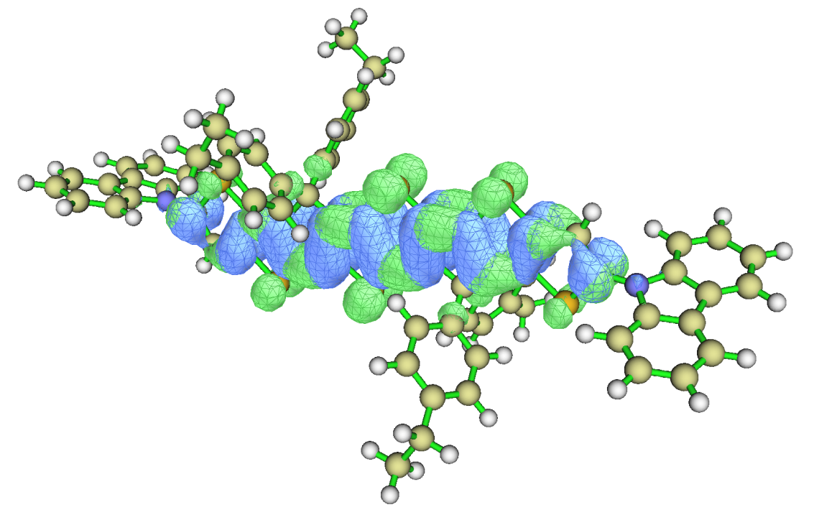
(hcb)₂TDH
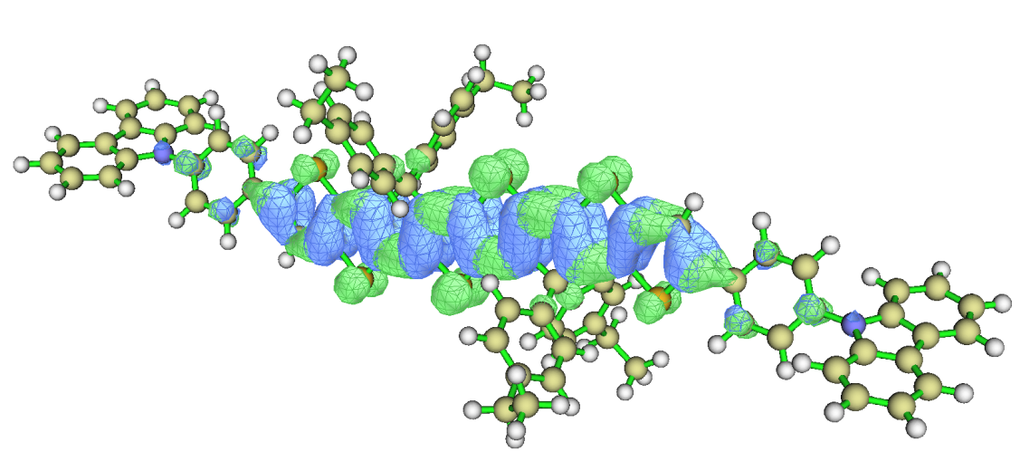
(npc)₂TDH
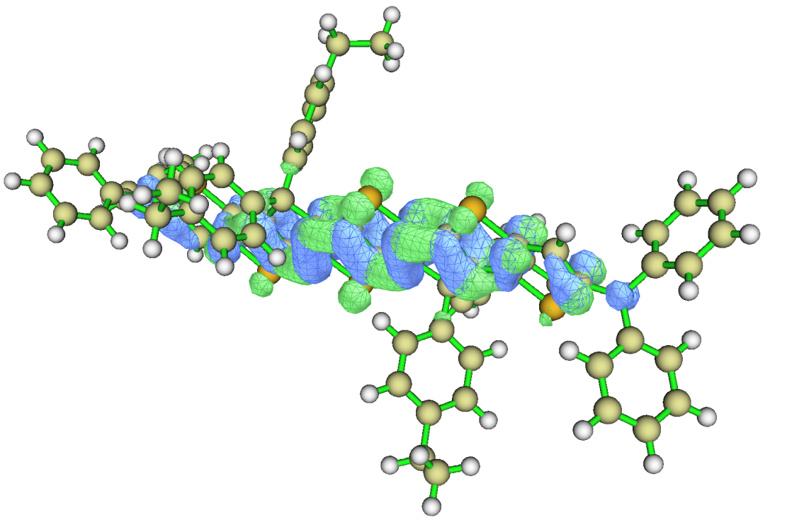
(dpl)₂TDH
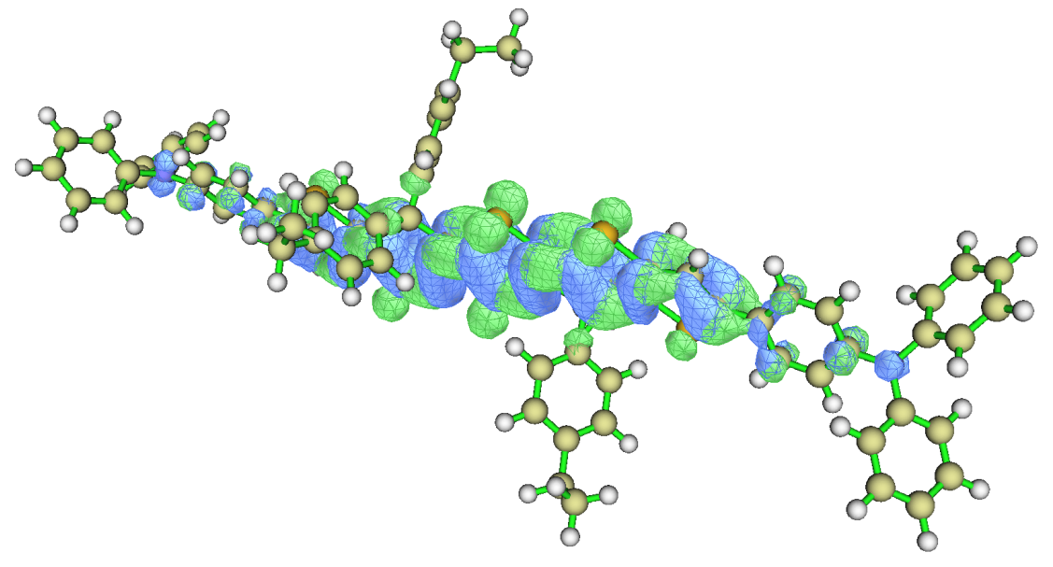
(ndipl)₂TDH

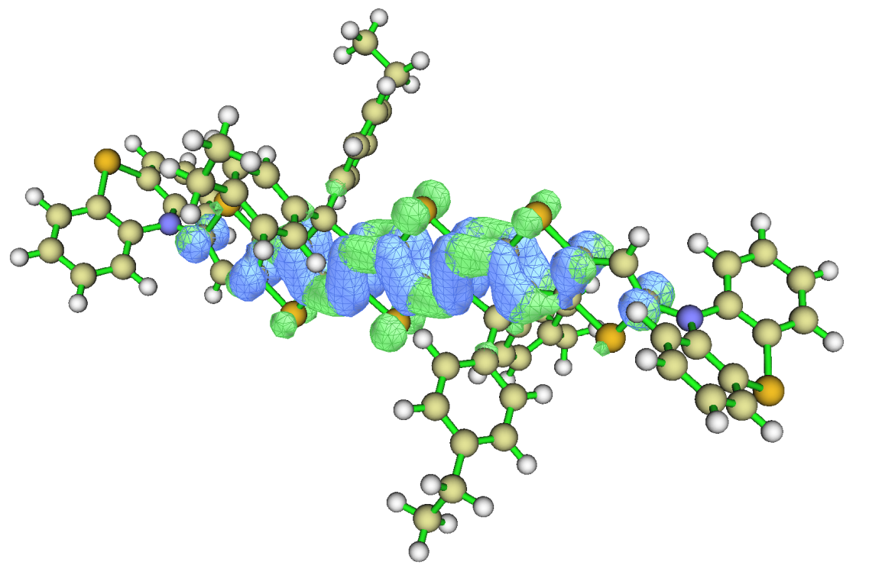
(pt)₂TDH
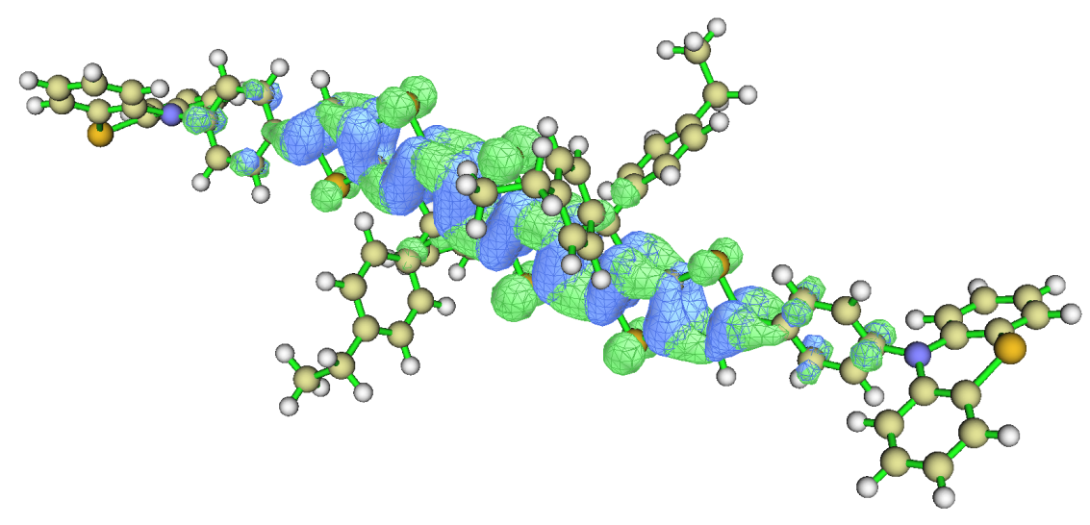
(ppt)₂TDH
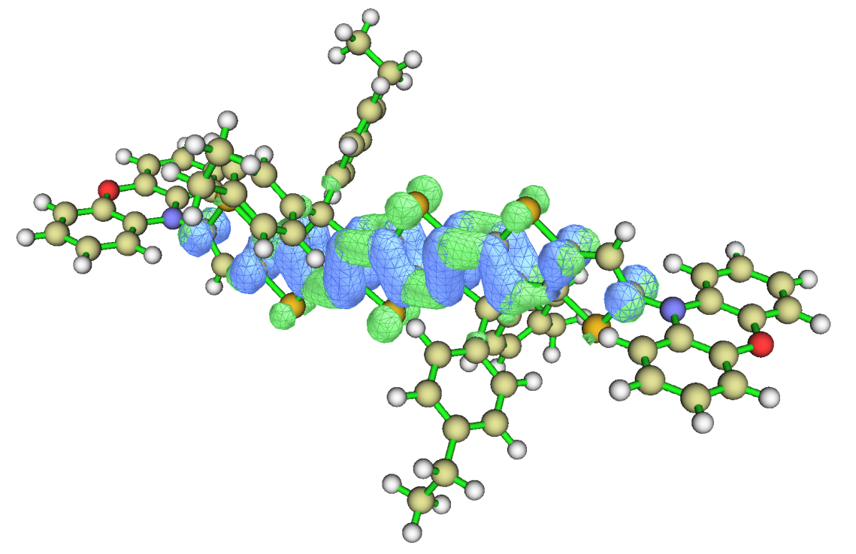
(px)₂TDH
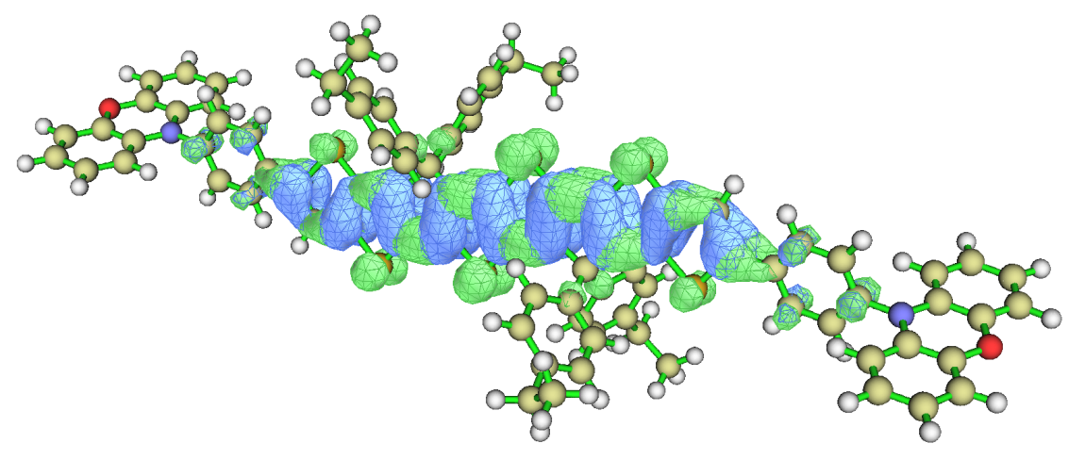
(ppx)₂TDH

Fig. S2 The obtained electron and hole diagrams for the work from (hcb)₂TD to (ppt)₂TDH in T₃ state (Green represents the electron distribution and blue represents the hole distribution)

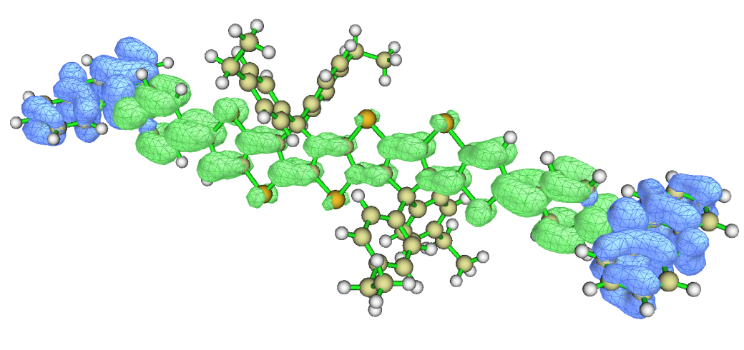
(hcb)₂TDH

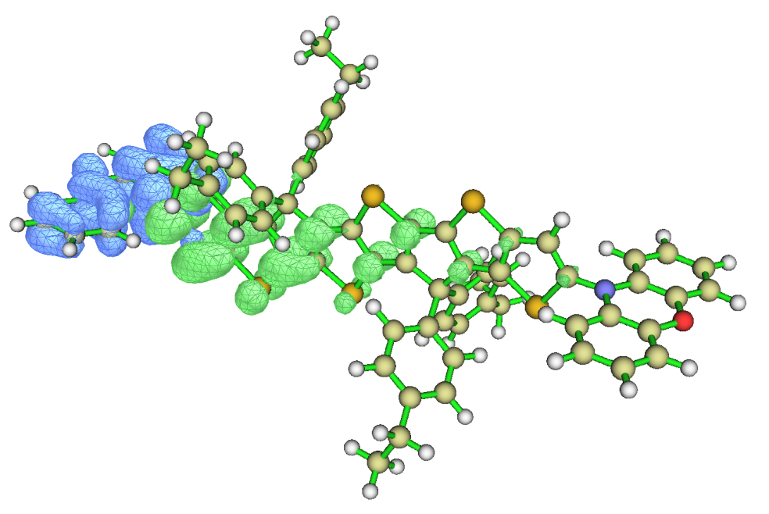
(npc)₂TDH
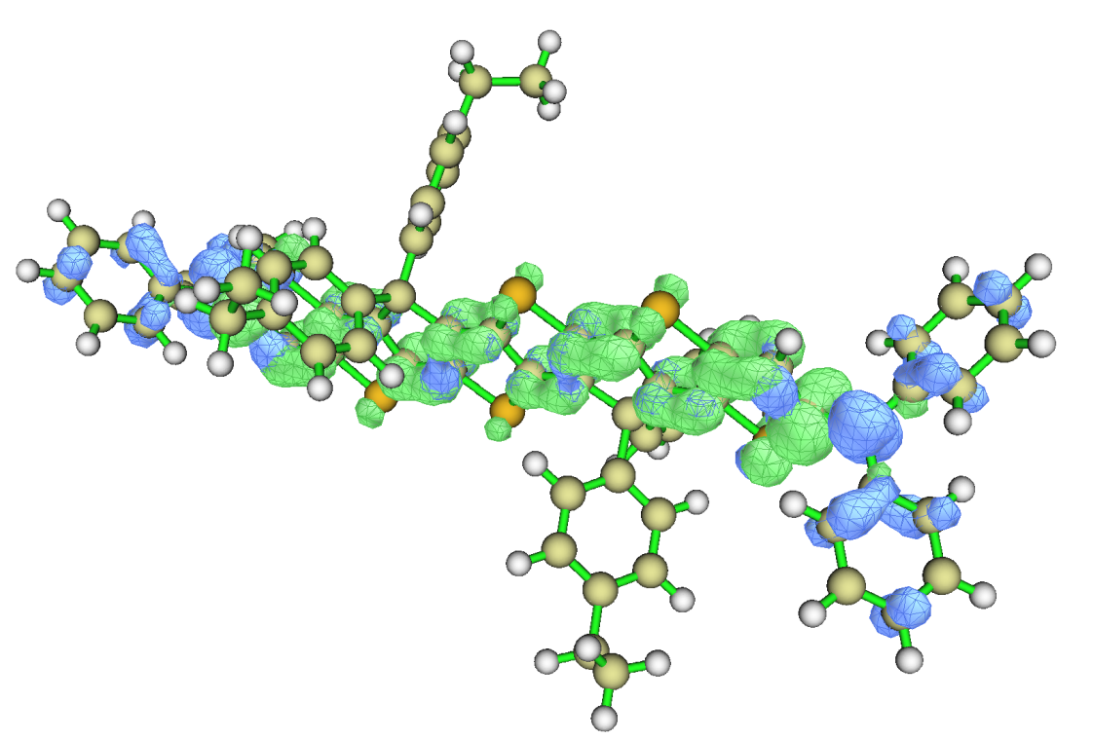
(dpl)₂TDH
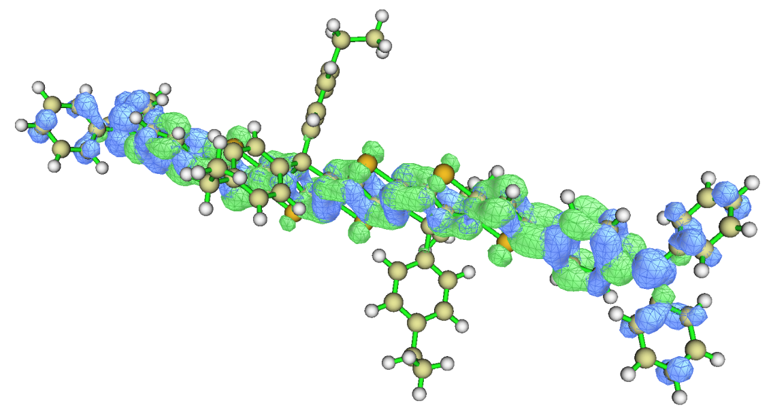
(ndipl)₂TDH
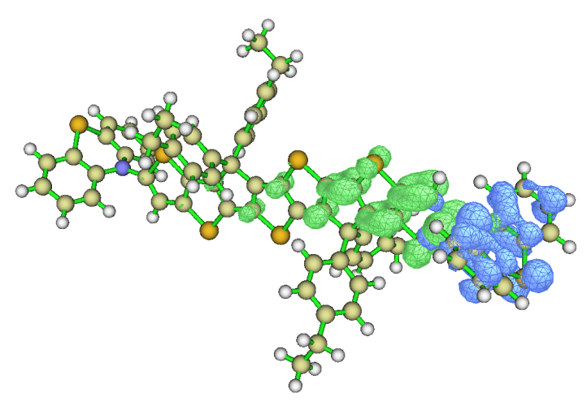
(pt)₂TDH
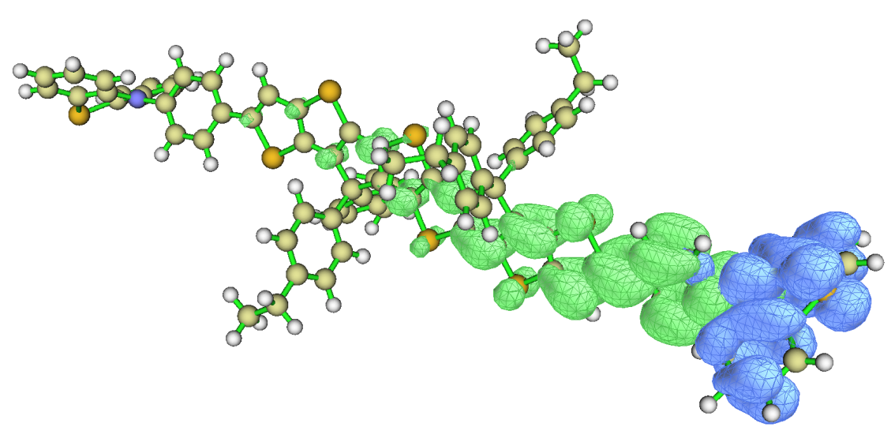
(ppt)₂TDH

Table S1 Bond parameters of all the researched molecules in water solution
Molecules | Bond length  A₁(Å) | Bond length  A₂ (Å) | Dihedral Angle  θ₁(°) | Dihedral Angle  θ₂ (°)
(hcb)₂TDH | 1.387 |  | -65.2/-64.3
(npc)₂TDH | 1.454 | 1.415 | -20.5/21.4 | 51.9/51.8
(dpl)₂TDH | 1.391 |  | -58.1/-58.2
(ndipl)₂TDH | 1.452 | 1.415/1.416 | 20.9/-21.8 | -37.2/-38.0
(pt)₂TDH | 1.399 |  | 86.3/86.5
(ppt)₂TDH | 1.454 | 1.436 | 18.4/18.9 | -83.9/-83.4
(px)₂TDH | 1.389 |  | -87.2/-86.5
(ppx)₂TDH | 1.454 | 1.428/1.419 | 22.3/-20.5 | -80.0/86.7
The bond length between the substituted linker and the attached acceptor part is A₁ and the dihedral angle is θ₁° The bond length between the original substituent and the benzene ring at the addition of the benzene ring is A₂ and the dihedral angle is θ₂°

Table S2 The lowest Vertical Singlet Excitation Energies (ΔE), Oscillator Strengths (f), Main Transitions, and Molecular Orbital Contribution (%) for all the Studied Complexes calculated in Water Solvent condition
Molecules | Excitation energy  (eV) | Wavelength  (nm) | f | Main  configuration
(hcb)₂TDH | 2.393 eV | 518.1 nm | f=1.7796 | H→L(69%)
(npc)₂TDH | 2.211 eV | 560.7 nm | f=2.5231 | H→L(69%)
(dpl)₂TDH | 2.253 eV | 550.1 nm | f=1.8527 | H→L(69%)
(ndipl)₂TDH | 2.136 eV | 580.3 nm | f=2.7058 | H→L(68%)
(pt)₂TDH | 2.148 eV | 577.0 nm | f=1.7698 | H→L(70%)
(ppt)₂TDH | 2.235 eV | 554.7 nm | f=2.3616 | H→ L(69%)
(px)₂TDH | 2.444 eV | 507.3 nm | f=1.6830 | H→L(70%)
(ppx)₂TDH | 2.235 eV | 554.5 nm | f=2.3310 | H→L(63%)
H = HOMO L = LUMO

Table S3 The triple excited state energies and properties of (hcb)₂TD to (ppx)₂TDH PSs
Molecules | States | Excitation energy  (eV) | λ (nm) | Main configuration
(hcb)₂TDH | T₁ | 1.569 eV | 790.1 nm | H→L(71%)
(hcb)₂TDH | T₂ | 2.395 eV | 517.4 nm | H-1→L(69%)
(hcb)₂TDH | T₃ | 2.641 eV | 469.4 nm | H-2→L(70%)
(npc)₂TDH | T₁ | 1.400 eV | 885.6 nm | H→L(71%)
(npc)₂TDH | T₂ | 2.134 eV | 579.8 nm | H-1→L(54%)
(npc)₂TDH | T₃ | 2.416 eV | 513.0 nm | H→L+1(49%)
(dpl)₂TDH | T₁ | 1.455 eV | 851.9 nm | H→L(71%)
(dpl)₂TDH | T₂ | 2.197 eV | 564.1 nm | H-1→L(64%)
(dpl)₂TDH | T₃ | 2.558 eV | 484.5 nm | H-1→L+1(61%)
(ndipl)₂TDH | T₁ | 1.338 eV | 926.3 nm | H→L(70%)
(ndipl)₂TDH | T₂ | 1.969 eV | 629.4 nm | H-1→L(64%)
(ndipl)₂TDH | T₃ | 2.287 eV | 542.0 nm | H-2→L(69%)
(pt)₂TDH | T₁ | 1.615 eV | 767.9 nm | H→L(71%)
(pt)₂TDH | T₂ | 2.250 eV | 550.9 nm | H-1→L(70%)
(pt)₂TDH | T₃ | 2.250 eV | 550.8 nm | H-2→L(70%)
(ppt)₂TDH | T₁ | 1.431 eV | 866.2 nm | H→L(71%)
(ppt)₂TDH | T₂ | 2.050 eV | 654.9 nm | H-1→L(70%)
(ppt)₂TDH | T₃ | 2.050 eV | 657.7 nm | H-2→L(69%)
(px)₂TDH | T₁ | 1.617 eV | 766.5 nm | H→L(71%)
(px)₂TDH | T₂ | 1.881 eV | 658.9 nm | H-1→L(69%)
(px)₂TDH | T₃ | 1.882 eV | 658.7 nm | H-2→L(69%)
(ppx)₂TDH | T₁ | 1.431 eV | 866.2 nm | H→L(71%)
(ppx)₂TDH | T₂ | 1.679 eV | 738.2 nm | H-1→L(70%)
(ppx)₂TDH | T₃ | 1.680 eV | 737.9 nm | H-2→L(69%)

Table S4 The holes and electrons contribution more than 1% of the orbital output
Molecules | States | Tracks |  | Excitation
(hcb)₂TDH | T₁ | HOMO | Hole:93.034 % | LE
(hcb)₂TDH | T₁ | LUMO | Electron:93.172 % | LE
(hcb)₂TDH | T₃ | HOMO | Hole:93.529 % | LE
(hcb)₂TDH | T₃ | LUMO | Electron:93.352 % | LE
(npc)₂TDH | T₁ | HOMO | Hole:89.828 % | LE
(npc)₂TDH | T₁ | LUMO | Electron:90.118 % | LE
(npc)₂TDH | T₃ | HOMO-1 | Hole:41.309 % | LE
(npc)₂TDH | T₃ | HOMO | Hole:32.170 % | LE
(npc)₂TDH | T₃ | LUMO | Electron:52.471 % | LE
(npc)₂TDH | T₃ | LUMO+1 | Electron:39.088 % | LE
(dpl)₂TDH | T₁ | HOMO | Hole:89.845 % | LE
(dpl)₂TDH | T₁ | LUMO | Electron:91.418 % | LE
(dpl)₂TDH | T₃ | HOMO-1 | Hole:57.184 % | LE
(dpl)₂TDH | T₃ | HOMO | Hole:24.983 % | LE
(dpl)₂TDH | T₃ | LUMO | Electron:56.439 % | LE
(dpl)₂TDH | T₃ | LUMO+1 | Electron:24.931 % | LE
(ndipl)₂TDH | T₁ | HOMO | Hole:86.527 % | LE
(ndipl)₂TDH | T₁ | LUMO | Electron:89.266 % | LE
(ndipl)₂TDH | T₃ | HOMO-1 | Hole:42.267 % | LE
(ndipl)₂TDH | T₃ | HOMO | Hole:30.425 % | LE
(ndipl)₂TDH | T₃ | LUMO | Electron:42.089 | LE
(ndipl)₂TDH | T₃ | LUMO+1 | Electron:27.663 % | LE
(pt)₂TDH | T₁ | HOMO | Hole:93.526 % | LE
(pt)₂TDH | T₁ | LUMO | Electron:93.306 % | LE
(pt)₂TDH | T₃ | HOMO-1 | Hole:92.526 % | CT
(pt)₂TDH | T₃ | LUMO | Electron:63.185 % | CT
(pt)₂TDH | T₃ | LUMO+1 | Electron:23.423 % | CT
(ppt)₂TDH | T₁ | HOMO | Hole:91.48 % | LE
(ppt)₂TDH | T₁ | LUMO | Electron:90.543 % | LE
(ppt)₂TDH | T₃ | HOMO-1 | Hole:96.263 % | CT
(ppt)₂TDH | T₃ | LUMO | Electron:52.805 % | CT
(ppt)₂TDH | T₃ | LUMO+1 | Electron:26.964 % | CT
(px)₂TDH | T₁ | HOMO | Hole:93.529 % | LE
(px)₂TDH | T₁ | LUMO | Electron:93.352 % | LE
(px)₂TDH | T₃ | HOMO-2 | Hole:96.595 % | CT
(px)₂TDH | T₃ | LUMO | Electron:67.431 % | CT
(px)₂TDH | T₃ | LUMO+1 | Electron:22.276 % | CT
(ppx)₂TDH | T₁ | HOMO | Hole:91.329 % | LE
(ppx)₂TDH | T₁ | LUMO | Electron:90.608 % | LE
(ppx)₂TDH | T₃ | HOMO-1 | Hole:43.441 % | CT+LE
(ppx)₂TDH | T₃ | HOMO | Hole:54.371 % | CT+LE
(ppx)₂TDH | T₃ | LUMO | Electron:54.862 % | CT+LE
(ppx)₂TDH | T₃ | LUMO+1 | Electron:26.922 % | CT+LE

Table S5 Molecular coordinates after geometric coordinate optimization
Molecules | geometric coordinate
(hcb)₂TDH | C 8.01159500 0.01837400 1.06360700  C 5.51797700 0.02919100 0.59084900  C 7.26131900 0.09936700 2.20409200  C 5.87206500 0.11622700 1.93419000  C 3.40093100 0.10176000 1.53036900  C 4.12885400 0.01742600 0.35671900  C 3.20123300 -0.06477500 -0.85357100  C 1.84512800 -0.01809400 -0.15042900  C 2.00554700 0.08940700 1.22108600  C 0.49083400 -0.03444000 -0.52561300  C -0.40616500 0.05976600 0.54438500  C -1.91871000 -0.15711800 -1.19488300  C -1.76033300 -0.00826100 0.17299100  C -3.11814300 0.06636900 0.87065200  C -4.04399900 -0.07917000 -0.33581900  C -3.31281000 -0.21037400 -1.50315500  C -5.78140700 -0.28363900 -1.91005600  C -5.43255900 -0.11716100 -0.57283300  C -7.16916800 -0.35684900 -2.17774800  C -7.92478700 -0.22609100 -1.04549900  C 3.04181900 -3.75716400 -1.88551600  C 4.08645900 -3.85462400 -2.80978500  C 4.81390400 -2.69676900 -3.10992100  C 4.50766100 -1.48118600 -2.50509100  C 3.45994500 -1.38857700 -1.57906800  C 2.73289200 -2.54340900 -1.27371000  H 2.46262400 -4.64649200 -1.64170700  H 5.63093800 -2.75228800 -3.82764300  H 5.07900500 -0.59125100 -2.76224200  H 1.92214600 -2.49537500 -0.55062400  C 3.34746200 3.43316800 -3.44762700  C 3.91421800 3.46951300 -2.17018200  C 3.89611300 2.34842700 -1.34205700  C 3.31032500 1.15487800 -1.77484000  C 2.73741300 1.11473800 -3.05328000  C 2.75573800 2.23821600 -3.87431500  H 4.37999400 4.38964500 -1.82080500  H 4.34278900 2.40374700 -0.35235700  H 2.28971400 0.19062300 -3.41458900  H 2.30733800 2.19036500 -4.86545200  C -3.37335000 -1.10270400 1.82601700  C -2.62318300 -2.27790200 1.76874000  C -2.92734600 -3.36135200 2.59649000  C -3.99173100 -3.30286600 3.49862400  C -4.74535300 -2.12017900 3.54740300  C -4.44427900 -1.03833200 2.73011100  H -1.79225200 -2.35463100 1.07146200  H -2.31879200 -4.25905600 2.53005900  H -5.58089400 -2.05252600 4.24257000  H -5.03573900 -0.12742800 2.80129400  C -2.67568400 1.62203700 2.82620600  C -3.23618800 1.43174300 1.55606100  C -3.81575500 2.52758200 0.90946900  C -3.83882400 3.77967200 1.52158500  C -3.27974600 3.97494300 2.78800000  C -2.69851700 2.87534200 3.43078100  H -2.23056800 0.77813600 3.35029700  H -4.24930800 2.40417900 -0.07996900  H -4.29861600 4.62224200 1.00741000  H -2.25858600 3.00719100 4.41809800  C -11.46636100 -0.67146500 -0.34876200  C -10.11963000 -1.09034500 -0.24289600  C -9.75089600 -2.23781300 0.45221500  C -10.76787700 -2.97170700 1.06022300  C -12.11065200 -2.57159200 0.97152700  C -12.46738600 -1.42446900 0.26726300  C -11.47641700 0.53931200 -1.14533400  C -10.13516600 0.82074700 -1.49441400  C -9.78262100 1.93205400 -2.25272600  C -10.81125400 2.77336400 -2.67295000  C -12.15036600 2.50900700 -2.34432000  C -12.48980400 1.39529400 -1.58045200  H -8.71209900 -2.54885000 0.51519500  H -10.51473800 -3.87299200 1.61127400  H -12.87848000 -3.16681900 1.45703000  H -13.50859000 -1.11978700 0.19665700  H -8.74525400 2.13595700 -2.50223000  H -10.57025200 3.65115400 -3.26584000  H -12.92832400 3.18345100 -2.68990500  H -13.52726800 1.19568000 -1.32395800  C 11.54960900 -0.56183500 0.45485900  C 10.20183000 -0.99016900 0.43929900  C 9.82783500 -2.25197000 -0.01201900  C 10.84096400 -3.09537100 -0.46437700  C 12.18490800 -2.68934300 -0.46135800  C 12.54673000 -1.42561000 -0.00167500  C 11.56434200 0.78361200 0.99399700  C 10.22468000 1.13183800 1.28455900  C 9.87618500 2.37259500 1.80735600  C 10.90744800 3.27863900 2.04820200  C 12.24501900 2.95133800 1.77457500  C 12.58039300 1.70718700 1.24674700  H 8.78800600 -2.56600900 -0.00930700  H 10.58382400 -4.08762500 -0.82399200  H 12.94973200 -3.37163100 -0.82068200  H 13.58885000 -1.11592900 0.00327100  H 8.83988200 2.62408900 2.01430800  H 10.66972400 4.25749600 2.45495500  H 13.02506900 3.67957600 1.97635800  H 13.61674800 1.45845000 1.03210800  N -9.30766700 -0.18008000 -0.94613300  N 9.39395600 0.04355100 0.95005700  S 6.97073000 -0.03335900 -0.45251300  S 4.41455700 0.18841600 3.00629400  S 0.45837500 0.18876300 2.12548900  S -0.37185300 -0.20874100 -2.10284900  S -4.32061400 -0.40583500 -2.97238400  S -6.89077300 0.01076800 0.45764400  H 7.71438600 0.13182100 3.18866800  H -7.61721200 -0.51107000 -3.15304800  C 2.04630300 5.48871600 -4.06763000  C 3.31474900 4.66333000 -4.31588400  H 2.01994300 6.38372900 -4.69988100  H 1.15063400 4.89082600 -4.27822200  H 1.99300800 5.80552300 -3.01845200  H 3.36250600 4.37268700 -5.37466800  H 4.20093500 5.28208800 -4.11736100  C 3.57370100 -5.27688700 -4.81588100  C 4.37693800 -5.15305600 -3.51546600  H 3.81680500 -4.45266100 -5.49835700  H 3.78430600 -6.22212100 -5.32927900  H 2.49712300 -5.22931900 -4.60892800  H 4.13679300 -5.99686900 -2.85366300  H 5.45072800 -5.22171200 -3.73922200  C -4.36061700 -4.44507200 4.41802300  C -3.51047600 -5.70242100 4.28212600  H -4.31314900 -4.08536900 5.45773300  H -5.41788700 -4.70064700 4.24685000  H -3.56868600 -6.11665700 3.26783300  H -2.45542300 -5.49854200 4.50361200  H -3.85260200 -6.47589900 4.97809300  C -4.63701400 5.43740100 4.31417000  C -3.36130300 5.31410400 3.47214000  H -4.69689100 6.41222800 4.81172100  H -5.52710300 5.31673200 3.68388500  H -4.66751100 4.65553200 5.08357300  H -3.33778300 6.11614300 2.72132100  H -2.48142600 5.45662200 4.11499200
(npc)₂TDH | C -8.04988000 0.31234500 0.93263900  C -5.53902200 0.23359500 0.49350600  C -7.29726600 0.60259500 2.04478100  C -5.90717900 0.55766400 1.79619800  C -3.43214100 0.42383300 1.43680500  C -4.14976600 0.15329300 0.28366800  C -3.20895700 -0.13917800 -0.88387500  C -1.86024400 0.00772300 -0.18049200  C -2.03539500 0.32923500 1.15593400  C -0.50294400 -0.11717400 -0.52148800  C 0.38222000 0.10822000 0.53932400  C 1.91632600 -0.25117100 -1.15744000  C 1.74035000 0.03621600 0.18669800  C 3.08873700 0.17212800 0.89311300  C 4.03008200 -0.08089500 -0.28275800  C 3.31364800 -0.31529600 -1.44452900  C 5.79010200 -0.39014100 -1.81443500  C 5.41962500 -0.11996100 -0.50022200  C 7.18069800 -0.44753500 -2.05709800  C 7.93142300 -0.22999600 -0.92704800  C -2.95598900 3.06592900 -2.98096600  C -4.01123700 2.91429100 -3.88516800  C -4.77636600 1.74357100 -3.81817700  C -4.49641500 0.75804600 -2.87653900  C -3.43873800 0.91551400 -1.97068900  C -2.67333700 2.08384100 -2.03263800  H -2.34760800 3.96820600 -3.02012400  H -5.60242400 1.60703600 -4.51436800  H -5.09577500 -0.15021300 -2.85096500  H -1.85325400 2.22988300 -1.33382300  C -3.38392600 -4.24103000 -2.34040800  C -3.94579600 -3.89856300 -1.10680500  C -3.91924300 -2.58418000 -0.64335200  C -3.32956100 -1.57336500 -1.40856900  C -2.76149600 -1.91229700 -2.64392200  C -2.78828400 -3.22698900 -3.09989600  H -4.41354400 -4.67370000 -0.50174600  H -4.36132000 -2.34367100 0.32052400  H -2.31082100 -1.13646000 -3.26031400  H -2.34339400 -3.47434100 -4.06252700  C 3.34917500 1.58382800 1.42758100  C 2.62135800 2.68615200 0.96906600  C 2.92838500 3.97152500 1.41268700  C 3.96852800 4.19304400 2.32019600  C 4.70010100 3.08734100 2.76996300  C 4.39640500 1.80135700 2.33294100  H 1.80795900 2.53988200 0.26237600  H 2.34791000 4.81923400 1.05185400  H 5.51516900 3.23987900 3.47582500  H 4.96558500 0.95402900 2.71086000  C 2.59198600 -0.67911800 3.23136000  C 3.17932300 -0.90452400 1.97907000  C 3.75748200 -2.15215500 1.72613000  C 3.75111600 -3.14634200 2.70319000  C 3.16329000 -2.92755600 3.95264400  C 2.58527400 -1.67687200 4.20144500  H 2.14799400 0.29006300 3.45178300  H 4.21217700 -2.35084300 0.75869300  H 4.20912900 -4.11150500 2.49241100  H 2.12343000 -1.48681500 5.16908400  C 15.74176000 0.66053900 -0.21084200  C 14.37691000 1.03633600 -0.25930400  C 13.98070200 2.36957500 -0.16250200  C 14.97660600 3.32829000 0.00876900  C 16.33303800 2.97128400 0.07620400  C 16.72170200 1.63992900 -0.03760200  C 15.79321200 -0.77510600 -0.38096700  C 14.45810400 -1.22464500 -0.52953100  C 14.15317400 -2.57725000 -0.67625100  C 15.21389100 -3.47992500 -0.69650000  C 16.54438100 -3.04939700 -0.56828200  C 16.83947500 -1.69915200 -0.40557900  H 12.93466700 2.65437600 -0.22759200  H 14.69567600 4.37479400 0.08804400  H 17.08364300 3.74424200 0.21269800  H 17.77280500 1.36453000 0.00206400  H 13.12570100 -2.91883300 -0.76119500  H 15.00460300 -4.53995900 -0.81016200  H 17.34771500 -3.77991200 -0.59044800  H 17.86865600 -1.36684900 -0.29343000  C -15.92082100 0.70909700 0.39275800  C -14.59155600 1.18652300 0.50212200  C -14.30434500 2.54997200 0.55085700  C -15.37710100 3.43759800 0.51220900  C -16.70199400 2.98109800 0.42143600  C -16.97939200 1.61881700 0.35674200  C -15.84941300 -0.73453400 0.32540300  C -14.47903900 -1.08623000 0.39346200  C -14.06285500 -2.41686200 0.39020300  C -15.04453100 -3.40014900 0.29324300  C -16.40643100 -3.06885300 0.20771800  C -16.81491200 -1.73856600 0.22796800  H -13.28119900 2.91014700 0.60626100  H -15.18196200 4.50573000 0.54922200  H -17.51523900 3.70045600 0.39559100  H -18.00449100 1.26594100 0.27382600  H -13.01223800 -2.68024300 0.46992100  H -14.74810100 -4.44536500 0.28750700  H -17.14592500 -3.86055300 0.13100400  H -17.87031900 -1.48270700 0.17425500  N 13.59902600 -0.11646300 -0.45456600  N -13.71702400 0.08816100 0.50184900  S -6.99144200 -0.03147400 -0.51757700  S -4.45933800 0.79997300 2.85770900  S -0.49919900 0.48710500 2.07016400  S 0.37921600 -0.45780000 -2.06103000  S 4.34353600 -0.59689200 -2.88548700  S 6.86942000 0.06718700 0.53130800  H -7.73757500 0.80879700 3.01408600  H 7.62289800 -0.61291300 -3.03330000  C -2.09228100 -6.39417900 -2.33996100  C -3.36057200 -5.67172700 -2.81048600  H -2.07335300 -7.43533400 -2.68216300  H -1.19680900 -5.88869200 -2.72285600  H -2.03126600 -6.38967300 -1.24442500  H -3.41574600 -5.70376100 -3.90765400  H -4.24656100 -6.20138600 -2.43349500  C -3.49776700 3.64732200 -6.23264500  C -4.27655400 3.94924900 -4.94659300  H -3.77969600 2.66472200 -6.63173200  H -3.69098600 4.40057100 -7.00508300  H -2.41891600 3.62691700 -6.03314000  H -3.99681300 4.94398900 -4.57272400  H -5.35226800 3.98574200 -5.16852900  C 4.33488400 5.58832100 2.75314500  C 5.38470000 6.20597800 1.82141000  H 3.43668900 6.22131300 2.76563800  H 4.72239000 5.56894800 3.78139800  H 6.29656800 5.59564500 1.81067700  H 5.00595400 6.25250900 0.79264200  H 5.65304600 7.22102100 2.13625400  C 4.46615300 -3.84884500 5.89345700  C 3.20923700 -3.98360700 5.02534200  H 4.49938800 -4.61800000 6.67365200  H 5.37015800 -3.94234700 5.27849300  H 4.49548000 -2.86489400 6.37851000  H 3.18631200 -4.98104200 4.56470100  H 2.31488900 -3.90741900 5.65942200  C 11.38965000 0.45150400 0.41416000  C 10.00595800 0.43263700 0.29569700  C 9.37805100 -0.20758700 -0.78687800  C 10.19477100 -0.83126300 -1.74879700  C 11.57868200 -0.79141500 -1.64869500  C 12.18838100 -0.15195800 -0.56285000  H 11.86281600 0.92729000 1.26864300  H 9.40181900 0.92780200 1.05194900  H 9.73584600 -1.35730700 -2.58142500  H 12.19991200 -1.24981900 -2.41324300  C -10.31715300 0.94249600 1.72098700  C -11.70090500 0.87601900 1.63231200  C -12.30652500 0.15085200 0.59931800  C -11.50408500 -0.51107600 -0.33608300  C -10.12024400 -0.46431200 -0.22749400  C -9.49671800 0.26186900 0.80204300  H -9.86083100 1.53483400 2.50938300  H -12.32485500 1.38031600 2.36505800  H -11.97471000 -1.05462400 -1.15063300  H -9.51219000 -1.00481600 -0.94885600
(dpl)₂TDH | C 8.04655800 -0.12940600 -1.05209600  C 5.54760800 -0.13244100 -0.56515600  C 7.29103200 -0.40692500 -2.15968600  C 5.90424100 -0.42167900 -1.87908300  C 3.43146100 -0.37614300 -1.48020800  C 4.15813300 -0.09805800 -0.33535400  C 3.22577300 0.17258900 0.84476100  C 1.87150800 -0.02137900 0.16355300  C 2.03647400 -0.33693600 -1.17498100  C 0.51630600 0.03603100 0.53173400  C -0.37780100 -0.22561200 -0.51257100  C -1.89850800 0.22911000 1.17394400  C -1.73315000 -0.11407000 -0.15782300  C -3.08726800 -0.27251800 -0.84811100  C -4.01969000 0.03278300 0.32335700  C -3.29387600 0.32670800 1.46458100  C -5.76773200 0.46852400 1.83692100  C -5.40924200 0.10704400 0.54166100  C -7.15495000 0.61779100 2.07381600  C -7.90791500 0.34655700 0.96301300  C 2.96723000 3.98559100 1.20875700  C 4.01710200 4.27391700 2.08571400  C 4.78181300 3.20801000 2.57457500  C 4.50617900 1.89678200 2.19840300  C 3.45289000 1.61241500 1.31891900  C 2.68877300 2.67458600 0.82547300  H 2.35913900 4.80129100 0.82038100  H 5.60505800 3.41205100 3.25748900  H 5.10785600 1.08315300 2.59868900  H 1.87222100 2.47709800 0.13510100  C 3.44215900 -2.78632100 4.03368000  C 4.00659500 -3.04672500 2.78151000  C 3.96640900 -2.09719400 1.76158200  C 3.36010000 -0.85500600 1.97155000  C 2.78991400 -0.59074500 3.22411300  C 2.82984200 -1.54384100 4.23729000  H 4.48749700 -4.00757800 2.60441200  H 4.41093700 -2.32415800 0.79564200  H 2.32792200 0.37695000 3.41128700  H 2.38294800 -1.32272700 5.20539300  C -3.33068400 0.77797800 -1.93724800  C -2.58230200 1.95764300 -1.99652700  C -2.88320500 2.94096400 -2.93796900  C -3.93786800 2.77731300 -3.84079000  C -4.68640400 1.59599400 -3.77606500  C -4.38838700 0.60945200 -2.84114000  H -1.75958300 2.11052000 -1.30221400  H -2.28795600 3.85209500 -2.97440700  H -5.51357200 1.45063200 -4.46919200  H -4.97509100 -0.30670700 -2.81895900  C -2.65070900 -2.05754100 -2.59796900  C -3.21141100 -1.70906900 -1.36185600  C -3.79520200 -2.71430200 -0.58490100  C -3.82215500 -4.03264000 -1.03681900  C -3.26347100 -4.38531500 -2.26895700  C -2.67804400 -3.37602700 -3.04264900  H -2.20109300 -1.28668900 -3.22140200  H -4.22819400 -2.46585900 0.38105700  H -4.28389600 -4.80380900 -0.42202200  H -2.23766100 -3.63105600 -4.00538500  N -9.29391000 0.30382600 0.85483300  N 9.43251800 -0.12615000 -0.93853000  S 7.00321500 0.12222200 0.44884800  S 4.44867600 -0.67945400 -2.92521200  S 0.49178000 -0.58715900 -2.05481600  S -0.35377200 0.42893700 2.06619000  S -4.31300500 0.73331600 2.88292600  S -6.86218100 -0.14024700 -0.47706500  H 7.73944800 -0.58704100 -3.13025400  H -7.60508900 0.91650300 3.01384700  C 2.17568800 -4.70915100 5.03586700  C 3.43426200 -3.83636900 5.11344400  H 2.16805700 -5.47335400 5.82168600  H 1.27353300 -4.09395500 5.14389600  H 2.11703200 -5.21339900 4.06309900  H 3.48736800 -3.35556800 6.10032600  H 4.32738700 -4.47013900 5.02190600  C 3.48492700 6.01282600 3.81885000  C 4.27596100 5.68412100 2.54692800  H 3.76020300 5.32767500 4.63066200  H 3.67343600 7.03883900 4.15552800  H 2.40788100 5.90041700 3.64140700  H 4.00220300 6.39106600 1.75127200  H 5.34979600 5.82109000 2.73674900  C -4.30654500 3.86900300 -4.81071500  C -5.36123400 4.81042700 -4.21598900  H -3.41059100 4.44466000 -5.08177300  H -4.69210100 3.42691800 -5.74014500  H -6.26955000 4.25302700 -3.95320400  H -4.98341900 5.27903100 -3.29852200  H -5.63502400 5.60373900 -4.92124500  C -4.62072700 -6.02004100 -3.60936500  C -3.34867800 -5.79872400 -2.78202600  H -4.68307600 -7.04867100 -3.98299200  H -5.51321800 -5.81826900 -3.00361500  H -4.64354700 -5.33907300 -4.46964400  H -3.33281200 -6.50158600 -1.93739600  H -2.46642200 -6.02381500 -3.39749000  C -11.24930700 -0.10632200 2.28023800  C -10.03103500 -0.53885600 1.74134400  C -9.52256400 -1.79416900 2.09658600  C -10.22753000 -2.60491000 2.98225700  C -11.44664000 -2.18112400 3.51339500  C -11.95292500 -0.93077200 3.15503600  H -11.63502300 0.87361000 2.01332700  H -8.57713300 -2.12500600 1.67463300  H -9.82510400 -3.57762100 3.25084200  H -11.99564800 -2.81763400 4.20084100  H -12.89633400 -0.58619900 3.56937800  C -11.16786800 2.56309000 -2.18638500  C -10.01618100 3.03897700 -1.55862000  C -9.40780800 2.30308500 -0.54528000  C -9.94323500 1.06804800 -0.15738200  C -11.09310900 0.58233400 -0.79428900  C -11.70186400 1.33390200 -1.79582800  H -11.64278800 3.14164800 -2.97306500  H -9.58991400 3.99422500 -1.85230500  H -8.51585200 2.67645700 -0.04962400  H -11.49992100 -0.38281200 -0.50667000  H -12.59229700 0.94754100 -2.28399700  C 10.16333200 -1.28521100 -1.34099500  C 11.37371900 -1.15188500 -2.03300000  C 12.07357600 -2.28777500 -2.43269400  C 11.57100600 -3.56169200 -2.16329700  C 10.35942100 -3.69092700 -1.48250800  C 9.65821200 -2.56192300 -1.06697700  H 11.75624900 -0.15987500 -2.25620700  H 13.01090500 -2.17464100 -2.97034000  H 12.11699300 -4.44446900 -2.48231300  H 9.96017600 -4.67734900 -1.26377700  H 8.71881800 -2.65911200 -0.52891900  C 10.20131600 3.41609200 -0.10744000  C 11.35118300 3.27813700 0.67073100  C 11.86622700 2.00319300 0.91141600  C 11.24095300 0.87558300 0.38635100  C 10.09346700 1.01805600 -0.40542300  C 9.57589100 2.29645200 -0.64958600  H 9.79024900 4.40251400 -0.30279700  H 11.83945400 4.15384600 1.08773900  H 12.75477100 1.88193400 1.52481100  H 11.63315100 -0.11662300 0.59019100  H 8.68548000 2.40252300 -1.26333700
(ndipl)₂TDH | C -8.05738100 -0.79790500 0.55014300  C -5.54292400 -0.42772000 0.31124800  C -7.30549000 -1.76342300 1.17548900  C -5.91453800 -1.55653000 1.03524100  C -3.43707100 -1.26020600 0.80250000  C -4.15297900 -0.25671300 0.17125500  C -3.20940800 0.75198400 -0.48195800  C -1.86195500 0.12679600 -0.12248700  C -2.03973000 -1.02818500 0.62174500  C -0.50383500 0.41316200 -0.34100200  C 0.38072000 -0.50419900 0.23798000  C 1.91688400 0.98326700 -0.65168800  C 1.73886100 -0.18477000 0.07196100  C 3.08624600 -0.78231600 0.47501400  C 4.03003000 0.23811700 -0.15945100  C 3.31435600 1.24149500 -0.79100300  C 5.79241700 1.58189300 -0.95182500  C 5.41996200 0.43976500 -0.24945000  C 7.18327600 1.78621300 -1.09563700  C 7.93465000 0.80227200 -0.49876700  C -2.91691900 3.73682400 1.91370800  C -3.96251000 4.56324900 1.49209500  C -4.73640800 4.14598100 0.40250700  C -4.47430300 2.94150500 -0.24382600  C -3.42506400 2.11619800 0.18259100  C -2.65170800 2.52789500 1.27254500  H -2.30188600 4.04559300 2.75765100  H -5.55535000 4.77627800 0.05899800  H -5.08204500 2.64302900 -1.09603900  H -1.83812500 1.89879100 1.62541800  C -3.40614100 0.84666100 -4.83203600  C -3.98020500 -0.20782200 -4.11583100  C -3.94692100 -0.23449400 -2.72255800  C -3.33807200 0.80103100 -2.00677400  C -2.75901100 1.85881400 -2.72035300  C -2.79212400 1.87811900 -4.11159300  H -4.46330400 -1.01887900 -4.65861600  H -4.39927900 -1.06654200 -2.18849200  H -2.29424700 2.68192800 -2.18056900  H -2.33784500 2.70754800 -4.65149200  C 3.31468500 -0.77108100 1.99036300  C 2.55146600 0.03375800 2.84175500  C 2.83240400 0.08716100 4.20616500  C 3.88117100 -0.65492400 4.75726400  C 4.64698600 -1.45416800 3.90012400  C 4.36892400 -1.51434600 2.53784800  H 1.73132700 0.62204300 2.43739100  H 2.22475000 0.71385400 4.85725100  H 5.46969800 -2.03804500 4.31005900  H 4.96459900 -2.15749400 1.89266400  C 2.63380400 -3.27823800 0.51811600  C 3.20882000 -2.18054200 -0.13625600  C 3.80515500 -2.38295400 -1.38455600  C 3.82976200 -3.65265800 -1.95950800  C 3.25585200 -4.75043700 -1.31136000  C 2.65823600 -4.54279500 -0.06242800  H 2.17561300 -3.14223200 1.49608800  H 4.25023900 -1.54292800 -1.91246200  H 4.30168300 -3.79514500 -2.93049000  H 2.20607600 -5.38551700 0.45837600  N 13.61157500 0.36068600 -0.25745800  N -13.73606600 -0.40070200 0.24918600  S -6.99439800 0.45194100 -0.25878800  S -4.46870300 -2.48139000 1.61604000  S -0.50334400 -1.82825200 1.09310100  S 0.38040500 1.75375100 -1.16998800  S 4.34685600 2.50265000 -1.54038000  S 6.87111900 -0.45652200 0.29504400  H -7.74831000 -2.57759400 1.73840300  H 7.62583000 2.61017300 -1.64428700  C -2.13967300 0.13949500 -6.88156400  C -3.39025800 0.84127500 -6.33809500  H -2.12574600 0.13574700 -7.97766100  H -1.23134300 0.64229100 -6.52639300  H -2.09989900 -0.89990000 -6.53218300  H -3.42495400 1.87337600 -6.71422600  H -4.28941500 0.33583300 -6.71731100  C -3.41259000 7.01423400 1.45799800  C -4.20746200 5.89771900 2.14585900  H -3.69429700 7.09154700 0.40017000  H -3.59066200 7.98573700 1.93345100  H -2.33679900 6.80186600 1.49957600  H -3.92746600 5.84792800 3.20737100  H -5.27983100 6.13609000 2.11233300  C 4.22033400 -0.54731000 6.22078000  C 5.23074200 0.57698100 6.47936300  H 3.30618000 -0.36064400 6.80148900  H 4.63293200 -1.50119600 6.57822500  H 6.15762600 0.39738500 5.92018300  H 4.82600300 1.54122100 6.14697400  H 5.47974300 0.65605200 7.54397300  C 4.60081900 -6.86811500 -1.44458800  C 3.33785900 -6.13136800 -1.90685600  H 4.66074000 -7.87337200 -1.87753300  H 5.49971500 -6.31169400 -1.73891000  H 4.61269200 -6.96261200 -0.35128500  H 3.33295200 -6.06332500 -3.00365100  H 2.44909600 -6.71166200 -1.62188500  C 11.38978500 -0.66007700 -0.10738800  C 10.00749100 -0.55195800 -0.15973100  C 9.37904300 0.67743200 -0.42574300  C 10.20315000 1.80144400 -0.62447500  C 11.58493800 1.70094300 -0.57086900  C 12.20117900 0.46568100 -0.31339900  H 11.85368000 -1.62376500 0.08280100  H 9.40310600 -1.44617100 -0.02419900  H 9.74861100 2.77545700 -0.78685400  H 12.20149000 2.58449000 -0.71041700  C -10.31991600 -1.81247300 0.65739300  C -11.70235000 -1.72001000 0.60092100  C -12.32446500 -0.49282100 0.32267800  C -11.51953700 0.63661700 0.11319400  C -10.13735500 0.54199600 0.19255700  C -9.50282900 -0.68241200 0.46570600  H -9.86018300 -2.77946100 0.84431000  H -12.31427500 -2.60307800 0.76183500  H -11.98807000 1.59115400 -0.10902600  H -9.53715500 1.43694600 0.04505500  C -15.73272100 3.00595300 1.75863500  C -14.65565400 2.45475600 2.45485100  C -14.00034300 1.32757300 1.96613800  C -14.40661100 0.74668800 0.75684200  C -15.48365600 1.30441600 0.05440800  C -16.14438200 2.42114100 0.55992400  H -16.24578300 3.88105400 2.14615400  H -14.33050800 2.89609800 3.39294500  H -13.17193800 0.88910600 2.51586100  H -15.79439300 0.85720600 -0.88585000  H -16.97778100 2.84423200 0.00585100  C -14.48868700 -1.45751600 -0.33662200  C -15.67800300 -1.89540100 0.26158900  C -16.41455900 -2.92435200 -0.32009200  C -15.96985200 -3.53936600 -1.49179400  C -14.78205600 -3.10740900 -2.08437700  C -14.04808900 -2.06777100 -1.51907600  H -16.01546300 -1.42452600 1.18091800  H -17.33480800 -3.25571200 0.15308000  H -16.54325300 -4.34607300 -1.93866800  H -14.42996700 -3.57290900 -3.00081800  H -13.13107600 -1.72043200 -1.98730700  C 14.06266200 1.24333100 -2.49890000  C 14.85634400 1.98958800 -3.36637300  C 16.02324800 2.60341800 -2.90788200  C 16.38613700 2.46984500 -1.56650900  C 15.58945300 1.73984500 -0.68795700  C 14.42151000 1.11779200 -1.14966800  H 13.16278000 0.75150100 -2.85821100  H 14.56788600 2.07942400 -4.41009500  H 16.64349900 3.17876100 -3.58873700  H 17.28919800 2.94761600 -1.19673500  H 15.86359500 1.64587100 0.35932700  C 14.22737200 -0.50384100 0.69139000  C 15.31591700 -1.30312900 0.31652400  C 15.92277500 -2.13926600 1.25057700  C 15.44530700 -2.20216300 2.56086000  C 14.35673900 -1.41115600 2.93253900  C 13.75442200 -0.55957000 2.00977900  H 15.67775900 -1.26247700 -0.70732500  H 16.76571700 -2.75458300 0.94832300  H 15.91683300 -2.86010300 3.28482600  H 13.98125500 -1.44586700 3.95155500  H 12.91613900 0.06751800 2.30114100
(pt)₂TDH | C 8.02681700 0.04263300 1.04420100  C 5.50796100 -0.05162900 0.57241700  C 7.26285300 0.01278100 2.18468700  C 5.88027600 -0.03853900 1.92390400  C 3.38265800 -0.05534800 1.52502200  C 4.13135500 -0.05859800 0.33546100  C 3.19743000 -0.08496200 -0.87638100  C 1.83667200 -0.07476600 -0.17154700  C 2.01266300 -0.05741800 1.22809700  C 0.50439600 -0.06553100 -0.54636300  C -0.42589700 -0.04264800 0.52670000  C -1.93257800 -0.12256600 -1.24735400  C -1.75819000 -0.07442800 0.15194800  C -3.12050000 -0.05994300 0.85441200  C -4.05252200 -0.09652300 -0.35871200  C -3.30188700 -0.14373700 -1.54597200  C -5.79851200 -0.16377100 -1.94902500  C -5.42871500 -0.11005600 -0.59784300  C -7.18089500 -0.13622000 -2.21410300  C -7.94706900 -0.05609200 -1.07761900  C 3.02674000 -3.73239800 -2.06671400  C 4.08063100 -3.79992200 -2.98435800  C 4.81746900 -2.63413300 -3.23020000  C 4.51127100 -1.44171500 -2.57869200  C 3.45511400 -1.37754600 -1.65832600  C 2.71851900 -2.54101000 -1.40989900  H 2.43923900 -4.62708300 -1.86487900  H 5.64091000 -2.66534900 -3.94244600  H 5.09104400 -0.54581900 -2.79370900  H 1.89803000 -2.51305700 -0.69667000  C 3.33534900 3.51437800 -3.33596800  C 3.89509800 3.50274600 -2.05385600  C 3.87882800 2.34822500 -1.27101600  C 3.30295900 1.16748900 -1.75212200  C 2.73608400 1.17787000 -3.03460100  C 2.75161700 2.33340600 -3.81188700  H 4.35303900 4.41137000 -1.66536000  H 4.31978000 2.36145600 -0.27691000  H 2.29242100 0.26742700 -3.43364100  H 2.30764300 2.32221700 -4.80636900  C -3.37177300 -1.31672500 1.69497700  C -2.62472800 -2.48416200 1.50318900  C -2.92529400 -3.64658800 2.21326900  C -3.98221000 -3.68063500 3.12917900  C -4.72983700 -2.51102400 3.31812400  C -4.43165500 -1.34742900 2.61298500  H -1.80138400 -2.48195600 0.79264900  H -2.32941300 -4.54445800 2.05502300  H -5.55633900 -2.51646200 4.02752100  H -5.02160900 -0.44849200 2.78283200  C -2.68137100 1.30557600 2.95458800  C -3.23781600 1.23148200 1.66981800  C -3.81281000 2.38587200 1.12735100  C -3.83765200 3.57725800 1.85241900  C -3.28385300 3.65394200 3.13489800  C -2.70498800 2.49801300 3.67404000  H -2.23623000 0.41769700 3.39994100  H -4.24239000 2.34962100 0.12882100  H -4.29448800 4.46465500 1.41637800  H -2.26857800 2.53689400 4.67117300  C -11.34935900 -1.27720700 -0.29205500  C -10.07883700 -1.21963400 -0.88056500  C -9.54847900 -2.39794900 -1.42442600  C -10.26885600 -3.58968400 -1.38182700  C -11.54406500 -3.62739800 -0.81807100  C -12.08435900 -2.46036800 -0.27935400  C -11.25476400 1.47563200 -0.45304300  C -9.99366200 1.26250600 -1.02609700  C -9.38758600 2.32979400 -1.70377200  C -10.02527200 3.56417500 -1.80517100  C -11.29225300 3.75503300 -1.25393700  C -11.90766400 2.69927200 -0.58258700  H -8.56026600 -2.37388700 -1.87218900  H -9.82950800 -4.49002800 -1.80085800  H -12.11199000 -4.55204300 -0.79266400  H -13.07293400 -2.46512500 0.17233700  H -8.40559500 2.18681900 -2.14260600  H -9.52808400 4.37643900 -2.32698000  H -11.79609100 4.71258200 -1.34019000  H -12.89162300 2.82419000 -0.13812300  C 11.44420300 -1.16816300 0.31375600  C 10.17778800 -1.09668800 0.90939400  C 9.67358000 -2.24758700 1.53103600  C 10.41500100 -3.42688600 1.55564500  C 11.68555500 -3.47735100 0.98243200  C 12.20012700 -2.33693700 0.36698600  C 11.30558500 1.58717100 0.31514900  C 10.05217600 1.38730100 0.90940700  C 9.43299800 2.48154800 1.52963700  C 10.05099000 3.72971300 1.55557300  C 11.31101400 3.90876000 0.98470300  C 11.93929200 2.82641100 0.36990800  H 8.68924200 -2.21256600 1.98647500  H 9.99606400 -4.30674700 2.03475000  H 12.26976400 -4.39177400 1.00883000  H 13.18486800 -2.35252800 -0.09272800  H 8.45646500 2.34800700 1.98344900  H 9.54415400 4.56250900 2.03392500  H 11.79975900 4.87755500 1.01238300  H 12.91800500 2.94159600 -0.08852100  N -9.33808200 -0.00162400 -0.93579400  N 9.41656400 0.10971700 0.89621100  S 6.96986500 -0.00056600 -0.47503400  S 4.41198200 -0.05062200 3.00782000  S 0.44187700 -0.01946200 2.13117800  S -0.36176500 -0.11733700 -2.15046400  S -4.32830400 -0.21609200 -3.02889200  S -6.89300600 -0.01787900 0.44344800  H 7.71195300 0.03383200 3.17338100  H -7.62855400 -0.16985400 -3.20308400  C 2.02362700 5.58345600 -3.89353300  C 3.30171400 4.77742800 -4.15645600  H 1.99956000 6.50157200 -4.49197600  H 1.13524800 4.98815000 -4.14011100  H 1.95505900 5.86076100 -2.83395500  H 3.36347200 4.52832500 -5.22506100  H 4.17936300 5.39589000 -3.92234400  C 3.59380900 -5.13555500 -5.05701100  C 4.37275400 -5.07146700 -3.73750200  H 3.85844900 -4.28766100 -5.70174800  H 3.80666900 -6.06191500 -5.60301700  H 2.51367900 -5.08729300 -4.86849800  H 4.11120800 -5.93894800 -3.11580700  H 5.44972800 -5.14115600 -3.94475000  C -4.26733400 -4.91823600 3.93933300  C -3.49825400 -4.91182700 5.26614400  H -5.34514600 -4.98919700 4.14179000  H -3.99227500 -5.81130800 3.36123900  H -2.41718600 -4.86240900 5.08351500  H -3.77575100 -4.03656600 5.86745500  H -3.70693300 -5.81294300 5.85438100  C -4.64685000 4.97063100 4.78516900  C -3.36747100 4.92395000 3.94068400  H -4.70615700 5.89499700 5.37136600  H -5.53438900 4.91308500 4.14209300  H -4.68150300 4.12053700 5.47862600  H -3.34114300 5.79251700 3.26811300  H -2.49125700 5.00421800 4.59900100  S -12.02452300 0.17985800 0.58236500  S 12.08698000 0.24599700 -0.65149800
(ppt)₂TDH | C -8.04867900 0.07357500 -0.95861400  C -5.53766600 -0.01966600 -0.52951900  C -7.30008000 0.16804700 -2.10703600  C -5.90975900 0.11484000 -1.86430700  C -3.43326200 0.08417300 -1.49160000  C -4.14786500 -0.03228400 -0.31100500  C -3.20511800 -0.15466900 0.88410800  C -1.85783900 -0.08850400 0.16589000  C -2.03540800 0.05519500 -1.20091200  C -0.49946500 -0.11093500 0.52361200  C 0.38416500 0.00982100 -0.55548500  C 1.91939700 -0.23463800 1.16047300  C 1.74243100 -0.06144300 -0.20303900  C 3.09004500 0.03383600 -0.91691000  C 4.03238600 -0.11871100 0.27551000  C 3.31686000 -0.27520800 1.45086300  C 5.79314100 -0.32916700 1.82360500  C 5.42195600 -0.15503400 0.49316800  C 7.18343100 -0.33085500 2.07349100  C 7.93276600 -0.15752800 0.93485200  C -3.04534100 -3.87979700 1.79191700  C -4.08076200 -4.00487000 2.72314800  C -4.80033900 -2.85517300 3.06994600  C -4.49586800 -1.62119300 2.50295700  C -3.45823900 -1.50124600 1.56876700  C -2.73839900 -2.64733000 1.21750800  H -2.47217600 -4.76243000 1.51223900  H -5.60980900 -2.93220500 3.79420700  H -5.05884000 -0.73776000 2.79817100  H -1.93528200 -2.57799200 0.48765400  C -3.31100000 3.25251800 3.59770900  C -3.89622900 3.33311300 2.33064400  C -3.89125700 2.24120800 1.46394700  C -3.30028900 1.03334800 1.84695900  C -2.70923300 0.94880400 3.11490500  C -2.71447900 2.04322400 3.97445100  H -4.36542100 4.26524200 2.01967600  H -4.35173300 2.33064800 0.48302900  H -2.25725300 0.01249300 3.43753700  H -2.25167700 1.96109700 4.95667600  C 3.34468100 -1.12225900 -1.88864400  C 2.59242000 -2.29968200 -1.84627300  C 2.89859500 -3.36580500 -2.69134200  C 3.96201500 -3.28885700 -3.59550900  C 4.71663800 -2.10996600 -3.62973200  C 4.41304400 -1.04121500 -2.79219200  H 1.76148500 -2.38514300 -1.15021000  H 2.29935700 -4.27413400 -2.65125500  H 5.55016400 -2.03133400 -4.32593100  H 5.00039700 -0.12660500 -2.85058700  C 2.61704900 1.60572900 -2.85229300  C 3.18823000 1.40771400 -1.58815500  C 3.75937000 2.50272200 -0.93265200  C 3.76366200 3.76191000 -1.53047300  C 3.19376900 3.96502300 -2.79093700  C 2.62125000 2.86609600 -3.44256800  H 2.17816500 0.76267900 -3.38298600  H 4.20073400 2.37294700 0.05259400  H 4.21637800 4.60406300 -1.00937300  H 2.17312900 3.00406900 -4.42534200  C 15.59132500 -0.98929000 -0.59707100  C 14.28443000 -1.08545100 -0.09536500  C 13.66501700 -2.34465700 -0.11522000  C 14.33537200 -3.46246800 -0.60789000  C 15.64590300 -3.35889400 -1.06849800  C 16.27235600 -2.11346400 -1.05267100  C 15.61227000 1.45991100 0.65763400  C 14.30356100 1.12655100 1.03879200  C 13.70230800 1.88730300 2.05350900  C 14.39152800 2.93125200 2.66722900  C 15.70327300 3.22689500 2.30379300  C 16.31195400 2.47748300 1.29782300  H 12.64802600 -2.44799200 0.24837700  H 13.82538200 -4.42138400 -0.62044700  H 16.17433100 -4.23080500 -1.44097600  H 17.29101300 -2.00012200 -1.41422500  H 12.68441400 1.66695000 2.35731500  H 13.89525700 3.50893300 3.44168300  H 16.24624900 4.03179100 2.78909800  H 17.33115800 2.69086300 0.98652600  C -15.70913300 -1.13552500 0.29127600  C -14.39804600 -1.09832200 -0.20736700  C -13.76981300 -2.32070800 -0.49209300  C -14.43532800 -3.52893700 -0.29513800  C -15.74955700 -3.54887200 0.16566800  C -16.38488000 -2.34100500 0.45104700  C -15.73721300 1.54863500 -0.31896600  C -14.42334100 1.32607900 -0.75848800  C -13.81822300 2.31814700 -1.54560100  C -14.50845000 3.47974100 -1.88610400  C -15.82497600 3.67031000 -1.47333200  C -16.43751900 2.69124900 -0.69220400  H -12.74942800 -2.32665500 -0.86052100  H -13.91823200 -4.45868500 -0.51406200  H -16.27420600 -4.48834600 0.30824800  H -17.40681900 -2.32545100 0.82067300  H -12.79660100 2.18422300 -1.88522500  H -14.00903000 4.23421600 -2.48704800  H -16.36886200 4.56868300 -1.74777200  H -17.46064600 2.81637400 -0.34758900  N 13.61079600 0.05330300 0.41941000  N -13.72836500 0.13531400 -0.42050500  S -6.98544100 -0.09675100 0.51811200  S -4.46485800 0.21903800 -2.95225600  S -0.49983600 0.17780800 -2.12201800  S 0.38400400 -0.31298100 2.08617400  S 4.34699300 -0.47823600 2.90475000  S 6.87047800 0.01350900 -0.54236400  H -7.74196200 0.29923000 -3.08851700  H 7.62488000 -0.42722400 3.05924400  C -1.99811100 5.28466600 4.26781400  C -3.26383500 4.45236300 4.50677300  H -1.96150100 6.15788200 4.92931200  H -1.10018500 4.67943500 4.44515300  H -1.95977100 5.63652300 3.22922100  H -3.29623800 4.12596600 5.55566300  H -4.15194800 5.07835400 4.34249000  C -3.56052500 -5.49302200 4.67893600  C -4.36984300 -5.32530800 3.38723600  H -3.79873800 -4.69124700 5.38933600  H -3.77056200 -6.45416200 5.16211600  H -2.48484400 -5.44064600 4.46845200  H -4.13439300 -6.14714800 2.69680800  H -5.44265000 -5.39977600 3.61363000  C 4.32772700 -4.46438200 -4.46311100  C 5.34301000 -5.37880600 -3.76678600  H 3.42432000 -5.03910800 -4.71033900  H 4.74650000 -4.10828800 -5.41472500  H 6.25967600 -4.82495100 -3.52804700  H 4.93244900 -5.76127200 -2.82381500  H 5.61148800 -6.23383500 -4.39783400  C 4.52293400 5.46189800 -4.30860600  C 3.25441700 5.31293900 -3.45991200  H 4.56734100 6.44297900 -4.79529700  H 5.41854100 5.34556100 -3.68530200  H 4.55819900 4.68936700 -5.08720400  H 3.22584100 6.10589200 -2.69971100  H 2.36873400 5.45195600 -4.09546300  C 11.37477500 0.50251300 -0.45582000  C 9.98984000 0.45552100 -0.33832800  C 9.37928000 -0.10901900 0.79490300  C 10.20785800 -0.63210900 1.80679800  C 11.59105200 -0.57503200 1.69344800  C 12.18300400 -0.00732400 0.55958700  H 11.84727700 0.94075000 -1.33004600  H 9.37335000 0.87943100 -1.12716700  H 9.76006000 -1.10574000 2.67609600  H 12.22972500 -0.98128800 2.47499800  C -10.32064500 -0.18551400 -1.92238700  C -11.70406000 -0.16150500 -1.80226800  C -12.30000000 0.11657000 -0.56703600  C -11.49540000 0.37363900 0.54227700  C -10.10995900 0.36118100 0.42035400  C -9.49544600 0.08406000 -0.81301000  H -9.87004900 -0.43662600 -2.87860800  H -12.34002400 -0.37114100 -2.65980600  H -11.97087500 0.58904400 1.49469400  H -9.49655000 0.58675700 1.28918700  S 16.37913800 0.64706100 -0.78664000  S -16.51125400 0.39929400 0.87035600
(px)₂TDH | C 8.00891100 0.04461800 1.07016300  C 5.51277400 0.00018100 0.57980400  C 7.24777600 0.02770600 2.20446900  C 5.85977100 0.00552800 1.92865700  C 3.39199300 0.00873200 1.51552900  C 4.12371900 0.00592600 0.34101400  C 3.19874800 -0.01576400 -0.87471400  C 1.84135200 -0.00591900 -0.17357400  C 1.99751200 0.00770600 1.20240700  C 0.48821100 0.00630900 -0.55306500  C -0.41105000 0.02315400 0.51897900  C -1.92013500 -0.04957900 -1.23523200  C -1.76400800 -0.01173800 0.14025800  C -3.12120600 -0.00765800 0.84160500  C -4.04646500 -0.03292600 -0.37400000  C -3.31451800 -0.06965000 -1.54789400  C -5.78201100 -0.10951500 -1.96052200  C -5.43540500 -0.05783500 -0.61256000  C -7.17005700 -0.11370700 -2.23700200  C -7.93189200 -0.05884800 -1.10438600  C 3.03032900 -3.65955100 -2.06932200  C 4.08514300 -3.72313800 -2.98469600  C 4.82190500 -2.55740200 -3.22638300  C 4.51558000 -1.36750300 -2.57268400  C 3.45788000 -1.30896700 -1.65517600  C 2.72075800 -2.47156500 -1.40907500  H 2.44364500 -4.55521200 -1.87075700  H 5.64739100 -2.58667800 -3.93583700  H 5.09503200 -0.47093900 -2.78436000  H 1.90150800 -2.45067200 -0.69437600  C 3.34208300 3.59218300 -3.31119700  C 3.87846100 3.58207900 -2.02002700  C 3.86216800 2.42535700 -1.24253900  C 3.30918800 1.24198800 -1.74150400  C 2.76595200 1.24838000 -3.03308300  C 2.78228900 2.40744400 -3.80359200  H 4.31851400 4.49423500 -1.61997100  H 4.28406900 2.44333200 -0.24045700  H 2.34519100 0.33313900 -3.44532100  H 2.35815400 2.39562000 -4.80642000  C -3.37075700 -1.27797000 1.66234900  C -2.61959100 -2.43973800 1.45859600  C -2.91915100 -3.60855300 2.15671400  C -3.97762200 -3.65354200 3.06883800  C -4.72875300 -2.48881800 3.26785000  C -4.43249200 -1.31802800 2.57626200  H -1.79686500 -2.43345600 0.74762900  H -2.32143500 -4.50355200 1.99084500  H -5.55770800 -2.50384900 3.97372600  H -5.02357500 -0.42185900 2.75488700  C -2.69907900 1.32408000 2.96048700  C -3.24083700 1.27499600 1.66928200  C -3.79695400 2.44009900 1.13220500  C -3.81657900 3.62128400 1.87195900  C -3.27686100 3.67544900 3.16062900  C -2.71856400 2.50742400 3.69311700  H -2.27214100 0.42470500 3.40038900  H -4.21391900 2.42529200 0.12798300  H -4.25758600 4.51933500 1.44210900  H -2.29390000 2.52951100 4.69555800  C -11.41755300 -1.23903500 -0.64877300  C -10.02668500 -1.27236600 -0.82099000  C -9.38475700 -2.51128600 -0.81671300  C -10.11871100 -3.68686500 -0.64674800  C -11.50061300 -3.63753200 -0.47971300  C -12.14998300 -2.40230200 -0.48106500  C -11.41837400 1.15668600 -0.75913500  C -10.02760600 1.17490900 -0.93452700  C -9.38726900 2.40965000 -1.04638400  C -10.12195500 3.59545900 -0.98530700  C -11.50346400 3.56073100 -0.81236500  C -12.15154600 2.33003900 -0.69881600  H -8.30729900 -2.55052900 -0.94686400  H -9.59984100 -4.64043300 -0.64589000  H -12.07400600 -4.54948000 -0.34791600  H -13.22390600 -2.31388000 -0.35341100  H -8.31017900 2.43684200 -1.18238300  H -9.60435800 4.54563500 -1.07414300  H -12.07759000 4.48045300 -0.76496300  H -13.22527400 2.25285700 -0.56253100  C 11.50701700 -1.12241600 0.67969000  C 10.11643400 -1.16087300 0.85277200  C 9.48734700 -2.40488900 0.91420100  C 10.23359500 -3.58022800 0.80809300  C 11.61512400 -3.52560000 0.63985400  C 12.25164700 -2.28536800 0.57527800  C 11.48279200 1.27563600 0.65966700  C 10.09172700 1.28884600 0.83341900  C 9.43851500 2.52105200 0.87844900  C 10.16083400 3.70937900 0.75309200  C 11.54274500 3.67971000 0.58223700  C 12.20374100 2.45153100 0.53582800  H 8.41016100 -2.44849500 1.04514100  H 9.72457300 -4.53781400 0.85771100  H 12.19812500 -4.43729000 0.55777000  H 13.32473800 -2.19273800 0.44365900  H 8.36113600 2.54417200 1.01290100  H 9.63329900 4.65749900 0.79006800  H 12.10726500 4.60143900 0.48471600  H 13.27831600 2.37831200 0.40411200  N -9.31713100 -0.05377600 -0.99651100  N 9.39407600 0.05802700 0.96187600  S 6.96808800 0.02729200 -0.45931500  S 4.39813600 0.00180300 2.99772400  S 0.44807500 0.04118600 2.10767400  S -0.37080200 -0.03927000 -2.14128100  S -4.32012700 -0.14311200 -3.02859900  S -6.89143100 -0.00050200 0.42438400  H 7.69448700 0.03143100 3.19225300  H -7.61621900 -0.15596400 -3.22413600  C 2.01847900 5.65000300 -3.87425500  C 3.30783600 4.85864300 -4.12552200  H 1.99165700 6.57167900 -4.46687800  H 1.13963000 5.04674100 -4.13449300  H 1.93267600 5.91875600 -2.81386800  H 3.38747900 4.61585100 -5.19437200  H 4.17712100 5.48348600 -3.87755600  C 3.59336200 -5.05530700 -5.05698300  C 4.37843100 -4.99190000 -3.74120300  H 3.85071900 -4.20427900 -5.70019300  H 3.80636400 -5.97899800 -5.60723100  H 2.51415000 -5.01024300 -4.86353500  H 4.12407200 -5.86166100 -3.11954700  H 5.45492500 -5.05756500 -3.95224500  C -4.26096600 -4.89927200 3.86625500  C -3.48967200 -4.90510200 5.19168900  H -5.33867300 -4.97333500 4.06823700  H -3.98734400 -5.78637800 3.27822700  H -2.40913000 -4.85143600 5.00815600  H -3.76593600 -4.03569400 5.80162500  H -3.69588400 -5.81175800 5.77203500  C -4.64386300 4.98767300 4.80967900  C -3.35516400 4.93656400 3.98000200  H -4.70113000 5.90570400 5.40576500  H -5.52429700 4.94541400 4.15611700  H -4.69665000 4.13004000 5.49223300  H -3.30950800 5.81241900 3.31789400  H -2.48507600 4.99945500 4.64835200  O -12.12991100 -0.03849500 -0.64418500  O 12.20686200 0.08342700 0.61027200
(ppx)₂TDH | C -8.05112500 -0.43746300 -0.86834800  C -5.53964300 -0.27848100 -0.46501500  C -7.30456400 -0.95116000 -1.90115800  C -5.91343100 -0.85713700 -1.67468200  C -3.43635500 -0.69667500 -1.33984700  C -4.14975600 -0.17977100 -0.27116400  C -3.20594500 0.33187400 0.81488700  C -1.85968400 0.01354300 0.16616300  C -2.03813500 -0.57256800 -1.07678400  C -0.50129500 0.17893100 0.48350100  C 0.38196200 -0.27762500 -0.50199400  C 1.91725300 0.40272400 1.09194800  C 1.74025100 -0.15612000 -0.16357000  C 3.08791800 -0.44974900 -0.82156300  C 4.03069600 0.04162200 0.27584200  C 3.31457100 0.51685000 1.36188600  C 5.78943100 0.66146100 1.71206600  C 5.42038300 0.12379600 0.48205000  C 7.17912100 0.78842500 1.93050200  C 7.93042700 0.34975400 0.86726700  C -3.04144900 -2.37335000 3.53264300  C -4.08866200 -2.00526100 4.38266000  C -4.81784700 -0.85104800 4.07220900  C -4.51131500 -0.09120700 2.94740900  C -3.46217300 -0.46566600 2.09710100  C -2.73212200 -1.61833600 2.40224200  H -2.46063300 -3.26588500 3.76013800  H -5.63581100 -0.54721000 4.72366000  H -5.08212400 0.81028800 2.73223400  H -1.91862900 -1.93013400 1.75148700  C -3.29391600 4.65057400 1.38050800  C -3.86709600 4.06946000 0.24539500  C -3.86850200 2.68692600 0.06655800  C -3.29617700 1.84666300 1.02628800  C -2.71697700 2.42458800 2.16397400  C -2.71578300 3.80564000 2.33537600  H -4.32211800 4.71039300 -0.50814900  H -4.31936900 2.25953000 -0.82585800  H -2.28069400 1.78583100 2.92985200  H -2.26289200 4.23936200 3.22559700  C 3.33780600 -1.94489700 -1.04144300  C 2.57931300 -2.92074100 -0.38816300  C 2.87743100 -4.27348100 -0.54719500  C 3.93890100 -4.68899600 -1.35628800  C 4.70051400 -3.70791100 -2.00282700  C 4.40544100 -2.35662600 -1.85087800  H 1.74905500 -2.62379200 0.24795600  H 2.27289600 -5.02181000 -0.03705700  H 5.53271000 -4.01151000 -2.63603400  H 4.99823800 -1.61238600 -2.37967600  C 2.63405100 -0.12663700 -3.29905200  C 3.18754600 0.37038000 -2.11173200  C 3.73859100 1.65555800 -2.11653000  C 3.74098600 2.42040900 -3.28166500  C 3.18877000 1.92958300 -4.46880100  C 2.63650800 0.64329800 -4.45872400  H 2.21061900 -1.12916900 -3.31832500  H 4.16457600 2.06366800 -1.20304800  H 4.17745300 3.41795400 -3.27054700  H 2.20230500 0.24331100 -5.37373300  C 15.68253300 -0.95515900 0.05518600  C 14.28209700 -0.95738200 0.16157700  C 13.61542100 -2.17946300 0.04438200  C 14.32871000 -3.35904200 -0.18469800  C 15.71570200 -3.33594700 -0.29637100  C 16.39272700 -2.12035700 -0.17219600  C 15.74044500 1.41959500 0.41103800  C 14.34055000 1.45810300 0.51596500  C 13.73046700 2.69722200 0.72650100  C 14.49985700 3.85804100 0.84103000  C 15.88682400 3.79903800 0.74324700  C 16.50621500 2.56621400 0.52391600  H 12.53395200 -2.20669400 0.13594300  H 13.78721600 -4.29614800 -0.27263900  H 16.27246000 -4.25016300 -0.47507800  H 17.47323700 -2.05135000 -0.24553200  H 12.64852000 2.75228800 0.79750700  H 14.00189600 4.80893400 1.00521100  H 16.48737500 4.69855100 0.83240200  H 17.58337600 2.46932700 0.43453200  C -15.88923900 -1.20655400 -0.24276200  C -14.49159600 -1.30462100 -0.33983900  C -13.91673700 -2.57768500 -0.32879500  C -14.71830700 -3.71769700 -0.22812900  C -16.10206100 -3.60198100 -0.13610300  C -16.68652500 -2.33262900 -0.14321200  C -15.75999000 1.19136400 -0.34008700  C -14.36041200 1.13055200 -0.44098900  C -13.65338000 2.33076700 -0.54499300  C -14.32791700 3.55439400 -0.54346400  C -15.71502800 3.59599700 -0.43953800  C -16.43169500 2.40064200 -0.33800500  H -12.83744100 -2.67425800 -0.39761800  H -14.24842900 -4.69662300 -0.22142500  H -16.72777900 -4.48522400 -0.05792000  H -17.76015100 -2.19160600 -0.07154500  H -12.57109500 2.30496700 -0.62816300  H -13.75649500 4.47414200 -0.62505700  H -16.24214500 4.54462600 -0.43774300  H -17.51372200 2.38187500 -0.25699900  N 13.60534200 0.25940200 0.39385600  N -13.72204900 -0.12706800 -0.43934900  S -6.98552900 0.19967700 0.47281700  S -4.46955800 -1.34194200 -2.65586900  S -0.50267300 -0.94599800 -1.92836400  S 0.38212600 0.81650000 1.92435400  S 4.34275500 1.09424100 2.71242900  S 6.87180700 -0.26451200 -0.48972100  H -7.75010200 -1.40467800 -2.77964100  H 7.61986200 1.21495700 2.82480100  C -1.96246400 6.73055800 0.92771700  C -3.24101100 6.14709100 1.54151600  H -1.92203900 7.81959100 1.04516600  H -1.07413300 6.29872900 1.40565600  H -1.90847900 6.49664200 -0.14295300  H -3.28879600 6.40837200 2.60793200  H -4.11937000 6.60350200 1.06424400  C -3.58672600 -2.25083100 6.83188900  C -4.38086600 -2.78860600 5.63530100  H -3.83596700 -1.19841500 7.01781800  H -3.79946600 -2.82089400 7.74353000  H -2.50875900 -2.30628000 6.63433800  H -4.13404100 -3.84756400 5.47658300  H -5.45607400 -2.74440000 5.85832800  C 4.29505400 -6.14720000 -1.47905400  C 5.31274000 -6.56642500 -0.41114700  H 3.38818500 -6.76038900 -1.38350100  H 4.70786700 -6.34646300 -2.47790500  H 6.23307400 -5.97604900 -0.50342900  H 4.90841500 -6.39370000 0.59418400  H 5.57346000 -7.62731400 -0.50024200  C 4.52500400 2.43867700 -6.53431300  C 3.24673300 2.73430600 -5.74043700  H 4.56736800 3.02469800 -7.45958300  H 5.41329100 2.67572400 -5.93520800  H 4.57705300 1.37467200 -6.79790500  H 3.20118900 3.80631500 -5.50329200  H 2.36838500 2.51017800 -6.36171400  C 11.38503500 0.25404900 -0.63986100  C 9.99936600 0.27116400 -0.52878400  C 9.37772400 0.31604400 0.73184300  C 10.19411000 0.33098200 1.87893200  C 11.57863900 0.31544400 1.76752300  C 12.18165300 0.27800000 0.50699400  H 11.86607400 0.22620500 -1.61403200  H 9.39036000 0.27576100 -1.42951200  H 9.73417700 0.32554000 2.86330200  H 12.20988200 0.32199500 2.65228300  C -10.30973600 -0.42437500 -1.89405600  C -11.69370700 -0.35777300 -1.79218800  C -12.29919900 -0.20708900 -0.54177600  C -11.50744700 -0.12664000 0.60533900  C -10.12284100 -0.20103300 0.50472000  C -9.49772500 -0.35422000 -0.74573900  H -9.84707400 -0.50632200 -2.87369300  H -12.32201300 -0.40834400 -2.67759300  H -11.99144000 -0.01059900 1.57145400  H -9.51817500 -0.16073400 1.40736000  O 16.42403600 0.22269700 0.18134500  O -16.53634700 0.03283400 -0.23982400

