Supplemental appendix

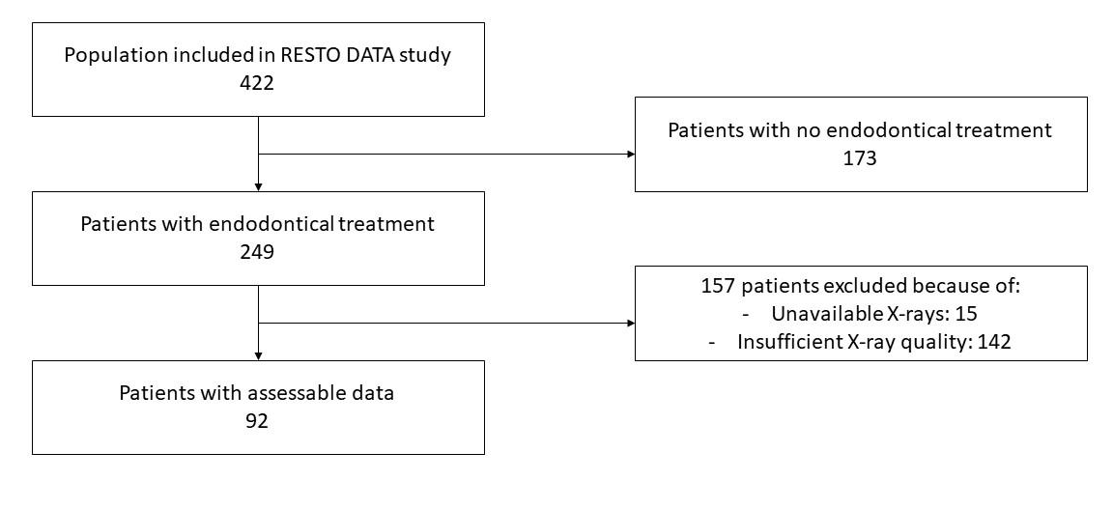
Appendix Figure 1: Flow diagram of patient inclusion in the descriptive study of the endodontic treatments.

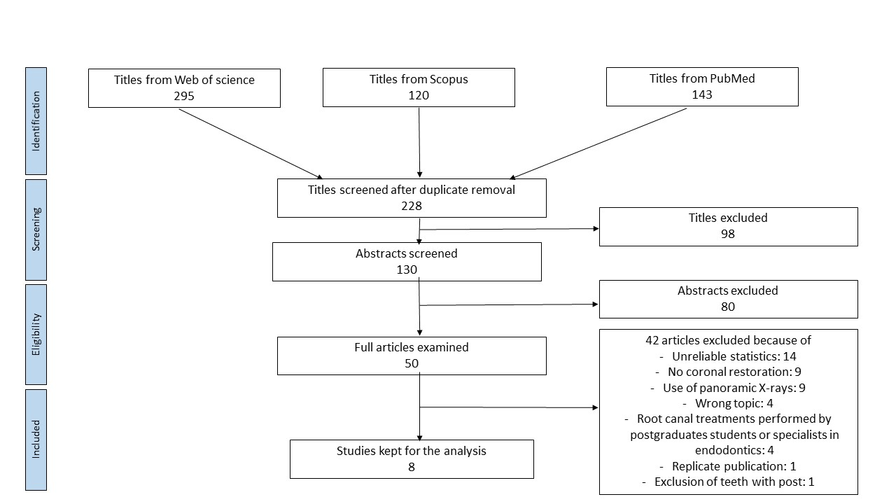
Appendix Figure 2: Flow diagram of publication inclusion in the literature systematic review.
Root canal treatments performed by postgraduate or specialists have been excluded because of the risk of overestimating the quality of endodontic treatments.

Appendix Table 1: Characteristics of included studies.

Author  Year  Country | Study design | Sample group (n)  % F and M | % of AP | % of adequate RCT | % of adequate coronal restoration | Results | Main conclusion
Moreno et al.  2013  Colombia | Cross sectional | 1086 teeth  66% F  34% M | 49% | 33% | 40% | PR/PE and normal PA: 43%  PR/PE and diseased PA: 57%  GR/GE and normal PA: 66%  GR/GE and diseased PA: 34%  GR/PE and normal PA: 52%  GR/PE and diseased PA: 48%  PR/GE and normal PA: 56%  PR/GE and diseased PA: 44% | The quality of the endodontic treatment was the most determinant factor for healthy periradicular status.
Hommez et al.  2002  Belgium | Cross sectional | 745 teeth  NA | 32.5% | 34.4% | 67.4% | PR/PE and normal PA: 56.8%  PR/PE and diseased PA:43.2 %  GR/GE and normal PA: 77.5%  GR/GE and diseased PA: 22.5%  GR/PE and normal PA: 65.6%  GR/PE and diseased PA: 34.4%  PR/GE and normal PA:75.7 %  PR/GE and diseased PA: 24.3% | The importance of a good coronal restoration, as well as of a good root filling should be emphasized as the technical quality of both influencing the periapical status.
Siqueira et al.  2005  Brasil | Cross sectional | 2051 teeth  66.3% F  33.7 M | 50.3% | 56.9% | 46.7% | PR/PE and normal PA: 25%  PR/PE and diseased PA: 75%  GR/GE and normal PA: 71%  GR/GE and diseased PA: 29%  GR/PE and normal PA: 38%  GR/PE and diseased PA: 62%  PR/GE and normal PA: 65%  PR/GE and diseased PA: 35% | Even though the coronal restoration had a significant impact on the periradicular health, the quality of the root canal filling was found to be the most critical factor in this regard.
Tronstad et al.  2000  Norway | Cross sectional | 1001 teeth  NA | 30% | 50.5% | 66.2% | PR/PE and normal PA: 48%  PR/PE and diseased PA: 52%  GR/GE and normal PA: 76%  GR/GE and diseased PA: 24%  GR/PE and normal PA: 57%  GR/PE and diseased PA: 43%  PR/GE and normal PA: 71%  PR/GE and diseased PA: 29% | The technical quality of the endodontic treatment as judged radiographically more important than the technical quality of the coronal restoration when the periapical status of endodontically treated teeth was evaluated.
Song et al.  2014  Korea | Cross sectional | 1030 teeth  55.1% F  44.9% M | 40.9% | 35.6% | 68.5% | PR/PE and normal PA:41.2 %  PR/PE and diseased PA: 58.8%  GR/GE and normal PA:82.3 %  GR/GE and diseased PA: 17.7%  GR/PE and normal PA: 54.7%  GR/PE and diseased PA: 45.3%  PR/GE and normal PA: 56.3%  PR/GE and diseased PA: 43.7% | The quality of endodontic treatment and coronal restorations were of equal importance and were strong independent predictors of the periapical status.
Thampibul et al.  2019  Thailand | Cross sectional | 1511 teeth  66% F  34% M | 35% | 51.9% | 73.7% | PR/PE and normal PA: 26.4%  PR/PE and diseased PA: 73.6%  GR/GE and normal PA: 90.1%  GR/GE and diseased PA: 9.9%  GR/PE and normal PA: 53.2%  GR/PE and diseased PA: 46.8%  PR/GE and normal PA: 61.2%  PR/GE and diseased PA: 38.8% | The periapical conditions of ETT were strongly associated with the technical quality of both the root fillings and restorations, indicating that the proposed training would definitely have a beneficial effect on treatment outcomes of the patients.
Tavares et al.  2009  France | Cross sectional | 1035 teeth  58.2% F  41.8% M | 33% | 19% | 64.5% | PR/PE and normal PA: 56%  PR/PE and diseased PA: 44%  GR/GE and normal PA: 93.5%  GR/GE and diseased PA: 6.5%  GR/PE and normal PA: 64%  GR/PE and diseased PA: 36%  PR/GE and normal PA: 82%  PR/GE and diseased PA: 18% | The quality of the endodontic treatment was the most important factor for success, although the quality of the coronal restoration also influenced the treatment outcome.
Dugas et al.  2003  Canada | Cross sectional | 383 teeth  53.8% F  46.2% M | 45.4% | 53.3% | 42.3% | PR/PE and normal PA: 43%  PR/PE and diseased PA: 57%  GR/GE and normal PA: 81.4%  GR/GE and diseased PA: 18.6%  GR/PE and normal PA: 46.7%  GR/PE and diseased PA: 53.3%  PR/GE and normal PA: 60.8%  PR/GE and diseased PA: 39.2% | The quality of both the root filling and the restoration were found to impact on the periapical health of root-filled teeth, with the impact of the restoration being most critical when the quality of the root filling was adequate.

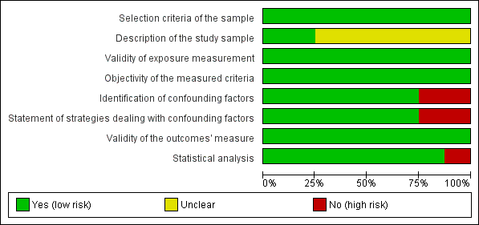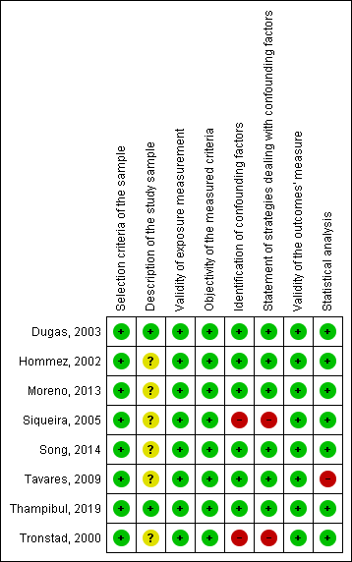
(A)
(B)
Appendix Figure 3: Graph and summary of the risk of bias judgement for each item. (A) Graph of judgement of risk of bias for each item in percentages. (B) Summary of the risk of bias judgement for each included study in the systematic review.
Abbreviations: + : low risk of bias; ? : unclear; - : high risk of bias.

