Supplementary Information

Environmental factors drive bacterial community (free-living vs particle-attached) assembly and more stable network in the pre-bloom period than post-bloom
Junming Ren^{a,1} & Jinliu Ye^{a,1}, Xinyu Cuiª, Xiaofeng Zhangª, Chengyu Langª, Wenming Xieª, Huan Heª, Han Meng^{a,b,d} *, Guoxiang Wangª, Limin Zhang^{a,c}

a School of Environment, Nanjing Normal University, Nanjing 210023, PR China
b School of Environment, Jiangsu Center for Collaborative Innovation in Geographical Information Resource Development and Application, Nanjing Normal University, Nanjing 210023, P. R. China
c Green Economy Development Institute, Nanjing University of Finance and Economics, Nanjing, 210023, P. R. China
d Jiangsu Engineering Lab of Water and Soil Eco-remediation, Nanjing 210023, China

* Corresponding authors (H. Meng)
Han Meng
School of Environment, Nanjing Normal University, Nanjing 210023, PR China
E-mail: hanmeng86@njnu.edu.cn (H. Meng)

1 J. Ren and J. Ye share the equal contribution of the first author.

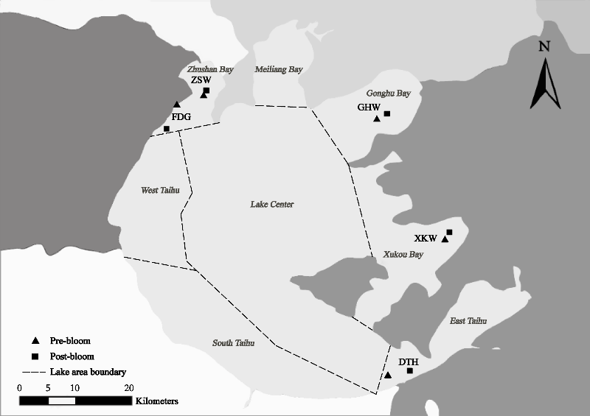
Fig. S1 Sample sites of Lake Taihu, China. Abbreviations: FDG, Fudu Port; ZSW, Zhushan Bay; GHW, Gonghu Bay; XKW, Xukou Bay; DTH, East Taihu.

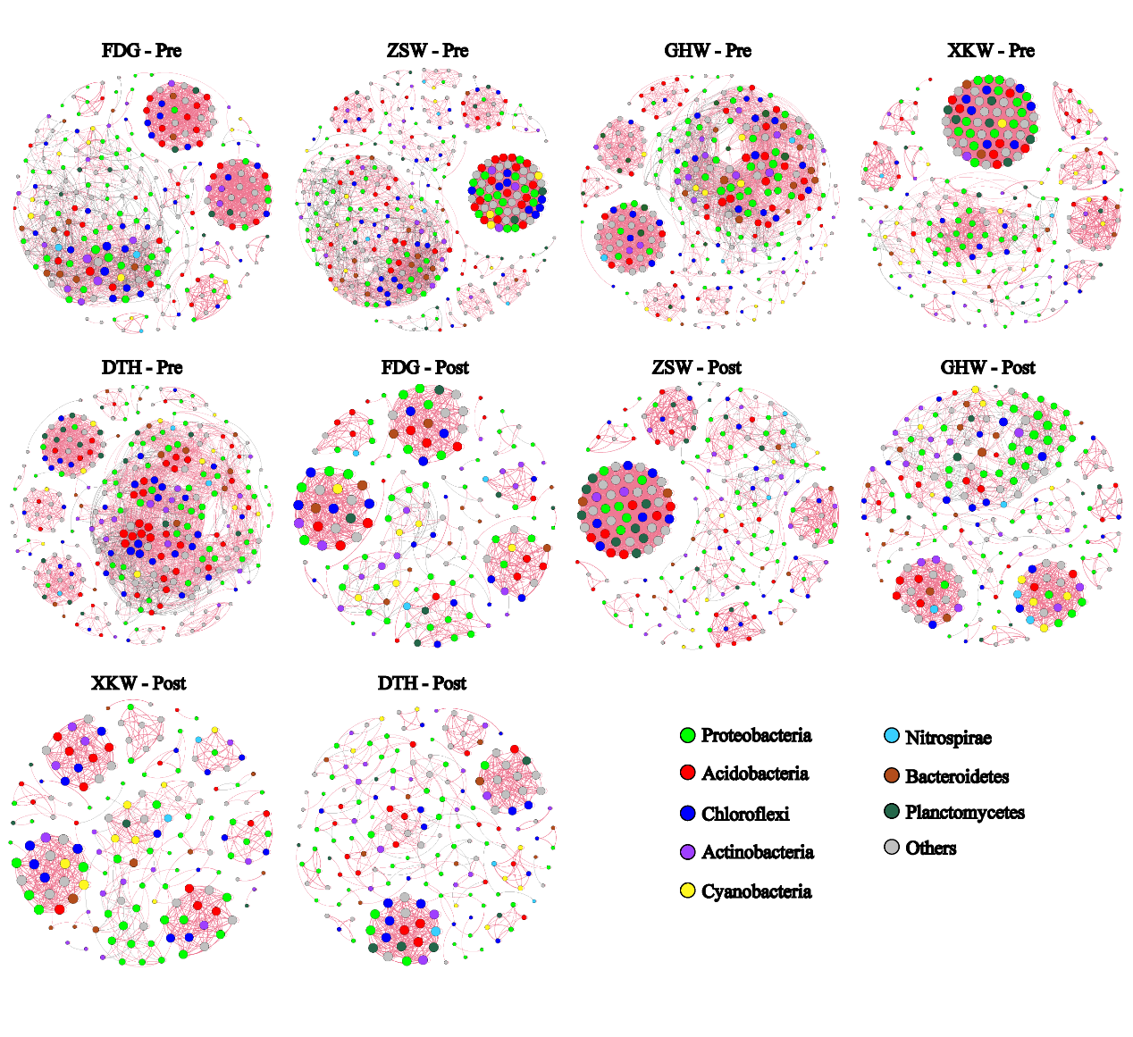
Fig. S2 The co-occurrence networks in different sites during the pre-bloom and post-bloom stages.

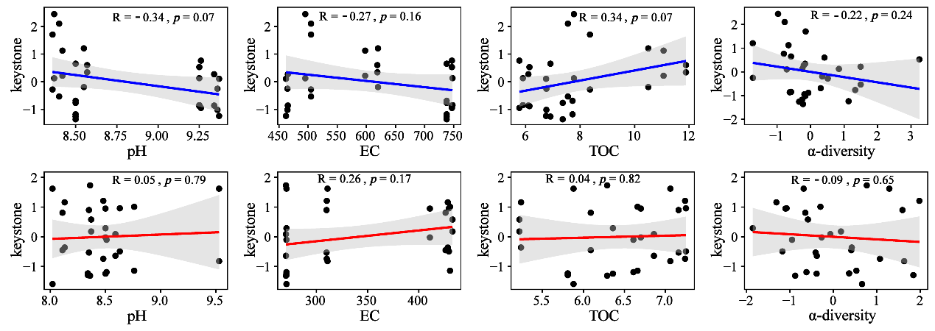
Fig. S3 Correlations between physicochemical parameters and keystone taxa. The blue lines indicate the relationships between environmental factors and keystone taxa (including FL and PA, normalized as z-score) in the pre-bloom, and the red lines indicate the relationships between environmental factors and keystone in the post-bloom period.

Table S1 Information of 15 keystones in the pre-bloom stage.
Name | Phylum | Class | Order | Family | Genus
ASV1975 | Proteobacteria | Betaproteobacteria | Burkholderiales | Burkholderiaceae | Polynucleobacter
ASV1503 | Proteobacteria | Alphaproteobacteria | Hyphomicrobiales | Hyphomicrobiaceae | Hyphomicrobium
ASV75 | Acidobacteria | / | / | / | /
ASV722 | Chloroflexi | Anaerolineae | / | / | /
ASV861 | Cyanobacteria | / | / | / | /
ASV1191 | Nitrospirae | Thermodesulfovibrionia | Thermodesulfovibrionales | / | /
ASV1952 | Proteobacteria | Betaproteobacteria | Burkholderiales | Burkholderiaceae | Limnobacter
ASV1414 | Proteobacteria | Alphaproteobacteria | Caulobacterales | Caulobacteraceae | Brevundimonas
ASV180 | Actinobacteria | Actinobacteria | Sporichthyales | Sporichthyaceae | /
ASV708 | Chloroflexi | Anaerolineae | / | / | /
ASV875 | Cyanobacteria | / | Chroococcales | Microcystaceae | Microcystis
ASV437 | Bacteroidetes | Cytophagia | Cytophagales | Microscillaceae | /
ASV435 | Bacteroidetes | Cytophagia | Cytophagales | Microscillaceae | /
ASV704 | Chloroflexi | Anaerolineae | / | / | /
ASV641 | Chloroflexi | Anaerolineae | Anaerolineales | Anaerolineaceae | Anaerolinea

Table S2 Information of 12 keystones in the post-bloom stage.
Name | Phylum | Class | Order | Family | Genus
ASV1103 | Proteobacteria | Gammaproteobacteria | Chromatiales | Chromatiaceae | Rheinheimera
ASV536 | Cyanobacteria | / | / | / | /
ASV140 | Actinobacteria | Actinomycetia | Sporichthyales | Sporichthyaceae | /
ASV332 | Bacteroidetes | Flavobacteriia | Flavobacteriales | Cryomorphaceae | /
ASV156 | Actinobacteria | Actinomycetia | Micrococcales | Microbacteriaceae | Candidatus Planktoluna
ASV929 | Proteobacteria | Alphaproteobacteria | / | / | /
ASV96 | Actinobacteria | Acidimicrobiia | Acidimicrobiales | Ilumatobacteraceae | /
ASV195 | Actinobacteria | Rubrobacteria | Gaiellales | / | /
ASV689 | Nitrospirae | Thermodesulfovibrionia | / | / | /
ASV841 | Proteobacteria | Alphaproteobacteria | Hyphomicrobiales | Beijerinckiaceae | /
ASV714 | Planctomycetes | / | / | / | /
ASV1142 | Proteobacteria | Betaproteobacteria | Burkholderiales | Burkholderiaceae | Limnobacter

Table S3 The topological features of each co-occurrence network.
Stage | Node | Edge | Positive (%) | Negative (%) | Modularity | Average clustering coefficient | Network diameter
Pre-bloom | 454 | 6025 | 50.19 | 49.81 | 0.52 | 0.66 | 10
Post-bloom | 306 | 1714 | 94.98 | 5.02 | 0.74 | 0.69 | 12
FDG-Pre | 254 | 2412 | 78.81 | 21.19 | 0.96 | 0.81 | 11
FDG-Post | 159 | 928 | 91.92 | 8.08 | 0.83 | 0.89 | 12
ZSW-Pre | 354 | 4714 | 88.59 | 11.41 | 0.48 | 0.82 | 14
ZSW-Post | 223 | 2069 | 94.54 | 5.46 | 0.46 | 0.88 | 14
GHW-Pre | 294 | 3600 | 87.89 | 12.11 | 0.77 | 0.80 | 12
GHW-Post | 217 | 1420 | 83.59 | 16.41 | 0.94 | 0.83 | 10
XKW-Pre | 250 | 3070 | 97.07 | 2.93 | 0.43 | 0.89 | 10
XKW-Post | 161 | 845 | 95.74 | 4.26 | 0.86 | 0.90 | 8
DTH-Pre | 302 | 3788 | 86.43 | 13.57 | 0.82 | 0.77 | 9
DTH-Post | 184 | 781 | 94.49 | 5.51 | 0.81 | 0.84 | 17

Table S4 The contributions of assembly processes on bacterial community during pre-bloom and post-bloom stages in Lake Taihu.
assembly process | Pre-bloom |  |  |  |  | Post-bloom
assembly process | FDG | ZSW | GHW | XKW | DTH | FDG | ZSW | GHW | XKW | DTH
homogeneous selection (%) | 73.3 | 93.3 | 100 | 93.3 | 100 | 33.3 | 26.7 | 0 | 40 | 0
homogenizing dispersal (%) | 0 | 0 | 0 | 6.7 | 0 | 0 | 0 | 13.3 | 0 | 0
undominated processes (%) | 20 | 0 | 0 | 0 | 0 | 0 | 53.3 | 46.7 | 33.3 | 53.3
dispersal limitation (%) | 6.7 | 6.7 | 0 | 0 | 0 | 66.7 | 20 | 40 | 26.7 | 46.7

Table S5 Odds ratio value of dominant bacteria preference for FL and PA in pre-bloom and post-bloom periods.
Sample ID | Proteobacteria |  | Actinobacteria |  | Cyanobacteria |  | Bacteroidetes |  | Verrucomicrobia
Sample ID | pre | post | pre | post | pre | post | pre | post | pre | post
FDG | -0.21 | -0.05 | -0.31 | -0.86 | 1.43 | 1.52 | -0.57 | 0.03 | 0.27 | -0.22
ZSW | -0.08 | -0.17 | -0.7 | -0.43 | 1.86 | 0.83 | -0.08 | -0.04 | -0.16 | -0.04
GHW | 0.03 | -0.08 | -0.8 | -0.47 | 1.02 | 0.79 | 0.12 | 0.2 | 0.04 | 0.21
XKW | -0.26 | 0.3 | -0.67 | -0.59 | 0.83 | 0.72 | 0.17 | -0.21 | 0.54 | -0.19
DTH | -0.02 | 0.2 | -0.55 | -0.65 | 0.93 | 0.35 | 0.14 | -0.13 | 0.64 | -0.27
The formula for the odds ratio is as follows: odds ratio = log10 (relative abundance in PA fraction/relative abundance in FL fraction), where odds ratio > 0 represents the PA preference, while odds ratio < 0 represents the FL preference.

