Supporting Information
Combined polyhexamethylene guanidine and nanocellulose for the conservation and enhancement of ancient paper
Xiaochun Maª, Shenglong Tianª, Xiaohong Li^{b}, Huiming Fanª, Shiyu Fu ^{a,}*
Contact information: State Key Laboratory of Pulp and Paper Engineering, South China University of Technology, Guangzhou 510640, China; *Corresponding author: shyfu@scut.edu.cn
ªState Key Laboratory of Pulp and Paper Engineering, South China University of Technology, Guangzhou 510640, 18742057146@163.com (X.M.); slonet623@163.com (S.T.); hmfan@scut.edu.cn.
^{b}Guangzhou Paper Co., Ltd, Guangzhou 510280, lixiaohong@gzpaper.cn.
*Corresponding author. Tel.: +13570017263. Email address: shyfu@scut.edu.cn

Supporting Table and Figure Captions
Fig. S1. The crystallinity (CrI) of treated and untreated paper fiber after accelerated aging.
Fig. S2. The photo of treated and untreated paper samples.
Table S1. The brightness and Chromatic aberration(ΔE) of treated and untreated paper samples after aging

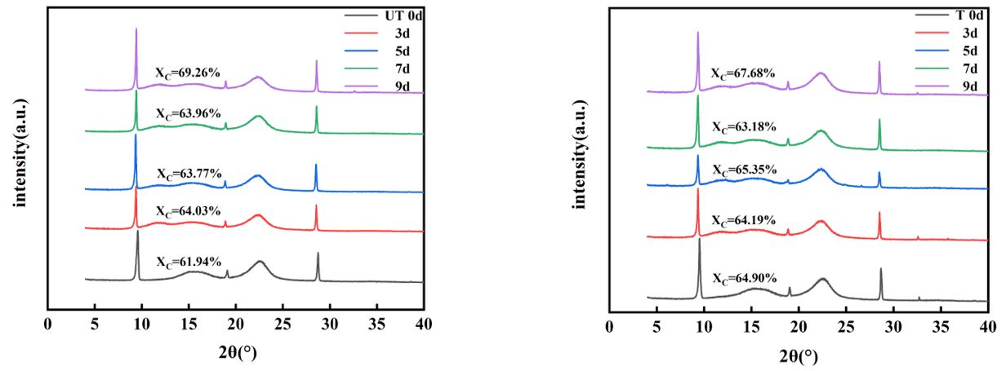
Fig. S1.
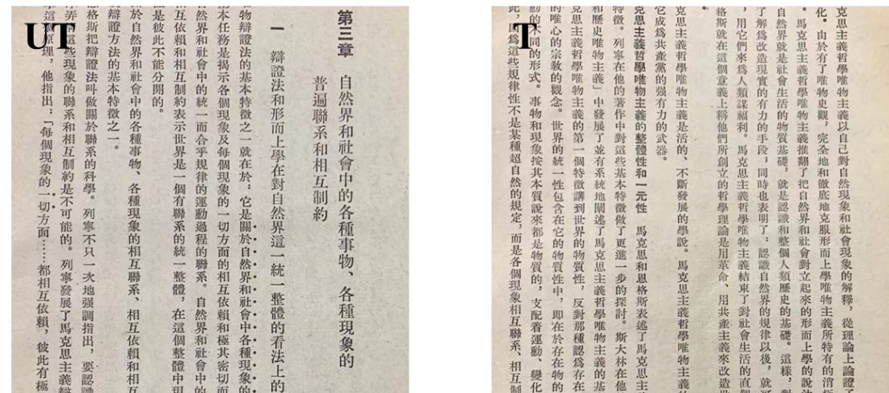
Fig. S2.

Table S1. The brightness and Chromatic aberration(ΔE) of treated and untreated paper samples after aging

Paper sample | Treatment conditions | L* | a* | b* | Brightness (%) | Chromatic aberration(ΔE)
0 | UT | 77.46 | 0.88 | 15.78 | 39.420 | ---
0³ | 0# aged 3 days | 76.39 | 1.44 | 16.18 | 38.27 | 0.929
0⁵ | 0# aged 5 days | 76.06 | 1.42 | 16.03 | 37.35 | 1.517
0⁷ | 0# aged 7 days | 75.63 | 1.56 | 15.9 | 36.75 | 1.951
0⁹ | 0# aged 9 days | 75.49 | 2.88 | 17.84 | 35.11 | 3.479
1 | T | 77.51 | 0.79 | 16.24 | 39.15 | 0.472
1³ | 1# aged 3 days | 76.17 | 1.87 | 17.94 | 35.52 | 2.701
1⁵ | 1# aged 5 days | 76.0 | 2.26 | 18.53 | 35.29 | 3.404
1⁷ | 1# aged 7 days | 75.80 | 2.21 | 18.3 | 35.20 | 3.296
1⁹ | 1# aged 9 days | 75.87 | 2.28 | 18.76 | 34.94 | 3.654

