Supplementary Fig.1 GO enrichment analysis results for differential genes.
Supplementary Fig.2 Forest plot showed the result of multivariate cox analysis
Supplementary Fig.3 Kaplan Meier analysis revealed that up-expression of AR, DEFB1, LRRK2, SEMA3G and down-expression of ULBP2, PTX3 were associated with better survival outcomes and low recurrence.
Supplementary Fig.4 Kaplan Meier analysis revealed that GEO verification database. (A) GSE65858. (B) GSE85446.
Supplementary Fig.5 Kaplan Meier analysis revealed that up-expression of B cell native, Mast cells resting, Plasma cells, T cells follicular helper, T cells regulatory (Tregs) and down-expression of Dendritic cells resting, Macrophages M2, Neutrophils, Mast cells activated were associated with better survival outcomes and low recurrence.

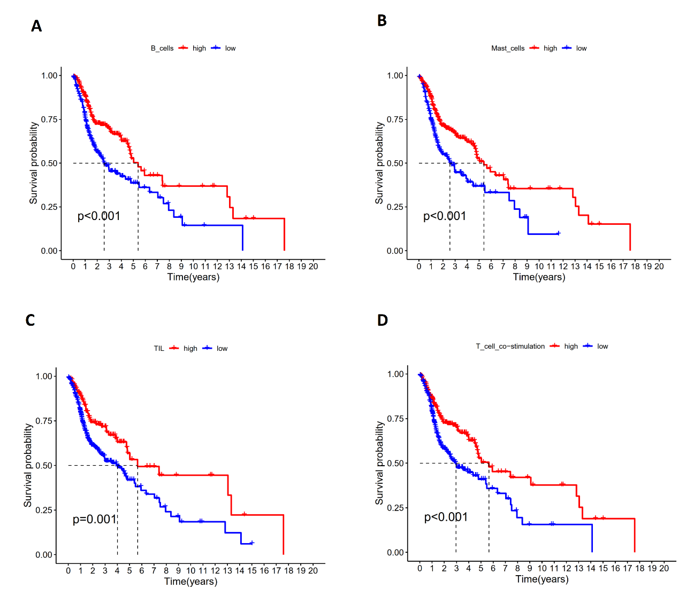
Supplementary Fig.6 (A-D) High risk score was correlated with less immune cell infiltration and lower immune signature enrichment. Kaplan Meier analysis revealed grouping prognosis. ( P<0.001)

Supplementary Table S1 This tables shows the outcome of GO enrichment analysis

Supplementary Table S2 This tables shows the outcome of KEGG enrichment analysis

