Supplementary Table 1. The result of the K-M life table analysis showing the cumulative survival probability of cows to CM during the lactation period
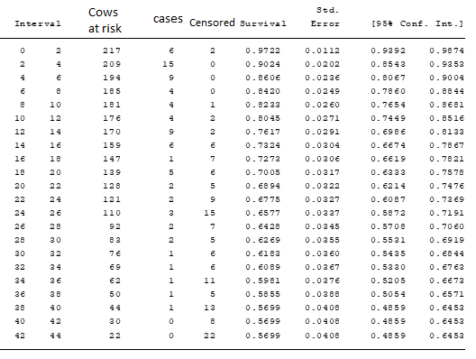

Supplementary Table 2. The result of the K-M life table analysis showing the cumulative incidence (failure) of CM in cows during the lactation period
