Supplementary Material

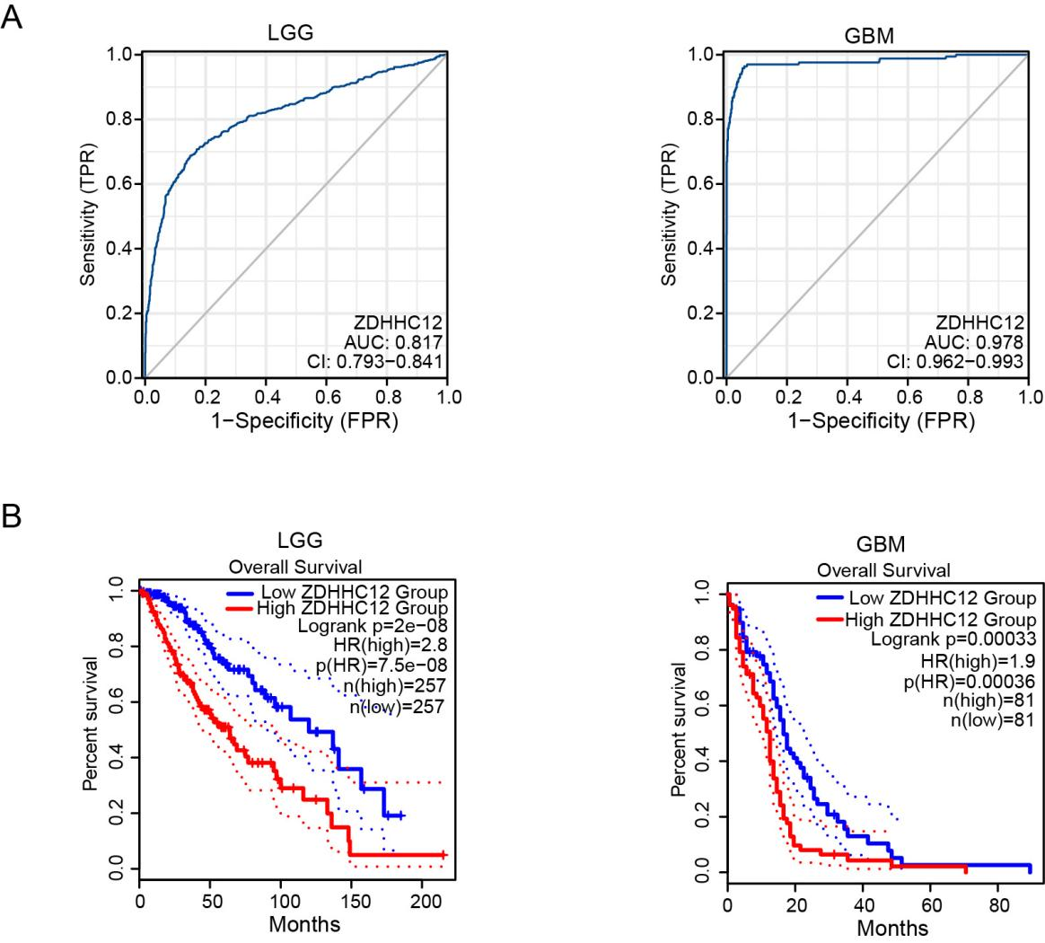

Supplementary Figure 1. The ROC curves and prognosis analysis of ZDHHC12 in glioma.
- The ROC curves of ZDHHC12 in glioma.
- The prognosis analysis of ZDHHC12 in glioma.

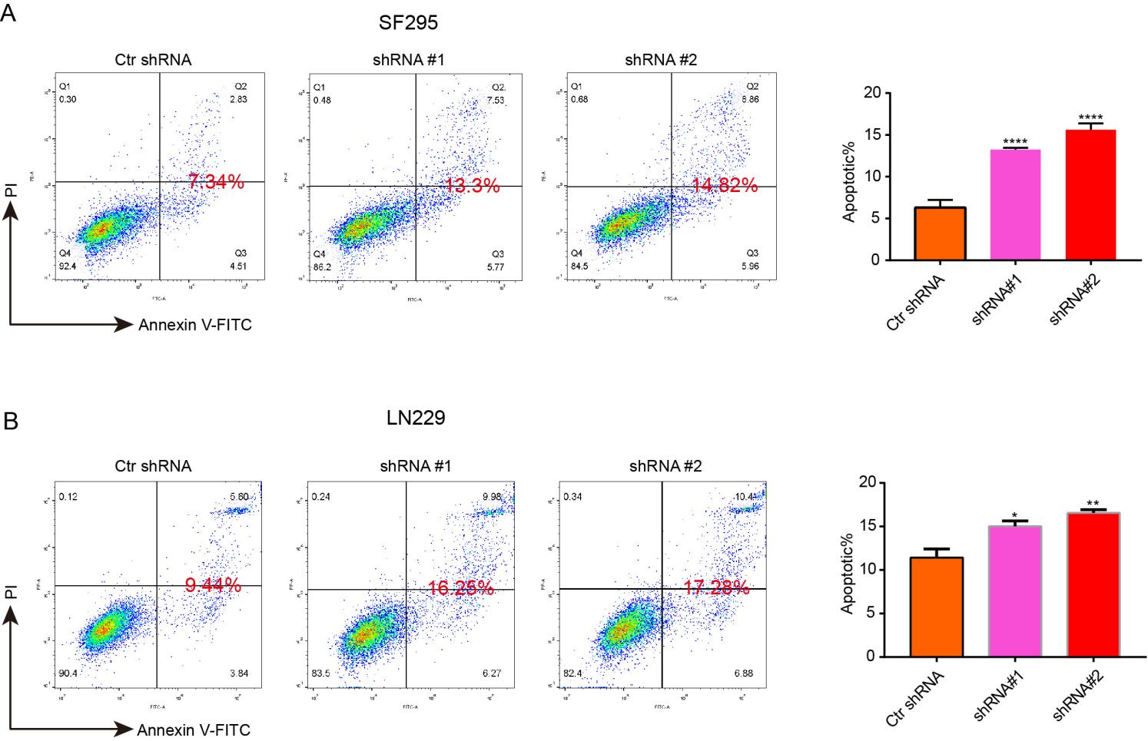

Supplementary Figure 2. Effects of ZDHHC12 knockdown on glioma cell apoptosis.
- Knockdown of ZDHHC12 promoted the apoptosis of SF295 cells.
- Knockdown of ZDHHC12 promoted the apoptosis of LN229 cells.

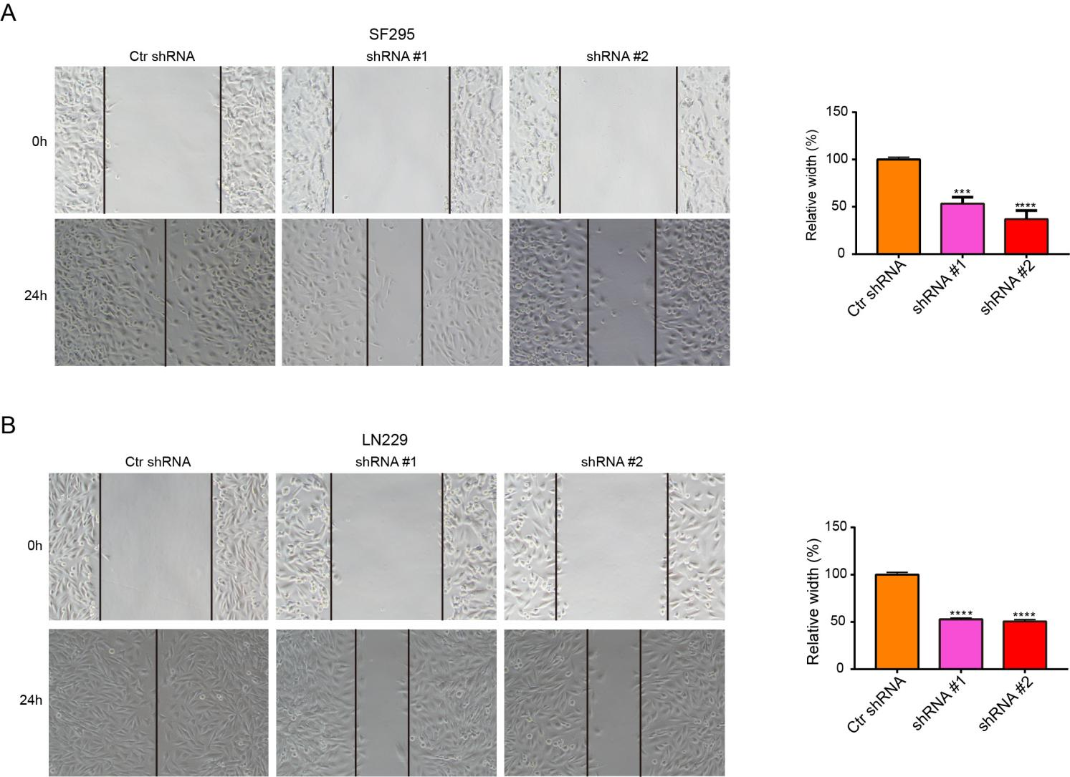

Supplementary Figure 3. Effects of ZDHHC12 knockdown on glioma cell migration.
- Knockdown of ZDHHC12 inhibited the migration of SF295 cells.
- Knockdown of ZDHHC12 inhibited the migration of LN229 cells.

