Additional file 1
A mitochondria-targeted molecular phototheranostics platform for NIR-II imaging-guided synergistic photothermal /photodynamic /immune therapy
Sha Yang^{1,2}, Gui-long Wu¹, Na Li¹, Minghui Wang¹, Peixian Wu¹, Yuxuan He¹, Wei Zhou¹, Hao Xiao¹, Xiaofeng Tan¹*, Li Tang^{1,3}*, Qinglai Yang¹*
1.Center for Molecular Imaging Probe, Hunan Province Key Laboratory of Cancer Cellular and Molecular Pathology, Cancer Research Institute, Hengyang Medical School, University of South China, Hengyang, Hunan 421001, China.
2. Cancer Pathology Research group & Department of Pathology, Xiangnan University, Chenzhou, Hunan 423099, China.
3. Key Laboratory of Tropical Medicinal Plant Chemistry of Ministry of Education, College of Chemistry and Chemical Engineering, Hainan Normal University, Haikou, Hainan 571158, China.
*Correspondence: tanxiaofeng@usc.edu.cn (X. Tan), tanglicq@outlook.com (L. Tang), qingyu513@usc.edu.cn (Q. Yang).

Instruments
¹H and ¹³C NMR spectra were performed on 500 MHz NMR spectrometers (Bruker AVANCE) using CDCl₃. Mass spectra were in general recorded on QSTAR Elite (ABI). High-resolution mass spectra (HRMS) were performed on a Bruker micrOTOF-Q II mass spectrometer. Fluorescence imaging (FI) was performed at a Xenogen IVIS Lumina system (Caliper Life Sciences). Confocal laser scanning microscopy images were collected with a confocal laser scanning microscope (Zeiss LSM980, Germany). Flow cytometry analysis was performed using a CytoFLEX flow cytometer (Beckman Coulter, Fullerton, CA, USA).

Quantum yield test
The fluorescence quantum yield of the fluorophores was measured in a similar way to the previous method.[1] The fluorescence spectra in the region of 900-1800 nm were measured by an array detector (Princeton OMA-V) and a spectrometer (Acton SP2300i) under an 808 nm diode laser excitation (RMPC lasers, 160 mW). The fluorescence quantum yield was determined against the reference fluorophore IR-FEP with a known quantum yield of 2.0% (Φ_{st}) in an aqueous solution.[2] All samples were measured at 25°C, and reference fluorophore IR-FEP was used with an optical density (OD) of 0.1 at 808 nm. Their NIR-II fluorescence emission intensities were measured under the same 808 nm excitation. Using the measured optical density (OD) at 808 nm and spectrally integrated fluorescence intensity (F), η the refractive index of the solvent, the quantum yield of the test sample can be calculated according to the following equation:
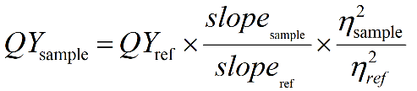
Both η_{sample} and η_{ref} are the refractive index of water。
Photothermal conversion efficiency
The photothermal conversion efficiency was calculated using the following equation: where h is the heat transfer coefficient, S is the surface of the container, T_{max} and T_{surr} are the equilibrium temperature and ambient temperature, respectively. Q₀ is the heat associated with the light absorbance of the solvent, A_{λ} is the absorbance of FEPT at 808 nm, and I is the laser power density. According to the above equation, the η value of FEPT was determined to be about 56.8%. The η was calculated by equation:[3]
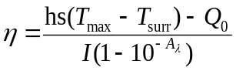 (1)
hs can be calculated by the follow equation:
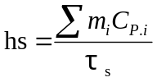 (2)
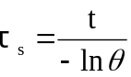 (3)
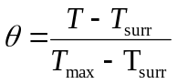 (4)
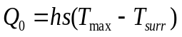 (5)
h represents the heat transfer coefficient,
s represents the sample container surface area,
T_{max} represents the steady-state maximum temperature,
T_{surr} represents the ambient room temperature,
T represents instantaneous temperature during cooling,
t represents the time it takes by T cooled to room temperature,
C approximate to the specific heat capacity of water,
m represented the mass of the solution (g),
Q₀ represents the energy input by the same solvent without NPs in the same quartz cuvette after the same laser irradiation.
Cell culture
4T1 breast cancer cells were cultured with Dulbecco’s Modified Eagle’s Medium (DMEM) supplemented with 10% fetal bovine serum (FBS) in a humidified 5% CO₂ environment at 37 °C.
In vitro cellular uptake
For cell uptake study, the 4T1 cells (1 × 10⁵ cells per dish) were cultured in a confocal dish with DMEM medium containing 10% fetal bovine serum (FBS, Gibco, Invitrogen, Carlsbad, CA, USA), 100 IU/ml penicillin, 100 µg/ml streptomycin for 24 hours and then substituted with the fresh medium contained FEPT (50 μM). Followed by incubation for different time (0, 2, 4, and 6 hours), and the suspension cells were collected. Then the cells were washed twice with PBS and the fluorescence of 4T1 cells were collected with a confocal laser scanning microscope (Zeiss LSM980, Germany).
Co-staining imaging in living cells
After the 4T1 cells (5 ×10⁴ cells per dish) were plated on chamber slides for 12 hours, 50 μM of FEPT or FEP was added into the medium. After 4 hours of incubation, the cells were incubated with Mito-Tracker Green FM (200 nM) for 30 minutes. Finally, the fluorescence imaging was performed. The excitation wavelength of Mito-Tracker Green FM and FEPT/FEP were 488 nm and 405 nm, respectively.

Monitoring of intracellular ROS generation
ROS generation inside cells under laser irradiation was detected with DCFH-DA as an indicator. 4T1 cells were cultured in a 35 mm confocal dish (glass bottom dish) at an appropriate density for12 hours. Following incubation with FEPT (50 μM) for 4 hours in the dark, DCFH-DA (1 × 10⁻⁵ M) was loaded into the cells. After 30 minutes of incubation, cells were washed twice with PBS and then irradiated under 808 nm laser (1.0 W/cm²) for 10 minutes. After another 30 minutes of incubation at 37 °C, the fluorescence images of treated cells were acquired by CLSM. The DCFH-DA was excited at 488 nm. No background fluorescence of cells was detected under the setting condition.
Monitoring changes of mitochondria transmembrane potential
A Mitochondria staining kit (JC-1) was employed to investigate the mitochondria transmembrane potential of the cells with different treatments. 4T1 cells (1 × 10⁵ cells per dish) were cultured in confocal dishes and divided into four groups: PBS only, PBS with laser irradiation, FEPT only, and FEPT with a laser irradiation. Cells were first incubated with different substrates for 4 hours, respectively, and the concentration of FEPT was 50 μM. The irradiation groups were irradiated with laser at 1.0 W/cm² for 10 minutes. After further incubation for 4 hours, JC-1 (2 μM) solution was added and incubated for 10 minutes under dark, and the confocal images were recorded with CLSM after washed the four groups with PBS. The excitation wavelength of JC-1was 488 nm.
Calcein-AM/PI Staining of Live/Dead Cell induced by laser irradiation
4T1 cells (1 × 10⁵ cells per dish) were seeded and cultured in a confocal dish with 2.0 ml of medium. 4T1 cells were pre-incubated with FEPT (50 μM) for 4 hours and then exposed to 808 nm laser irradiation for 10 minutes. After incubated for another one hour, the cells were stained with a mixed solution of PI (8 μM) and Calcein-AM (2 μM) for 30 minutes in the PBS. After being washed gently with PBS, the cells were then imaged by CLSM980. The excitation wavelength was 488 nm for Calcein-AM, and 543 nm for PI.
Evaluation of cleaved caspase-3 with IF and ELISA
The immunofluorescence (IF) staining was performed to evaluate the cleaved caspase-3 expression of 4T1 cells with different treatments. The cells were treated with blank medium and medium containing FEPT (50 μM) for 4 hours. Then the cells were fixed with 4% PFA for 20 minutes at 4 °C and treated with 0.2% Triton X-100-PBS for exact 5 minutes. BSA-PBS was used to block the cells for 1 hour at room temperature. Subsequently, the cells were stained with anti-cleaved caspase-3 primary antibody, secondary antibody and Hoechst 33258. Finally, the cells were evaluated by confocal fluorescence imaging (Ex = 488 nm). ELISA was further performed with Mouse cleaved caspase-3 ELISA Kit. 4T1 cells (2 × 10⁵ cells per well) were seeded in six-well plates overnight. Then, a fresh medium containing FEPT was used to replace the medium. After 4 hours of incubation, the medium containing the probes was replaced, and then the cells were irradiated using an 808 nm laser (1.0 W/cm², 10 minutes). Afterward, the medium was discarded and washed with cold PBS. Protein lysis buffer (100 μl, containing 1 mM PMSF) was added to each well, and the cells were grinded for 30 minutes. The whole process was operated on ice. After 30 minutes, all samples were centrifuged to collect the supernatant (13000 rpm, 15 minutes, 4 °C). Thereafter, the collected proteins were measured with Mouse cleaved caspase-3 ELISA Kit.

Animal cancer models
Balb/c mice (female, 4-5 weeks old) were obtained from Hunan SJA Laboratory Animal Co., Ltd. 100 μl of 4T1 cell suspension (2 × 10⁶ cells) were subcutaneous injected into each mouse to establish the cancer models. All animal experiments were approved by University of South China Animal Experiment Ethics Review and the Health Guide for the Care and Use of Laboratory Animals of National Institutes. All mice received care in accordance with international ethics guidelines.
Systemic toxicity assessment
To evaluate the systemic toxicity, the mice were divided into two groups. Control group: intravenous injection with PBS (100 μl); FEPT group: intravenous injection with FEPT (100 μl, 500 μM). In vivo blood biochemistry and blood routine analysis were comprehensively carried out to study the long-term biotoxicity of FEPT. Blood from two groups was collected on day 15. The hepatic function and kidney function parameters, including alkaline phosphatase (ALP), aspartate aminotransferase (AST), alanine transaminase (ALT), γ-glutamyltranspeptidase (γ-GT), creatinine (CREA), urea (UREA) and uric acid (UA) were monitored. For the blood routine examination, relative indexes such as white blood cells (WBC), red blood cells (RBC), hematocrit (HCT), hemoglobin (HGB), platelets (PLT), mean corpuscular volume (MCV), mean corpuscular hemoglobin (MCH), and mean corpuscular hemoglobin concentration (MCHC) were evaluated. Blood routine examinations and biochemical indexes were examined by hematology analyzer.

Histological analysis
After the treatment, major organs (heart, liver, spleen, lung, and kidney) and tumors of all mice were harvested. The CD4⁺ T cells (stained with APC Anti-Mouse CD3 Antibody and FITC Anti-mouse CD4 Antibody), CD8⁺ T cells (stained with APC Anti-Mouse CD3 Antibody and PE Anti-Mouse CD8a Antibody) and regulatory T cells (stained with FITC Anti-Mouse CD4 Antibody and PE Anti-Mouse Foxp3 Antibody) in spleens were detected by flow cytometry. Cytokines in serum were evaluated with ELISA. Tissues were washed with PBS, and fixed with paraformaldehyde for histology analysis. After the tumor tissues were weighed, they were fixed in 4% neutral buffered formalin, processed routinely into paraffin, and sectioned at 4 μm. The tumor tissues were stained with a primary antibody with Rabbit anti-mouse Ki-67, cleaved caspase-3, HSP70, and Foxp3 antibodies at 4 °C overnight, respectively. Besides, spleen slices were also fixed and stained with Rabbit anti-mouse Foxp3 antibodies. After washing three times with cold PBS buffer, HRP-conjugated secondary antibody (1:1000) were added and incubated for 2 hours at room temperature. Finally, added TMB resolutions for color reactions. The IF stainings of Terminal dUTP Nick End Labeling (TUNEL), CRT, HMGB1, CD4⁺T and CD8⁺T in tumor/spleen tissues were also performed after being fixed. According to the standard protocols. In IHC and IF staining, the cellular nuclei were stained with hematoxylin and Hoechst 33258, respectively. The sections were eventually scanned with Pannoramic DESK, P-MIDI, P250, P1000 (3D HISTECH, HUN).

Synthetic procedures and characterization data for NIR-II fluorophores
Synthesis of FEPT and FEP
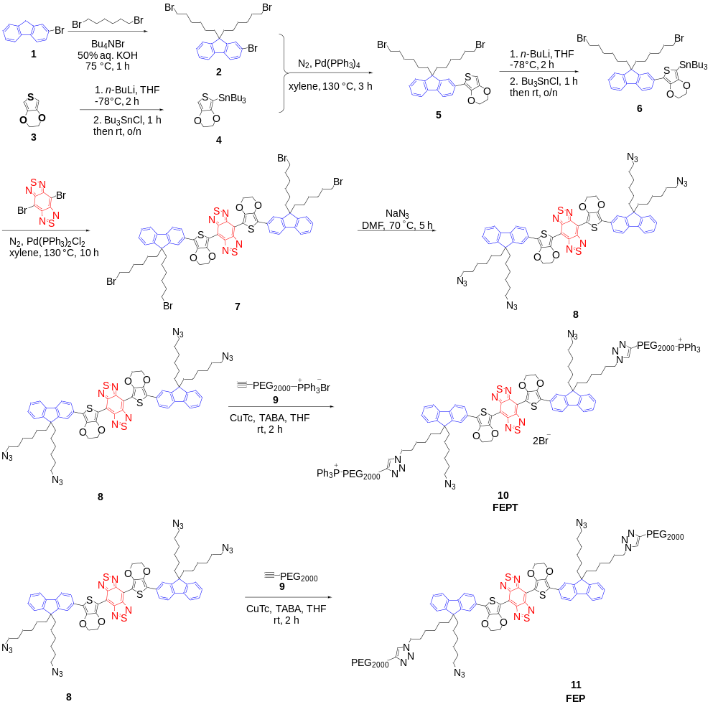
Fig. S1 Synthetic routes of FEPT and FEP.

2-bromo-9,9-bis(6-bromohexyl)-9H-fluorene (2): To a 150 ml of 45% aqueous potassium hydroxide was added 6.0 g (24.4 mmol) 2-bromofluorene, 59.3 g (0.244 mol) 1,6-dibromohexane and 0.78 g (2.4 mmol) tetrabutylammonium bromide at 75°C. The mixture was stirring for one hour, and then cooled down to room temperature. The aqueous layer was extracted with dichloromethane. The organic layer was washed with 1.0 M aqueous HCl, then brine and water, and dried over anhydrous magnesium sulfate. After removal of the solvent and the excess 1,6-dibromohexane under reduced pressure, the residue was purified by column chromatography on silica gel (eluent petroleum ether) to afford yellow, which was further purified by recrystallization by petroleum ether under -20 °C to give white solid product 8.79 g (63%). ¹H NMR (500 MHz, CDCl₃). δ (ppm): δ 7.67 – 7.64 (m, 1H), 7.57 – 7.53 (m, 1H), 7.47 – 7.42 (m, 2H), 7.34 – 7.30 (m, 3H), 3.27 (t, J = 6.8 Hz, 4H), 2.00 – 1.89 (m, 4H), 1.69 – 1.61 (m, 4H), 1.23 – 1.15 (m, 4H), 1.10 – 1.02 (m, 4H), 0.66 – 0.54 (m, 4H). ¹³C NMR (125 MHz, CDCl₃). δ (ppm): 152.59, 149.93, 140.16, 140.03, 130.05, 127.59, 127.10, 126.06, 122.80, 121.11, 121.05, 119.84, 55.24, 40.11, 33.86, 32.60, 28.98, 27.74, 23.46.
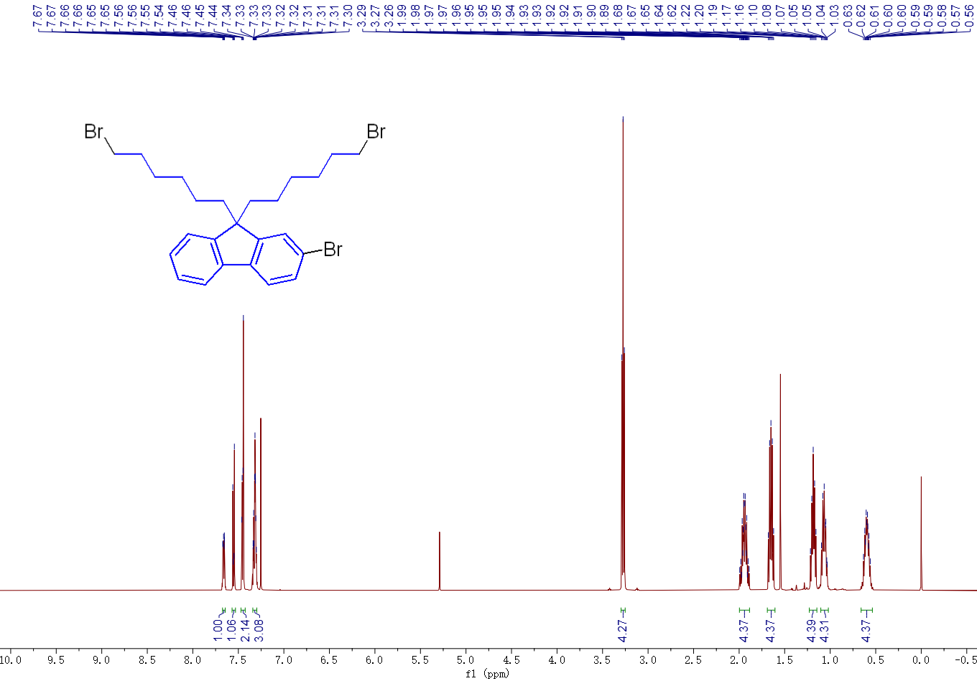
Fig. S2 ¹H NMR of compound 2.
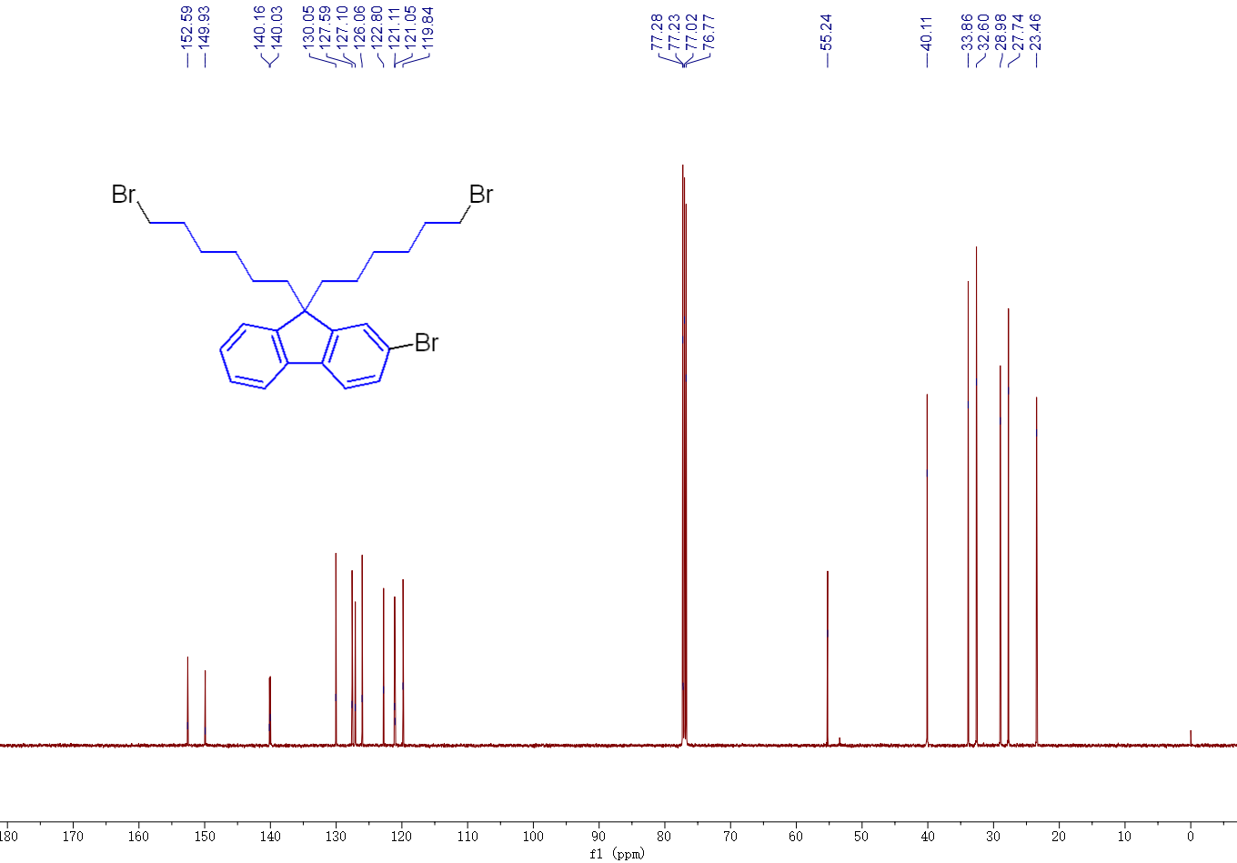
Fig. S3 ¹³C NMR of compound 2.
Tributyl(2,3-dihydrothieno[3,4-b][1,4]dioxin-5-yl)stannane (4): To a solution of compound 3 (2.13 g, 15.00 mmol) in THF (25.00 ml) at - 78 °C under nitrogen, n-BuLi solution (2.50 M in hexane, 7.20 ml, 18.00 mmol) was added dropwise. After the mixture was stirred at this temperature for another 2.0 h, tributyltin chloride (5.86 g, 18.00 mmol) was added to the solution. The reaction mixture was then slowly warmed to room temperature and stirred for overnight. After that the mixture was poured into water and extracted twice with ethyl acetate, the combined organic phase was dried with MgSO₄ and evaporated in vacuo without further purification.
5-(9,9-bis(6-bromohexyl)-9H-fluoren-2-yl)-2,3-dihydrothieno[3,4-b][1,4]dioxine (5): To a solution of compound 2 (5.71 g, 10.00 mmol) and the crude product from previous step in xylene (100 mL) under nitrogen, Pd(PPh₃)₄ (1.16 g) was added. The mixture was stirred at 130 °C for 3 h. After cooling to room temperature, the mixture was poured into water and extracted twice with ethyl acetate, dried with MgSO₄ and evaporated in vacuo. The crude product was subjected to column chromatography on silica gel to afford IR-FE as a dark green solid (3.71 g, 58.6%). ¹H NMR (500 MHz, Chloroform-d) δ (ppm): 8.06 (s, 1H), 7.72 (dd, J = 8.0, 1.6 Hz, 1H), 7.69 – 7.65 (m, 2H), 7.63 (d, J = 1.3 Hz, 1H), 7.35 – 7.28 (m, 3H), 6.31 (s, 1H), 4.38 – 4.33 (m, 2H), 4.29 – 4.25 (m, 2H), 4.17 (t, J = 6.6 Hz, 2H), 3.41 (t, J = 6.8 Hz, 2H), 3.26 (t, J = 6.8 Hz, 4H), 2.01 – 1.95 (m, 4H), 1.91 – 1.83 (m, 2H), 1.71 – 1.60 (m, 6H), 1.52 – 1.44 (m, 2H), 1.44 – 1.38 (m, 2H), 1.22 – 1.15 (m, 4H), 1.11 – 1.02 (m, 4H), 0.71 – 0.60 (m, 4H). ¹³C NMR (125 MHz, CDCl₃) δ (ppm): 161.13, 150.76, 150.56, 142.39, 140.87, 139.69, 138.05, 132.09, 127.00, 126.91, 124.99, 122.75, 120.26, 119.84, 119.67, 118.22, 97.31, 64.86, 64.50, 63.80, 54.99, 40.15, 33.96, 33.60, 32.62, 32.57, 29.02, 28.34, 27.71, 25.06, 23.50.
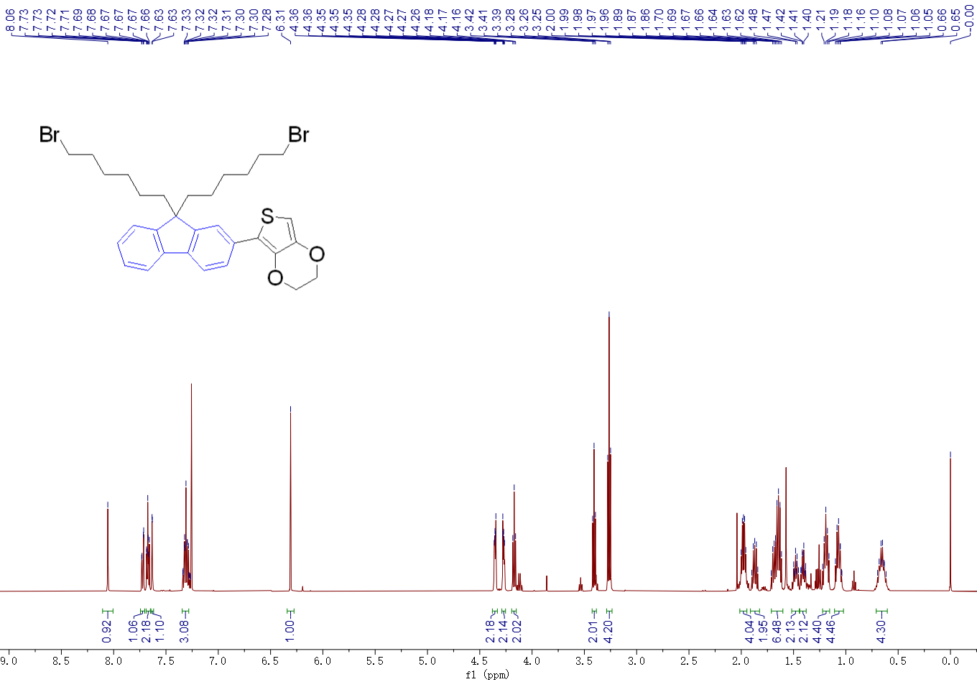
Fig. S4 ¹H NMR of compound 5.
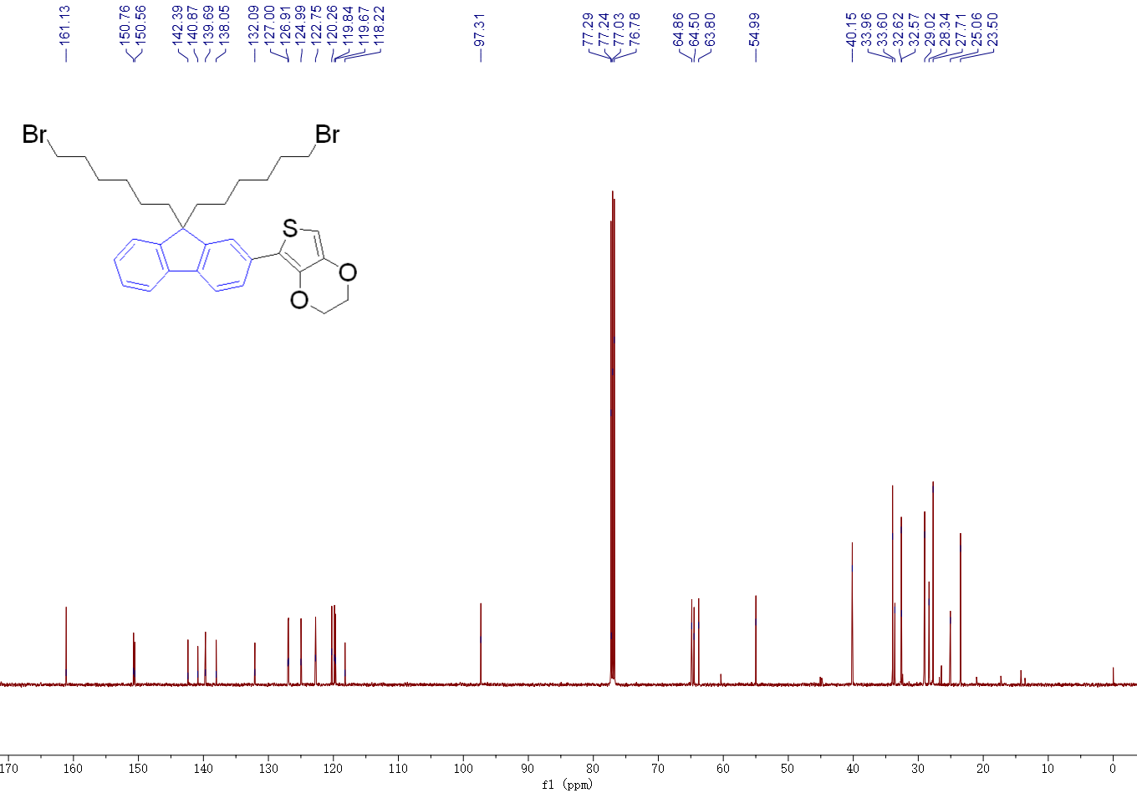
Fig. S5 ¹³C NMR of compound 5.
(7-(9,9-bis(6-bromohexyl)-9H-fluoren-2-yl)-2,3-dihydrothieno[3,4-b][1,4]dioxin-5-yl)tributylstannane (6): To a solution of compound 5 (1.90 g, 3.00 mmol) in THF (15.00 ml) at - 78 °C under nitrogen, n-BuLi solution (2.50 M in hexane, 1.80 mL, 4.50 mmol) was added dropwise. After the mixture was stirred at this temperature for another 2.0 h, tributyltin chloride (1.46 g, 4.50 mmol) was added to the solution. The reaction mixture was then slowly warmed to room temperature and stirred for overnight. After that the mixture was poured into water and extracted twice with ethyl acetate, the combined organic phase was dried with MgSO₄ and evaporated in vacuo without further purification.
IR-FE (7): To a solution of compound BBTD (352 mg, 1.00 mmol) and the crude product from previous step in xylene (20 ml) under nitrogen, Pd (PPh₃)₂Cl₂ (70 mg) was added. The mixture was stirred at 130 °C for 10 hours. After cooling to room temperature, the mixture was poured into water and extracted twice with ethyl acetate, dried with MgSO₄ and evaporated in vacuo. The crude product was subjected to column chromatography on silica gel to afford IR-FE as a dark green solid (452 mg, 31.1%). ¹H NMR (500 MHz, Chloroform-d) δ (ppm): 7.91 (dd, J = 7.9, 1.6 Hz, 2H), 7.77 – 7.70 (m, 6H), 7.36 – 7.30 (m, 6H), 4.55 – 4.49 (m, 4H), 4.41 – 4.36 (m, 4H), 3.28 (t, J = 6.8 Hz, 8H), 2.06 – 1.97 (m, 8H), 1.69 – 1.63 (m, 8H), 1.24 – 1.17 (m, 8H), 1.14 – 1.02 (m, 9H), 0.73 – 0.62 (m, 8H). ¹³C NMR (125 MHz, CDCl₃) δ (ppm): 152.63, 150.81, 150.67, 141.97, 140.84, 140.37, 138.98, 138.36, 131.77, 127.19, 126.97, 125.63, 122.77, 122.69, 120.70, 119.92, 119.80, 114.03, 113.16, 108.80, 64.76, 64.60, 55.11, 40.24, 34.00, 32.64, 29.04, 27.77, 26.78, 23.55, 17.31, 13.59.
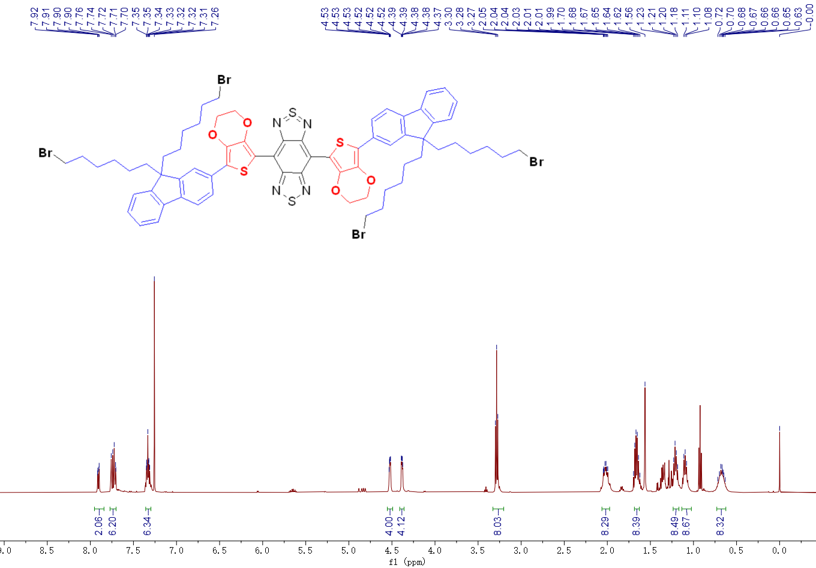
Fig. S6 ¹H NMR of compound IR-FE.
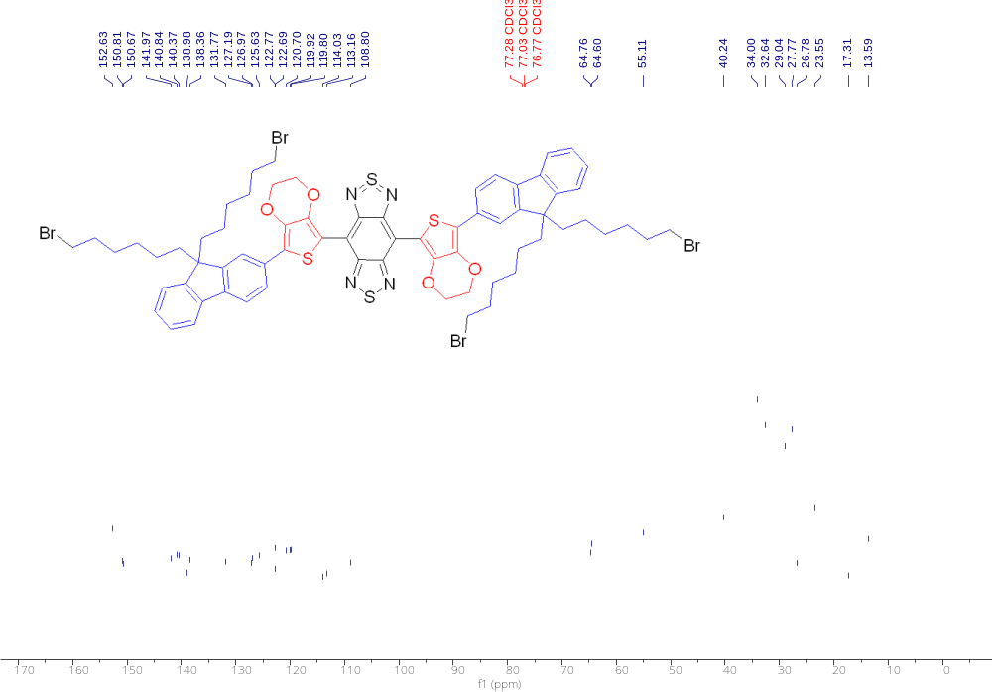
Fig. S7 ¹³C NMR of compound IR-FE.
IRFE-N3 (8): Compound IR-FE (50 mg, 0.069 mmol) and sodium azide (47 mg, 0.72 mmol) were dissolved in DMF (3 ml) and heated for 5 h at 70 °C. After cool to room temperature, a large amount of water was added and stirred until all solids dissolved. The solution was extracted twice with ethyl acetate. The combined organic phase was washed with saturated aqueous NaHCO₃ solution, brine and water, then was dried with MgSO₄ and evaporated in vacuo. The crude product was subjected to flash column chromatography (PE/EA = 2) on silica gel to afford dark green solid (45 mg). ¹H NMR (500 MHz, Chloroform-d) δ (ppm): 7.90 (d, J = 1.7 Hz, 2H), 7.77 – 7.70 (m, 6H), 7.37 – 7.30 (m, 6H), 4.55 – 4.48 (m, 4H), 4.41 – 4.35 (m, 4H), 3.13 (t, J = 7.0 Hz, 8H), 2.06 – 1.98 (m, 8H), 1.45 – 1.37 (m, 8H), 1.20 – 1.06 (m, 16H), 0.74 – 0.61 (m, 8H). ¹³C NMR (125 MHz, CDCl₃) δ (ppm): 152.66, 150.83, 150.68, 142.00, 140.87, 140.40, 138.39, 131.79, 127.21, 127.00, 125.66, 122.78, 122.71, 120.70, 119.94, 119.82, 114.04, 108.80, 64.76, 64.61, 55.13, 51.41, 40.26, 31.45, 30.22, 29.44, 28.68, 26.32, 23.60.

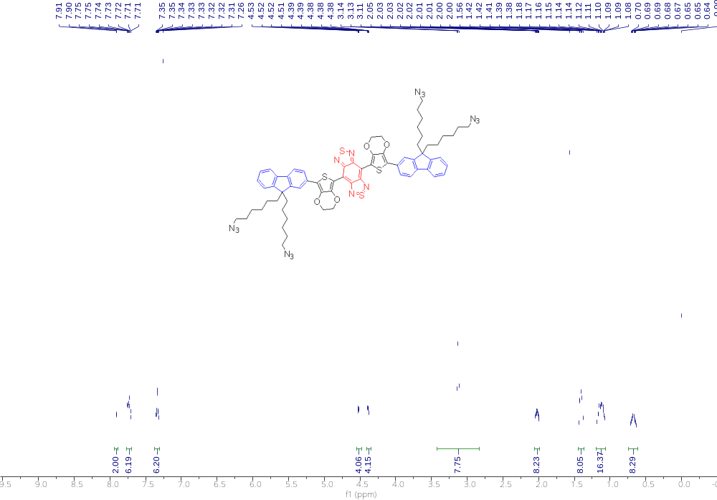
Fig. S8 ¹H NMR of compound 8.
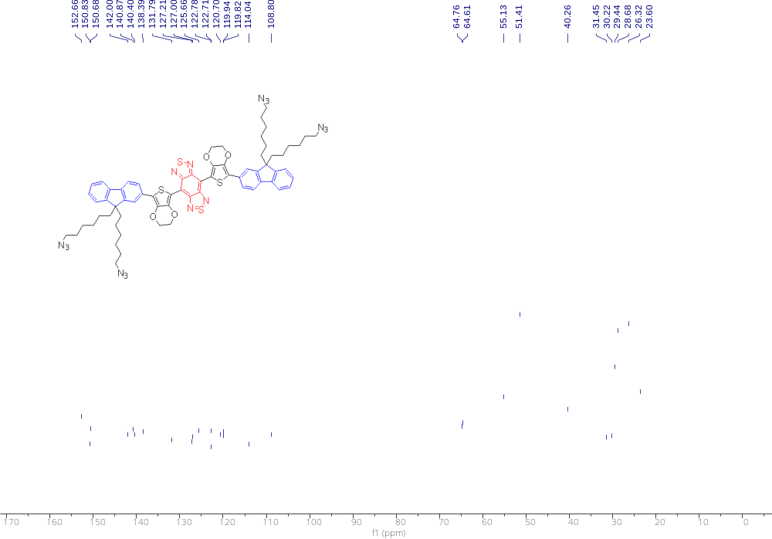
Fig. S9 ¹³C NMR of compound 8.
FEPT (10): The compound 8 (50 mg) was dissolved in 5 mL THF and copper(I) thiophene-2-carboxylate (CuTc) (10 mg), w-alkynyl-PEG- triphenylphosphonium bromide (Mw = 2000) (192 mg), and tris[(1-benzyl-1H-1,2,3-triazol-4-yl)methyl]amine (TBTA) (5 mg) were added. The system was stirred at RT for 2 h, then filtered with diatomite. The solvent was evaporated in vacuo. Then the crude product was purified by column chromatography under DCM/MeOH = 7:1 to give 177 mg of green viscous oil 10 (FEPT) in 87% yield. ¹H NMR (500 MHz, Chloroform-d) δ (ppm): δ 8.01 – 7.65 (m, 40H), 7.38 – 7.31 (m, 6H), 4.58 – 4.49 (m, 4H), 4.42 – 4.37 (m, 4H), 4.24 (t, J = 4.7 Hz, 8H), 4.21 – 4.15 (m, 6H), 4.10 (t, J = 4.9 Hz, 4H), 4.01 – 3.96 (m, 8H), 3.80 – 3.50 (m, 740H), 2.40 – 2.36 (m, 8H), 2.04 – 1.95 (m, 8H), 1.12 – 1.04 (m, 16H), 0.70 – 0.57 (m, 8H) ¹³C NMR (125 MHz, CDCl₃) δ (ppm): 156.80, 156.05, 152.57, 140.79, 135.44, 135.42, 133.68, 133.60, 130.76, 130.66, 117.92, 117.24, 113.95, 108.67, 80.27, 71.69, 70.68, 70.60, 70.54, 69.46, 69.15, 64.60, 64.46, 64.29, 64.15, 55.13, 40.99, 35.23, 31.86, 30.84, 30.05, 29.70, 29.57, 29.52, 29.32, 29.29, 29.25, 27.37, 23.73, 23.34, 22.64, 14.12, 13.76, 8.67. ³¹P NMR (500 MHz, Chloroform-d) δ (ppm): 20.47. HRMS (ESI) m/z [2654.4934±22(m+n)] [(M-2Br)²⁺].

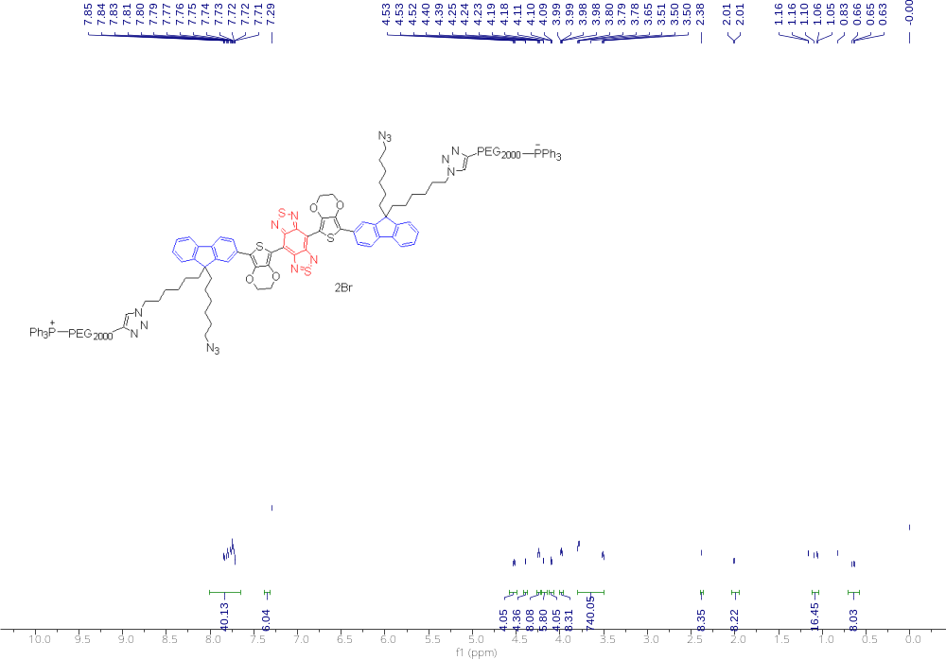
Fig. S10 ¹H NMR of compound FEPT.
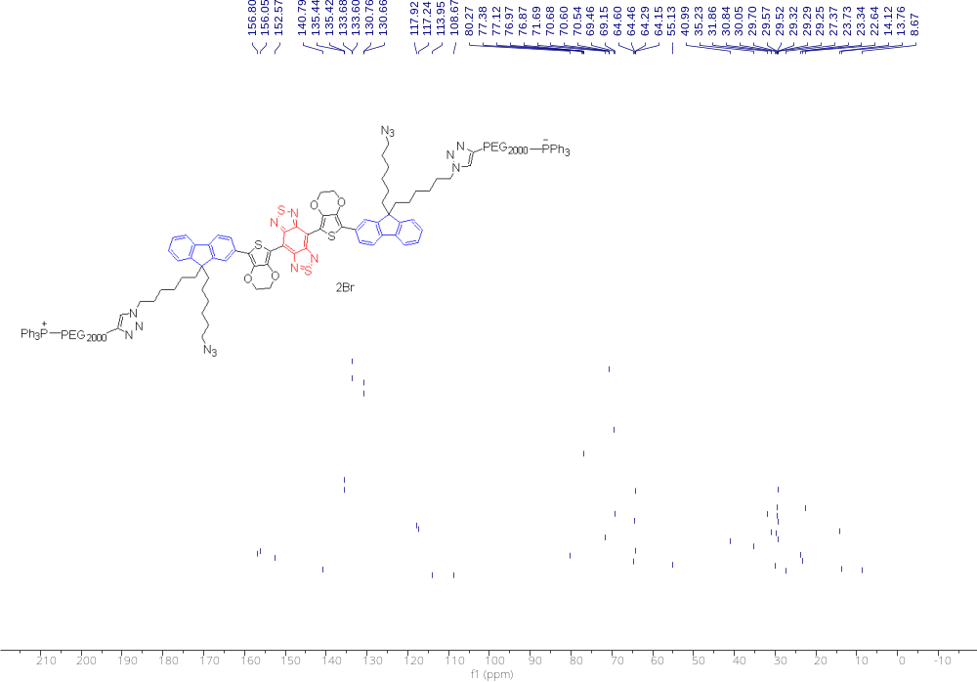
Fig. S11 ¹³C NMR of compound FEPT.
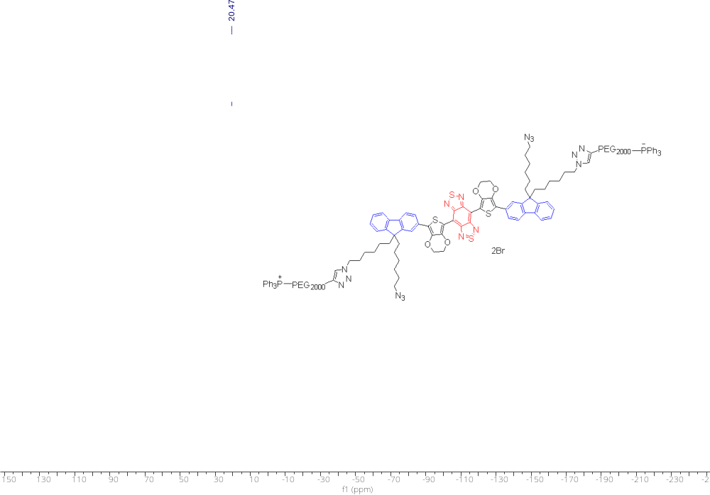
Fig. S12 ¹³P NMR of compound FEPT.
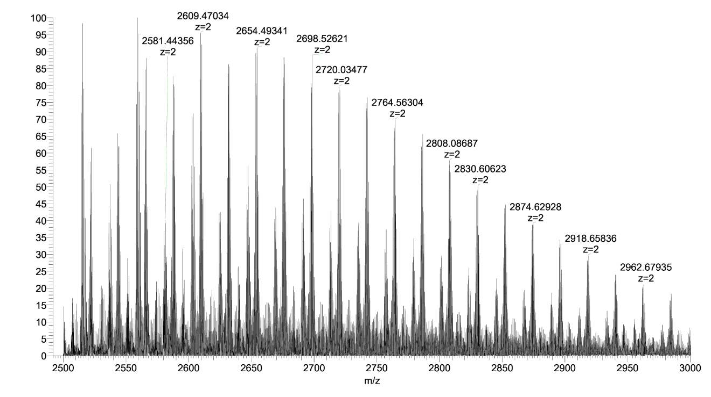
Fig. S13 HRMS of compound FEPT.

FEP (11): The compound 8 (20 mg) was dissolved in 5 mL THF and copper(I) thiophene-2-carboxylate (CuTc) (5 mg), w-alkynyl-PEG (Mw ≈ 2000) (38 mg), and tris[(1-benzyl-1H-1,2,3-triazol-4-yl)methyl]amine (TBTA) (1 mg) were added. The system was stirred at RT for 2 h, then filtered with diatomite. The solvent was evaporated in vacuo. Then the crude product was purified by column chromatography under DCM/MeOH = 7:1 to give 39 mg of green viscous oil 10 (FEP) in 90% yield. ¹H NMR (500 MHz, Methanol-d₄) δ 8.03 – 7.56 (m, 10H), 7.29 (s, 6H), 4.58 – 4.41 (m, 8H), 4.38 – 4.24 (m, 3H), 4.23 – 4.03 (m, 8H), 3.64 – 3.55 (m, 622H), 2.73 – 2.55 (m, 185H), 2.04 – 1.76 (m, 8H), 1.59 (d, J = 70.1 Hz, 8H), 0.94 – 0.80 (m, 16H), 0.53 (s, 8H). ¹³C NMR (125 MHz, Methanol-d₄) δ (ppm): δ 151.98, 144.44, 142.44, 140.71, 138.85, 132.06, 123.59, 120.11, 109.34, 79.49, 78.44, 74.93, 71.60, 70.18, 69.99, 69.38, 68.75, 63.68, 61.92, 57.81, 57.68, 54.97, 49.80, 48.55, 39.13, 31.71, 29.79, 29.44, 29.39, 29.33, 29.29, 29.11, 28.92, 27.88, 26.60, 25.83, 22.40, 18.89, 13.38, 13.24, 12.83. HRMS (ESI) m/z [4149.4325±44(m+n)] ⁺].

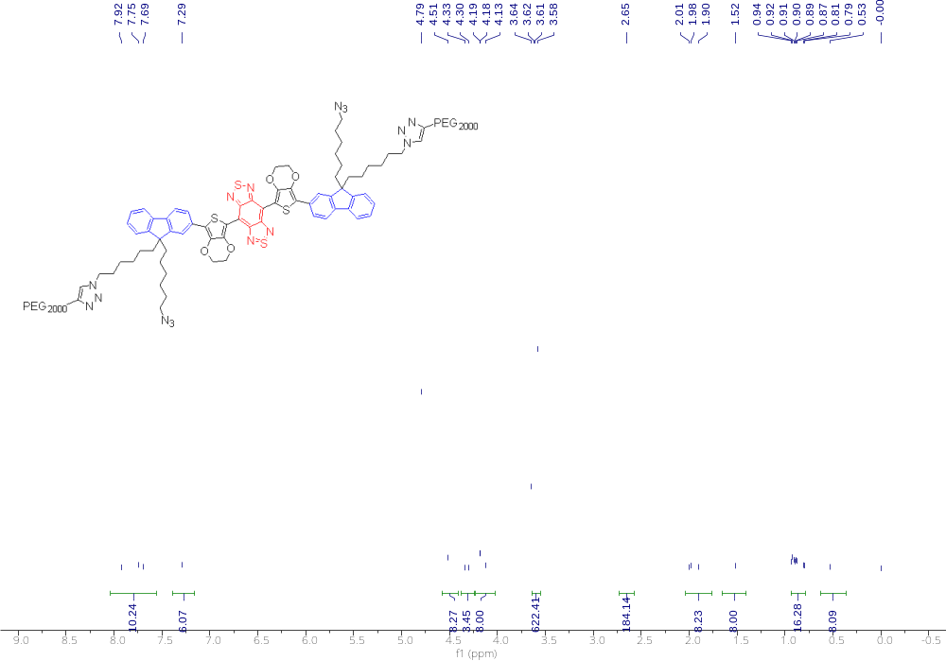
Fig. S14 ¹H NMR of compound FEP.
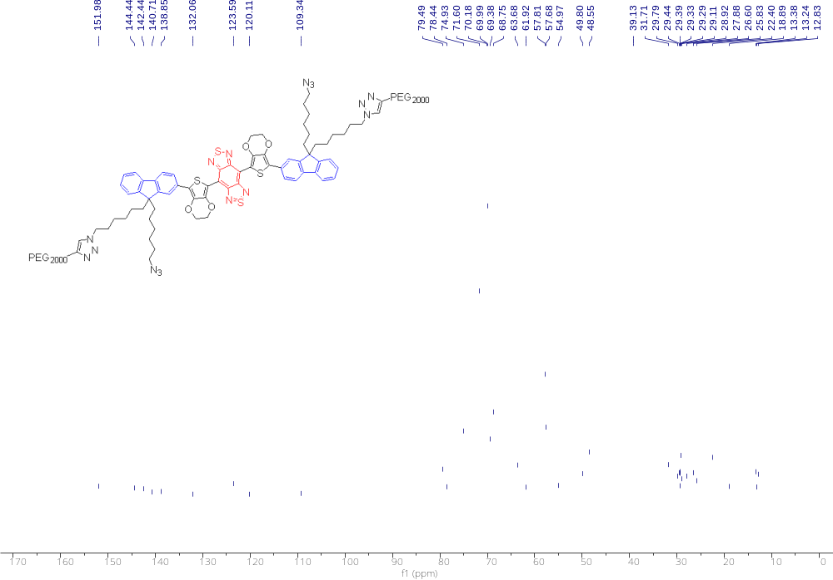
Fig. S15 ¹³C NMR of compound FEP.
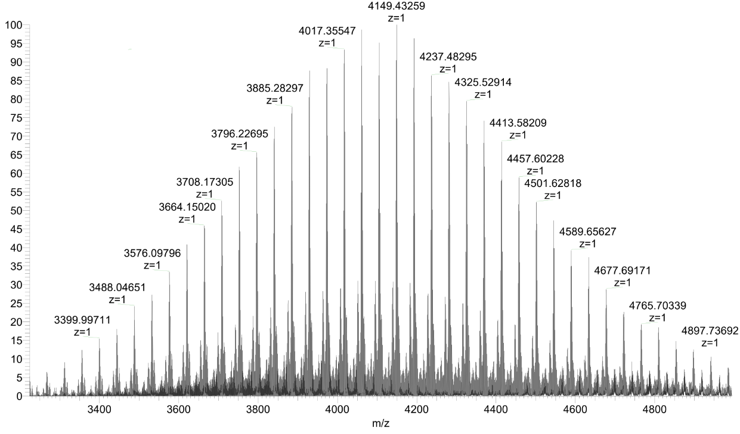
Fig. S16 HRMS of compound FEP.

Fig. S17 A UV-Vis absorbance spectra of FEPT. B UV-Vis absorbance of FEPT (black line) and NIR-II fluorescence emission of FEPT (red line) with a peak at 1085 nm under an 808 nm excitation laser (solvents: water). C The fluorescence emission of FEP (blackline) and FEPT (red line) under a 405 nm excitation laser (solvents: water). D Photothermal conversion performance curves of FEP.

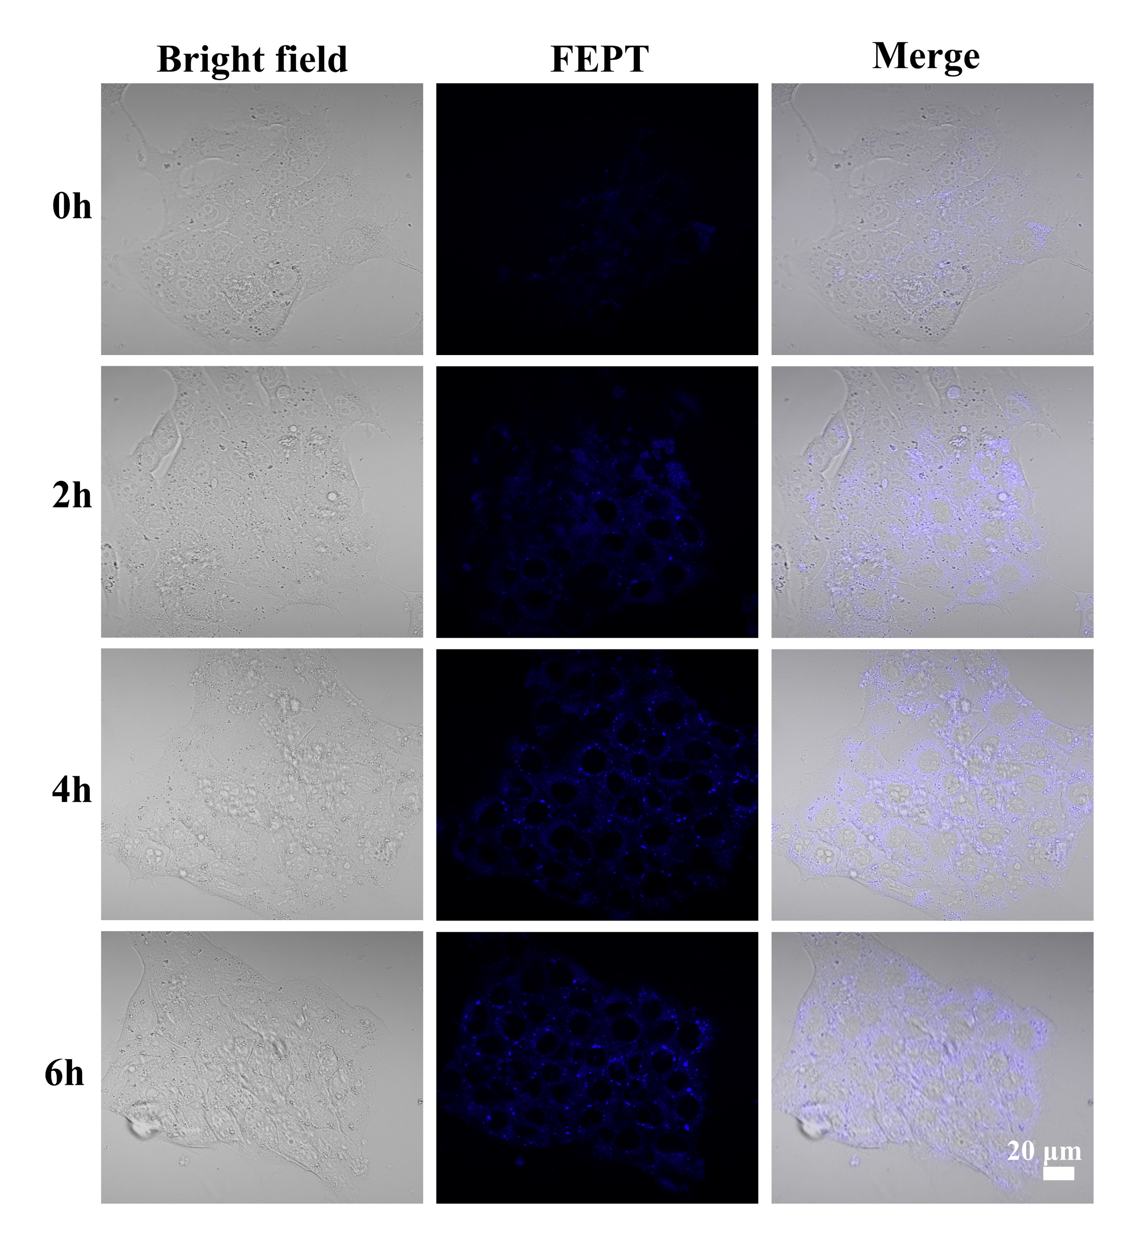
Fig. S18 Cellular uptake images of FEPT in 4T1 cells captured by fluorescence inverted microscope. Scale bar: 20 μm.
Fig. S19 A Mean fluorescence intensity of ROS in 4T1 cells detected with DCFH-DA probe after different treatments. B Change in mitochondrial membrane potential (ΔΨm) of the relative fluorescent intensity of JC-1 aggregates and monomer of 4T1 cells with FEPT incubated for 4 hours and 808 nm irradiation (1W/cm², 10 minutes). C Quantitative fluorescence intensity of cleaved caspase-3 in 4T1 cells with different treatments analyzed by CLSM. D Cleaved caspase-3 detection of 4T1 cells after different treatments by ELISA. Error bars: mean ± SD (n = 3). *P < 0.05; **P < 0.01; ***P < 0.001.

Fig. S20 Mean fluorescence intensity of cell live/dead imaging in 4T1 cells with different treatments. Live cells were marked with calcein-AM (green), while dead cells were marked with propidium (red). The power density of 808 nm laser was 1W/ cm² (10 minutes). Error bars: mean ± SD (n = 3). *P < 0.05; **P < 0.01; ***P < 0.001

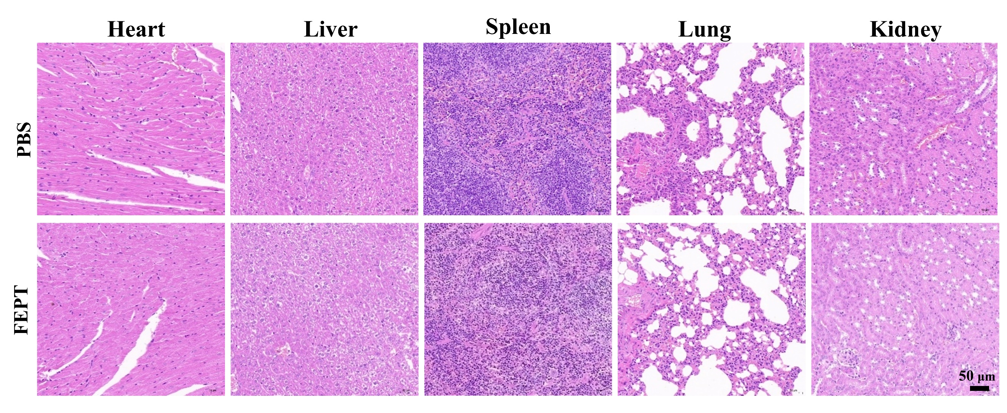
Fig. S21 H&E staining images of five major organs (heart, liver, spleen, lung and kidney) after injection with FEPT without 808 nm laser in healthy Balb/c mice at 15 days post-injection. Scale bar: 50 μm.

Fig. S22 A Blood routine examinations in the PBS and FEPT groups. B Chemistry indexes of the liver and renal function tests of PBS and FEPT groups. All the tests are detected in healthy Balb/c mice without NIR irradiation at 15 days post-injection.

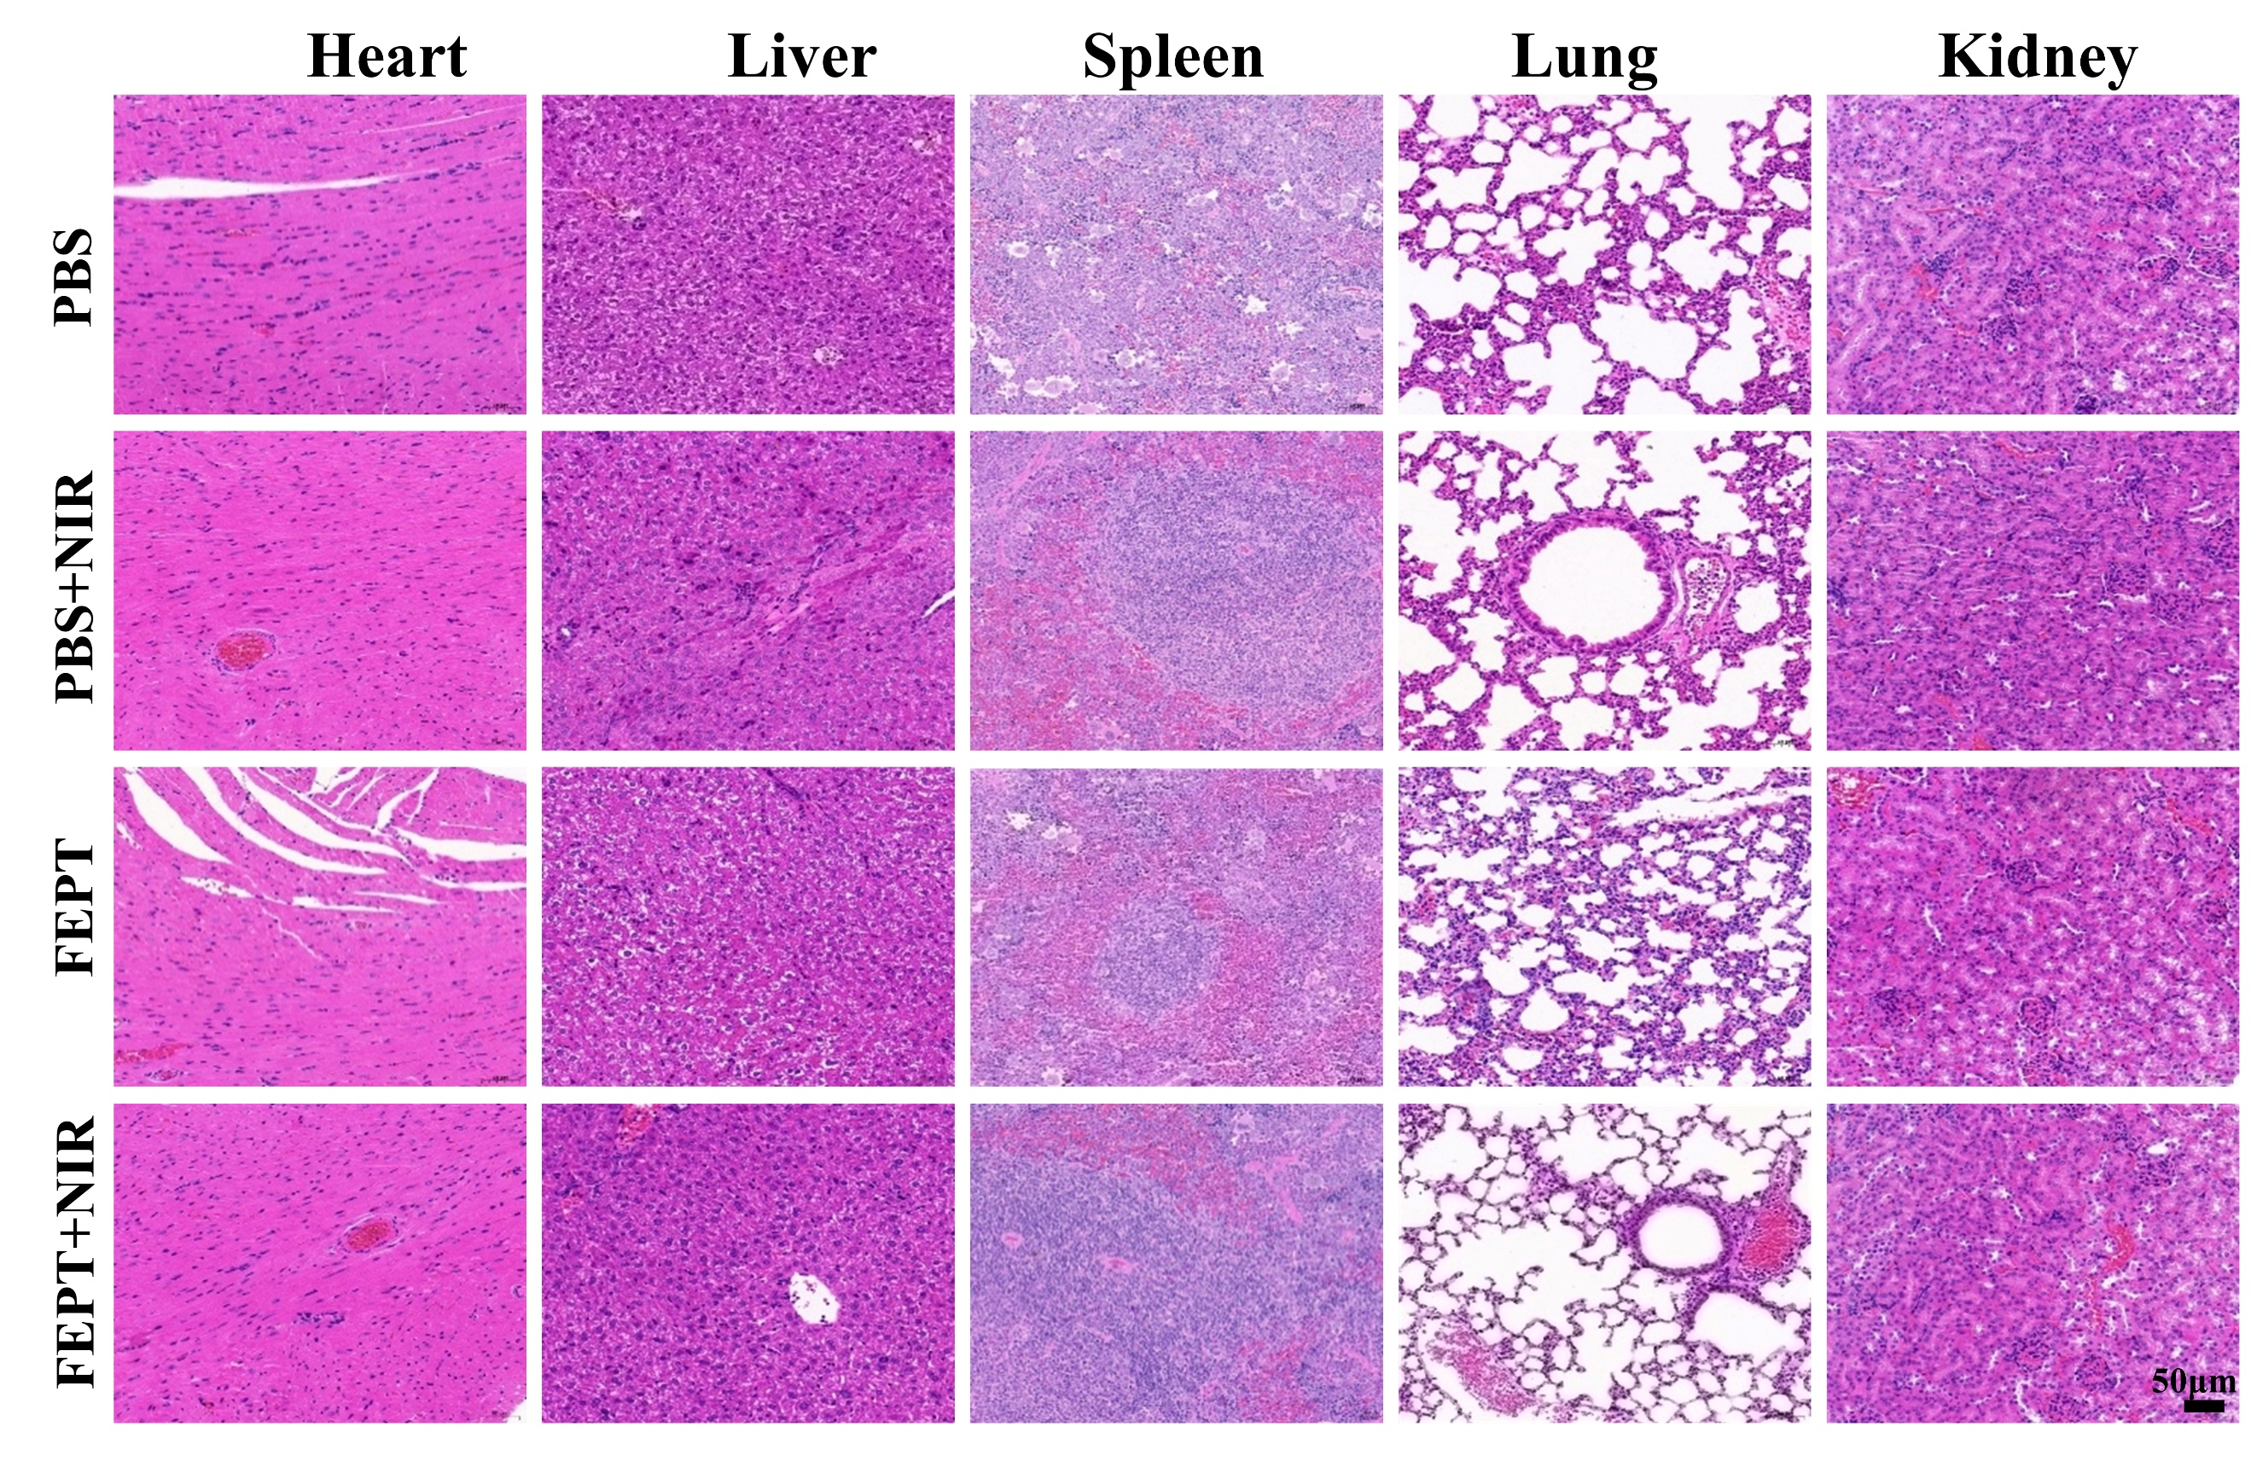
Fig. S23 H&E staining images of five major organs (heart, liver, spleen, lung, and kidneys) with different treatments after the anti-tumor therapy in 4T1 tumor-bearing mice on day 15. Scale bar: 50μm.

Fig. S24 Quantitative results of CD3⁺CD4⁺T cells, CD3⁺CD8⁺T cells, and Tregs in CD4⁺T cells in splenic lymphocytes isolated from various treated mice. Mean ± SD (n = 3). *P < 0.05; **P < 0.01; ***P < 0.001.
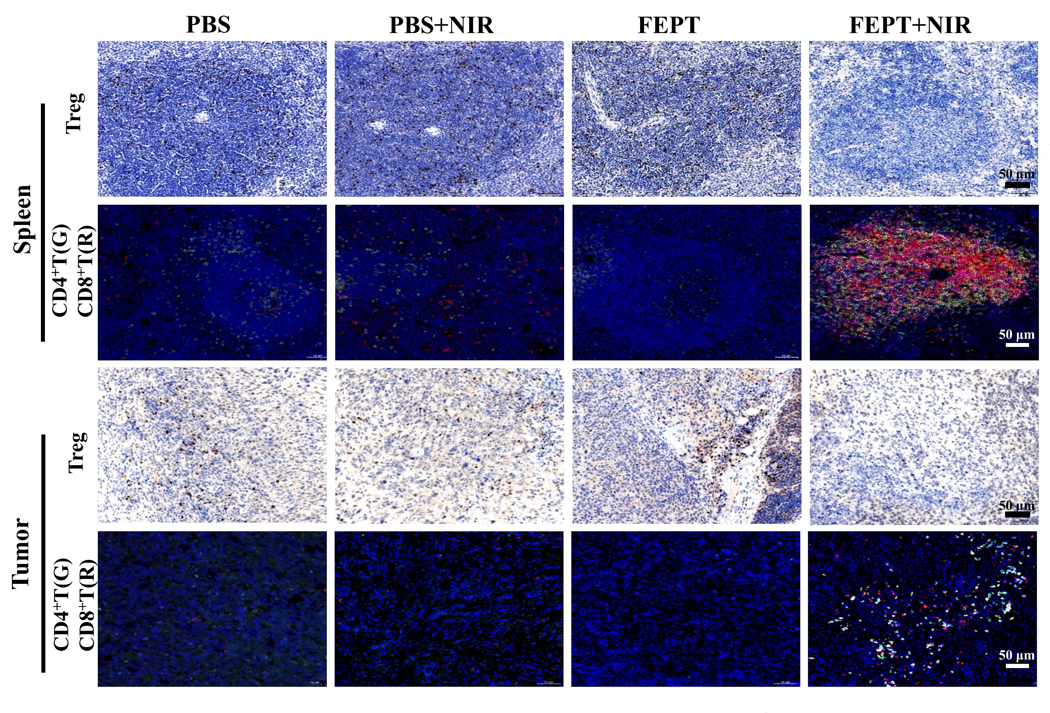
Fig. S25 The IHC analysis of Tregs and the IF analysis of infiltrating CD4⁺T (green) and CD8⁺T (red) cells in spleens and tumors. The blue signal in IHC and IF staining indicates cellular nuclei are stained with hematoxylin and Hoechst 33258, respectively. The positive signal of Tregs in IHC staining are brown. Green or red fluorescence signal indicates CD4⁺T, CD8⁺T cells, respectively. Scale bar: 50 μm.

Reference
1. Diao S, Hong G, Robinson JT, Jiao L, Antaris AL, Wu JZ, Choi CL, Dai H: Chirality Enriched (12,1) and (11,3) Single-Walled Carbon Nanotubes for Biological Imaging. J Am Chem Soc 2012, 134:16971-16974.
2. Yang Q, Ma Z, Wang H, Zhou B, Zhu S, Zhong Y, Wang J, Wan H, Antaris A, Ma R, et al: Rational Design of Molecular Fluorophores for Biological Imaging in the NIR-II Window. Adv Mater 2017, 29:1605497.
3. Wang Q, Xu J, Geng R, Cai J, Li J, Xie C, Tang W, Shen Q, Huang W, Fan Q: High performance one-for-all phototheranostics: NIR-II fluorescence imaging guided mitochondria-targeting phototherapy with a single-dose injection and 808 nm laser irradiation. Biomaterials 2020, 231:119671.

