Table S1. Sowing and transplanting dates of rice in the field from different regions of Jiangxi province
Date (day/month) | Jiujiang | Pingxiang | Nanchang | Jian | Fuzhou | Ganzhou
Sowing date | 1/4 | 29/3 | 28/3 | 26/3 | 28/3 | 25/3
Transplanting date | 29/4 | 28/4 | 27/4 | 23/4 | 26/4 | 21/4

Figure S1. GJDN1 exhibits greater AMF colonization than ZZ35. (a) Images of Rhizophagus irregularis growing on rice roots stained with Trypan blue at MA. Upper, Zhongzao 35 (ZZ35); Bottom: Ganjundao NO.1 (GJDN1). A, arbuscule; EH, extraradical hyphae; HP, hyphopodium; S, spore. Bars: 100μm. A significantly stronger colonization was observed in GJDN1 compared with ZZ35.

Table S2. Dry matter accumulation in GJDN1 and ZZ35 in the field in Pingxiang
Variety | Fertilization treatment | Dry matter weight at MA (t/hm²) | Harvest index (%)
ZZ35 | FM0(0%N) | 13.77 b | 50.47 a
ZZ35 | FM1(50%N) | 14.52 ab | 52.43 a
ZZ35 | FM2(75%N) | 14.62 ab | 52.34 a
ZZ35 | FM3(90%N) | 14.68 ab | 52.34 a
ZZ35 | CK(100%N) | 15.53 ab | 54.70 a
GJDN1 | FM0(0%N) | 14.56 ab | 52.82 a
GJDN1 | FM1(50%N) | 15.22 ab | 51.47 a
GJDN1 | FM2(75%N) | 15.23 ab | 52.18 a
GJDN1 | FM3(90%N) | 16.81 a | 52.80 a
GJDN1 | CK(100%N) | 16.75 a | 54.11 a
Variance  analysis | V | ** | ns
Variance  analysis | T | ** | ns
Variance  analysis | V×T | ns | ns
Values within a column followed by different lowercase letters are significantly different. V, variety; T, treatment; ns, not significant. *, P < 0.05; **, P < 0.01. ZZ35, Zhongzao35; GJDN1, Ganjundao NO.1. Five nitrogen application levels were set in this experiment, which were 0% (FM0), 50% (FM1), 75% (FM2), 90% (FM3), and 100% (CK) of the conventional nitrogen application.
Table S3. Yield of GJDN1 and ZZ35 in the field from different regions of Jiangxi province（t/hm²)
Variety | Fertilization treatment | Jiujiang | Pingxiang | Jinxian | Jian | Fuzhou | Ningdu
ZZ35 | FM0(0%N) | 6.96 c | 7.51 a | 5.65 d | 6.49 c | 5.87 b | 5.85 c
ZZ35 | FM1(50%N) | 7.98 b | 7.58 a | 6.19 c | 7.36 b | 7.32 a | 8.18 b
ZZ35 | FM2(75%N) | 8.88 a | 7.90 a | 6.94 b | 7.6 a | 7.47 a | 9.00 ab
ZZ35 | FM3(90%N) | 8.77 ab | 7.95 a | 7.31 ab | 7.63 a | 7.86 a | 9.58 a
ZZ35 | CK(100%N) | 9.03 a | 8.01 a | 7.48 a | 7.75 a | 7.83 a | 9.93 a
GJDN1 | FM0(0%N) | 7.36 d | 7.87 a | 5.84 d | 6.87 b | 6.09 b | 6.08 b
GJDN1 | FM1(50%N) | 8.21 b | 8.11 a | 6.30 c | 7.84 a | 7.67 a | 8.41 a
GJDN1 | FM2(75%N) | 9.11 a | 8.47 a | 7.29 b | 8.09 a | 7.72 a | 9.61 a
GJDN1 | FM3(90%N) | 9.16 a | 8.54 a | 7.56 ab | 8.20 a | 7.87 a | 9.93 a
GJDN1 | CK(100%N) | 9.09 a | 8.55 a | 7.74 a | 8.01 a | 7.67 a | 10.14 a
Variance  analysis | V | * | ** | ** | ** | ns | ns
Variance  analysis | T | ** | * | ** | ** | ** | **
Variance  analysis | V×T | ns | ns | ns | ns | ns | ns
Values within a column followed by different lowercase letters are significantly different. V, variety; T, treatment; ns, not significant. *, P < 0.05; **, P < 0.01. ZZ35, Zhongzao35; GJDN1, Ganjundao NO.1. Five nitrogen application levels were set in this experiment, which were 0% (FM0), 50% (FM1), 75% (FM2), 90% (FM3), and 100% (CK) of the conventional nitrogen application.

Table S4. Yield components of GJDN1 and ZZ35 in the field in Pingxiang
Variety | Fertilization treatment | Panicles per plant | Spikelets per panicle | Filled grains rate (%) | 1000-grain  weight (g)
ZZ35 | FM0(0%N) | 9.78 c | 129.09 a | 84.98 a | 24.32 a
ZZ35 | FM1(50%N) | 10.78 bc | 131.20 a | 81.43 ab | 23.30 ab
ZZ35 | FM2(75%N) | 10.67 bc | 134.99 a | 83.17 ab | 23.31 ab
ZZ35 | FM3(90%N) | 11.33 ab | 134.64 a | 79.40 b | 23.20 ab
ZZ35 | CK(100%N) | 11.33 ab | 137.91 a | 80.07 ab | 23.24 ab
GJDN1 | FM0(0%N) | 10.56 bc | 127.93 a | 84.52 a | 23.92 ab
GJDN1 | FM1(50%N) | 11.56 ab | 126.68 a | 82.98 ab | 23.27 ab
GJDN1 | FM2(75%N) | 11.67 ab | 129.13 a | 82.94 ab | 23.42 ab
GJDN1 | FM3(90%N) | 12.00 a | 134.36 a | 80.02 ab | 22.76 b
GJDN1 | CK(100%N) | 12.33 a | 128.59 a | 80.30 ab | 23.14 ab
Variance  analysis | V | ** | ns | ns | ns
Variance  analysis | T | ** | ns | ** | **
Variance  analysis | V×T | ns | ns | ns | ns
Values within a column followed by different lowercase letters are significantly different. V, variety; T, treatment; ns, not significant. *, P < 0.05; **, P < 0.01. ZZ35, Zhongzao35; GJDN1, Ganjundao NO.1. Five nitrogen application levels were set in this experiment, which were 0% (FM0), 50% (FM1), 75% (FM2), 90% (FM3), and 100% (CK) of the conventional nitrogen application.
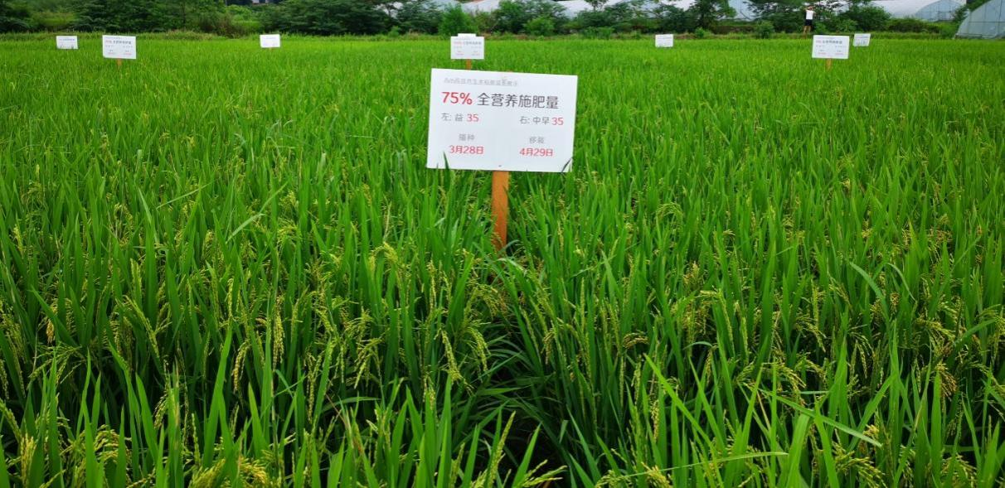
Figure S2. Gross morphological phenotypes of GJDN1 (left) and ZZ35 (right) grown in the field in Pingxiang

Table S5. Nutrient accumulation of GJDN1 and ZZ35 in the field in Pingxiang
Variety | Fertilization treatment | Nitrogen（×10^{–2} t/hm²） | Phosphate（×10^{–2} t/hm²） | Potassium（×10^{–2} t/hm²）
ZZ35 | FM0(0%N) | 7.72 g | 11.67 c | 24.15 bc
ZZ35 | FM1(50%N) | 11.01 e | 13.59 abc | 25.29 bc
ZZ35 | FM2(75%N) | 12.27 cd | 12.67 bc | 23.43 c
ZZ35 | FM3(90%N) | 12.76 bc | 13.58 abc | 23.68 c
ZZ35 | CK(100%N) | 12.80 bc | 14.26 ab | 33.08 a
GJDN1 | FM0(0%N) | 8.58 f | 12.31 bc | 25.63 bc
GJDN1 | FM1(50%N) | 11.77 d | 13.56 abc | 27.61 abc
GJDN1 | FM2(75%N) | 13.09 b | 14.09 abc | 29.19 abc
GJDN1 | FM3(90%N) | 13.90 a | 13.26 abc | 30.21 ab
GJDN1 | CK(100%N) | 14.36 a | 15.45 a | 32.88 a
Variance  analysis | V | ** | ns | **
Variance  analysis | T | ** | ** | **
Variance  analysis | V×T | * | ns | ns
Values within a column followed by different lowercase letters are significantly different. V, variety; T, treatment; ns, not significant. *, P < 0.05; **, P < 0.01. ZZ35, Zhongzao35; GJDN1, Ganjundao NO.1. Five nitrogen application levels were set in this experiment, which were 0% (FM0), 50% (FM1), 75% (FM2), 90% (FM3), and 100% (CK) of the conventional nitrogen application.

Table S6. Nitrogen efficiency of GJDN1 and ZZ35 in the field in Pingxiang
Variety | Fertilization  treatment | NRE  (%) | NPFP  (kg kg^{–1}) | NGPE  (g g^{–1}) | NDMPE  (kg kg^{–1}) | NEG  (kg)
ZZ35 | FM0(0%N) | - | - | 101.36 a | 178.40 a | 0.986 f
ZZ35 | FM1(50%N) | 36.60 bcd | 89.45 a | 73.12 b | 131.85 b | 1.368 e
ZZ35 | FM2(75%N) | 33.67 cde | 62.11 b | 68.34 b | 119.18 b | 1.463 cd
ZZ35 | FM3(90%N) | 31.14 de | 52.03 b | 66.03 b | 114.98 b | 1.514 bc
ZZ35 | CK(100%N) | 28.21 e | 48.57 b | 68.33 b | 121.35 b | 1.464 cd
GJD1H | FM0(0%N) | - | - | 95.47 a | 169.69 a | 1.047 f
GJD1H | FM1(50%N) | 45.02 a | 94.20 a | 72.00 bc | 129.27 b | 1.389 de
GJD1H | FM2(75%N) | 39.76 abc | 65.04 b | 67.05 b | 116.34 b | 1.491 bc
GJD1H | FM3(90%N) | 38.16 bc | 54.36 b | 63.33 b | 120.91 b | 1.579 ab
GJD1H | CK(100%N) | 36.87 bcd | 49.02 b | 61.47 b | 116.68 b | 1.627 a
Variance  analysis | V | ** | ns | ns | ns | **
Variance  analysis | T | ** | ** | ** | ** | **
Variance  analysis | V×T | ns | ns | ns | ns | *
Values within a column followed by different lowercase letters are significantly different. V, variety; T, treatment; ns, not significant. *, P < 0.05; **, P < 0.01.NRE, N recovery efficiency; NPFP, N partial factor productivity; NGPE, N grain production efficiency; NDMPE, N dry matter production efficiency; NEG, N requirement for 100-kg grain. ZZ35, Zhongzao35; GJDN1, Ganjundao NO.1. Five nitrogen application levels were set in this experiment, which were 0% (FM0), 50% (FM1), 75% (FM2), 90% (FM3), and 100% (CK) of the conventional nitrogen application.

