Enhanced osmotic transport in individual double-walled carbon nanotube
Supplementary Information
Guandong Cui^{1,2}, Zhi Xu^{1,2}, Han Li^{1,2}, Alessandro Siria³, Ming Ma^{1,2*}
¹Department of Mechanical Engineering, State Key Laboratory of Tribology in Advanced Equipment, Tsinghua University, Beijing 100084, China.
²Center for Nano and Micro Mechanics, Tsinghua University, Beijing 100084, China.
³Laboratoire de Physique de l’Ecole normale Supérieure, ENS, Université PSL, CNRS, Sorbonne Université, Université de Paris, Paris, France.

In this supplementary information, we provide additional details on certain aspects of the study reported in the manuscript. The following issues are discussed:
- Fabrication process of individual carbon nanotube nanofluidic chip
- Sealing test of individual carbon nanotube nanofluidic chip
- The calculations of slip length

- Fabrication process of individual carbon nanotube nanofluidic chip
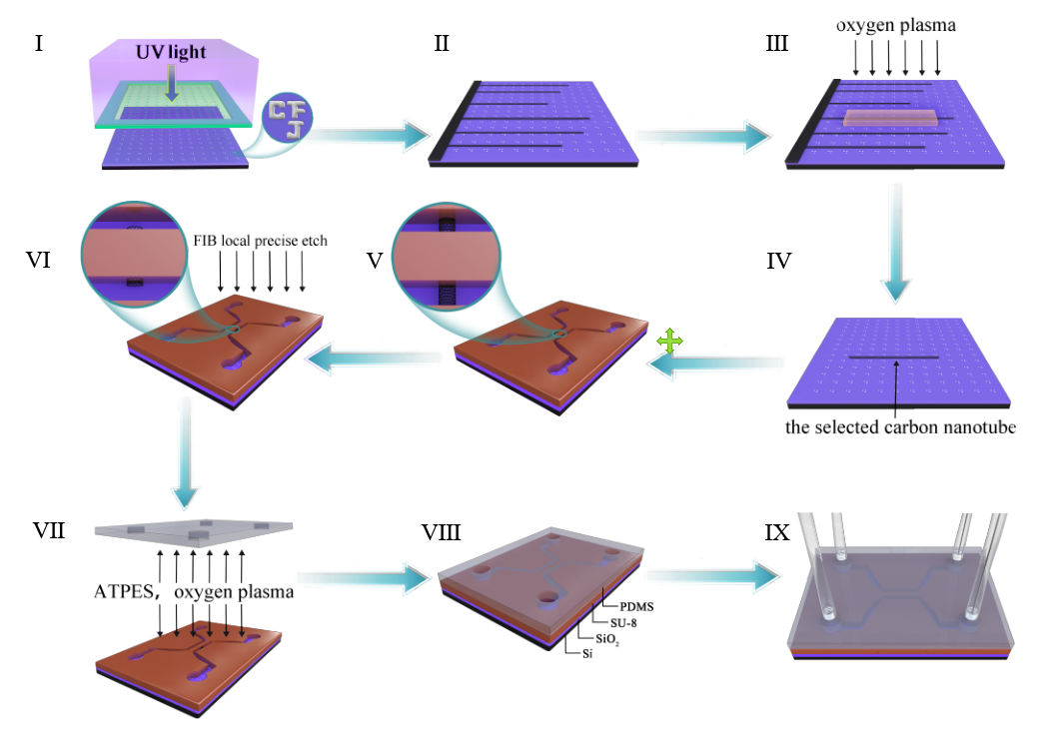
Figure S1. Fabrication process of individual carbon nanotube nanofluidic chip. The specific markers that indicate the position of the CNT on silicon wafer are etched by RIE technique. Ultra-long horizontally aligned CNTs are grown using CVD. Only one CNT is remained as the specific nanochannel in the device and protected using positive photoresist, whereas all other CNTs are removed by oxygen plasma etching process. SU-8 photoresist is used to fabricate the two independent microchannels for reservoirs of ionic solution and a mask against plasma etching. By alignment lithography technology, the microfluidic channels are precisely constructed on silicon wafer. The FIB precise etching technology removes the exposed parts of the CNT and opens both ends of CNT underneath the epoxy wall, which connects the two microchannels. The PDMS is bonded on the SU8 microchannels after being immersed in an aqueous solution of ATPES. Then assemble the liquid inlet and outlet pipes, as well as the Ag/AgCl electrode.

- Sealing test of individual carbon nanotube nanofluidic chip
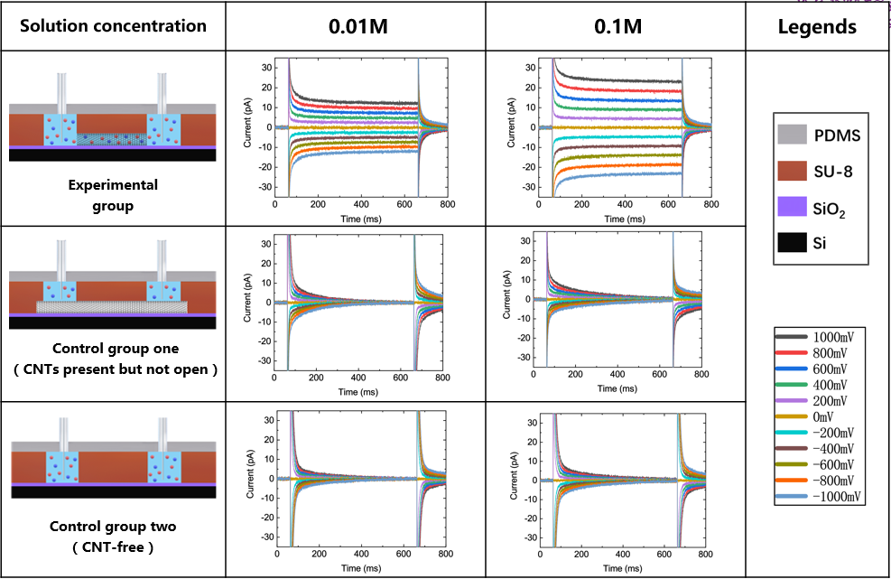
Figure S2. Sealing test of individual carbon nanotube nanofluidic chip. The two reservoirs formed by SU8 are separated either without any tube connecting them or connecting with close-ended CNT. The I -V curve is measured using Axopatch 200B and is calibrated by model cell. Using the same protocol for the I-V measurements with the open-ended CNT nanofluidic device, all the control devices displayed negligible conductance (i.e. ∼1pS) that was independent of the salt concentration. Such small current is contributed to the intrinsic electrical conduction through the substrate and the other materials constituting the microfluidic devices. Therefore, these comparative experiments suggest that the current can only be induced by electrolyte ions flow inside the individual carbon nanotube as shown below.

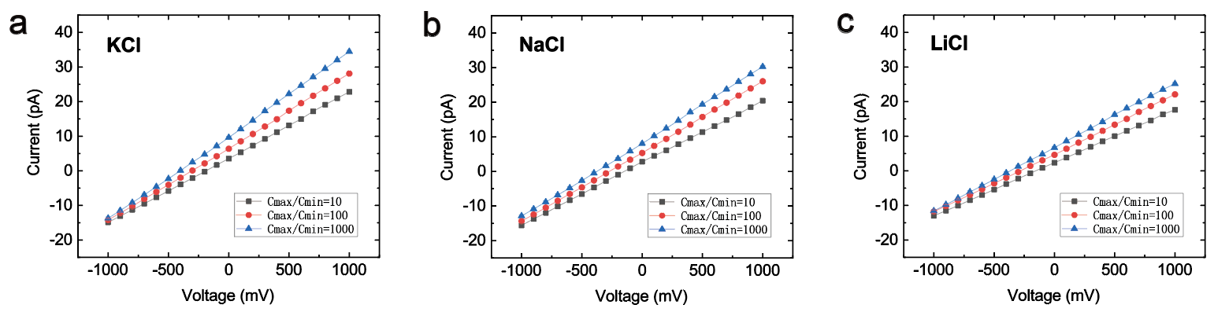
Figure S3. Osmotic power generation under salinity gradients. Current vs voltage for various concentration drops across single CNT nanochannel with KCl (a), with NaCl (b) and with LiCl (c).

3. The calculations of slip length
As presented in the main text, the surface conductivity of the single double-walled CNT can be expressed as
$$\begin{aligned}K_{surf}=\frac{2}{R}\left[μe\left|Σ_{m}\right|\left(1+δ\right)\frac{χ}{\sqrt{1+χ^{2}}+1}+\frac{b_{0}}{η}\frac{{\left(1-α_{ion}\right)}^{2}Σ_{m}^{2}}{1+β_{s}\frac{\left|Σ_{m}\right|}{e}l_{B}^{2}}+eμ_{m}\left|Σ_{m}\right|\right], \#\left(S1\right)\end{aligned}$$
where $δ=1/2πl_{B}μη$, $χ=2πλ_{D}l_{B}Σ_{m}/e$, $λ_{D}={\left(8πl_{B}C_{s}\right)}^{-1/2}$, $Σ_{m}$ is surface charge density and $b_{0}$ is the slip length in the absence of ions. The value of the parameters can be found in the table S1. We use the values of surface charge density for pristine graphene (1), as the pH values of KCl solution are the same. $Σ_{m}=γ_{1}C_{S}^{γ_{2}}$, where $γ_{1}=0.0112$, $γ_{2}=0.42$ with C_{s} in the units of mM. From C_{s} = 1 mM to 1 M, $Σ_{m}$ increase from 0.01 C/m² to 0.20 C/m². Here we consider $α_{ion}=0.8$ which is the same as previous literatures for KCl solution sliding on pristine graphene surface (2). Through the conductivity measurement for a series concentration of KCl solution, we used the least square fit method to obtain $b_{0}=21 μm$ and $β_{s}=105$. $b_{0}$ is the same for NaCl and LiCl solutions transporting through CNT, because $b_{0}$ is the slip length in the absence of ions. For NaCl and LiCl solutions, due to the similar electronegativity of the cations and the same type of physisorbed ions OH⁻ on the carbon surface, it is reasonable to assume that the surface charge $Σ_{m}$ would remain. And the physisorbed ions OH⁻ for different solutions suggest the same $λ_{w},$ which is the friction coefficient of physisorbed ions and wall. With the conductivity measurement for different concentrations of NaCl and LiCl solutions, the least square fit method was used to obtain $α_{ion}$ and $β_{s}$. $β_{s}/α_{ion}=λ_{w}/λ_{0}$ is controlled as a constant during the fitting process. As a result, $(α_{ion},β_{s})$ are (0.815, 107) and (0.833, 109) for NaCl and LiCl respectively. With these values, the friction coefficient between physisorbed ions and solutions $λ_{s}$are $2.2×{10}^{4}$, $2.5×{10}^{4}$, $2.8×{10}^{4} kg/(s·m2)$ for KCl, NaCl and LiCl respectively.

Table S1 The value of parameters for equation (2)
R | Diameter | 4.6 nm
$μ_{KCl}$/$μ_{NaCl}$/$μ_{LiCl}$ | Ion mobility | 4.86/4.10/3.73 ×10¹¹ s/kg
$$μ_{m}$$ | Mobility of physiosorbed ions | 1.3×10¹² s/kg
e | Elementary charge | 1.6×10⁻¹⁹ C
$$k_{B}$$ | Boltzmann constant | 1.38×10²³
T | temperature | 298 K
$$η$$ | viscosity | 8.9×10⁻⁴ kg/(s·m)
$$C_{s}$$ | Concentration | 0.001 – 1 M
$α_{ion} ($K⁺/Na⁺/Li⁺$)$ | $$λ_{s}/(λ_{s}+λ_{w})$$ | 0.8/0.815/0.833
$β_{s} ($K⁺/Na⁺/Li⁺$)$ | $$\frac{1}{λ_{0}}\frac{λ_{s}λ_{w}}{λ_{s}+λ_{w}}$$ | 105/107/109
$$λ_{0}$$ | Water-wall friction coefficient | 42.38 kg/(s·m²)
$λ_{s}$ (K⁺/Na⁺/Li⁺) | Ion-wall friction coefficient | 2.2×10⁴/2.5×10⁴/2.8×10⁴ kg/(s·m²)
$$λ_{w}$$ | Ion-water friction coefficient | 5.6×103 kg/(s·m²)

References:
1. T. Emmerich et al., Enhanced nanofluidic transport in activated carbon nanoconduits. Nat. Mater., (2022).
2. T. Mouterde et al., Molecular streaming and its voltage control in angstrom-scale channels. Nature 567, 87-+ (2019).

