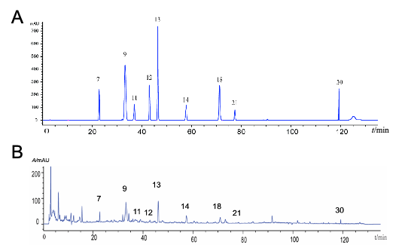
Supplement Fig. 1 HPLC chromatograms of the standard substance and extract of YGY (A) HPLC chromatograms of the standard substances. (B) HPLC chromatogram of YGY extract. 7 Geniposidic acid; 9, Morroniside; 11, Chlorogenic acid; 12, Geniposide; 13, Loganin; 14, Pinoresinol diglucoside; 18, Liquiritin; 21, Rutin; 30, Glycyrhizic acid.

Tab. 1 The quality control of YGY aqueous extract.
NO. | Bioactive components | Content (mg·g⁻¹)
7 | Geniposidic acid | 0.1046
9 | Morroniside | 0.3487
11 | Chlorogenic acid | 0.1100
12 | Geniposide | 0.0850
13 | Loganin | 0.1880
14 | Pinoresinol diglucoside | 0.1630
18 | Liquiritin | 0.0610
21 | Rutin | 0.1600
30 | Glycyrrhizic acid | 0.0791

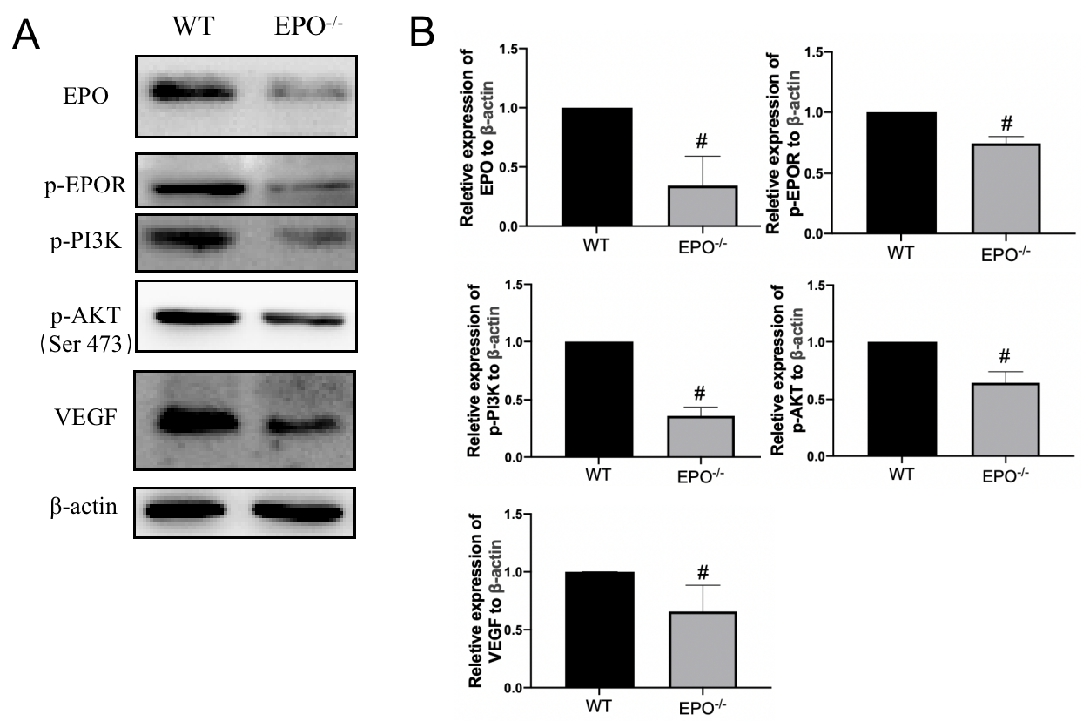
Supplement Fig. 11 EPO^{-/-} mice reduced the EPO/VEGF-related pathway in the renal cortex. (A)(B) Expression of EPO/VEGF pathway-related proteins in the kidney of EPO^{-/-} mice was significantly reduced. Values are expressed as mean±SD, n=3. #P<0.05 compared with NC group.

