Supplementally Tables & Figures
Development of softening and ballasted flocculation as a pretreatment process for seawater desalination through a reverse osmosis membrane

Tomohiro Yadai, Yoshihiro Suzuki*
Department of Civil and Environmental Engineering, Faculty of Engineering, University of Miyazaki, Gakuen Kibanadai-Nishi 1-1, Miyazaki 889-2192, Japan

*Corresponding author
E-mail: ysuzuki@cc.miyazaki-u.ac.jp

Table S1. The characteristics of treated water quality by softening for actual seawater collected from different sampling points.

(a) Aoshima Port
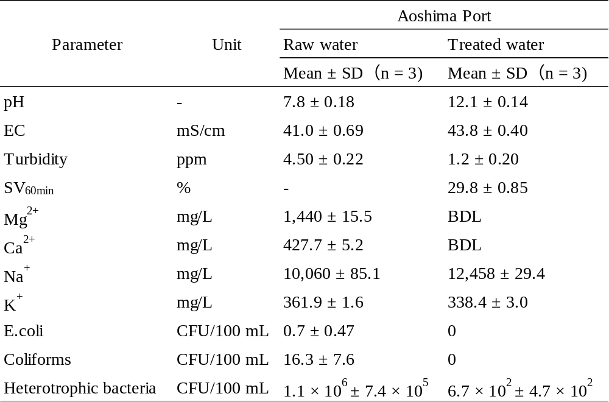

(b) Tsukunami River
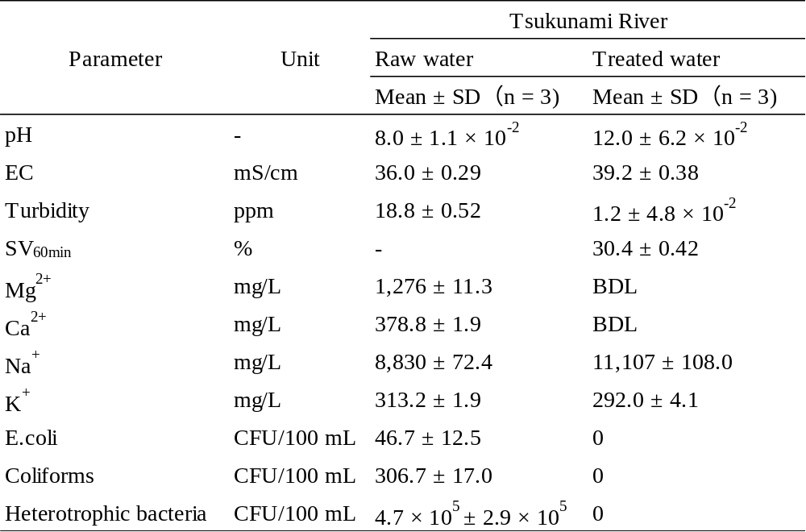

(c) Kizaki Beach
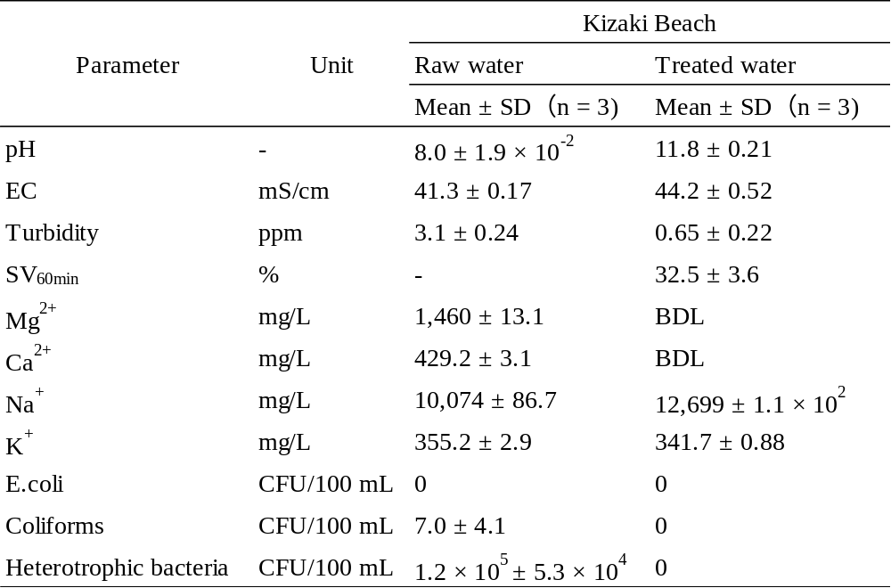

(d) Miyazaki Port
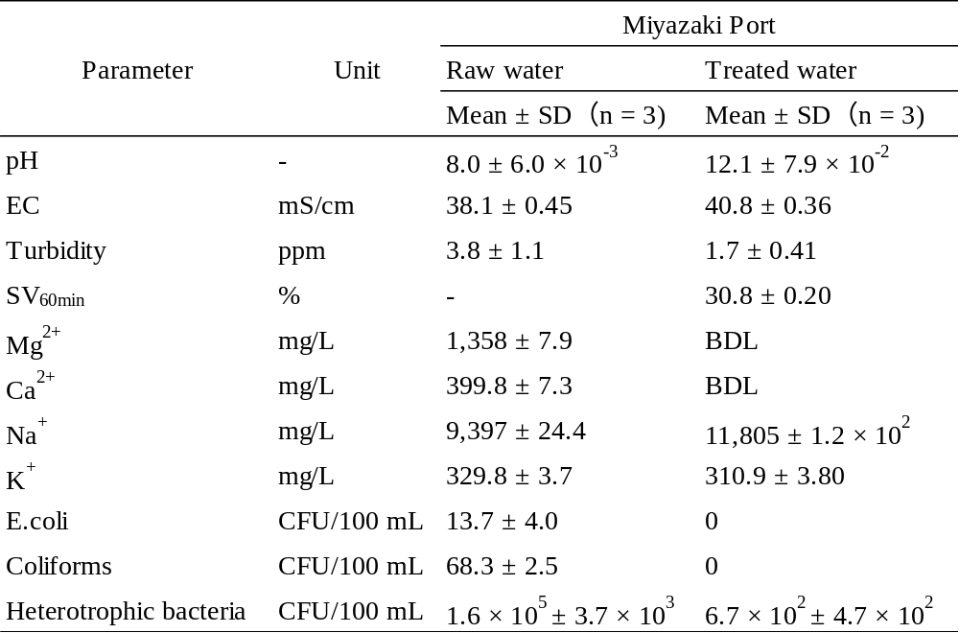

(e) Sun-Marina Port
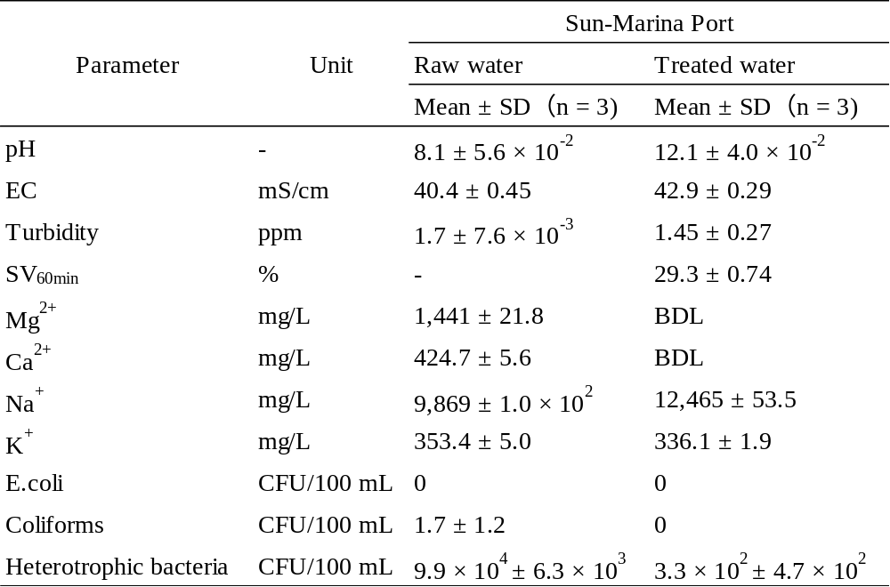

Table S2. Properties of polymer coagulants

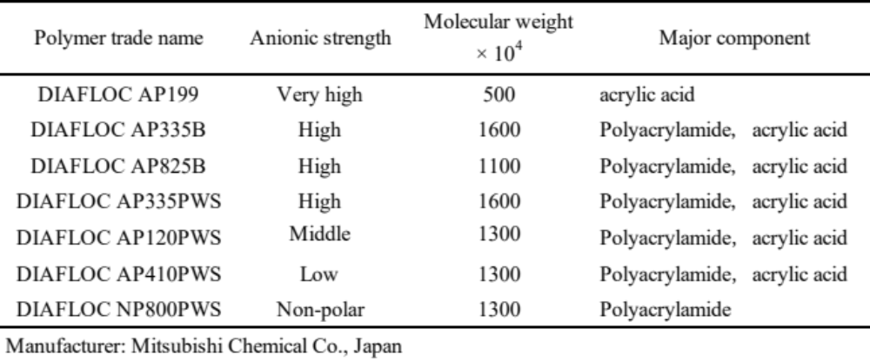

Table S3. The SDI values of raw seawater and treated seawater obtained by actual seawater samples

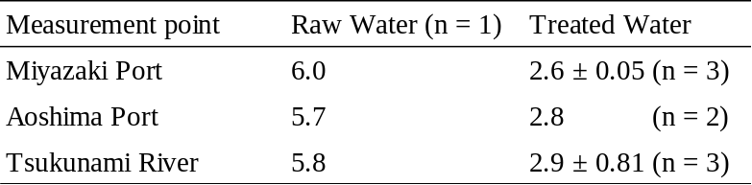

Table S4. The Ruth definitional constants K and C in the dehydration test of each sample

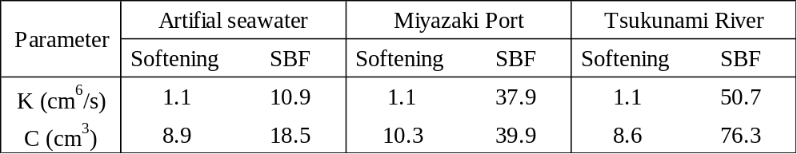

Table S5. The composition of artificial seawater
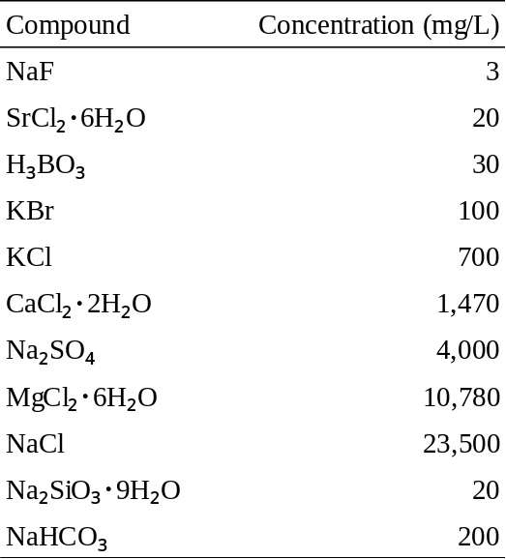

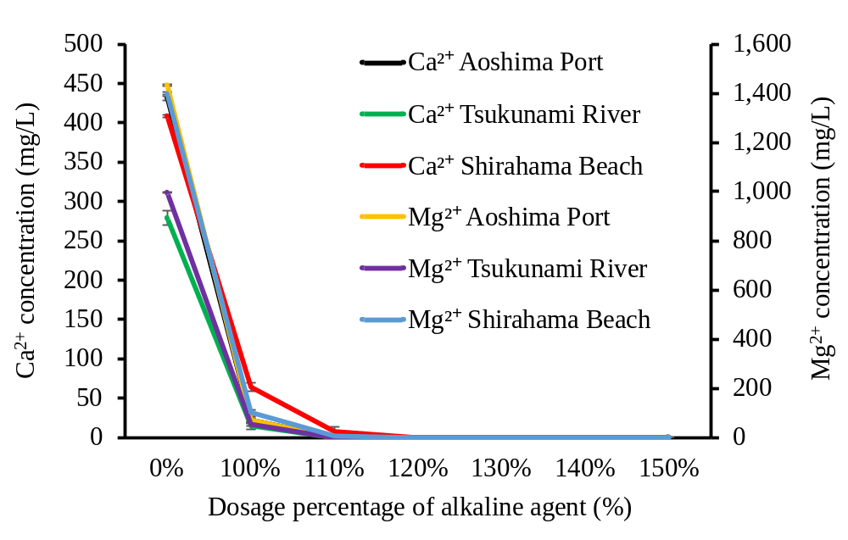

Fig. S1. Changes in concentrations of Mg²⁺ and Ca²⁺ at each dosage parentage of alkaline agent by conventional softening for three actual seawaters.
(n = 3, Mean ± standard deviation)

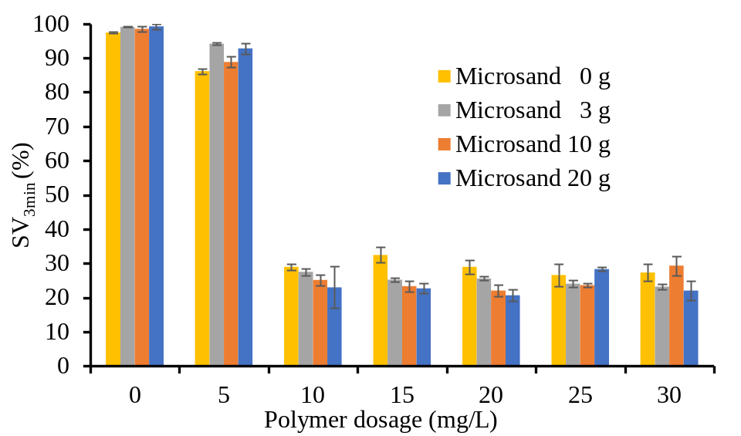

Fig. S2. Sludge Volume after 3 min (SV_{3min}) at each dosage of micro-sand.
(n = 3, Mean ± standard deviation)

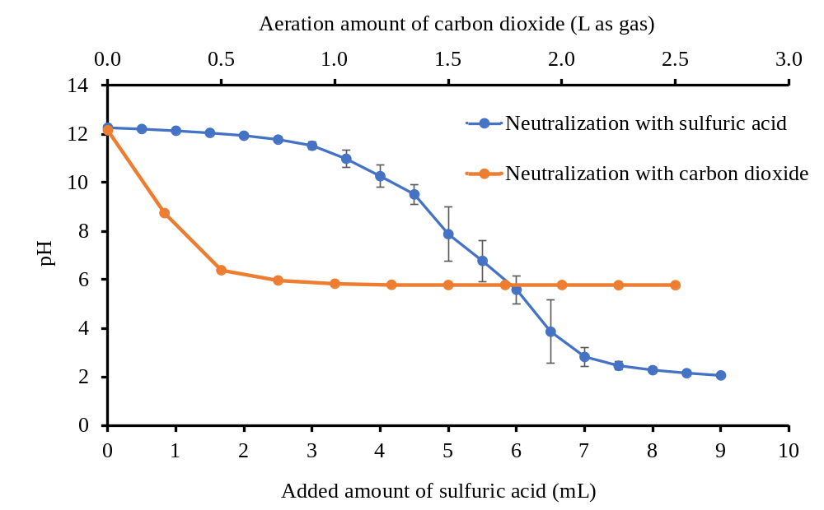

Fig. S3. Change in pH by neutralization with sulfuric acid solution (1 mol/L) and CO₂ gas. (n = 3, Mean ± standard deviation)

