Supplementary Materials

N-space (NS)-Framework: a generalized solution for soft continuum robots via reinforcement learning
Dehao Wei^{1,2}, Jiaqi Zhou^{1,2}, Yinheng Zhu^{1,2}, Jiabin Ma^{1,2} and Shaohua Ma^{1,2,3}
- Tsinghua Shenzhen International Graduate School (SIGS), Tsinghua University, Shenzhen 518055, China
- Tsinghua-Berkeley Shenzhen Institute (TBSI), Shenzhen 518055, China
- Corresponding Email: ma.shaohua@sz.tsinghua.edu.cn

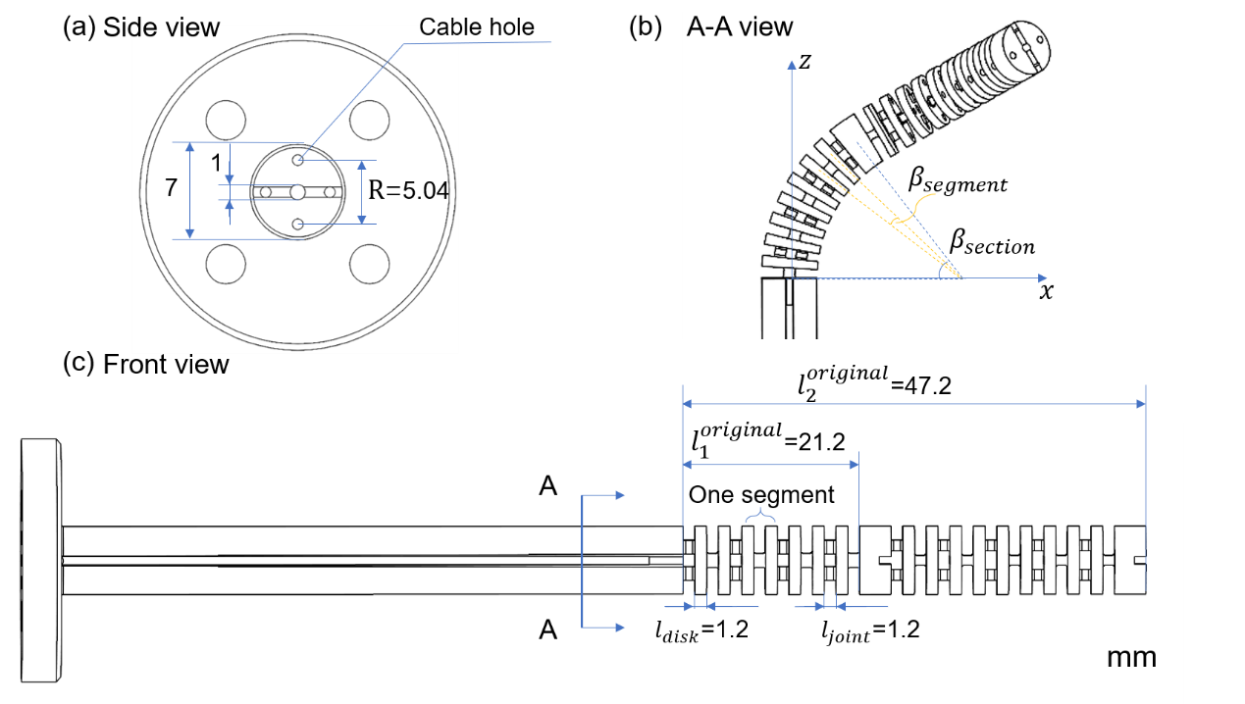
Supplementary Figure 1. (a) Side view of the robot arm. The distance between the two cable holes is 5.04mm. (b) Bending of the robot arm. (c) Front view of the robot arm.

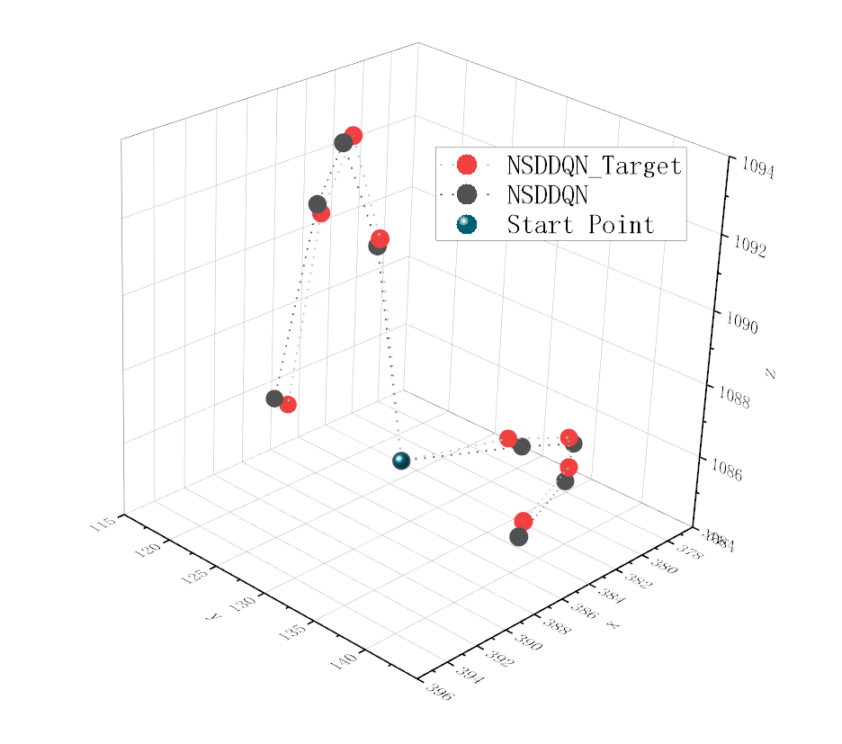
Supplementary Figure 2. Point Tracking (3D sine function shape) with NSDDQN controller. Start Position: x=386mm, y=126mm, z=1086mm.

Table 1. Robot Parameters

Parameter | Value
$$l_{disk}$$ | 1.2mm
$$l_{joint}$$ | 1.2mm
$$l_{1}^{original}$$ | 21.2mm
$$l_{2}^{original}$$ | 47.2mm
$$N_{1}$$ | 4
$$N_{2}$$ | 5
$$R$$ | 2.52mm

where $l_{disk}$ was the thickness of the disks. $l_{joint}$ was the length of the compliant joints. $l_{1}^{original}$ was the original length of one pair of cables in the first section. $l_{2}^{original}$ was the length of one pair of cables in the second section. $N_{1}$ was the quantity of segments in the first single section. $N_{2}$ was the quantity of segment in the second section. $R$ was the distance from center of the disk to the cable anchor point. $β_{segment}$ was the bending angle of a segment and $β_{section}$ was the bending angle of a section (see Supplementary Figure 1b).

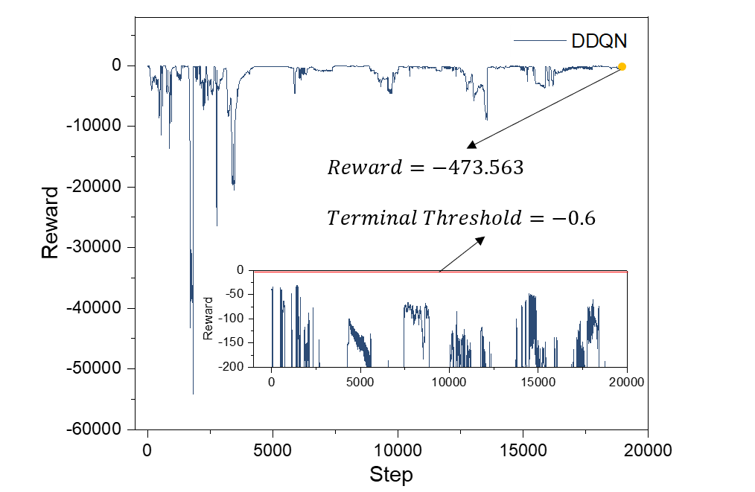
Supplementary Figure 3. The training performance of the DDQN controller with the terminal threshold at -0.6. The model was not convergence at 18334 steps, where the reward was -473.563.

