Supplementary Information

Two-photon excitation fluorescent spectral and decay properties of retrograde neuronal tracer Fluoro-Gold

Matthew Q. Miller^{1,#}, Iván Coto Hernández^{1,#,*}, Jenu V. Chacko², Steven Minderler¹, Nate Jowett^{1,*}
¹Surgical Photonics and Engineering Laboratory, Massachusetts Eye and Ear, Harvard Medical School, Boston, Massachusetts
²Laboratory for Optical and Computational Instrumentation, University of Wisconsin, Madison, WI, United States

# These authors have contributed equally to the work.
* Corresponding author: ivan_cotohernandez@meei.harvard.edu; nate_jowett@meei.harvard.edu

Supplementary Figure S1. Power curve of Fluoro-Gold. (A) 2PE imaging of FG -labeled cell bodies at 760 nm. (B) Quadratic dependence of Fluoro-Gold’s fluorescent emission signal on excitation power. The laser’s average power was measured before passing through the objective lens.

Supplementary Figure S2. The background tissue mean lifetime across all excitation wavelengths is 1.35 ns.
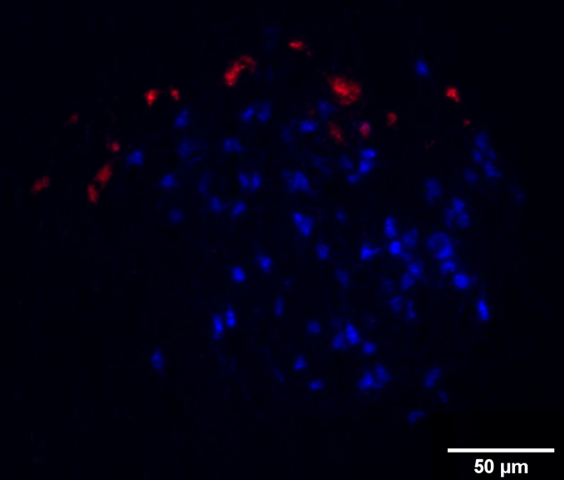
Supplementary Figure S3. Widefield microscopy (5x) image of left rat facial nucleus. Fluoro-Gold was delivered to the transected facial nerve buccal branch and Fluoro-Ruby was delivered to the transected zygomatic branch. Both dyes delivered using conduit reservoir technique, 10 minutes of exposure. Note isolated Fluoro-Gold (blue) labeling of lateral and intermediate subnuclei, and Fluoro-Ruby (red) labeling restricted to the dorsolateral subnucleus.

