Supplementary Material

Design, synthesis and biological evaluation of novel 2- (indole arylamide) benzoic acid analogs as dual COX-2 / 5-LOX inhibitors

Le Du¹ · Shuaishuai Du¹ · Jiaming Li^{1, 2, 3} · Hongwei Wang¹

Le Du¹
2019677763@qq.com
Shuaishuai Du¹
1729511049@qq.com
Fan Jin¹
2280925161@qq.com
✉ Jiaming Li^{1,2,3}
lijiaming2017@sina.com
Hongwei Wang¹
18119629721@163.com

¹ School of Pharmacy, Anhui University of Chinese Medicine, Hefei 230031, China

² Department of Medicinal Chemistry, Anhui Academy of Chinese Medicine, Hefei 230031, China

³Anhui Province Key Laboratory of Research & Development of Chinese Medicine, Hefei 230012, China

Contents

General Methods S2

¹H NMR and ¹³C NMR Spectra of Compounds………………………….S2-S45 HRMS spectra of compounds…………………………………………….S45-S66

Generalmethods:

1H and 13C NMR spectra were recorded at room temperature at 400 MHz and 100 MHz respectively using a QNP probe.NMR spectra were recorded in deuterated dimethyl sulfoxide (DMSO-d6) at room temperature unless otherwise stated. Chemical shifts (δ values) are reported in parts per million, and are referenced to the deuterated residual solvent peak. NMR data was reported as: δ value (chemical shift, J-value(Hz), integration, where s = singlet, d = doublet, t = triplet, q = quartet, brs = broad singlet). High-resolution mass spectra (HRMS) were recorded with a bruker microTOF ESI-TOF mass spectrometer in positive ion mode unless otherwise specified.

1H NMR and 13C NMR Spectra of Compounds

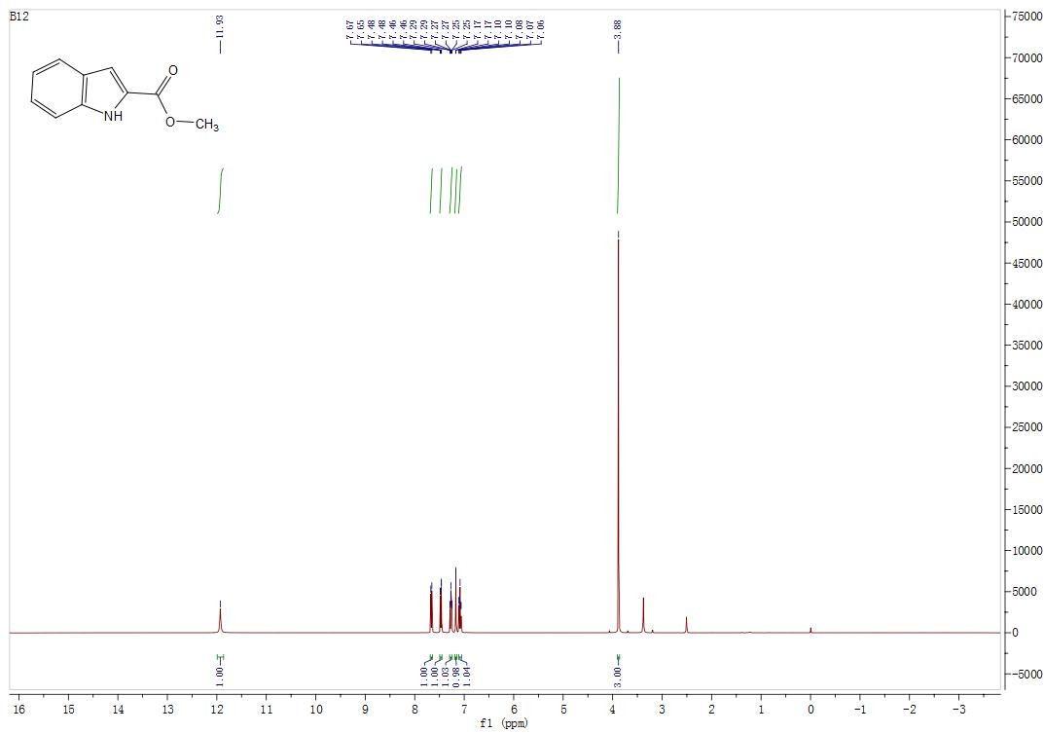
¹H NMR (DMSO-d6, 400 MHz). Methyl 1H-indole-2-carboxylate (2a)

¹³C NMR (DMSO-d6, 100 MHz). Methyl 1H-indole-2-carboxylate (2a)

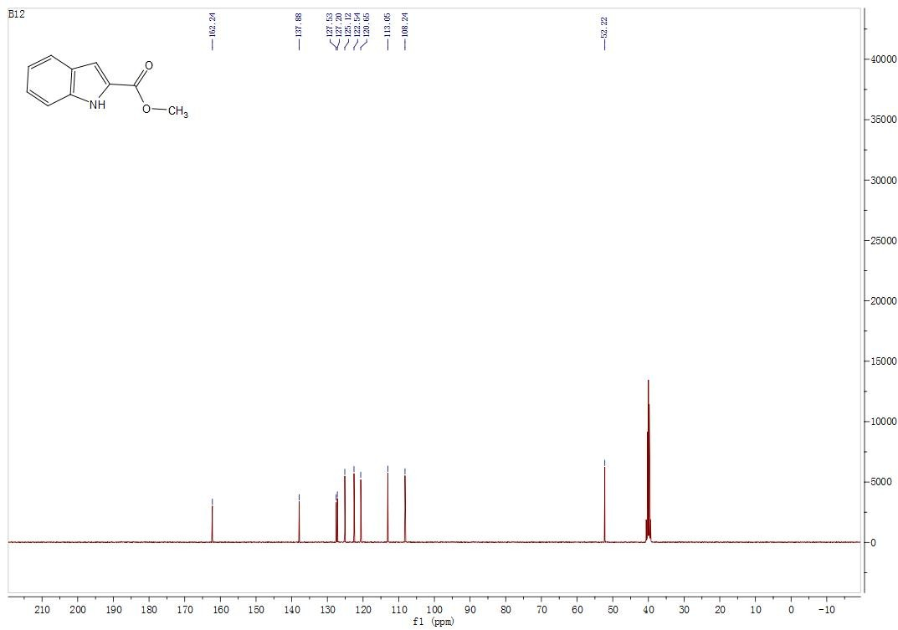

¹H NMR (DMSO-d6, 400 MHz). Methyl 5-chloro-1H-indole-2-carboxylate (2b)

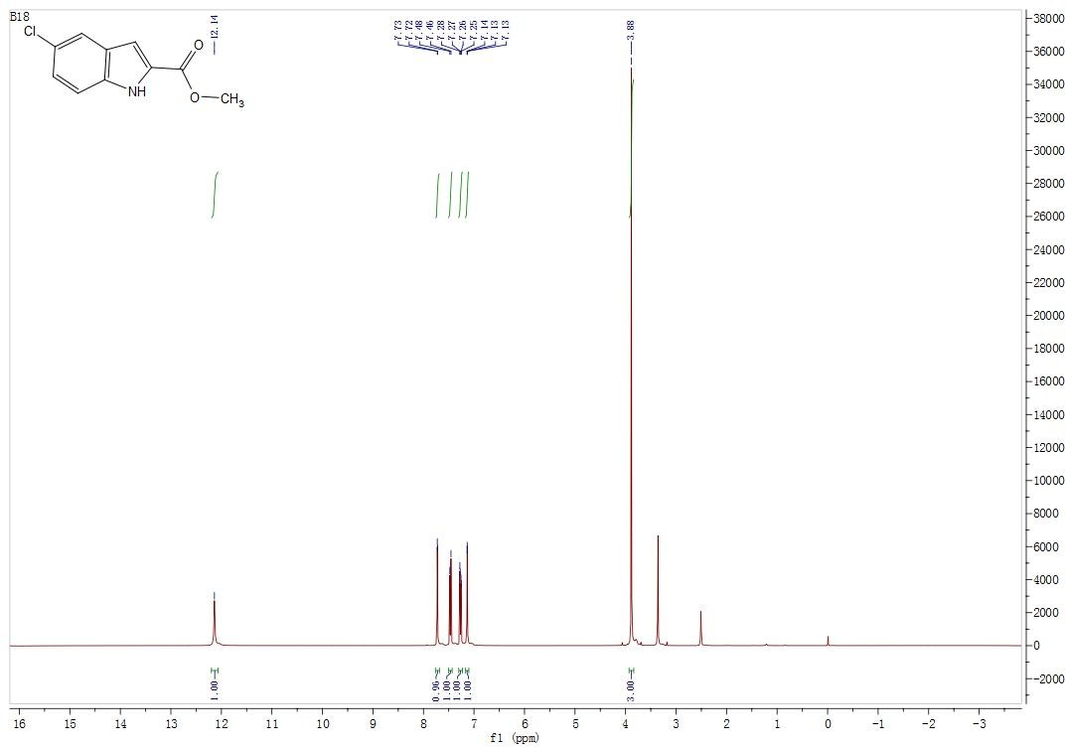

¹³C NMR (DMSO-d6, 100 MHz). Methyl 5-chloro-1H-indole-2-carboxylate (2b)

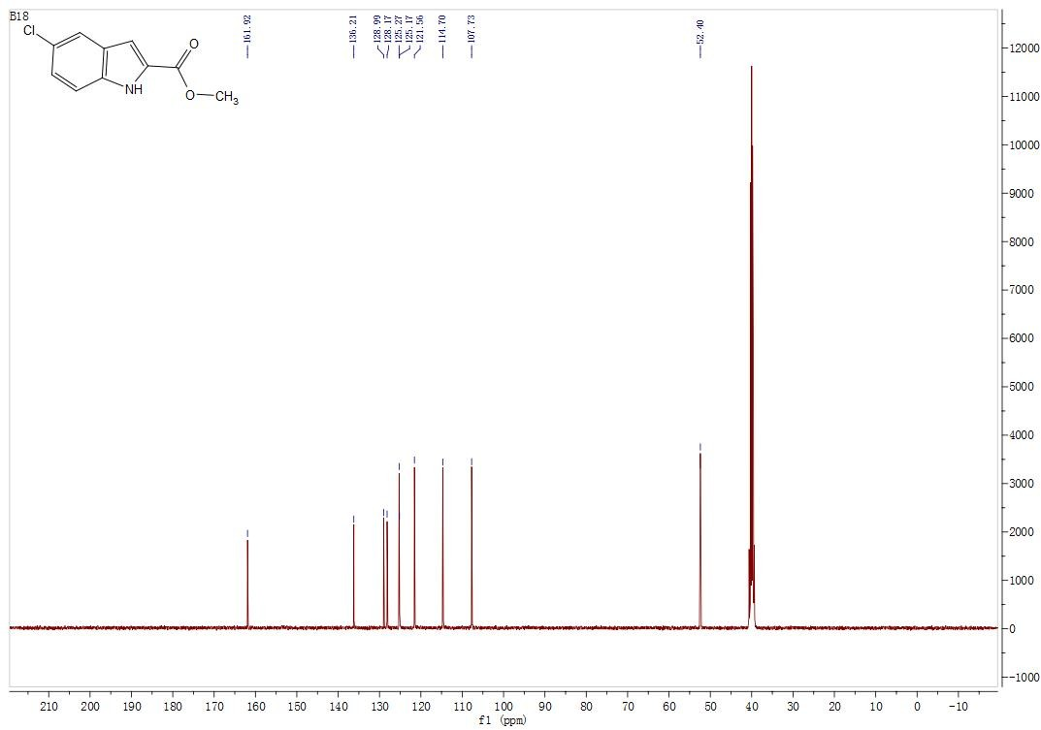

¹H NMR (DMSO-d6, 400 MHz). Methyl 1H-indole-3-carboxylate (2c)
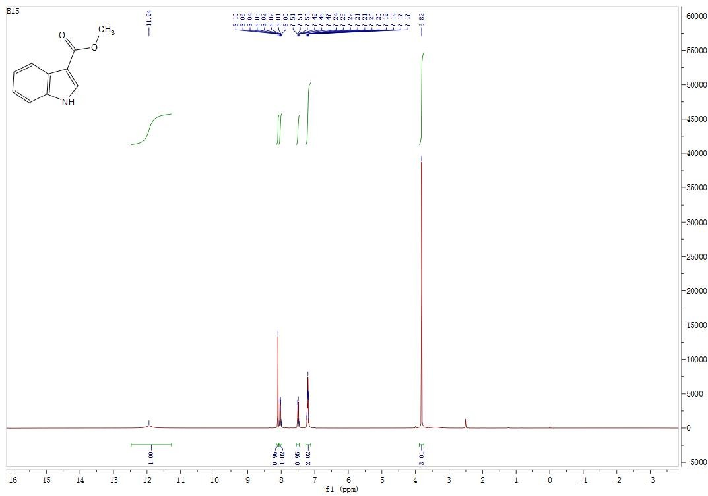

¹³C NMR (DMSO-d6, 100 MHz). Methyl 1H-indole-3-carboxylate (2c)

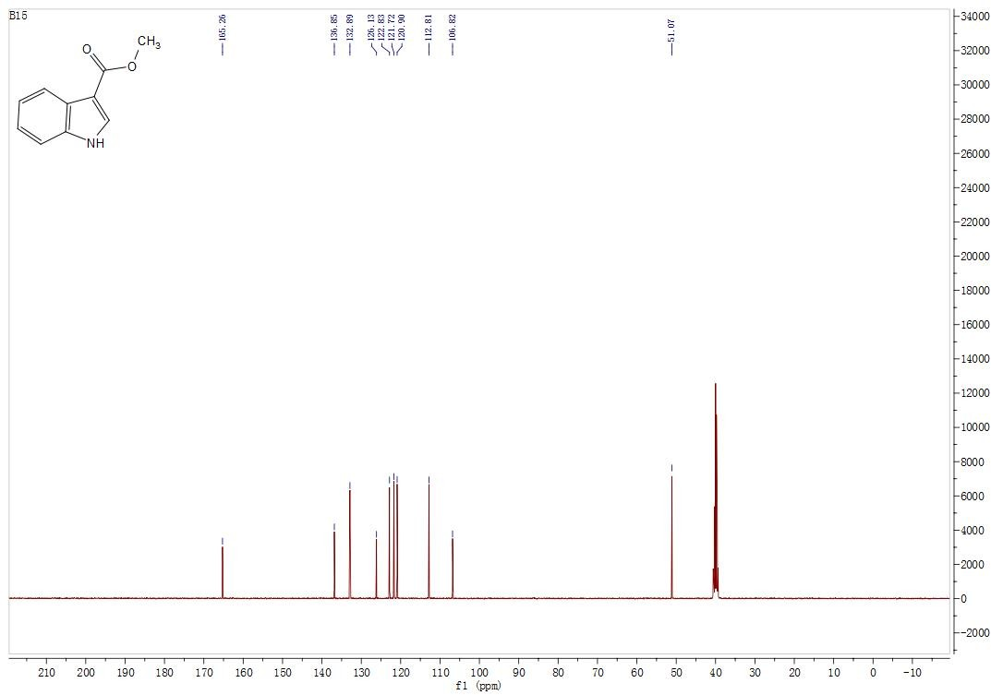

¹H NMR (DMSO-d6, 400 MHz). Methyl 5-chloro-1H-indole-3-carboxylate (2d)
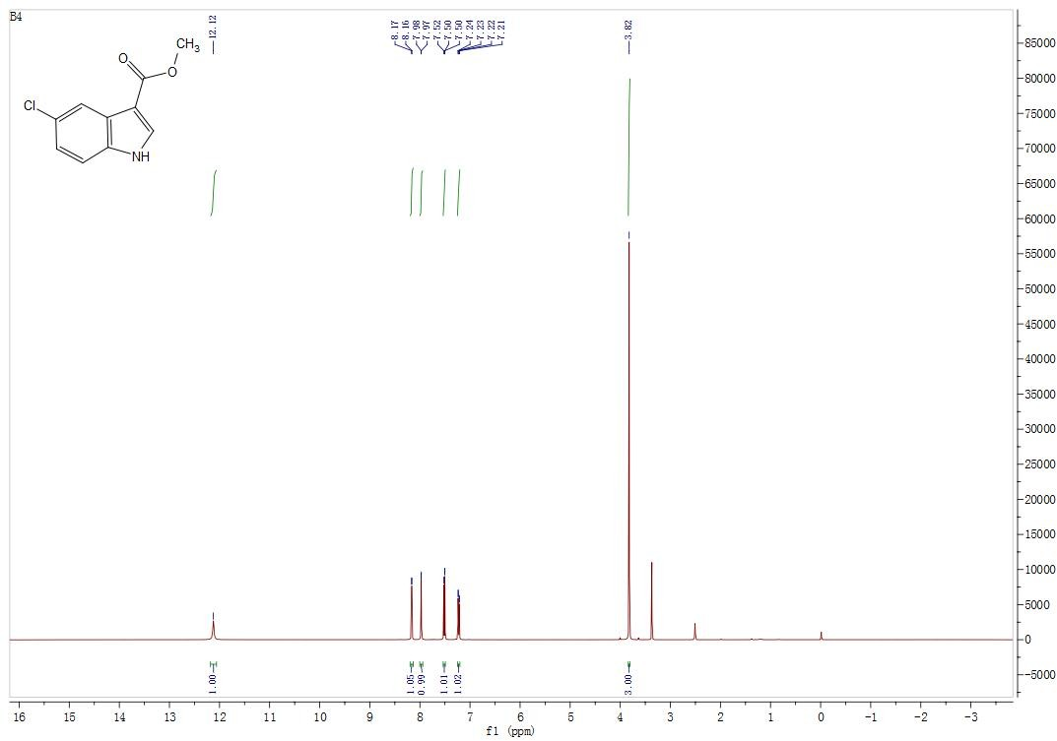

¹³C NMR (DMSO-d6, 100 MHz). Methyl 5-chloro-1H-indole-3-carboxylate (2d)

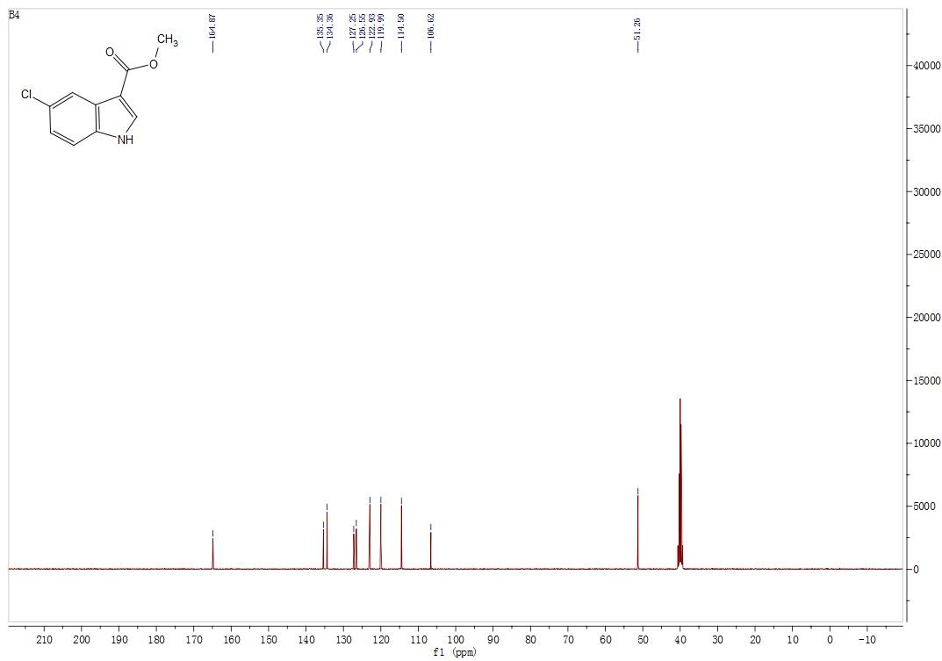

¹H NMR (DMSO-d6, 400 MHz). Methyl 1H-indazole-3-carboxylate (2e)

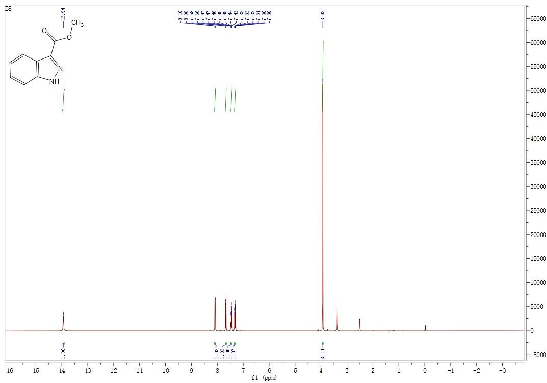

¹³C NMR (DMSO-d6, 100 MHz). Methyl 1H-indazole-3-carboxylate (2e)
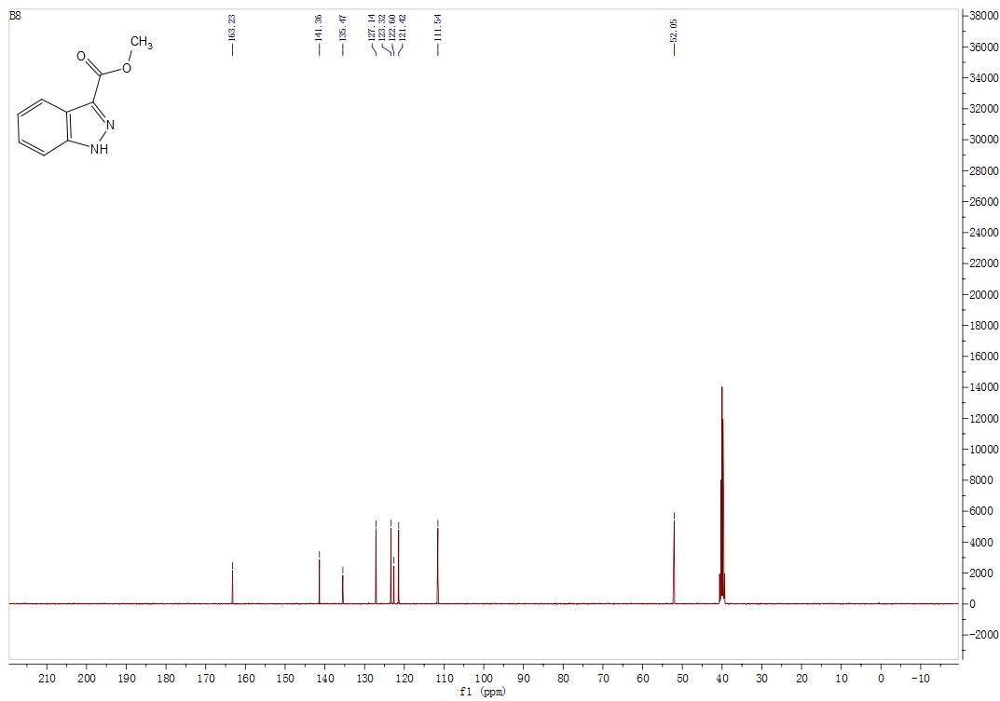

¹H NMR (DMSO-d6, 400 MHz). Methyl 1-(4-methylbenzyl)-1H-indole-2-carboxylate (3d)
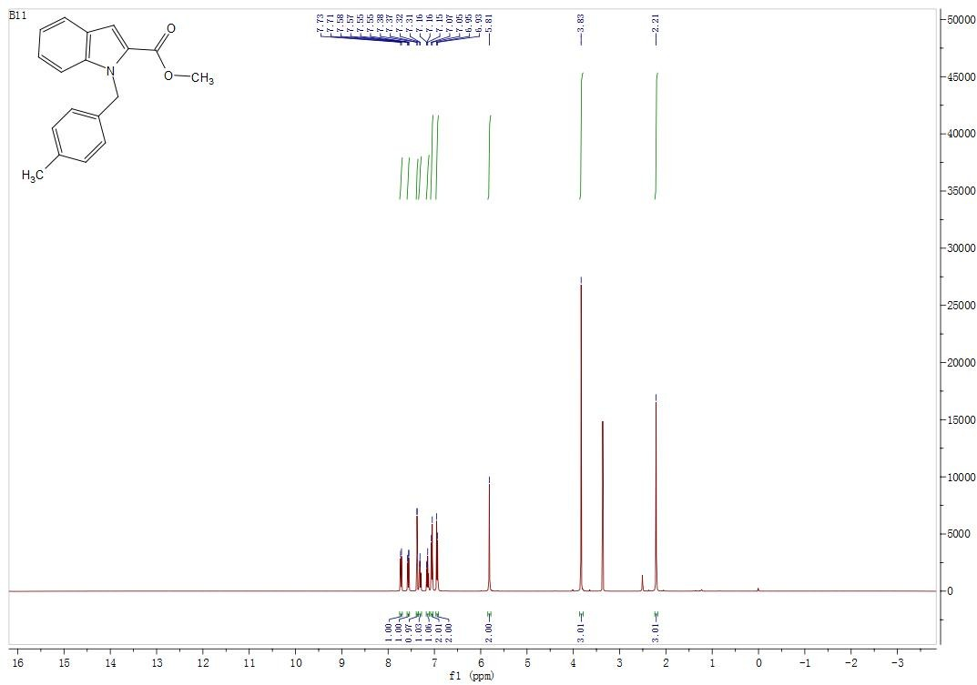

¹³C NMR (DMSO-d6, 100 MHz). Methyl 1-(4-methylbenzyl)-1H-indole-2-carboxylate (3d)

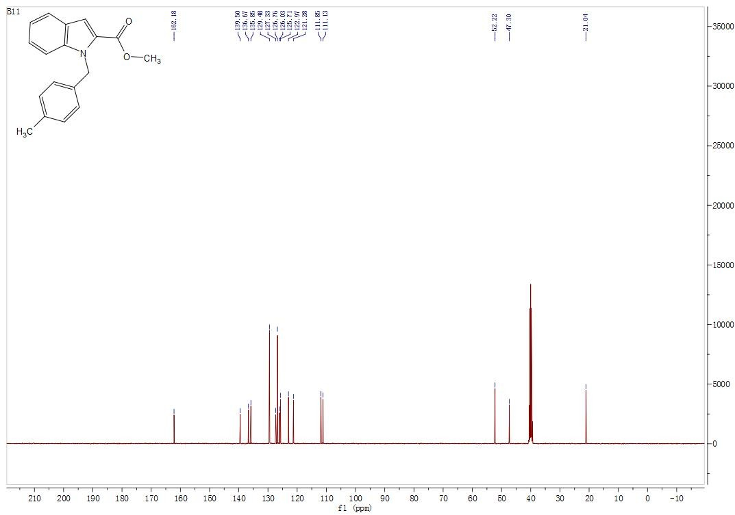

¹H NMR (DMSO-d6, 400 MHz). Methyl 5-chloro-1-(4-methylbenzyl)-1H-indole-2-carboxylate (3i)
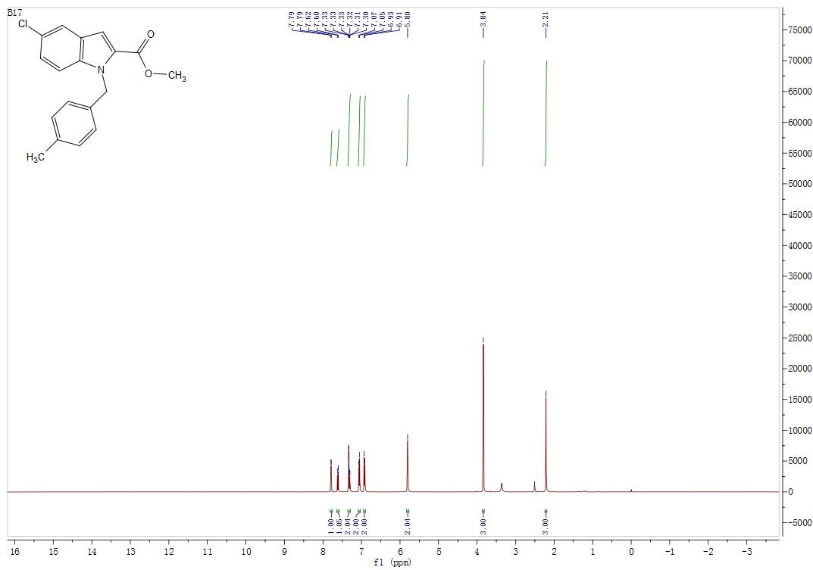

¹³C NMR (DMSO-d6, 100 MHz). Methyl 5-chloro-1-(4-methylbenzyl)-1H-indole-2-carboxylate (3i)

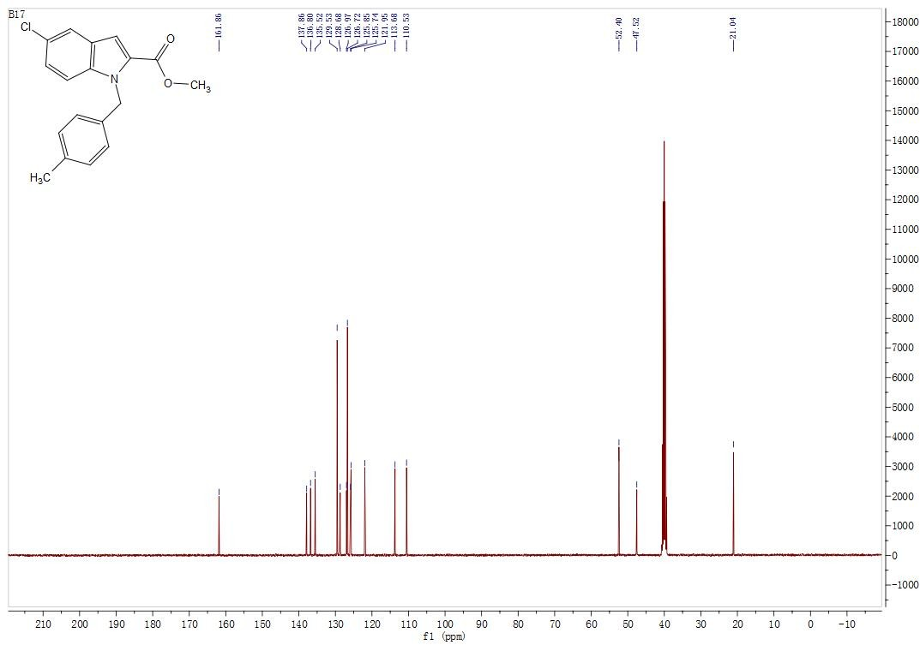

1H NMR (CDCl3, 300 MHz). Methyl 1-(4-fluorobenzyl)-1H-indole-3-carboxylate (3k)
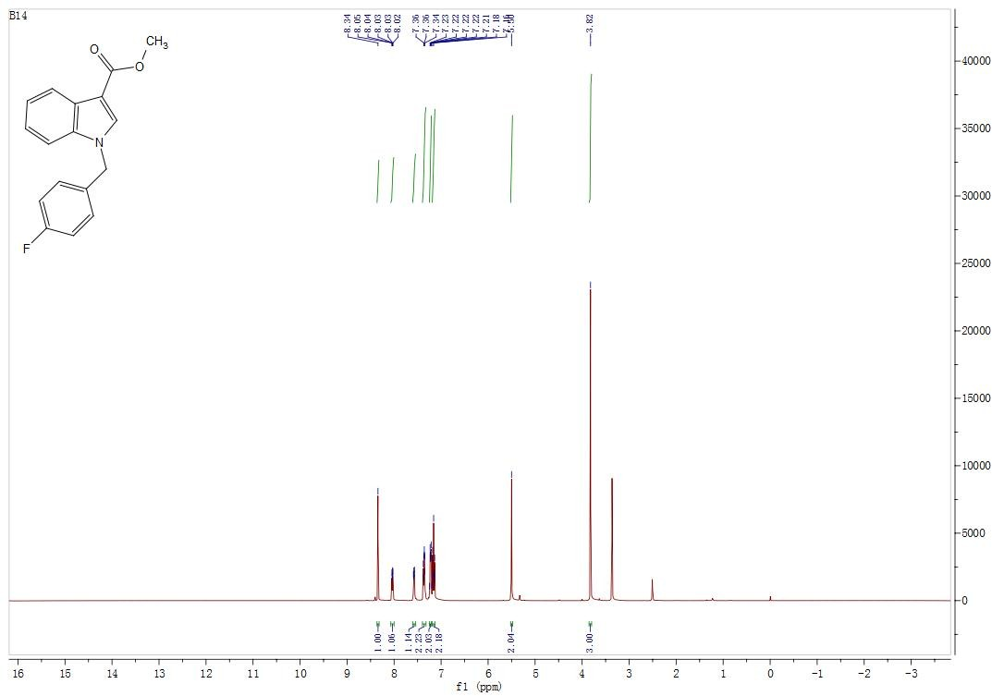

¹³C NMR (DMSO-d6, 100 MHz). Methyl 1-(4-fluorobenzyl)-1H-indole-3-carboxylate (3k)

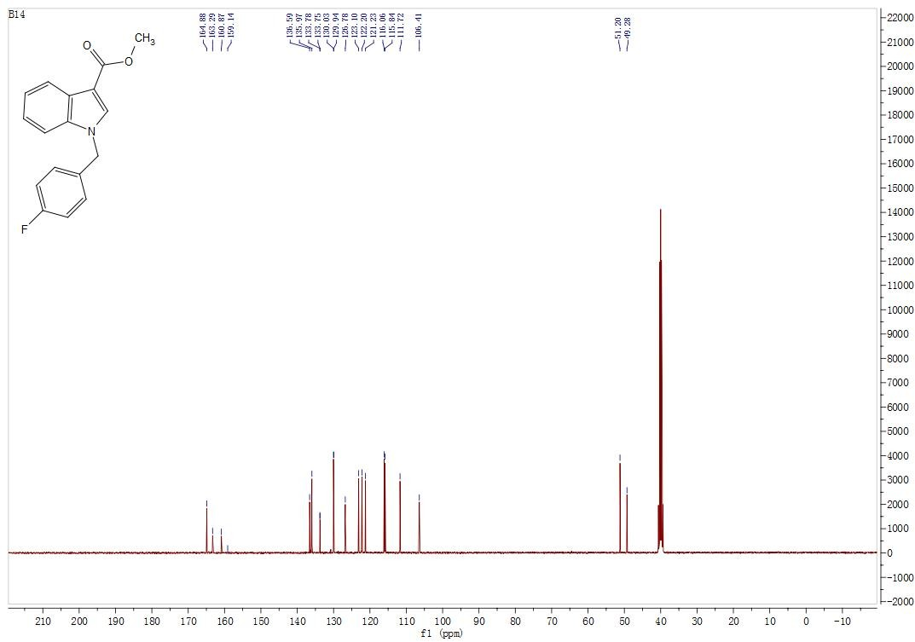

1H NMR (DMSO-d6, 400 MHz). Methyl 5-chloro-1-(4-methylbenzyl)-1H-indole-3-carboxylate (3r)
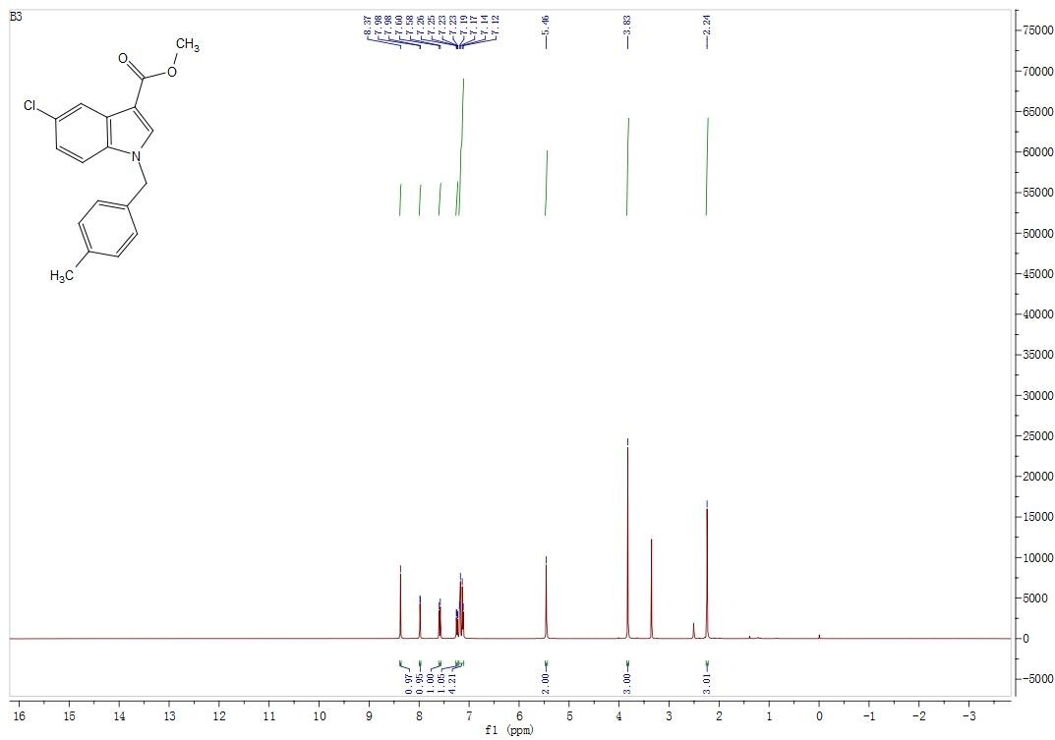

¹³C NMR (DMSO-d6, 100 MHz). Methyl 5-chloro-1-(4-methylbenzyl)-1H-indole-3-carboxylate (3r)

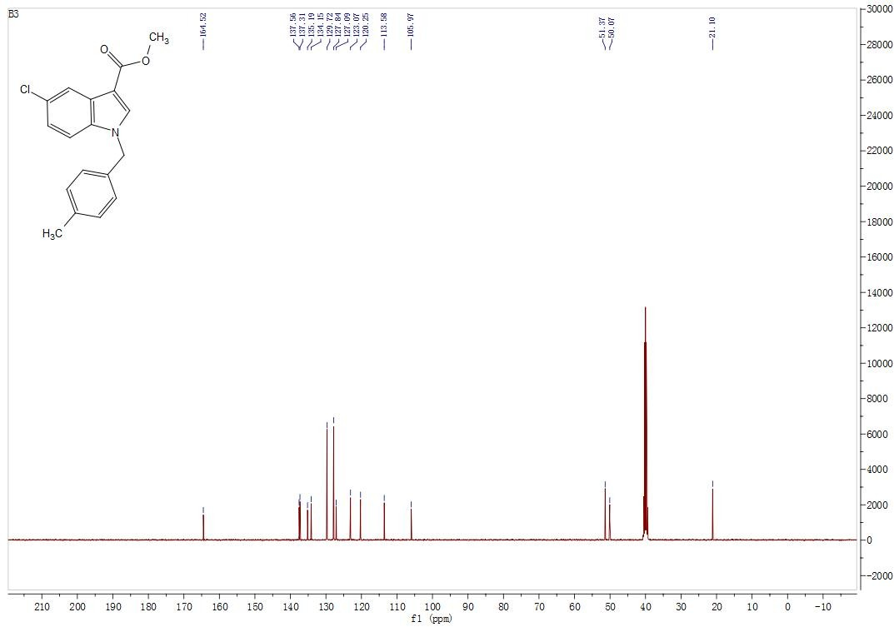

1H NMR (DMSO-d6, 400 MHz). Methyl 1-(4-fluorobenzyl)-1H-indazole-3-carboxylate (3t)
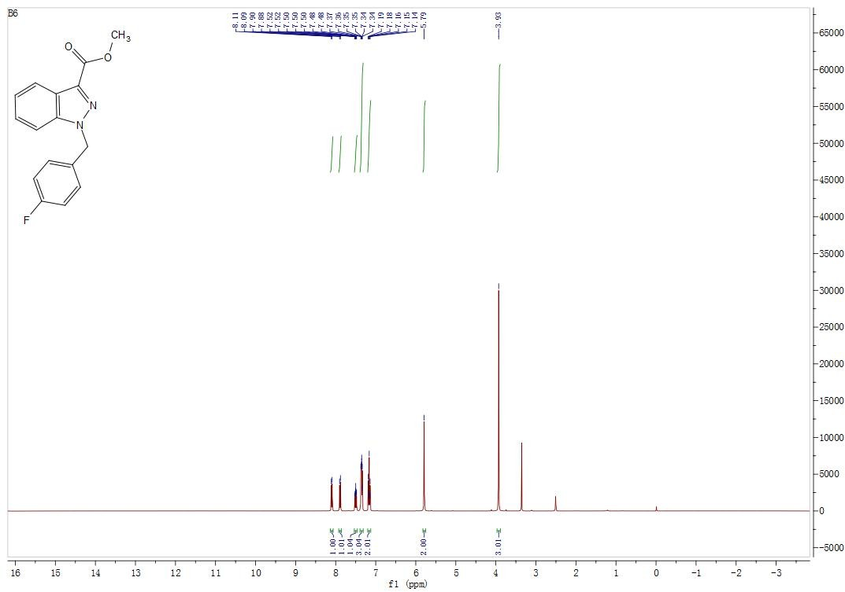

¹³C NMR (DMSO-d6, 100 MHz). Methyl 1-(4-fluorobenzyl)-1H-indazole-3-carboxylate (3t)

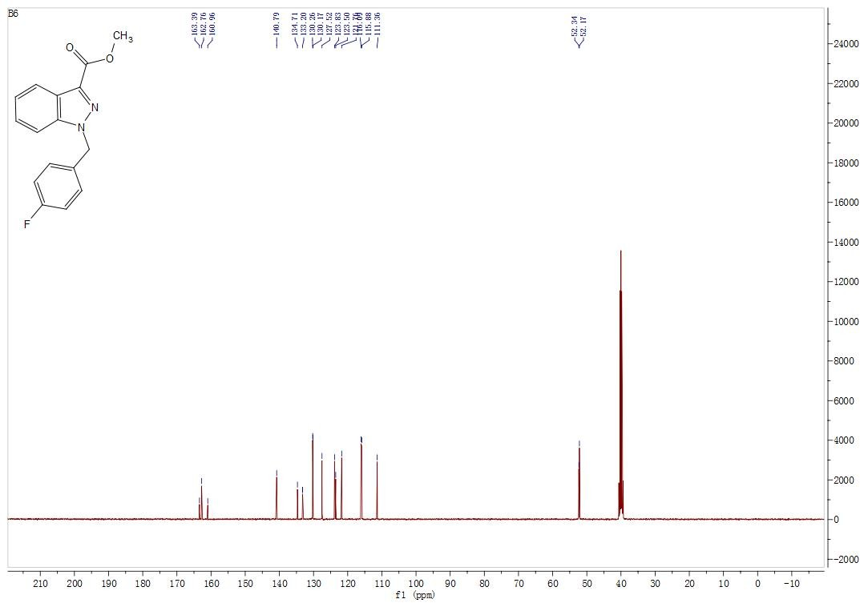

¹H NMR (DMSO-d6, 400 MHz). 1-(4-methylbenzyl)-1H-indole-2-carboxylic acid (4d)

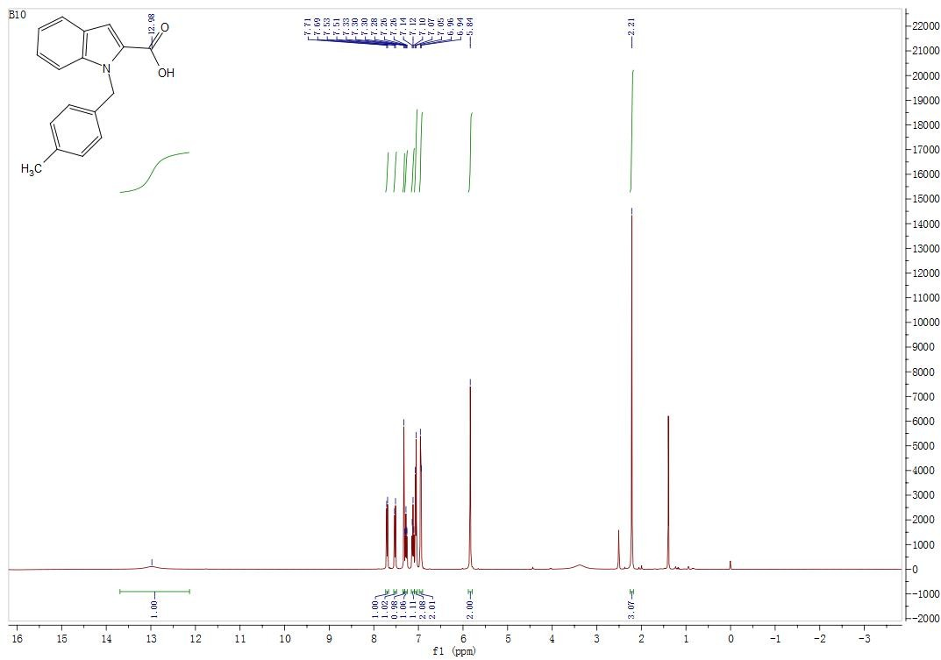

¹³C NMR (DMSO-d6, 100 MHz). 1-(4-methylbenzyl)-1H-indole-2-carboxylic acid (4d)
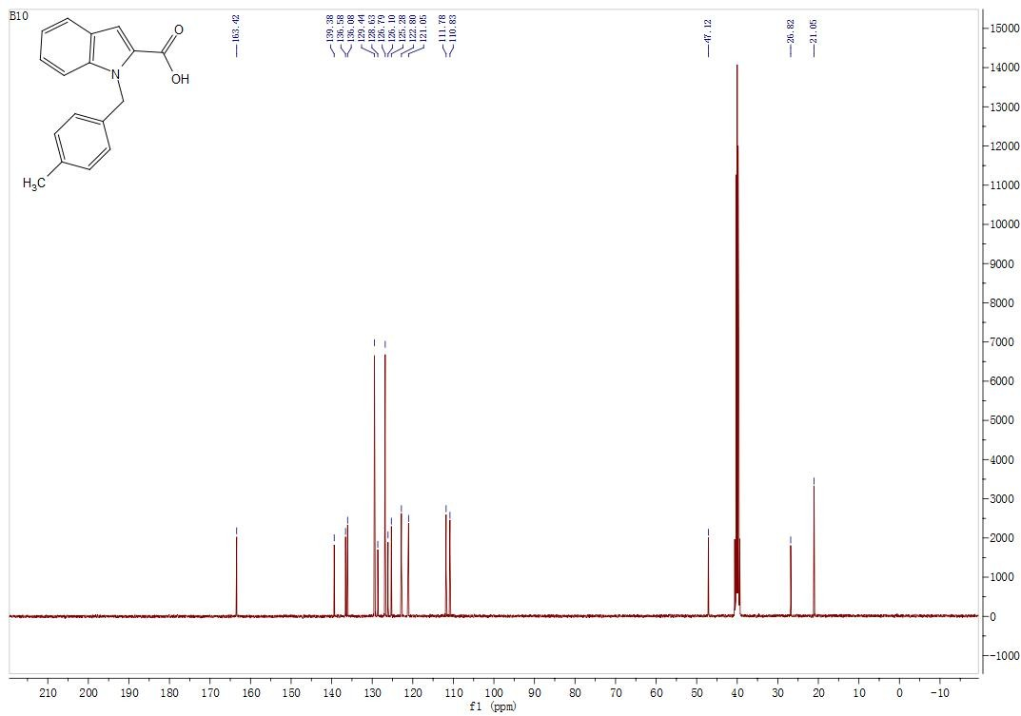

¹H NMR (DMSO-d6, 400 MHz). 5-chloro-1-(4-methylbenzyl)-1H-indole-2-carboxylic acid (4i)
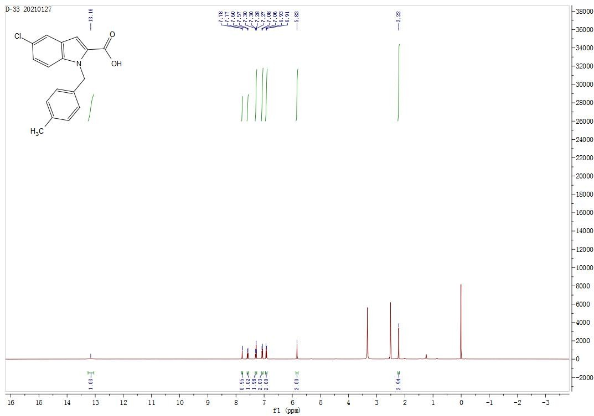

¹³C NMR (DMSO-d6, 100 MHz). 5-chloro-1-(4-methylbenzyl)-1H-indole-2-carboxylic acid (4i)
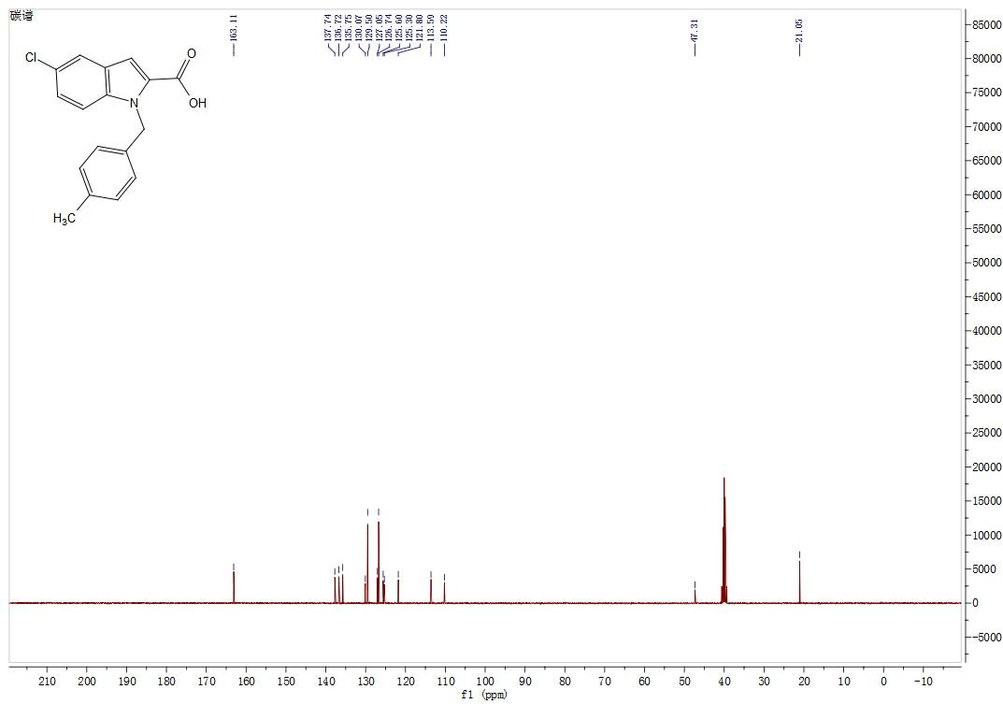

¹H NMR (DMSO-d6, 400 MHz). 1-(4-fluorobenzyl)-1H-indole-3-carboxylic acid (4k)
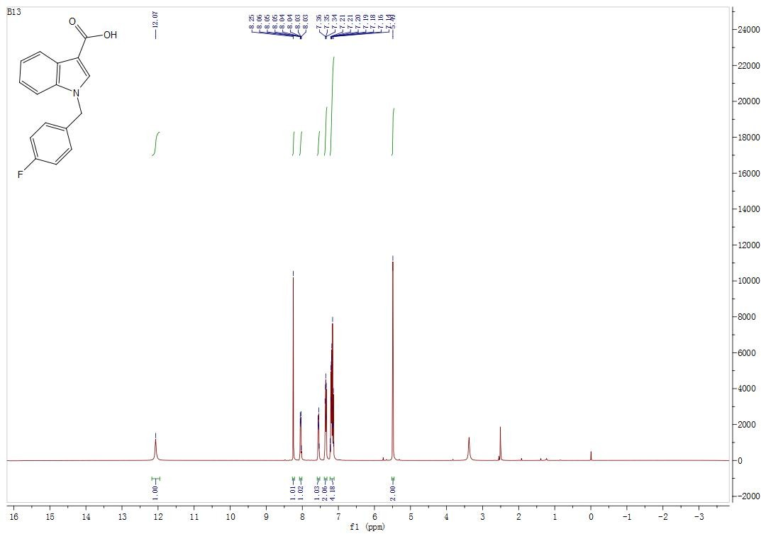

¹³C NMR (DMSO-d6, 100 MHz). 1-(4-fluorobenzyl)-1H-indole-3-carboxylic acid (4k)

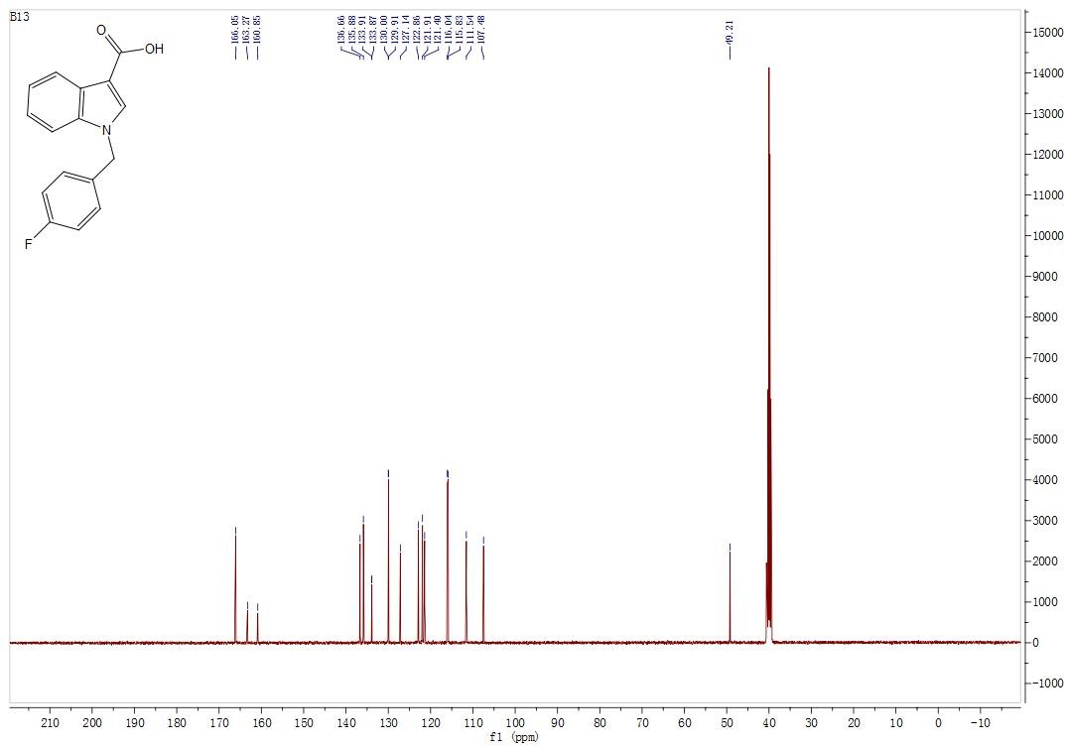

¹H NMR (DMSO-d6, 400 MHz). 5-chloro-1-(4-methylbenzyl)-1H-indole-3-carboxylic acid (4r)
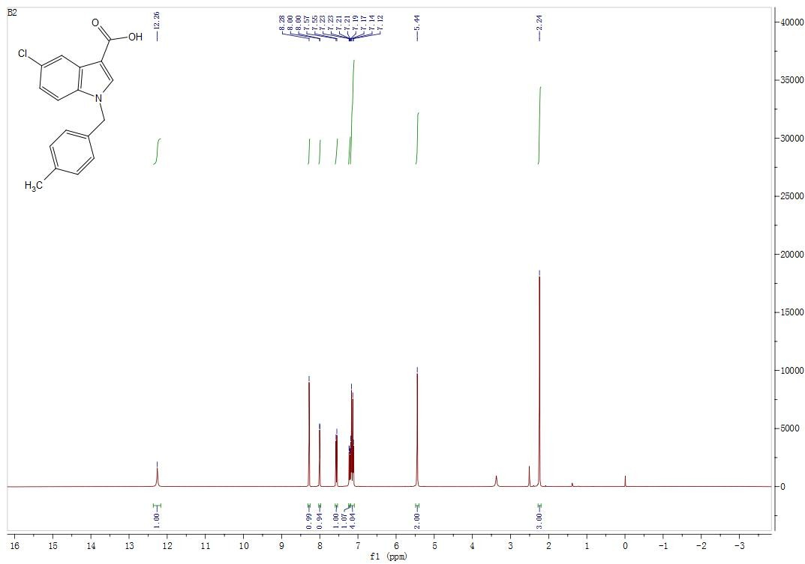

¹³C NMR (DMSO-d6, 100 MHz). 5-chloro-1-(4-methylbenzyl)-1H-indole-3- carboxylic acid (4r)

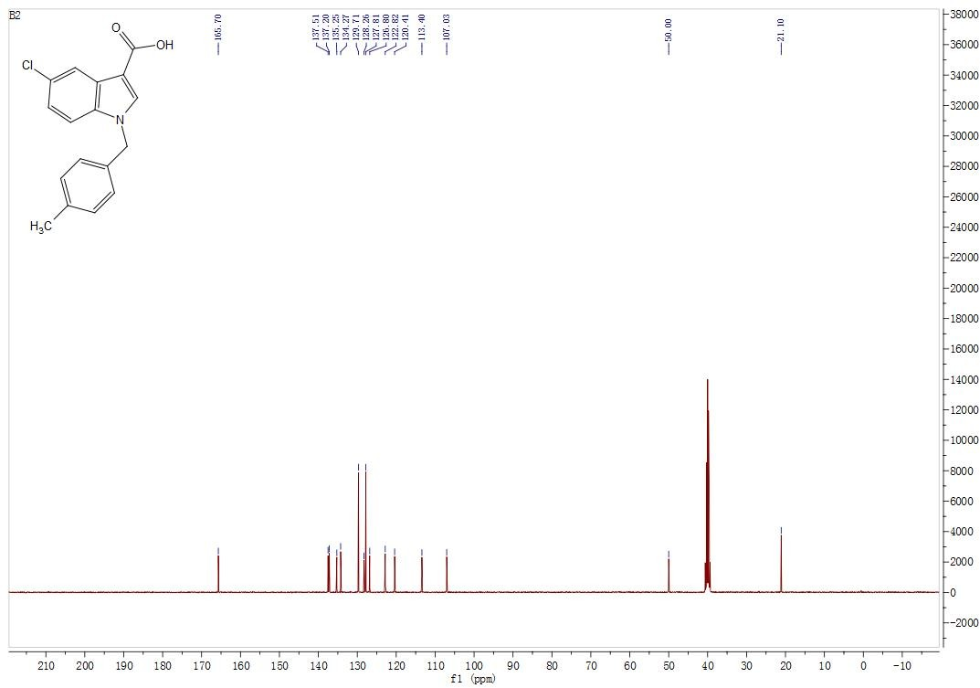

¹H NMR (DMSO-d6, 400 MHz). 1-(4-fluorobenzyl)-1H-indazole-3-carboxylic acid (4t)
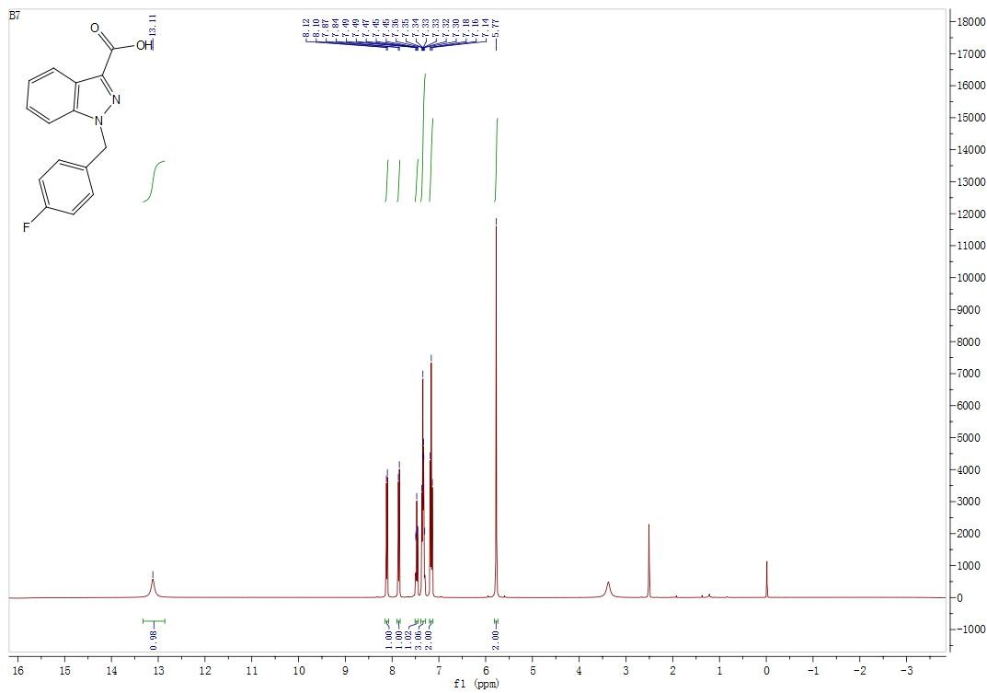

¹³C NMR (DMSO-d6, 100 MHz). 1-(4-fluorobenzyl)-1H-indazole-3-carboxylic acid (4t)
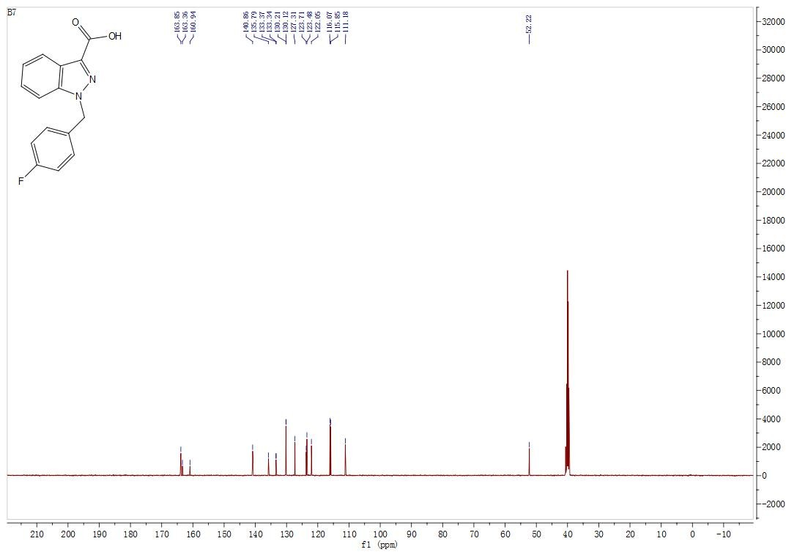

¹H NMR (DMSO-d6, 400 MHz). Ethyl 2-(1-(4-methylbenzyl)-1H-indole-2-carboxamido)benzoate (6d)
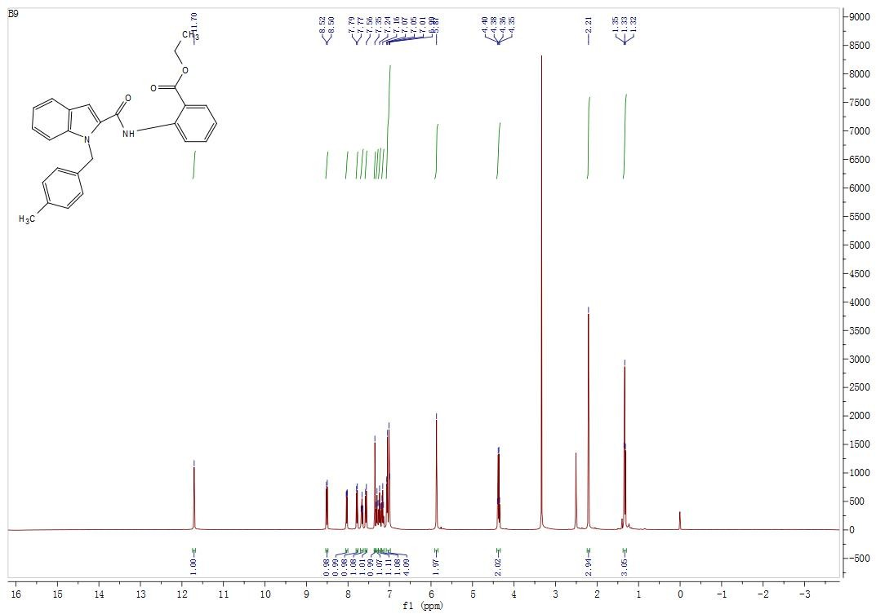

¹³C NMR (DMSO-d6, 100 MHz). Ethyl 2-(1-(4-methylbenzyl)-1H-indole-2-carboxamido)benzoate (6d)
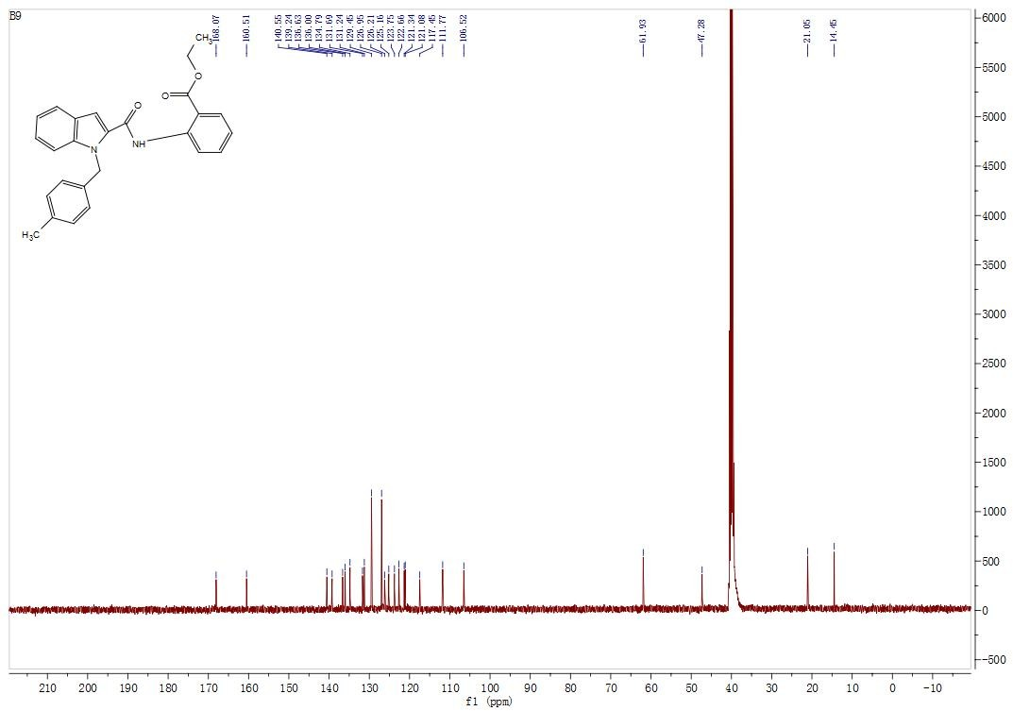

¹H NMR (DMSO-d6, 400 MHz). Ethyl 2-(5-chloro-1-(4-methylbenzyl)-1H-indole-2-carboxamido)benzoate (6i)

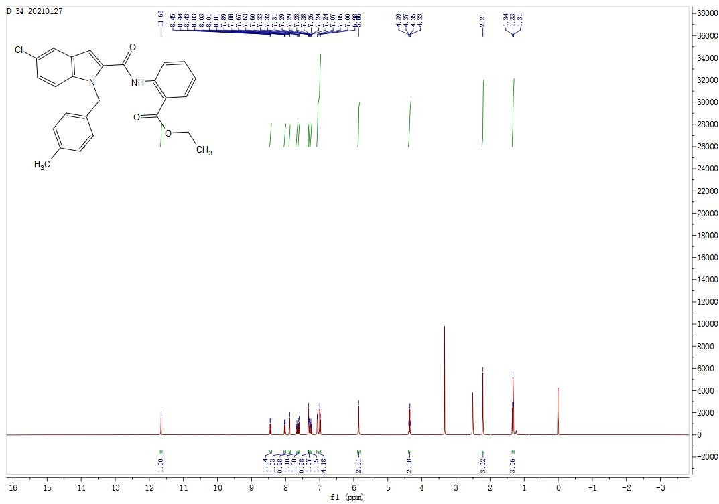

¹³C NMR (DMSO-d6, 100 MHz). Ethyl 2-(5-chloro-1-(4-methylbenzyl)-1H-indole-2-carboxamido)benzoate (6i)
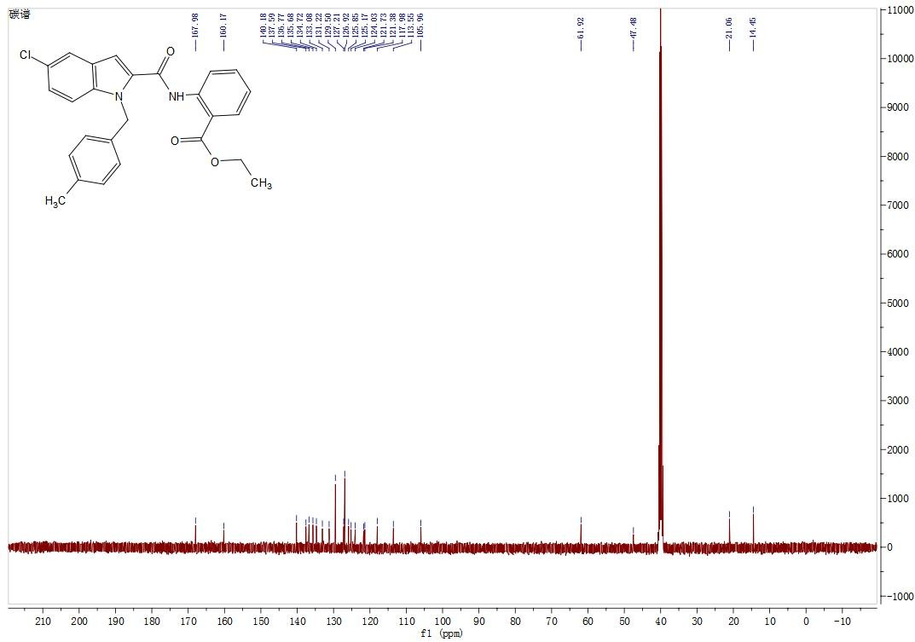

¹H NMR (DMSO-d6, 400 MHz). Ethyl 2-(1-(4-fluorobenzyl)-1H-indole-3-carboxamido)benzoate (6k)
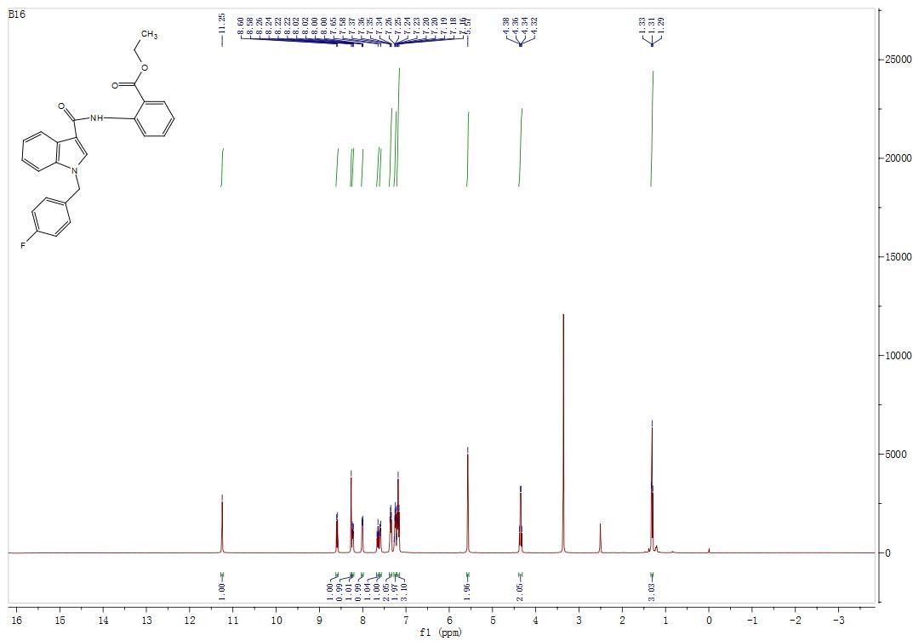

¹³C NMR (DMSO-d6, 100 MHz). Ethyl 2-(1-(4-fluorobenzyl)-1H-indole-3-carboxamido)benzoate (6k)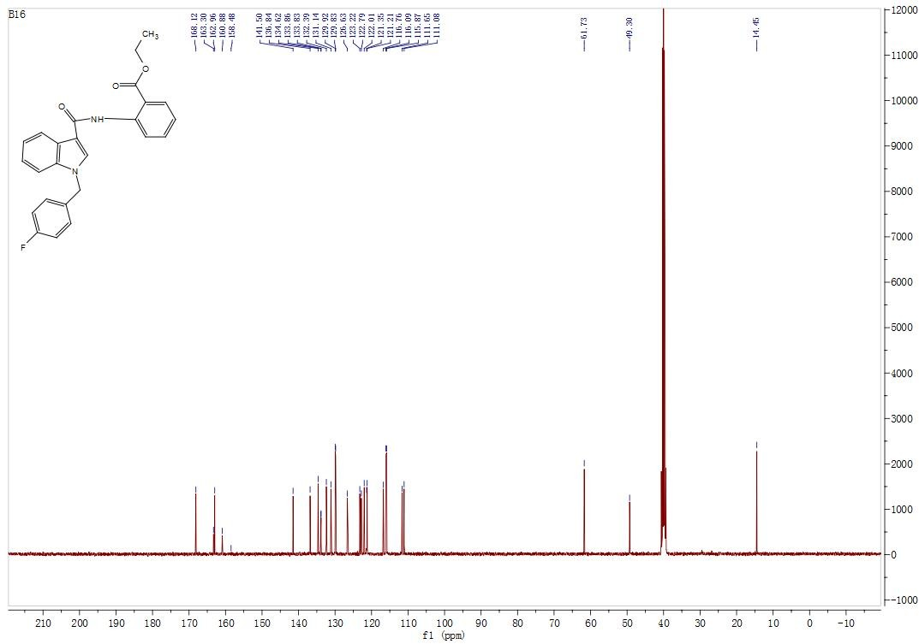

¹H NMR (DMSO-d6, 400 MHz). Ethyl 2-(5-chloro-1-(4-methylbenzyl)-1H-indole-3-carboxamido)benzoate (6r)
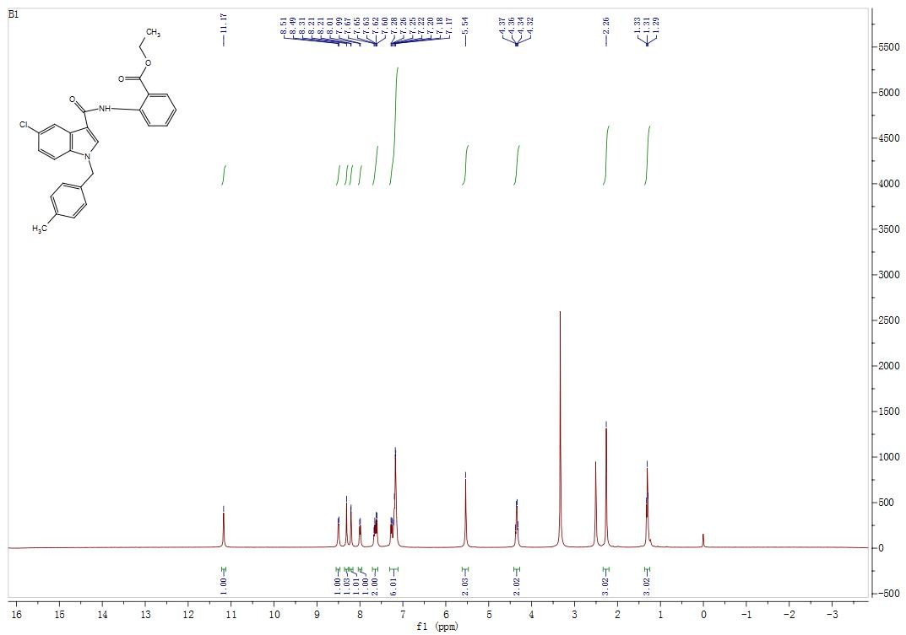

¹³C NMR (DMSO-d6, 100 MHz). Ethyl 2-(5-chloro-1-(4-methylbenzyl)-1H-indole-3-carboxamido)benzoate (6r)
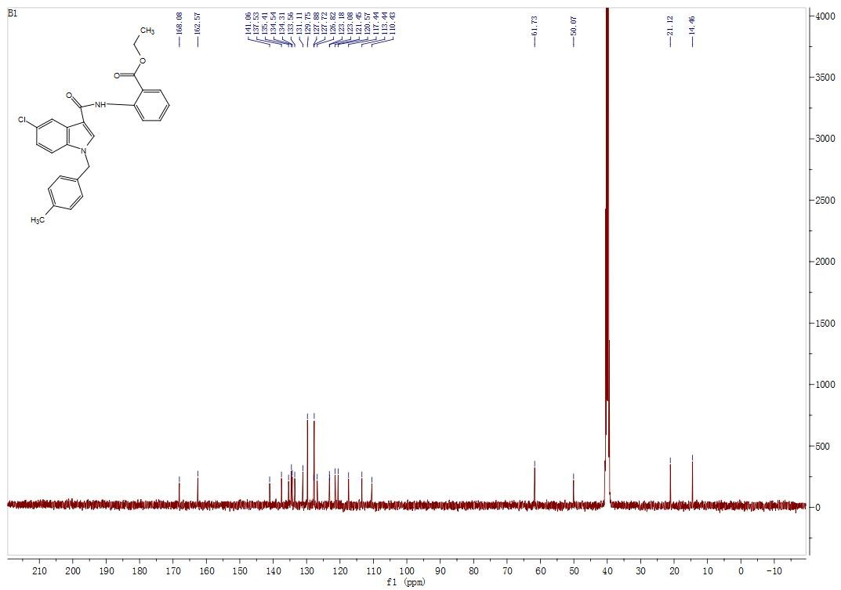

¹H NMR (DMSO-d6, 400 MHz). Ethyl 2-(1-(4-fluorobenzyl)-1H-indazole-3-carboxamido)benzoate (6t)
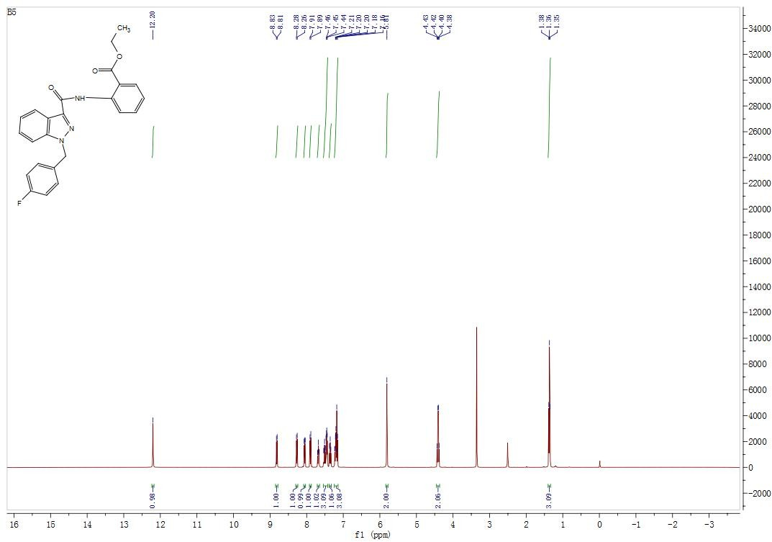

¹³C NMR (DMSO-d6, 100 MHz). Ethyl 2-(1-(4-fluorobenzyl)-1H-indazole-3-carboxamido)benzoate (6t)
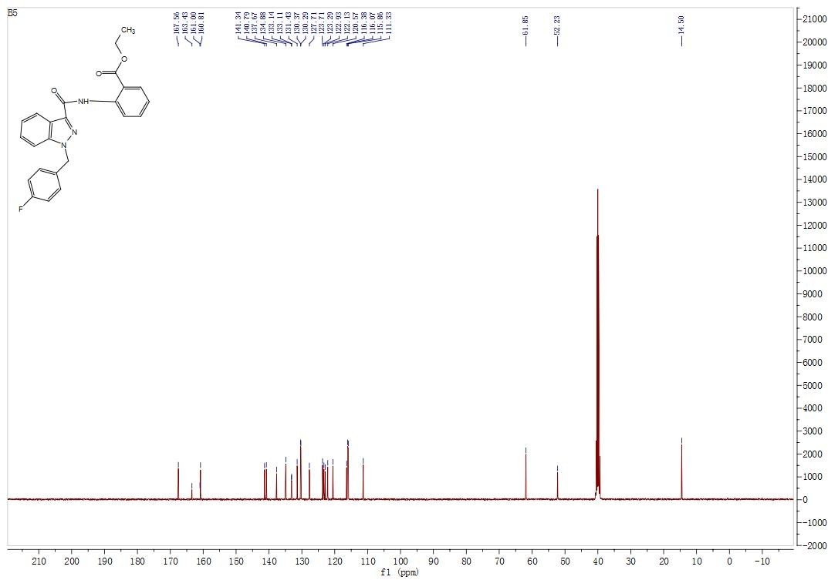

¹H NMR (DMSO-d6, 400 MHz). 2-(1-(4-fluorobenzyl)-1H-indole-2-carboxamido)benzoic acid (7a)
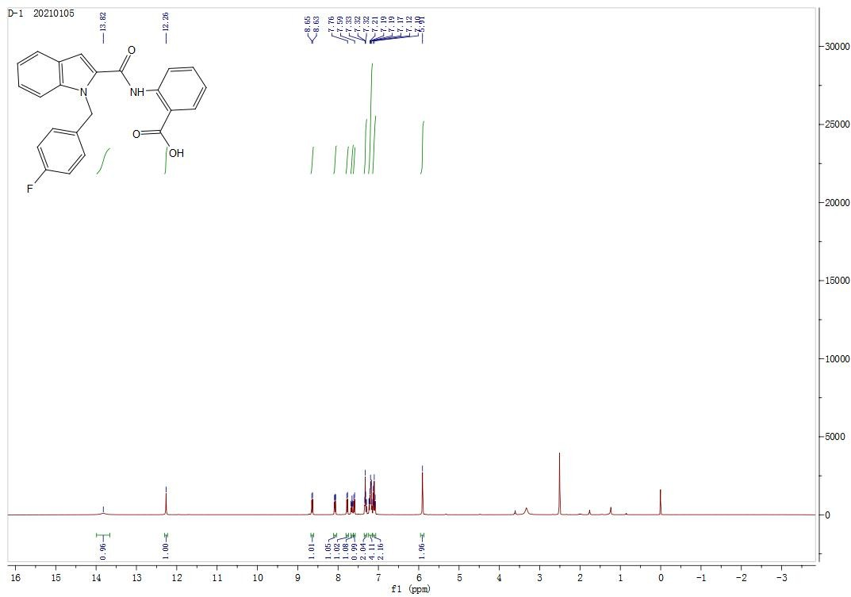

¹³C NMR (DMSO-d6, 100 MHz). 2-(1-(4-fluorobenzyl)-1H-indole-2-carboxamido)benzoic acid (7a)
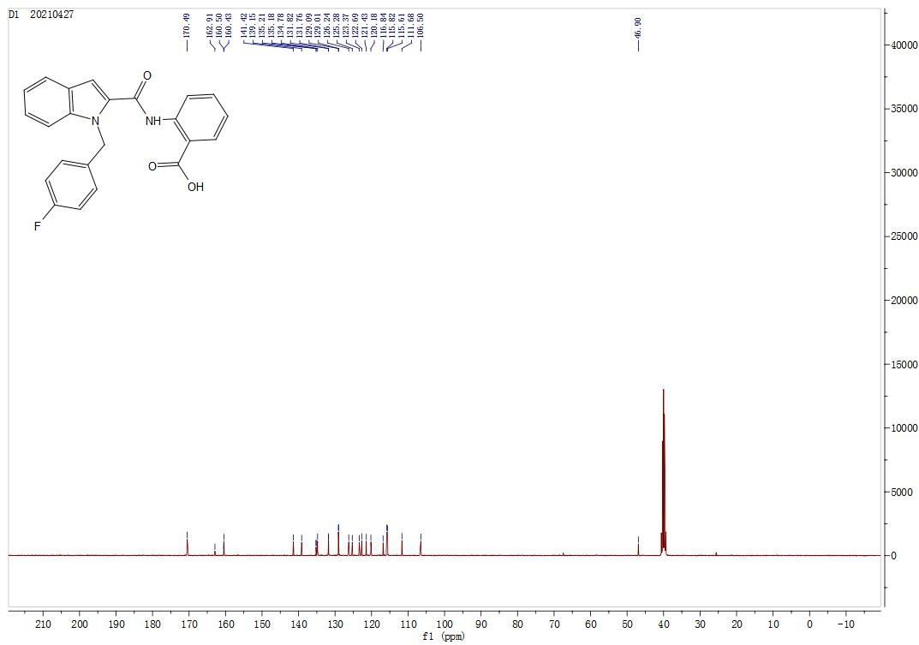

- ¹H NMR (DMSO-d6, 400 MHz).2-(1-(4-chlorobenzyl)-1H-indole-2-carboxamido)benzoic acid (7b)
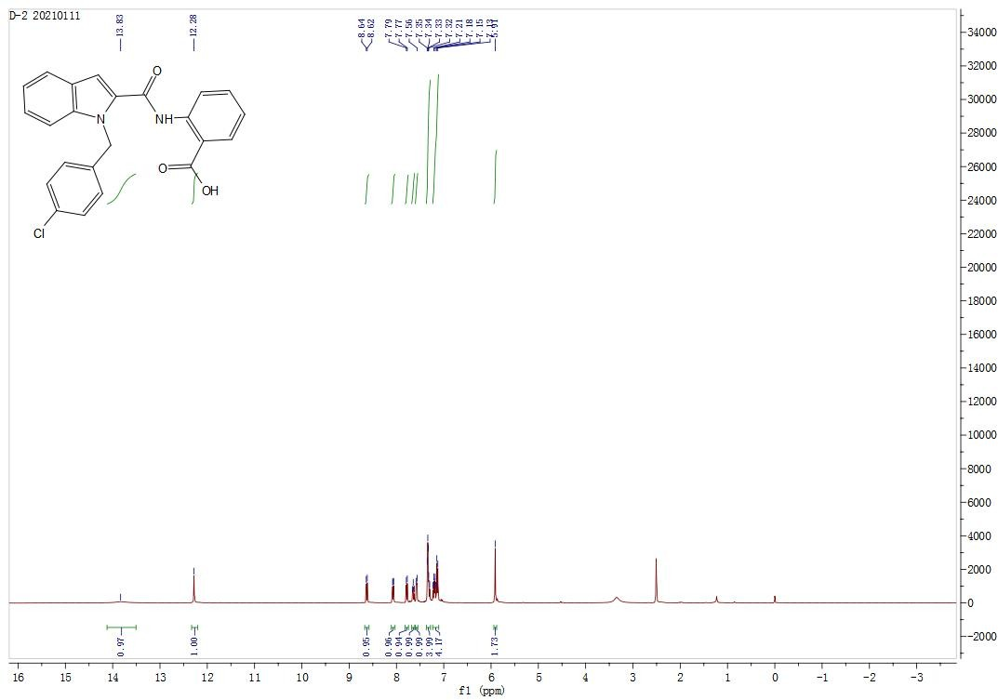

¹³C NMR (DMSO-d6, 100 MHz). 2-(1-(4-chlorobenzyl)-1H-indole-2-carboxamido)benzoic acid (7b)

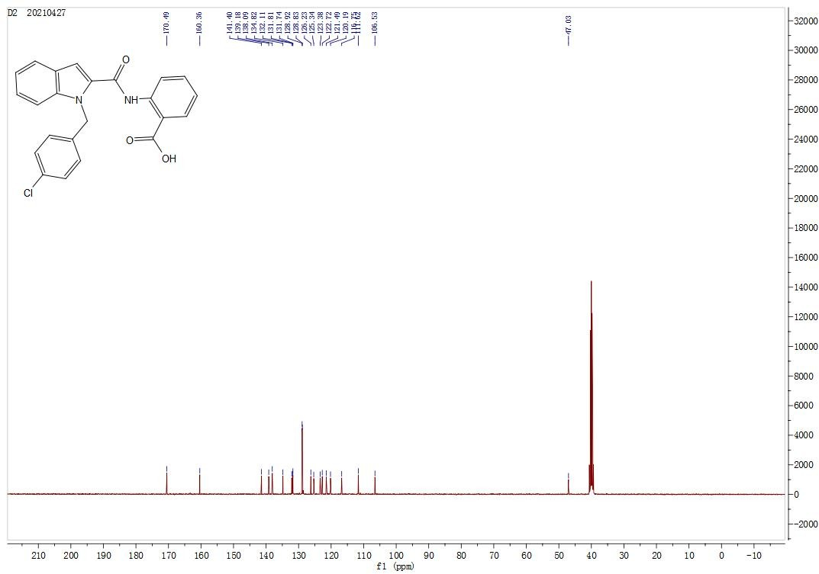

¹H NMR (DMSO-d6, 400 MHz). 2-(1-(4-methoxybenzyl)-1H-indole-2-carboxamido)benzoic acid (7c)
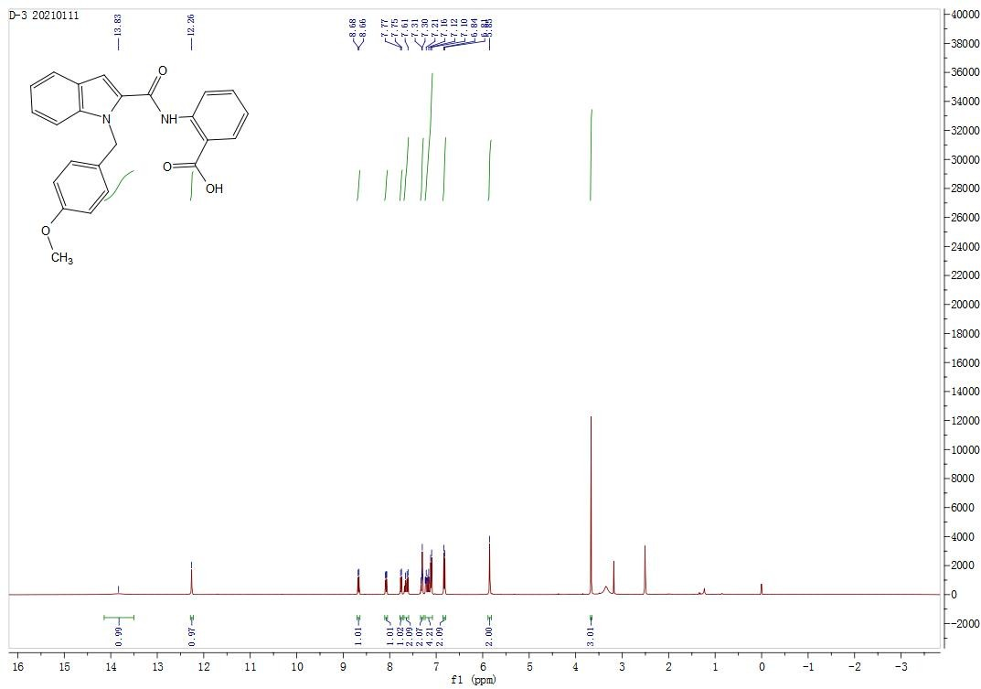

¹³C NMR (DMSO-d6, 100 MHz). 2-(1-(4-methoxybenzyl)-1H-indole-2-carboxamido)benzoic acid (7c)

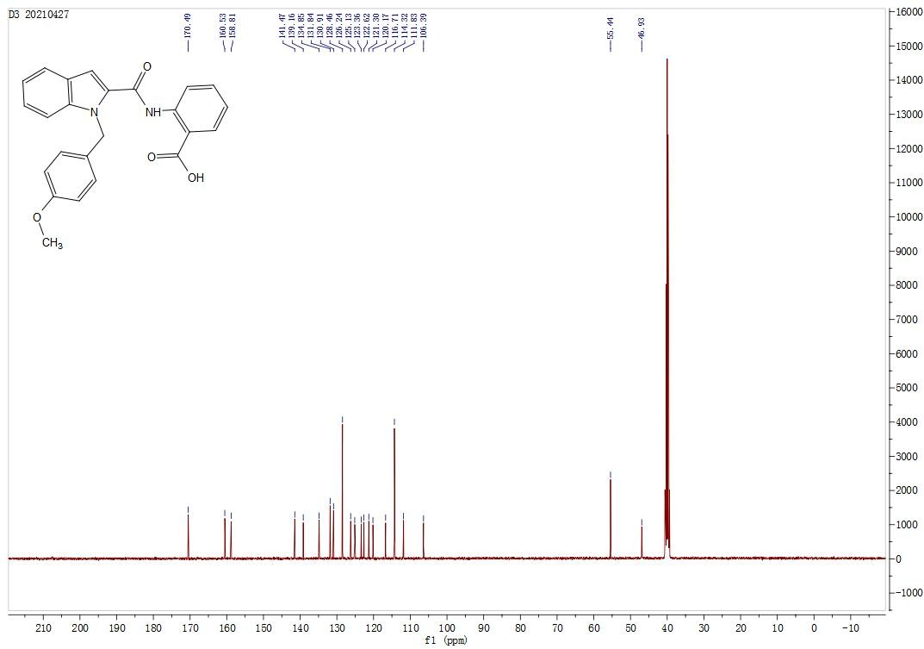

¹H NMR (DMSO-d6, 400 MHz). 2-(1-(4-methylbenzyl)-1H-indole-2-carboxamido)benzoic acid (7d)

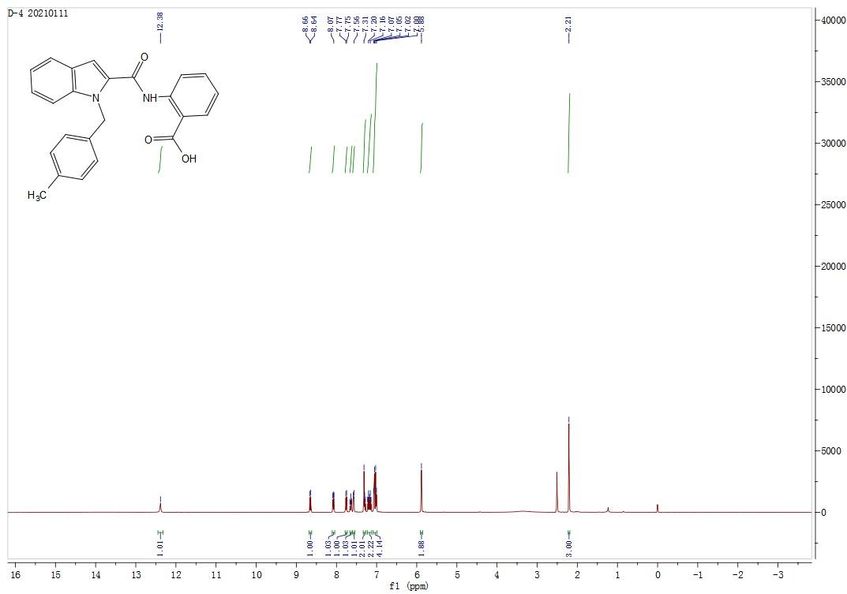

¹³C NMR (DMSO-d6, 100 MHz). 2-(1-(4-methylbenzyl)-1H-indole-2-carboxamido)benzoic acid (7d)

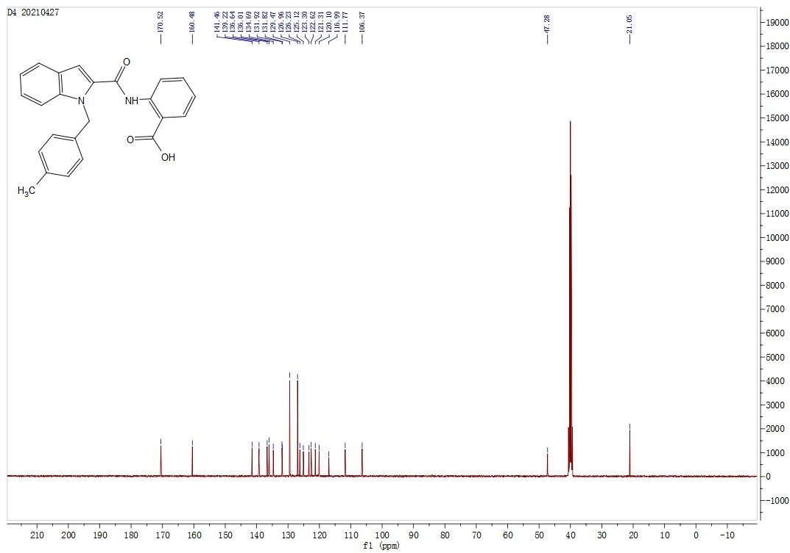

¹H NMR (DMSO-d6, 400 MHz). 2-(1-(4-(trifluoromethyl)benzyl)-1H-indole-2-carboxamido)benzoic acid (7e)

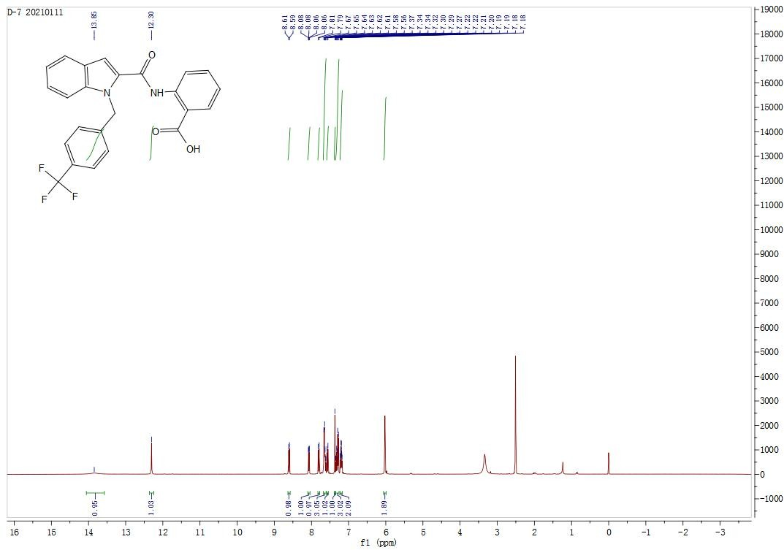
¹³C NMR (DMSO-d6, 100 MHz). 2-(1-(4-(trifluoromethyl)benzyl)-1H-indole-2-carboxamido)benzoic acid (7e)

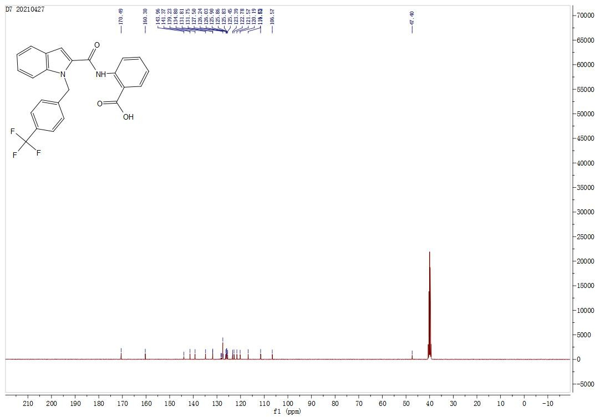

¹H NMR (DMSO-d6, 400 MHz). 2-(5-chloro-1-(4-fluorobenzyl)-1H-indole-2-carboxamido)benzoic acid (7f)

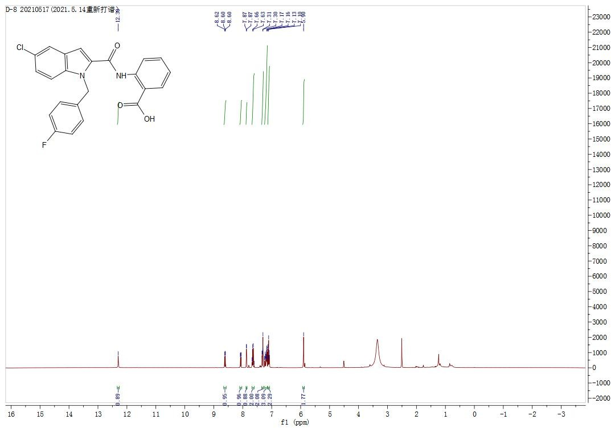

¹³C NMR (DMSO-d6, 100 MHz). 2-(5-chloro-1-(4-fluorobenzyl)-1H-indole-2-carboxamido)benzoic acid (7f)

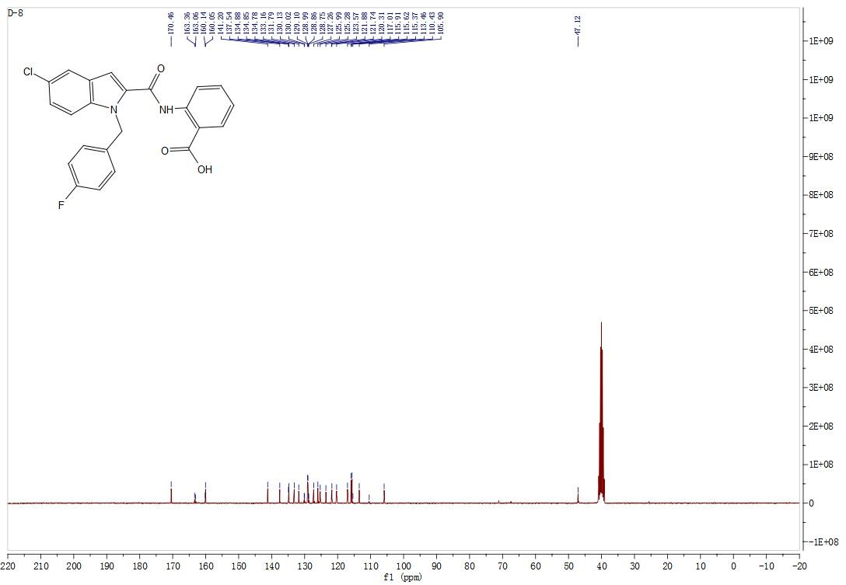

¹H NMR (DMSO-d6, 400 MHz). 2-(5-chloro-1-(4-chlorobenzyl)-1H-indole-2-carboxamido)benzoic acid (7g)
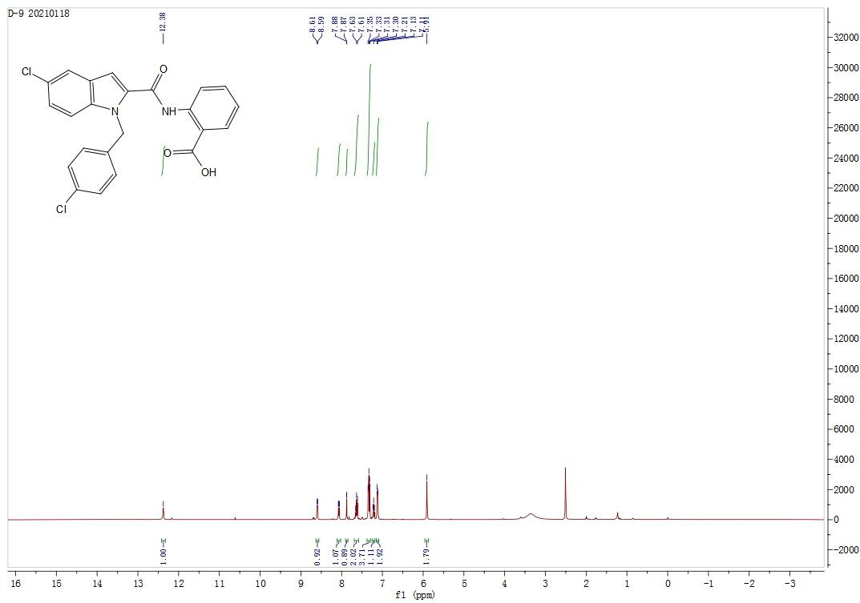

¹³C NMR (DMSO-d6, 100 MHz). 2-(5-chloro-1-(4-chlorobenzyl)-1H-indole-2-carboxamido)benzoic acid (7g)

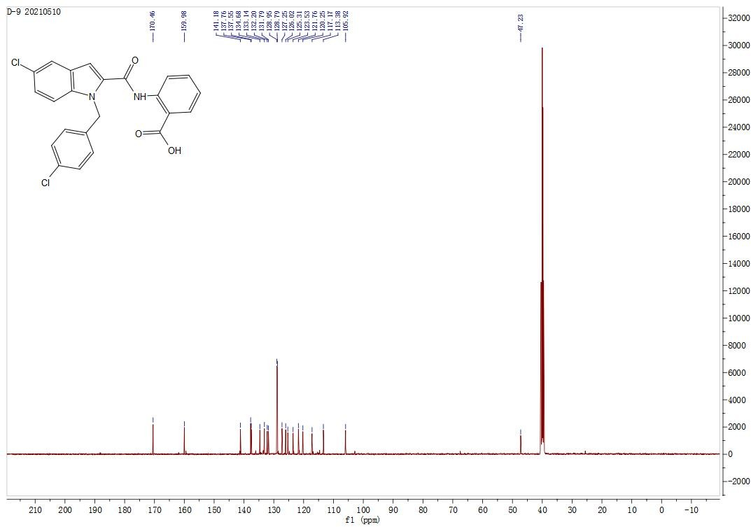

¹H NMR (DMSO-d6, 400 MHz). 2-(5-chloro-1-(4-methoxybenzyl)-1H-indole-2-carboxamido)benzoic acid (7h)
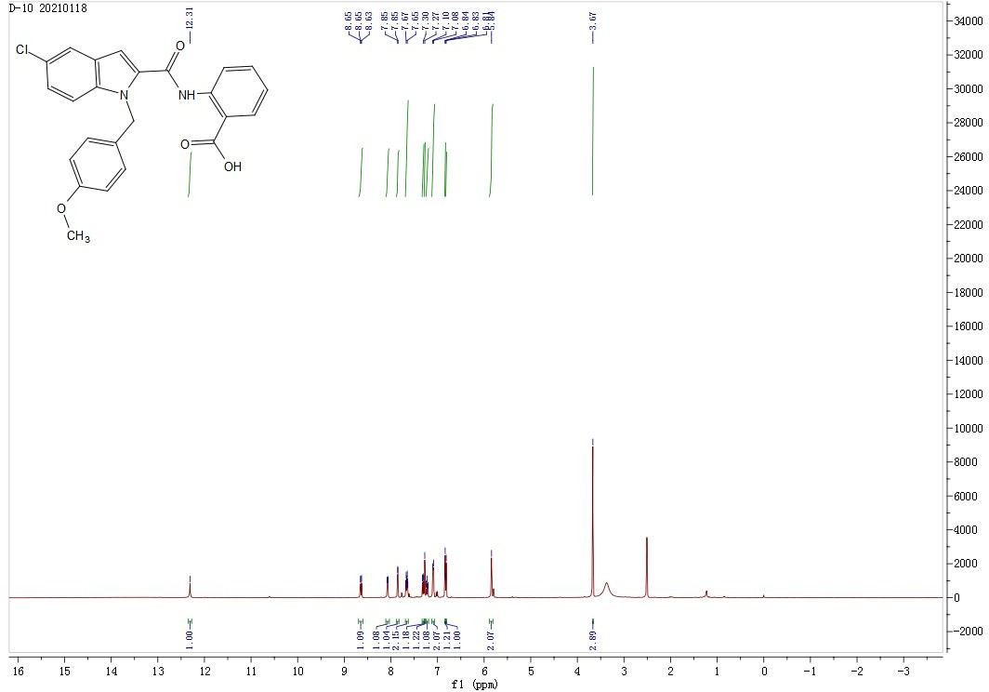
¹³C NMR (DMSO-d6, 100 MHz). 2-(5-chloro-1-(4-methoxybenzyl)-1H-indole-2-carboxamido)benzoic acid (7h)

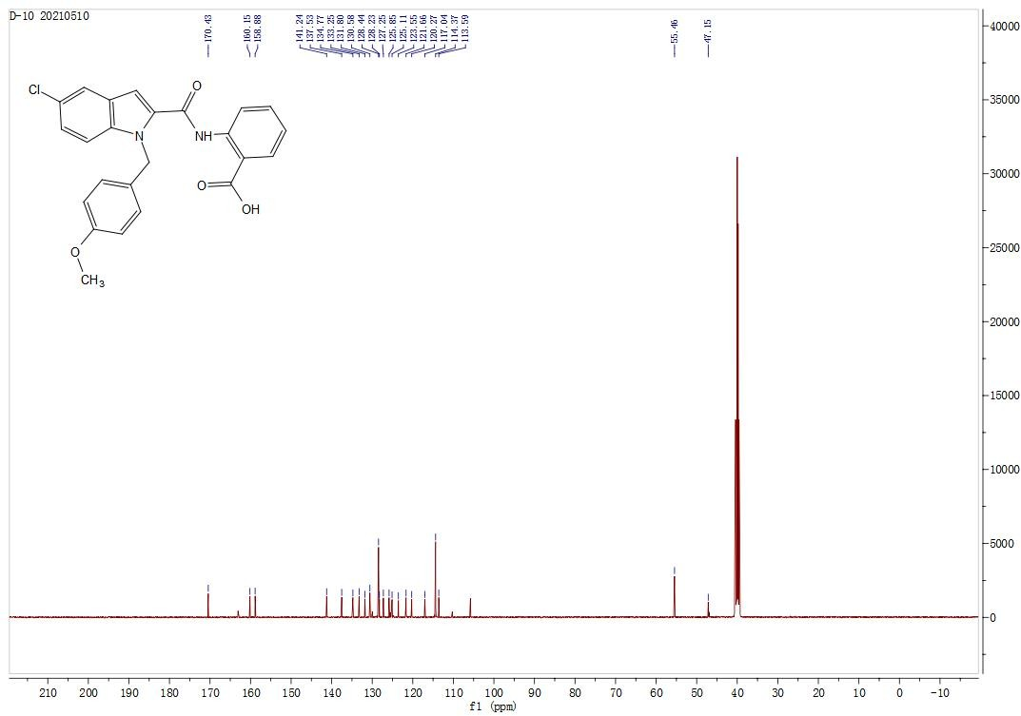

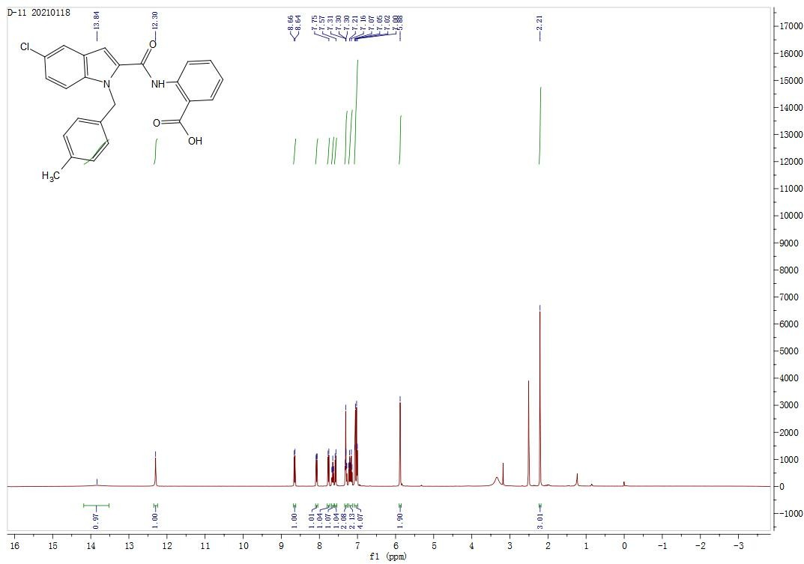
¹H NMR (DMSO-d6, 400 MHz). 2-(5-chloro-1-(4-methylbenzyl)-1H-indole-2-carboxamido)benzoic acid (7i)

¹³C NMR (DMSO-d6, 100 MHz). 2-(5-chloro-1-(4-methylbenzyl)-1H-indole-2-carboxamido)benzoic acid (7i)
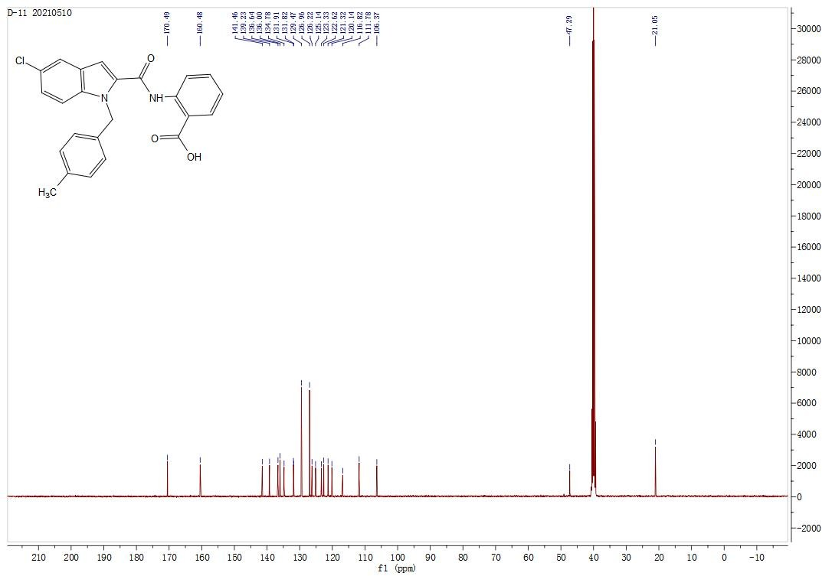

¹H NMR (DMSO-d6, 400 MHz). 2-(5-chloro-1-(4-(trifluoromethyl)benzyl)-1H-indole-2-carboxamido)benzoic acid (7j)

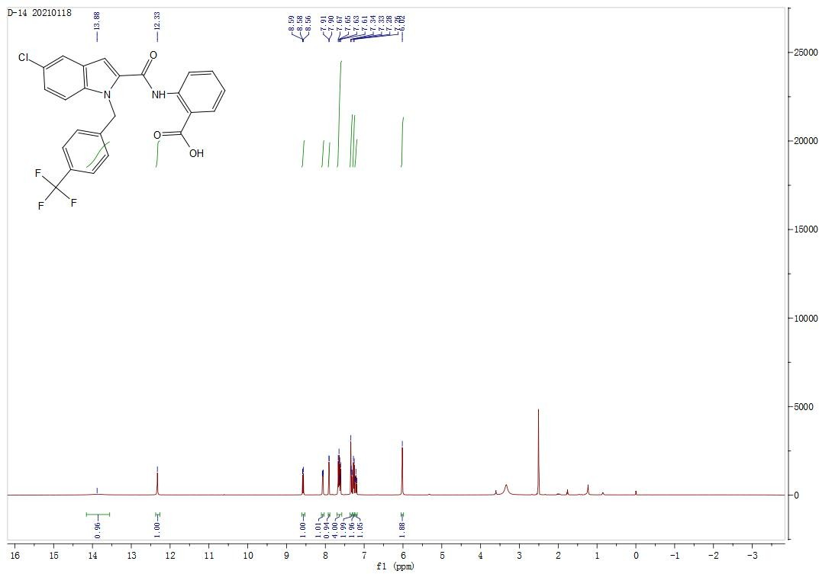

¹³C NMR (DMSO-d6, 100 MHz). 2-(5-chloro-1-(4-(trifluoromethyl)benzyl)-1H-indole-2-carboxamido)benzoic acid (7j)
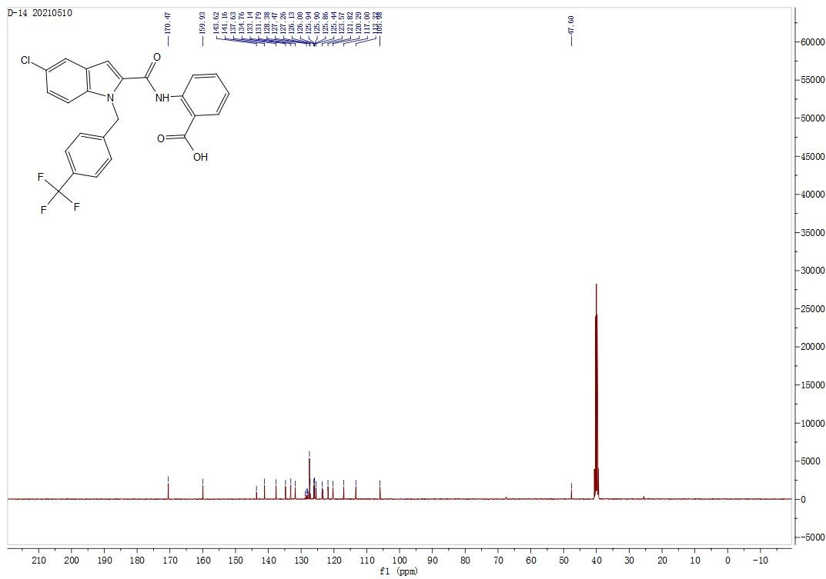

¹H NMR (DMSO-d6, 400 MHz). 2-(1-(4-fluorobenzyl)-1H-indole-3-carboxamido)benzoic acid (7k)
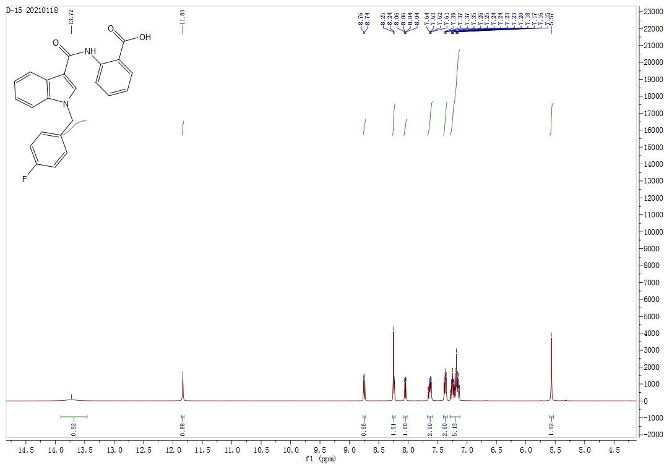

¹³C NMR (DMSO-d6, 100 MHz). 2-(1-(4-fluorobenzyl)-1H-indole-3-carboxamido)benzoic acid (7k)

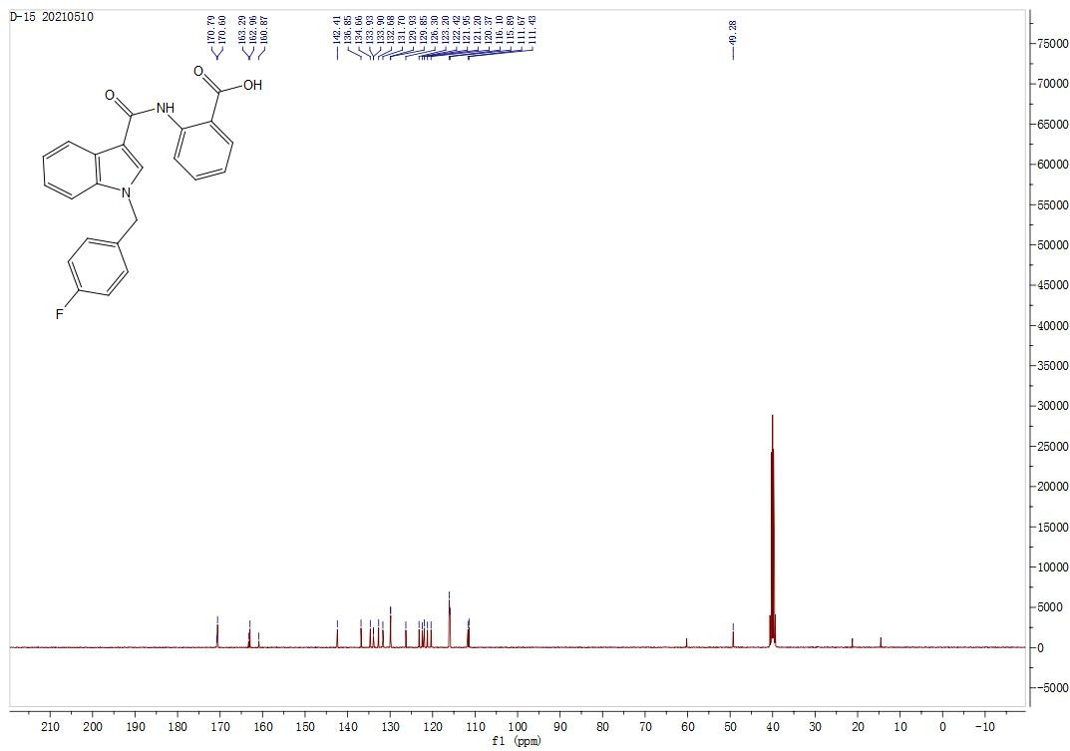

¹H NMR (DMSO-d6, 400 MHz). 2-(1-(4-chlorobenzyl)-1H-indole-3-carboxamido)benzoic acid (7l)
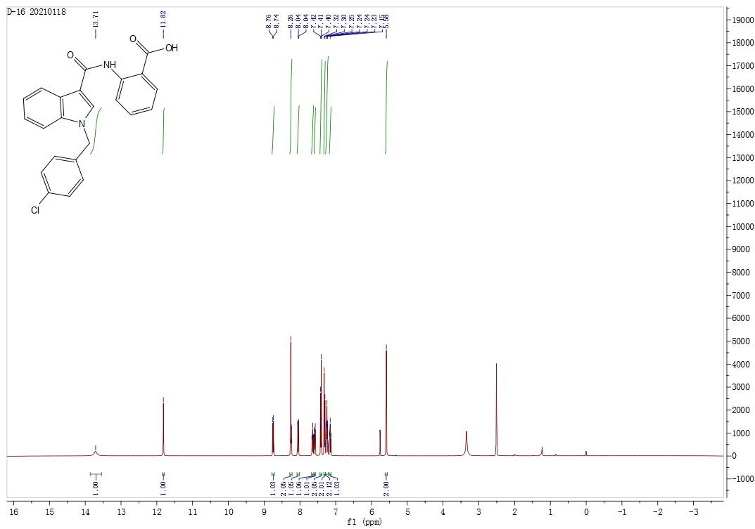

¹³C NMR (DMSO-d6, 100 MHz). 2-(1-(4-chlorobenzyl)-1H-indole-3-carboxamido)benzoic acid (7l)
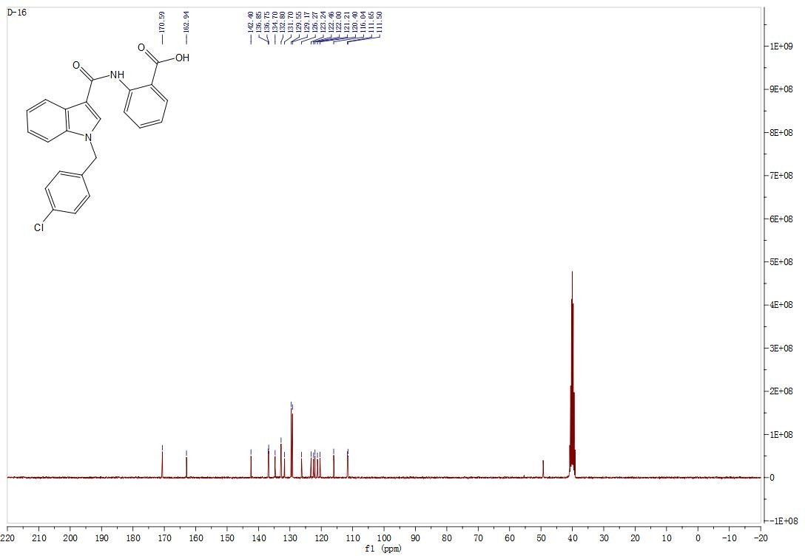

¹H NMR (DMSO-d6, 400 MHz). 2-(1-(4-methoxybenzyl)-1H-indole-3-carboxamido)benzoic acid (7m)

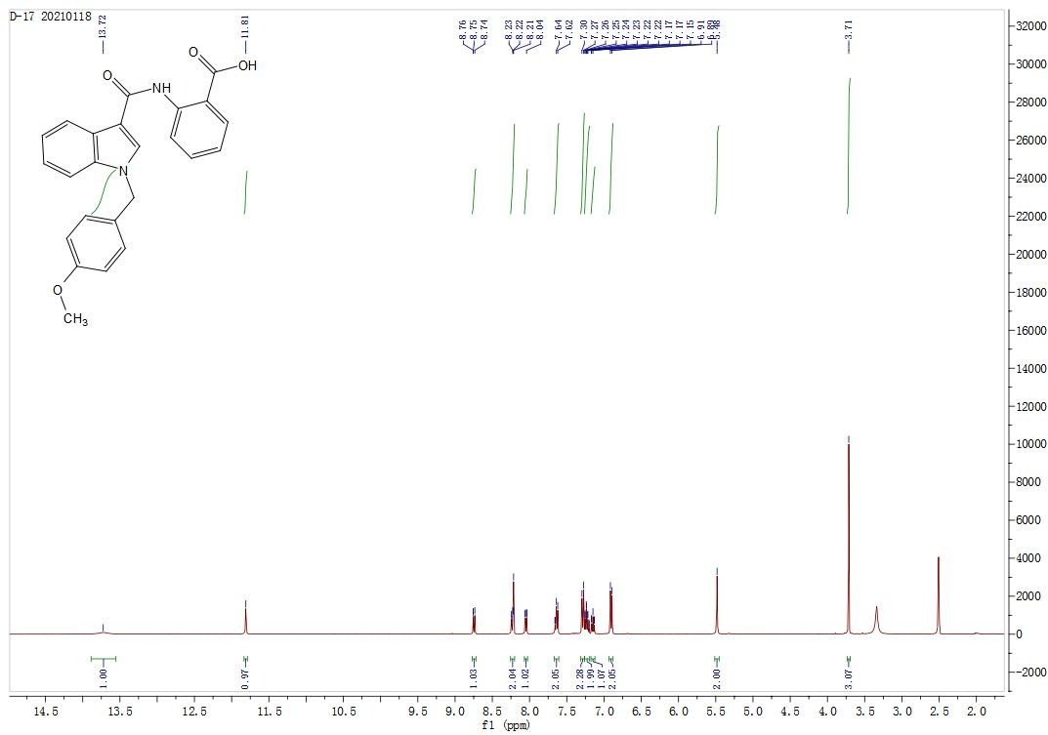
¹³C NMR (DMSO-d6, 100 MHz). 2-(1-(4-methoxybenzyl)-1H-indole-3-carboxamido)benzoic acid (7m)

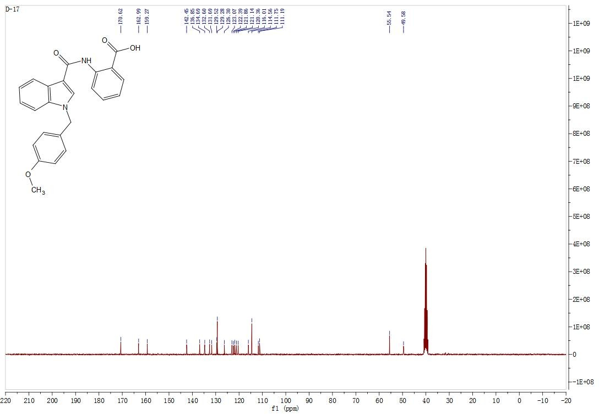

¹H NMR (DMSO-d6, 400 MHz). 2-(1-(4-methylbenzyl)-1H-indole-3-carboxamido)benzoic acid (7n)

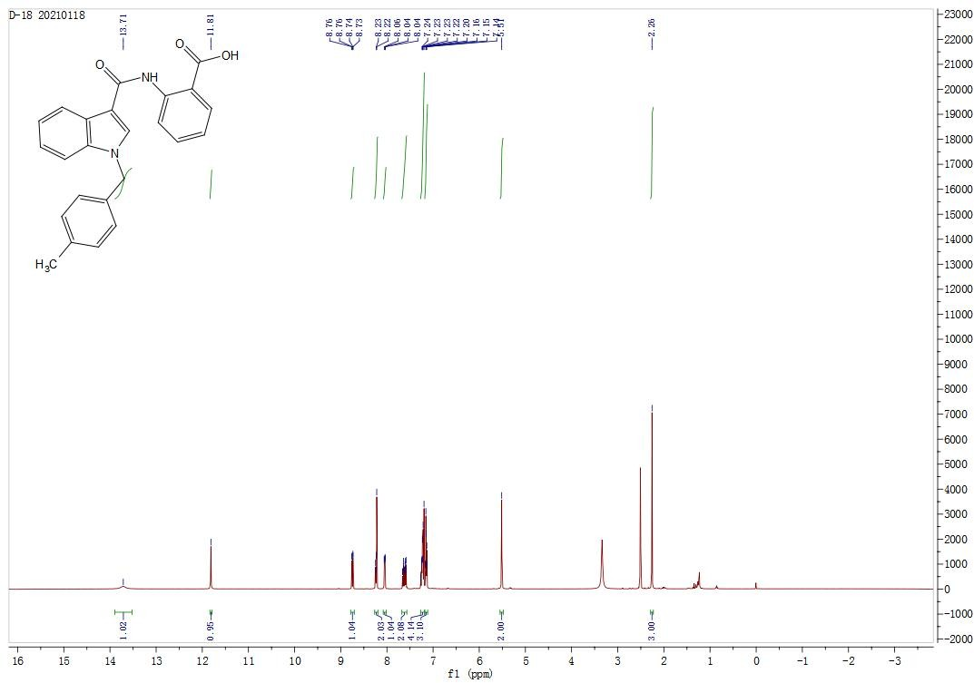

¹³C NMR (DMSO-d6, 100 MHz). 2-(1-(4-methylbenzyl)-1H-indole-3-carboxamido)benzoic acid (7n)

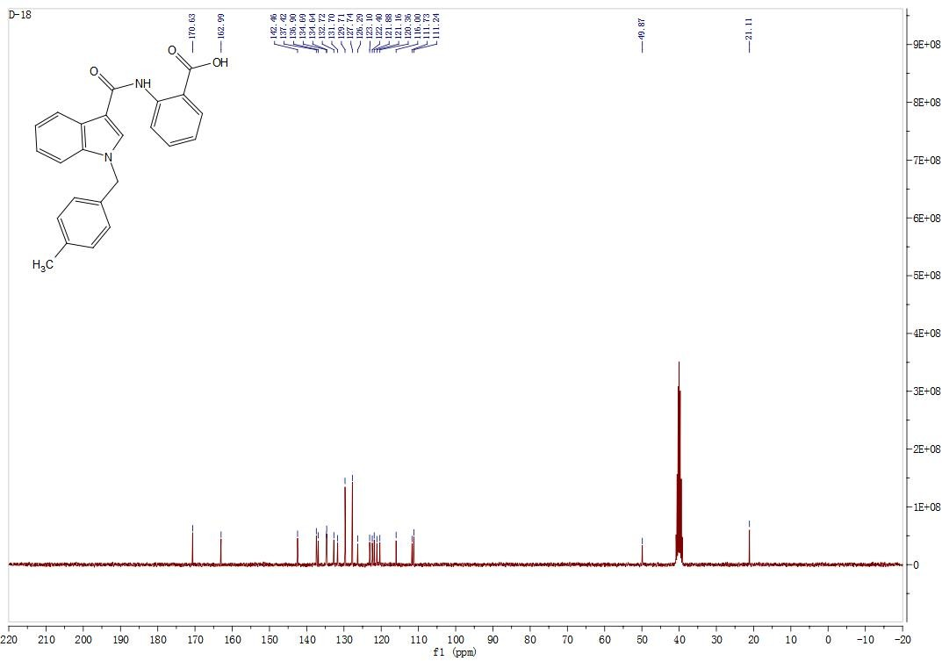

¹H NMR (DMSO-d6, 400 MHz). 2-(1-(4-(trifluoromethyl)benzyl)-1H-indole-3-carboxamido)benzoic acid (7o)
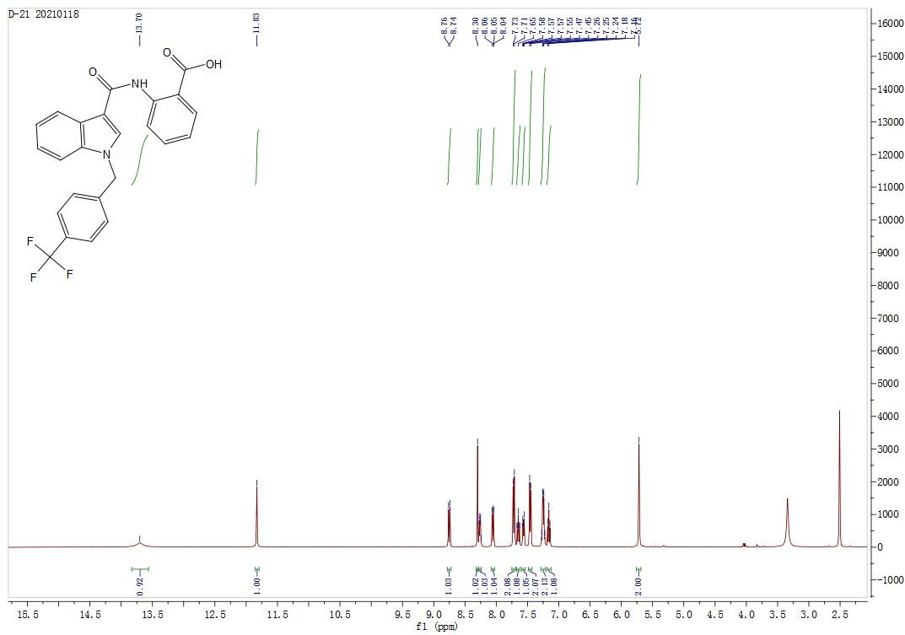

¹³C NMR (DMSO-d6, 100 MHz). 2-(1-(4-(trifluoromethyl)benzyl)-1H-indole-3-carboxamido)benzoic acid (7o)

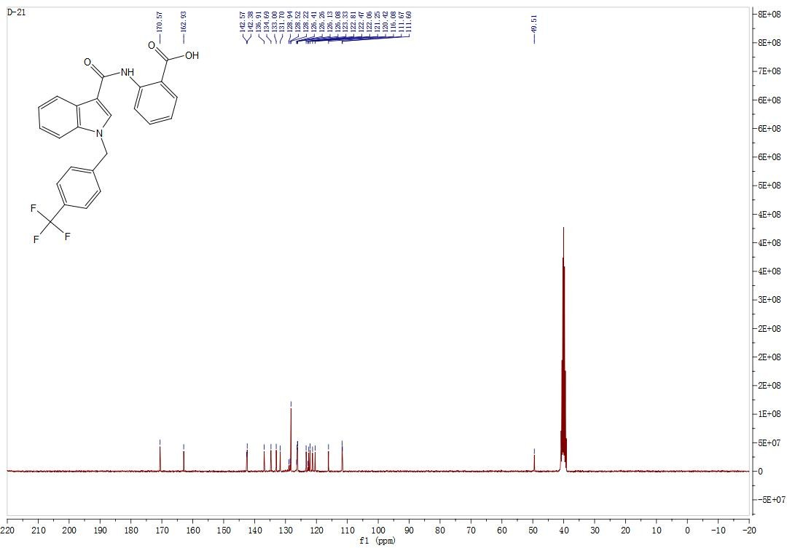

¹H NMR (DMSO-d6, 400 MHz). 2-(1-(4-fluorobenzyl)-1H-indazole-3-carboxamido)benzoic acid (7t)
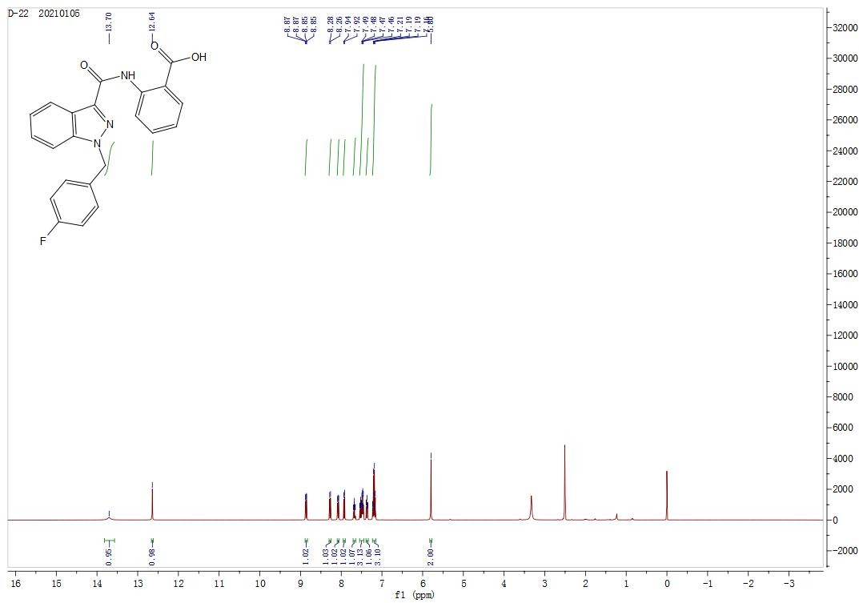

¹³C NMR (DMSO-d6, 100 MHz). 2-(1-(4-fluorobenzyl)-1H-indazole-3-carboxamido)benzoic acid (7t)

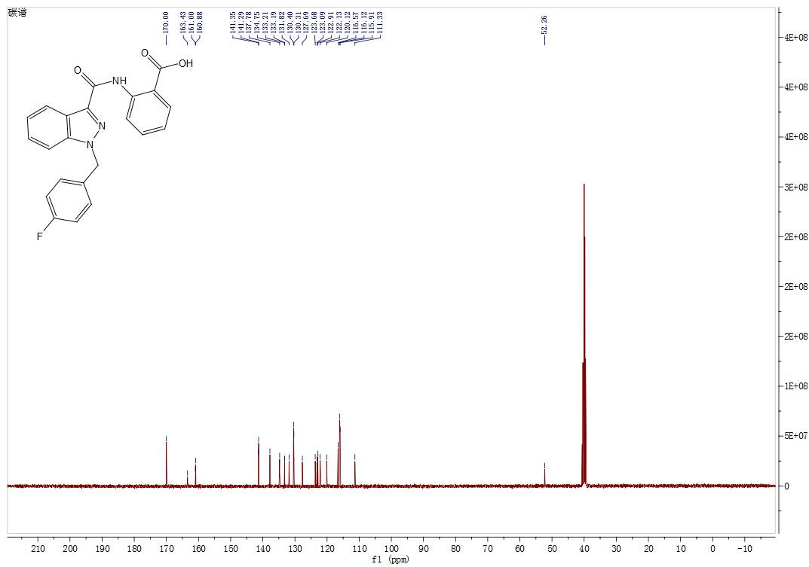

¹H NMR (DMSO-d6, 400 MHz). 2-(1-(4-methoxybenzyl)-1H-indazole-3-carboxamido)benzoic acid (7u)
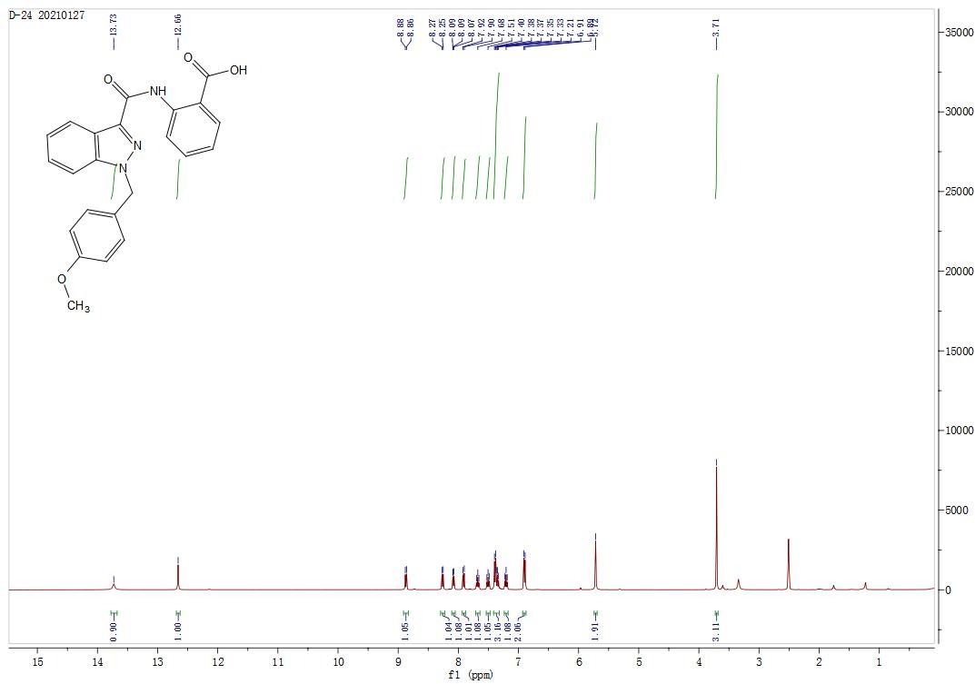

¹³C NMR (DMSO-d6, 100 MHz). 2-(1-(4-methoxybenzyl)-1H-indazole-3-carboxamido)benzoic acid (7u)

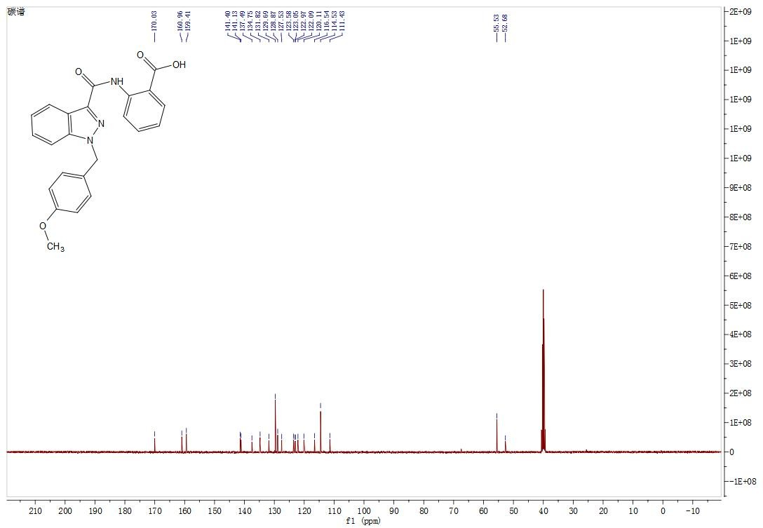

¹H NMR (DMSO-d6, 400 MHz). 2-(1-(4-methylbenzyl)-1H-indazole-3-carboxamido)benzoic acid (7v)

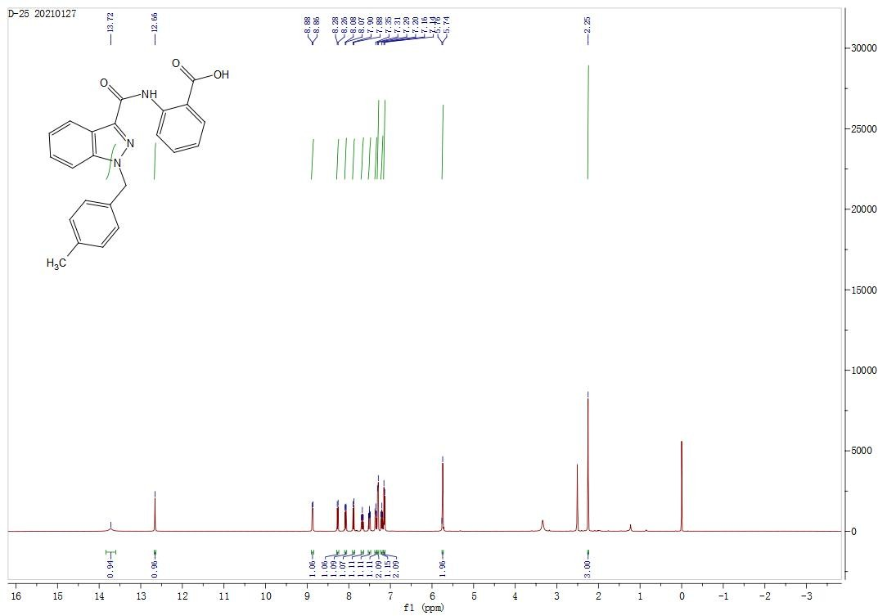

¹³C NMR (DMSO-d6, 100 MHz). 2-(1-(4-methylbenzyl)-1H-indazole-3-carboxamido)benzoic acid (7v)
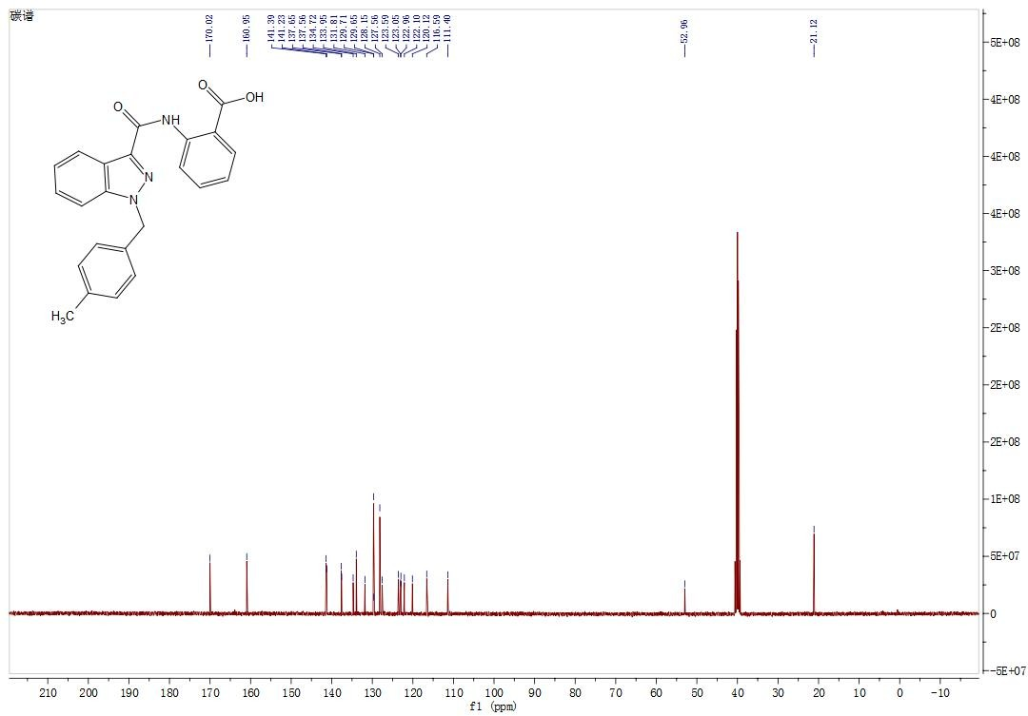

¹H NMR (DMSO-d6, 400 MHz). 2-(1-(4-(trifluoromethyl)benzyl)-1H-indazole-3-carboxamido)benzoic acid (7w)

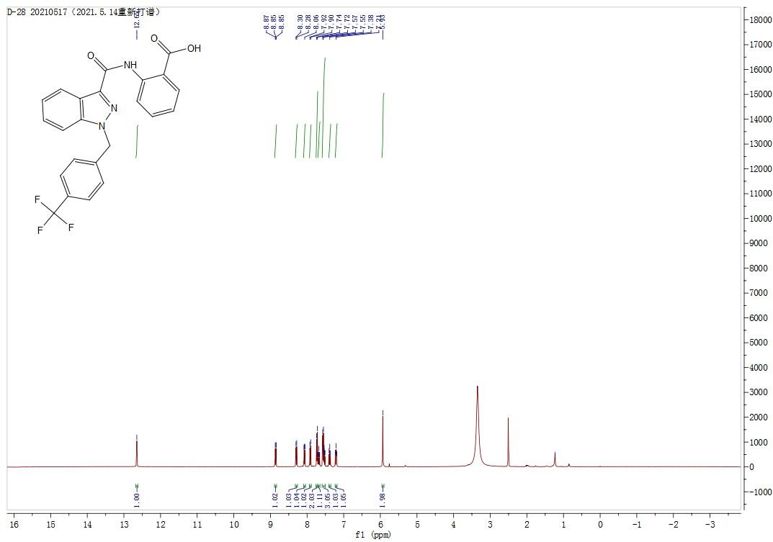
¹³C NMR (DMSO-d6, 100 MHz). 2-(1-(4-(trifluoromethyl)benzyl)-1H-indazole-3-carboxamido)benzoic acid (7w)

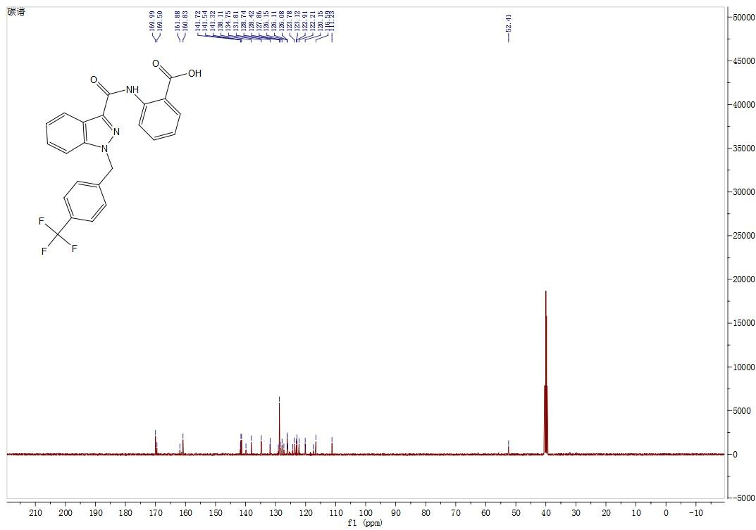

¹H NMR (DMSO-d6, 400 MHz). 2-(5-chloro-1-(4-fluorobenzyl)-1H-indole-3-carboxamido)benzoic acid (7p)

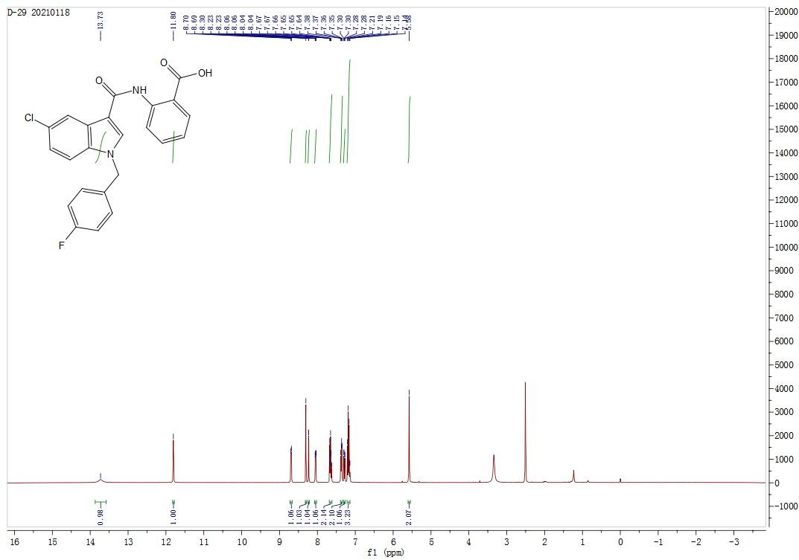
¹³C NMR (DMSO-d6, 100 MHz). 2-(5-chloro-1-(4-fluorobenzyl)-1H-indole-3-carboxamido)benzoic acid (7p)
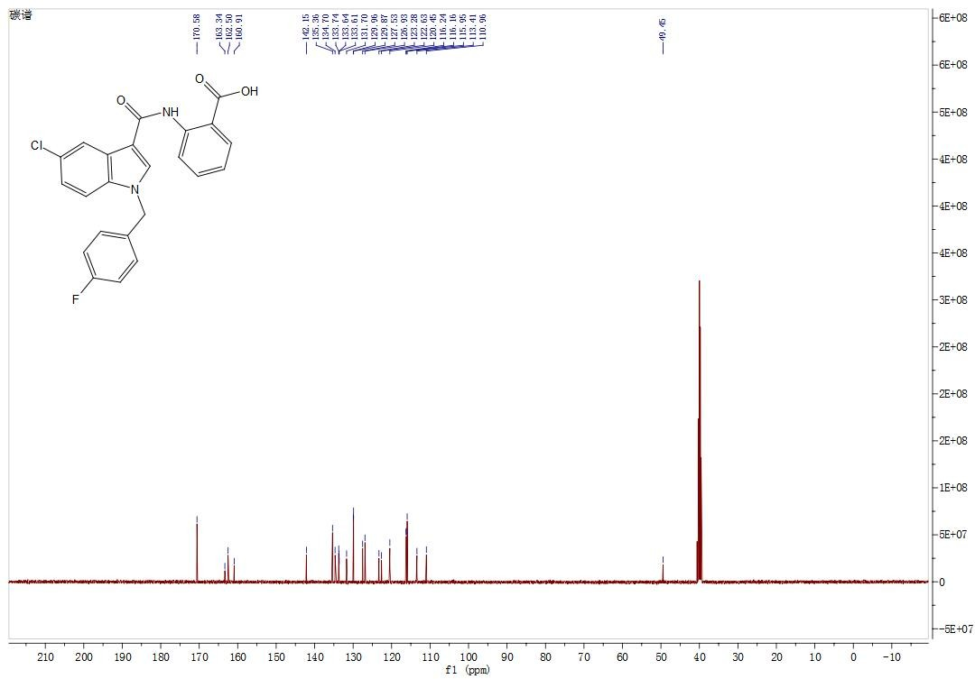

¹H NMR (DMSO-d6, 400 MHz). 2-(5-chloro-1-(4-methoxybenzyl)-1H-indole-3-carboxamido)benzoic acid (7q)

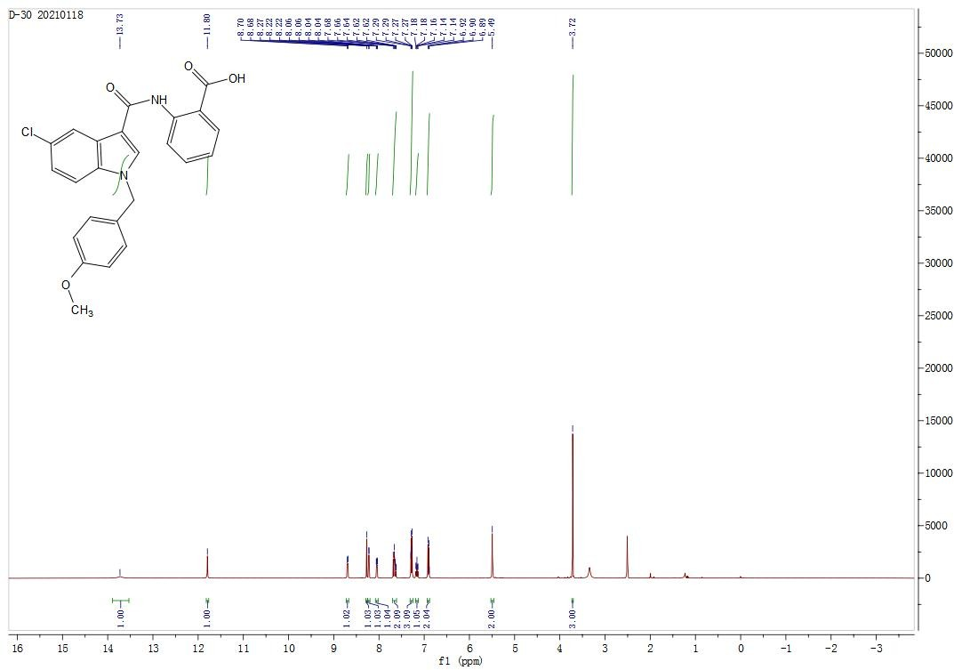

¹³C NMR (DMSO-d6, 100 MHz). 2-(5-chloro-1-(4-methoxybenzyl)-1H-indole-3-carboxamido)benzoic acid (7q)

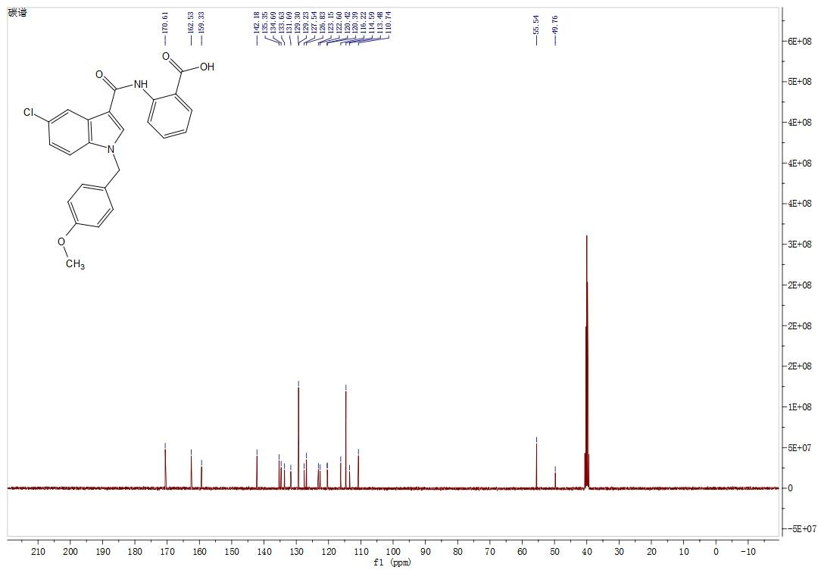

¹H NMR (DMSO-d6, 400 MHz). 2-(5-chloro-1-(4-methylbenzyl)-1H-indole-3-carboxamido)benzoic acid (7r)
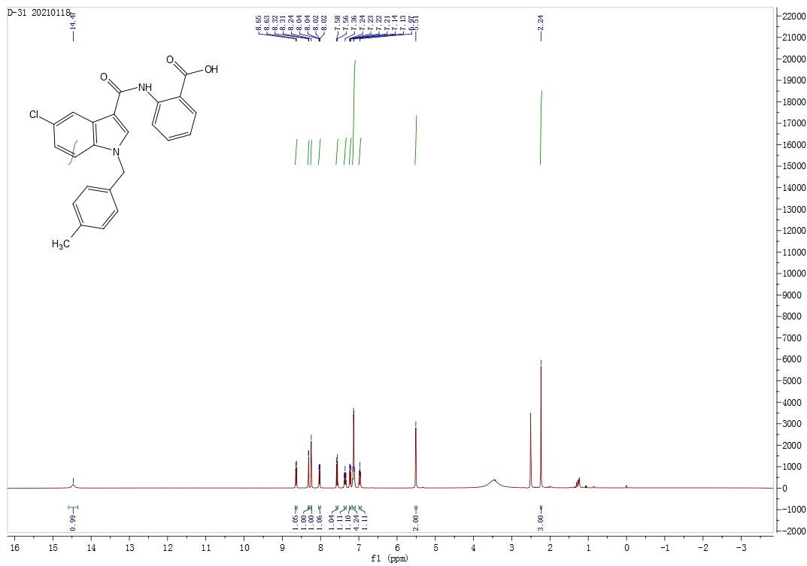
¹³C NMR (DMSO-d6, 100 MHz). 2-(5-chloro-1-(4-methylbenzyl)-1H-indole-3-carboxamido)benzoic acid (7r)
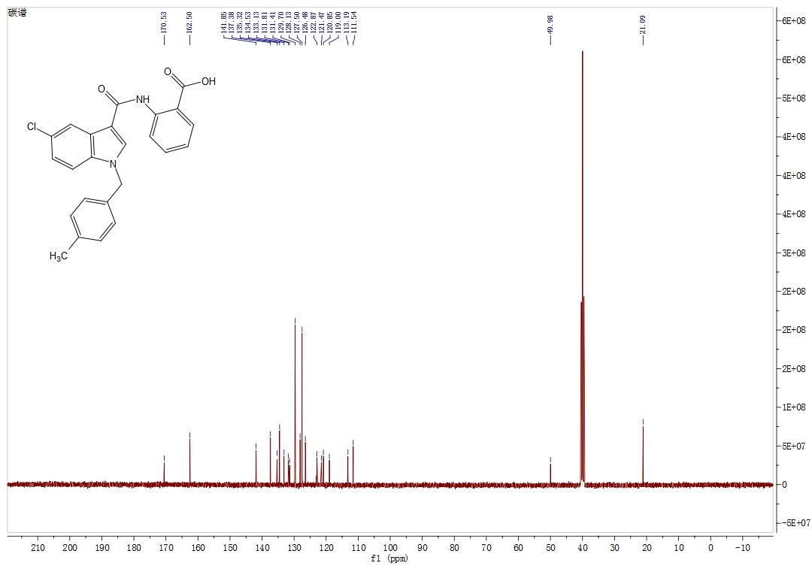

¹H NMR (DMSO-d6, 400 MHz). 2-(5-chloro-1-(4-(trifluoromethyl)benzyl)-1H-indole-3-carboxamido)benzoic acid (7s)

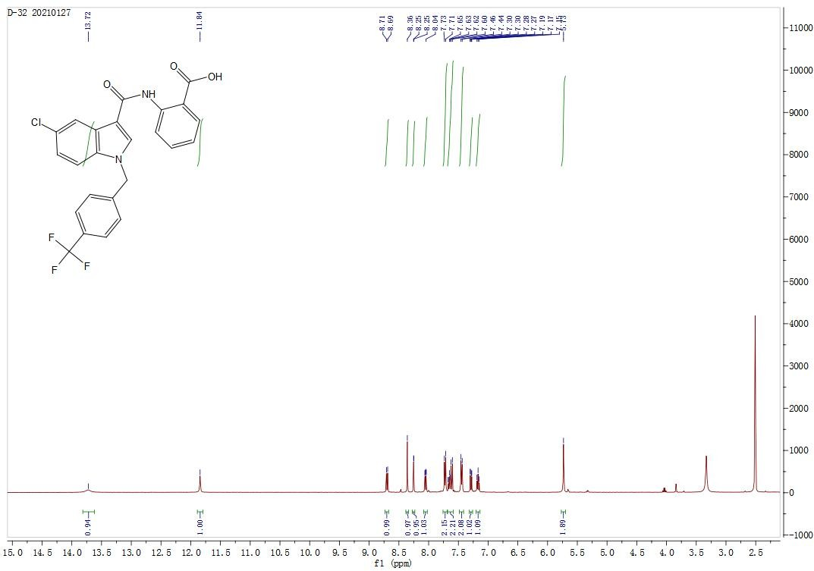
¹³C NMR (DMSO-d6, 100 MHz). 2-(5-chloro-1-(4-(trifluoromethyl)benzyl)-1H-indole-3-carboxamido)benzoic acid (7s)
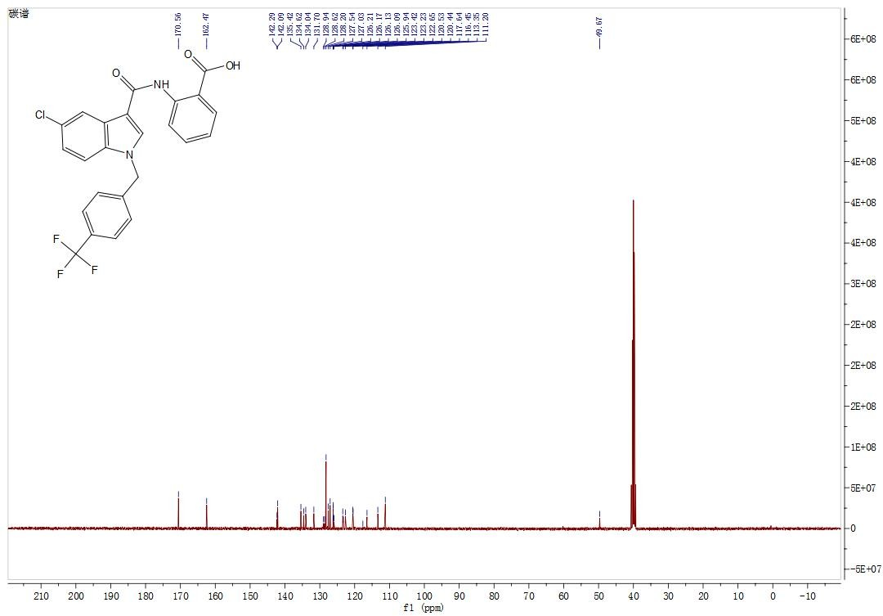

HRMS spectra of compounds

Methyl 1H-indole-2-carboxylate (2a)
HRMS Calculated for C₁₀H₉NO₂ [M+H]⁺ 176.0712, found 176.0705.

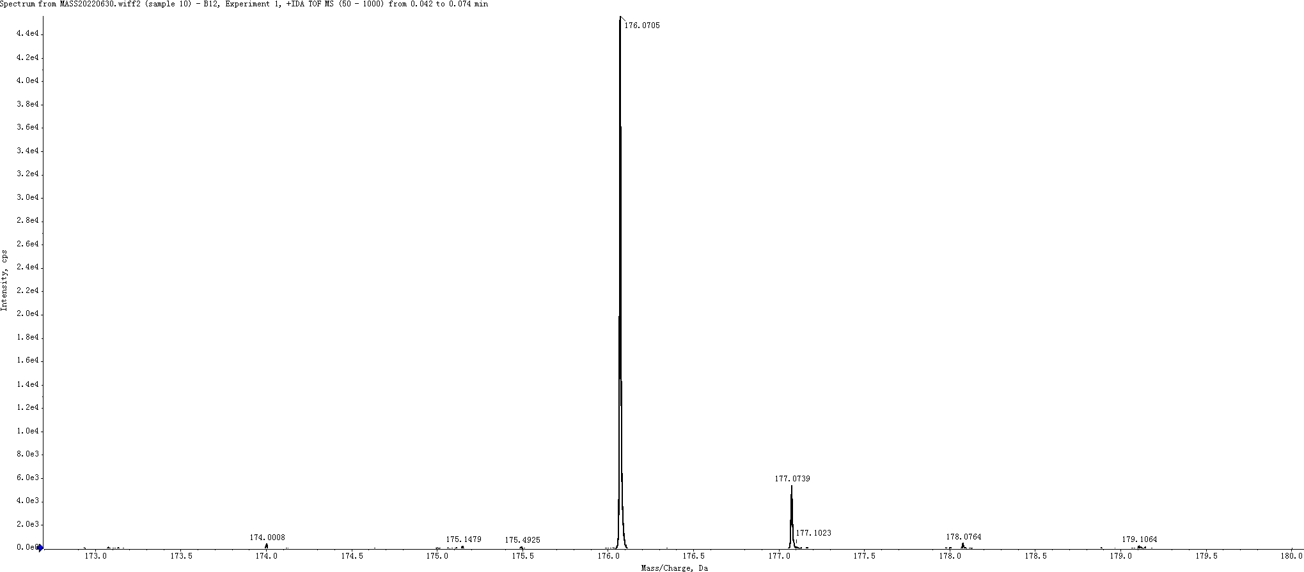

Methyl 5-chloro-1H-indole-2-carboxylate (2b)
HRMS Calculated for C₁₀H₈ClNO₂ [M+H]⁺ 176.0712, found 176.0705.
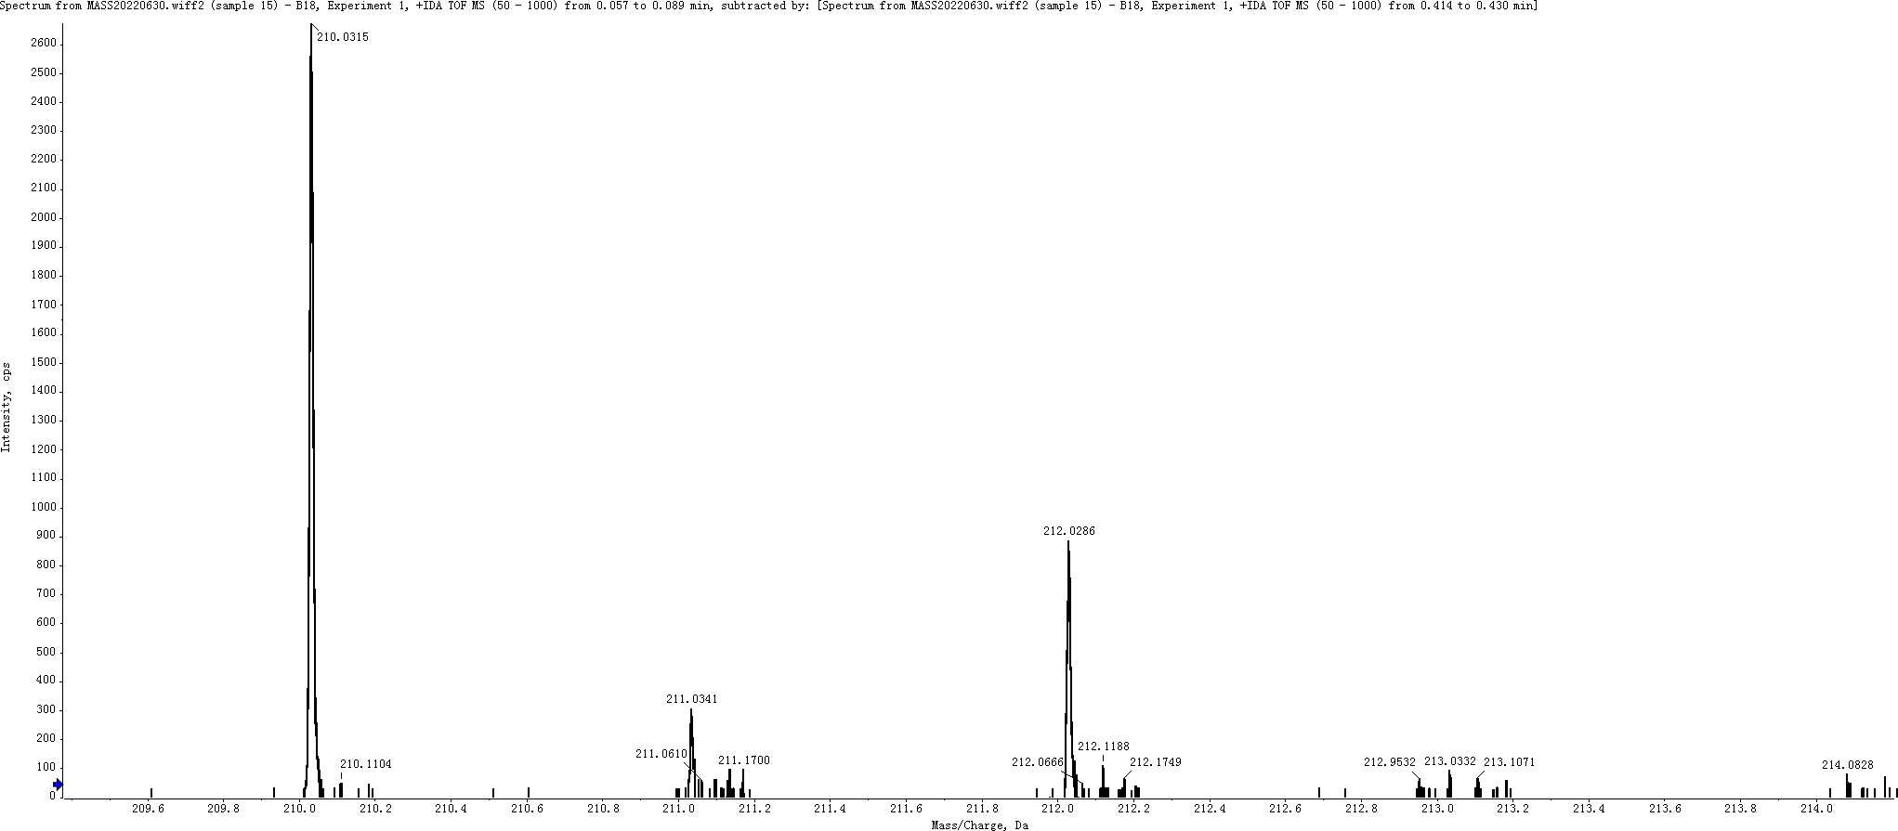

Methyl 1H-indole-3-carboxylate (2c)
HRMS Calculated for C₁₀H₉NO₂ [M+H]⁺ 176.0712, found 176.0706

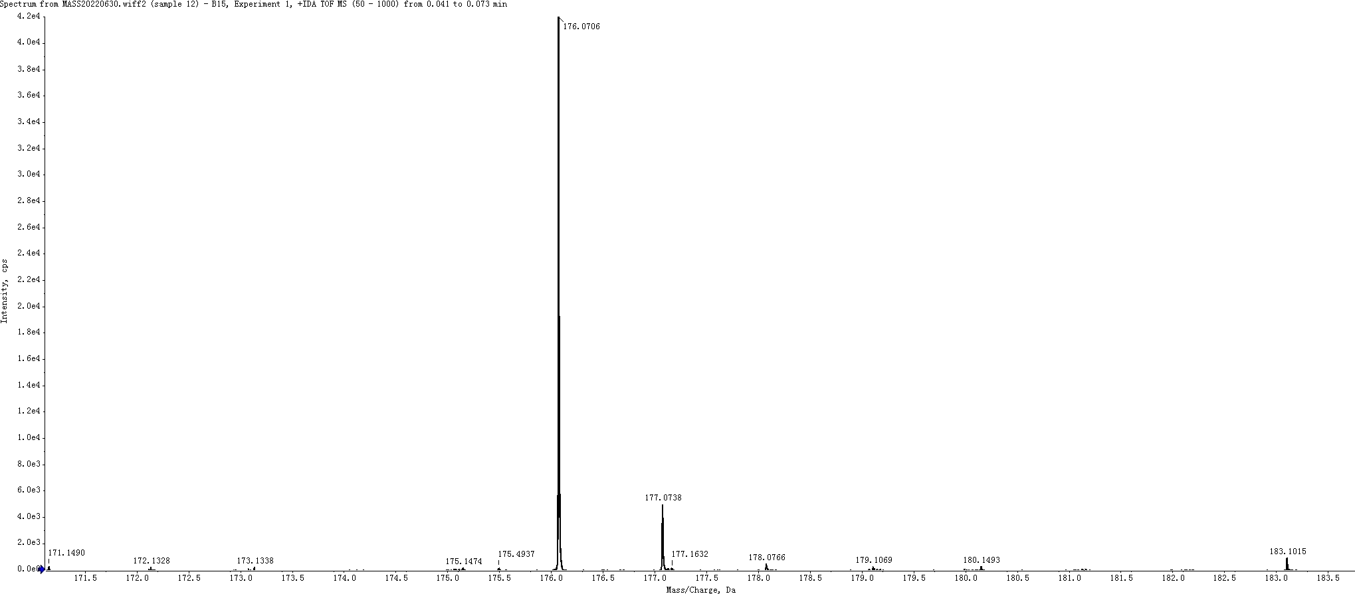
Methyl 5-chloro-1H-indole-3-carboxylate (2d)
HRMS Calculated for C₁₀H₈ClNO₂ [M+H]⁺ 210.0322, found 210.0316.
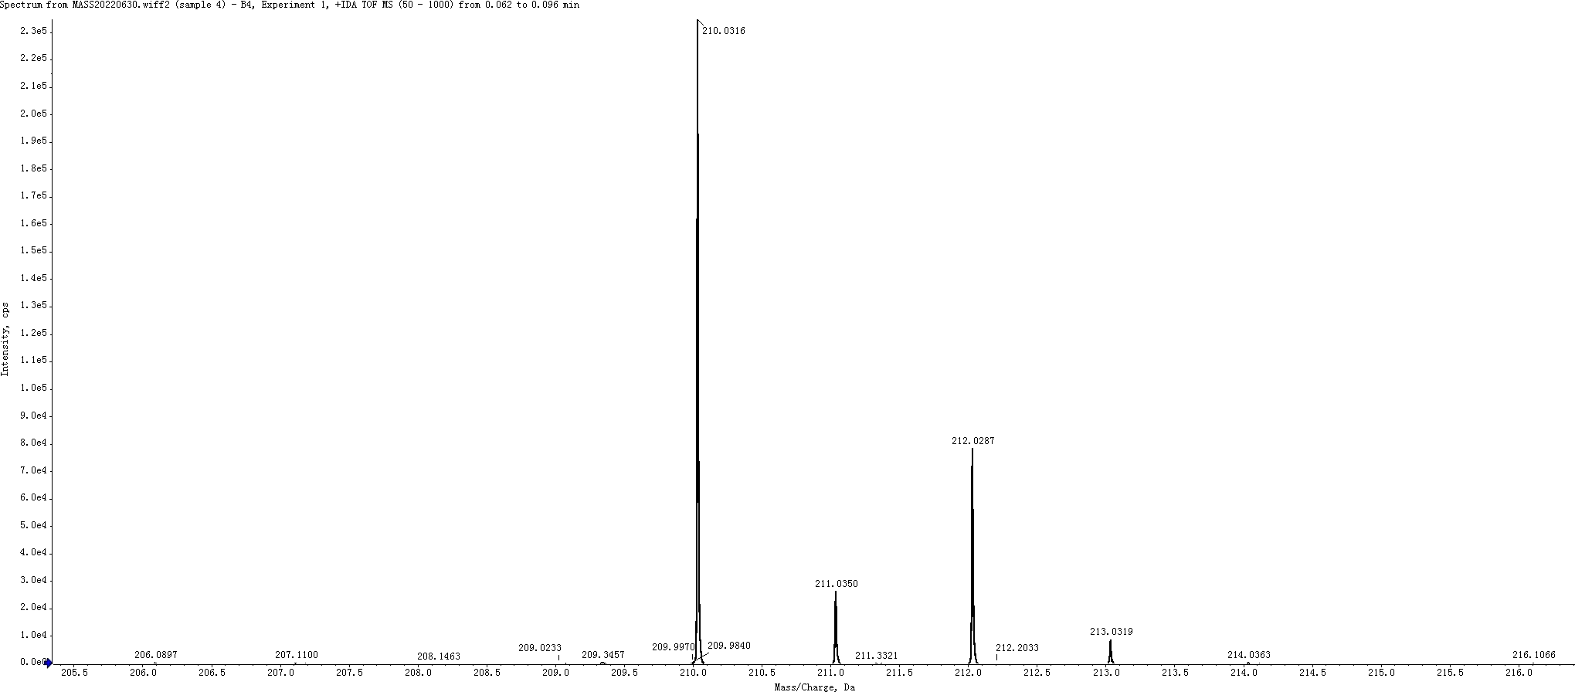

Methyl 1H-indazole-3-carboxylate (2e)
HRMS Calculated for C₉H₈N₂O₂ [M+H]⁺ 177.0664, found 177.0657.

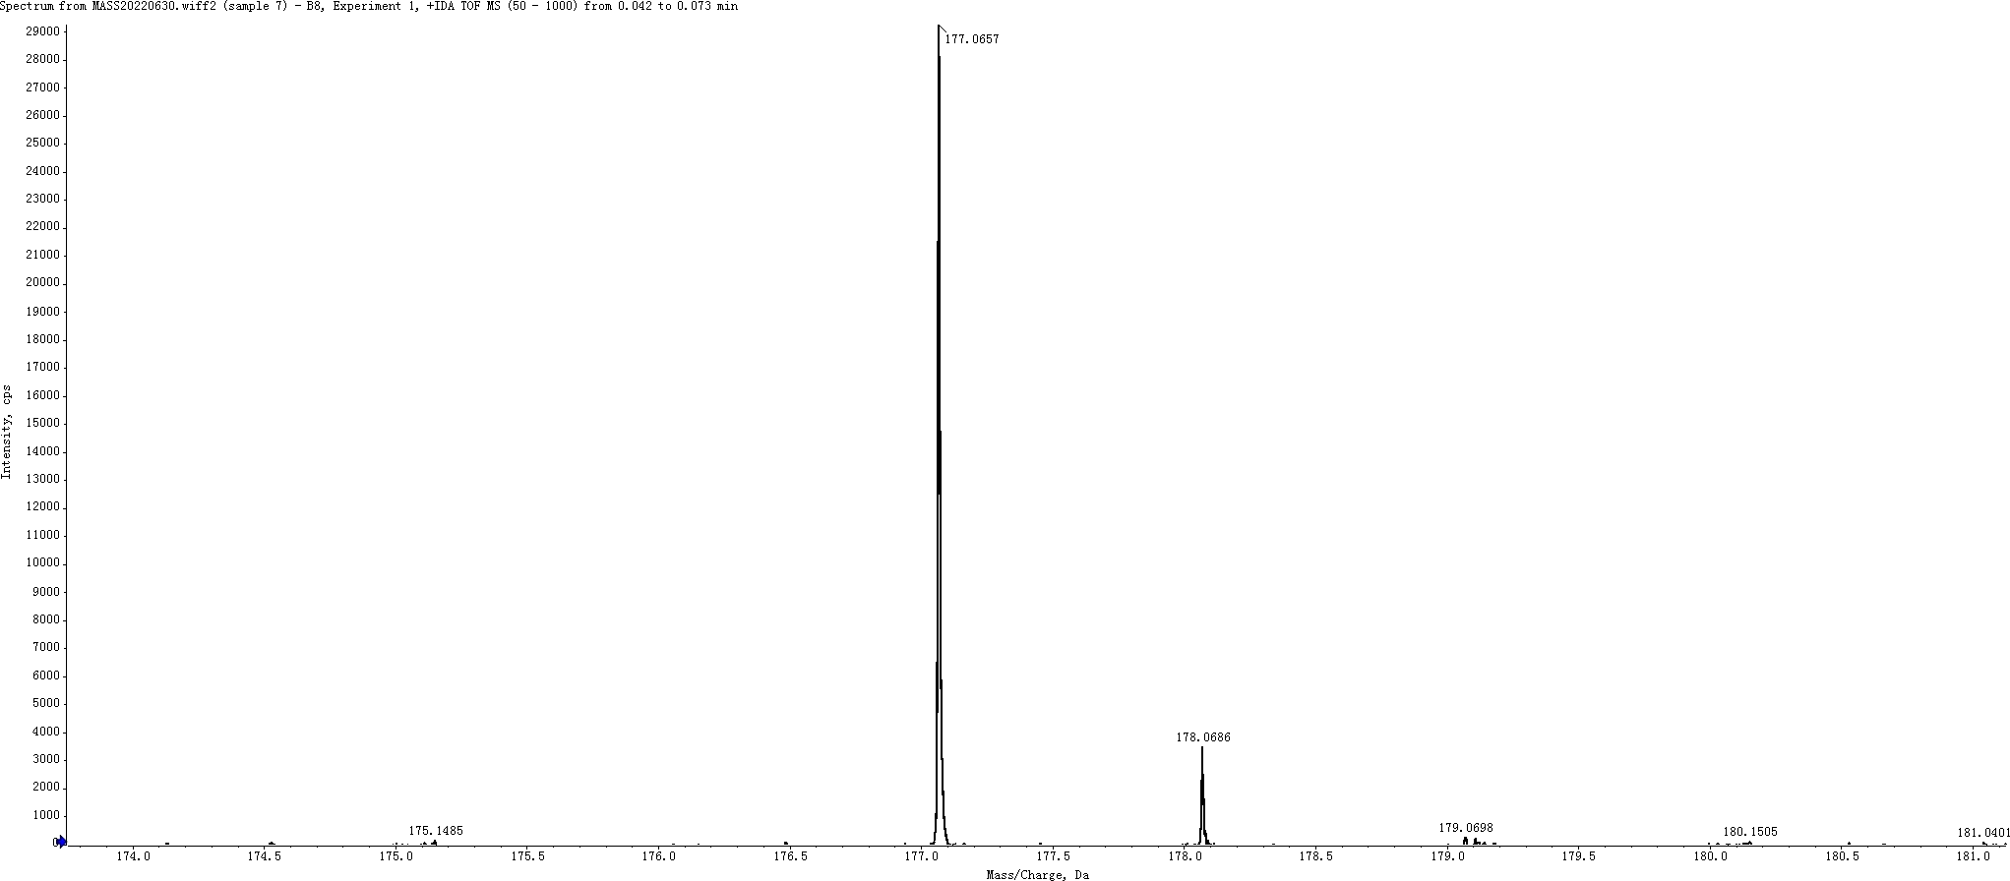

Methyl 1-(4-methylbenzyl)-1H-indole-2-carboxylate (3d)
HRMS Calculated for C₁₈H₁₇NO₂ [M+H]⁺ 280.1338, found 280.1328.
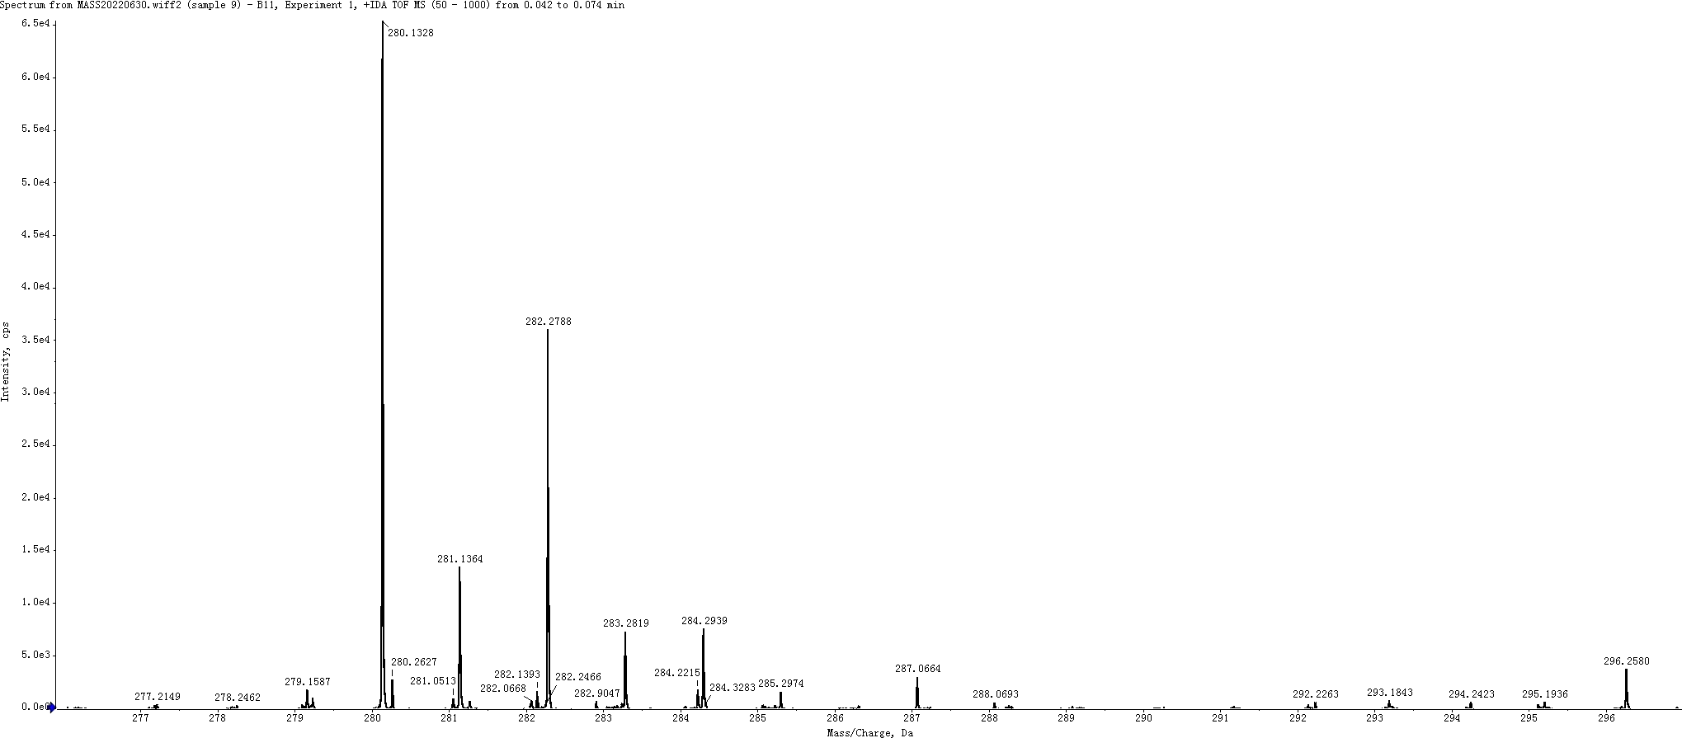

Methyl 5-chloro-1-(4-methylbenzyl)-1H-indole-2-carboxylate (3i)
HRMS Calculated for C₁₈H₁₆ClNO₂ [M+H]⁺ 314.0948, found 314.0939.
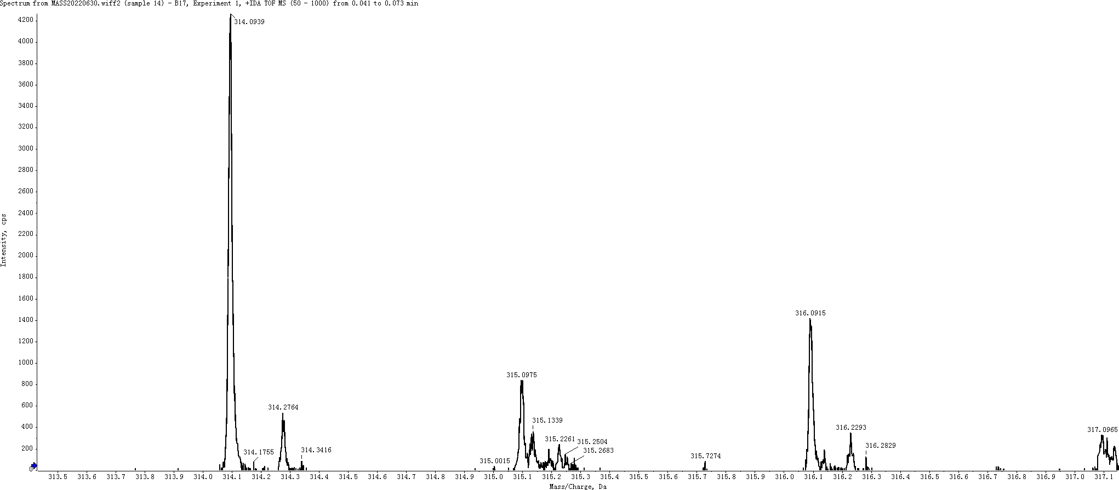

Methyl 1-(4-fluorobenzyl)-1H-indole-3-carboxylate (3k)
HRMS Calculated for C₁₈H₁₇NO₂ [M+H]⁺ 284.1087, found 284.1078.
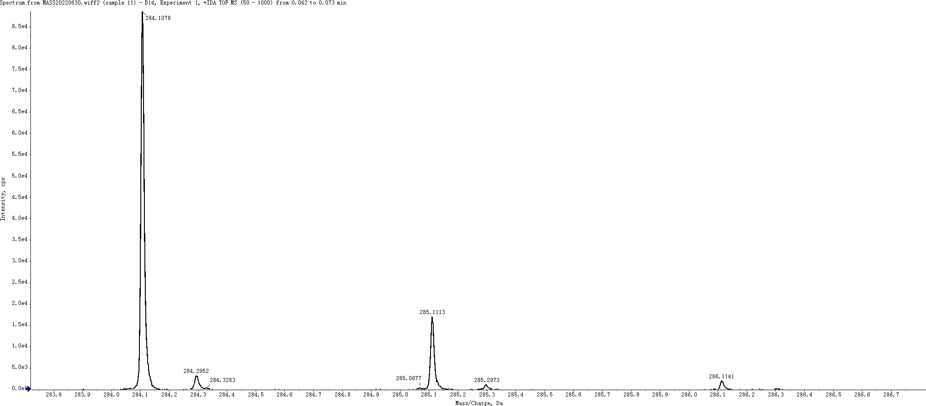

Methyl 5-chloro-1-(4-methylbenzyl)-1H-indole-3-carboxylate (3r)
HRMS Calculated for C₁₈H₁₆ClNO₂ [M+H]⁺ 314.0948, found 314.0937.
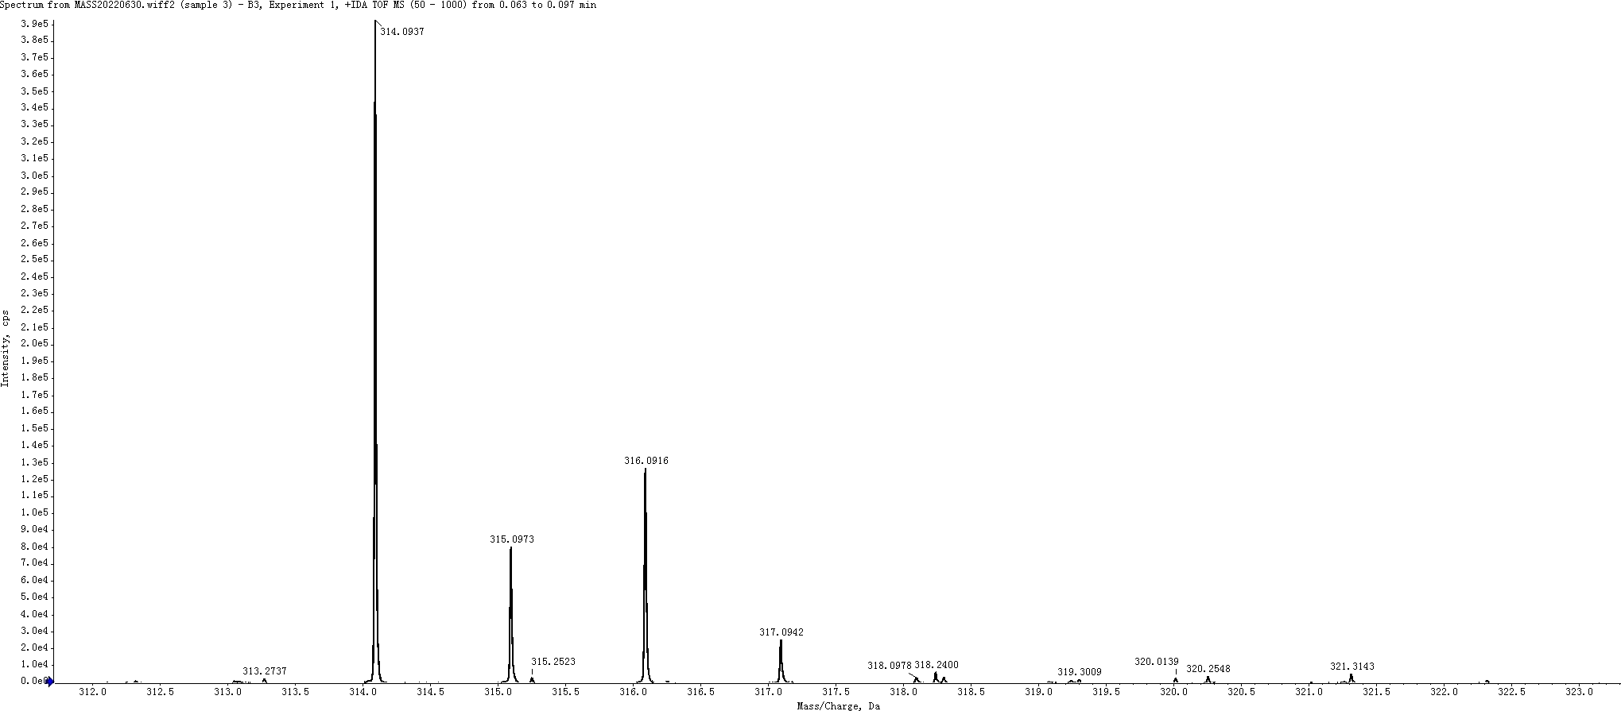

Methyl 1-(4-fluorobenzyl)-1H-indazole-3-carboxylate (3t)
HRMS Calculated for C₁₆H₁₃FN₂O₂ [M+H]⁺ 285.1039, found 285.1033.
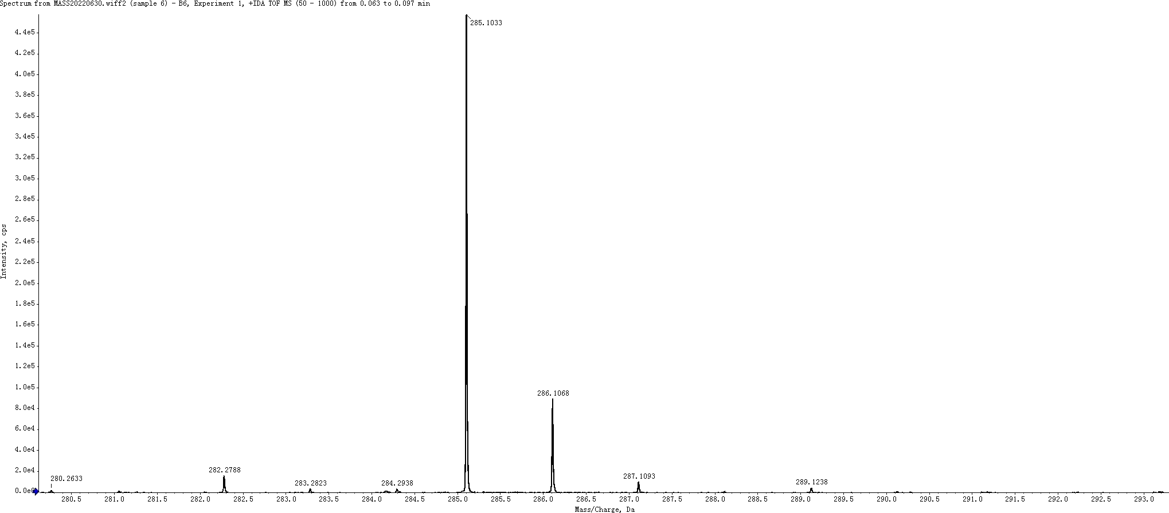

5-chloro-1-(4-methylbenzyl)-1H-indole-2-carboxylic acid (4i)
HRMS Calculated for C₁₇H₁₄ClNO₂ [M-H]⁻ 298.0635, found 298.0629.

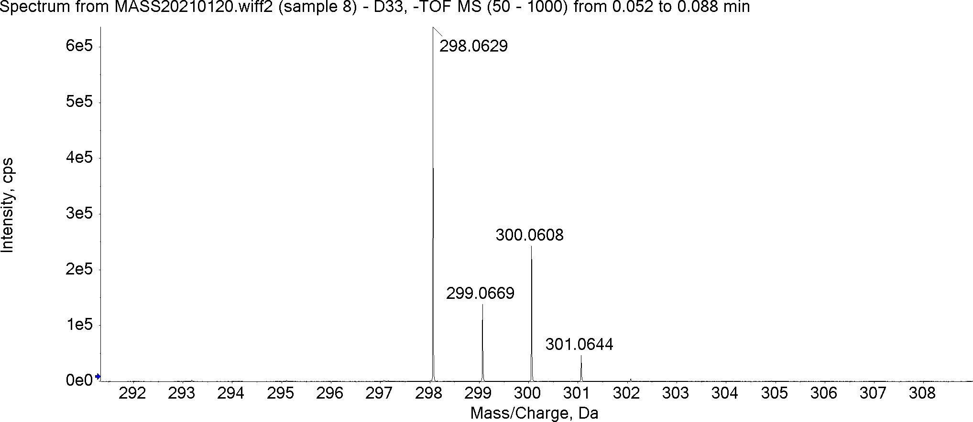

1-(4-methylbenzyl)-1H-indole-2-carboxylic acid (4d)
HRMS Calculated for C₁₇H₁₅NO₂ [M-H]⁻ 264.1025, found 264.1027.
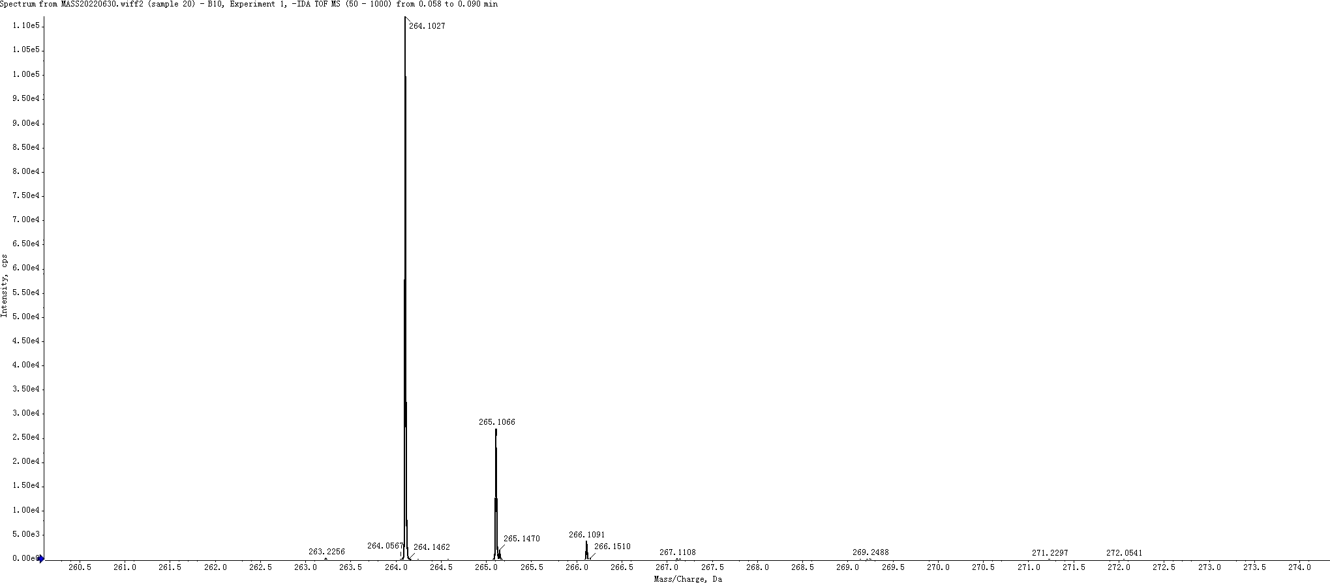

1-(4-fluorobenzyl)-1H-indole-3-carboxylic acid (4k)
HRMS Calculated for C₁₆H₁₂FNO₂ [M-H]⁻ 268.0774, found 268.0773.
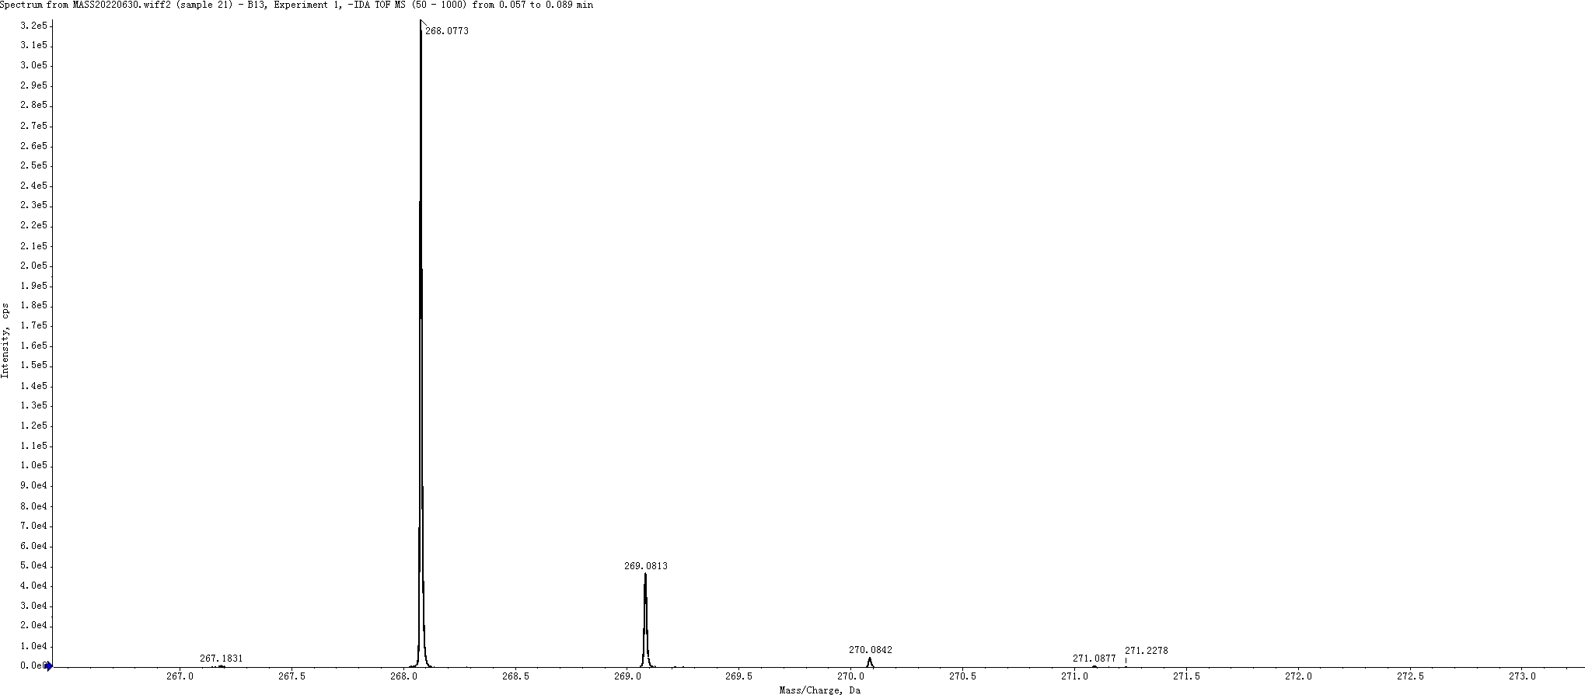

5-chloro-1-(4-methylbenzyl)-1H-indole-3-carboxylic acid (4r)
HRMS Calculated for C₁₇H₁₄ClNO₂ [M-H]⁻ 298.0635, found 298.0638.
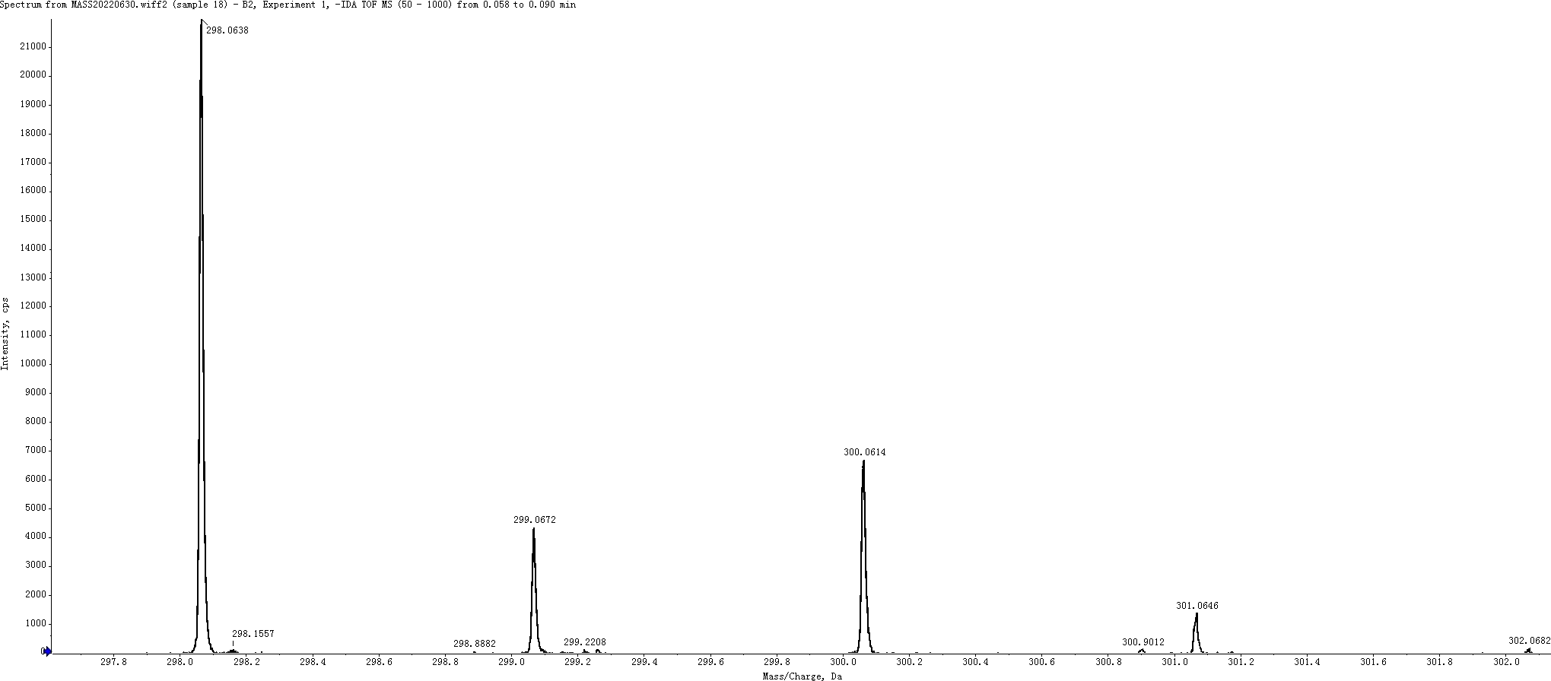

1-(4-fluorobenzyl)-1H-indazole-3-carboxylic acid (4t)
HRMS Calculated for C₁₅H₁₁FN₂O₂ [M-H]⁻ 269.0727, found 269.0733.
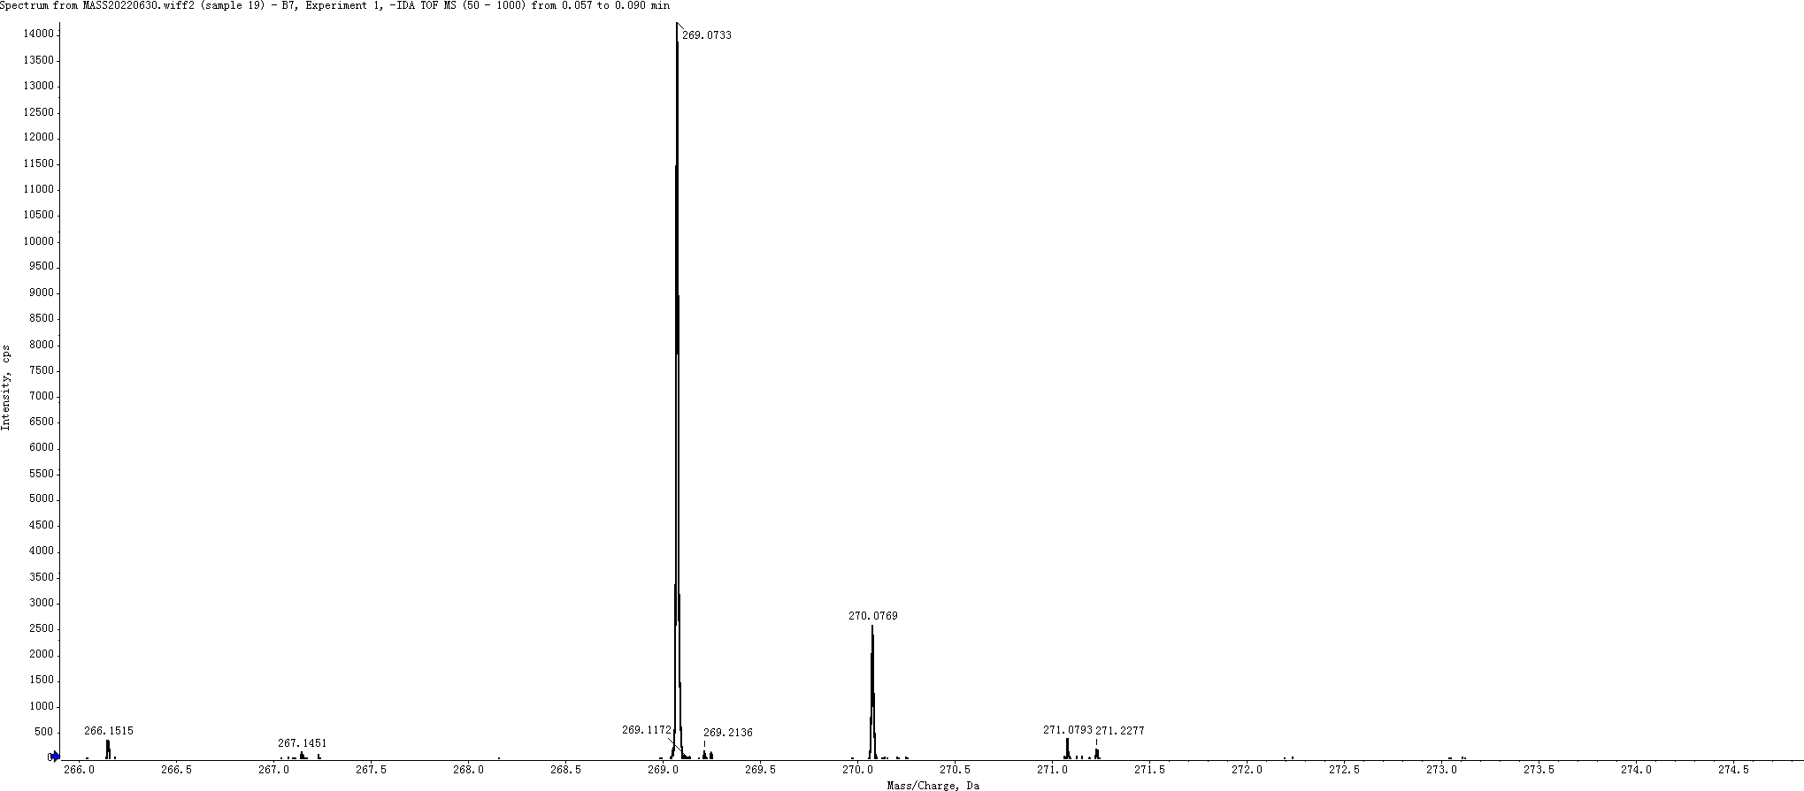

Ethyl 2-(5-chloro-1-(4-methylbenzyl)-1H-indole-2-carboxamido)benzoate (6i)
HRMS Calculated for C₂₆H₂₃ClN₂O₃ [M+H]⁺ 447.1475, found 447.1465.
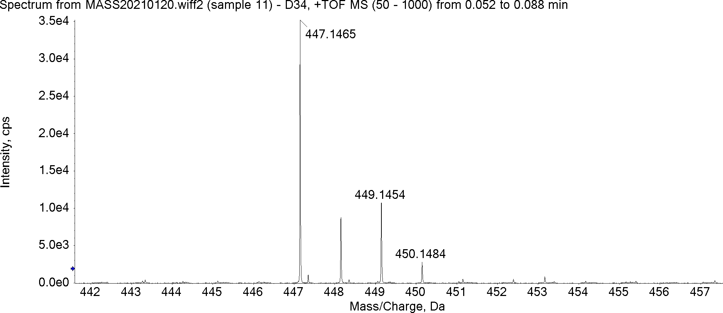

Ethyl 2-(1-(4-methylbenzyl)-1H-indole-2-carboxamido)benzoate (6d)
HRMS Calculated for C₂₆H₂₄N₂O₃ [M+H]⁺ 413.1865, found 413.1858.
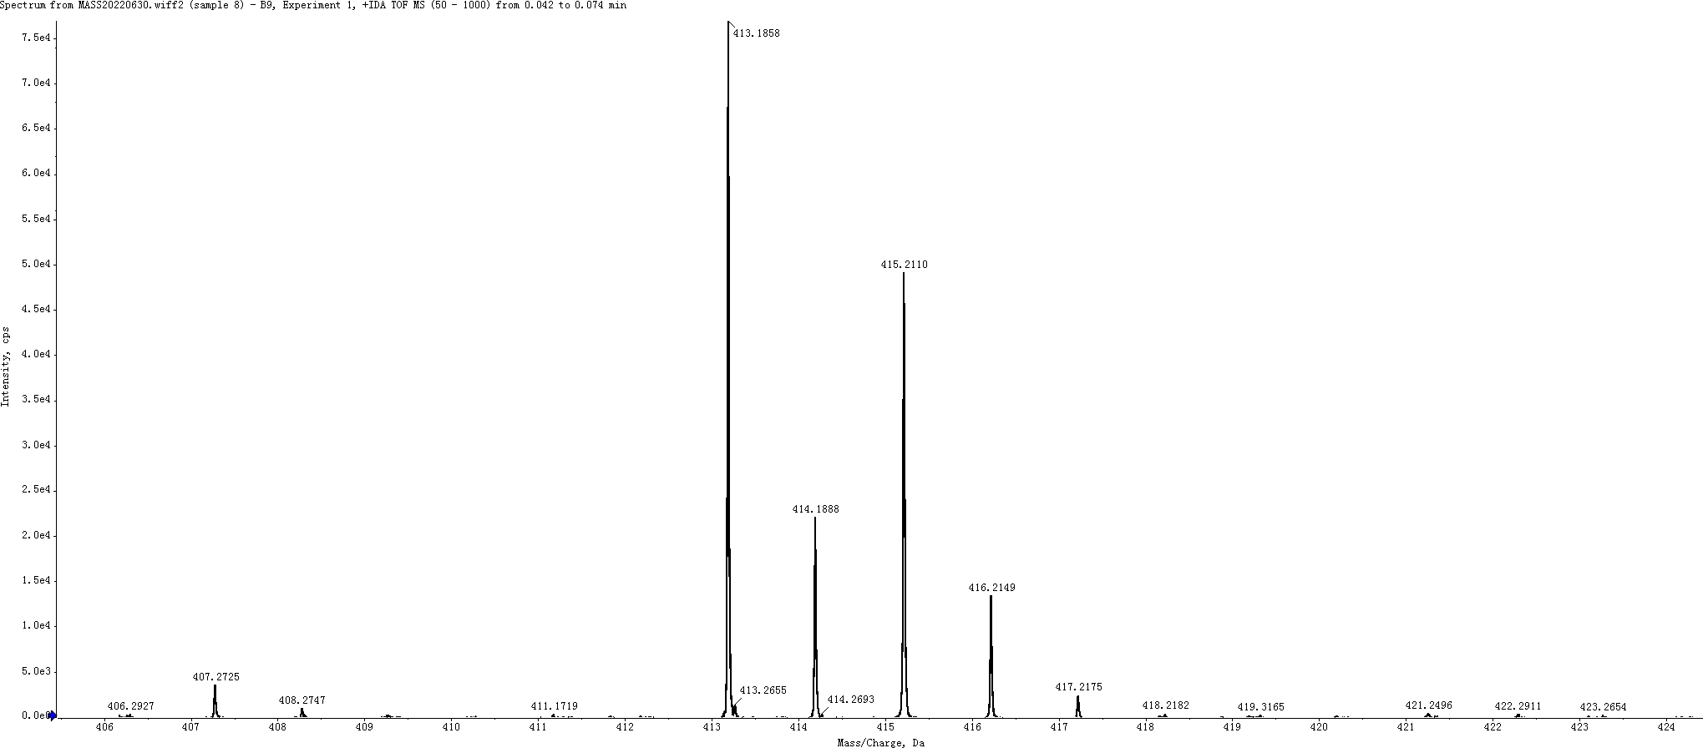

Ethyl 2-(1-(4-fluorobenzyl)-1H-indole-3-carboxamido)benzoate (6k)
HRMS Calculated for C₂₅H₂₁FN₂O₃ [M+H]⁺ 417.1614, found 417.1606.
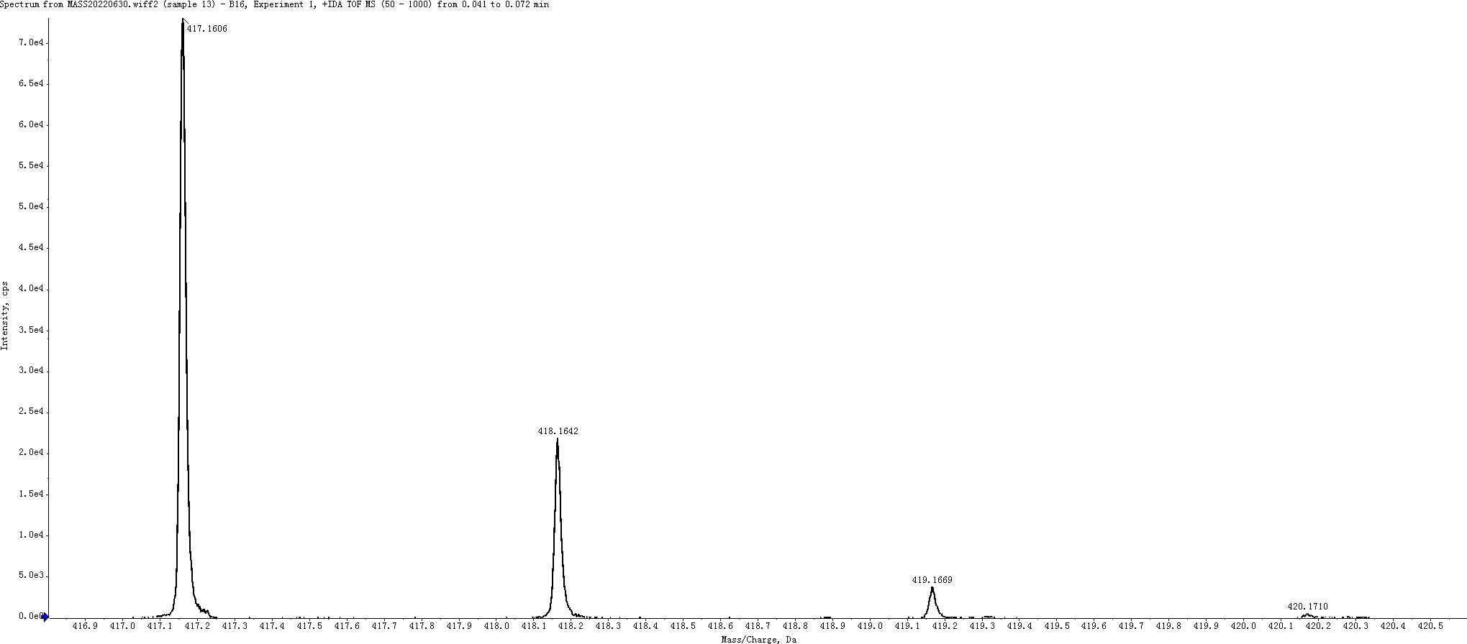

Ethyl 2-(5-chloro-1-(4-methylbenzyl)-1H-indole-3-carboxamido)benzoate (6r)
HRMS Calculated for C₂₆H₂₃ClN₂O₃ [M+H]⁺ 447.1475, found 447.1466.

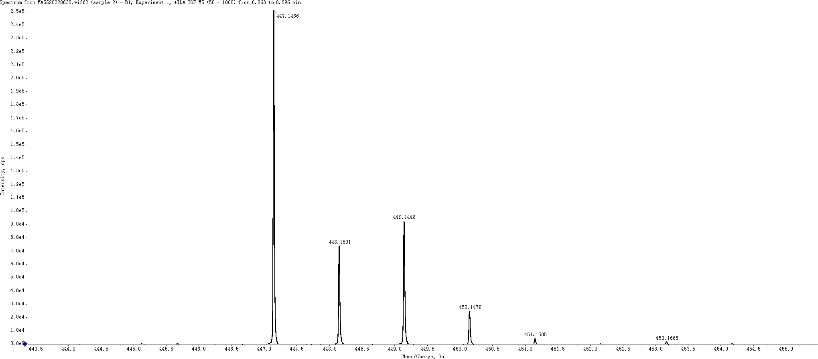

Ethyl 2-(1-(4-fluorobenzyl)-1H-indazole-3-carboxamido)benzoate (6t)
HRMS Calculated for C₂₄H₂₀FN₃O₃ [M+H]⁺ 418.1567, found 418.1553.
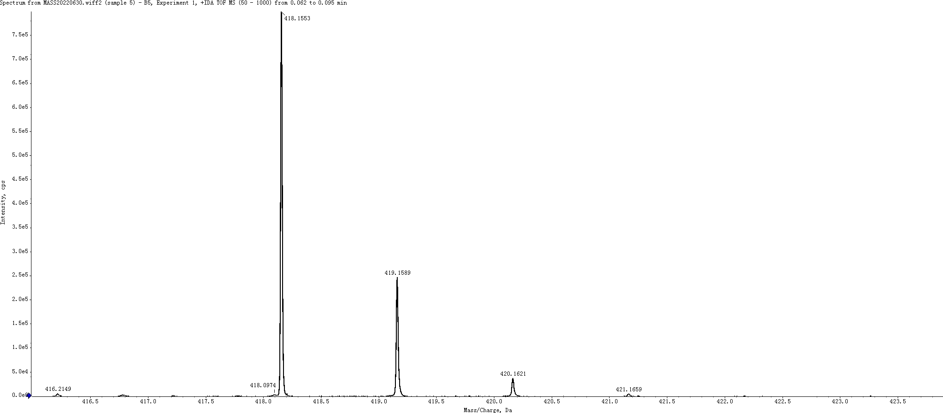

2-(1-(4-fluorobenzyl)-1H-indole-2-carboxamido)benzoic acid (7a)
HRMS Calculated for C₂₃H₁₇FN₂O₃ [M-H]⁻ 387.1145, found 387.1147.
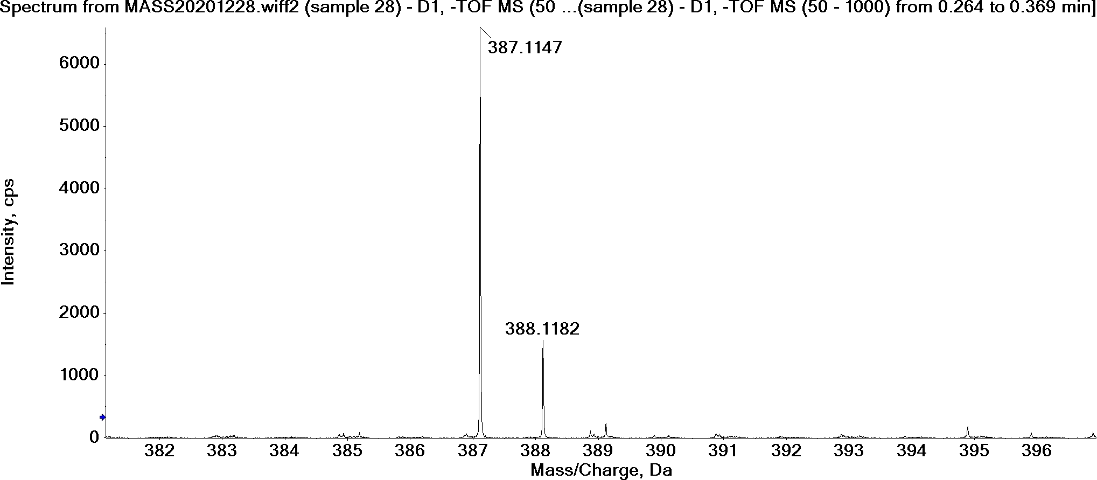

2-(1-(4-chlorobenzyl)-1H-indole-2-carboxamido)benzoic acid (7b)
HRMS Calculated for C₂₃H₁₇ClN₂O₃ [M-H]⁻ 403.0849, found 403.0851.
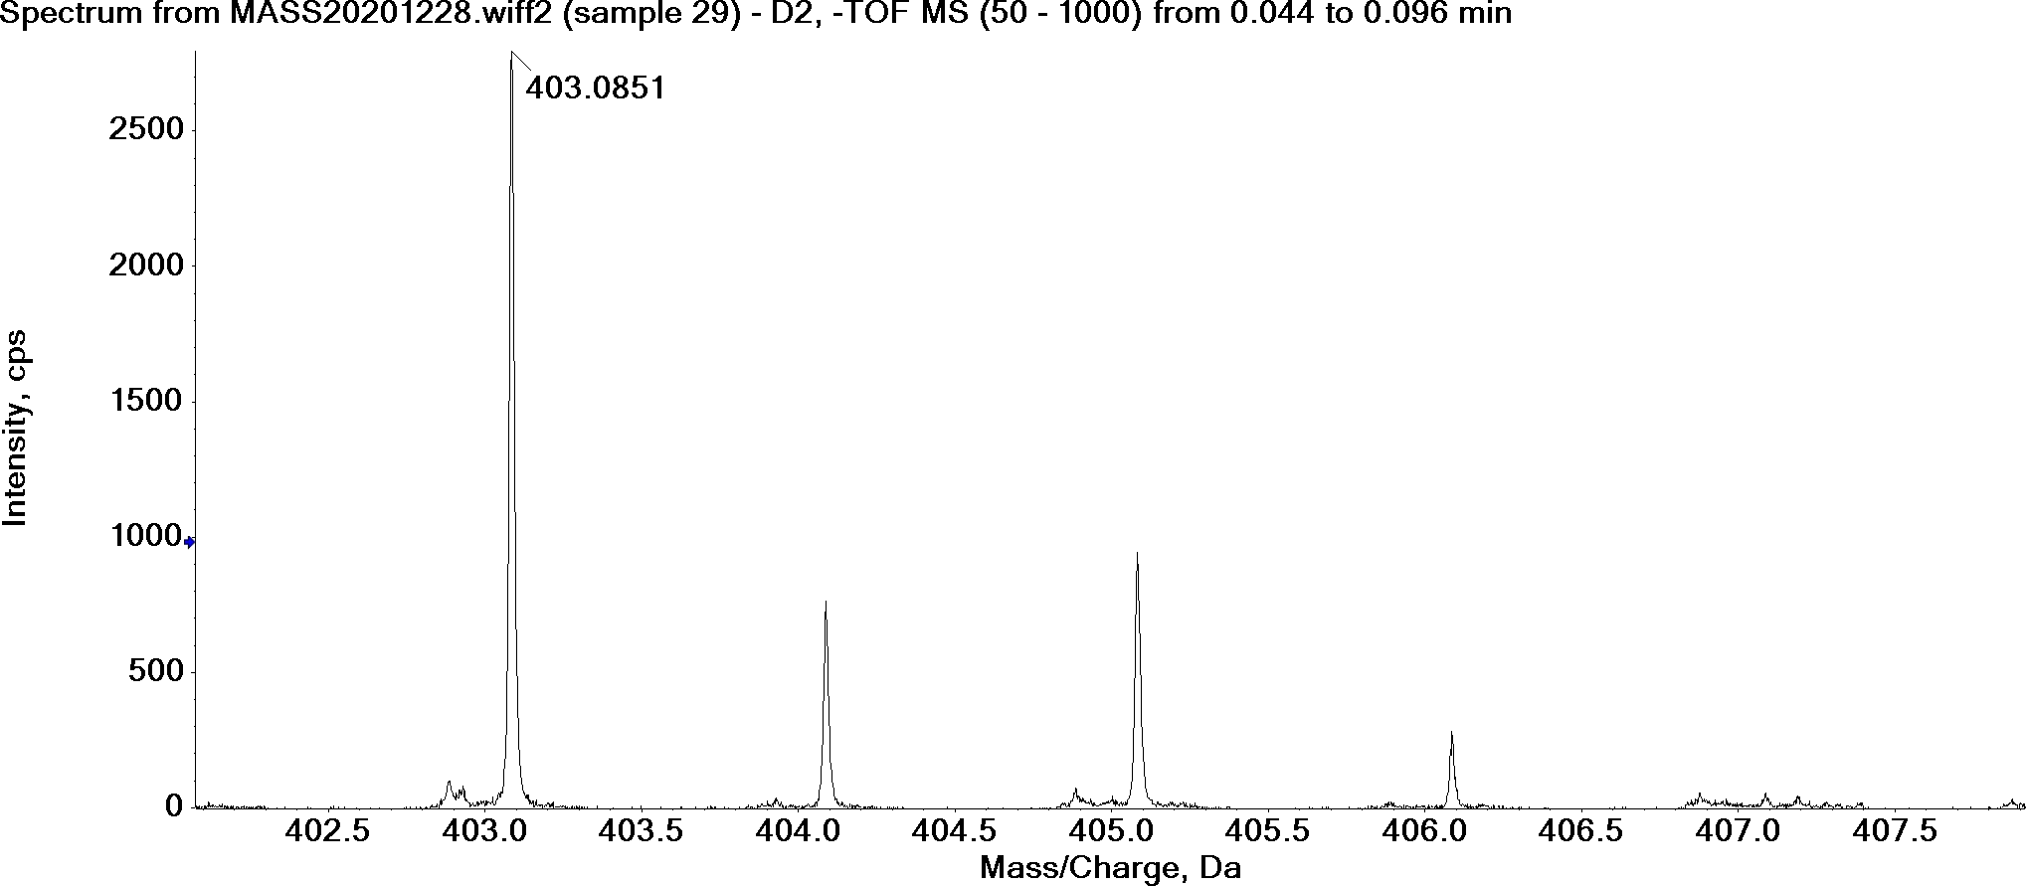

2-(1-(4-methoxybenzyl)-1H-indole-2-carboxamido)benzoic acid (7c)
HRMS Calculated for C₂₄H₂₀N₂O₄ [M-H]⁻ 399.1345, found 399.1345.
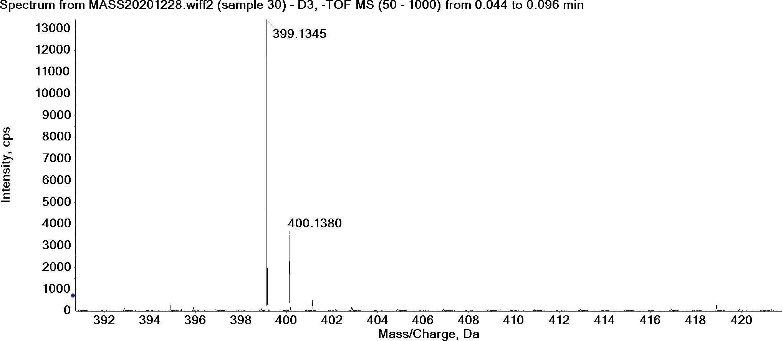

2-(1-(4-methylbenzyl)-1H-indole-2-carboxamido)benzoic acid (7d)
HRMS Calculated for C₂₄H₂₀N₂O₃ [M-H]⁻ 383.1396, found 383.1399.
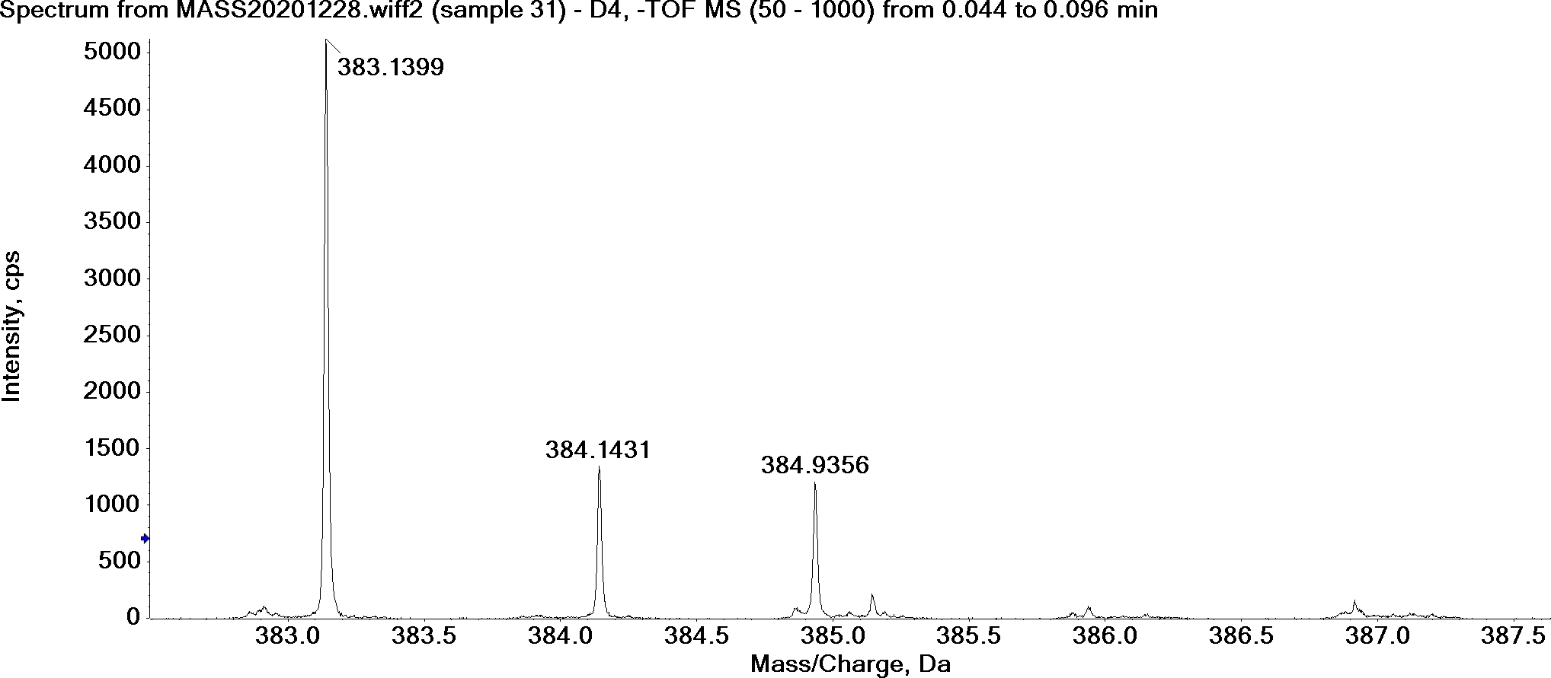

2-(1-(4-(trifluoromethyl)benzyl)-1H-indole-2-carboxamido)benzoic acid (7e)
HRMS Calculated for C₂₄H₁₇F₃N₂O₃ [M-H]⁻ 437.1113, found 437.1118.
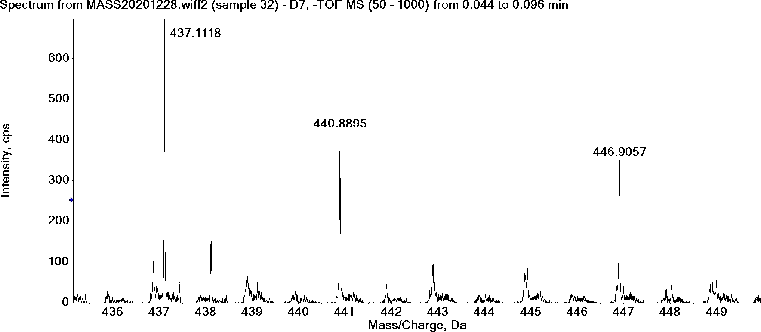

2-(5-chloro-1-(4-fluorobenzyl)-1H-indole-2-carboxamido)benzoic acid (7f)
HRMS Calculated for C₂₃H₁₆ClFN₂O₃ [M-H]⁻ 421.0755, found 421.0759.
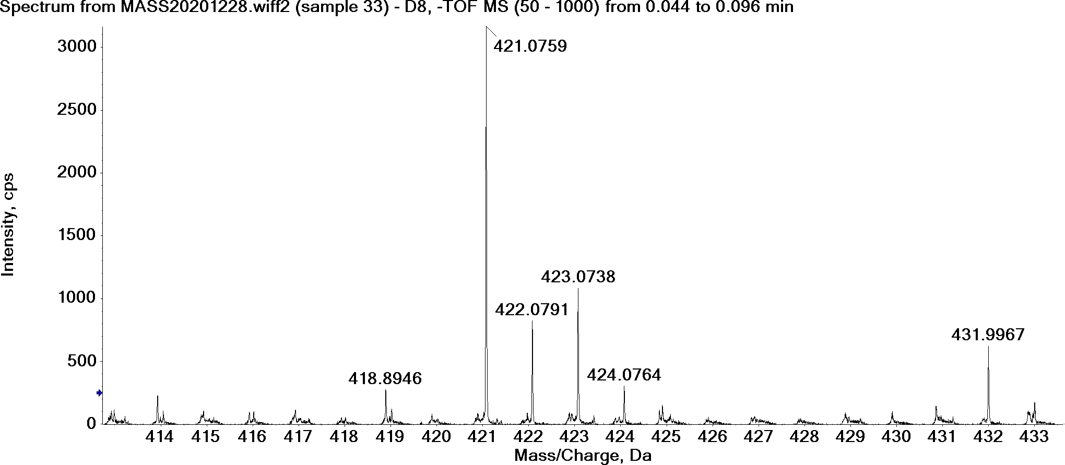

2-(5-chloro-1-(4-chlorobenzyl)-1H-indole-2-carboxamido)benzoic acid (7g)
HRMS Calculated for C₂₃H₁₆Cl₂N₂O₃ [M-H]⁻ 437.0460, found 437.0458.
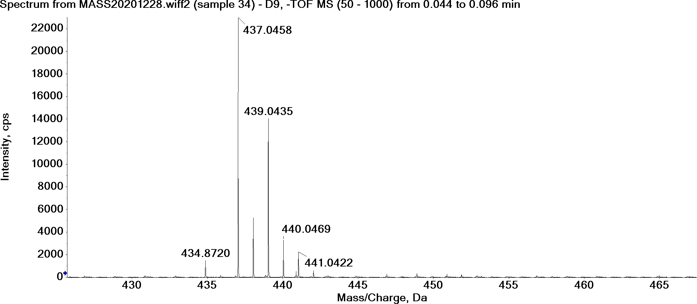

2-(5-chloro-1-(4-methoxybenzyl)-1H-indole-2-carboxamido)benzoic acid (7h)
HRMS Calculated for C₂₄H₁₉ClN₂O₄ [M-H]⁻ 433.0955, found 433.0941.
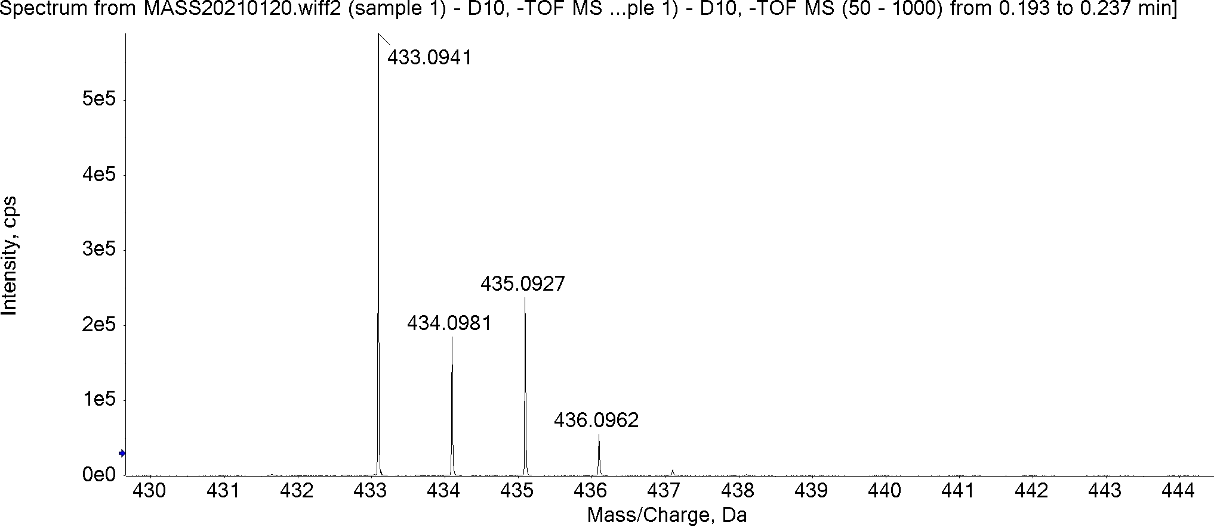

2-(5-chloro-1-(4-methylbenzyl)-1H-indole-2-carboxamido)benzoic acid (7i)
HRMS Calculated for C₂₄H₁₉ClN₂O₃ [M-H]⁻ 417.1006, found 417.0993.
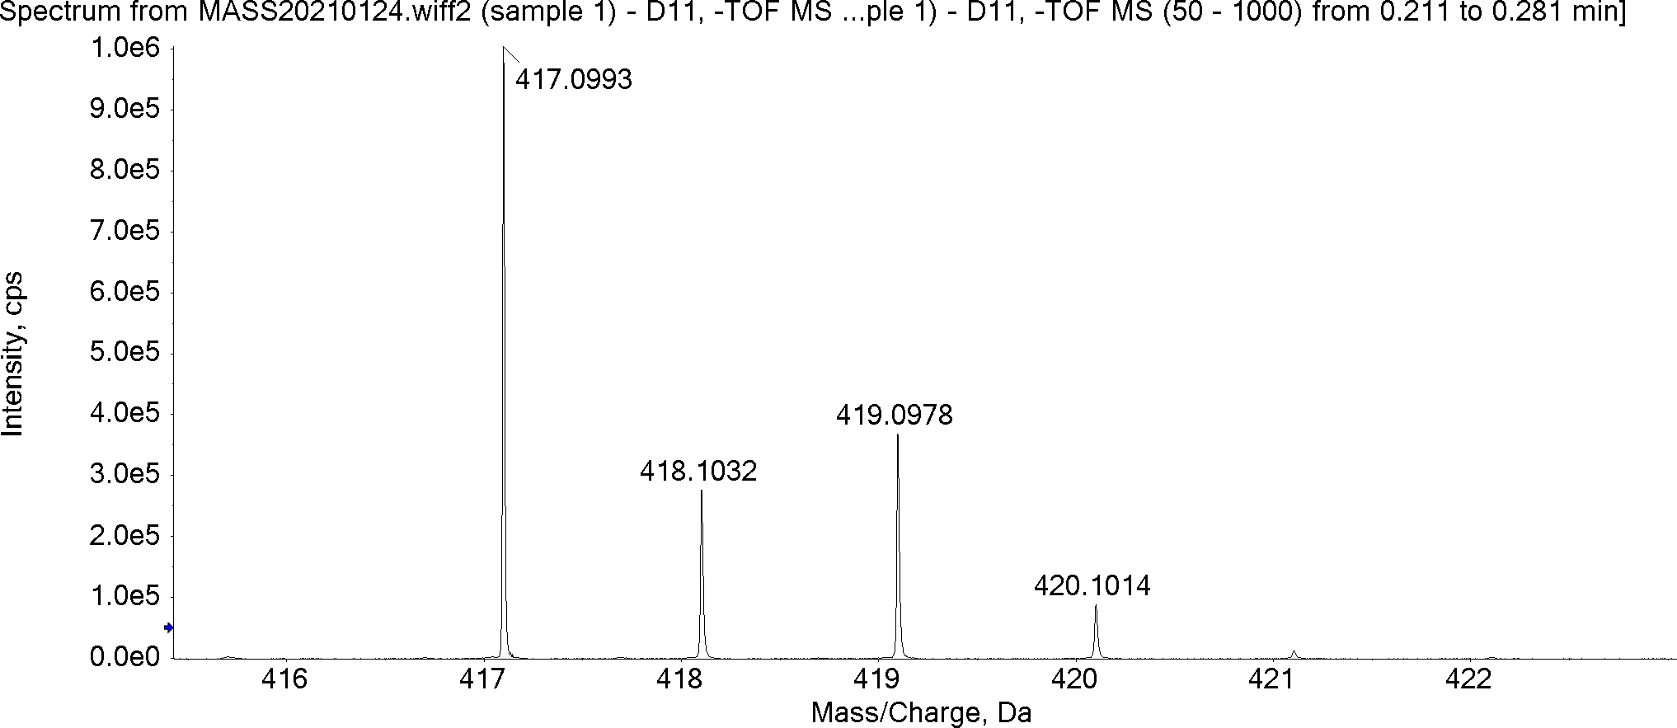

2-(5-chloro-1-(4-(trifluoromethyl)benzyl)-1H-indole-2-carboxamido)benzoic acid (7j)
HRMS Calculated for C₂₄H₁₆ClF₃N₂O₃ [M-H]⁻ 471.0723, found 471.0706.
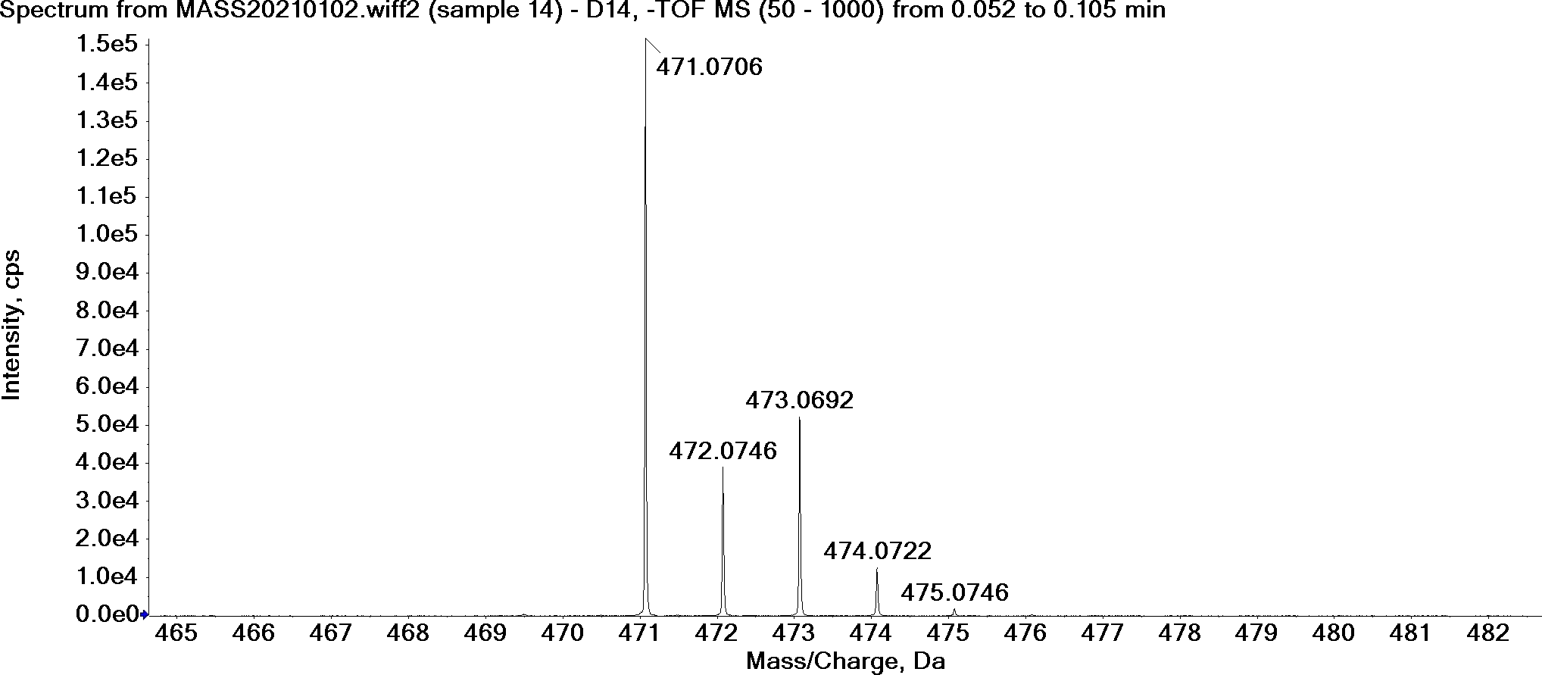

2-(1-(4-fluorobenzyl)-1H-indole-3-carboxamido)benzoic acid (7k)
HRMS Calculated for C₂₃H₁₇FN₂O₃ [M-H]⁻ 387.1145, found 387.1137.
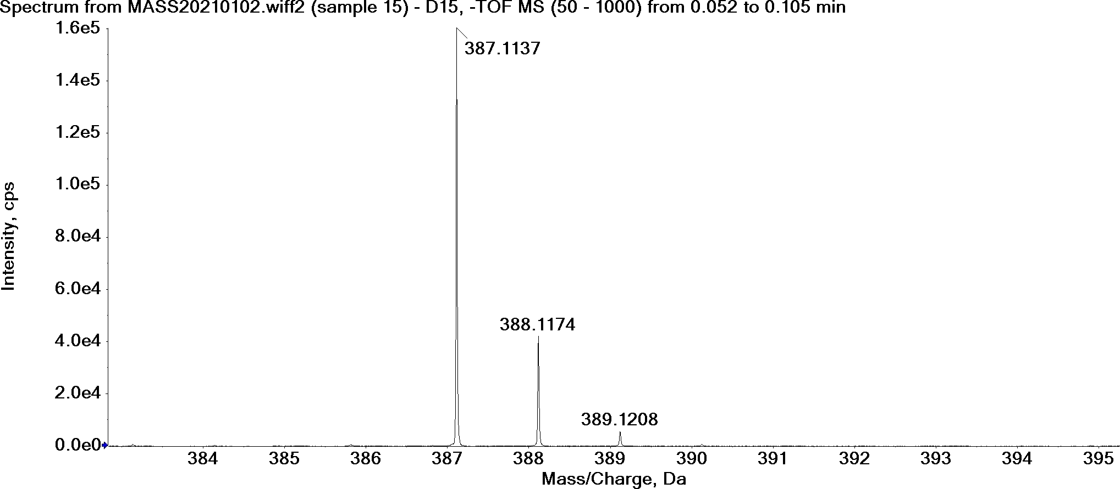

2-(1-(4-chlorobenzyl)-1H-indole-3-carboxamido)benzoic acid (7l)
HRMS Calculated for C₂₃H₁₇ClN₂O₃ [M-H]⁻ 403.0849, found 403.0841.
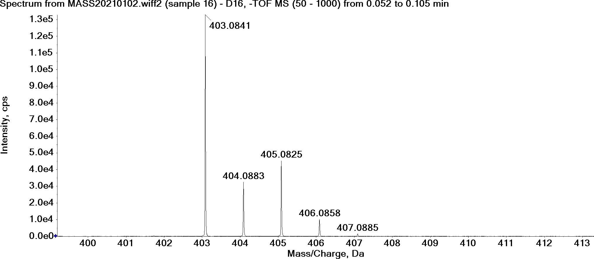

2-(1-(4-methoxybenzyl)-1H-indole-3-carboxamido)benzoic acid (7m)
HRMS Calculated for C₂₄H₂₀N₂O₄ [M-H]⁻ 399.1345, found 399.1340.
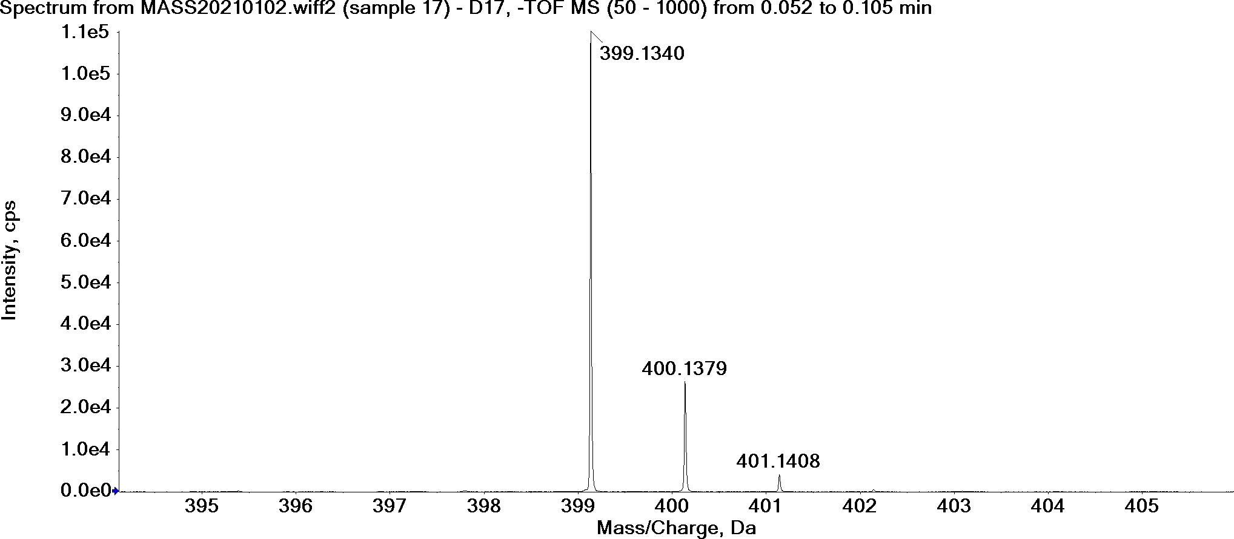

2-(1-(4-methylbenzyl)-1H-indole-3-carboxamido)benzoic acid (7n)
HRMS Calculated for C₂₄H₂₀N₂O₃ [M-H]⁻ 383.1396, found 383.1394.
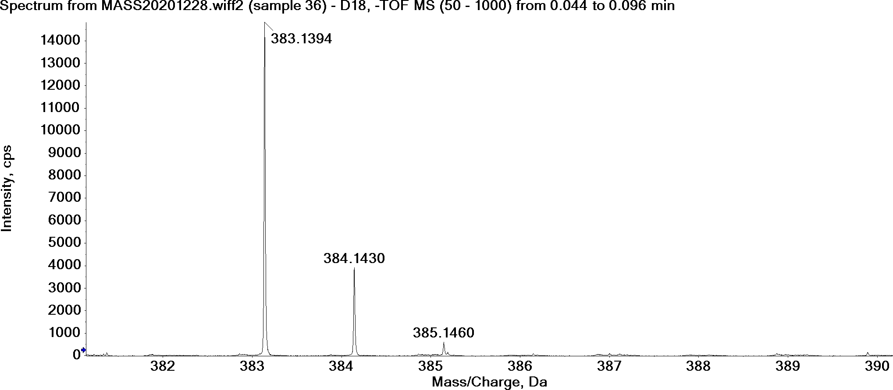

2-(1-(4-(trifluoromethyl)benzyl)-1H-indole-3-carboxamido)benzoic acid (7o)
HRMS Calculated for C₂₄H₁₇F₃N₂O₃ [M-H]⁻ 437.1113, found 437.1091.
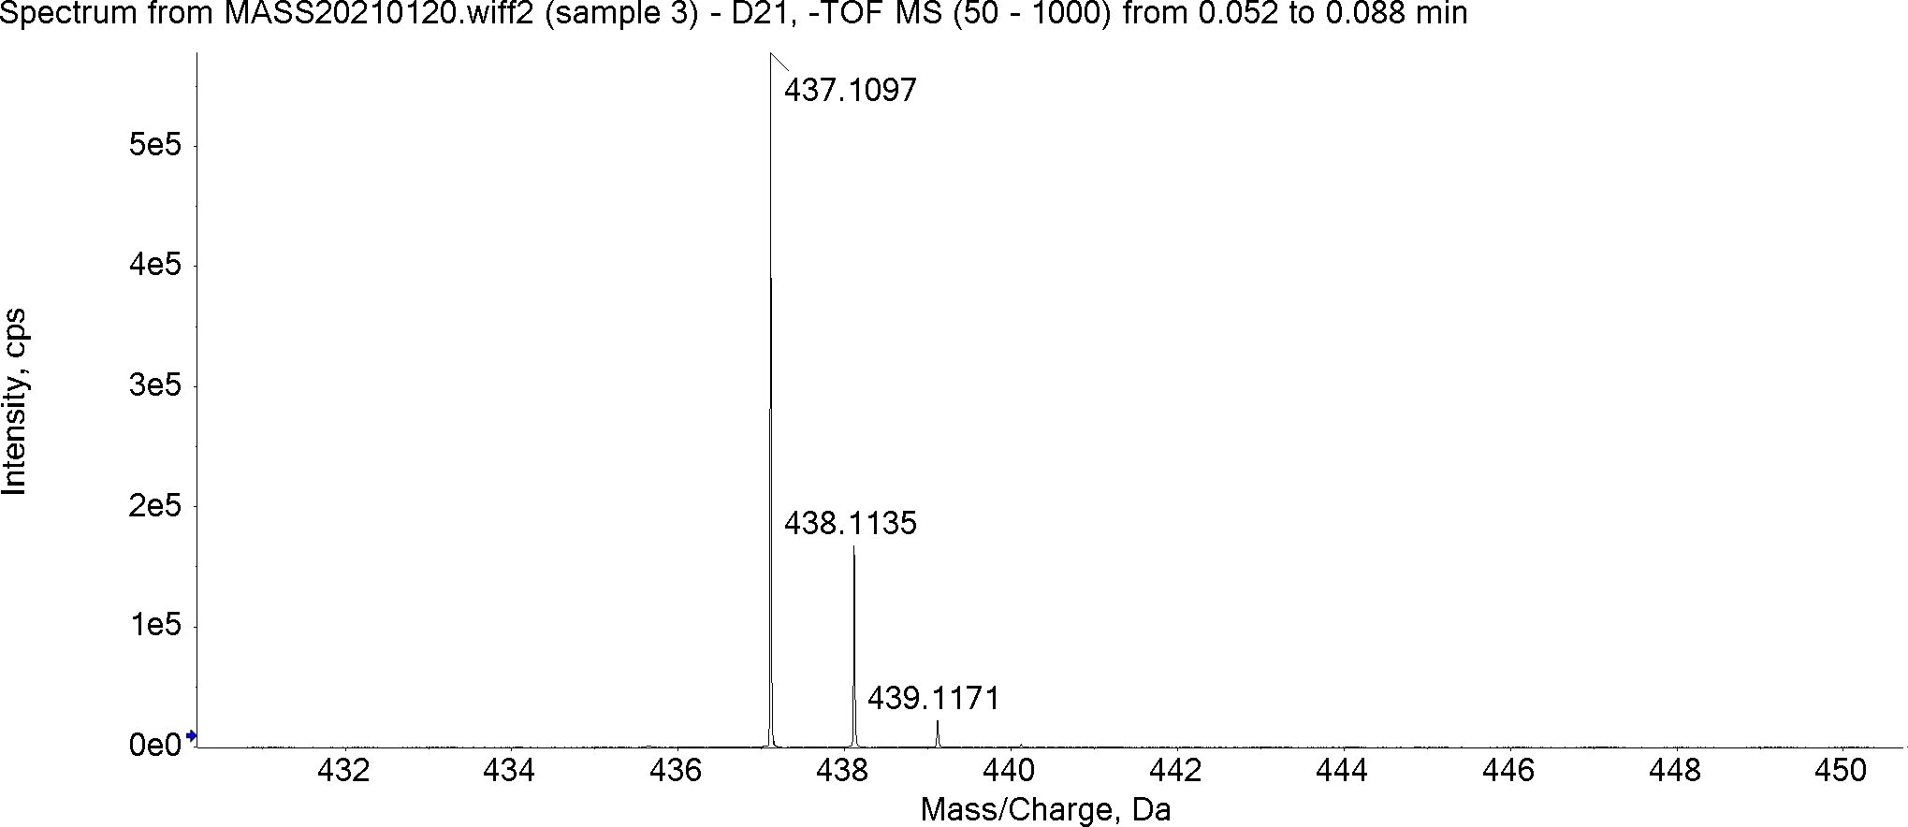

2-(1-(4-fluorobenzyl)-1H-indazole-3-carboxamido)benzoic acid (7t)
HRMS Calculated for C₂₂H₁₆FN₃O₃ [M-H]⁻ 388.1097, found 388.1091.
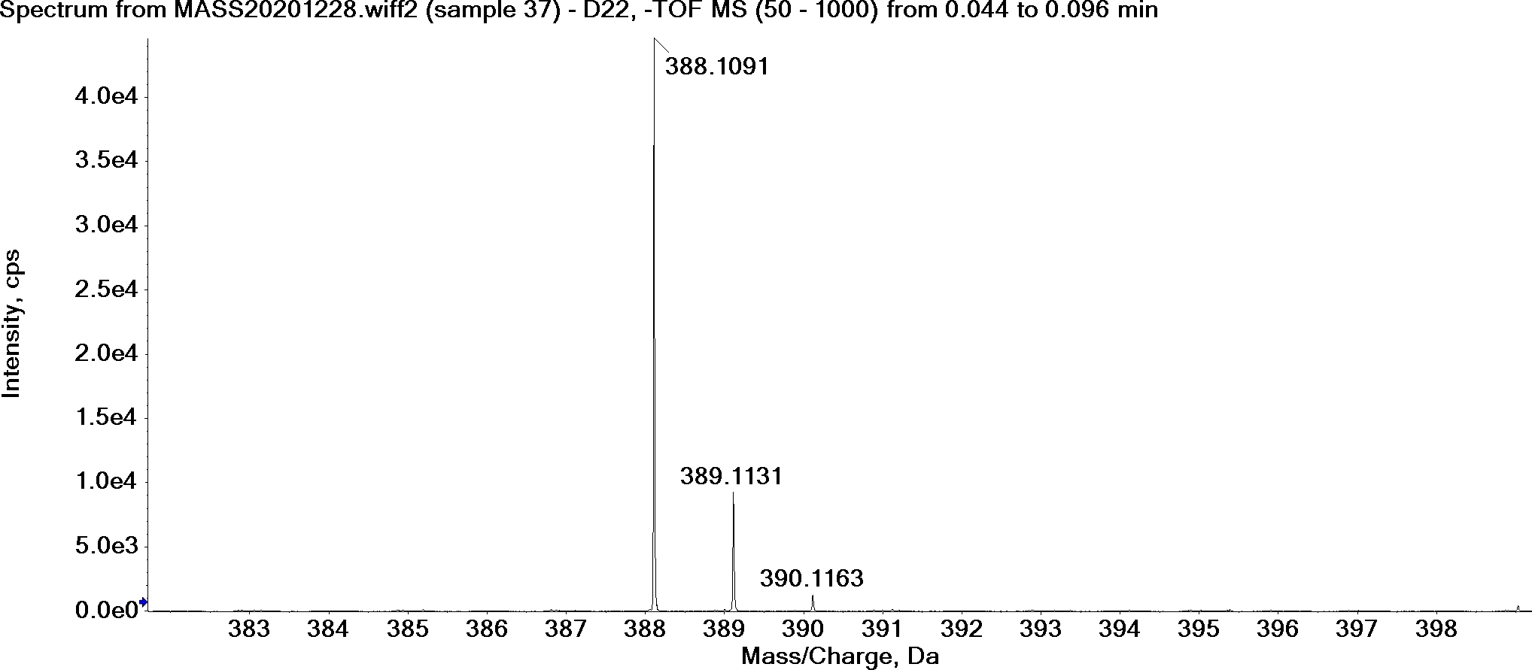

2-(1-(4-methoxybenzyl)-1H-indazole-3-carboxamido)benzoic acid (7u)
HRMS Calculated for C₂₃H₁₉N₃O₄ [M-H]⁻ 400.1297, found 400.1296.
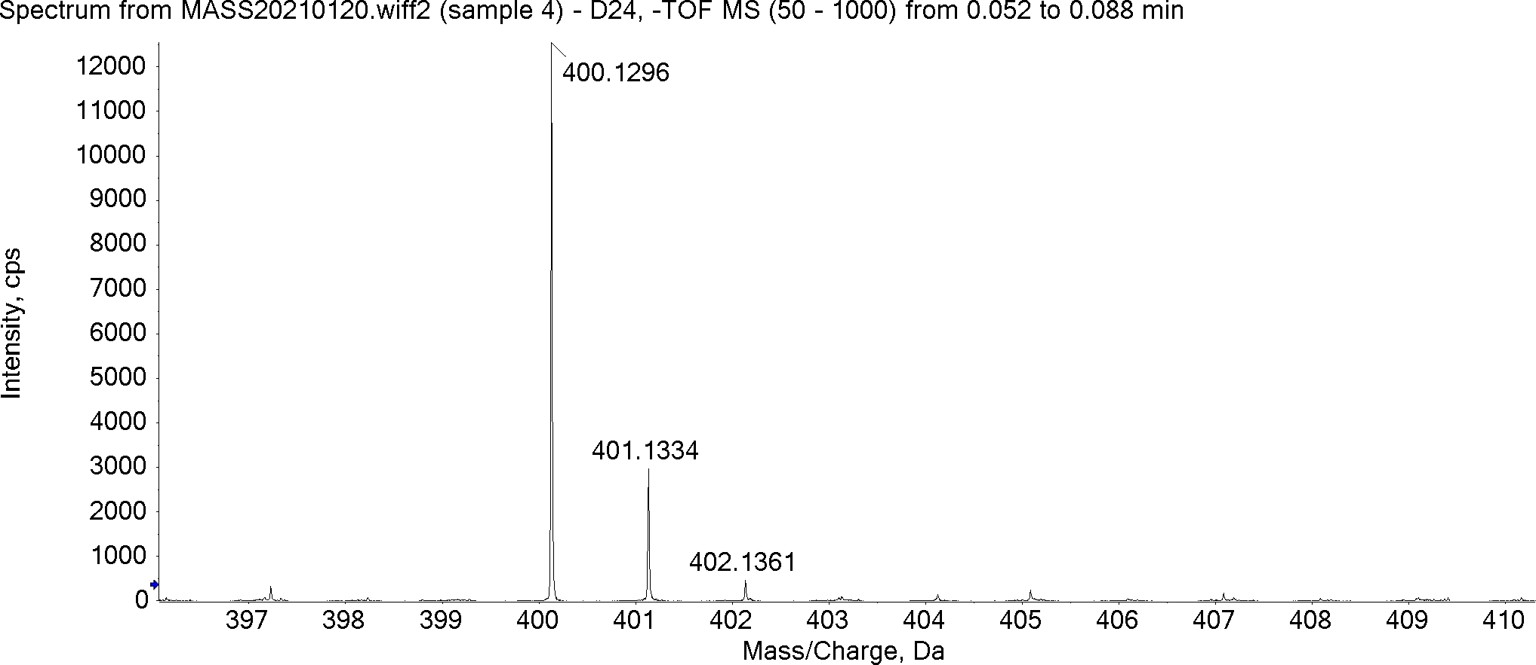

2-(1-(4-methylbenzyl)-1H-indazole-3-carboxamido)benzoic acid (7v)
HRMS Calculated for C₂₃H₁₉N₃O₃ [M-H]⁻ 384.1348, found 384.1340.
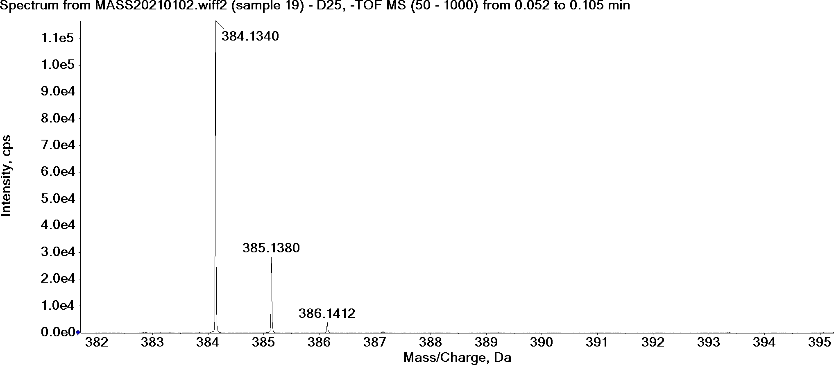

2-(1-(4-(trifluoromethyl)benzyl)-1H-indazole-3-carboxamido)benzoic acid (7w)
HRMS Calculated for C₂₃H₁₆F₃N₃O₃ [M-H]⁻ 438.1066, found 438.1049.
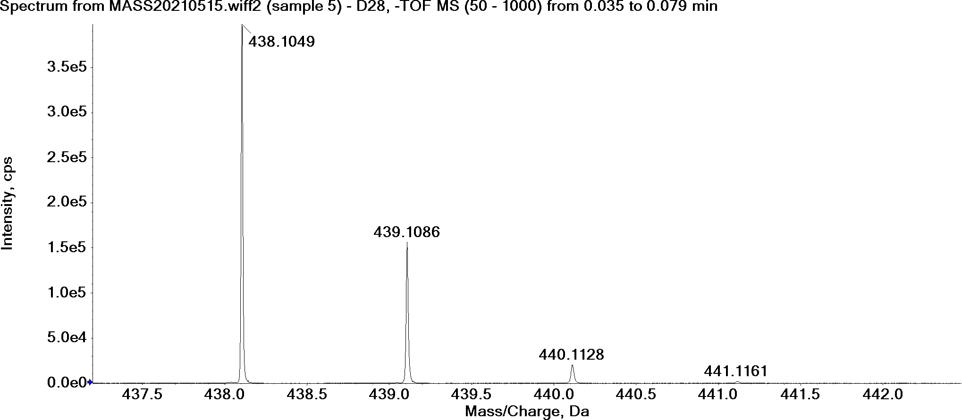

2-(5-chloro-1-(4-fluorobenzyl)-1H-indole-3-carboxamido)benzoic acid (7p)
HRMS Calculated for C₂₃H₁₆ClFN₂O₃ [M-H]⁻ 421.0755, found 421.0745.
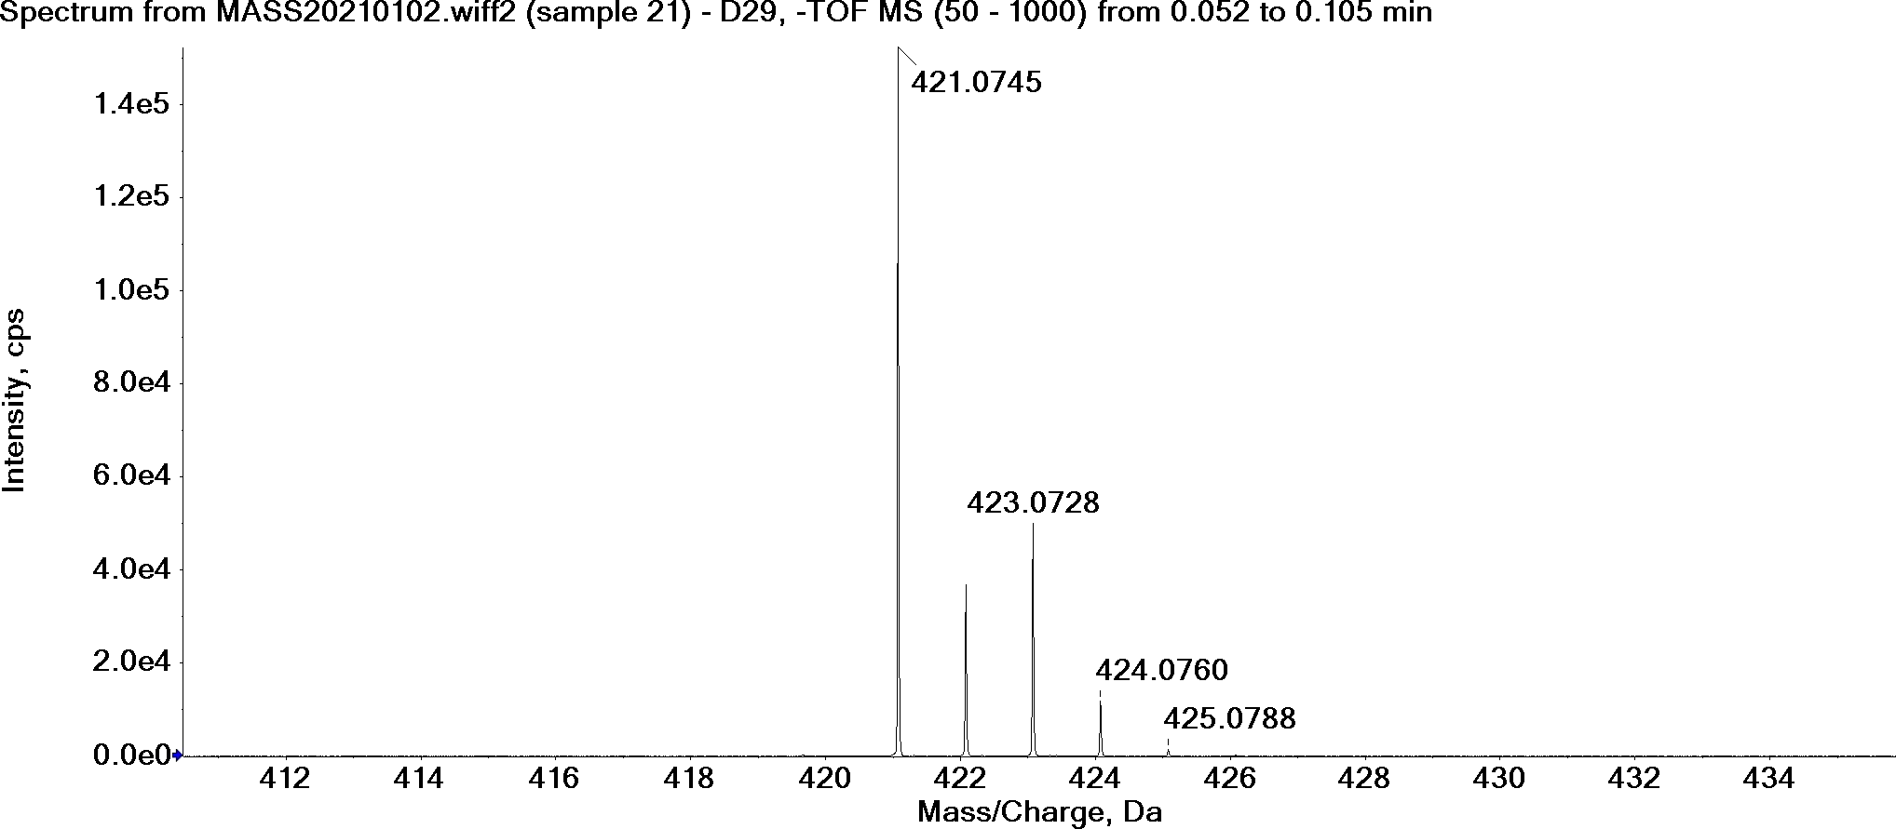

2-(5-chloro-1-(4-methoxybenzyl)-1H-indole-3-carboxamido)benzoic acid (7q)
HRMS Calculated for C₂₄H₁₉ClN₂O₄ [M-H]⁻ 433.0955, found 433.0946.

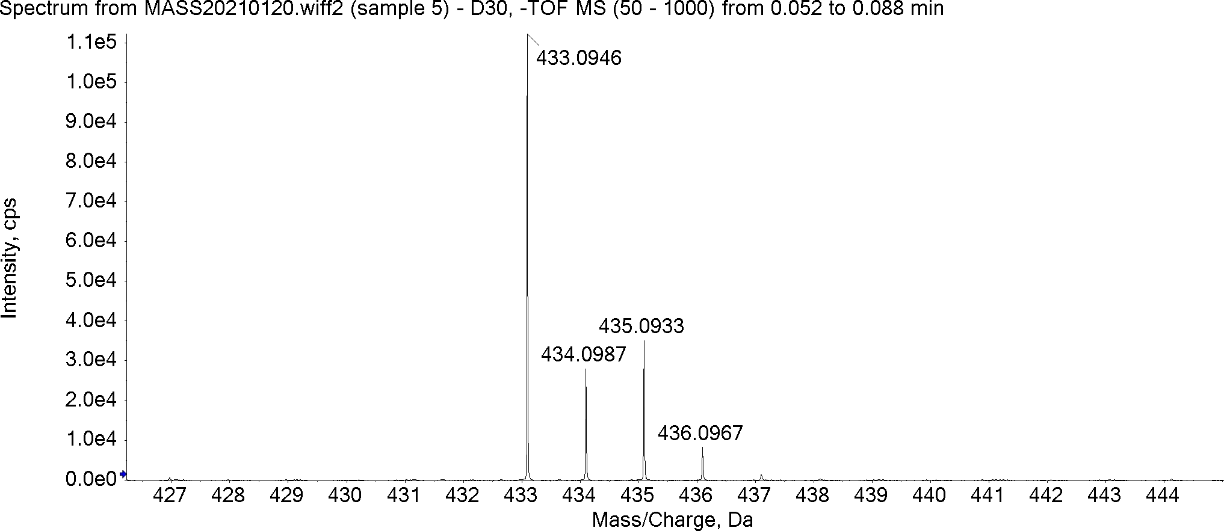

2-(5-chloro-1-(4-methylbenzyl)-1H-indole-3-carboxamido)benzoic acid (7r)
HRMS Calculated for C₂₄H₁₉ClN₂O₃ [M-H]⁻ 417.1006, found 417.1004.
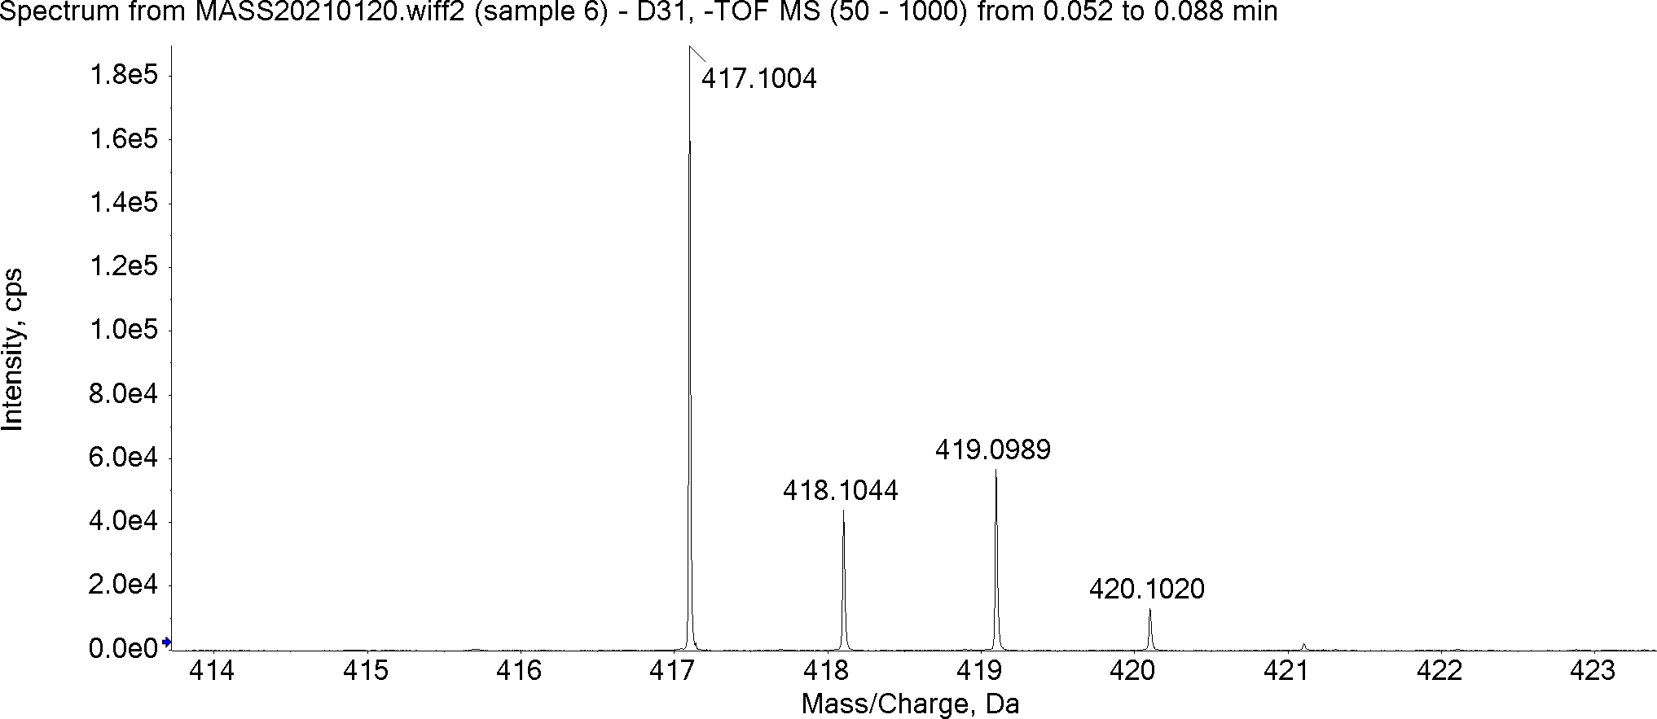

2-(5-chloro-1-(4-(trifluoromethyl)benzyl)-1H-indole-3-carboxamido)benzoic acid (7s)
HRMS Calculated for C₂₄H₁₆ClF₃N₂O₃ [M-H]⁻ 471.0723, found 471.0711.
