Supplementary Materials for

Photocatalytic antiviral activity of zinc hydroxide for H1N1 virus under weak visible light

Feng Ouyang^{1,2}*†, Zhaoyong Ren^{1,3}†, Jingyuan Liu⁴, Hangliang Li¹, Zhengya Gong¹,Youhua Fan³, Xiaoxiong Zha¹, Gang Cao¹, Bandna Bharti¹*

Correspondence to: 2475382878@qq.com.

This file includes:

Materials and Methods
Figs. S1 to S3
Tables S1

Materials and Methods
Preparation of Mask-1
A mixture of zinc hydroxide (Zn(OH)₂) and water was obtained by adding 1.0 g of Zn(OH)₂ (AR) to 350 mL of distilled water. Then the white polypropylene (PP) gauze layer was soaked in the above mixture for 5 times followed by natural air drying. The non-woven fabric filter layer was placed between highly water-absorbent cotton layer (inner layer) and the above treated PP gauze layer (outer layer), and then the three layers were sewn together. After sprayed by 2.0 vol.% hydrogen peroxide (H₂O₂), Mask-1 was eventually obtained.
Preparation of Mask-2
To further enhance anti-virus efficiency, the non-woven fabric filter was soaked in natural washing agent solution accompanied by air drying, and then sewed between highly water-absorbent cotton layer (middle layer) and the above treated PP gauze layer (outer layer). H₂O₂ (2.0 vol.%) was sprayed over the outer layer and the middle layer, with both the middle layer and the inner layer sprinkled by distilled water. Finally, sample donated as Mask-2 was obtained.
Analysis of irradiation intensities error
The distances side by side between two 1.7 W of white LED lamps and samples were 4.2 cm and 20cm, respectively. Intensities in different positions A, B and C are listed Table S1. To analyze error, data were measured by twice. From Table S1, it could be seen that light distributed relatively even. Maximum and minimum were 0.347 and 0.306 mW·cm⁻², respectively. Average was 0.327±0.021 mW·cm⁻² with the relative error of ±6.3%. This showed the reliability of the data.
The irradiance is measured by the visible irradiance meter produced by Beijing Normal University Photoelectric Technology Co., Ltd. The effect of 30 W fluorescent lamp as illumination light resource with 2.5 m distance was also investigated. It was found that its effect was too small to ignore. On the other hand, two 30W LED cylindrical lamps were also used as light resources. The cylindrical forms leaded to inhomogeneity of the light intensities, which inside and outside were 6.9-14.1 and 5.8-7.5 mW·cm⁻², and two lamps illuminated different light intensities (6.9-14.1 and 8.7-13.4 mW·cm⁻²). Four data on the three sets were taken, including transverse and longitudinal directions, to calculate average values, which were 11.3, 11.4 and 6.8 mW·cm⁻². Their average value was 9.9 mW·cm⁻², which was close to the average value calculated from the maximum and the minimum intensities, that was 9.9±4.2 mW·cm⁻². Relative error of 45% might act as reference.
Tests of antivirus activity for Mask-1 and Mask-2
The irradiation on sample Mask-1 last for 30, 120, 210 and 240 min, respectively, which were 2.5 and 15 min for sample Mask-2. The detection method was implemented according to ISO 18184 2014 (E), simply was ascribed as following: as of TCID₅₀ method, picking up 96 wells microplate with monolayer cells and adding 0.1 mL of the maintenance medium; Inoculating 0.1 mL of wash-out virus suspension and diluting virus suspension of the test 8 wells for one virus suspension and 1/10 dilution for the virus suspension to the second 8 wells as such, to the final 8 wells, evaluate infective state and titre.
Analysis and characterizations
Powder X-ray diffraction (XRD) patterns were collected with a BrukerD8 Advanced diffractometer with Nickel filter was utilized. The scan range of 2θ is from 5 to 90°. Scanning electron microscopy (SEM) characterization was conducted by Zeiss Supra 55 with a beam energy of 20 kV. Transmission electron microscope (TEM) and High-resolution TEM (HRTEM) images were obtained with FEI Talos F200X instrument operated at 300 kV. X-ray photoelectron spectroscopy (XPS) characterization was conducted using Thermo Scientific K-Alpha instrument with Al Kα ray (1486.6 eV) as excitation source and working voltage of 12 kV. The binding energy of all XPS spectra were calibrated using C1s of 284.8 eV. The UV-visible absorption spectroscopy was recorded using Shimadzu UV-2401PC spectrophotometer in the wavelength range 200 nm to 800 nm. Fourier transform infrared (FTIR) spectra were recorded with a Nicolet is 50 spectrometer from 4000 cm⁻¹ to 400 cm⁻¹ with a 2 cm⁻¹ resolution. Raman Spectroscopy measurements were conducted on a Hololab Series 5,000 microscope with the wavelength fixed at 785 nm.

Fig. S1.
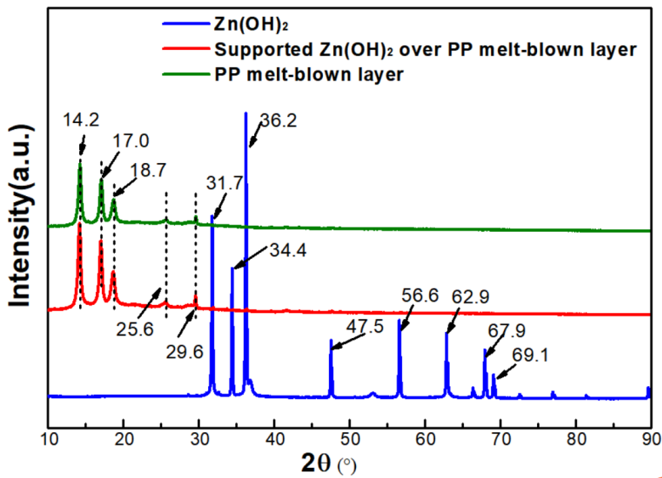

Fig. S1. XRD pattern of as-synthesized sample.

Fig. S2.

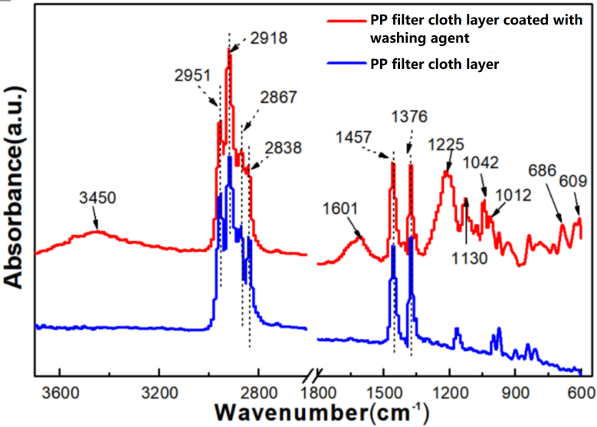

Fig. S2. FTIR spectra of PP filter layer and washing agent coated PP filter layer.

Fig. S3.

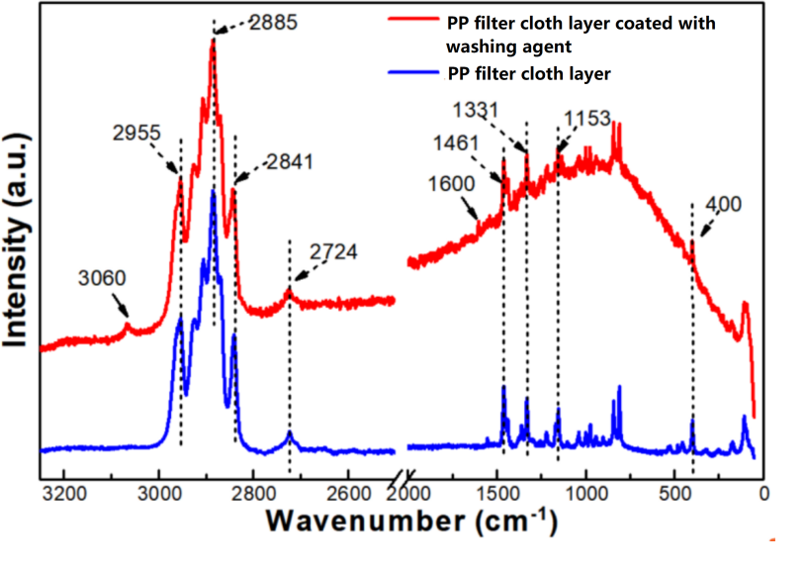
Fig. S3. Raman spectra of PP filter layer and washing agent coated PP filter layer.

Table S1.
Table S1. Relative error analysis of experimental light intensity
Placement location (repeated) |  | Light intensity(mW·cm-2)
 |  | On illumination | Off illumination
A | 1st | 0.311 | 0.306
A | 2nd | 0.313 | 0.306
A | Error(%) | 0 | 0
B | 1st | 0.34 | 0.329
B | 2nd | 0.342 | 0.334
B | Error(%) | 0 | 0.8
C | 1st | 0.33 | 0.342
C | 2nd | 0.33 | 0.347
C | Error(%) | 0 | 0.7

