Additional file 6

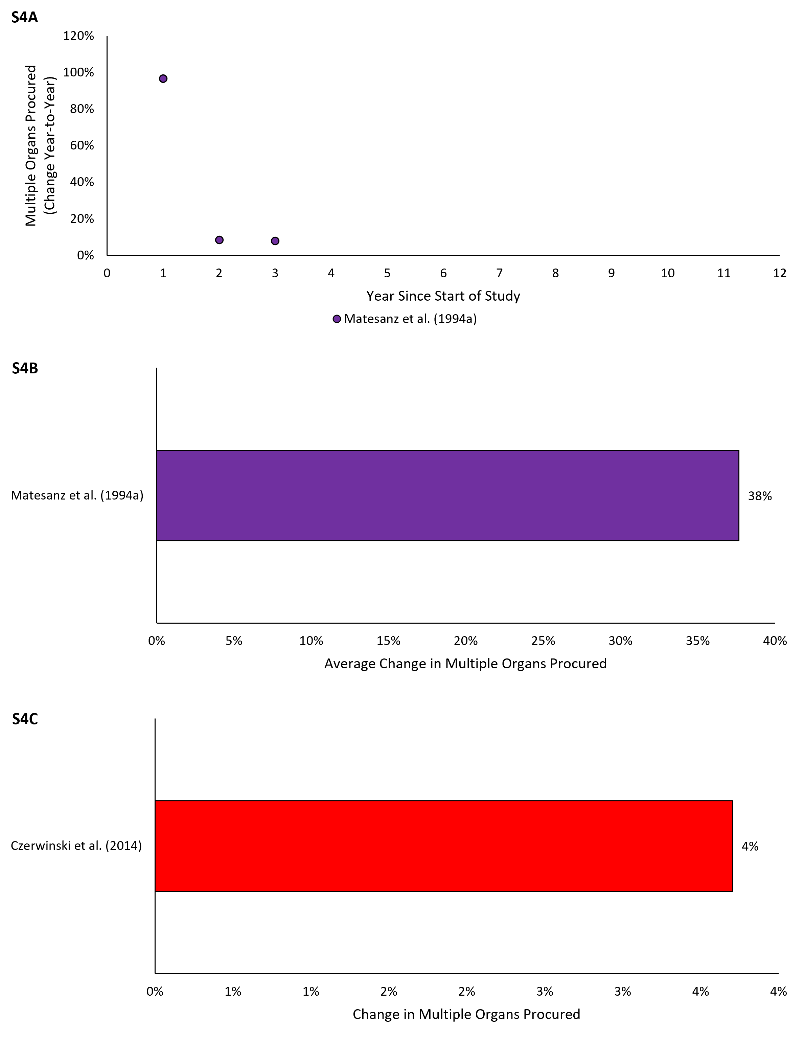

Figure S4. Percent change in multiple organs procured for interrupted time series (S4A-B) and before-and-after (S4C) studies. Figure S4A reflects the average relative year-to-year increase in multiple organs procured over the course of the study. Figure S4B reflects average relative change year-over-year of the time series data presented in Figure S4A. Figure S4C reflects the percent change in multiple organs procured following the intervention.

