Appendix
Figure A1. Job turnover rates in Belgium, traditional growth rate measure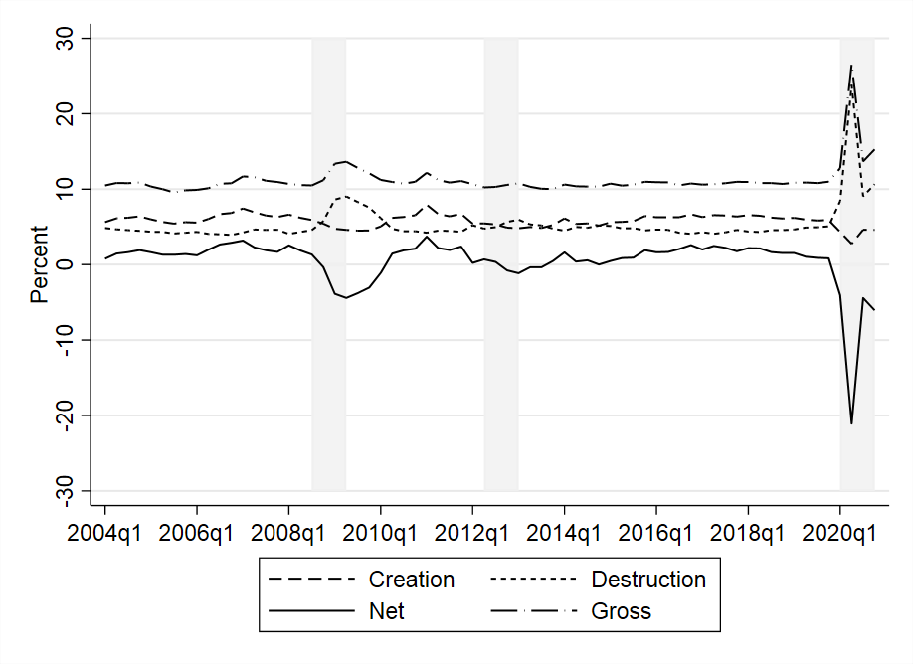

Figure A2. Net employment growth by firm size, base size classification 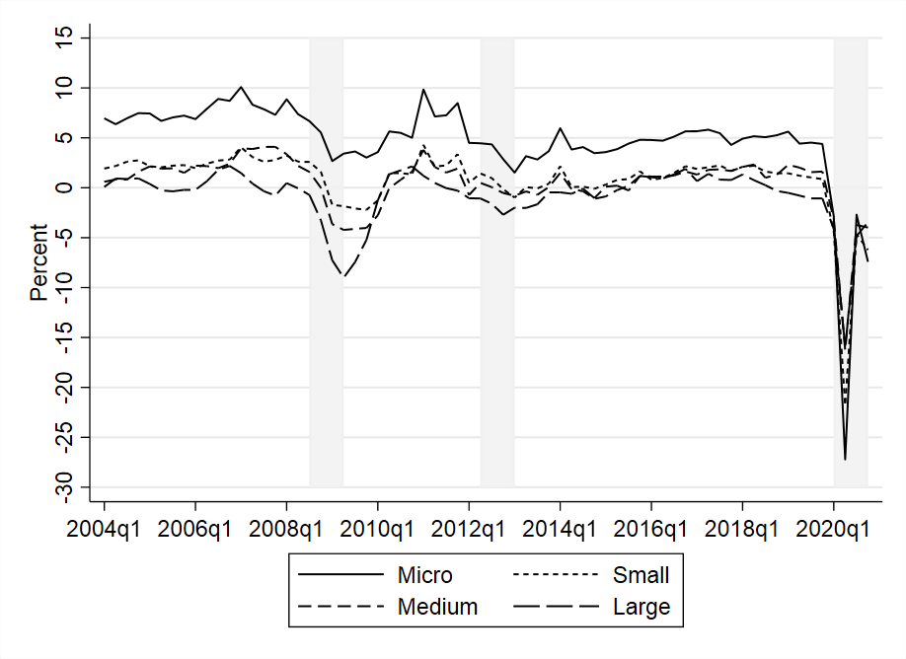
Figure A3. Job creation and job destruction rates by firm size, base size classification 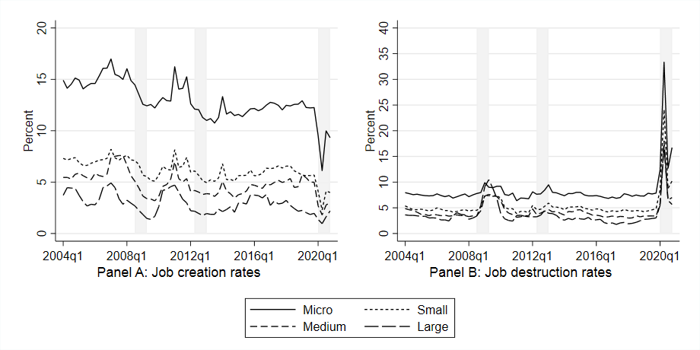

Figure A4. Net employment growth by firm age, excluding entry 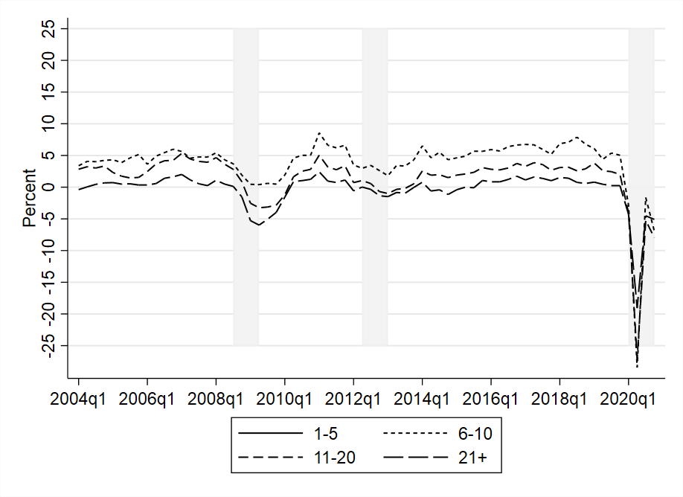

Figure A5. Job creation and job destruction rates by firm age, excluding entry 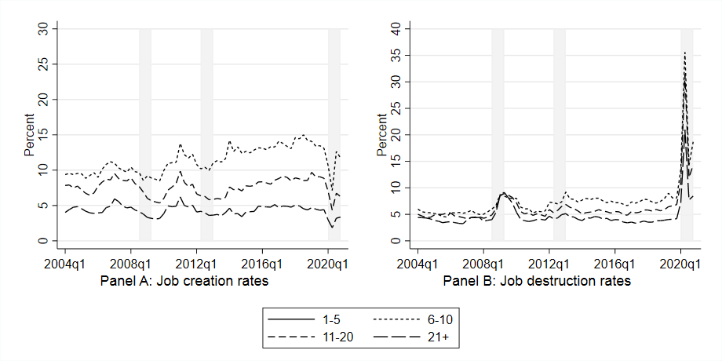

Figure A6. Net employment growth by firm wage, base wage classification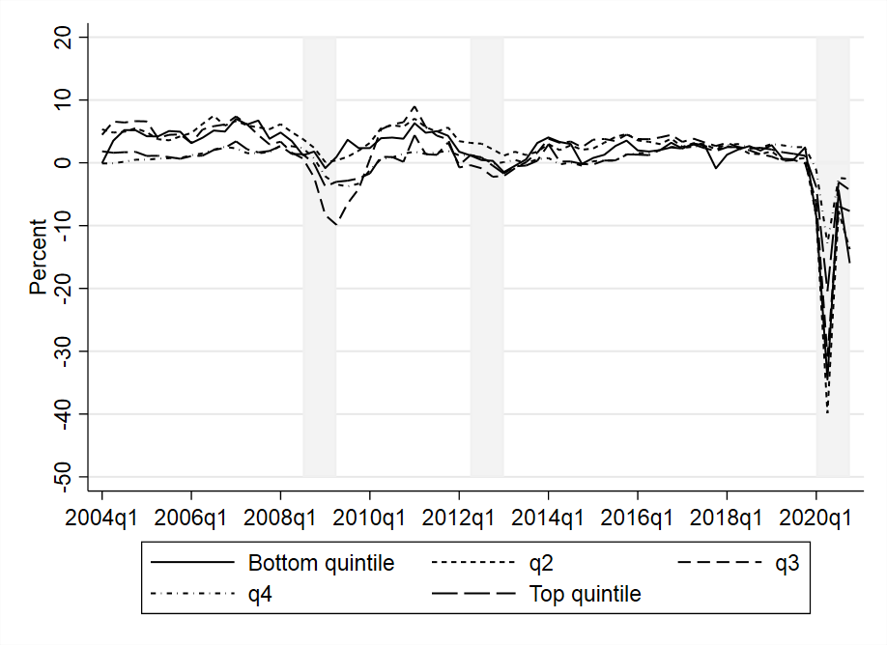

Figure A7. Job creation and job destruction rates by firm wage, base wage classification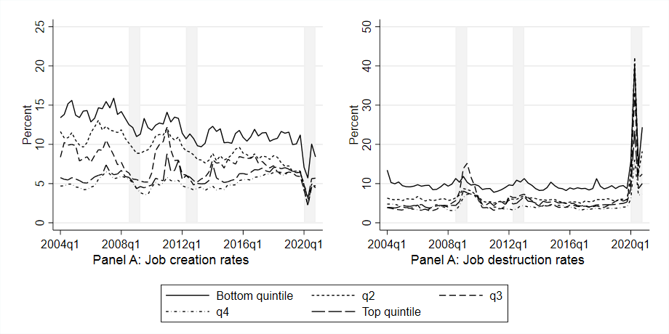

 | (1) | (2)
 | Deviation from HP trend | First difference
 | By size: large minus small
Net creation | 0.547** | 1.108***
 | (0.242) | (0.388)
Job creation | 0.503*** | 0.629***
 | (0.096) | (0.163)
Job destruction | -0.044 | -0.479*
 | (0.170) | (0.285)
 | By wage: high wage minus low-wage
Net creation | -1.077 | 0.675
 | (0.667) | (0.907)
Job creation | 0.430** | 0.067
 | (0.194) | (0.265)
Job destruction | 1.507** | -0.607
 | (0.589) | (0.807)
Table A1. Differential job flows by firm size and wage and unemployment rate, base size and wage classification

Table A2. Differential job flows by firm size and wage and unemployment rate, alternative size and wage classification
 | (1) | (2)
 | Deviation from HP trend | First difference
 | By size: large minus small
Net creation | 0.248 | 1.168**
 | (0.293) | (0.469)
Job creation | 0.372*** | 0.513***
 | (0.097) | (0.181)
Job destruction | 0.124 | -0.655*
 | (0.230) | (0.366)
 | By wage: high wage minus low-wage
Net creation | -0.676 | 1.330**
 | (0.469) | (0.647)
Job creation | 0.335** | 0.732**
 | (0.126) | (0.285)
Job destruction | 1.011** | -0.598
 | (0.398) | (0.522)

Table A3. Differential job flows by firm size and wage and unemployment rate, alternative size and wage classification: excluding 2020
 | (1) | (2)
 | Deviation from HP trend | First difference
 | By size: large minus small
Net creation | 0.682*** | 0.680**
 | (0.153) | (0.308)
Job creation | 0.437*** | 0.473***
 | (0.075) | (0.154)
Job destruction | -0.245* | -0.208
 | (0.123) | (0.240)
 | By wage: high wage minus low-wage
Net creation | 0.127 | 0.886**
 | (0.244) | (0.434)
Job creation | 0.393*** | 0.892***
 | (0.136) | (0.301)
Job destruction | 0.265* | 0.006
 | (0.135) | (0.248)

Table A4. Differential job flows by firm size and wage and GDP growth rate
 | (1) | (2)
 | Deviation from HP trend | First difference
 | By size: large minus small
Net creation | -0.387*** | -0.027
 | (0.081) | (0.054)
Job creation | -0.113*** | 0.003
 | (0.035) | (0.022)
Job destruction | 0.274*** | 0.030
 | (0.065) | (0.041)
 | By wage: high wage minus low-wage
Net creation | -1.152*** | -0.332***
 | (0.152) | (0.090)
Job creation | -0.180*** | -0.200***
 | (0.052) | (0.035)
Job destruction | 0.972*** | 0.133*
 | (0.135) | (0.077)

