Supplementary Information for
Upgrading Traditional Poly(1,3-dioxolane) Electrolytes via Integrated Design of Ultra-Stable Network for Solid-State Lithium Metal Batteries

Hao Li^{1#}*, Yunfei Du^{1,2#}, Long Zhao^{1#}, Chenyu Xiong², Erqing Zhao³, Changgong Li³*, Shumeng Hao⁴ and Weidong Zhou⁴*

¹Key Lab for Special Functional Materials of Ministry of Education, School of Materials Science and Engineering, Henan University, Kaifeng 475004, China. ²School of Materials Science and Engineering, University of Science and Technology Beijing, Beijing 100083, China. ³School of Chemistry and Chemical Engineering, Henan Institute of Science and Technology, Xinxiang 453003, China. ⁴State Key Laboratory of Organic-Inorganic Composites, Advanced Innovation Center for Soft Matter Science and Engineering, Beijing University of Chemical Technology, Beijing 100029, China
*Corresponding author: li_hao@henu.edu.cn; lichanggong@hist.edu.cn; zhouwd@mail.buct.edu.cn.
#These authors contributed equally: Hao Li, Yunfei Du, Long Zhao

Supplementary Figures

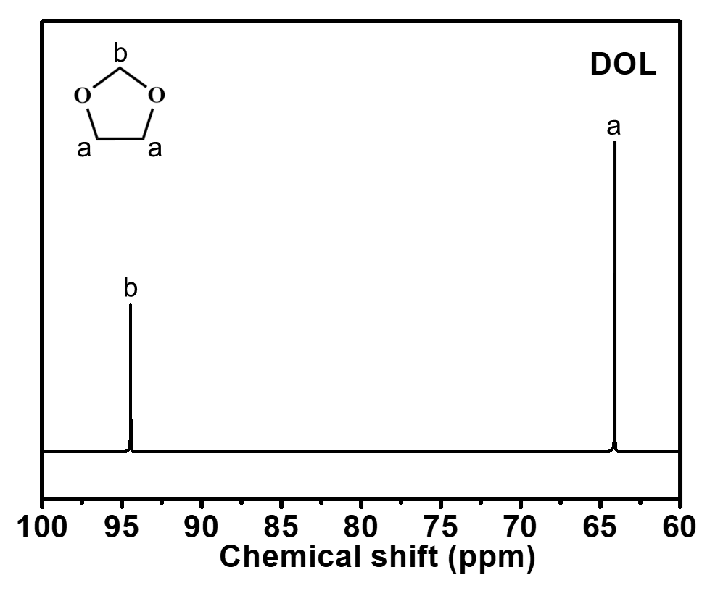
Supplementary Figure 1. ¹³C NMR spectra of DOL.

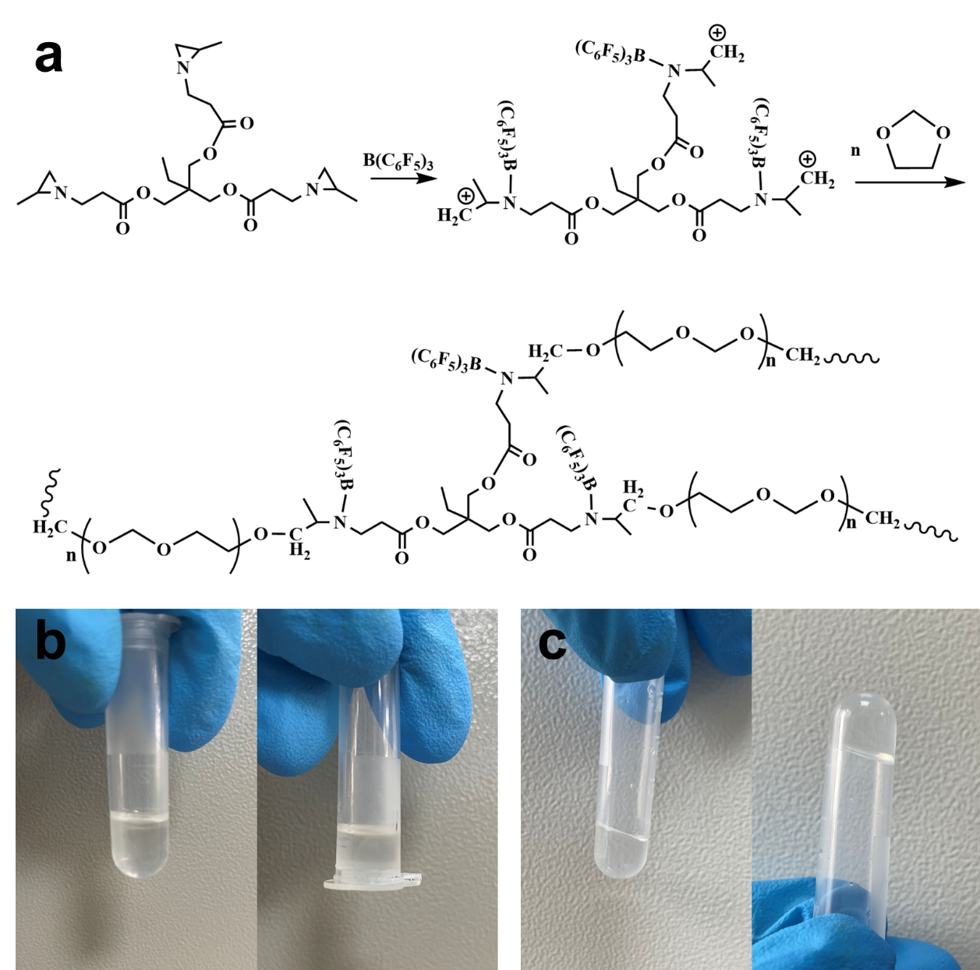
Supplementary Figure 2. (a) Schematic diagram of the polymerization mechanism of PTADOL. Optical images of DOL/TTMAP/LiTFSI mixture (b) before and (c) after addition of 0.8 wt% TFB.

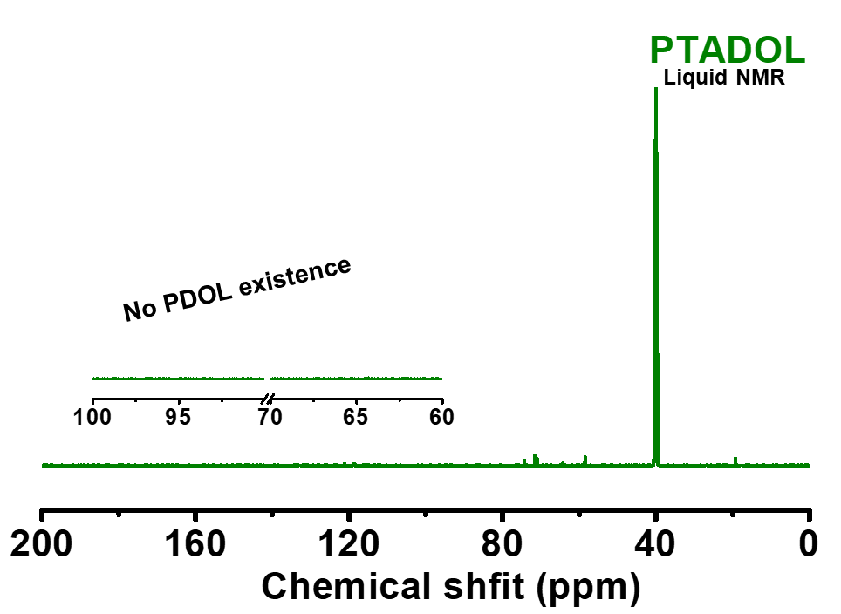
Supplementary Figure 3. ¹³C NMR spectra of PTADOL. (DMSO-d6 as solvent)

The PTADOL solid was immersed in 0.55 mL DMSO-d6 for at least 48 h at room temperature. Then the solvent was extracted for NMR characterization. As seen in Supplementary Fig. 3, the disordered peaks in the range of 70-80 ppm are attributed to trace PTADOL dissolved in DMSO-d6. The peaks at 120 ppm are assigned to -CF₃ on TFSI⁻, which were not observed in the spectra, implying that TFSI⁻ anions were restrained in the structural framework of PTADOL.

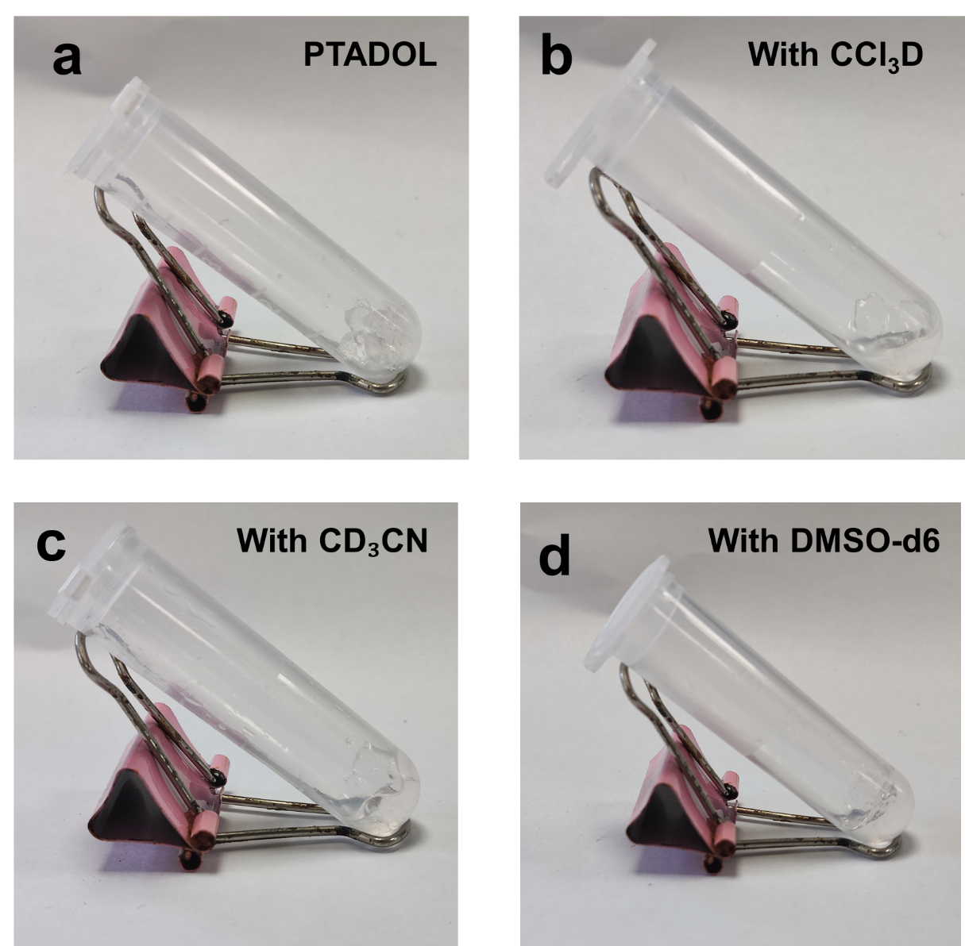
Supplementary Figure 4. Solubility test of PTADOL in virous deuterated solvent.

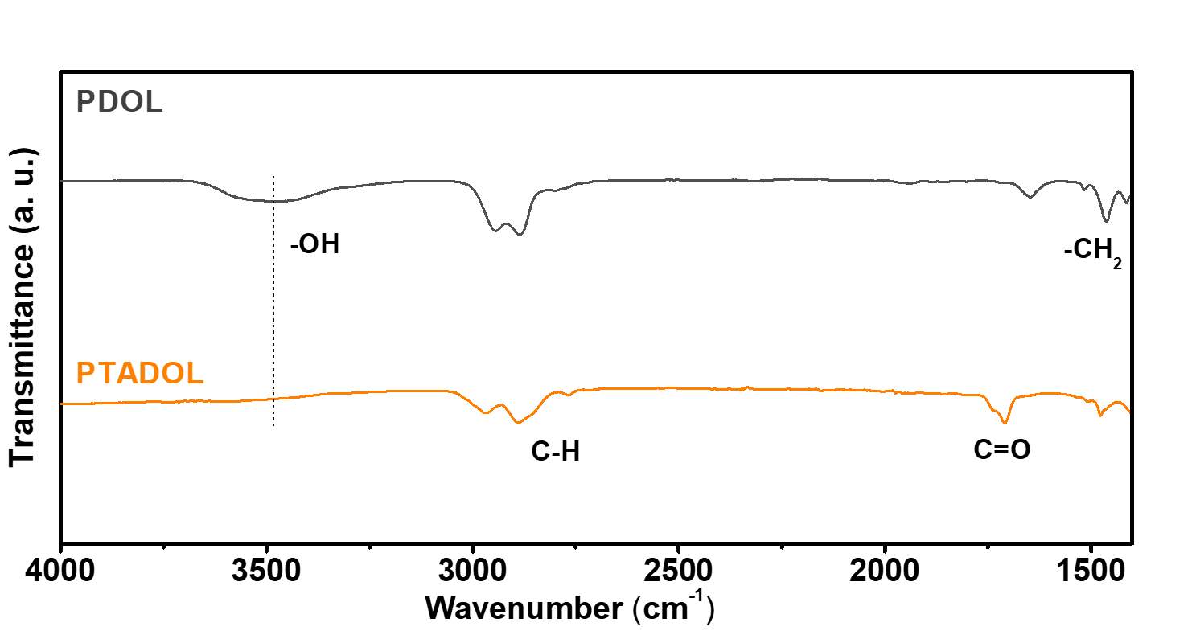
Supplementary Figure 5. FTIR spectra of PDOL and PTADOL membranes.

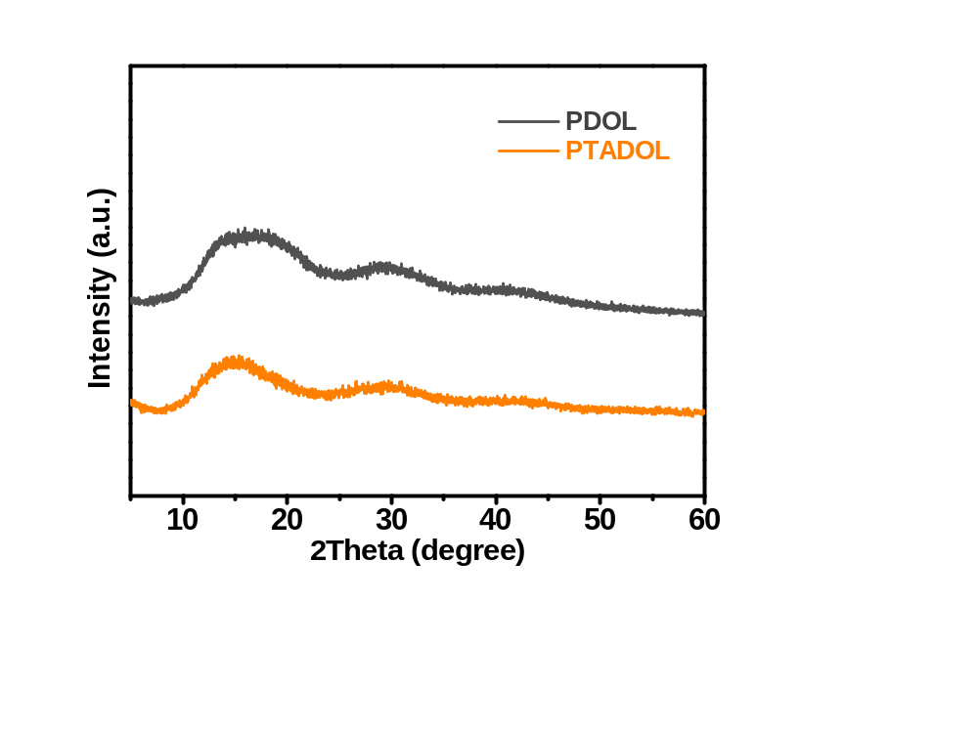
Supplementary Figure 6. XRD patterns of PDOL and PTADOL membranes.

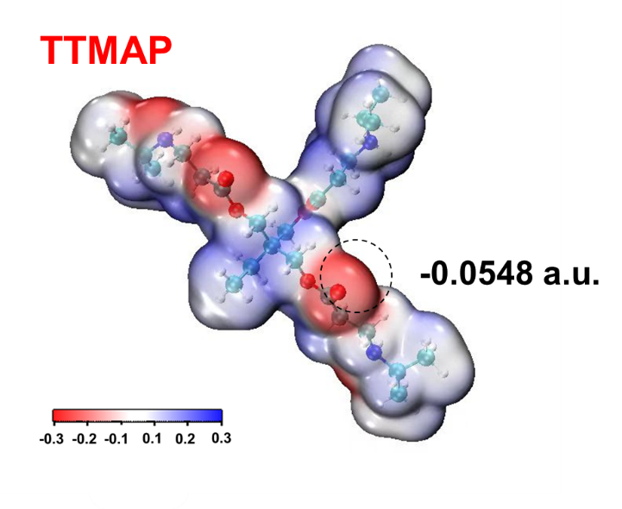
Supplementary Figure 7. The calculated electrostatic potential of the TTMAP group. The N-based heterocyclic ring is opened and end-capped by methyl group.

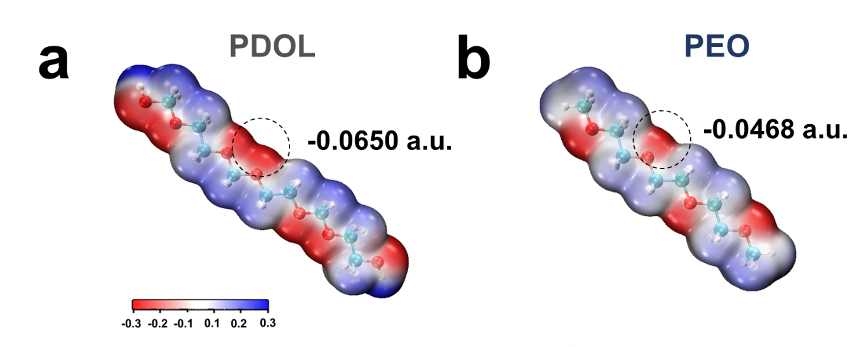
Supplementary Figure 8. The calculated electrostatic potential of (a) PDOL and (b) PEO groups.

The electrostatic potential of the TTMAP, PDOL, and PEO groups was calculated by DFT. As shown in Supplementary Fig. 7, the red areas in carbonyl groups represent uniform negative electrostatic potential, which contributes to coordination of polymer-Li⁺ in TTMAP groups. Moreover, compare to the C-C-O groups from PEO, O-C-O groups from PDOL exhibit much stronger electronegativity, implying excessive O-Li⁺ interaction (Supplementary Fig. 8).

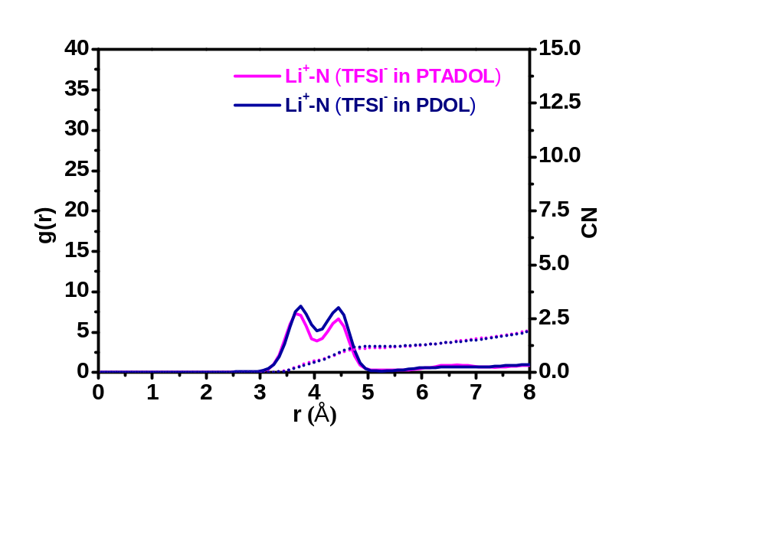
Supplementary Figure 9. Calculated radial distribution functions (g(r), solid lines) and coordination numbers (CN, dash lines) for lithium salt anions.

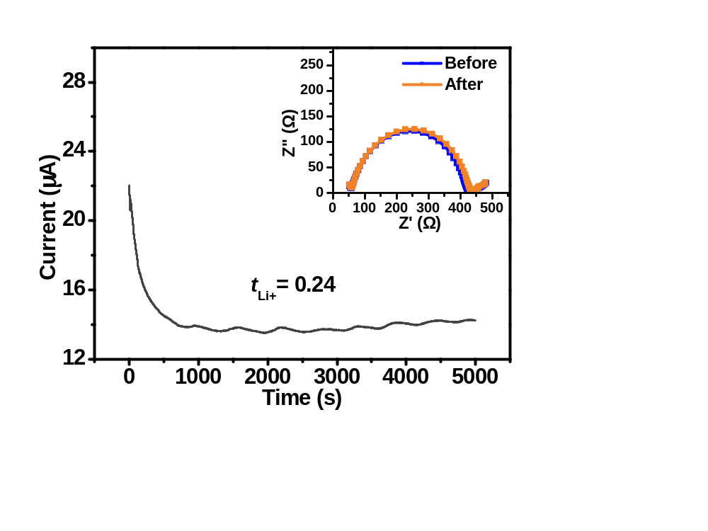
Supplementary Figure 10. Current-time profiles of the Li symmetrical cells with PDOL. The inset shows the Nyquist impedance spectra of the batteries before and after polarization.

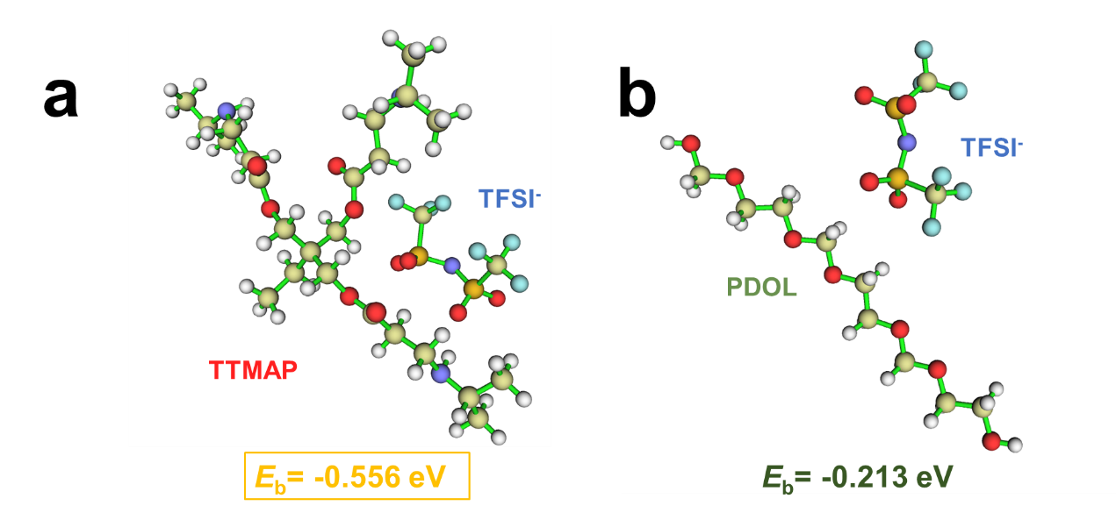
Supplementary Figure 11. Schematic diagram of interaction energy of (a)TTMAP and TFSI–; (b) PDOL and TFSI–.

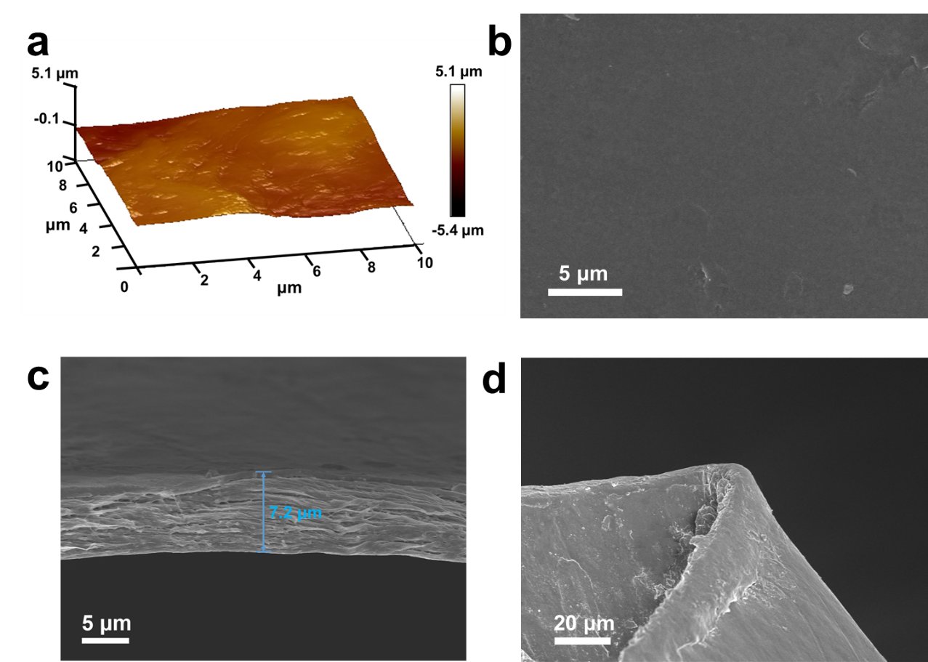
Supplementary Figure 12. (a) AFM image of PTADOL membrane. (b) Top-view, and (c) Side-view SEM images of PTADOL membrane (with PE separator). (d) Cross-sectional SEM image of PTADOL membrane in the curled state.

The Atomic Force Microscope (AFM) and field emission scanning electron microscopy (FE-SEM) images of the PTADOL membranes are displayed in Supplementary Fig. 12. The membranes exhibit smooth surface, dense and colloidal cross-section morphology, demonstrating uniform distribution of PTADOL in PE separator.

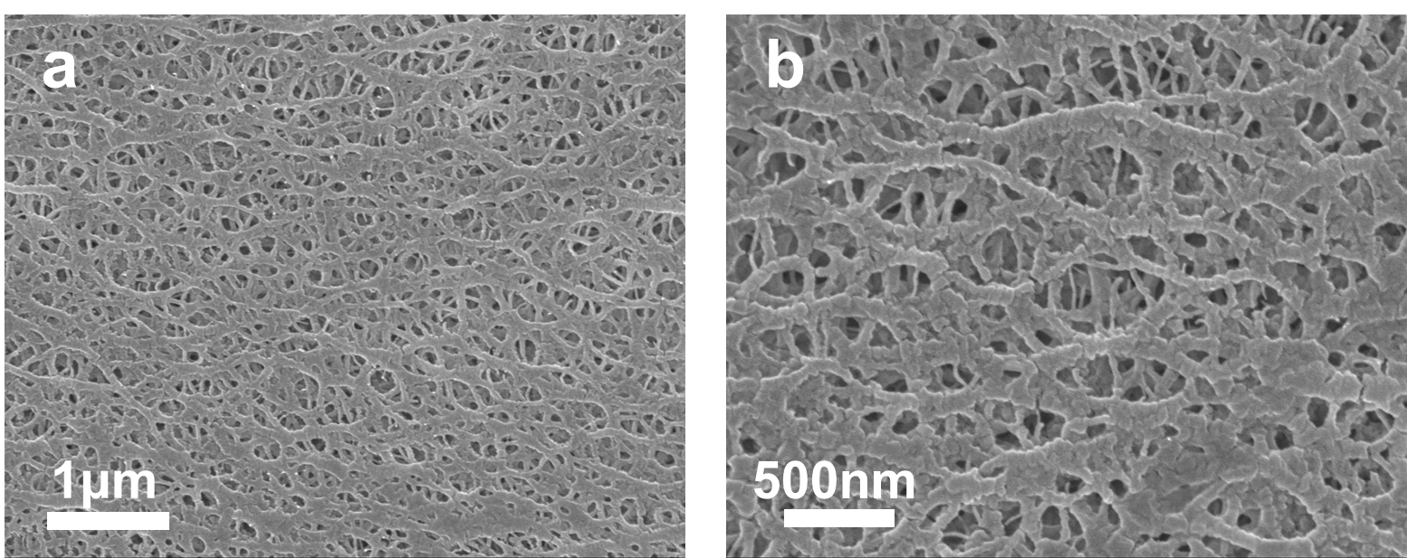
Supplementary Figure 13. SEM images of polyethylene (PE) separator with thickness of ~6 μm.

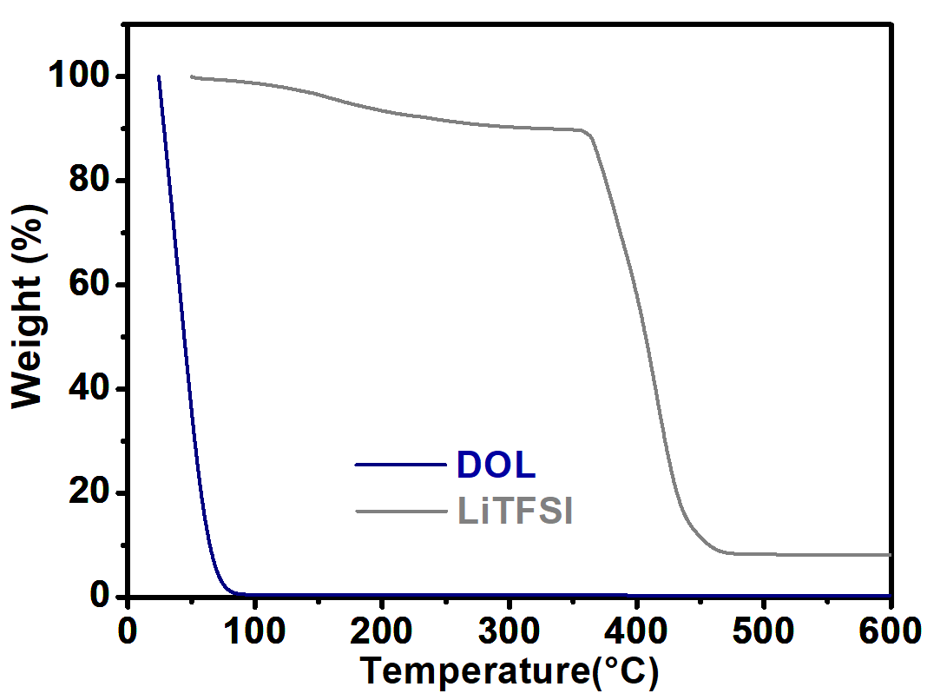
Supplementary Figure 14. TGA thermograms of pure DOL and LiTFSI salt.

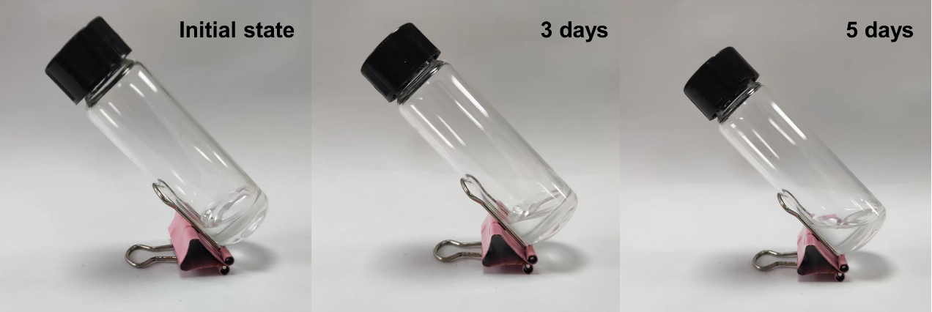
Supplementary Figure 15. The optical images of PDOL storing in glass tube over different time.

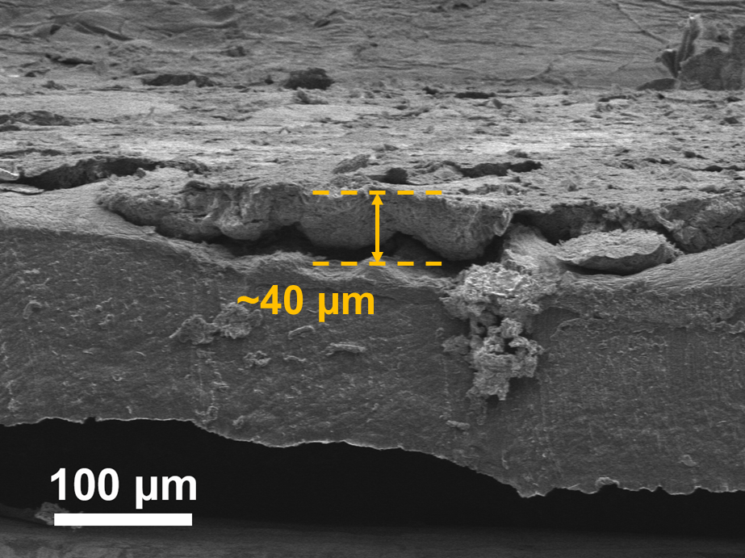
Supplementary Figure 16. Cross-section SEM image of lithium metal after 1200 cycles in PDOL.

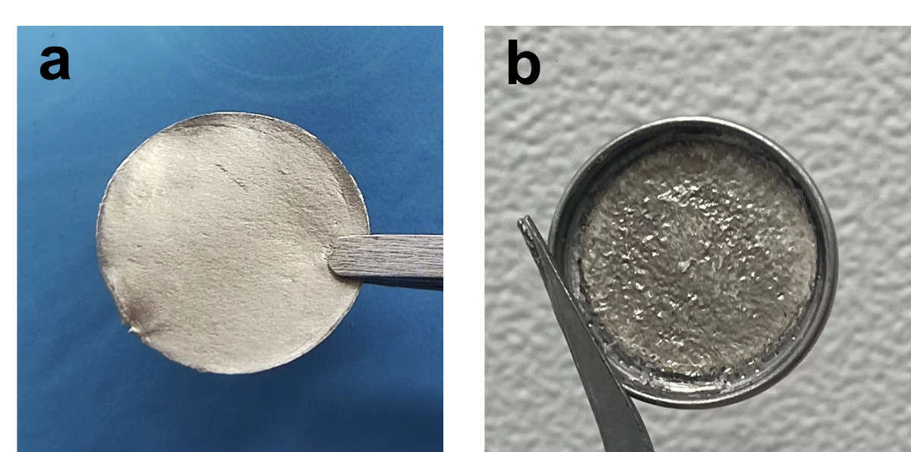
Supplementary Figure 17. Optical images of cycled lithium metal in (a) Li||PTADOL||Li battery and (b) Li||PDOL||Li battery after Li plating/stripping 1200 h.

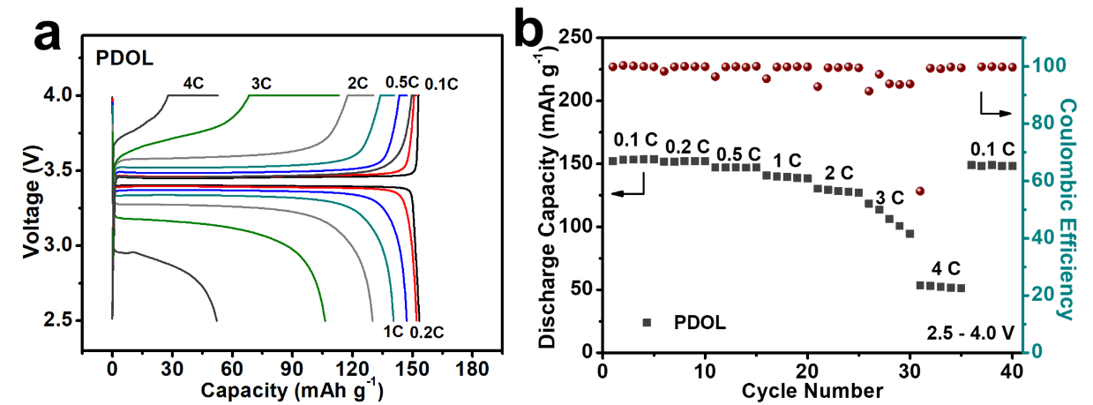
Supplementary Figure 18. (a) Rate capability, and (b) charge-discharge voltage profiles of LFP||PDOL||Li battery at various rates.

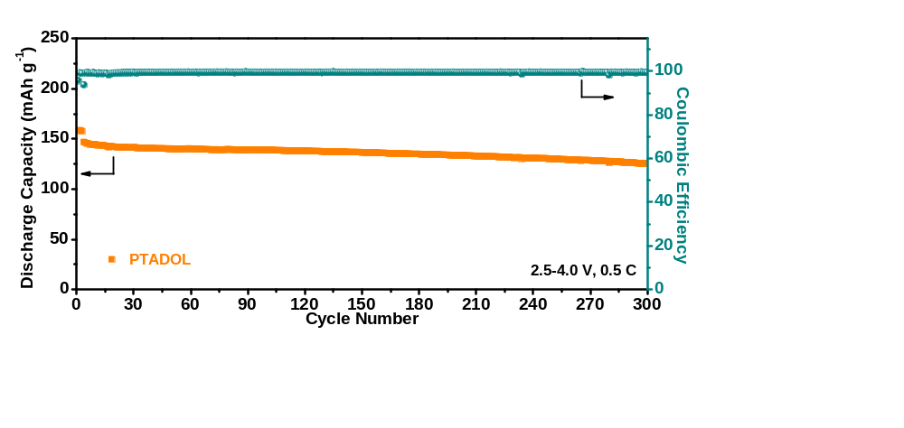
Supplementary Figure 19. Capacity retention performance of PTADOL based batteries at 2.5-4.0 V and 0.5 C.

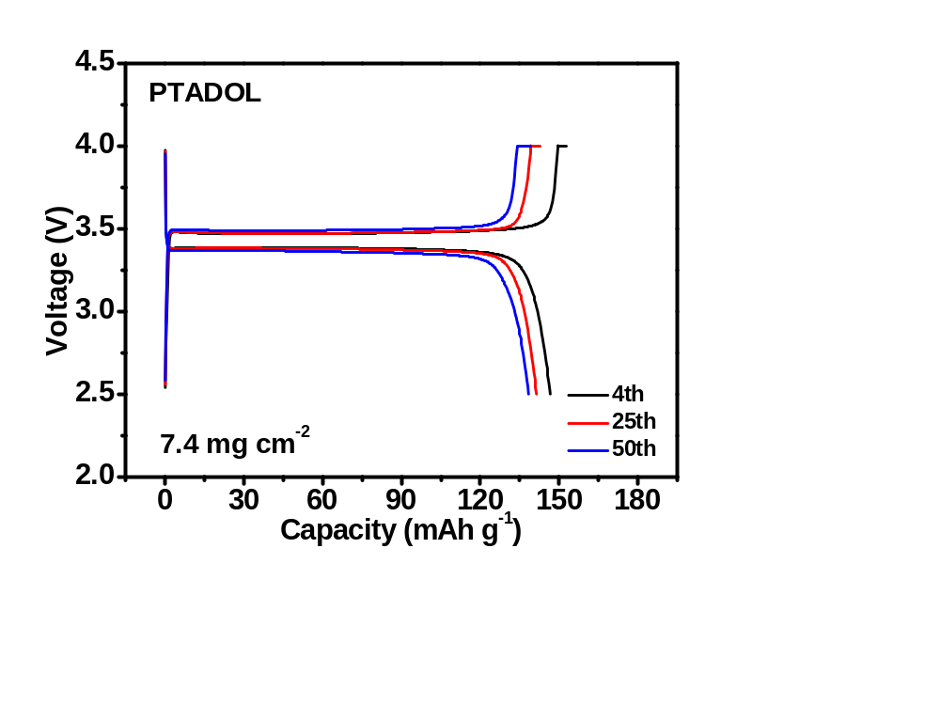
Supplementary Figure 20. Typical charge-discharge voltage profiles of LFP||PTADOL||Li battery with 7.4 mg cm⁻² LFP loading at 0.3 mA cm⁻².

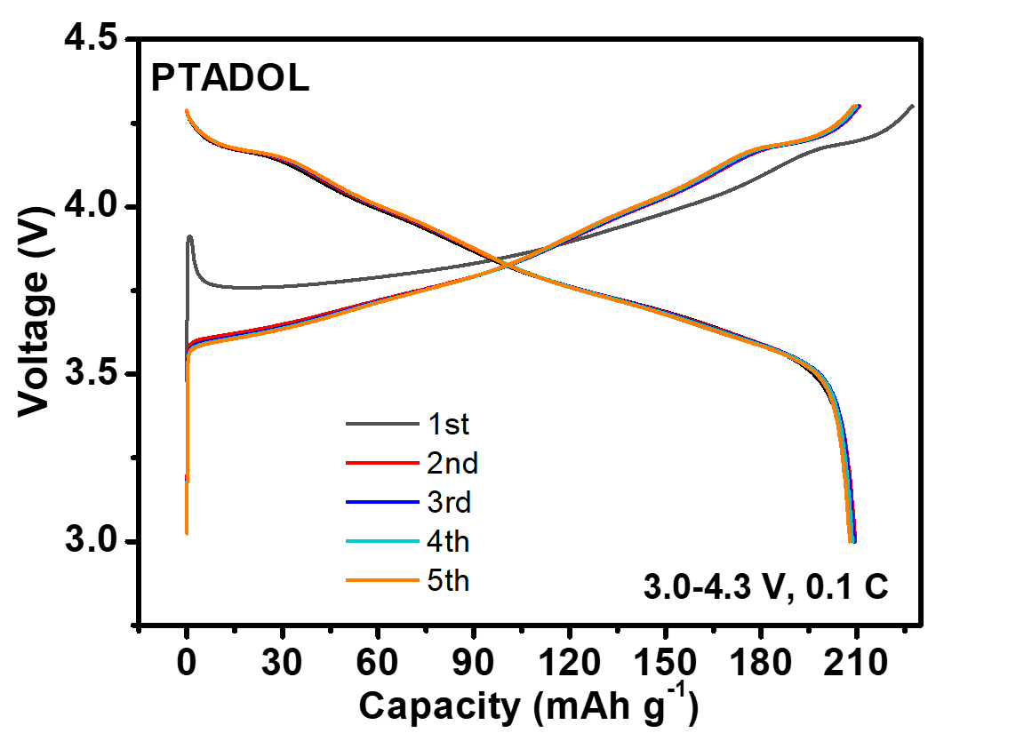
Supplementary Figure 21. Typical charge-discharge voltage profiles of NMC811||PTADOL||Li battery at 0.1 C.

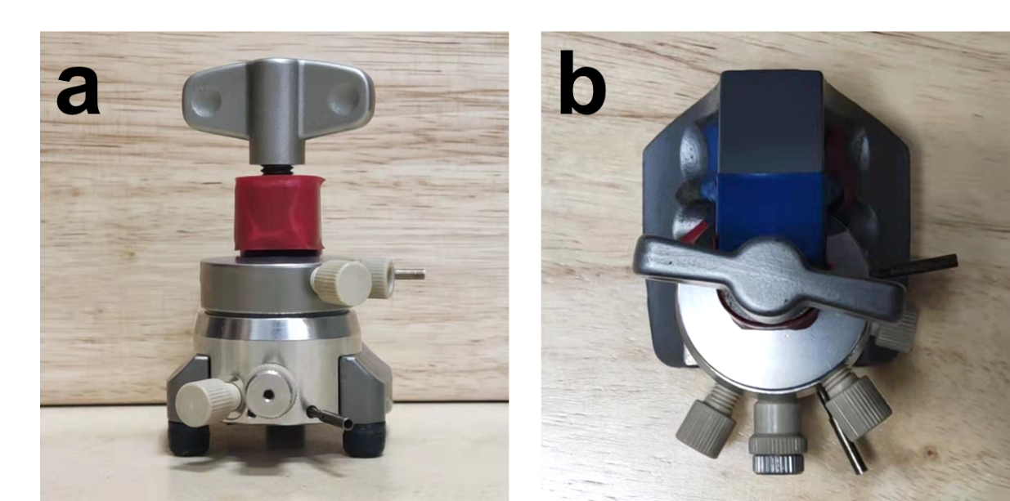
Supplementary Figure 22. Optical images of the battery mold for DEMS test.

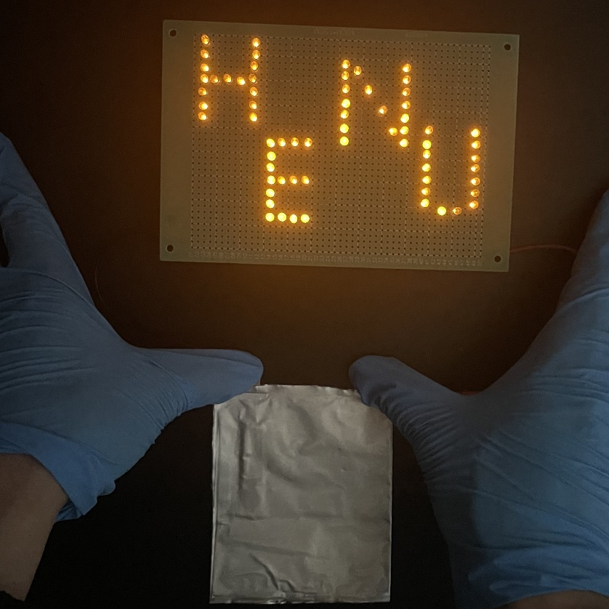
Supplementary Figure 23. Photograph of NMC811||PTADOL||Li pouch cell lighting LED array.

Supplementary Tables

Supplementary Table 1. The values of fitting parameters of ionic conductivity of PTADOL.
Sample |  |  | E_{a} (eV) | Conductivity (S cm⁻¹)  (25 ºC) | Conductivity (S cm⁻¹)  (80 ºC)
PTADOL |  |  | 0.237 | 1.48 × 10⁻⁴ | 5.78 × 10⁻⁴
PDOL |  |  | 0.335 | 1.29 × 10⁻⁴ | 8.79 × 10⁻⁴

Supplementary Table 2. Bond distances (in Å) for Li⁺ with the polymer matrix and TFSI– anions at 313 K in PTADOL and PDOL, respectively.
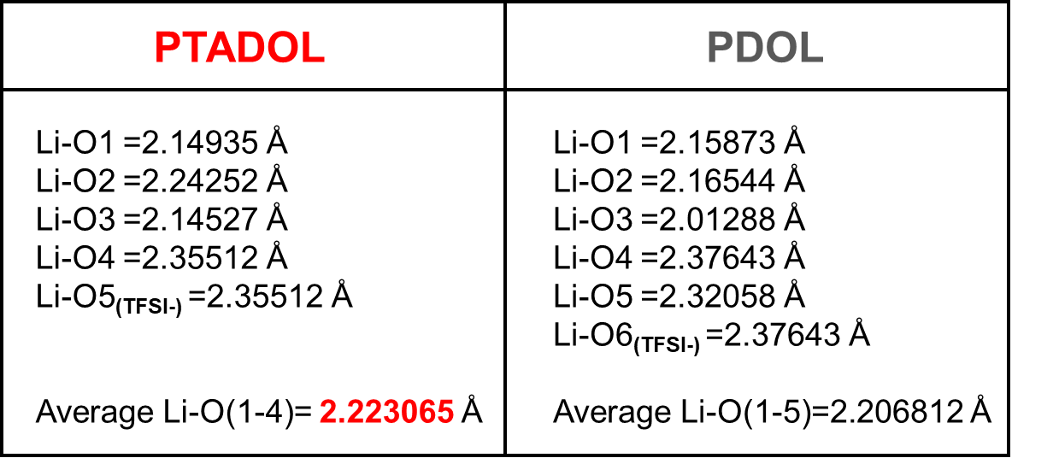

Supplementary Table 3. The parameters for the calculation of lithium-ion transference number of PTADOL.
Sample | I₀ (μA) | I_{S} (μA) | R_{bulk}(0)(Ω) | R_{bulk}(∞) (Ω) | R_{Li}(0) (Ω) | R_{Li}(∞) (Ω) | t_{Li+}
PTADOL | 0.087 | 0.077 | 7.98 | 8.03 | 92.87 | 100.94 | 0.76
PDOL | 0.022 | 0.014 | 51.92 | 52.69 | 377.28 | 386.17 | 0.24

