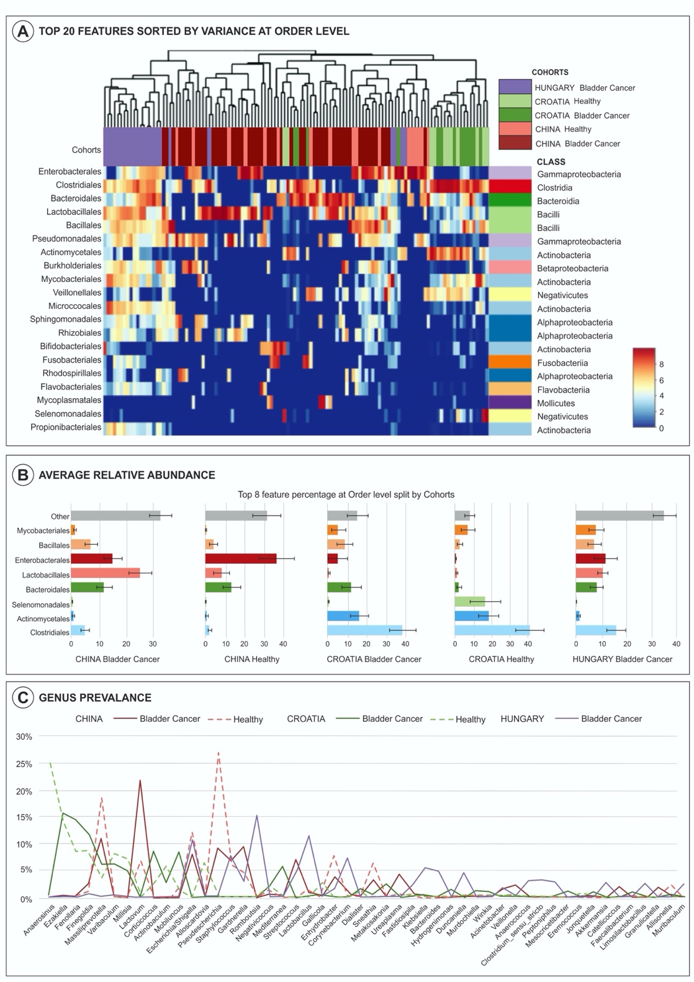

Supplementary Figure 1: A) Heatmap of all three published cohorts by order level (B), with subsequent prevalence by order (B) and genus (B) phylogenic composition of common bacteria taxa ( >0.1% abundance)

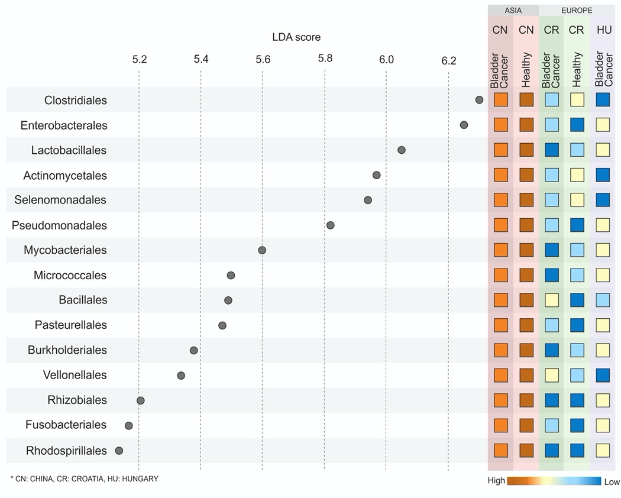

Supplementary Figure 2: LDA scores by Country and Continent
LDA scores computed for top differentially abundant taxa in the urine microbiome of bladder cancer and healthy controls in three published cohorts, with LDA score >3, p<0.01, FDR adjusted.

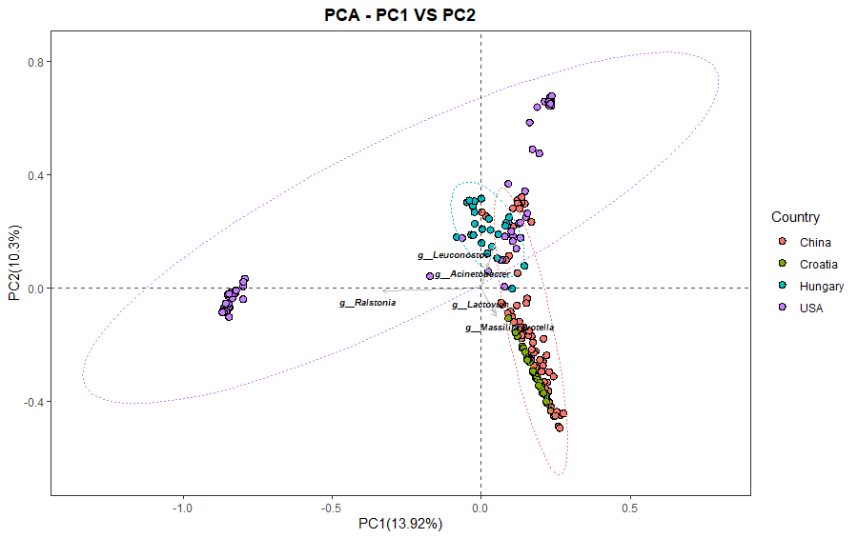

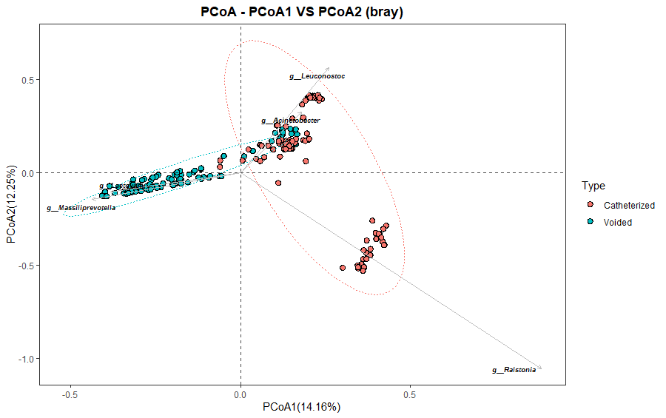

Supplementary Figure 3: Diversity PCoA clustering in bladder cancer samples only by A) Country of origin and B) Collection methodology. Although clustering by country is visualized, there are significant compositional differences and clustering changes present by collection method.

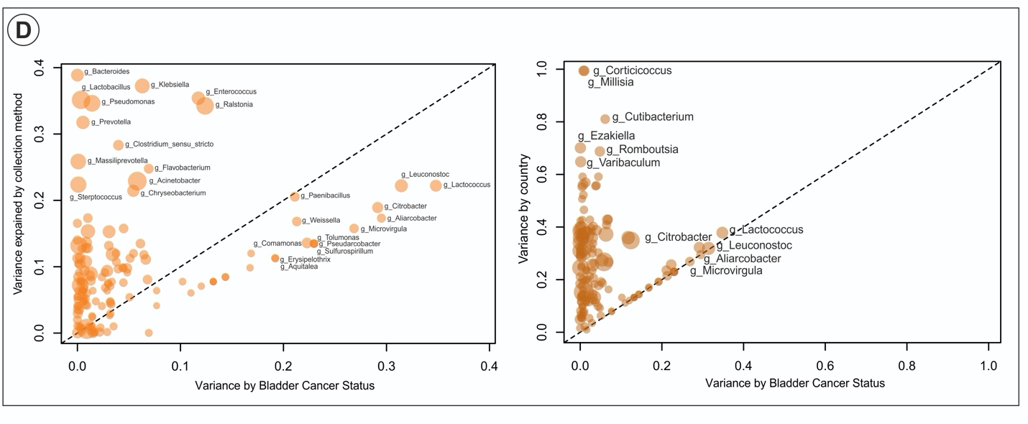
Supplementary Figure 4: Analysis of Variance by Collection Status Across all 4 cohorts
Analysis of covariates that potentially confound microbiome-disease associations and classification models showing different collection methodology as well as presence of disease to be responsible for the differences observed in the ML model (A). However, when assessing by country (further confounded by methodology), the results by disease status are not as profound, as they are for country.

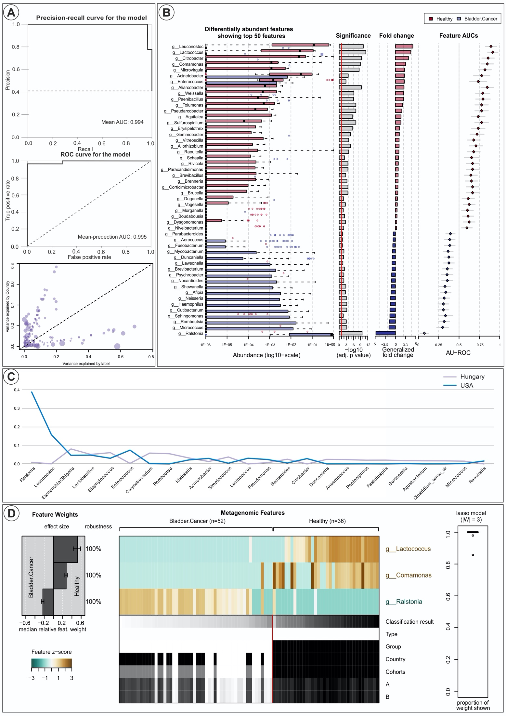
Supplementary Figure 5: ML model of USA and Hungary Only (Catheterized samples only) By inclusion of catheterized samples from USA and Hungary only, ML reveals a much stronger prediction model, with univariate analysis seen in (A) with associated strength and p value. (B) Heatmap representation of normalized values across all samples (as used for model fitting) along with classification (USA vs Hungary, bladder cancer vs healthy controls), showing test prediction and meta-variables on the bottom with healthy cohort having a high predictability of Lactococcus and Comamonas genus. (C) Analysis of variance by cancer and country, showing variability by country and disease status now equivalent with associated ML AUC 0.995 (D)

