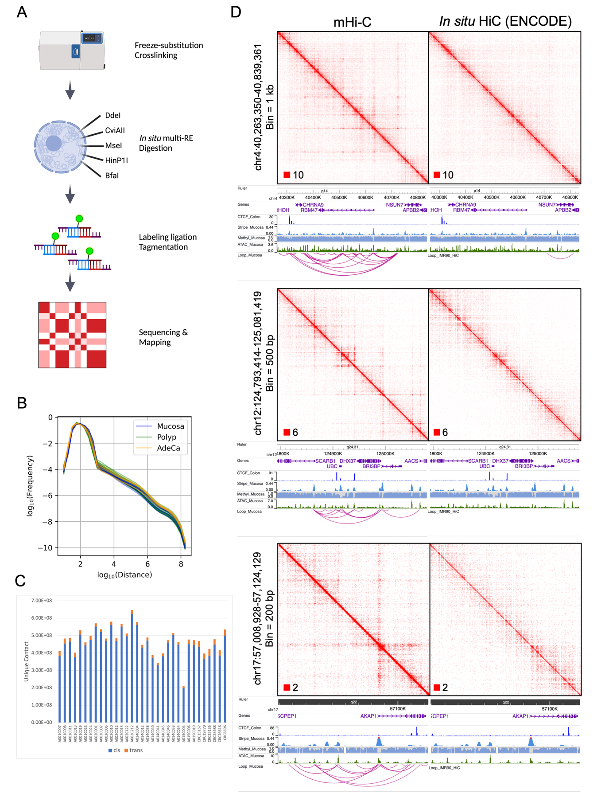
Figure S1 mHi-C design and results. (A) Schematic for the mHi-C workflow. (B) Intrachromosomal interaction frequencies by distance for samples. (C) Number of unique interaction contacts by samples. (D) Comparison of mHi-C with in situ HiC (ENCODE) at various resolutions.
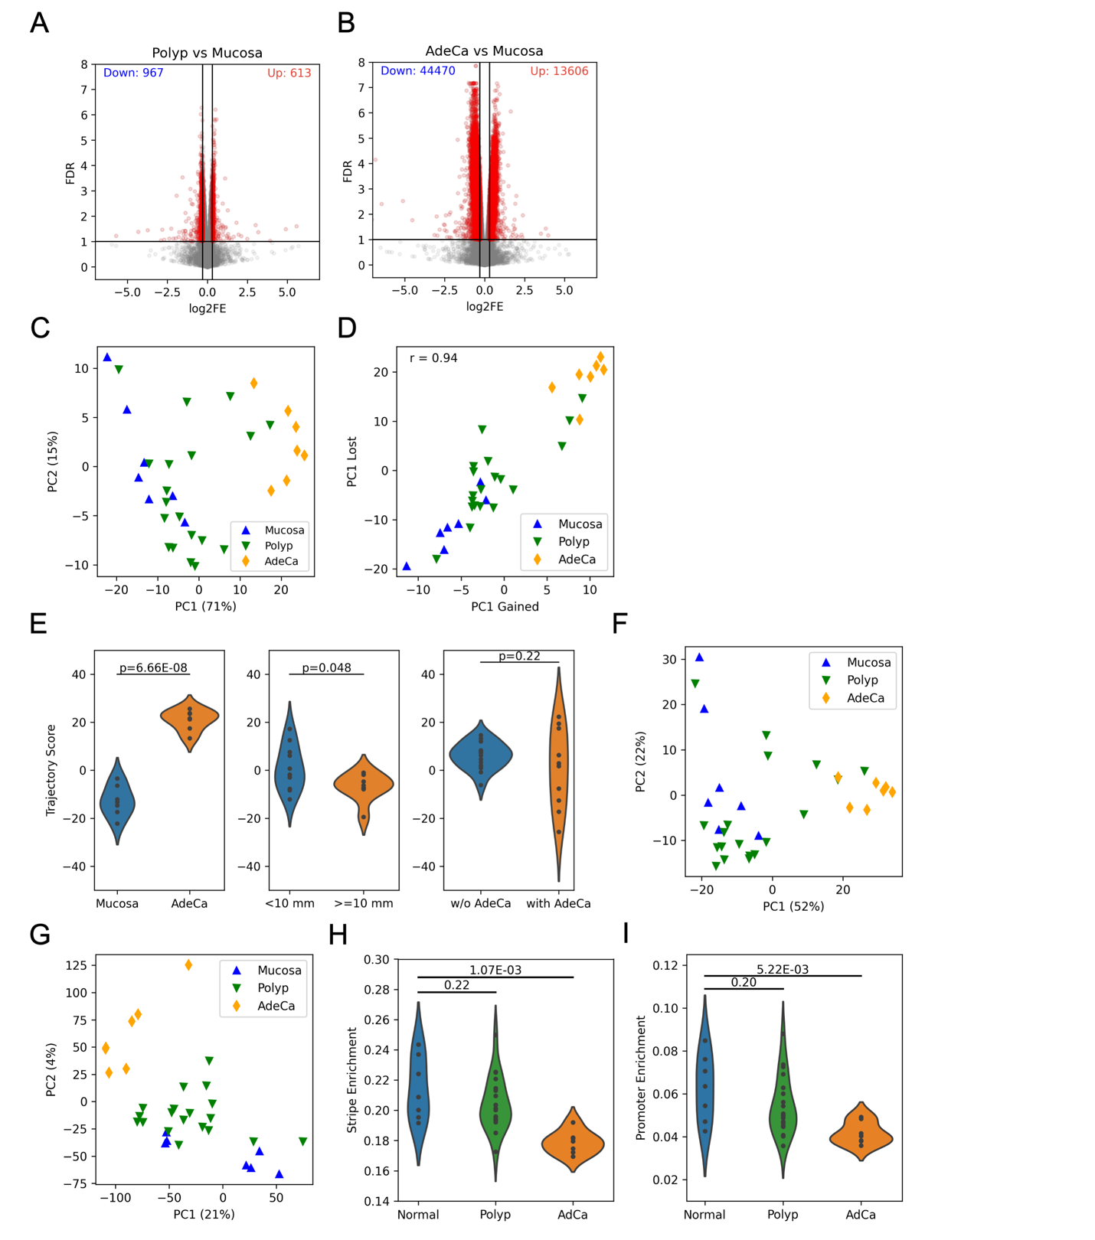
Figure S2 Sample stratification by mHi-C. (A) Volcano plots for differential analyses of stripes between mucosa-polyp and mucosa-adenocarcinoma. (B) PCA analysis of stripes significantly differential between mucosa and adenocarcinoma. (C) Sample correlation using PC1 values from PCAs of gained and lost stripes in adenocarcinoma. (D) Comparisons of PC1 values shown in (B) by sample phenotypes between i) mucosa and adenocarcinoma, ii) small (<10 mm) and large (>= 10mm) polyps, and iii) polyps from cancer-developed FAP patients (A001, A015) versus without (A002, A014). (E) PCA analysis using the whole stripe profile. (F) PCA analysis using the whole loop strength profile. (G) Fraction of distal (> 1.5 kb) intrachromosomal reads on all stripes and (H) gene TSS for samples.
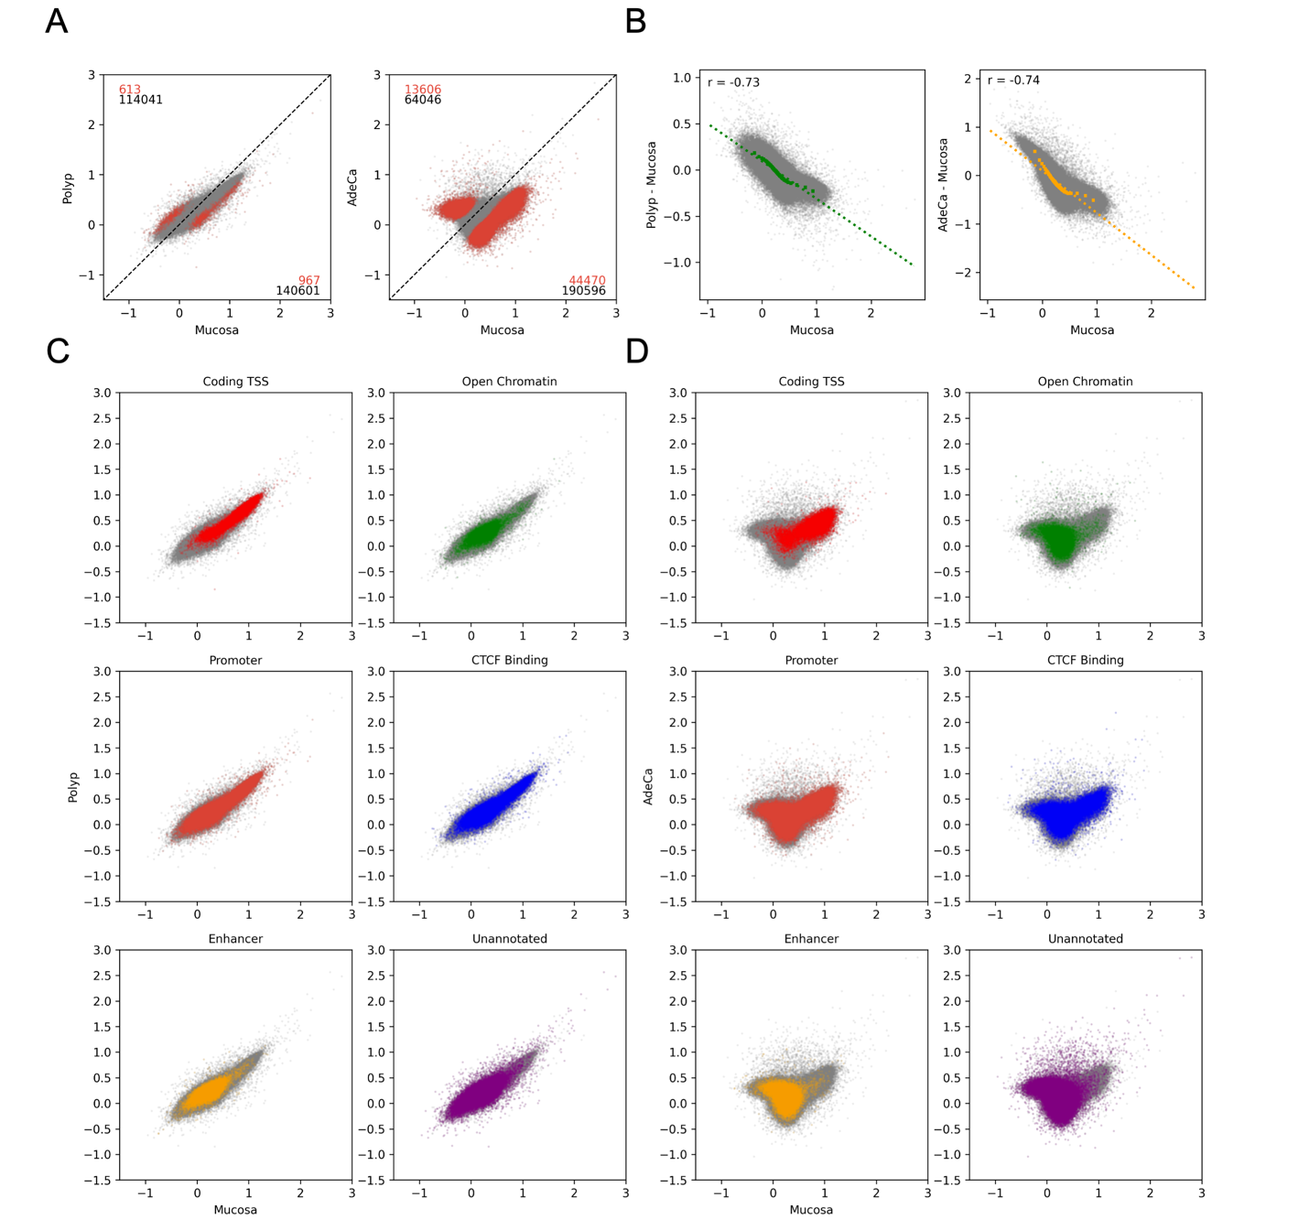
Figure S3 Alterations of stripe strengths in different cancer stages. (A) Scatter plots comparing stripe strengths between different stages. Red numbers indicate significantly differential stripes above and below the line of y = x, while black numbers indicate that for all stripes. (B) Scatter plots comparing basic stripe strengths in mucosa versus changes in advanced stages. Linear regression was performed and Pearson correlation r was indicated. (C) Scatter plots of stripe strengths by functional annotation in polyps and (D) adenocarcinoma versus mucosa.

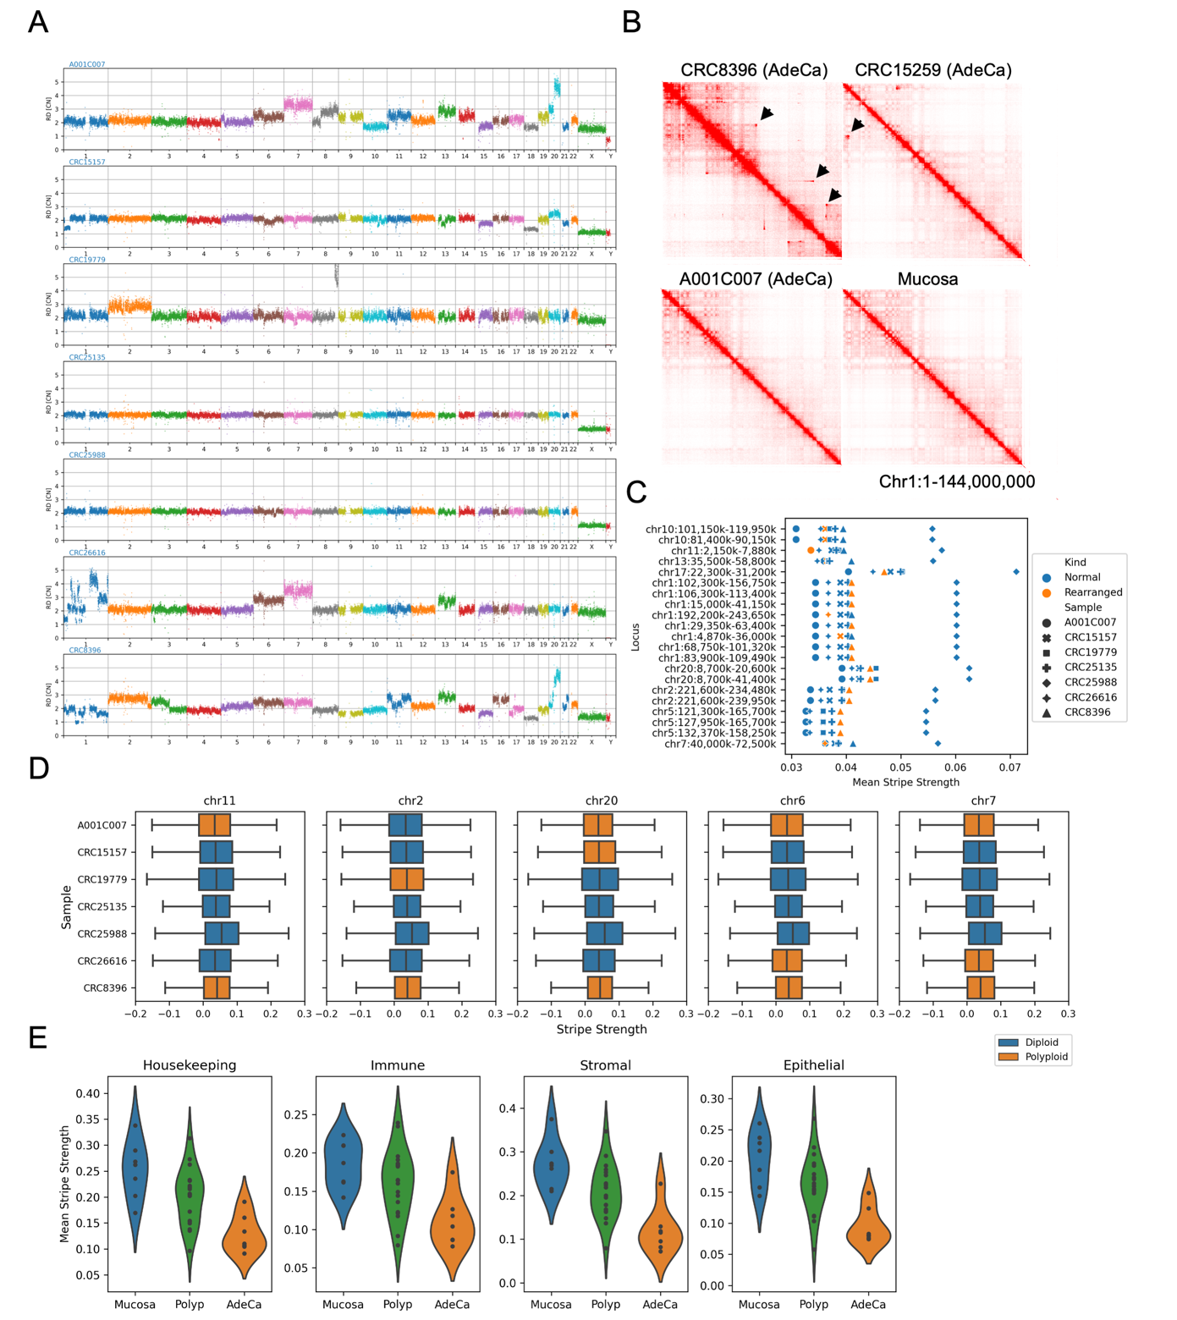
Figure S4 Impact of confounding factors on stripe quantification. (A) Manhattan plot showing chromosomal copy number variations in adenocarcinoma samples. (B) Examples of visually inspected chromosomal rearrangements. (C) Comparison of mean fold enrichments for stripes located within 100kb to the rearrangement junction sites in adenocarcinoma samples with and without the indicated rearrangement. (D) Comparisons of stripe strength distributions in chromosomes with polyploidy in subsets of adenocarcinoma samples. Paired t test was performed between mean stripe fold enrichment in samples with diploid and polyploid. No significant difference (p<0.05) was identified for any of five chromosomes. (E) Violin plots showing sample mean stripe fold enrichment for genes that are housekeeping or specific to immune, stromal, or epithelial cells.
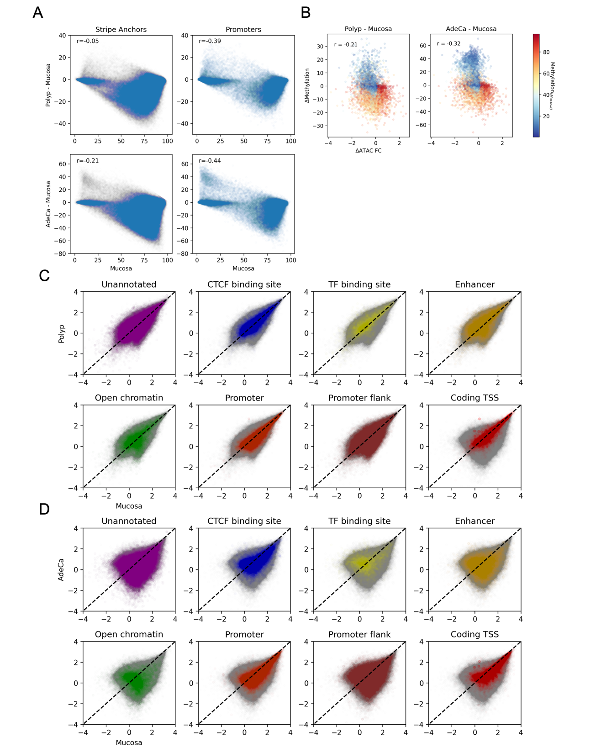
Figure S5 Association between DNA methylation and open accessibility during CRC development. (A) Scatter plots between methylation percentage in mucosa and differential methylation in polyps and adenocarcinoma for all stripe anchors (N = 230,658) TSS regions (N = 55,093) Colors indicate methylation degrees in mucosa. Pearson correlation r is indicated for each comparison. (B) Scatter plots comparing differential open accessibility and methylation for gene TSS (N = 15,387). Pearson correlation r is indicated for each comparison. (C) Scatter plots comparing strengths of ATAC peak with various annotations between mucosa and polyp or (D) adenocarcinoma (N = 258,346).
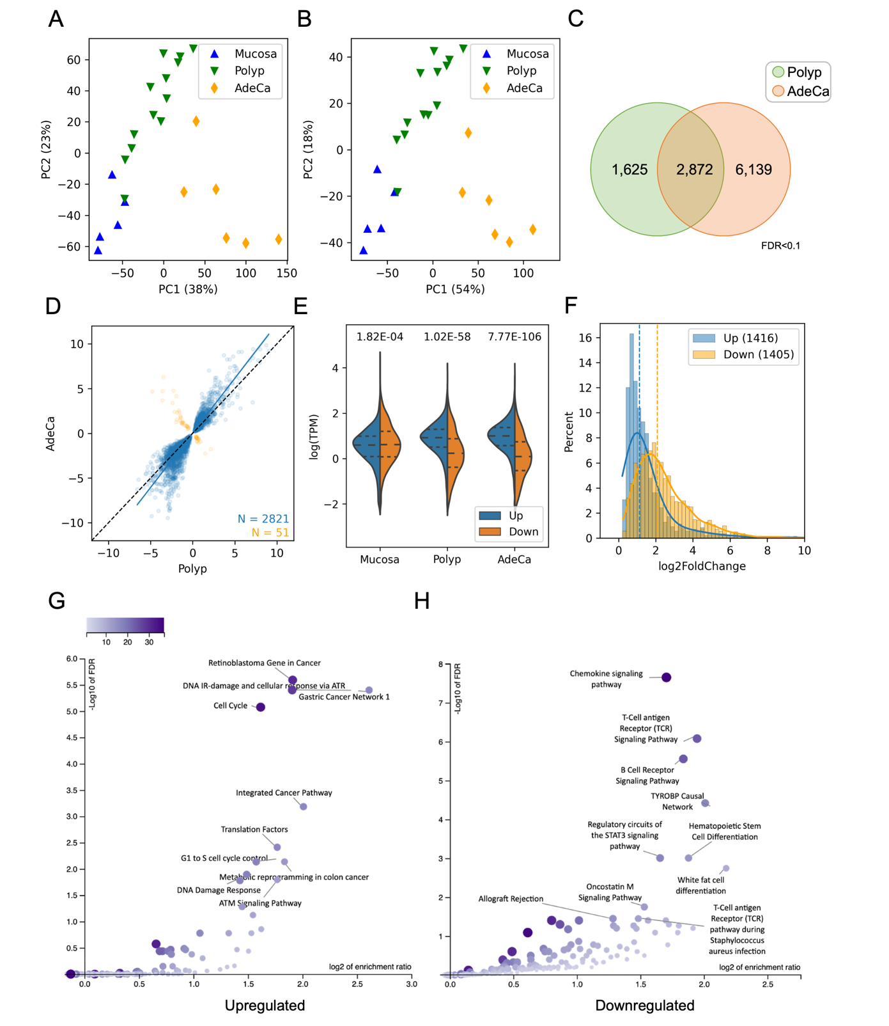
Figure S6 Alterations of transcriptomes during CRC development. (A) PCA analysis for the whole transcriptome and (B) differential genes between mucosa and adenocarcinoma. (C) Overlap of differential genes at stages compared to mucosa. (D) Scatter plot comparing differential expression (log2 fold change) in polyp and cancer. (E) Violin plot showing distributions of expression levels (log TPM) for commonly up- and down-regulated genes. Lines within the plot indicate quarter quartiles. P values from two-side t tests are indicated on top. (F) Distributions of log differential expressions for commonly up- and down-regulated genes in adenocarcinoma. Dotted lines indicate medians. (G) Enriched pathways for commonly up- and (H) down-regulated genes.
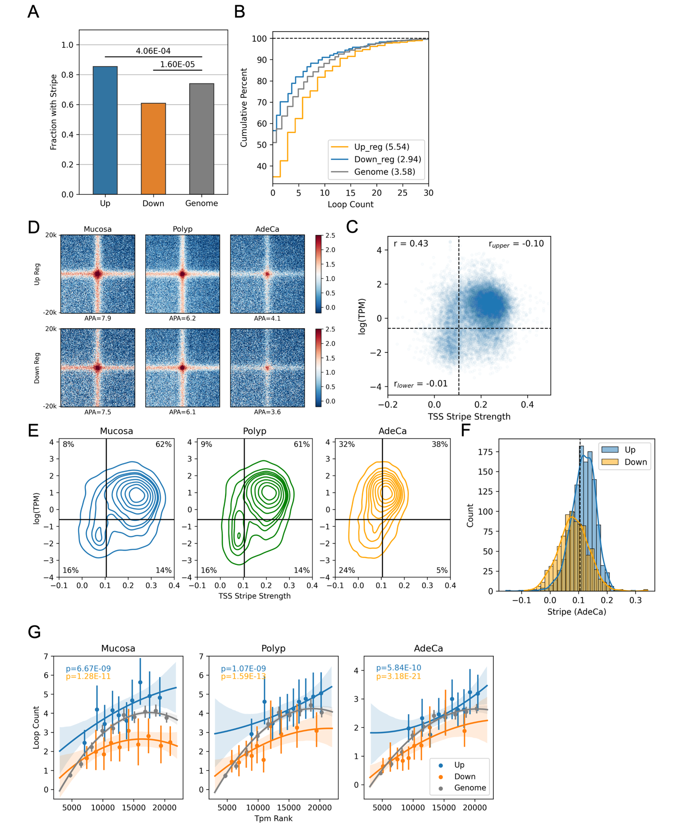
Figure S7 Relationship between promoter distal interaction and gene expression. (A) Comparison of fraction with promoter interaction stripes for up-regulated, down-regulated or all expressing genes in mucosa. Numbers on top indicate significance of differential fraction tested by the 2x2 Chi-squared test. (B) Cumulative distributions of loop counts for up-, down-regulated or all genes in mucosa. Numbers in legends indicate mean loop counts. (C) APA analyses of the complete loop profiles for up- and down-regulated genes at different stages. (D) Scatter plot comparing the promoter stripe strength with expression in mucosa. Dotted lines indicate thresholds separating the low stripe-low expression and high stripe-high expression clusters. Pearson correlation r was calculated for the whole plot as well as the lower left and upper right sections. (E) KDE plots comparing the promoter stripe strength with expression at different stages. Lines indicate the same thresholds shown in (D). (F) Distribution of stripe strengths for commonly differential expressed genes in adenocarcinomas. Dotted lines indicate the stripe threshold defined in (D). (G) Regression plot between TSS loop count and transcription (TPM) rank in different stages. Similar to Figure 5A, a second-order polynomial model was used to fit the up- and down-regulated genes compared to the whole genome. Significance of alternative models are indicated.
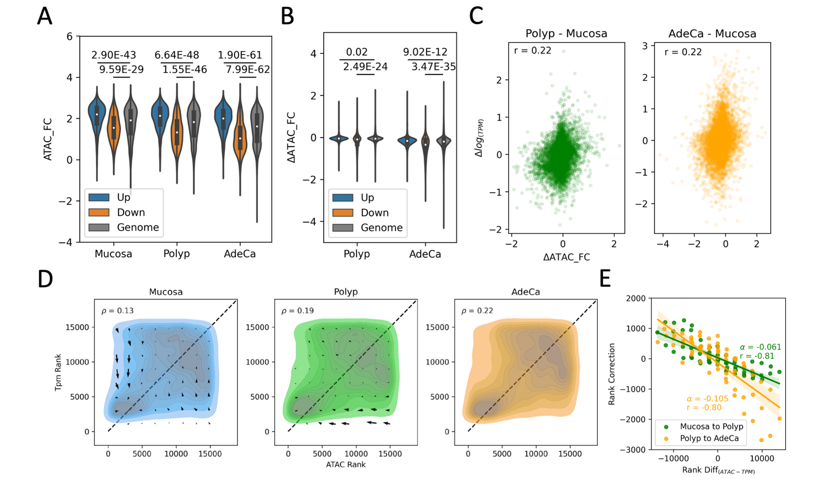
Figure S8 Association between differential expression and open accessibility. (A) Violin plots showing promoter ATAC seq peak strengths (log fold change) and (B) changes in polyps and adenocarcinoma for up- and down-regulated genes. Significance of differential distribution compared to the genome was examined with the two-sided t test. (C) Scatter plots showing genome-wide association between ATAC peak alteration and differential gene expression in polyps (N = 14,805) and adenocarcinoma (N = 14,672). Pearson correlation r is indicated. (D) KDE plot comparing expression and ATAC peak ranks for all genes (N = 15,626). Spearman correlation ρ for each stage is indicated. Quiver matrices indicate average directionalities of rank shifts in the next stage for genes at each arrow position. Dashed lines indicate equal ranking. (E) Comparison between rank difference (y - x) for the quivers indicated in (D) versus their net rank correction (Δy - Δx) in the next stage. Correlation was estimated with first order linear regression, with coefficient alpha and Pearson coefficient r indicated.

