Supplementary material for
Social media use among the least influential factors in adolescent mental health: Results from a panel network analysis

Table S1.

Intracluster correlation coefficients of indicators
Indicators | Females | Males
Social media use | 0.00 | 0.26
Close friends | 0.07 | 0.00
Lack of family support | 0.05 | 0.01
Restless | 0.08 | 0.22
Somatic | 0.12 | 0.09
Withdrawn | 0.17 | 0.21
Worried | 0.00 | 0.16
Unhappy | 0.09 | 0.09
Concentration | 0.14 | 0.00
Nervous | 0.05 | 0.09
Bullied | 0.01 | 0.00
School work dissatisfaction | 0.02 | 0.07
Appearance dissatisfaction | 0.07 | 0.00
Family dissatisfaction | 0.00 | 0.15
Friends dissatisfaction | 0.00 | 0.02
School dissatisfaction | 0.00 | 0.12
Life dissatisfaction | 0.07 | 0.06

Table S1.

Intracluster correlation coefficients of indicators for networks without covariates
Indicators | Females | Males
Social media use | 0.00 | 0.00
Close friends | 0.08 | 0.14
Lack of family support | 0.04 | 0.00
Restless | 0.07 | 0.22
Somatic | 0.06 | 0.06
Withdrawn | 0.06 | 0.20
Worried | 0.00 | 0.12
Unhappy | 0.08 | 0.08
Concentration | 0.10 | 0.00
Nervous | 0.14 | 0.17
Bullied | 0.00 | 0.00
School work dissatisfaction | 0.00 | 0.00
Appearance dissatisfaction | 0.08 | 0.05
Family dissatisfaction | 0.02 | 0.06
Friends dissatisfaction | 0.00 | 0.00
School dissatisfaction | 0.00 | 0.00
Life dissatisfaction | 0.00 | 0.07

Figure S1. Contemporaneous (average within-lag) network with no covariates.

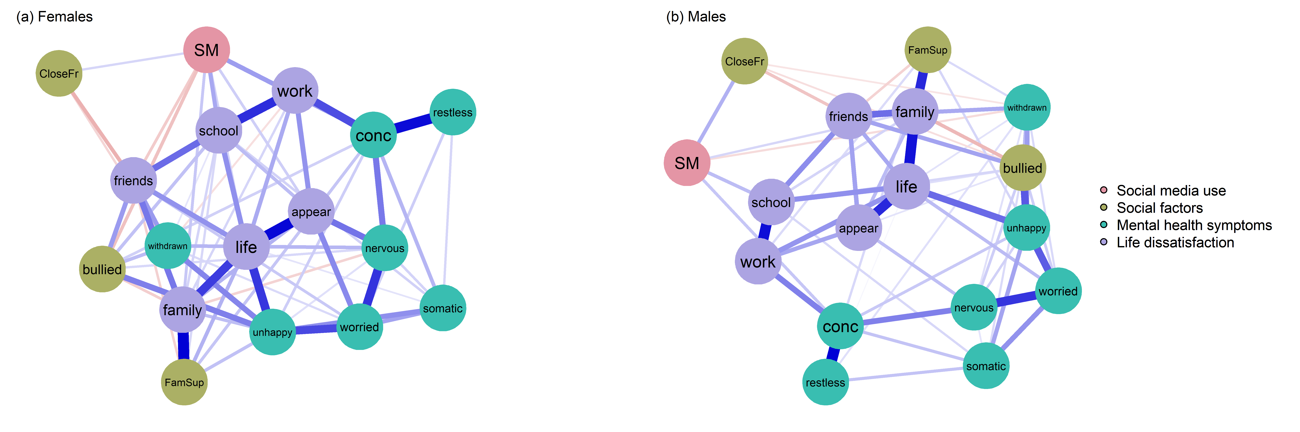

Note. Edges = partial correlations. Blue edges = positive associations; red edges = negative associations. The thicker the edges, the stronger the correlation. Higher scores on all nodes = more negative outcomes. Higher scores on CloseFr = more close friends.

Figure S2. Temporal (directed) network.

Note. Arrowed edges = directed partial correlations; curved arrows = autoregressions. Blue edges = positive associations; red edges = negative associations. The thicker the edges, the stronger the correlation. Higher scores on all nodes = more negative outcomes. Higher scores on CloseFr = more close friends.

Figure S3. Between network with no covariates.

Note. Edges = partial correlations. Blue edges = positive associations; red edges = negative associations. The thicker the edges, the stronger the correlation. Higher scores on all nodes = more negative outcomes. Higher scores on CloseFr = more close friends.

Figure S4. The (a) outgoing and (b) ingoing expected influence of the temporal network (with no covariates) for females and males by factor.

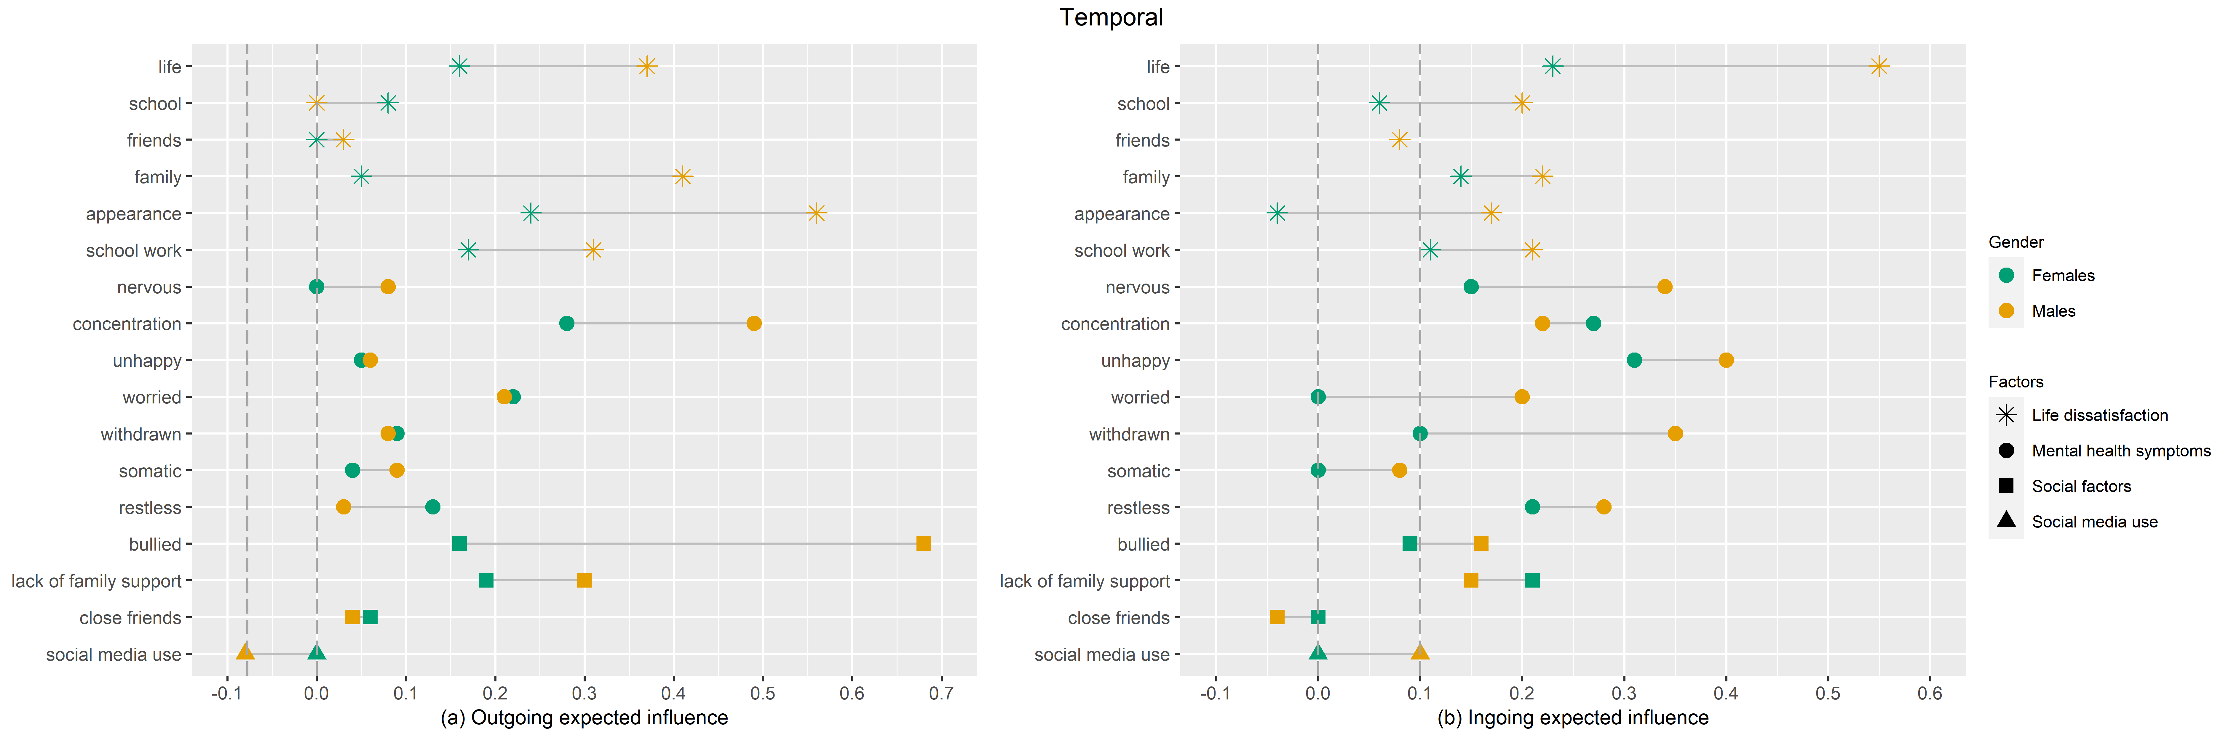

Note. The dashed vertical lines represent the expected influence of social media use.

