Appendix 1 - Directed acyclic graph of the exposure, confounders and outcomes in the study.
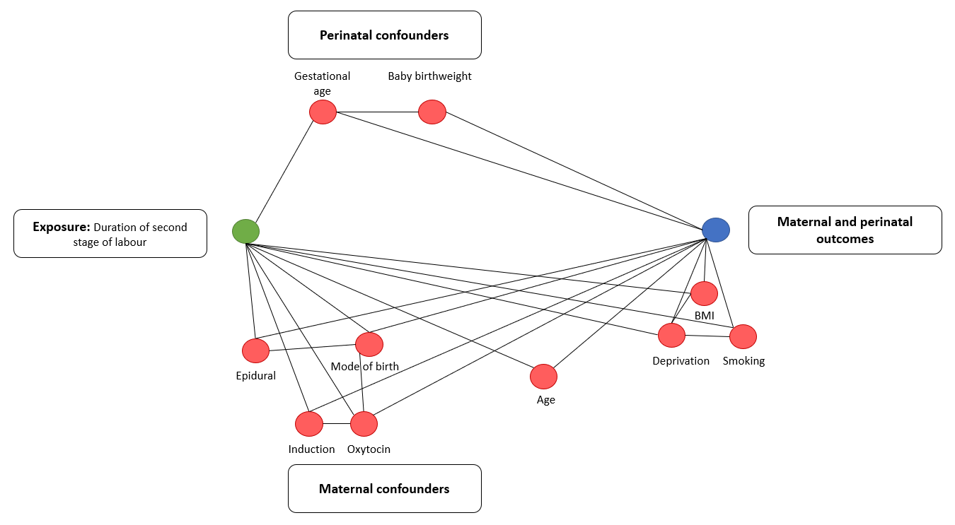

Appendix 2 – Count and proportion of adverse outcomes by hourly intervals of 2nd stage duration in nulliparous women
 |  | <3  (n=19359) |  | 3-4  (n=2898) |  | 4-5  (n=1749) |  | 4-5  (n=950) |  | >6  (n=346)
 |  | n | % | n | % | n | % | n | % | n | %
OASI |  | 1079 | 5.6 | 237 | 8.2 | 198 | 11.3 | 122 | 12.8 | 46 | 13.3
Episiotomy |  | 5565 | 28.7 | 1439 | 49.7 | 968 | 55.3 | 526 | 55.4 | 183 | 47.1
Mode of birth | SVD | 13282 | 80.1 | 803 | 33.5 | 319 | 20.6 | 66 | 7.3 | 21 | 6.4
 | Forceps | 2800 | 16.9 | 1228 | 51.3 | 1033 | 66.6 | 695 | 77.5 | 221 | 66.7
 | Caesarean | 19 | 0.1 | 0 | 0.0 | 0 | 0.0 | 0 | 0.0 | 0 | 0.0
 | Assisted breech | 474 | 2.9 | 365 | 15.2 | 200 | 12.9 | 137 | 15.2 | 88 | 26.7
PPH |  | 3801 | 19.6 | 1015 | 35.0 | 810 | 46.3 | 500 | 52.6 | 155 | 44.8
Admission to NICU |  | 2048 | 8.0 | 64 | 12.4 | 17 | 8.0 | 9 | 11.4 | 3 | 9.7

Appendix 3 – Count and proportion of adverse outcomes by hourly intervals of 2nd stage duration in parous women
 |  | <2 |  | 2-3 |  | 3-4  (n=516) |  | 4-5  (n=210) |  | 5-6  (n=82) |  | >6  (n=31)
 |  | n | % | n | % | n | % | n | % | n | % | n | %
OASI |  | 358 | 1.5 | 38 | 3.5 | 20 | 3.8 | 13 | 6.1 | 6 | 7.3 | 4 | 12.5
Episiotomy |  | 1541 | 6.3 | 340 | 31.4 | 225 | 42.5 | 113 | 52.8 | 44 | 53.7 | 17 | 53.1
Mode of birth | SVD | 23100 | 97.2 | 558 | 66.2 | 158 | 35.3 | 29 | 15.3 | 12 | 15.6 | 3 | 9.4
 | Forceps | 478 | 2.0 | 226 | 26.8 | 221 | 49.3 | 136 | 72.0 | 51 | 66.2 | 25 | 78.1
 | Caesarean | 122 | 0.5 | 59 | 7.0 | 69 | 15.4 | 24 | 12.7 | 14 | 18.2 | 4 | 12.5
 | Assisted breech | 73 | 0.3 | 0 | 0.0 | 0 | 0.0 | 0 | 0.0 | 0 | 0.0 | 0 | 0.0
PPH |  | 2294 | 9.4 | 257 | 23.8 | 173 | 32.6 | 83 | 38.8 | 39 | 47.6 | 11 | 34.4
Admission to NICU |  | 1948 | 8.0 | 99 | 9.2 | 65 | 12.3 | 17 | 7.9 | 8 | 10.0 | 4 | 12.5

Appendix 4 - Flowchart of the population included in the study
