Table 1. Standard Protocol Items: Recommendations for Interventional Trials (SPIRIT) figure.
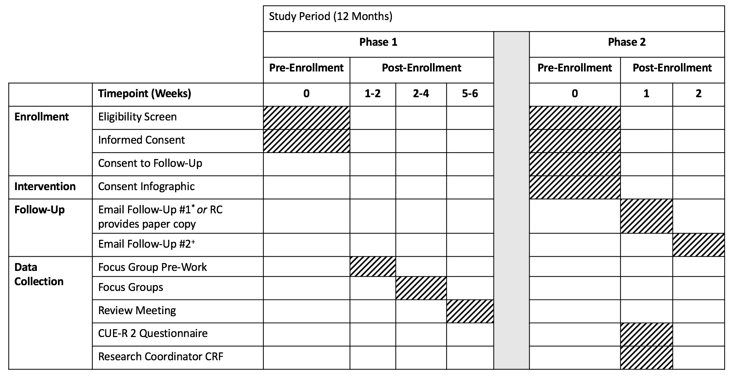
Legend: This table summarizes participant activities for both phases of this study, which will take place over a 12-month period.
* The first email follow-up will be sent to all patients/SDMs who consent to follow-up and will contain an electronic link to the CUE-R 2 questionnaire.
⁺ The second email follow-up will be sent to patients/SDMs who do not complete the CUE-R 2 one week after the initial email was sent.
Abbreviations: CUE-R 2 – Consent Understanding Evaluation-Revised 2 Tool; CRF – Case Report Form.
Table 2. Phase 2 outcome measures, constructs and questions.
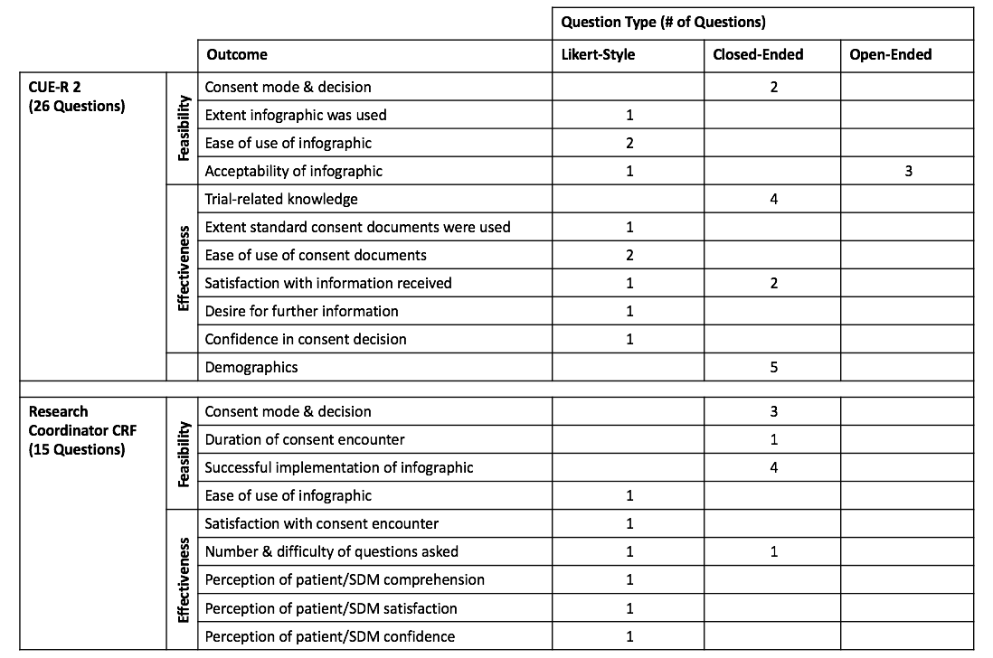
Legend: This table summarizes outcome measures for Phase 2. The CUE-R 2 electronic survey will be completed by patients/SDMs who receive the consent infographic. The Research Coordinator (RC) CRF will be completed electronically by RCs who use the infographic during consent encounters with patients/SDMs.
Abbreviations: CUE-R 2 – Consent Understanding Evaluation-Revised 2 Tool; CRF – Case Report Form.

