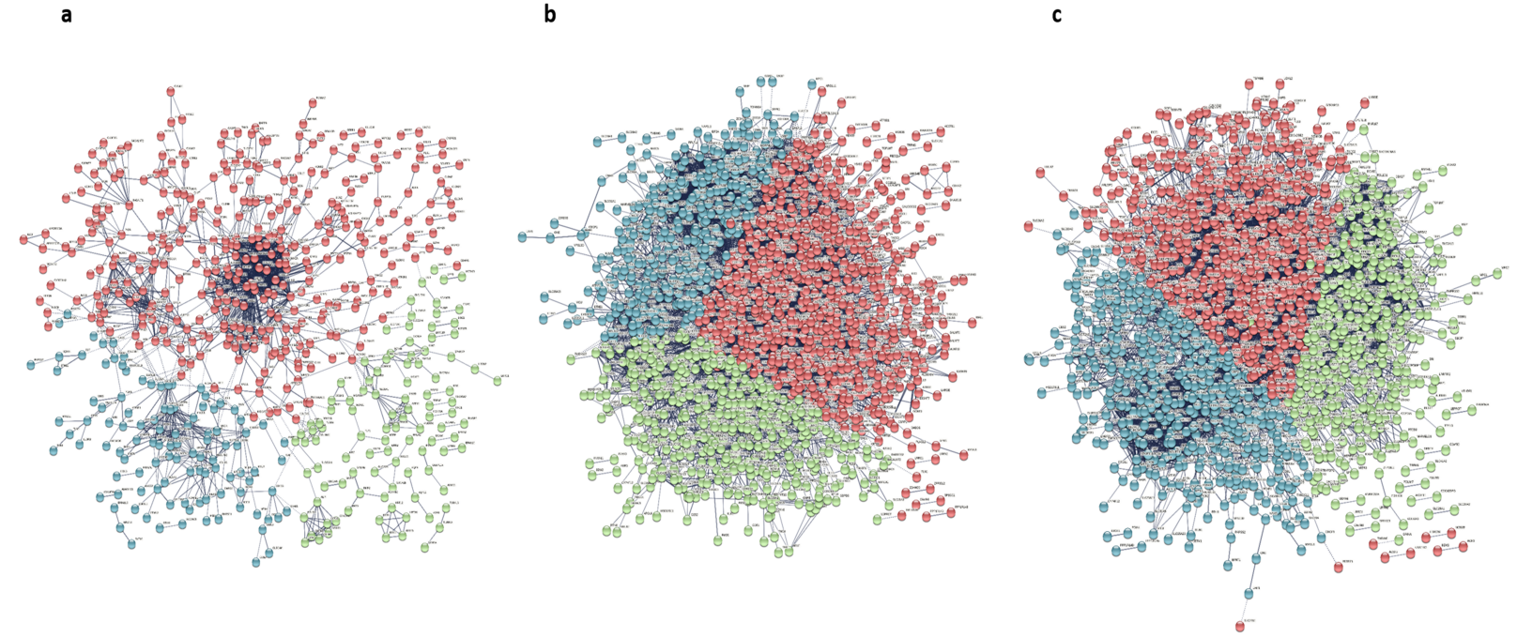
Online Resource 1. The PPI network of DEGs in three groups. (a) The PPI network consisted of 1042 nodes and 4073 edges were constructed by overlapping DEGs in obese group. (b) The PPI network consisted of 1936 nodes and 9328 edges were constructed by overlapping DEGs in non-obese group. (c) The PPI network consisted of 1940 nodes and 11029 edges were constructed by overlapping DEGs in total group. PPI, protein-protein interaction.

