Table 3. Comparison of statistical mixed-effects models fit to the MSEL functional domain scores including age, gender, birth weight, maternal education (MatEd) and with (left column) and without (right column) the myelin content in the common core network. For all domains, myelination was an important contributor (high T-statistic) and the model containing myelination was preferable (lower AIC)
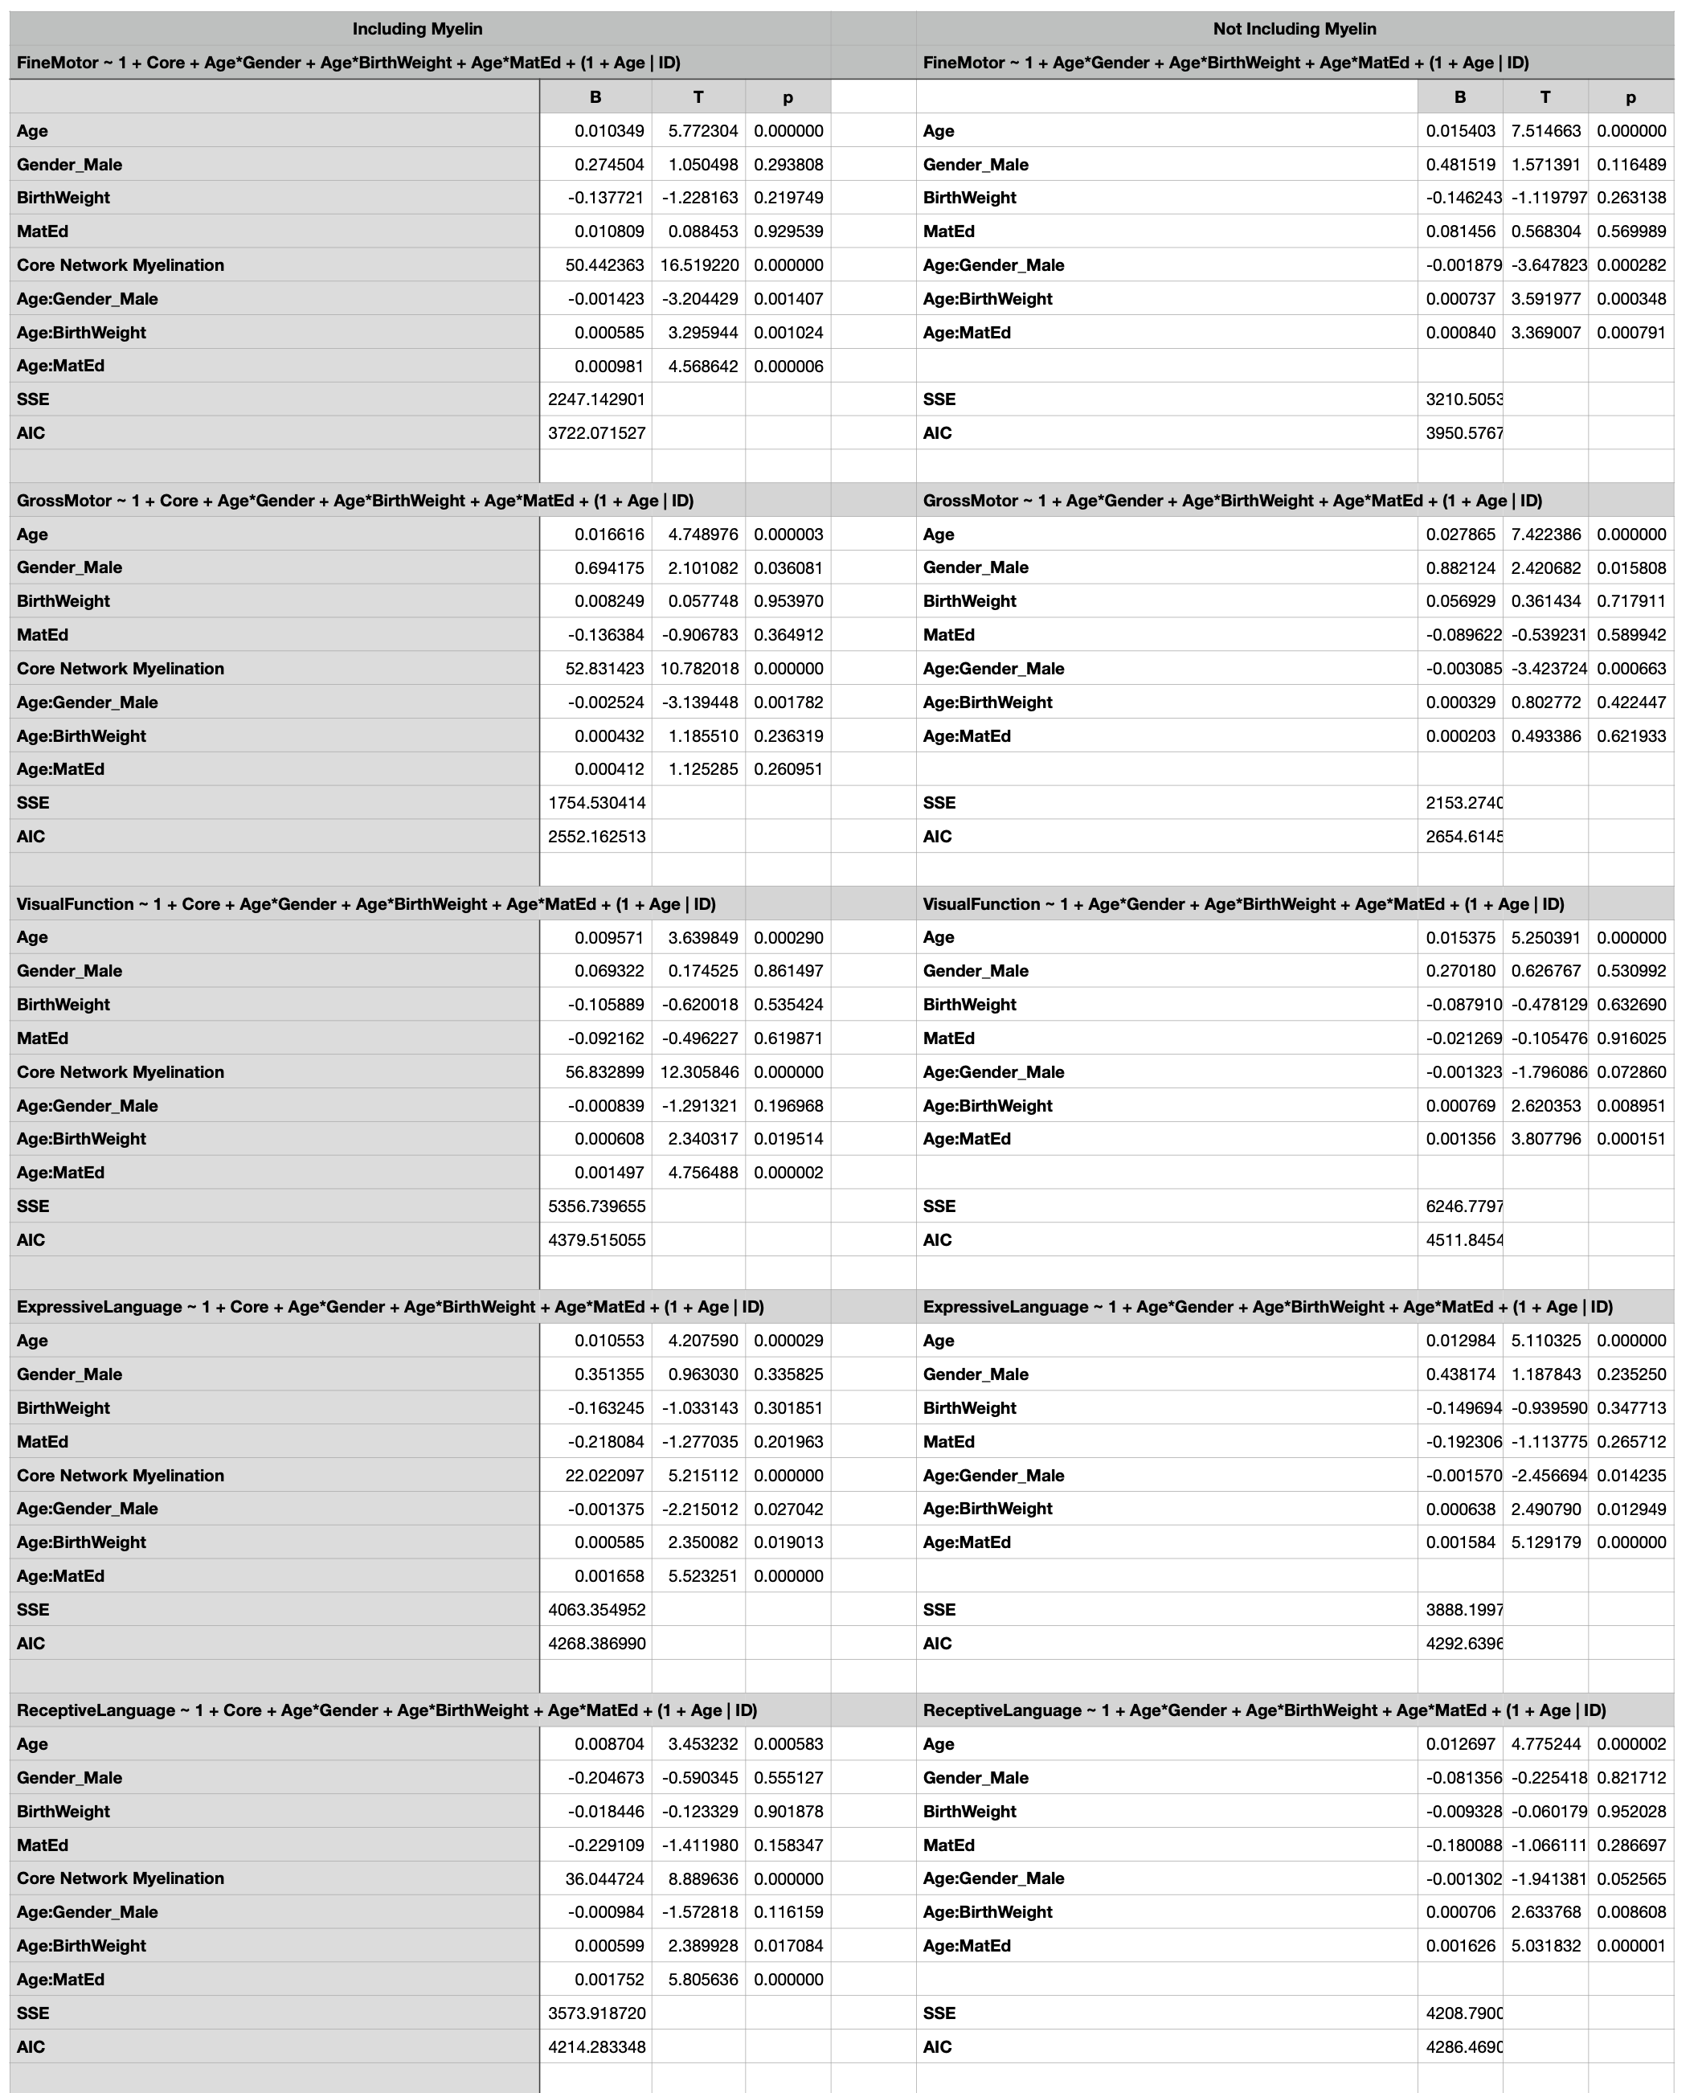
Table 4. Comparison of statistical mixed-effects models fit to the MSEL functional domain scores including age, gender, birth weight, maternal education (MatEd) and with (left column) and without (right column) each network’s specific myelination. For all domains, myelination was an important contributor (high T-statistic) and the model containing myelination was preferable (lower AIC).
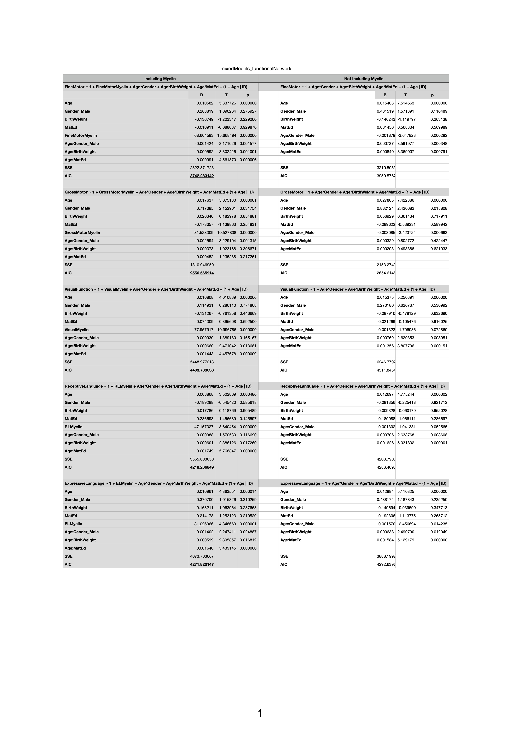
Table 5. Mixed model analysis of the associations between child gender, birth weight, and maternal education level on mean network myelin content. We find no significant effects after correcting for multiple comparisons, however, child birth weight shows a trend towards significance for both core and gross motor network myelination.
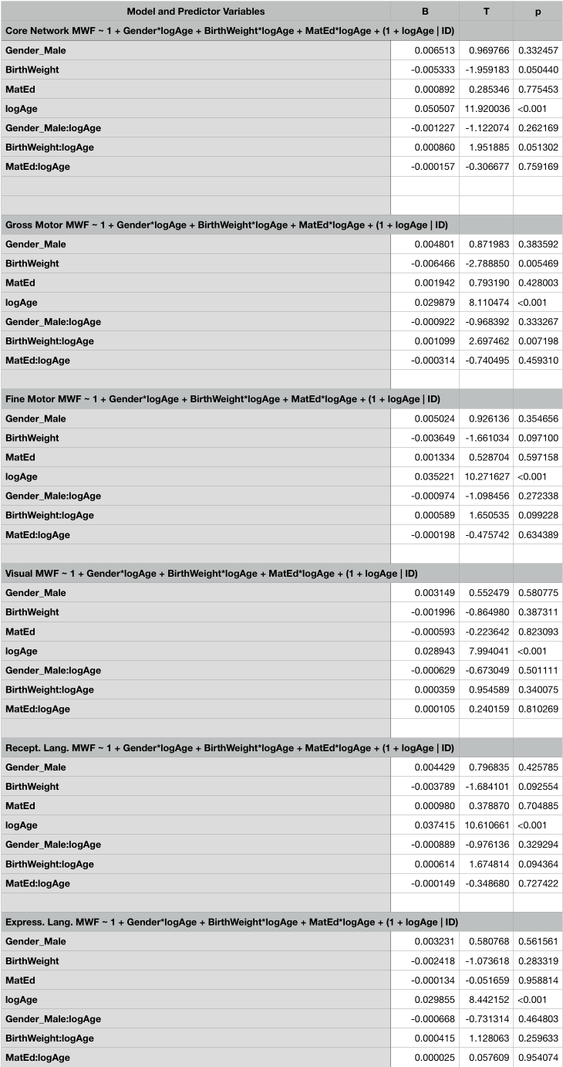
Table 6. Examining the contribution of the core vs. functionally-specific network myelination to cognitive measures. While inclusion of both networks improves upon the model without myelin (Tables 3 and 4), the addition of the functionally-specific network information does not significantly improve the fit over the core network alone.
