Supplementary material 3. Details of statistical analysis.
Analysis of 2nd sample Journal club (JC).

First, we conducted an analysis to identify significant differences between the result of the complex test and parameters using the simple linear regression. We got the unadjusted (crude) results (supplementary table 1).

Supplementary table 1. Single-factor linear regression (crude analysis) of complex test.
Factor | B | 95%CI | p-value | R²
Groups (participants JC) | 1.44 | 0.12; 2.76 | 0.032 | 0.052
Age | -0.17 | -0.28; -0.06 | 0.004 | 0.091
Common roles  - students  - residents  - postgraduate student  - physician  - other | Reference  -0.49  -1.08  -1.12  -1.17 | Reference  -2.12; 1.13  -5.58; 3.43  -2.49; 0.25  -3.08; 0.74 | 0.552  0.637  0.109  0.229 | 0.05
Specific roles  - students 4 years  - students 5 years  - students 6 years  - residents 1 years  - residents 2 years  - postgraduate student 1 years  - postgraduate student 2 years  - postgraduate student 3 years  - physician  - other | Reference  1.68  1.26  0.74  0.86  0.43  -  -3.57  1.93  0.05 | Reference  -0.49; 3.85  -0.56; 3.09  -1.12; 2.59  -1.51; 3.22  -2.09; 2.94  -  -5.1; -2.05  0.25; 3.6  -1.83; 1.94 | 0.129  0.175  0.436  0.477  0.738  -  <0.001  0.024  0.955 | 0.114
Publications in journals | -0.07 | -1.12; 0.97 | 0.889 | <0.001
Participation on journal clubs before our JC | 0.07 | -0.41; 1.83 | 0.215 | 0.02
JC – Journal club, B – standardized coefficient of regression, CI – confidence interval, R² – coefficient of determination.

The results showed that participation in the journal club, age and some of specific roles are significant. Based on our assumptions, we built a directed acyclic graph (DAG), which shows (supplementary figure 1) that the analysis needs to be adjusted. Therefore, a multiple linear regression (supplementary table 2) is used that fixed factors (age, specific roles).

Supplementary figure 1. Directed acyclic graph (DAG) for test.
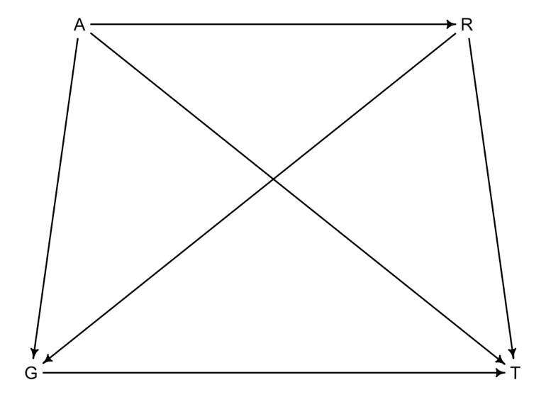
G – Groups (participants or non-participants), T – results of test, A – age, R – roles (common or specific).

Supplementary table 2. Multiple analysis of complex test.
Factor | B | 95%CI | p-value | R²
Groups (participants JC) | 0.95 | -0.5; 2.46 | 0.212 | 0.166
Age | -0.16 | -0.39; 0.03 | 0.077 | 0.166
Specific roles  - students 4 years  - students 5 years  - students 6 years  - residents 1 years  - residents 2 years  - postgraduate student 1 years  - postgraduate student 2 years  - postgraduate student 3 years  - physician  - other | Reference  0.49  0.16  -0.1  0.45  0.19  -  -3.37  1.73  0.58 | Reference  -0.49; 3.85  -0.56; 3.09  -1.12; 2.59  -1.51; 3.22  -2.09; 2.94  -  -5.1; -2.05  0.25; 3.6  -1.83; 1.94 | 0.718  0.897  0.93  0.743  0.893  -  <0.001  0.102  0.577 | 0.166
JC – Journal club, B – standardized coefficient of regression, CI – confidence interval, R² – coefficient of determination.

Thus, we found that there is no association between the participation in the journal club and the results of Complex test after age and specific roles adjusted. We think that a significant result in the category «postgraduate student 3 years» should not be taken into account since there is only one observation in this group. If we take into account the common roles, then the age is not adjusted (-0.18, 95% CI -0.36; -0.01, p=0,025), the confidence interval is borderline and the coefficient of determination (R²=0.118) is lower.

Analysis of 3rd sample Journal club (JC).

Just as for the 2 sample, we conducted an analysis to identify significant differences between the result of the modified SPLIT test and parameters using the simple linear regression. Supplementary table 3 shows the unadjusted (crude) results.

Supplementary table 3. Single-factor linear regression (crude analysis) of modified SPLIT test.
Factor | B | 95%CI | p-value | R²
Groups (participants JC) | -0.68 | -2.1; 0.74 | 0.347 | 0.015
Age | 0.09 | -0.11; -0.3 | 0.376 | 0.011
Common roles  - students  - residents  - postgraduate student  - physician  - other | Reference  0.05  -  -1.12  2.21 | Reference  -1.68; 1.77  -  -2.7; 0.46  0.65; 3.77 | 0.959  -  0.165  0.005 | 0.107
Specific roles  - students 4 years  - students 5 years  - students 6 years  - residents 1 years  - residents 2 years  - postgraduate student 1 years  - postgraduate student 2 years  - postgraduate student 3 years  - physician  - other | Reference  -2.14  -1.0  -2.78  -3.0  -1.57  -  -  -  -3.33 | Reference  -4.28; <-0.01  -3.48; 1.48  -4.53; -1.02  -5.19; -0.81  -4.07; 0.93  -  -  -  -5.19; -1.48 | 0.049  0.429  0.002  0.007  0.218  -  -  -  <0.001 | 0.164
Publications in journals | -0.71 | -1.97; 0.55 | 0.268 | 0.019
Participation on journal clubs before our JC | -0.17 | -1.45; 1.11 | 0.792 | 0.001
JC – Journal club, B – standardized coefficient of regression, CI – confidence interval, R² – coefficient of determination.
We decided to carry out multiple linear regression with to fixation by age and role, because the parameters for evaluation remained the same and the DAG scheme (figure 1) did not change (from complex test to modified SPLIT test). Significant results were found in the single-factor analysis in the categories of common and specific roles. We show the result of the adjusted model (age and specific roles) in supplementary table 4.

Supplementary table 4. Multiple analysis of modified SPLIT test with specific roles.
Factor | B | 95%CI | p-value | R²
Groups (participants JC) | -0.41 | -1.9; 1.09 | 0.595 | 0.22
Age | 0,28 | 0.05; 0.5 | 0.017 | 0.22
Specific roles  - students 4 years  - students 5 years  - students 6 years  - residents 1 years  - residents 2 years  - postgraduate student 1 years  - postgraduate student 2 years  - postgraduate student 3 years  - physician  - other | Reference  -0.93  0.27  -1.66  -2.79  -1.29  -  -  -  -3.62 | Reference  -3.31; 1.44  -2.42; 2.95  -3.71; 0.4  -4.77; -0.81  -3.7; 1.12  -  -  -  -5.5; -1.74 | 0.44  0.846  0.114  0.006  0.295  -  -  -  <0.001 | 0.22
JC – Journal club, B – standardized coefficient of regression, CI – confidence interval, R² – coefficient of determination.

It can be seen that participation in the journal club does not affect the results of modified SPLIT test. But age and categories of specific roles have a significant impact. We decided to build a 3D-graph using the package «plotly» (Supplementary 4). A minor trend in age is visible, but due to the low coefficient of determination (R²), we think that this statistically significant result does not reflect the causal effect.

