Supplementary material. Tests of evidence-based medicine and statistics.
Complex test for 2nd sample

USMLE sample test questions step1 2020 (1 point for each answer)

№1. A study is designed to evaluate the feasibility of acupuncture in children with chronic headaches. Sixty children with chronic headaches are recruited for the study. In addition to their usual therapy, all children are treated with acupuncture three times a week for 2 months. Which of the following best describes this study design?
A. Case-control
B. Case series
C. Randomized clinical trial

№2. A placebo-controlled clinical trial is conducted to assess whether a new antihypertensive drug is more effective than standard therapy. A total of 5000 patients with essential hypertension are enrolled and randomly assigned to one of two groups: 2500 patients receive the new drug and 2500 patients receive placebo. If the alpha is set at 0.01 instead of 0.05, which of the following is the most likely result?
A. Significant findings can be reported with greater confidence
B. The study will have more power
C. There is a decreased likelihood of a Type II error
D. There is an increased likelihood of a Type I error

Fresno Test of Evidence Based Medicine

Clinical scenarios: «You have just seen Lydia who recently delivered a healthy baby. She plans to breastfeed, but also wants to start oral contraception. You generally prefer to prescribe combination oral contraceptives (estrogen + progesterone) but you have been told that these might more negatively affect her breastmilk production than progesterone only pills»

№3. Write a focused clinical question for each of these patient encounters that will help you organize a search of the clinical literature for an answer and choose the best article from among those you find.
Answer: 1 point for a PICO question (else 0)

№4. Where might clinicians go to find an answer to questions like these? Name as many possible types or categories of information sources as you can.
Answer: 6 points for 4 different types of sources (databases of original research, journals, textbook, systematic reviews, professional medical guidelines, synthesized summaries, medical website, General internet search or people), 4 for 3, 2 for 2 (else 0)

«Design and Interpretation of Clinical Trials course» Coursera platform (1 point for each answer)

№ 5. True or False: The purpose of a non-inferiority trial is to determine whether a new treatment is at least as effective as an already established treatment.
True

№6. True or False: In an adaptive design, adaptations are not specified in the protocol in order to allow investigators maximum flexibility for adjusting study parameters throughout the trial.
False
Modified SPLIT test (1 point for each answer)

№1. To increase study power, one should increase:
A. Sample size
B. P value
C. Statistical test power
D. Internal validity of research
E. Specificity

№2. Why isn't arithmetic mean a representative measure of central tendency in a skewed distribution?
A. Because a skewed distribution does not have a measure of central tendency.
B. Because it is difficult to present graphically.
C. Because skewed distribution cannot be mathematically defined.
D. Because a single extreme result can significantly alter the mean.
E. Because calculating arithmetic mean includes squaring, which in case of skewed distribution disproportionally increases extreme values.

№3. Why does a randomised controlled trial (RCT) provide better quality of evidence than a cohort study?
A. RCT has a control group, and a cohort study does not.
B. RCT has balanced group sizes, and a cohort study does not.
C. RCT is cheaper than a cohort study.
D. RCT is shorter in duration than a cohort study.
E. RCT controls exposure to investigated factor, and a cohort study does not.

№4. The guideline for reporting cohort study results is called:
A. COCHRANE.
B. PRISMA.
C. STARD.
D. CONSORT.
E. STROBE.

№5. You want to search databases for information on breast cancer. Searching the key word «breast» retrieved 4200 articles, and key word «cancer» retrieved 34150 articles. Which of the following statements is correct?
A. Using those two key words and the operator AND will retrieve 38150 articles.
B. By using the operator OR to combine «breast» and «cancer» will retrieve at least 4200 articles.
C. Search strategy «breast NOT cancer» will retrieve more than 4200 articles.
D. Search strategy «cancer NOT breast» will retrieve 34150 articles.
E. By using the operator OR you will get fewer than 4200 articles.

№6. Prevalence of disease in a population is best determined by:
A. Randomized controlled trial (RCT).
B. Cohort study.
C. Cross-sectional study.
D. Qualitative study.
E. Retrospective study.

№7. Prevalence of headache in one year on a sample of Split-Dalmatia County citizens was measured, and these are the results:

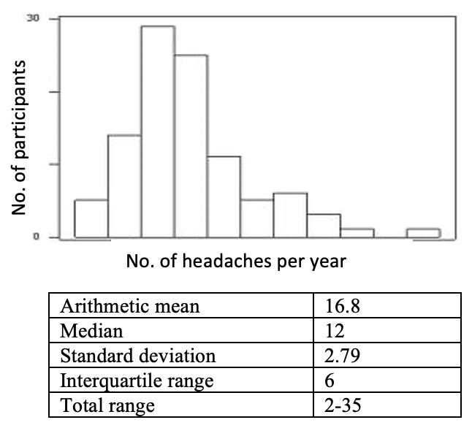

Which measures should be used to describe the sample?
A. Arithmetic mean and standard deviation (M=16.8, SD=2.79).
B. Median and interquartile range (Md=12, IQR=6).
C. Arithmetic mean and total range (M=16.8 and total range 2-35).
D. All of 5 listed measures, depending on statistical test being used.
E. Median and standard deviation (Md=12, SD=2.79).

№8. The proportion of true negative results of a diagnostic test in the total number of healthy participants is called:
A. Positive predictive value.
B. Precision.
C. Negative predictive value.
D. Specificity.
E. Sensitivity.

№9. A new treatment for social anxiety was investigated and it provided normal everyday functioning in 20% of the patients, compared to 10% of the patients who were treated by standard treatment. How many patients should be included in the new program to assure that one of them achieves normal everyday functioning?
A. 2.
B. 5.
C. 20.
D. 10.
E. 15.

№10. A study of relation between consumption of black tea and weight loss in overweight participants gave the following results: group that consumed black tea for six months lost an average of 328 g (95% CI 125 – 922 g), and the group that did not lost an average of 121 g (95% CI 50 – 211 g). What conclusions can you draw from this research?
A. Black tea helped in reducing bodyweight for an average of 207 g.
B. Black tea helped in reducing bodyweight, but the result is not statistically significant.
C. Black tea helped in reducing bodyweight and the result is statistically significant.
D. We cannot make conclusions about efficacy of black tea from available data.
E. Black tea did not help in reducing bodyweight.

№11. While investigating a possible connection between marijuana smoking and lung cancer, it was found that the number of participants who smoked marijuana was significantly higher in the group who had lung cancer than the healthy control group (OR=1.3, 95% CI 1.1-1.7). Correct interpretation of this result is:
A. Subjects who smoke marijuana are 10-70% less likely to get lung cancer.
B. Subjects who smoke marijuana are 30% more likely to get lung cancer.
C. Subjects who smoke marijuana are 30% less likely to get lung cancer.
D. There is no association between marijuana smoking and lung cancer.
E. No conclusion can be made on the association between marijuana smoking and lung cancer.

№12. A conclusion that participants exposed to a factor A had lower incidence of disease was made out of:
A. Cross-sectional study.
B. Cohort study.
C. Diagnostic study.
D. Physiological study.
E. Case-control study.

№13. The result of a case-control study is expressed as:
A. Odds ratio.
B. Prevalence.
C. Absolute risk reduction.
D. Relative risk.
E. Positive predictive value.

№14. Complete the summary with a conclusion.
Introduction: To investigate if acute fear can actually «freeze the blood in your veins», researchers recruited 24 healthy volunteers (under 30 years).
Methods: Via random selection, 14 of the volunteers were sorted into a group that watched a horror movie before watching a documentary, and the remaining 10 volunteers watched the movies in reverse order. The movies were about 90 minutes long each and the volunteers watched them 7 days apart. Primary outcome was blood levels of coagulation factor VIII. Secondary outcome was participants’ own experience of fear while watching the movies.
Results: Results show that, after watching the horror movie, mean difference in perceived fear was 5.4 units (95% CI 4.7-6.1) on a visual analogue scale (VAS), and blood levels of coagulation factor VII were significantly increased (mean difference 11.1 IU/dL (111 IU/L), 95% CI 1.2-21.0 IU/dL).

Conclusion is the following:
A. There was a statistically significant difference in levels of coagulation factor VIII after watching the documentary.
B. We cannot conclude with certainty, but the results indicate that horror movies increase blood levels of coagulation factor VII.
C. There is not enough evidence to conclude that horror movies affect blood levels of coagulation factor VIII.
D. Fear can actually «freeze the blood in your veins».
E. There was a statistically significant increase of coagulation factor, but not of perceived fear.

№15. You want to find the article that described the study mentioned above. What combination of key words would you choose to find the exact same article?
A. Healthy volunteers, documentary/horror movie, factor VIII.
B. Healthy volunteers, factor VIII, visual analogue scale, horror movie.
C. Healthy volunteers, horror movie, visual analogue scale, factor VIII.
D. Healthy volunteers, horror movie, documentary, factor VIII.
E. Horror movie, documentary, visual analogue scale, factor VIII.

