Supplementary material

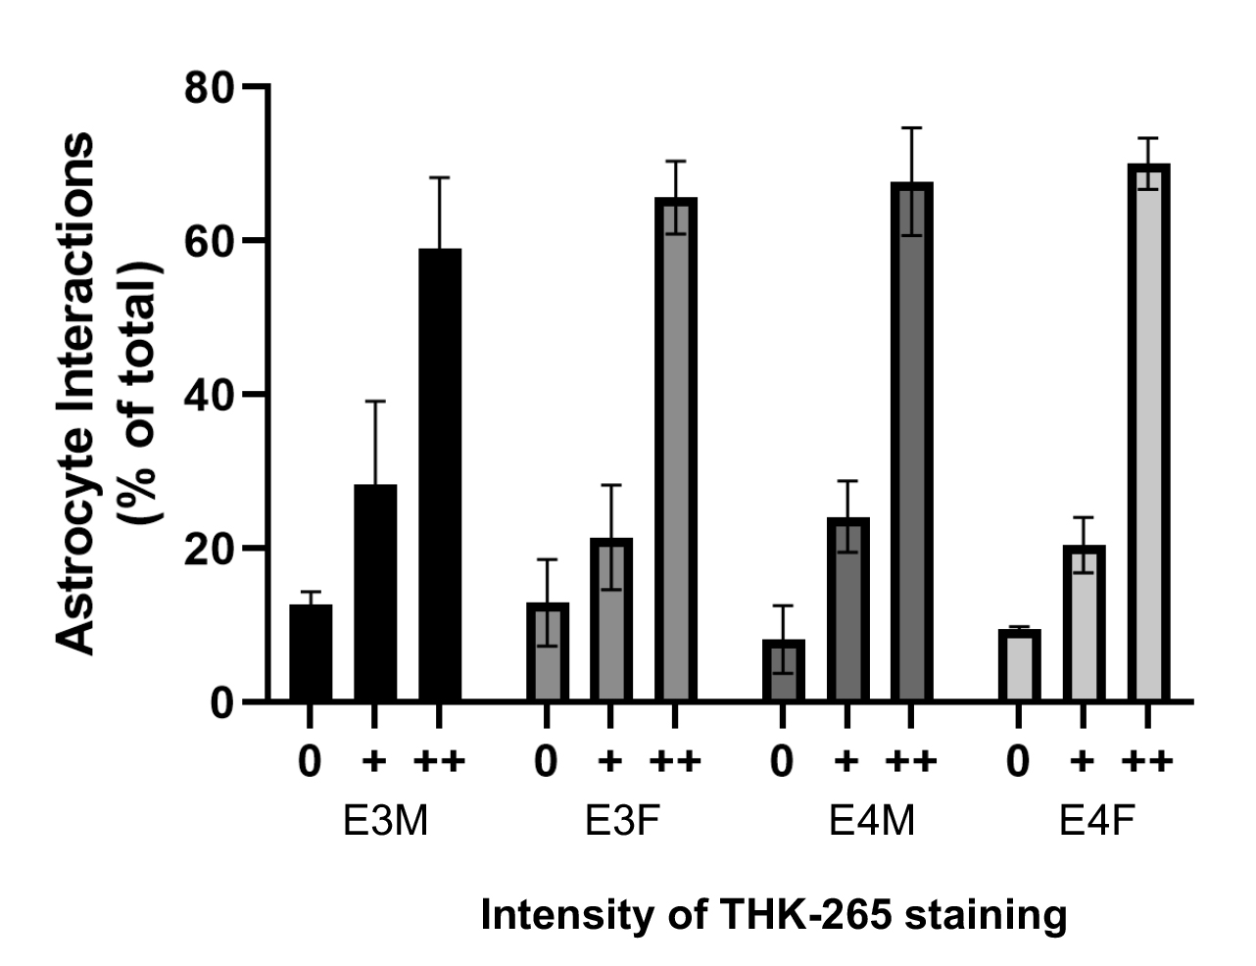

Supplementary Figure 1. Astrocytes colocalize with amyloid plaques across APOE genotypes and sex. Plaques from EFAD mice (n=3 per group; age 6 months) were immunolabeled for Aβ (MOAB-2) and astrocytes (GFAP), then stained with the amyloid dye THK-265. Aβ plaques (n=20 per brain) were scored for (i) the presence or absence of colocalized GFAP-labeled cells or processes, and (ii) the intensity of THK-265 labeling: absent (0), positive but weak (+), or strongly positive (++). Data show percentage (+SEM) of total plaques with colocalized astrocyte stratified according to THK-265 staining intensity in male (E3M) and female (E3F) E3FAD and male (E4M) and female (E4F) E4FAD mice. There was a main effect of THK-265 intensity (F(_{2,30}) = 105.4, p < 0.0001) but not APOE genotype (F(_{1,30}) = 0.1, p = 0.99) and no interaction (F(_{2,30}) = 0.9, p = 0.42) by two-way ANOVA.

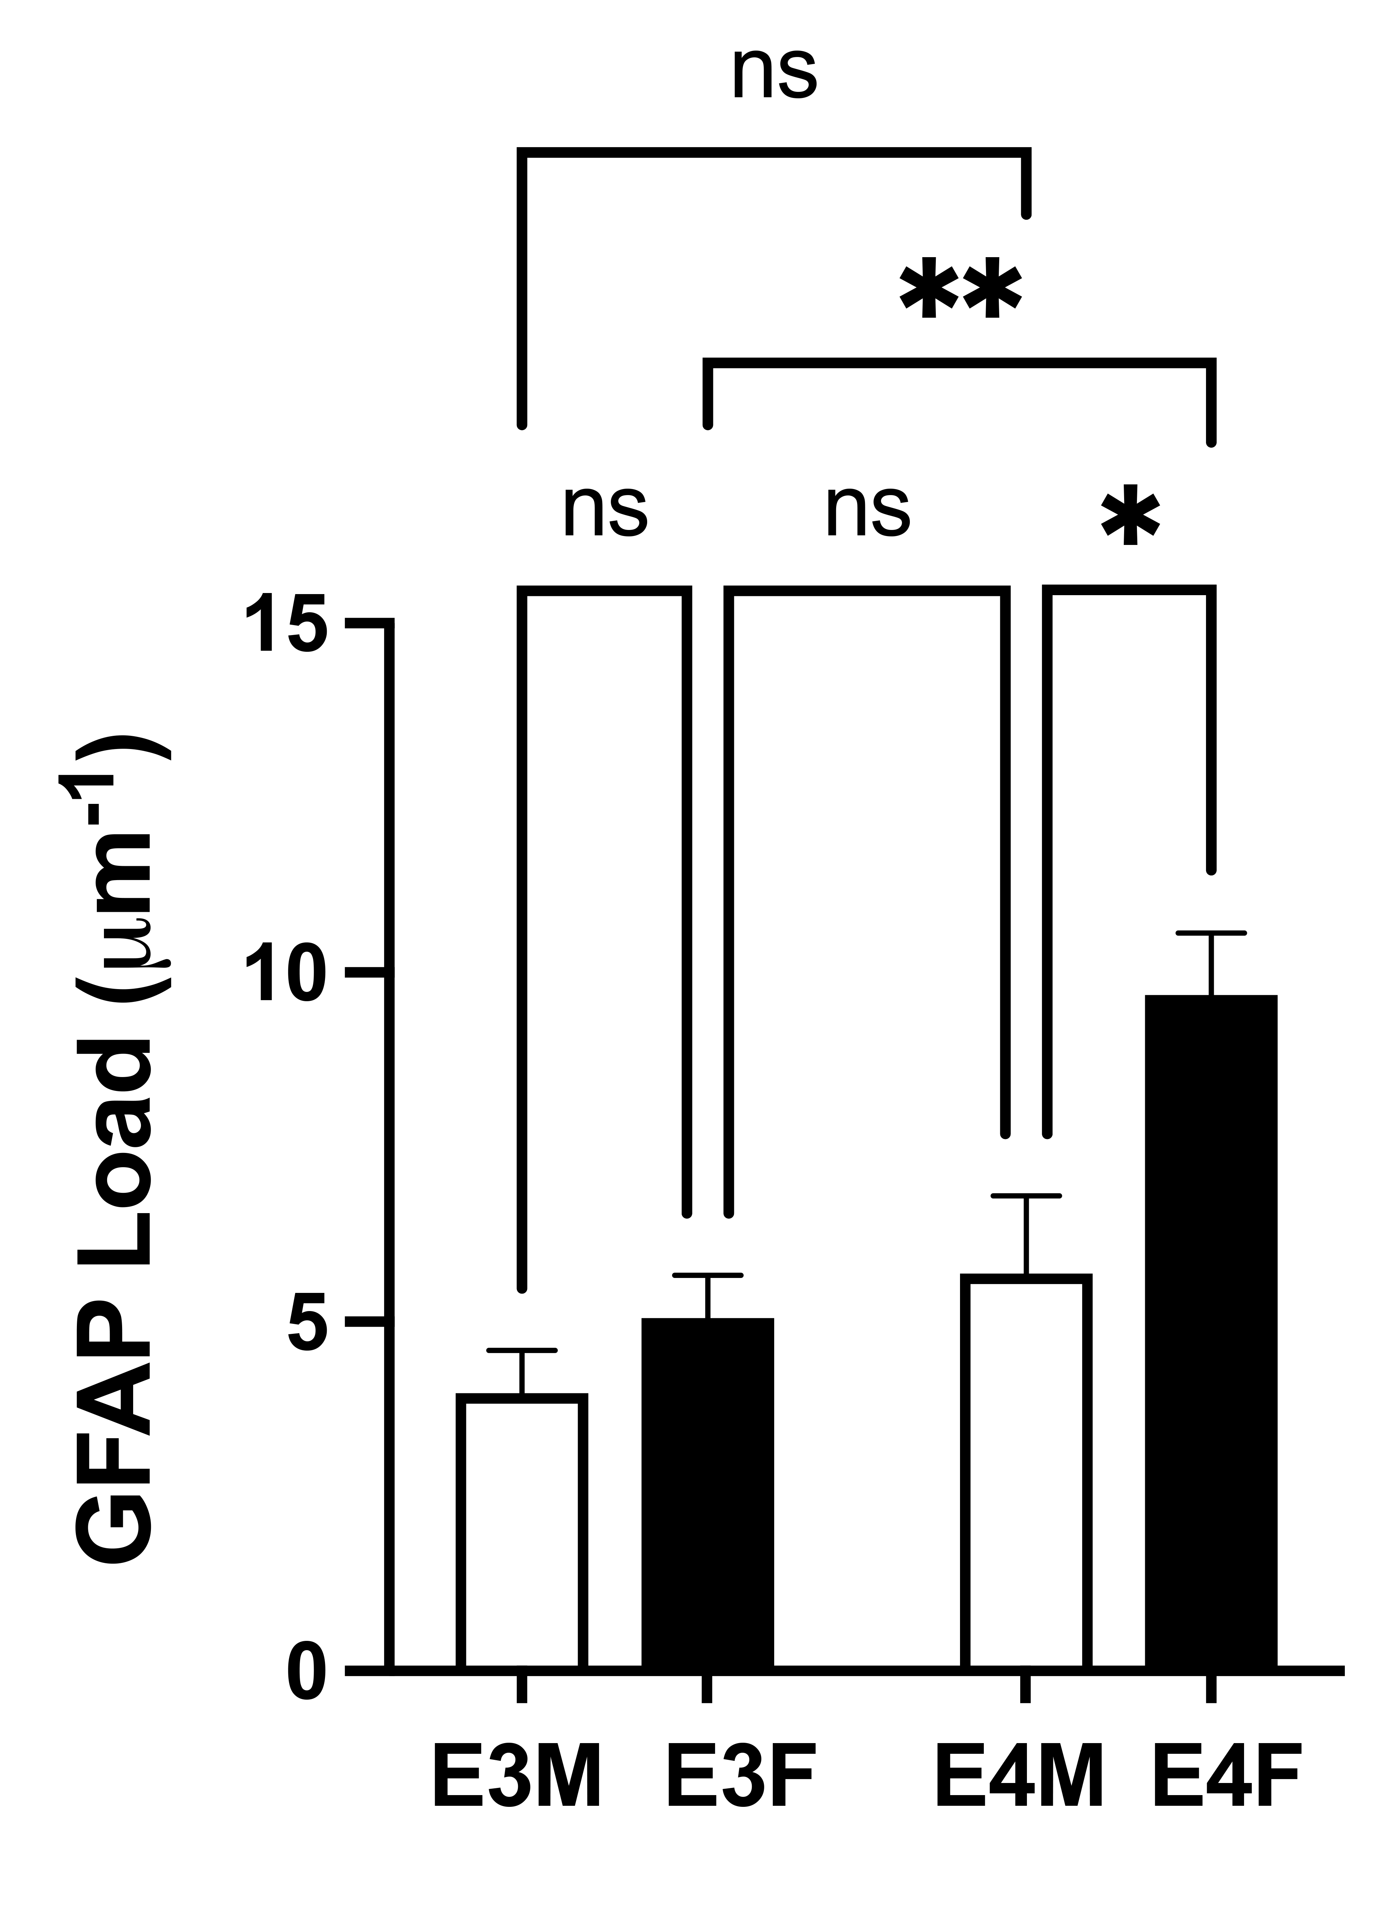

Supplementary Figure 2. Astrocyte immunoreactive load varies across APOE genotypes and sex. Confocal images of GFAP immunolabeling were converted to 8-bit grayscale and thresholded at a constant value using NIH ImageJ software to yield binary images of positive and negative labeling, as previously described (Stephen et al., 2019). The immunoreactive load was calculated as the percentage of pixels within the entire field with positive labeling. Data show mean levels (+SEM) of GFAP immunoreactive load in male (E3M) and female (E3F) E3FAD and male (E4M) and female (E4F) EFAD mice (n=6/group, age 6 months). There were significant main effects of APOE genotype (F(_{1,34}) = 8.4, p = 0.006) and sex (F(_{1,34}) = 13.2, p = 0.0009) and no interaction (F(_{1,34}) = 1.3, p = 0.1) by two-way ANOVA. * p < 0.05, ** p < 0.01, ns: not significant.

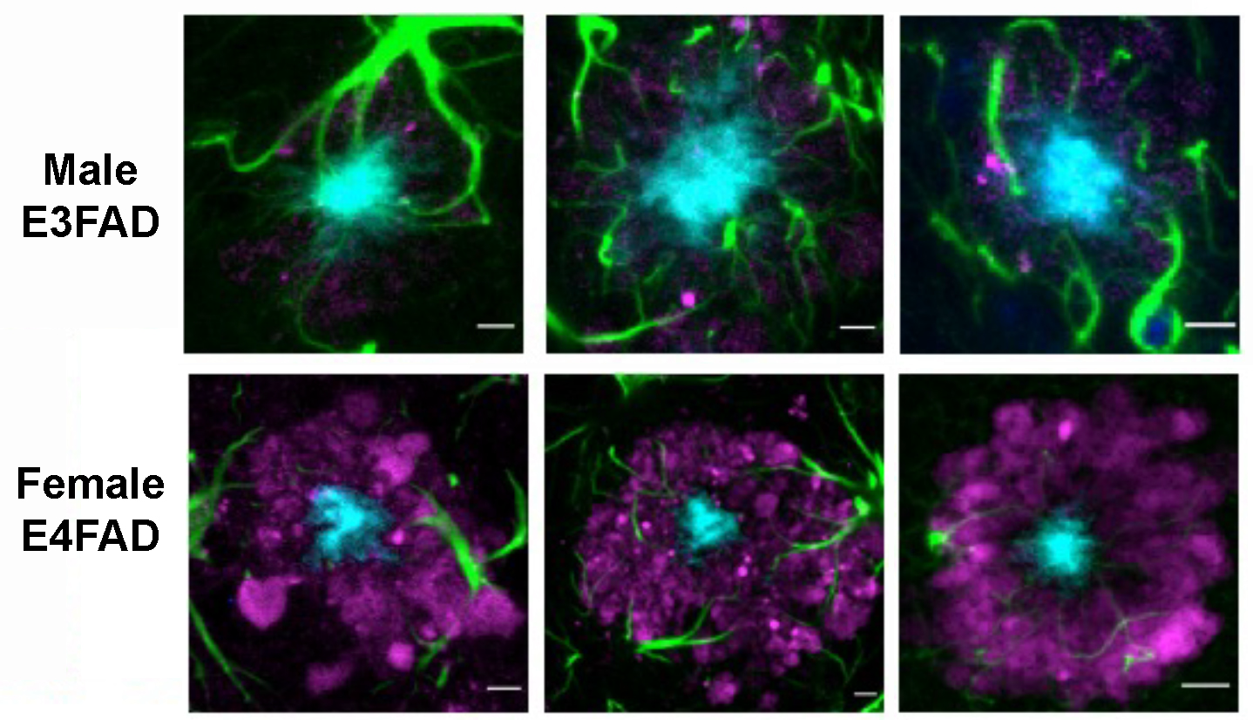

Supplementary Figure 3. Astrocyte immunoreactive load varies across APOE genotypes and sex. Confocal images of THK-265-positive amyloid plaques (cyan), GFAP-immunoreactive astrocytes (green), LAMP1-positive dystrophic neurites (magenta) and cell nuclei labeled with 4’,6-diamidino-2-phenylindole (dark blue) in three different male E3FAD and female E4FAD mice (age 6 months). Scale bars = 5 μm.

