Supplementary material for Equity in vaccine coverage in Uganda
Figure 1: Uganda EPI schedule (2019).
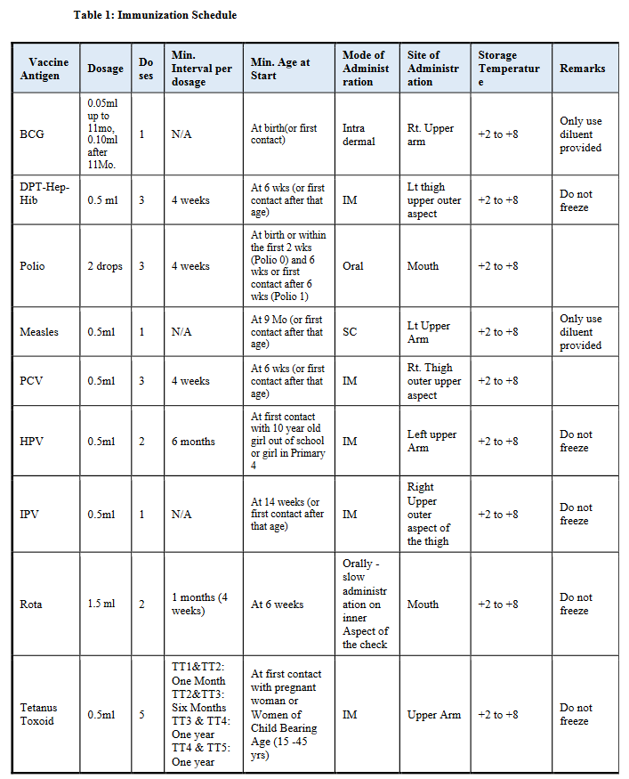
Source: UNEPI https://www.health.go.ug/wp-content/uploads/2019/11/UNEPI-Immunization-guidelines.pdf
Note that PCV was introduced in 2013 in Uganda and the rotavirus vaccine in 2018.
National-level data
Levels of coverage and equity
For the VERSE Equity Toolkit, “coverage” (Variable: Coverage Results) is a measure of effectiveness. In this analysis, coverage refers to vaccine coverage. When the issue of interest is instead a health outcome, this variable represents prevalence, defined as the proportion of the population impacted by the health outcome. For instance, Table 1 shows a 2.2% coverage for ZERO; it means that 2.2% of the children did not receive any vaccine and are considered “zero-dose children”.
The concentration index (CI) and the absolute equity gap (AEG) are measures of equity. A greater concentration index (with or without the Erreyger correction) indicates that the vaccine (or health outcome) coverage is less equitable (regardless of its level). AEG can be interpreted as the deviation in vaccination outcomes between the top and bottom quintiles of the population as ranked by unfair disadvantage such that a greater AEG value indicates less equity. The lower (“Low”) and upper (“High”) boundaries of the 95% confidence interval are displayed in the tables below.
Table 1: National-level coverage data for 2016.
Vaccine or health outcome ¹ | Coverage | Concentration index |  |  |  |  |  |  |  |  | Absolute Equity Gap  Multivariate
Vaccine or health outcome ¹ | Coverage | Wealth only (Wagstaff) ² |  |  | Multivariate (Wagstaff) |  |  | Multivariate (Erreyger) ³
Vaccine or health outcome ¹ | Coverage | Base | Low | High | Base | Low | High | Base | Low | High | Base | Low | High
BCG | 94.2% | -0.071 | -0.084 | -0.058 | 0.020 | 0.017 | 0.023 | 0.077 | 0.074 | 0.080 | 0.098 | 0.082 | 0.114
DPT1 | 92.7% | -0.062 | -0.075 | -0.049 | 0.020 | 0.016 | 0.024 | 0.071 | 0.067 | 0.075 | 0.106 | 0.084 | 0.128
DPT2 | 86.8% | -0.052 | -0.064 | -0.040 | 0.033 | 0.027 | 0.039 | 0.106 | 0.100 | 0.112 | 0.146 | 0.121 | 0.171
DPT3 | 76.8% | -0.042 | -0.053 | -0.031 | 0.054 | 0.046 | 0.062 | 0.150 | 0.142 | 0.158 | 0.183 | 0.154 | 0.212
POLIO1 | 89.7% | -0.058 | -0.070 | -0.046 | 0.023 | 0.018 | 0.028 | 0.077 | 0.072 | 0.082 | 0.107 | 0.083 | 0.131
POLIO2 | 82.5% | -0.051 | -0.063 | -0.039 | 0.039 | 0.032 | 0.046 | 0.120 | 0.113 | 0.127 | 0.153 | 0.126 | 0.180
POLIO3 | 65.9% | -0.048 | -0.059 | -0.037 | 0.071 | 0.061 | 0.081 | 0.169 | 0.159 | 0.179 | 0.185 | 0.154 | 0.216
PCV1 | 81.4% | -0.049 | -0.061 | -0.037 | 0.044 | 0.038 | 0.050 | 0.137 | 0.131 | 0.143 | 0.177 | 0.150 | 0.204
PCV2 | 74.6% | -0.043 | -0.054 | -0.032 | 0.058 | 0.050 | 0.066 | 0.161 | 0.153 | 0.169 | 0.215 | 0.186 | 0.244
PCV3 | 64.1% | -0.035 | -0.046 | -0.024 | 0.071 | 0.061 | 0.081 | 0.164 | 0.154 | 0.174 | 0.197 | 0.166 | 0.228
MCV1 | 82.7% | -0.029 | -0.040 | -0.018 | 0.055 | 0.045 | 0.065 | 0.133 | 0.123 | 0.143 | 0.180 | 0.149 | 0.211
ZERO | 2.2% | -0.078 | -0.091 | -0.065 | 0.425 | 0.341 | 0.509 | 0.022 | -0.062 | 0.106 | 0.027 | 0.019 | 0.035
FULL | 40.8% | -0.043 | -0.054 | -0.032 | 0.110 | 0.096 | 0.124 | 0.181 | 0.167 | 0.195 | 0.230 | 0.199 | 0.261
COMPLETE | 39.0% | -0.044 | -0.063 | -0.025 | 0.140 | 0.114 | 0.166 | 0.218 | 0.192 | 0.244 | 0.267 | 0.214 | 0.320
Notes: ^{1.} ZERO, the child didn’t receive any vaccine by 12 months old; FULL, the child is under 24 months old and is fully immunized for their age; COMPLETE, the child is above 24 months and completed the routine pediatric immunization schedule.
^{2.} Concentration index based on households ranked by socioeconomic status (as defined in the DHS) only.
^{3.} See (1, 2) for details on the Erreyger’s correction.

Table 2: National-level coverage data for 2011.
Vaccine or health outcome ¹ | Coverage | Concentration index |  |  |  |  |  |  |  |  | Absolute Equity Gap  Multivariate
Vaccine or health outcome ¹ | Coverage | Wealth only (Wagstaff) ² |  |  | Multivariate (Wagstaff) |  |  | Multivariate (Erreyger) ³
Vaccine or health outcome ¹ | Coverage | Base | Low | High | Base | Low | High | Base | Low | High | Base | Low | High
BCG | 92.1% | -0.079 | -0.083 | -0.075 | 0.029 | 0.025 | 0.033 | 0.106 | 0.102 | 0.110 | 0.141 | 0.121 | 0.161
DPT1 | 89.0% | -0.074 | -0.079 | -0.069 | 0.029 | 0.024 | 0.034 | 0.104 | 0.099 | 0.109 | 0.147 | 0.123 | 0.171
DPT2 | 80.8% | -0.063 | -0.068 | -0.058 | 0.047 | 0.040 | 0.054 | 0.152 | 0.145 | 0.159 | 0.181 | 0.154 | 0.208
DPT3 | 66.9% | -0.047 | -0.053 | -0.041 | 0.078 | 0.069 | 0.087 | 0.207 | 0.198 | 0.216 | 0.263 | 0.230 | 0.296
POLIO1 | 89.0% | -0.073 | -0.078 | -0.068 | 0.025 | 0.020 | 0.030 | 0.089 | 0.084 | 0.094 | 0.120 | 0.096 | 0.144
POLIO2 | 79.5% | -0.063 | -0.068 | -0.058 | 0.041 | 0.034 | 0.048 | 0.129 | 0.122 | 0.136 | 0.165 | 0.136 | 0.194
POLIO3 | 57.3% | -0.039 | -0.045 | -0.033 | 0.076 | 0.064 | 0.088 | 0.169 | 0.157 | 0.181 | 0.221 | 0.186 | 0.256
MCV1 | 70.9% | -0.043 | -0.048 | -0.038 | 0.050 | 0.041 | 0.059 | 0.137 | 0.128 | 0.146 | 0.157 | 0.124 | 0.190
ZERO | 0.8% | -0.092 | -0.096 | -0.088 | 0.527 | 0.424 | 0.630 | 0.016 | -0.087 | 0.119 | 0.019 | 0.011 | 0.027
FULL | 48.9% | -0.032 | -0.043 | -0.021 | 0.111 | 0.087 | 0.135 | 0.216 | 0.192 | 0.240 | 0.321 | 0.258 | 0.384
COMPLETE | 54.8% | -0.027 | -0.040 | -0.014 | 0.144 | 0.114 | 0.174 | 0.305 | 0.275 | 0.335 | 0.379 | 0.297 | 0.461

Table 3: National-level coverage data for 2006.
Vaccine or health outcome ¹ | Coverage | Concentration index |  |  |  |  |  |  |  |  | Absolute Equity Gap  Multivariate
Vaccine or health outcome ¹ | Coverage | Wealth only (Wagstaff) ² |  |  | Multivariate (Wagstaff) |  |  | Multivariate (Erreyger) ³
Vaccine or health outcome ¹ | Coverage | Base | Low | High | Base | Low | High | Base | Low | High | Base | Low | High
BCG | 88.7% | -0.088 | -0.090 | -0.086 | 0.038 | 0.033 | 0.043 | 0.135 | 0.130 | 0.140 | 0.162 | 0.138 | 0.186
DPT1 | 41.2% | -0.060 | -0.064 | -0.056 | 0.087 | 0.071 | 0.103 | 0.143 | 0.127 | 0.159 | 0.185 | 0.152 | 0.218
DPT2 | 35.5% | -0.063 | -0.067 | -0.059 | 0.110 | 0.093 | 0.127 | 0.153 | 0.136 | 0.170 | 0.196 | 0.165 | 0.227
DPT3 | 24.5% | -0.071 | -0.075 | -0.067 | 0.147 | 0.125 | 0.169 | 0.143 | 0.121 | 0.165 | 0.159 | 0.130 | 0.188
POLIO1 | 87.5% | -0.084 | -0.086 | -0.082 | 0.031 | 0.026 | 0.036 | 0.107 | 0.102 | 0.112 | 0.123 | 0.098 | 0.148
POLIO2 | 76.9% | -0.064 | -0.067 | -0.061 | 0.041 | 0.033 | 0.049 | 0.122 | 0.114 | 0.130 | 0.172 | 0.141 | 0.203
POLIO3 | 53.8% | -0.044 | -0.047 | -0.041 | 0.063 | 0.050 | 0.076 | 0.130 | 0.117 | 0.143 | 0.169 | 0.136 | 0.202
MCV1 | 68.4% | -0.053 | -0.056 | -0.050 | 0.059 | 0.049 | 0.069 | 0.150 | 0.140 | 0.160 | 0.177 | 0.144 | 0.210
ZERO | 1.6% | -0.100 | -0.101 | -0.099 | 0.473 | 0.394 | 0.552 | 0.027 | -0.052 | 0.106 | 0.032 | 0.022 | 0.042
FULL | 12.5% | -0.070 | -0.070 | -0.070 | 0.180 | 0.123 | 0.237 | 0.090 | 0.033 | 0.147 | 0.117 | 0.076 | 0.158
COMPLETE | 15.8% | -0.059 | -0.062 | -0.056 | 0.189 | 0.122 | 0.256 | 0.125 | 0.058 | 0.192 | 0.167 | 0.104 | 0.230
Notes: ^{1.} ZERO, the child didn’t receive any vaccine by 12 months old; FULL, the child is under 24 months old and is fully immunized for their age; COMPLETE, the child is above 24 months and completed the routine pediatric immunization schedule.
^{2.} Concentration index based on households ranked by socioeconomic status (as defined in the DHS) only.
^{3.} See (1, 2) for details on the Erreyger’s correction.

Table 4: National-level coverage data for 2000.
Vaccine or health outcome ¹ | Coverage | Concentration index |  |  |  |  |  |  |  |  | Absolute Equity Gap  Multivariate
Vaccine or health outcome ¹ | Coverage | Wealth only (Wagstaff) ² |  |  | Multivariate (Wagstaff) |  |  | Multivariate (Erreyger) ³
Vaccine or health outcome ¹ | Coverage | Base | Low | High | Base | Low | High | Base | Low | High | Base | Low | High
BCG | 77.4% | 0.167 | 0.162 | 0.172 | 0.072 | 0.064 | 0.080 | 0.226 | 0.218 | 0.234 | 0.269 | 0.240 | 0.298
DPT1 | 76.8% | 0.157 | 0.152 | 0.162 | 0.070 | 0.062 | 0.078 | 0.211 | 0.203 | 0.219 | 0.234 | 0.203 | 0.265
DPT2 | 65.6% | 0.135 | 0.129 | 0.141 | 0.101 | 0.090 | 0.112 | 0.260 | 0.249 | 0.271 | 0.305 | 0.270 | 0.340
DPT3 | 49.7% | 0.127 | 0.120 | 0.134 | 0.150 | 0.136 | 0.164 | 0.295 | 0.281 | 0.309 | 0.358 | 0.323 | 0.393
POLIO1 | 83.0% | 0.173 | 0.169 | 0.177 | 0.051 | 0.044 | 0.058 | 0.166 | 0.159 | 0.173 | 0.185 | 0.156 | 0.214
POLIO2 | 73.5% | 0.144 | 0.140 | 0.148 | 0.073 | 0.064 | 0.082 | 0.209 | 0.200 | 0.218 | 0.261 | 0.228 | 0.294
POLIO3 | 56.0% | 0.117 | 0.112 | 0.122 | 0.120 | 0.107 | 0.133 | 0.257 | 0.244 | 0.270 | 0.317 | 0.282 | 0.352
MCV1 | 67.8% | 0.123 | 0.117 | 0.129 | 0.087 | 0.075 | 0.099 | 0.200 | 0.188 | 0.212 | 0.234 | 0.197 | 0.271
ZERO | 8.4% | 0.236 | 0.233 | 0.239 | 0.427 | 0.379 | 0.475 | 0.106 | 0.058 | 0.154 | 0.123 | 0.103 | 0.143
FULL | 38.1% | 0.133 | 0.127 | 0.139 | 0.163 | 0.145 | 0.181 | 0.260 | 0.242 | 0.278 | 0.291 | 0.254 | 0.328
COMPLETE | 47.9% | 0.133 | 0.124 | 0.142 | 0.154 | 0.134 | 0.174 | 0.309 | 0.289 | 0.329 | 0.363 | 0.312 | 0.414
Notes: ^{1.} ZERO, the child didn’t receive any vaccine by 12 months old; FULL, the child is under 24 months old and is fully immunized for their age; COMPLETE, the child is above 24 months and completed the routine pediatric immunization schedule.
^{2.} Concentration index based on households ranked by socioeconomic status (as defined in the DHS) only.
^{3.} See (1, 2) for details on the Erreyger’s correction.

Figure 2: Vaccine coverage and equity maps for 2016.
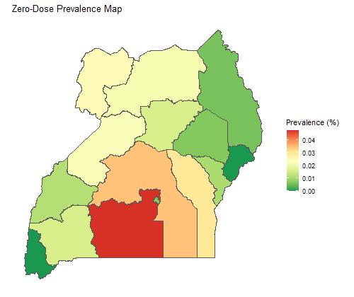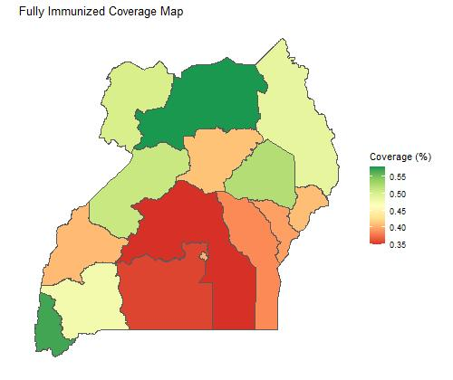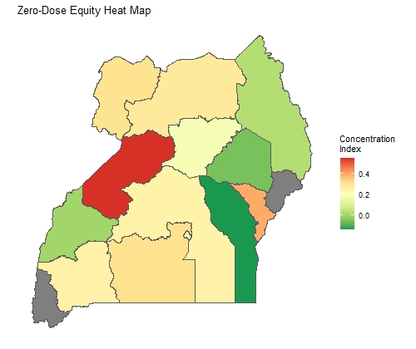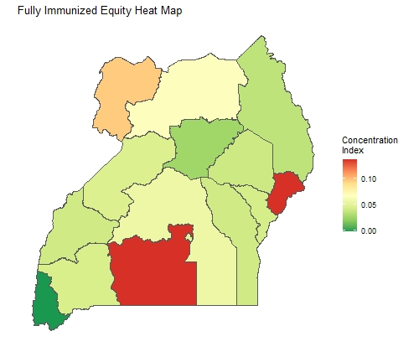
A
C
B
D
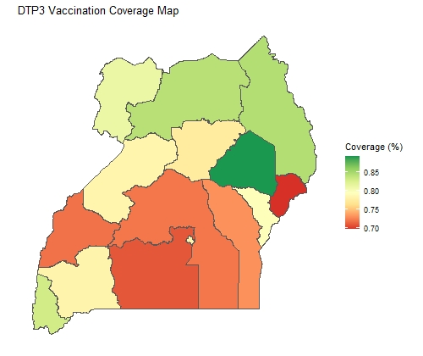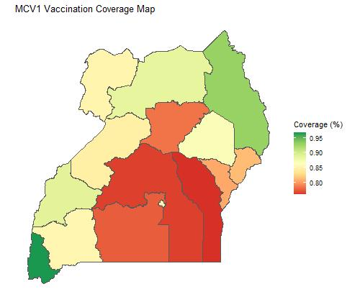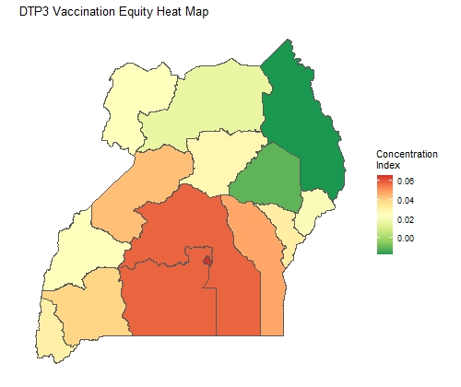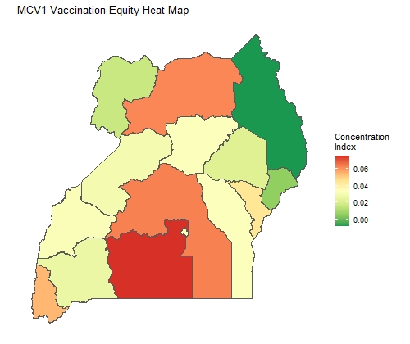
E
G
F
H
Figure 3: Vaccine coverage and equity maps for 2011.
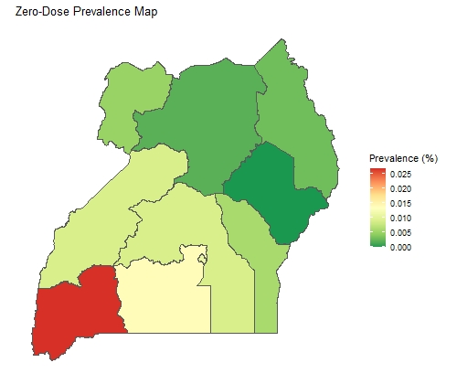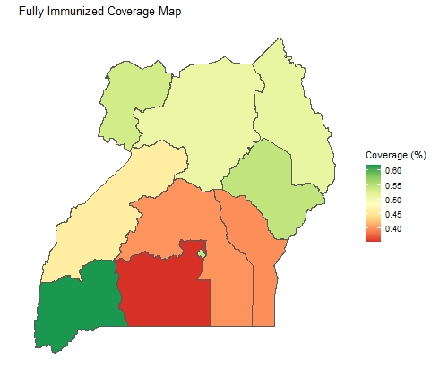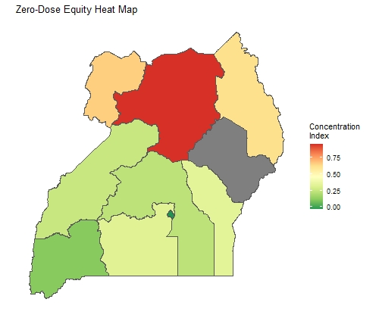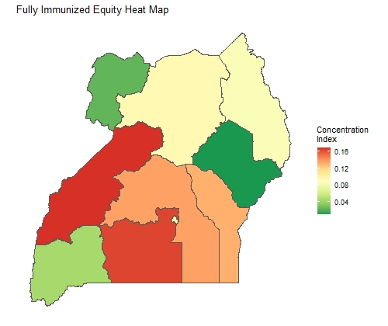
A
C
B
D
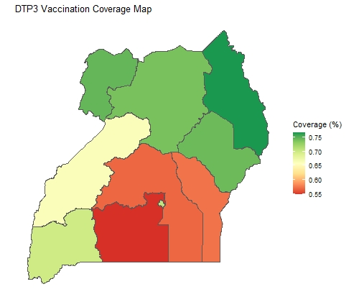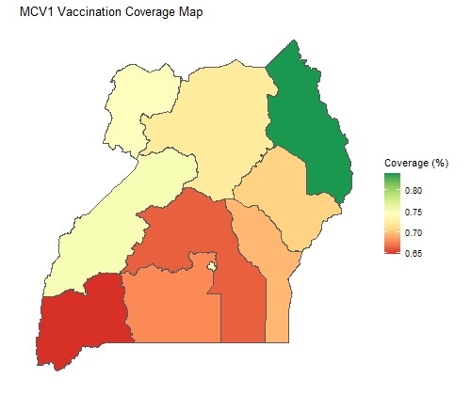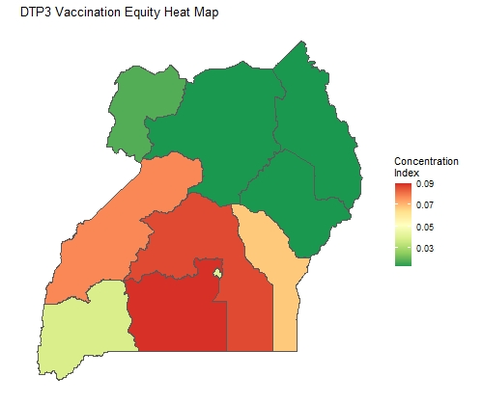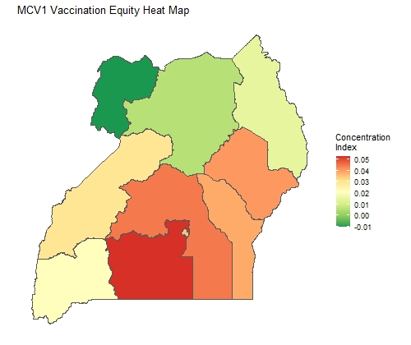
E
G
F
H

Figure 4: Vaccine coverage and equity maps for 2006.
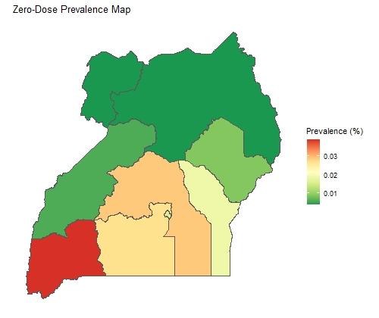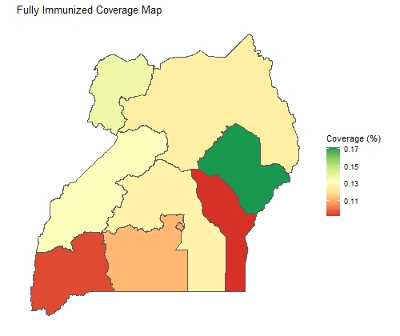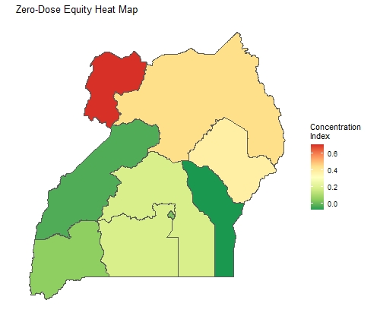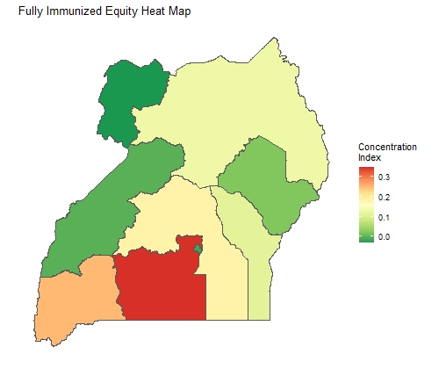
A
C
B
D
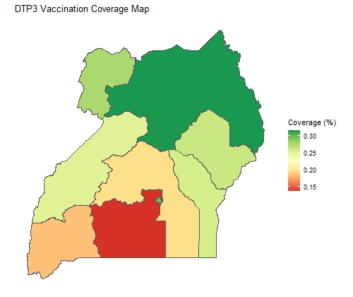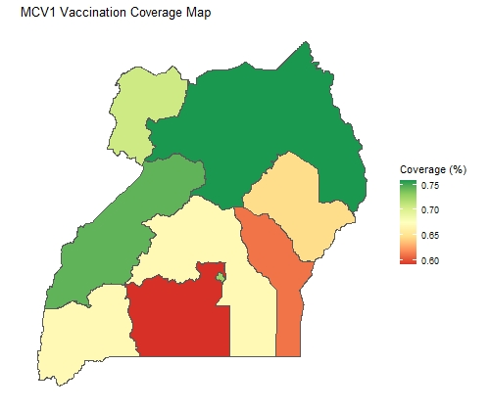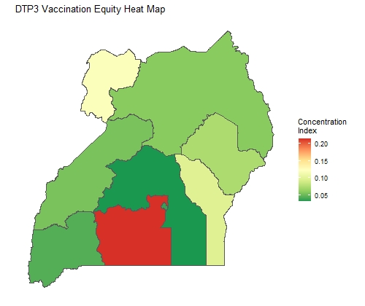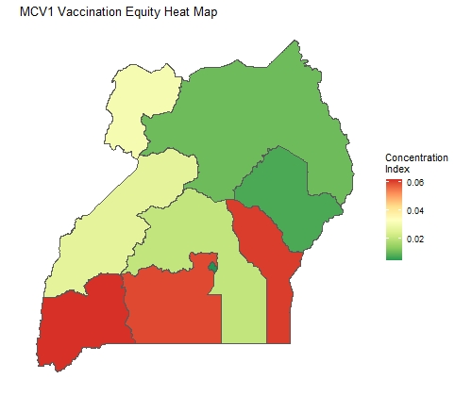
E
G
F
H

Figure 5: Vaccine coverage and equity maps for 2000.
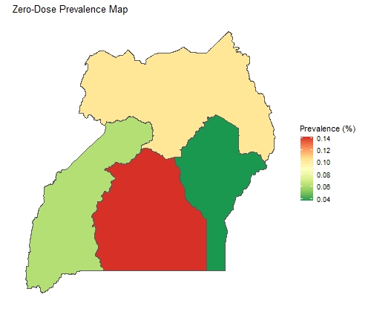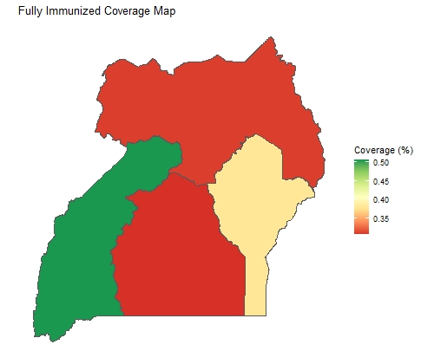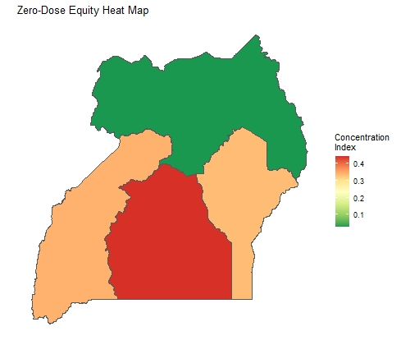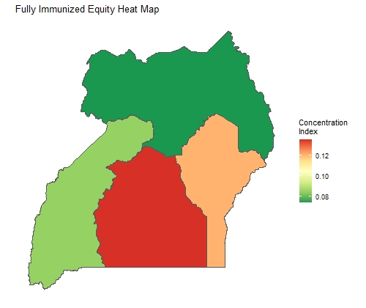
A
C
B
D
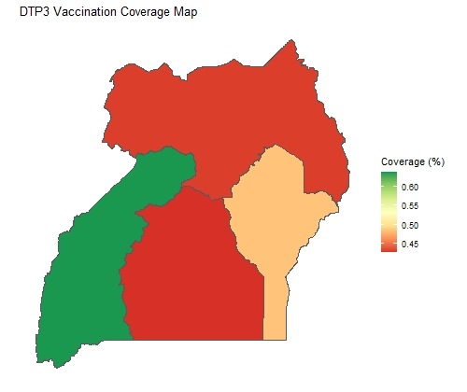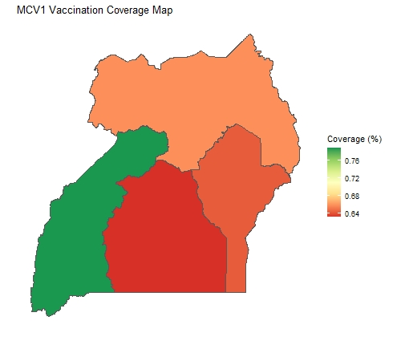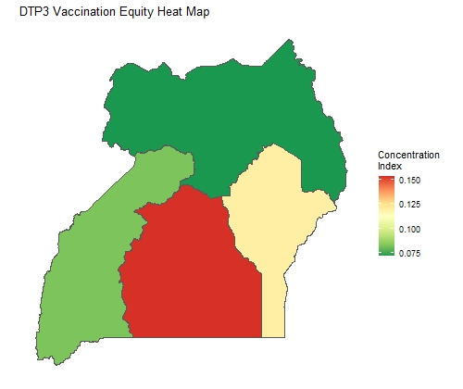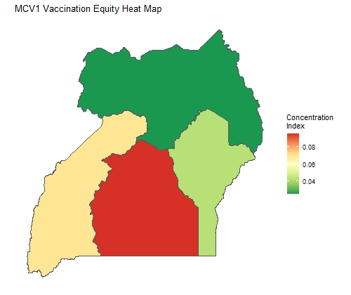
E
G
F
H

Figure 6: Effect of fair and unfair factors on zero-dose prevalence from 2000 to 2016.
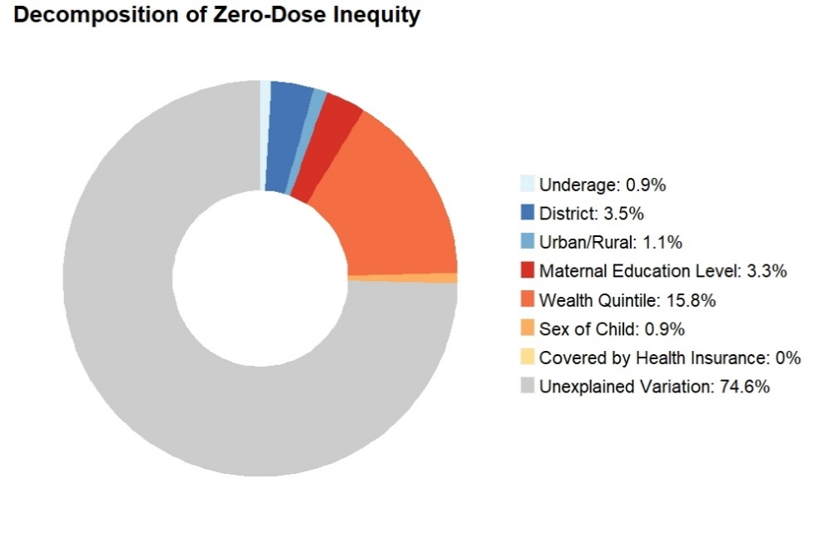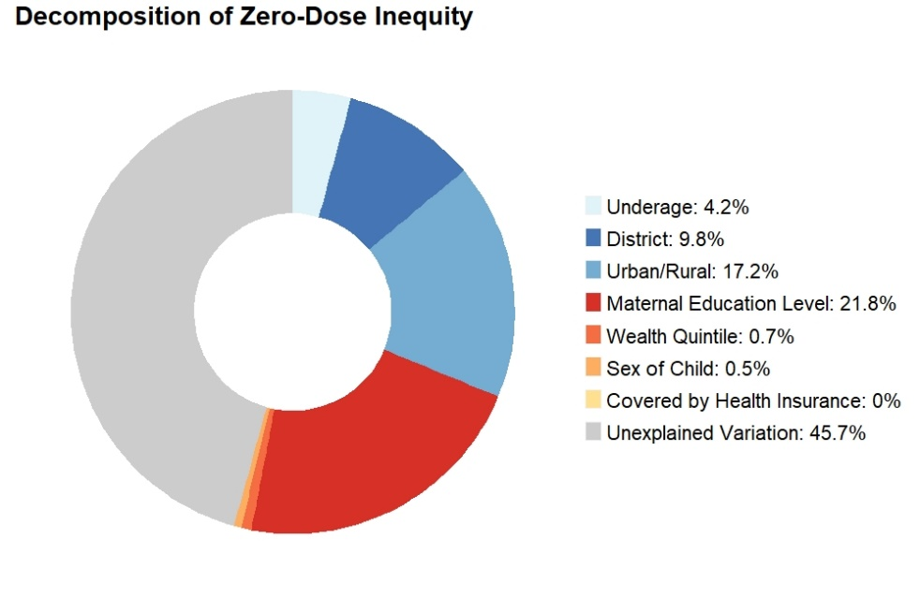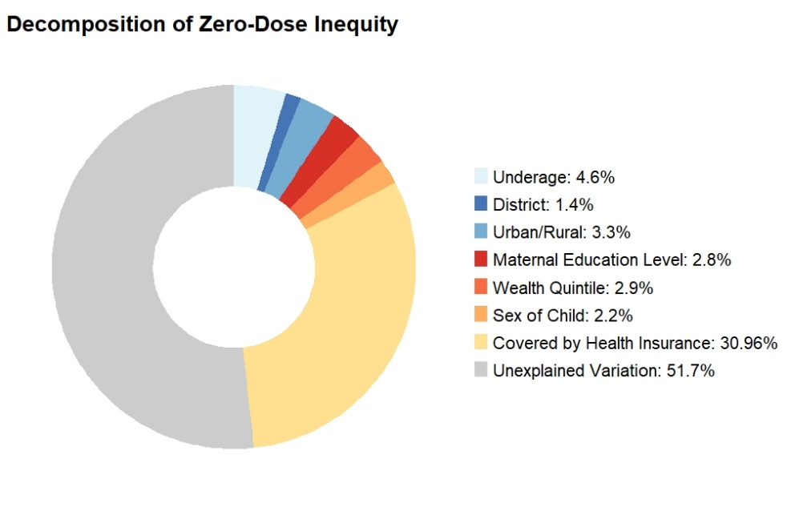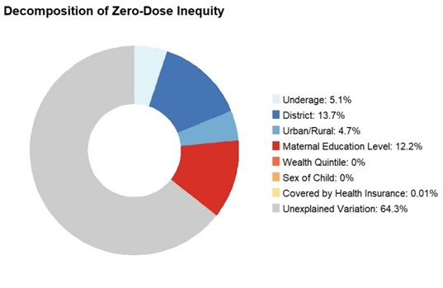
A
B
C
D
2000
2011
2006
2016
Notes: Being underaged for vaccination (a fair contributor) refers to children who are younger than 12 months old and have not received any vaccines yet: they are at risk of becoming “zero-dose” as per Gavi’s definition.

Figure 7: Effect of fair and unfair factors on being fully immunized for age from 2000 to 2016.
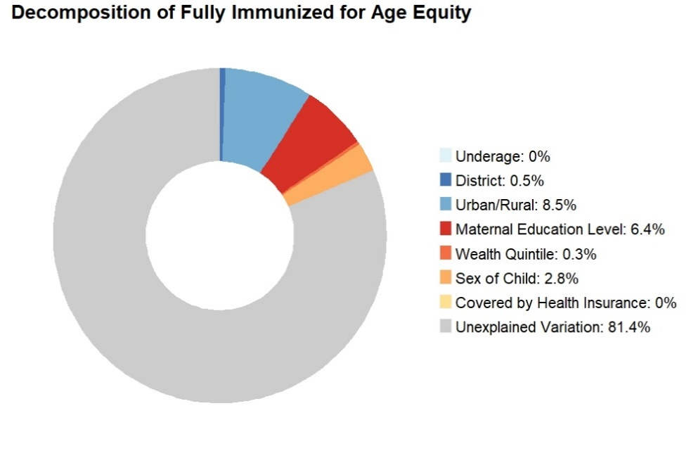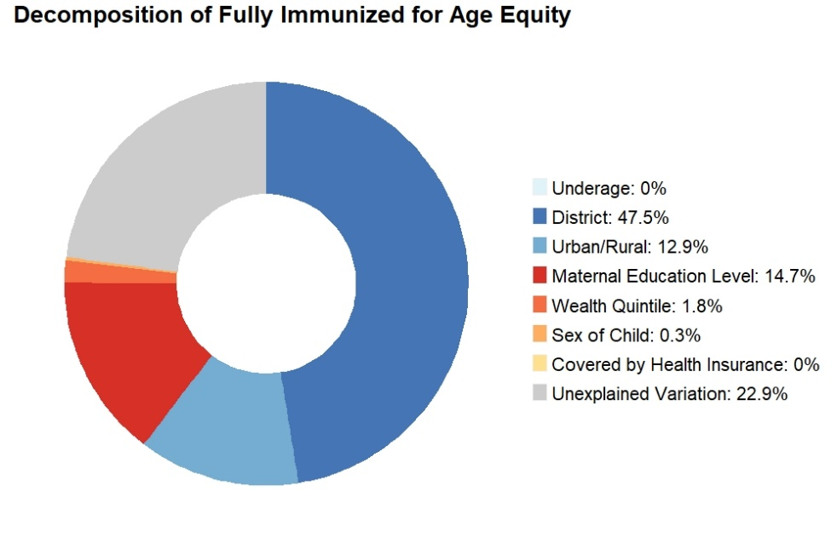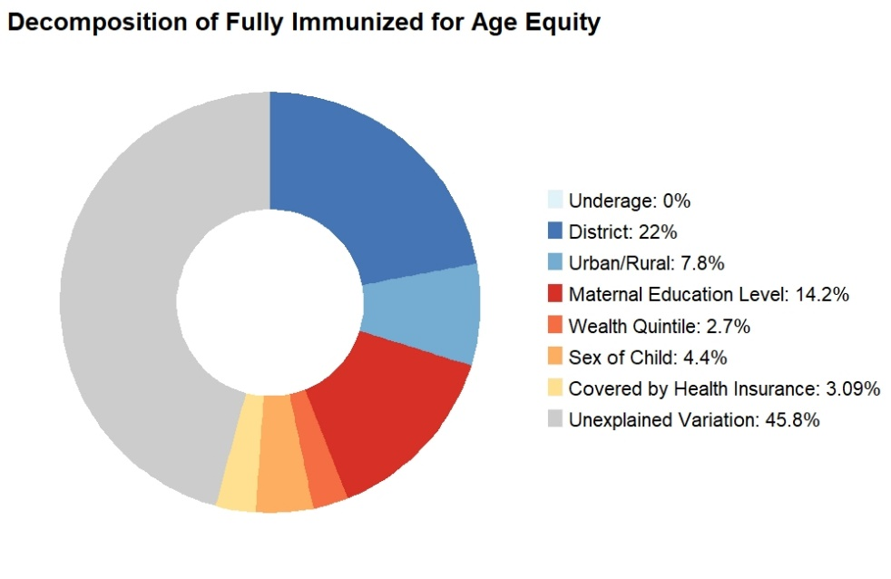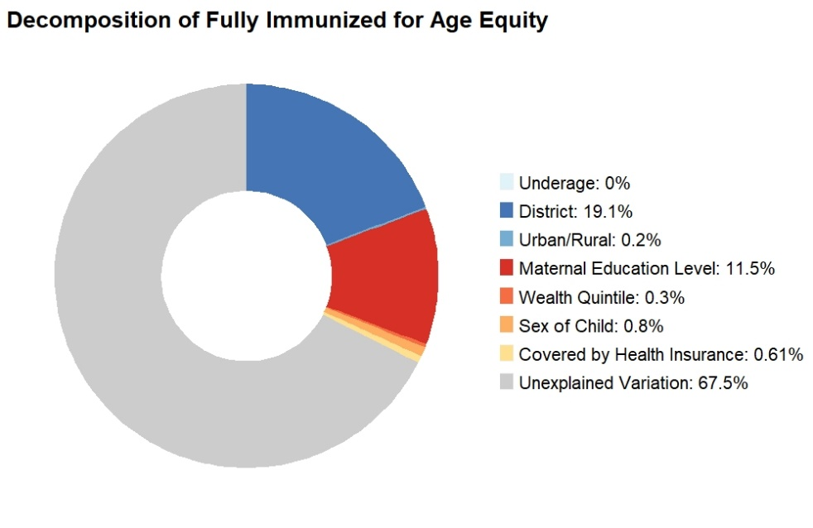
A
B
C
D
2000
2011
2006
2016

Figure 8: Effect of fair and unfair factors of DPT3 vaccine coverage from 2000 to 2016.
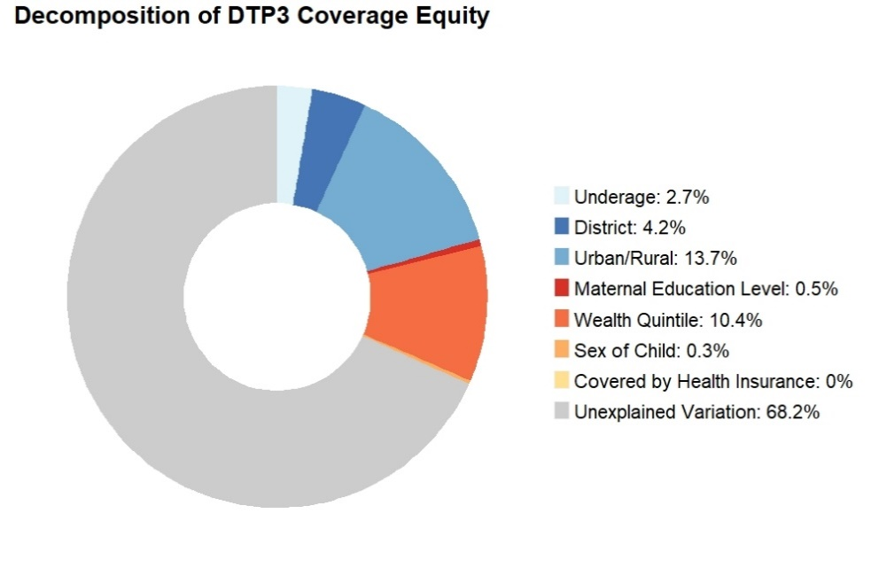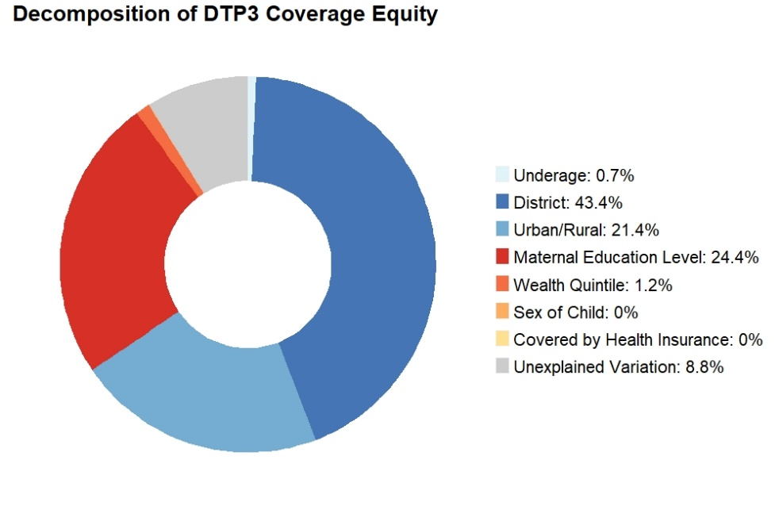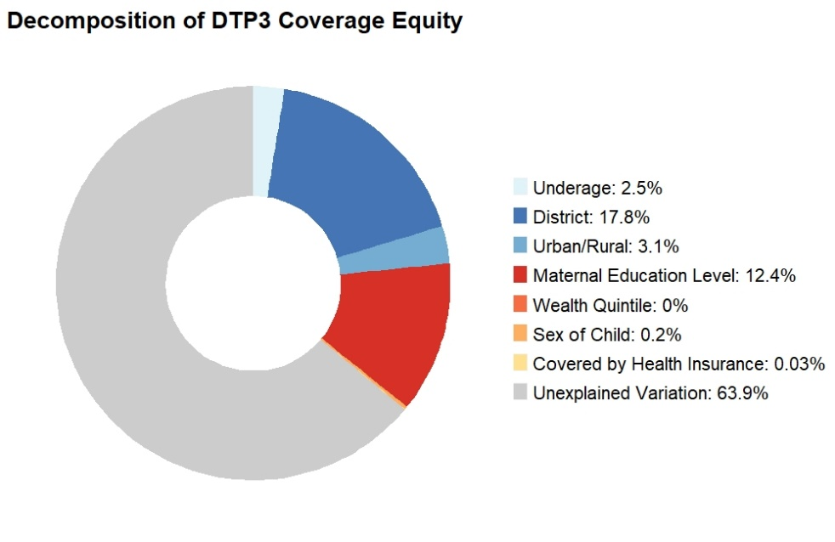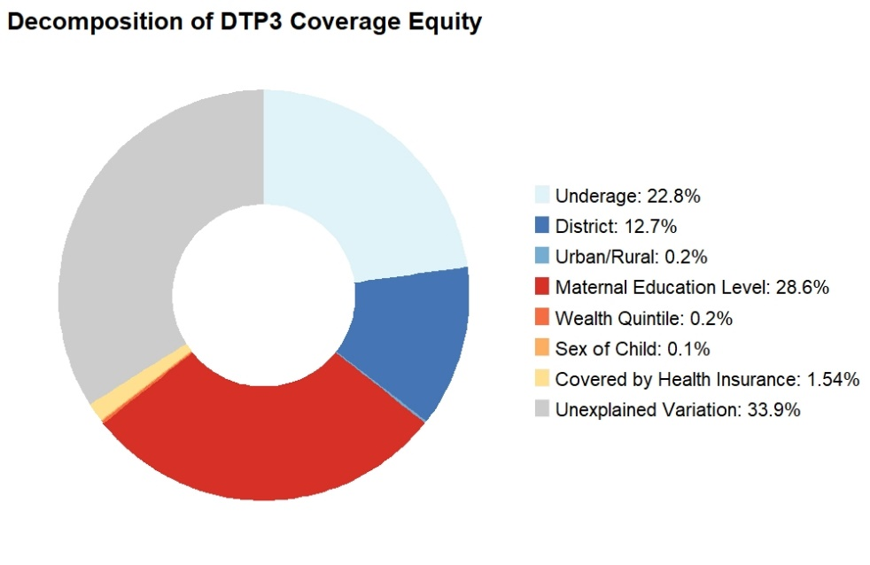
A
B
C
D
2000
2011
2006
2016

Figure 9: Effect of fair and unfair factors on zero-dose prevalence from 2000 to 2016.
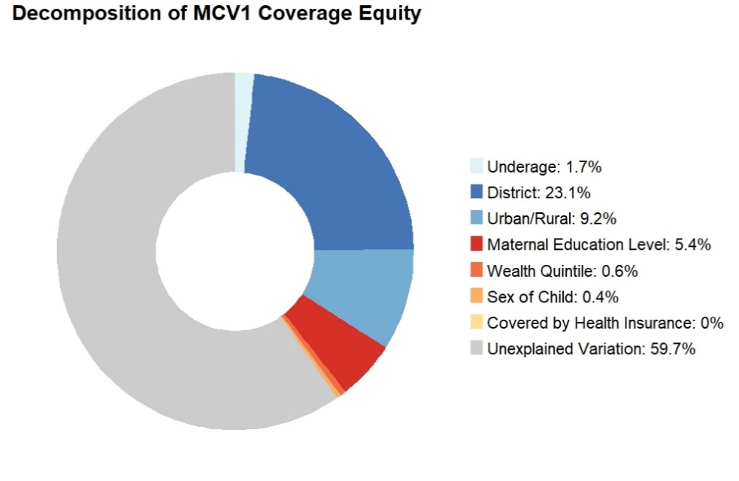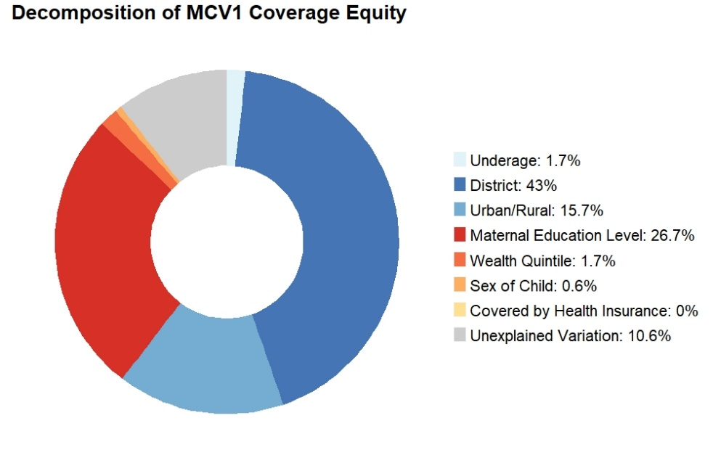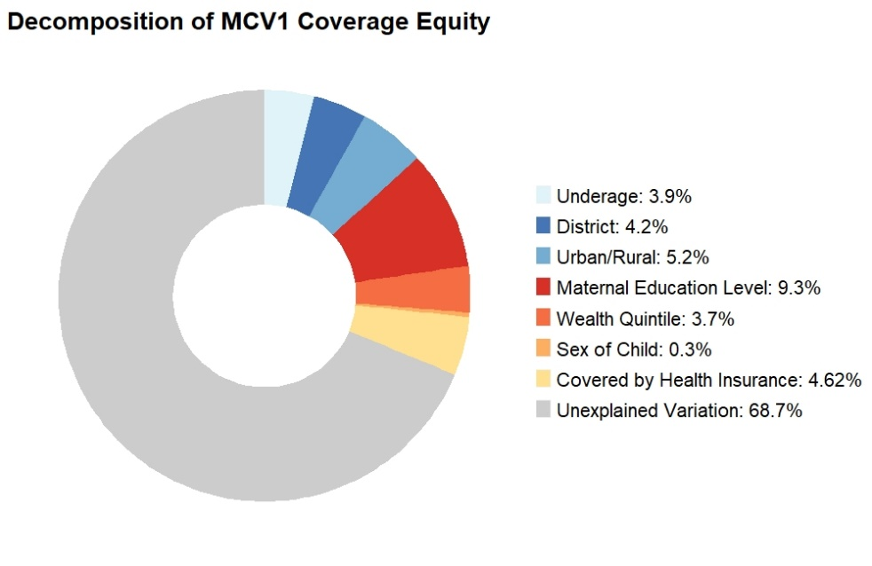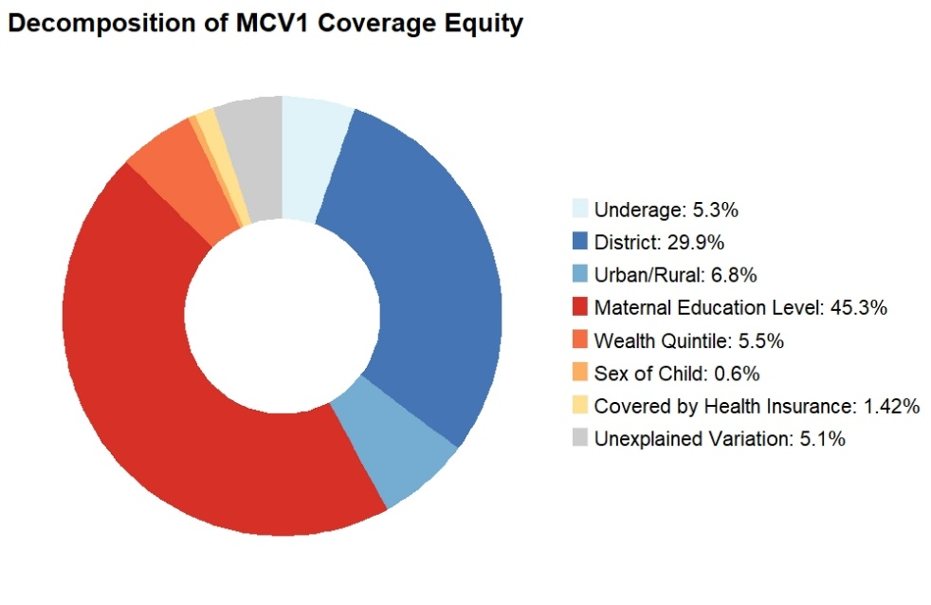
A
B
C
D
2000
2011
2006
2016

Subnational data
Figure 6 is an “equity-coverage plane”, highlighting the relative position of each region (as defined in 2000 and 2016 in the DHS) in coverage and equity for being fully immunized for age.
Figure 6: Equity-coverage plane for full immunization for age status by region from 2000 to 2016.

Table 5: Subnational vaccine coverage rates for 2016.
Region | Vaccines and health outcomes
Region | BCG | DPT1 | DPT2 | DPT3 | OPV1 | OPV2 | OPV3 | PCV1 | PCV2 | PCV3 | MCV1 | ZERO | FULL | COMP
Kampala | 96.8% | 93.1% | 86.0% | 78.3% | 90.8% | 79.3% | 56.9% | 88.4% | 79.0% | 67.9% | 85.3% | 0.7% | 39.5% | 34.8%
South Buganda | 90.0% | 88.2% | 81.1% | 70.9% | 86.5% | 76.8% | 56.4% | 76.6% | 68.1% | 58.6% | 77.5% | 4.8% | 35.5% | 30.9%
North Buganda | 90.5% | 89.2% | 83.6% | 72.1% | 85.2% | 78.1% | 58.1% | 77.7% | 69.2% | 57.8% | 76.5% | 3.5% | 33.4% | 33.8%
Busoga | 93.4% | 90.8% | 87.3% | 73.1% | 88.2% | 82.2% | 62.5% | 81.3% | 75.7% | 66.5% | 76.0% | 3.0% | 38.8% | 41.8%
Bukedi | 96.9% | 96.6% | 91.6% | 79.8% | 94.2% | 83.8% | 63.7% | 89.6% | 85.1% | 69.3% | 80.6% | 1.1% | 43.5% | 43.0%
Bugisu | 97.4% | 95.6% | 80.1% | 69.7% | 82.9% | 70.8% | 59.4% | 87.1% | 69.4% | 54.8% | 81.4% | 0.0% | 36.6% | 26.6%
Teso | 97.6% | 96.0% | 94.0% | 89.3% | 93.9% | 92.3% | 80.3% | 79.2% | 74.6% | 67.0% | 86.9% | 0.7% | 44.0% | 39.0%
Karamoja | 98.0% | 96.7% | 89.8% | 84.5% | 93.1% | 86.9% | 69.7% | 91.5% | 85.0% | 76.6% | 93.0% | 0.6% | 52.3% | 53.9%
Lango | 96.1% | 91.9% | 87.8% | 77.5% | 87.9% | 81.8% | 65.0% | 68.5% | 64.3% | 54.8% | 78.4% | 1.6% | 32.7% | 24.8%
Acholi | 96.9% | 94.2% | 90.2% | 84.3% | 89.8% | 87.8% | 75.5% | 85.3% | 77.8% | 68.8% | 88.6% | 2.2% | 46.8% | 38.3%
West Nile | 95.2% | 94.1% | 89.4% | 81.2% | 92.3% | 87.5% | 75.4% | 86.6% | 82.3% | 71.5% | 85.3% | 2.5% | 51.6% | 52.1%
Bunyoro | 92.1% | 92.0% | 85.7% | 78.4% | 91.2% | 85.2% | 73.2% | 81.5% | 75.7% | 68.5% | 84.7% | 2.3% | 48.0% | 47.0%
Tooro | 95.5% | 92.2% | 84.0% | 71.9% | 90.2% | 81.3% | 64.7% | 74.9% | 66.0% | 56.8% | 88.9% | 1.2% | 34.1% | 36.6%
Ankole | 92.4% | 94.5% | 90.5% | 78.3% | 93.1% | 86.6% | 71.7% | 82.7% | 80.6% | 69.9% | 85.5% | 1.6% | 44.3% | 48.2%
Kigezi | 97.1% | 96.8% | 90.3% | 83.1% | 96.2% | 88.1% | 77.6% | 89.0% | 84.9% | 71.6% | 96.8% | 0.0% | 52.1% | 48.2%

Table 6: Subnational vaccine coverage rates for 2011.
Region | Vaccines and health outcomes
Region | BCG | DPT1 | DPT2 | DPT3 | OPV1 | OPV2 | OPV3 | MCV1 | ZERO | FULL | COMP
Kampala | 94.8% | 91.2% | 80.4% | 70.7% | 89.8% | 79.9% | 63.4% | 74.6% | 1.1% | 54.6% | 52.9%
Central 1 | 85.7% | 83.6% | 71.4% | 54.9% | 84.0% | 69.8% | 43.3% | 67.9% | 1.4% | 35.2% | 40.4%
Central 2 | 90.7% | 84.1% | 73.3% | 56.9% | 87.2% | 73.3% | 48.0% | 66.3% | 0.9% | 40.0% | 42.6%
East central | 92.6% | 88.9% | 77.1% | 57.4% | 88.7% | 78.6% | 57.9% | 69.6% | 0.6% | 39.7% | 47.2%
Eastern | 97.1% | 94.1% | 87.1% | 74.5% | 93.9% | 84.8% | 56.8% | 70.7% | 0.0% | 54.6% | 61.3%
North | 94.0% | 92.1% | 88.5% | 74.1% | 90.0% | 83.2% | 56.2% | 72.4% | 0.2% | 50.8% | 54.4%
Karamoja | 97.6% | 92.7% | 86.1% | 76.8% | 91.8% | 83.7% | 53.4% | 84.1% | 0.3% | 51.2% | 45.9%
West Nile | 96.3% | 92.8% | 86.1% | 74.8% | 92.4% | 84.7% | 60.2% | 74.6% | 0.5% | 53.5% | 61.7%
Western | 92.5% | 91.8% | 83.3% | 66.3% | 90.8% | 81.9% | 63.2% | 75.1% | 0.9% | 46.1% | 53.0%
Southwest | 83.8% | 80.8% | 76.8% | 70.0% | 81.9% | 76.9% | 67.4% | 64.8% | 2.7% | 62.0% | 76.0%

Table 7: Subnational vaccine coverage rates for 2006.
Region | Vaccines and health outcomes
Region | BCG | DPT1 | DPT2 | DPT3 | OPV1 | OPV2 | OPV3 | MCV1 | ZERO | FULL | COMP
Central 1 | 76.5% | 33.7% | 24.0% | 13.8% | 76.3% | 61.3% | 44.8% | 59.2% | 2.7% | 11.2% | 13.6%
Central 2 | 83.9% | 33.8% | 28.8% | 19.7% | 84.8% | 75.5% | 56.5% | 67.0% | 2.9% | 12.7% | 16.3%
Kampala | 90.8% | 42.7% | 39.5% | 29.7% | 87.9% | 79.4% | 53.2% | 72.8% | 1.6% | 11.0% | 11.8%
East central | 88.7% | 42.5% | 36.2% | 25.8% | 86.3% | 72.2% | 48.6% | 61.1% | 1.9% | 9.2% | 12.8%
Eastern | 91.4% | 42.7% | 37.9% | 26.3% | 89.6% | 78.6% | 55.3% | 64.7% | 0.9% | 17.2% | 22.3%
North | 94.0% | 48.2% | 41.9% | 31.6% | 91.7% | 80.6% | 50.9% | 75.9% | 0.4% | 12.5% | 17.6%
West Nile | 93.5% | 40.0% | 35.9% | 27.6% | 93.7% | 83.1% | 52.6% | 70.8% | 0.4% | 13.8% | 14.9%
Western | 93.2% | 46.3% | 40.6% | 25.1% | 91.3% | 81.3% | 59.9% | 74.5% | 0.6% | 13.3% | 13.5%
Southwest | 81.5% | 32.5% | 28.1% | 18.6% | 83.1% | 77.6% | 58.8% | 67.0% | 3.9% | 9.5% | 14.2%

Table 8: Subnational vaccine coverage rates for 2000.
Region (2000) | Vaccines and health outcomes
Region (2000) | BCG | DPT1 | DPT2 | DPT3 | OPV1 | OPV2 | OPV3 | MCV1 | ZERO | FULL | COMP
Central | 70.3% | 68.3% | 56.6% | 42.8% | 74.9% | 63.7% | 43.4% | 63.2% | 14.2% | 30.8% | 41.2%
Eastern | 83.5% | 80.3% | 66.9% | 48.6% | 87.8% | 75.8% | 59.5% | 64.3% | 3.7% | 38.2% | 44.6%
Northern | 75.9% | 76.5% | 62.4% | 43.2% | 80.3% | 73.6% | 53.2% | 65.9% | 10.3% | 31.2% | 37.5%
Western | 79.1% | 82.9% | 76.9% | 63.9% | 88.4% | 82.4% | 68.7% | 79.0% | 6.3% | 50.7% | 66.2%

Table 9: Subnational vaccine equity metric for 2016: Wagstaff multivariate concentration index.
Region | Vaccines and health outcomes
Region | BCG | DPT1 | DPT2 | DPT3 | OPV1 | OPV2 | OPV3 | PCV1 | PCV2 | PCV3 | MCV1 | ZERO | FULL | COMP
Kampala | 0.008 | 0.012 | 0.036 | 0.066 | 0.008 | 0.043 | 0.063 | 0.019 | 0.050 | 0.059 | 0.036 | 0.229 | 0.057 | 0.173
South Buganda | 0.030 | 0.027 | 0.042 | 0.059 | 0.025 | 0.032 | 0.067 | 0.053 | 0.063 | 0.080 | 0.076 | 0.312 | 0.140 | 0.146
North Buganda | 0.028 | 0.029 | 0.040 | 0.059 | 0.030 | 0.049 | 0.012 | 0.051 | 0.088 | 0.117 | 0.064 | 0.254 | 0.089 | 0.119
Busoga | 0.009 | 0.018 | 0.017 | 0.048 | 0.006 | 0.023 | 0.033 | 0.005 | 0.024 | 0.066 | 0.033 | -0.142 | 0.052 | -0.002
Bukedi | 0.008 | 0.002 | 0.029 | 0.032 | 0.000 | 0.028 | 0.047 | -0.006 | 0.026 | 0.037 | 0.045 | 0.397 | 0.063 | 0.059
Bugisu | 0.005 | 0.017 | 0.027 | 0.022 | 0.014 | 0.037 | 0.042 | 0.033 | 0.029 | 0.036 | 0.006 | NA | 0.111 | 0.211
Teso | -0.001 | -0.013 | -0.005 | -0.010 | -0.004 | 0.004 | 0.004 | 0.007 | 0.014 | 0.020 | 0.022 | -0.055 | 0.046 | 0.054
Karamoja | 0.005 | 0.004 | -0.007 | -0.017 | 0.004 | 0.004 | -0.026 | 0.019 | 0.030 | 0.008 | -0.008 | 0.029 | 0.040 | 0.031
Lango | 0.005 | 0.007 | 0.019 | 0.028 | 0.005 | 0.022 | 0.007 | 0.007 | 0.024 | 0.014 | 0.033 | 0.182 | 0.025 | -0.136
Acholi | 0.000 | 0.019 | 0.023 | 0.017 | 0.021 | 0.022 | 0.024 | 0.042 | 0.017 | 0.045 | 0.063 | 0.284 | 0.072 | 0.078
West Nile | 0.013 | 0.008 | 0.012 | 0.024 | 0.008 | 0.018 | 0.046 | 0.001 | 0.009 | 0.024 | 0.017 | 0.307 | 0.076 | 0.097
Bunyoro | 0.025 | 0.020 | 0.027 | 0.044 | 0.016 | 0.016 | 0.031 | 0.042 | 0.031 | 0.050 | 0.030 | 0.553 | 0.048 | 0.027
Tooro | 0.006 | 0.015 | 0.031 | 0.024 | 0.015 | 0.026 | 0.006 | 0.017 | 0.023 | 0.026 | 0.032 | 0.000 | 0.047 | 0.044
Ankole | 0.023 | 0.022 | 0.027 | 0.040 | 0.023 | 0.025 | 0.054 | 0.022 | 0.038 | 0.033 | 0.027 | 0.257 | 0.059 | 0.139
Kigezi | 0.017 | 0.011 | 0.032 | 0.031 | 0.015 | 0.015 | 0.020 | 0.024 | 0.032 | 0.037 | 0.055 | NA | -0.007 | 0.095

Table 10: Subnational vaccine equity metric for 2011: Wagstaff multivariate concentration index.
Region | Vaccines and health outcomes
Region | BCG | DPT1 | DPT2 | DPT3 | OPV1 | OPV2 | OPV3 | MCV1 | ZERO | FULL | COMP
Kampala | 0.008 | 0.006 | 0.017 | 0.041 | 0.015 | 0.043 | 0.033 | 0.036 | -0.032 | 0.105 | 0.012
Central 1 | 0.042 | 0.033 | 0.058 | 0.090 | 0.015 | 0.037 | 0.064 | 0.053 | 0.327 | 0.165 | 0.164
Central 2 | 0.021 | 0.024 | 0.040 | 0.087 | 0.018 | 0.038 | 0.079 | 0.045 | 0.231 | 0.137 | 0.171
East central | 0.010 | 0.004 | 0.027 | 0.068 | 0.001 | 0.017 | 0.032 | 0.039 | 0.341 | 0.132 | 0.093
Eastern | 0.002 | 0.012 | 0.012 | 0.013 | 0.009 | 0.021 | 0.004 | 0.041 | NA | 0.009 | -0.019
North | 0.014 | 0.006 | 0.009 | 0.013 | 0.007 | 0.017 | 0.053 | 0.006 | 0.959 | 0.095 | 0.057
Karamoja | 0.000 | -0.002 | 0.001 | 0.013 | 0.007 | 0.001 | 0.114 | 0.015 | 0.621 | 0.086 | 0.156
West Nile | 0.005 | 0.011 | 0.017 | 0.018 | 0.009 | 0.009 | -0.003 | -0.010 | 0.663 | 0.023 | 0.085
Western | 0.020 | 0.019 | 0.034 | 0.078 | 0.016 | 0.016 | 0.070 | 0.030 | 0.259 | 0.170 | 0.202
Southwest | 0.016 | 0.007 | 0.015 | 0.039 | 0.014 | 0.020 | 0.034 | 0.022 | 0.117 | 0.044 | 0.024

Table 11: Subnational vaccine equity metric for 2006: Wagstaff multivariate concentration index.
Region | Vaccines and health outcomes
Region | BCG | DPT1 | DPT2 | DPT3 | OPV1 | OPV2 | OPV3 | MCV1 | ZERO | FULL | COMP
Central 1 | 0.035 | 0.079 | 0.133 | 0.215 | 0.006 | 0.009 | 0.048 | 0.060 | 0.189 | 0.351 | 0.559
Central 2 | 0.007 | 0.029 | 0.028 | 0.033 | 0.005 | -0.011 | 0.009 | 0.021 | 0.189 | 0.187 | 0.161
Kampala | 0.007 | -0.009 | 0.006 | 0.038 | 0.008 | 0.032 | 0.052 | 0.005 | 0.024 | -0.016 | 0.197
East central | 0.029 | 0.001 | 0.010 | 0.098 | 0.030 | 0.041 | 0.069 | 0.061 | -0.074 | 0.114 | 0.072
Eastern | 0.016 | 0.035 | 0.073 | 0.075 | 0.009 | 0.000 | -0.024 | 0.008 | 0.386 | 0.023 | 0.025
North | 0.007 | 0.048 | 0.057 | 0.061 | -0.001 | 0.011 | 0.028 | 0.011 | 0.449 | 0.131 | 0.128
West Nile | 0.001 | 0.066 | 0.075 | 0.121 | 0.003 | 0.024 | 0.060 | 0.031 | 0.710 | -0.031 | -0.140
Western | 0.017 | 0.025 | 0.054 | 0.056 | 0.011 | 0.029 | 0.045 | 0.027 | -0.027 | -0.003 | 0.032
Southwest | 0.021 | 0.014 | 0.033 | 0.045 | 0.020 | 0.044 | 0.053 | 0.062 | 0.054 | 0.254 | 0.213

Table 12: Subnational vaccine equity metric for 2000: Wagstaff multivariate concentration index.
Region (2000) | Vaccines and health outcomes
Region (2000) | BCG | DPT1 | DPT2 | DPT3 | OPV1 | OPV2 | OPV3 | MCV1 | ZERO | FULL | COMP
Central | 0.099 | 0.090 | 0.112 | 0.154 | 0.079 | 0.092 | 0.122 | 0.096 | 0.443 | 0.136 | 0.101
Eastern | 0.053 | 0.046 | 0.069 | 0.120 | 0.009 | 0.033 | 0.054 | 0.043 | 0.336 | 0.121 | 0.114
Northern | 0.024 | 0.012 | 0.050 | 0.072 | 0.004 | 0.006 | 0.018 | 0.025 | 0.029 | 0.074 | 0.055
Western | 0.053 | 0.049 | 0.053 | 0.083 | 0.037 | 0.049 | 0.078 | 0.070 | 0.344 | 0.085 | 0.057

Table 13: Subnational vaccine equity metric for 2016: Erreyger multivariate concentration index.
Region | Vaccines and health outcomes
Region | BCG | DPT1 | DPT2 | DPT3 | OPV1 | OPV2 | OPV3 | PCV1 | PCV2 | PCV3 | MCV1 | ZERO | FULL | COMP
Kampala | 0.031 | 0.044 | 0.118 | 0.191 | 0.029 | 0.131 | 0.134 | 0.064 | 0.150 | 0.151 | 0.095 | 0.007 | 0.093 | 0.226
South Buganda | 0.107 | 0.094 | 0.128 | 0.157 | 0.085 | 0.093 | 0.142 | 0.159 | 0.160 | 0.173 | 0.176 | 0.033 | 0.197 | 0.188
North Buganda | 0.103 | 0.098 | 0.124 | 0.149 | 0.095 | 0.141 | 0.023 | 0.150 | 0.224 | 0.232 | 0.143 | 0.019 | 0.113 | 0.144
Busoga | 0.034 | 0.061 | 0.053 | 0.118 | 0.019 | 0.067 | 0.068 | 0.016 | 0.065 | 0.151 | 0.067 | -0.014 | 0.076 | -0.002
Bukedi | 0.029 | 0.006 | 0.097 | 0.090 | -0.001 | 0.086 | 0.106 | -0.018 | 0.078 | 0.089 | 0.109 | 0.012 | 0.108 | 0.101
Bugisu | 0.018 | 0.062 | 0.081 | 0.055 | 0.045 | 0.096 | 0.089 | 0.110 | 0.075 | 0.071 | 0.013 | NA | 0.158 | 0.222
Teso | -0.003 | -0.046 | -0.018 | -0.032 | -0.015 | 0.014 | 0.010 | 0.022 | 0.038 | 0.045 | 0.052 | -0.001 | 0.080 | 0.084
Karamoja | 0.020 | 0.016 | -0.025 | -0.051 | 0.015 | 0.011 | -0.064 | 0.067 | 0.094 | 0.023 | -0.022 | 0.000 | 0.081 | 0.067
Lango | 0.021 | 0.026 | 0.063 | 0.079 | 0.018 | 0.068 | 0.016 | 0.018 | 0.058 | 0.029 | 0.077 | 0.008 | 0.033 | -0.136
Acholi | 0.001 | 0.069 | 0.076 | 0.050 | 0.070 | 0.069 | 0.063 | 0.135 | 0.048 | 0.109 | 0.162 | 0.015 | 0.131 | 0.120
West Nile | 0.049 | 0.028 | 0.040 | 0.070 | 0.028 | 0.057 | 0.124 | 0.003 | 0.028 | 0.061 | 0.041 | 0.023 | 0.155 | 0.196
Bunyoro | 0.093 | 0.071 | 0.084 | 0.122 | 0.054 | 0.049 | 0.079 | 0.127 | 0.084 | 0.119 | 0.072 | 0.043 | 0.092 | 0.051
Tooro | 0.023 | 0.054 | 0.099 | 0.064 | 0.051 | 0.081 | 0.013 | 0.049 | 0.059 | 0.055 | 0.083 | 0.000 | 0.067 | 0.064
Ankole | 0.085 | 0.079 | 0.089 | 0.113 | 0.081 | 0.079 | 0.139 | 0.068 | 0.111 | 0.081 | 0.061 | 0.011 | 0.108 | 0.276
Kigezi | 0.068 | 0.040 | 0.105 | 0.093 | 0.053 | 0.049 | 0.054 | 0.081 | 0.099 | 0.093 | 0.152 | NA | -0.014 | 0.183

Table 14: Subnational vaccine equity metric for 2011: Erreyger multivariate concentration index.
Region | Vaccines and health outcomes
Region | BCG | DPT1 | DPT2 | DPT3 | OPV1 | OPV2 | OPV3 | MCV1 | ZERO | FULL | COMP
Kampala | 0.030 | 0.020 | 0.056 | 0.114 | 0.052 | 0.131 | 0.076 | 0.100 | -0.002 | 0.220 | 0.024
Central 1 | 0.148 | 0.109 | 0.165 | 0.197 | 0.050 | 0.102 | 0.119 | 0.136 | 0.017 | 0.268 | 0.299
Central 2 | 0.074 | 0.081 | 0.115 | 0.193 | 0.063 | 0.110 | 0.147 | 0.114 | 0.010 | 0.214 | 0.290
East central | 0.038 | 0.014 | 0.080 | 0.153 | 0.004 | 0.053 | 0.071 | 0.103 | 0.007 | 0.216 | 0.180
Eastern | 0.009 | 0.045 | 0.040 | 0.039 | 0.035 | 0.072 | 0.009 | 0.109 | NA | 0.019 | -0.045
North | 0.052 | 0.021 | 0.032 | 0.040 | 0.026 | 0.056 | 0.119 | 0.017 | 0.011 | 0.209 | 0.130
Karamoja | -0.001 | -0.006 | 0.002 | 0.040 | 0.025 | 0.004 | 0.188 | 0.046 | 0.011 | 0.123 | 0.208
West Nile | 0.020 | 0.042 | 0.059 | 0.055 | 0.034 | 0.029 | -0.008 | -0.029 | 0.011 | 0.050 | 0.216
Western | 0.074 | 0.070 | 0.110 | 0.204 | 0.057 | 0.053 | 0.175 | 0.088 | 0.008 | 0.330 | 0.439
Southwest | 0.053 | 0.022 | 0.046 | 0.108 | 0.047 | 0.062 | 0.090 | 0.053 | 0.011 | 0.110 | 0.074

Table 15: Subnational vaccine equity metric for 2006: Erreyger multivariate concentration index.
Region | Vaccines and health outcomes
Region | BCG | DPT1 | DPT2 | DPT3 | OPV1 | OPV2 | OPV3 | MCV1 | ZERO | FULL | COMP
Central 1 | 0.105 | 0.102 | 0.119 | 0.105 | 0.017 | 0.021 | 0.084 | 0.129 | 0.025 | 0.135 | 0.270
Central 2 | 0.022 | 0.039 | 0.033 | 0.027 | 0.017 | -0.032 | 0.019 | 0.052 | 0.021 | 0.092 | 0.109
Kampala | 0.025 | -0.015 | 0.010 | 0.045 | 0.028 | 0.097 | 0.105 | 0.013 | 0.001 | -0.008 | 0.100
East central | 0.103 | 0.002 | 0.013 | 0.090 | 0.102 | 0.116 | 0.129 | 0.139 | -0.005 | 0.039 | 0.036
Eastern | 0.057 | 0.058 | 0.103 | 0.071 | 0.031 | 0.000 | -0.051 | 0.020 | 0.015 | 0.014 | 0.021
North | 0.024 | 0.095 | 0.097 | 0.078 | -0.002 | 0.034 | 0.056 | 0.032 | 0.007 | 0.073 | 0.102
West Nile | 0.005 | 0.102 | 0.103 | 0.127 | 0.011 | 0.076 | 0.125 | 0.081 | 0.009 | -0.017 | -0.084
Western | 0.061 | 0.045 | 0.083 | 0.053 | 0.039 | 0.090 | 0.104 | 0.074 | -0.001 | -0.001 | 0.018
Southwest | 0.069 | 0.019 | 0.038 | 0.037 | 0.065 | 0.134 | 0.123 | 0.157 | 0.007 | 0.117 | 0.149

Table 16: Subnational vaccine equity metric for 2000: Erreyger multivariate concentration index.
Region (2000) | Vaccines and health outcomes
Region (2000) | BCG | DPT1 | DPT2 | DPT3 | OPV1 | OPV2 | OPV3 | MCV1 | ZERO | FULL | COMP
Central | 0.286 | 0.247 | 0.252 | 0.262 | 0.234 | 0.230 | 0.206 | 0.203 | 0.179 | 0.172 | 0.170
Eastern | 0.177 | 0.143 | 0.177 | 0.220 | 0.029 | 0.093 | 0.119 | 0.092 | 0.039 | 0.187 | 0.209
Northern | 0.075 | 0.035 | 0.123 | 0.124 | 0.014 | 0.016 | 0.036 | 0.057 | 0.008 | 0.100 | 0.089
Western | 0.173 | 0.162 | 0.159 | 0.210 | 0.130 | 0.156 | 0.207 | 0.187 | 0.063 | 0.181 | 0.155

Reference
1. Erreygers G. Correcting the concentration index. J Health Econ. 2009;28(2):504-15.
2. Wagstaff A. The concentration index of a binary outcome revisited. Health Econ. 2011;20(10):1155-60.

