Singh et al. Supplemental Material

Supplemental Fig. 1
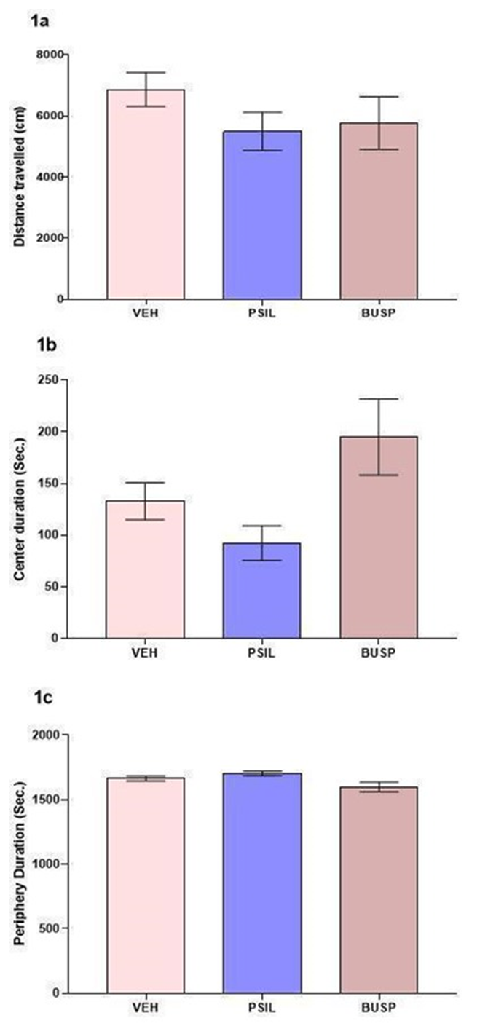
Supplemental Fig. 1: 1a: Effect of psilocybin 4.4 mg/kg and buspirone 5 mg/kg on distance travelled in the open field over 30 minutes. One way ANOVA: F2,30 = 1.044; p=0.3645 . p N.S. vs. VEH.
1b: Effect of psilocybin 4.4 mg/kg and buspirone 5 mg/kg on time spent in the center of the
open field over 30 minutes. One way ANOVA: F 2, 30 = 4.934; p=0.0140. p N.S. vs. VEH.
1c: Effect of psilocybin 4.4 mg/kg and buspirone 5 mg/kg on time spent in the periphery of the
open field over 10 minutes. One way ANOVA: F 2, 30 = 5.003; p = 0.0133. p N.S vs VEH, n= 9-
15 (Tukey's multiple comparisons test).

Supplemental Fig. 2
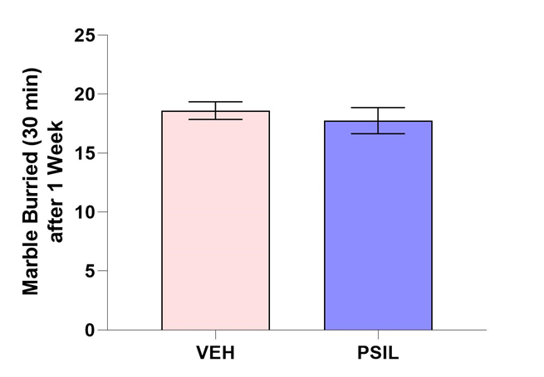
Supplemental Fig. 2: Effect of psilocybin 4.4 mg/kg after 1 week on total marbles buried over 30 minutes. No significant effect of psilocybin was observed (vehicle 18.6 ± 1.6, n=5; psilocybin 17.75± 2.21 n=4; p =0.53).

Supplemental Figure 3
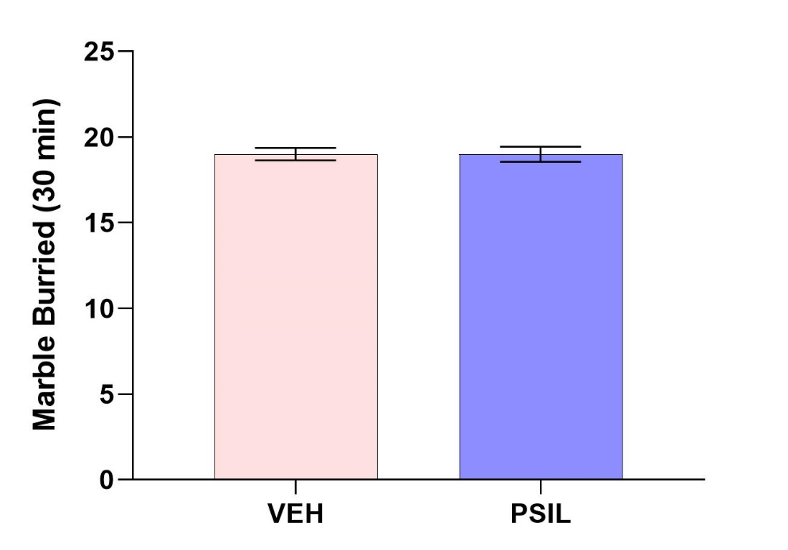
Supplemental Fig. 3: Effect of psilocybin 4.4 mg/kg drug in staggered fashion over a period of 3.0 hours i.e. i.p. injections of 1.1 mg/kg every 60 minutes; MBT performed 30 minutes after the last injection. No significant effect of psilocybin was observed (vehicle 19±0.89 n=6; psilocybin 19±1.32 n=9; p>0.10) (n=6-9).

SUPPLEMENTAL VIDEO
This video shows ICR mice engaged in marble-burying. This behavior serves as the basis for the
Marble-burying test. Mice did not receive any pretreatment before being placed in the test
cage which contained twenty marbles equidistant from each other in a 5 × 4 pattern. The
experiment was done under dim light in a quiet room to reduce the influence of anxiety on
behavior. The mice were left in the cage with the marbles for a 30-min period after which the
test was terminated by removing the mice. Number of buried marbles was counted after 10, 20
and 30 minutes.
https://drive.google.com/file/d/1n5oKtI4ZyewVwn1suDFXxifdbwjO4Wtt/view?usp=sharing
(Filmed by Dr Alexander Botvinnik, Biological Psychiatry Laboratory and Hadassah BrainLabs,
Hadassah Medical Center, Hebrew University, Jerusalem, Israel)

