Supporting Information

Enhancement of superconducting properties in the La–Ce–H system at moderate pressures

Wuhao Chen¹, Xiaoli Huang^{1,*}, Dmitrii V. Semenok², Su Chen¹, Di Zhou², Kexin Zhang¹, Artem R. Oganov², and Tian Cui^{3,1*}

¹ State Key Laboratory of Superhard Materials, College of Physics, Jilin University, Changchun 130012, China
² Skolkovo Institute of Science and Technology, Skolkovo Innovation Center, Bolshoy Boulevard 30, bldg. 1, Moscow 121205, Russia
³ School of Physical Science and Technology, Ningbo University, Ningbo 315211, China

*Corresponding authors’ e-mails: huangxiaoli@jlu.edu.cn, cuitian@nbu.edu.cn

Experimental details
The La–Ce alloys were prepared using the multitarget magnetron sputtering (Fig. S1). We sputtered the La (99.9%) and Ce (99.9%) metals simultaneously to the glass slide using DC and RF power supplies, respectively. The Ar pressure was 1.5 Pa, and both targets were pre-sputtered to remove the surface oxides. Depending on the distance to the target, La: Ce ratio has a specific distribution. The La–Ce alloy was further characterized using the scanning electron microscope (SEM) Regulus 8100, equipped for the energy-dispersive X-ray spectroscopy (EDX). The La–Ce alloys for high-pressure experiment were located on the glass side very close to the SEM-characterized area and kept strictly in the glove box (O₂ < 0.01 ppm, H₂O < 0.01 ppm). Normal type-Ⅰa diamonds with 60–150 μm culets single-beveled to 250–300 μm were used; the pressure was measured according to the Raman vibration edge of diamond using Akahama’s calibration^{1,2}. The resistance was measured using the four-probe method with the delta model of the Keithley current source (Model 6221, 1 mA) and voltmeter (Model 2182A). The electrodes were integrated to the diamond by a lithographic Mo (300-500 nm thick)³ or manually cutting Pt (2–3 um thick) foil. To protect the electrodes during decompression, we tested the nano-polycrystalline diamonds (NPD) without bevels in some runs. Because of the high fluorescence background of the NPDs, their Raman edge cannot be distinguished. Therefore, the NPDs (200–300 um culet) were combined with the normal diamonds, and the electrodes were set on the NPD side. The indentation of a tungsten gasket was insulated using c-BN/epoxy first, and the bevel part was filled with oxides (Al₂O₃, MgO)/epoxy. The La–Ce samples were loaded into the chamber filled with ammonia borane (AB), which acted as a hydrogen source. The sample was heated at the target pressure by a 1070 nm infrared laser with 3–5 um focus spot and an exposure time of 1–3 s. Afterward, we put the DAC into a helium cryostat (1.5–300 K) equipped with a 0–9 T superconducting magnet for low temperature electrical measurements. The crystal structure was determined using the synchrotron X-ray diffraction (XRD) on the BL15U1 synchrotron beamline with a wavelength of 0.6199 Å at the Shanghai Synchrotron Research Facility (SSRF). The experimental XRD images were integrated and analyzed for possible phases using the Dioptas software package⁴. To fit the diffraction patterns and obtain the cell parameter, we analyzed the data using Materials Studio and Jana2006 software⁵, employing the Le Bail method⁶.

Table S1. Initial samples and the pressure before and after the laser-heating in different experimental runs. The La: Ce ratios of the alloys in runs #1,2,3 and 7 should be close to 3, because these alloys were prepared in similar conditions (as shown in the below Fig. S1).
Run | Initial sample | La:Ce | Pressure before and after laser heating | Measurements
#1 | (La,Ce)+AB | Unknown | 102–82 GPa | XRD
#2 | (La,Ce)+AB | Unknown | 113–112 GPa | XRD, R–T
#3 | (La,Ce)+AB | Unknown | 130–131 GPa | XRD, R–T
#4 | (La,Ce)+AB | ≈6 | 107–103 GPa | EDX, R–T
#5 | (La,Ce)+AB | 3.2–3.5 | 129–132 GPa | EDX, R–T
#6 | (La,Ce)+AB | 2.7–2.9 | 152–150 GPa | EDX, R–T
#7 | (La,Ce)+AB | Unknown | without laser-heating | R–T
#8 | (La,Ce)+AB | ≈3 | 129–131 GPa, 131–130 GPa | EDX, R–T
#9 | (La,Ce)+AB | 3.4–3.5 | 120–118 GPa, 122–120 GPa, 127–125 GPa | EDX, R–T
#L1 | La+AB | Pure La | 125–123 GPa, 130–127 GPa, 132–129 GPa | R–T
#L2 | La+AB | Pure La | 113–111 GPa | R–T
#L3 | La+AB | Pure La | 109 GPa heated | R–T
#S | La+AB | Pure La | 132–130 GPa | XRD

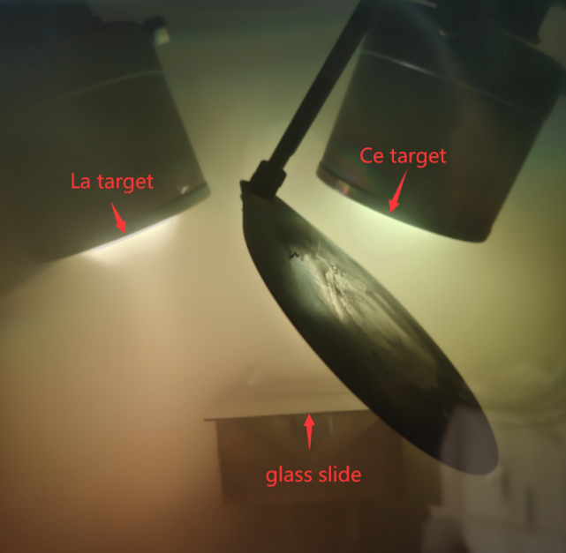
Fig. S1. Photograph of the chamber inside the magnetron sputtering equipment. The La and Ce ions were mixed in the Ar atmosphere and then deposited on a glass slide.

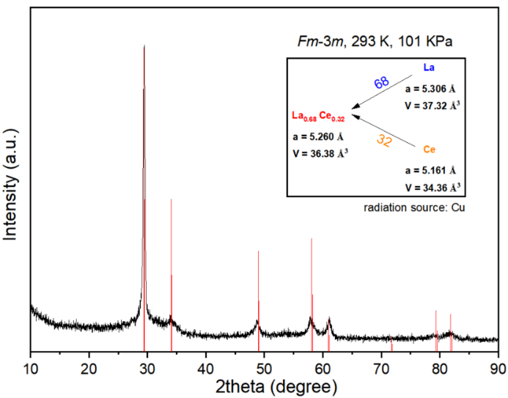
Fig. S2. XRD (Cu: K_{α1}=1.54056Å, K_{α2}=1.54439Å) of a typically prepared La–Ce alloy at ambient conditions. Red lines show the indexing results of the calculated diffraction of Fm$\overline{3}$m structure. The related cell parameters are shown in the inset. The La–Ce ratio was estimated from the calculations of cell volume. The La contents decreases to 64% according to the a-spacing because of the deviation from the linear relation⁷.

Run #1
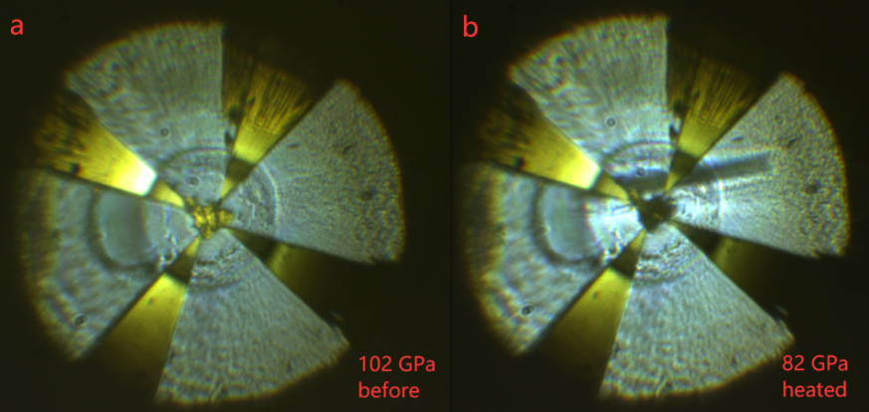
Fig. S3. Photographs of DAC #1 (a) before and (b) after laser-heating. A vertical crack appeared and grew gradually during the laser-heating.

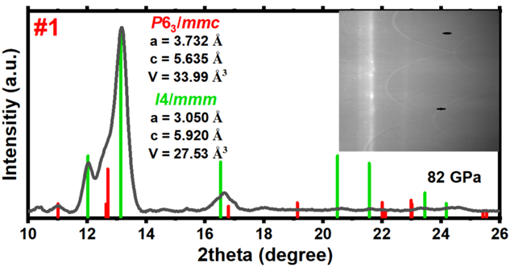
Fig. S4. Le Bail fitting of the XRD pattern of the sample in DAC #1 at 82 GPa. The inset shows the integrated XRD pattern.

Run #2
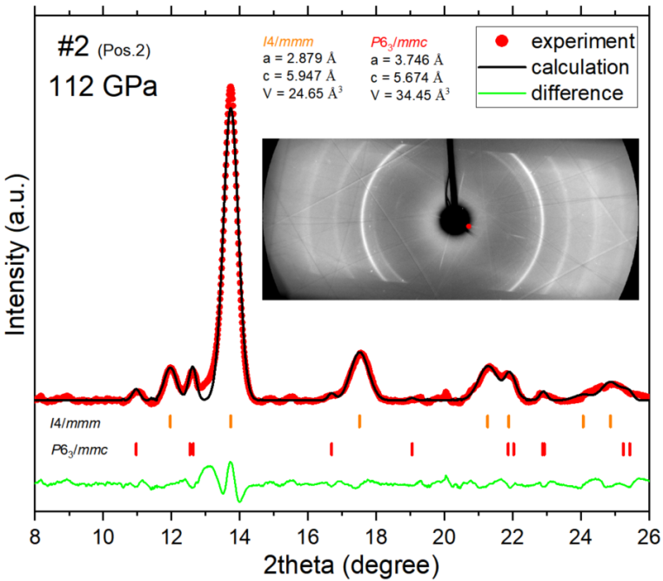
Fig. S5. Le Bail fitting of the XRD pattern for another detected position of DAC #2 at 112 GPa. The inset shows the XRD pattern.
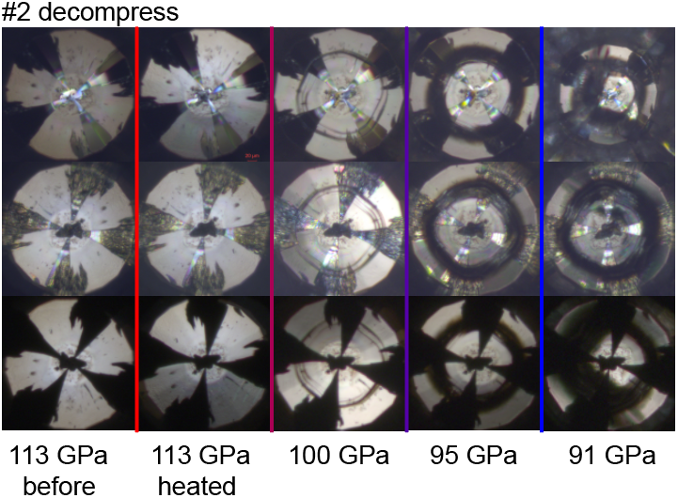
Fig. S6. Changes in the diamond’s bevel during the decompression of DAC #2 from different photographic views.

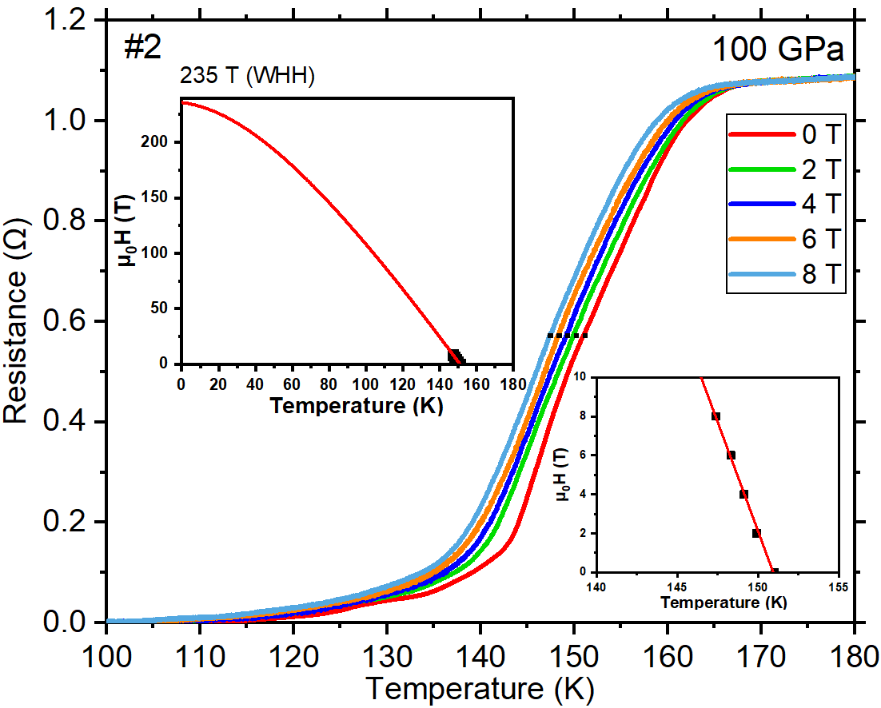
Fig. S7. Superconducting transitions of sample #2 under an external magnetic field at 100 GPa. Black dots indicate the positions where the T_{c}s where taken. Insets are the fitting with the simplified WHH formula and the enlarged part of fitting, respectively.

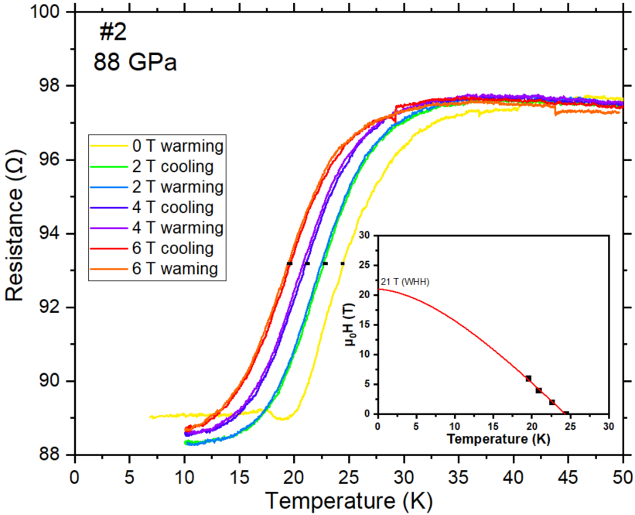
Fig. S8. Superconducting transitions of sample #2 under an external magnetic field at 88 GPa. Black dots indicate the positions where the T_{c}s where taken. Inset is the fitting with simplified WHH formula.

Run #3
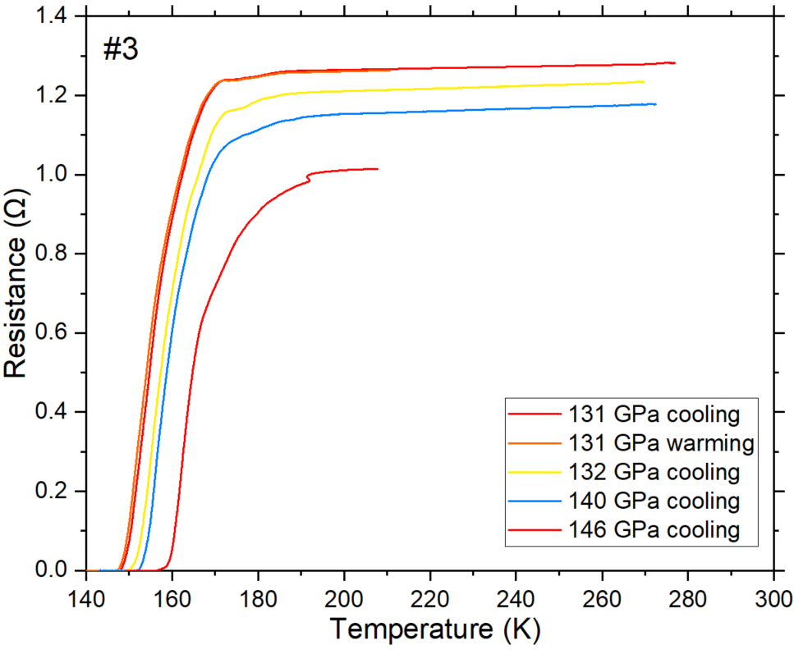
Fig. S9. Temperature dependence of the electrical resistance for the La-Ce-H sample in DAC #3 at different pressures.

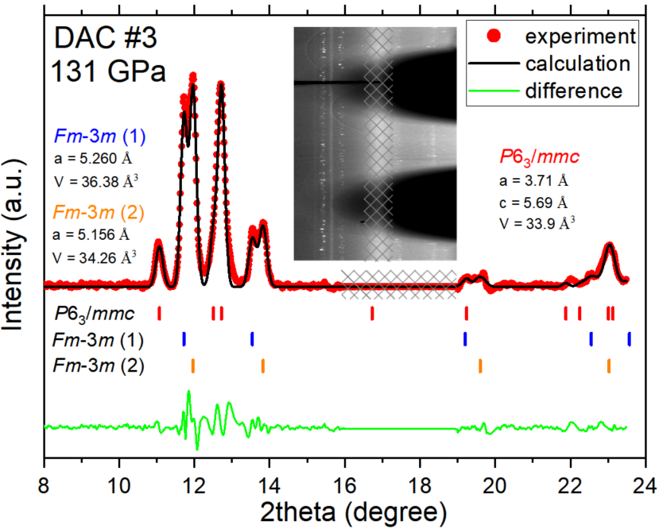
Fig. S10. Le Bail fitting of the XRD pattern of the sample in DAC #3 at 131 GPa. The inset shows the integrated diffraction pattern. The diffraction on the impurity that located on the seat surface of the diamond, as discussed below, is masked by gridlines.

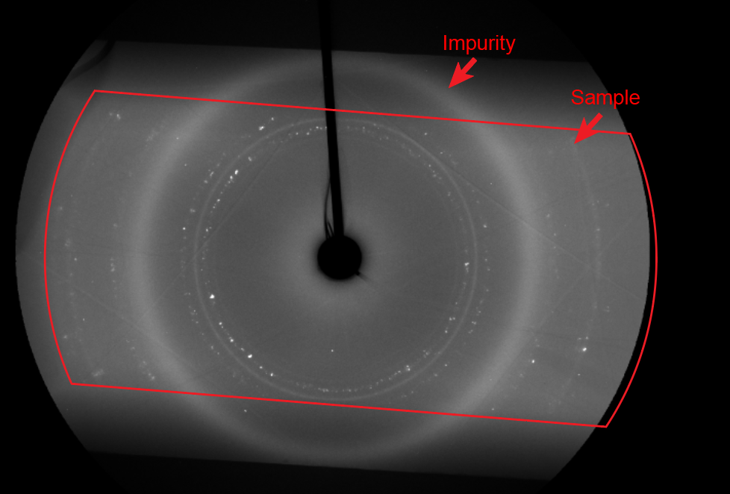
Fig. S11. XRD diffraction pattern of the sample in DAC #3 at 131 GPa. The red frame represents the projection of the long opening angle in the diamond seat. The sample shows a set of incomplete diffraction circles because of the occlusion of the seat, whereas the impurity shows a full broad entire circle. This means the impurity is not in the sample chamber and is closer to the diamond seat (possibly some dirt on the seat surface of diamond).

Run #4
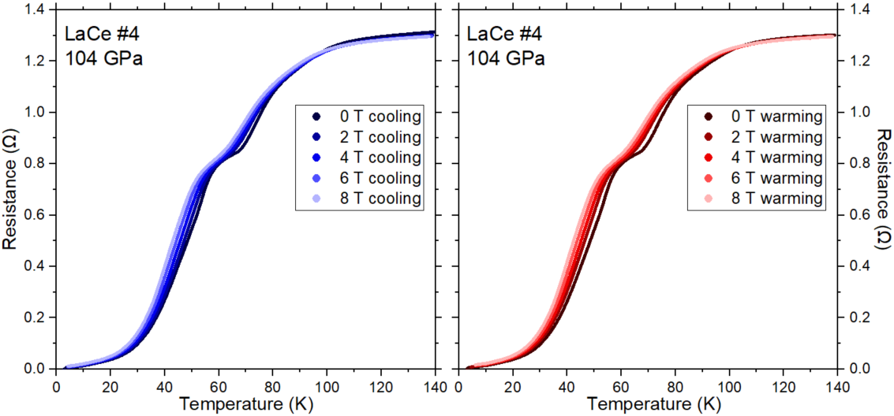
Fig. S12. Temperature dependence of the electrical resistance in DAC #4 near the superconducting transition in an external magnetic field for cooling(left) and warming(right) cycles.

Run #5
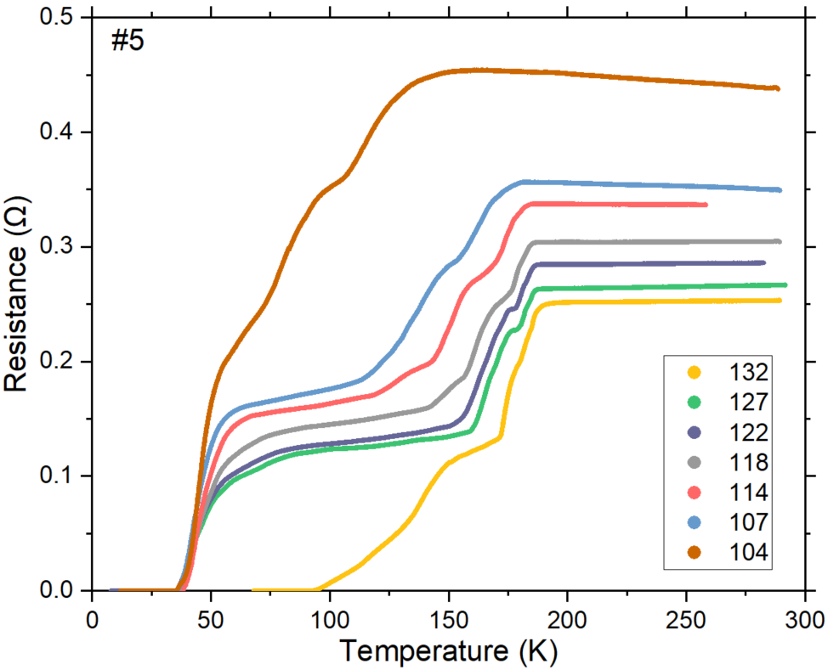
Fig. S13. Temperature dependence of the electrical resistance for the La-Ce-H sample in DAC #5 at different pressures.

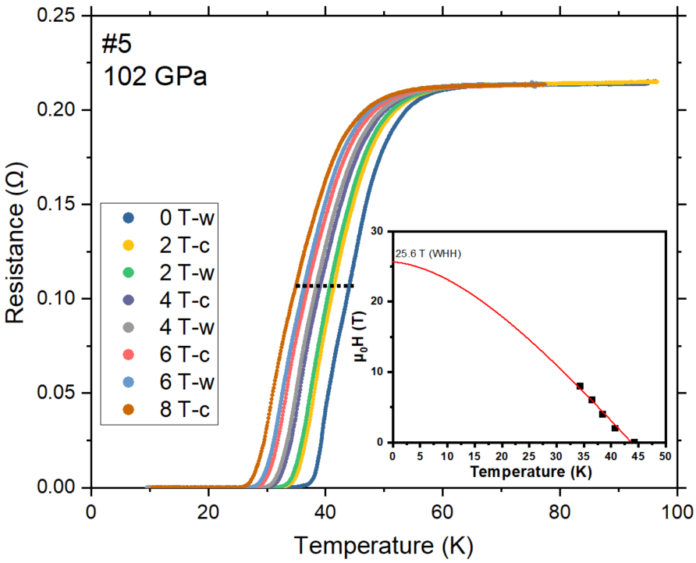
Fig. S14. Superconducting transitions of sample #5 under an external magnetic field at 102 GPa. Black dots indicate the positions where the T_{c}s were taken. Inset is the fitting with the simplified WHH formula.

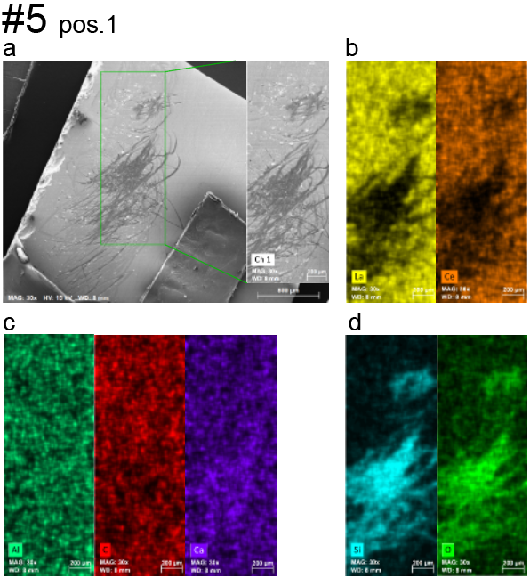
Fig. S15. Scanning electron microscopy (SEM) and energy dispersive X-ray spectroscopy (EDX) analysis of the
La–Ce alloy in DAC #5, pos. 1 (a) The SEM photo of the sample on the glass slide. (b–d) Elements distribution in the rectangular area shown by green lines in panel (a).

In DAC #5, the alloy composition was characterized after the sample loading. We used a tungsten needle to scratch the La–Ce layer on the glass slide to get particles, which left traces (Fig. S15a). La and Ce were both uniformly distributed except for the scratched area (Fig. S15b). Si and O mainly come from the glass slide, thus the scratched area has high intensity (Fig. S15d). On the La–Ce surface, there was a tiny amount of oxygen because of the oxides formed during the transfer. Moreover, Al, C and Ca exist all over the selected region and can be viewed as a background signal. Fig. S13 shows that the scratched particles have a uniform distribution of La and Ce. The sputtered La–Ce can form clusters or smooth solid solutions.

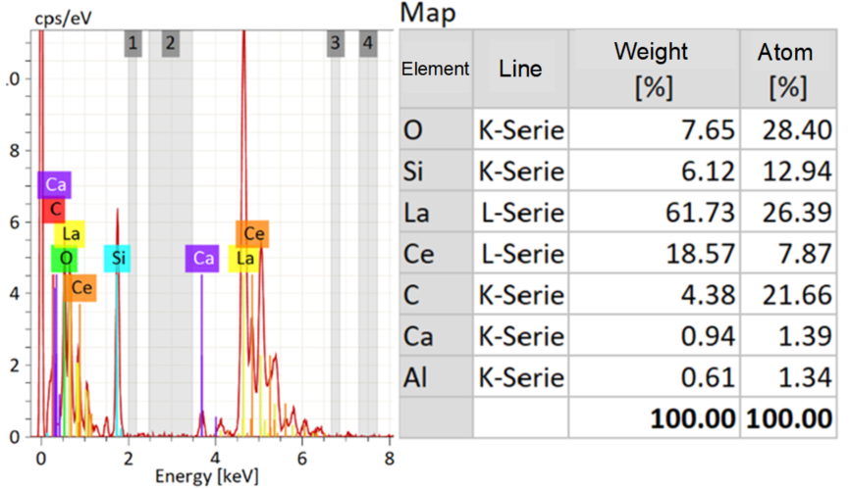
Fig. S16. Compositions analyzed using the EDX in DAC #5.

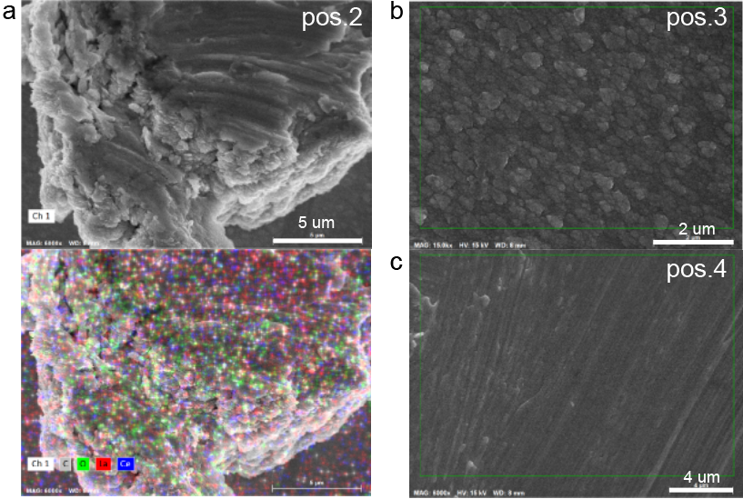
Fig. S17. The SEM photos of other positions in DAC #5. (a) The selected particle (top) and the element distribution on it (bottom). (b, c) Positions 3 and 4.
Run #6

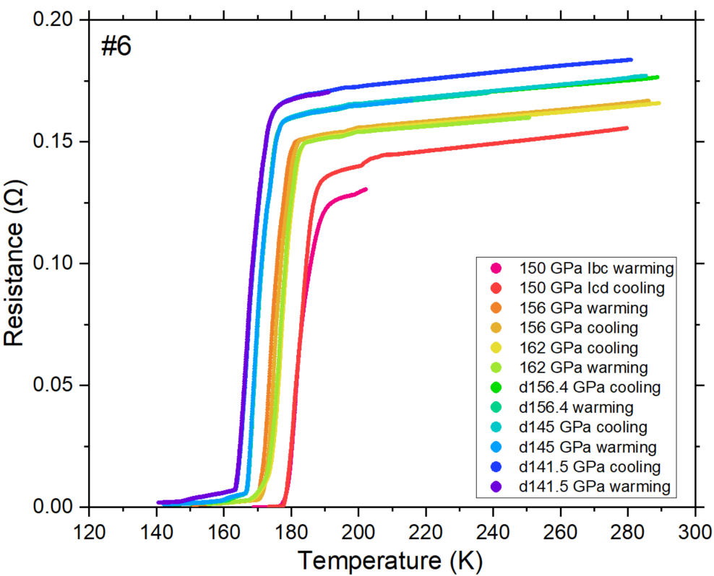
Fig. S18. Temperature dependence of the electrical resistance for the La-Ce-H sample in DAC #6 at different pressures.

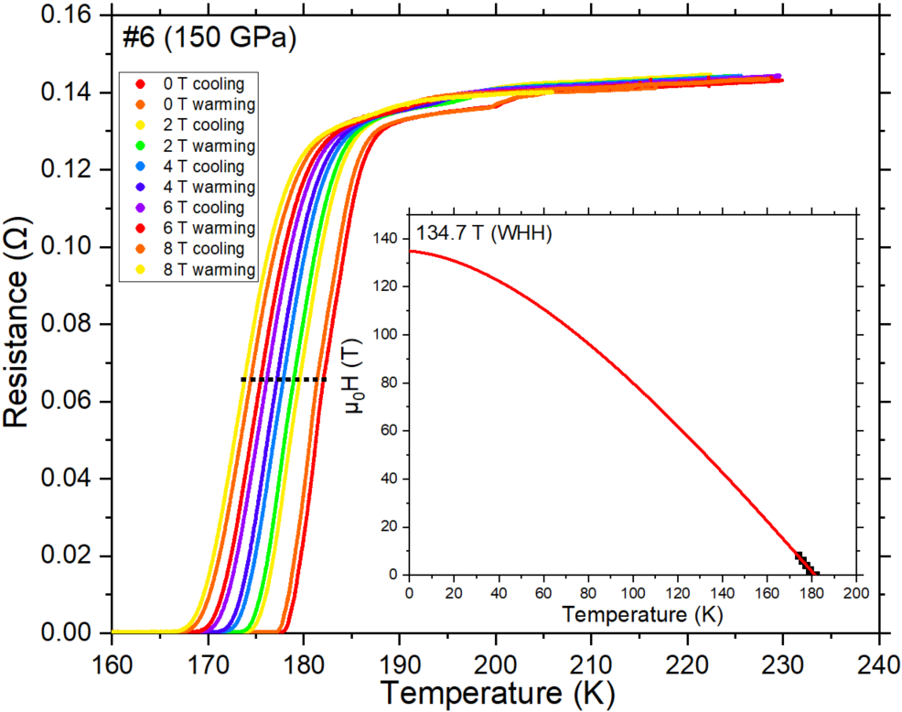
Fig. S19. Superconducting transitions of sample #6 under an external magnetic field at 150 GPa. Black dots indicate the positions where the T_{c}s where taken. Inset is the fitting with the simplified WHH formula.

Run #7
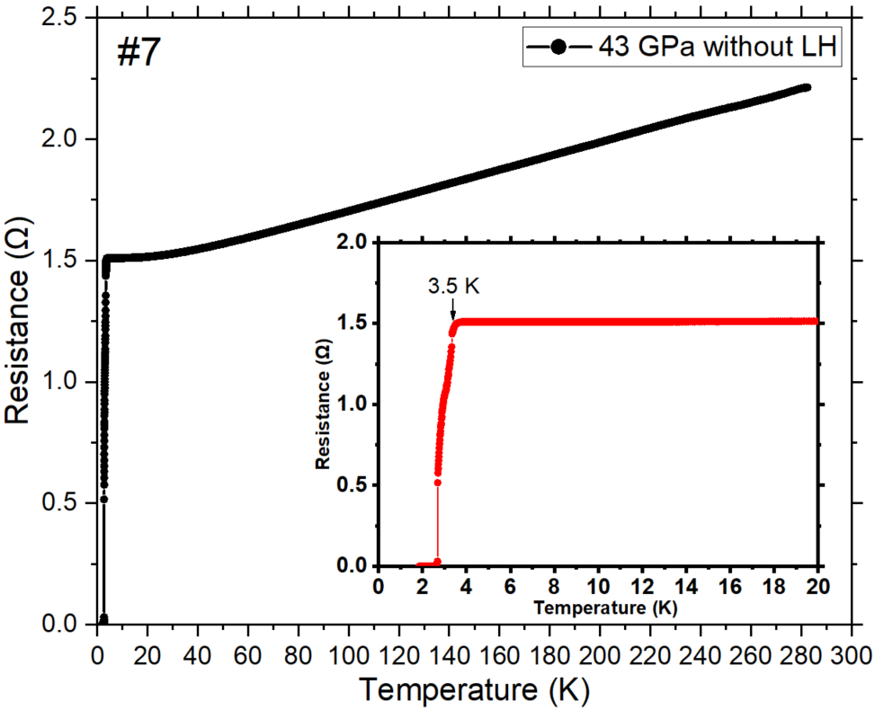
Fig. S20. R–T dependence of La–Ce alloy in run #7 at 43 GPa before the laser-heating (LH). Inset shows the enlarged part of the plot.

Run #8
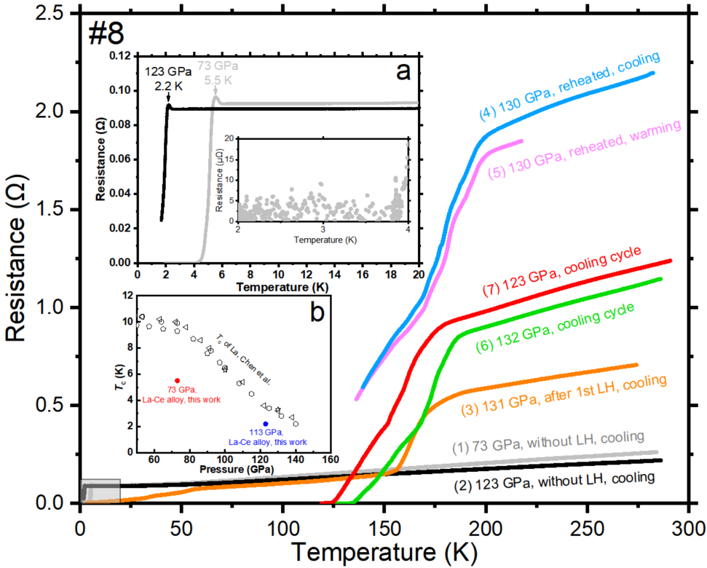
Fig. S21. R–T dependence of the sample in DAC #8 at different conditions. Numbers from (1) to (7) indicate the sequence of the experiments. Inset (a) shows the enlarged part of the plot, with the superconducting transition of La–Ce alloy before the laser-heating. In inset (b), a comparison of T_{c} of the La–Ce alloy and pure La is shown⁸.
Run #9
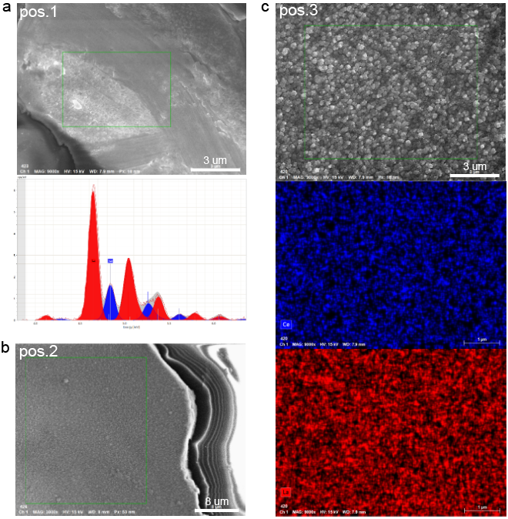
Fig. S22. The EDX analysis of the La–Ce alloy in DAC #9. (a) Top: the selected particle, bottom: L-Serie energy spectrum of the La–Ce alloy. (b) SEM photo at position 2. (c) Top: SEM photo at position 3, middle: Ce distribution, bottom: La distribution.

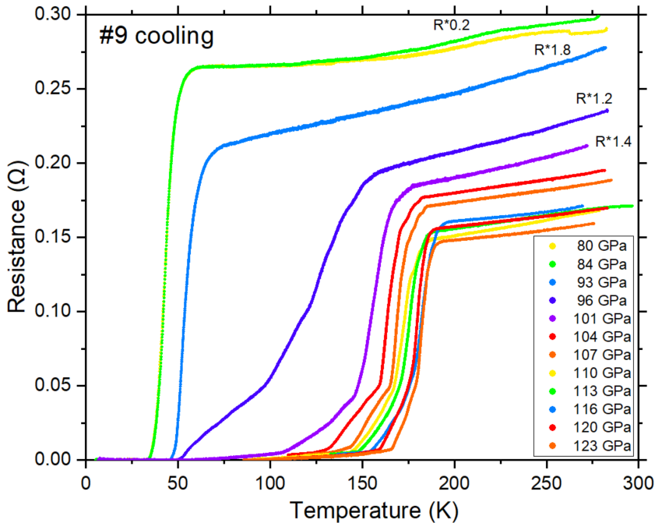
Fig. S23. Temperature dependence of the electrical resistance for the La-Ce-H sample in DAC #9 in the cooling cycle at different pressures. For the curves at low pressure, the resistances are multiplied by different factors.
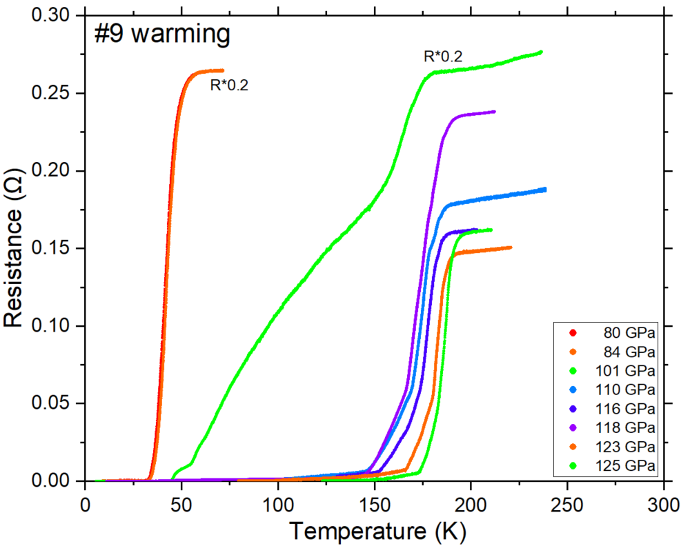
Fig. S24. Temperature dependence of the electrical resistance for the La-Ce-H sample in DAC #9 in the warming cycle at different pressures. For the curves at low pressure, the resistances are multiplied by factors 0.2.

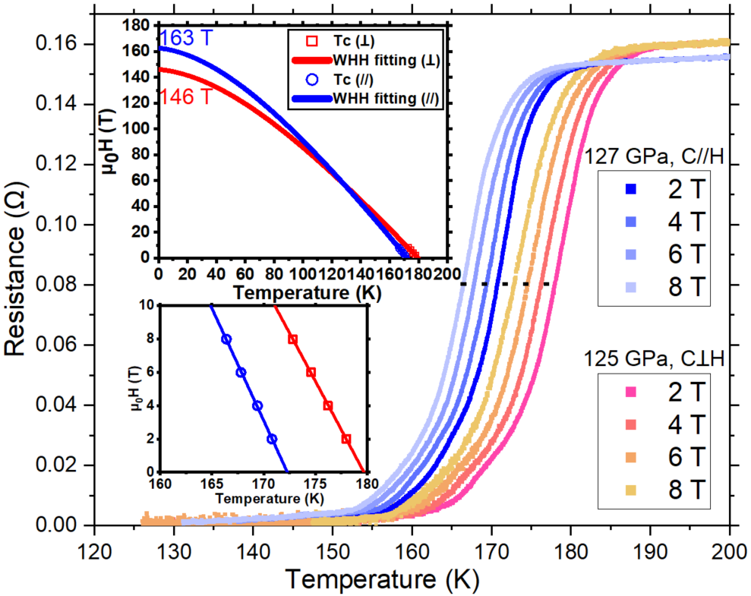
Fig. S25. Superconducting transitions of sample #9 under an external magnetic field at 125 and 127 GPa. Black dots indicate the positions where the T_{c}s where taken. Insets are the fitting with the simplified WHH formula and the enlarged part of fitting, respectively.

An important question in studies of hydride superconductivity is the presence or absence of anisotropy in the behavior of samples in an external magnetic field. To investigate possible anisotropy, we applied a magnetic field parallel and perpendicular to the culet in DAC #9, keeping the sample exactly in the center of the field (Fig. S25). The upper critical field was measured first in the perpendicular position at 125 GPa, showing H_{c2}(0) = 146 T. After DAC #9 was taken out of the cryostat and rotated by 90°, the pressure increased by 2 GPa, thus both the onset resistance and T_{c} decreased slightly. However, H_{c2}(0) increased to 163 T. Therefore, this La–Ce–H sample may have a texture, which leads to the difference in the upper critical magnetic fields: H_{c2||} > H_{c2⊥}. This is the first such experimental study of anisotropy for superhydrides in DACs.

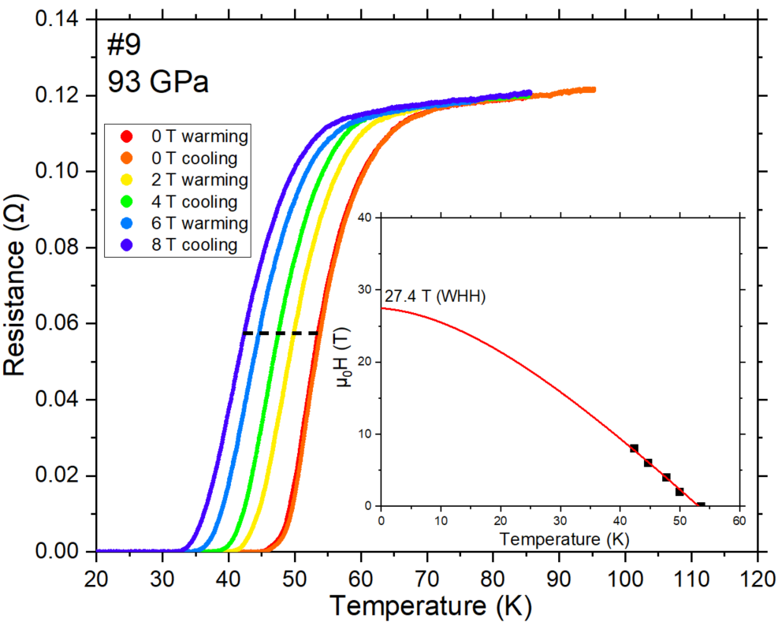
Fig. S26. Superconducting transitions of sample #9 under an external magnetic field at 93 GPa. Black dots indicate the positions where the T_{c}s where taken. Inset is the fitting with simplified WHH formula.

Run #L1

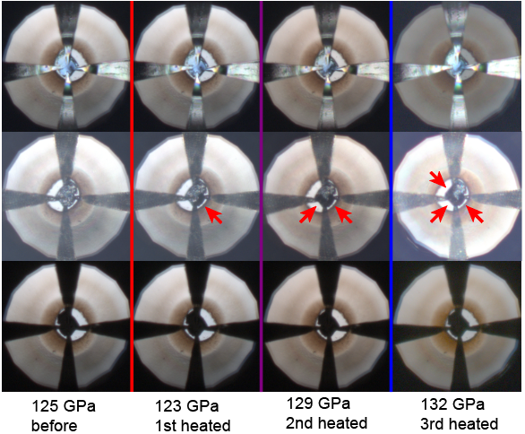
Fig. S27. Photographs of the sample in DAC #L1 before and after laser-heating for three times. The tips of four Pt electrodes were directly compressed to the edge of the sample. Arrows show the changes of the sample after the heating.

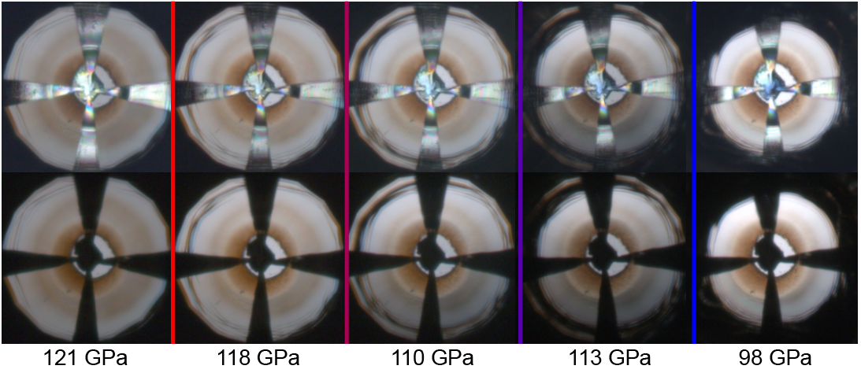
Fig. S28. Changes of the diamond’s bevel during decompression of DAC #L1 at different pressures.

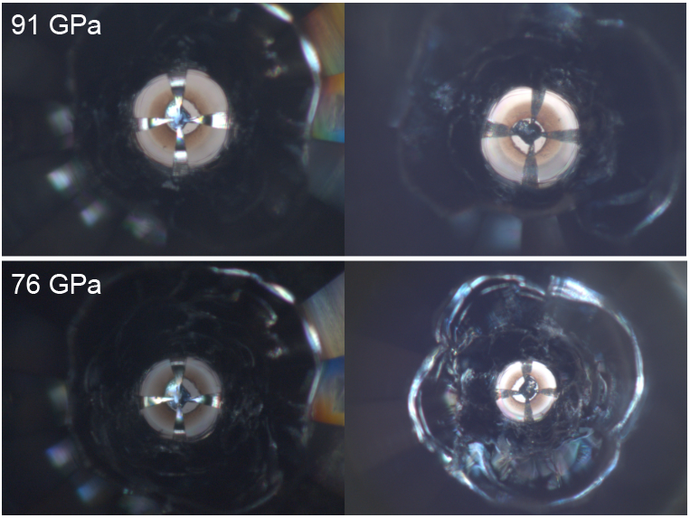
Fig. S29. Front and back views of the diamonds in DAC #L1 at 91 GPa and 76 GPa.

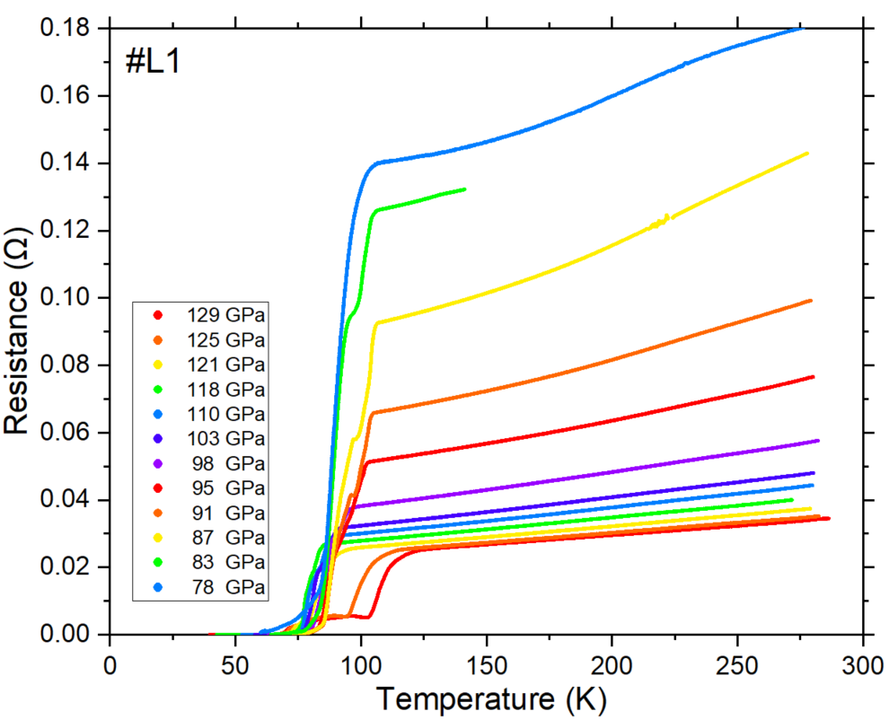
Fig. S30. Temperature dependence of the electrical resistance for the La- H sample in DAC #L1 at different pressures.

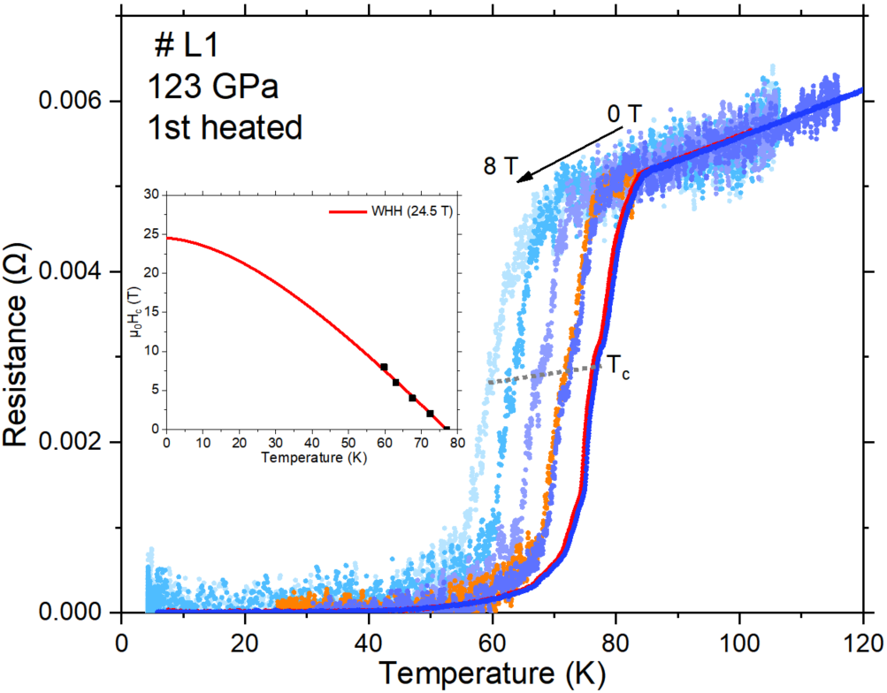
Fig. S31. Superconducting transition in DAC #L1 characterized by the temperature dependence of the resistance in an external magnetic field at 123 GPa after the first laser-heating. Inset shows the WHH fitting of the experimental data.

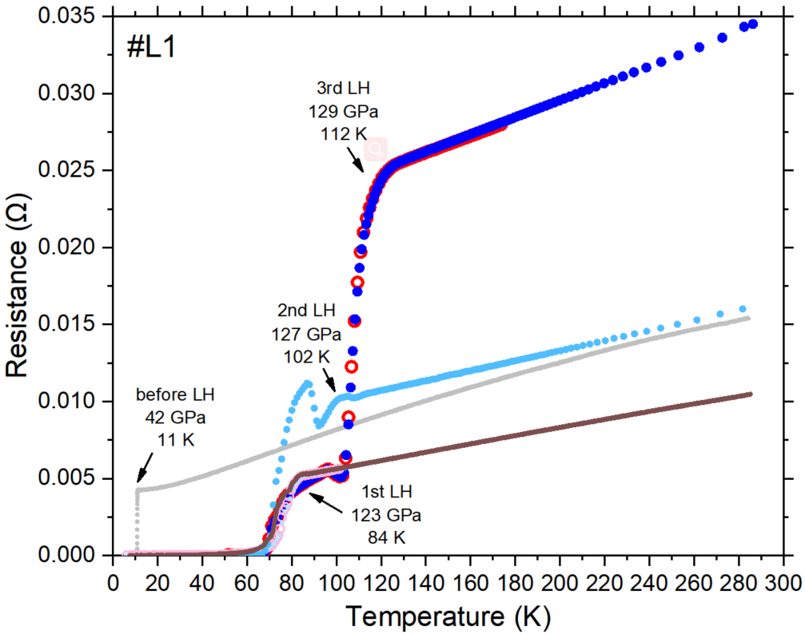
Fig. S32. Temperature dependence of the electrical resistance after laser-heating (LH) for three times. Solid circles represent the cooling cycle, and open circles represent the warming cycle. The horizontal density of the data points indicates the rate of the temperature change.
Run #L2
Currently, there is no effective way to reduce the plastic deformation of the insulating gasket. Considering that the circular cracks are related to the cleavage feature and the anisotropy of hardness peculiar to single-crystal diamond (SCD)⁹, we tested the nano-polycrystalline diamond (NPD) then¹⁰. NPD consists of randomly oriented fine diamond nanocrystals and has higher Knoop hardness than SCD¹¹. Besides, NPD has been well studied for ultrahigh-pressure measurements^{12,13,14,15}. Here, we used NPD for the decompression process. Additionally, it is expectable that the longitudinal cleavage plane (Fig. S6) arising inside the SCD mainly because of the hydrogen diffusion can be effectively suppressed. We combined a flat NPD with a 200 μm culet and a beveled SCD (200 μm to 100 μm in 8.5°) in DAC #L2 (Fig. S33). The pressure dropped from 113 GPa to 111 GPa after the laser-heating, and a very clear transition was detected at 80 K (Fig. S34). Upon further decompression, T_{c} can be tracked to 92 K at 77 GPa (Fig. S35).

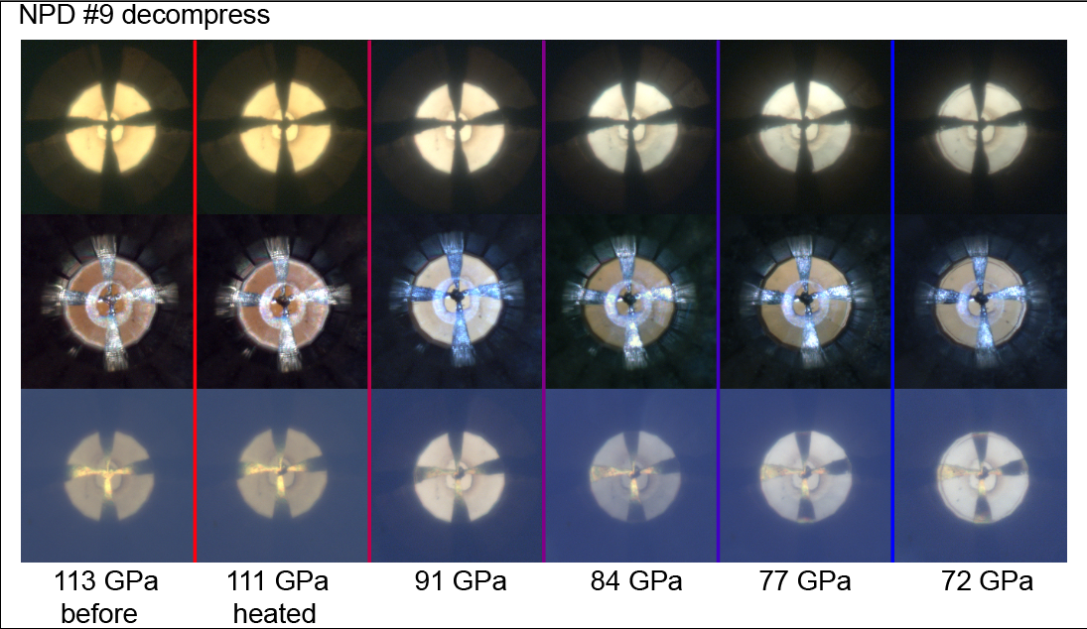
Fig. S33. Different photographic views of the diamond’s bevel during the decompression of DAC #L2.

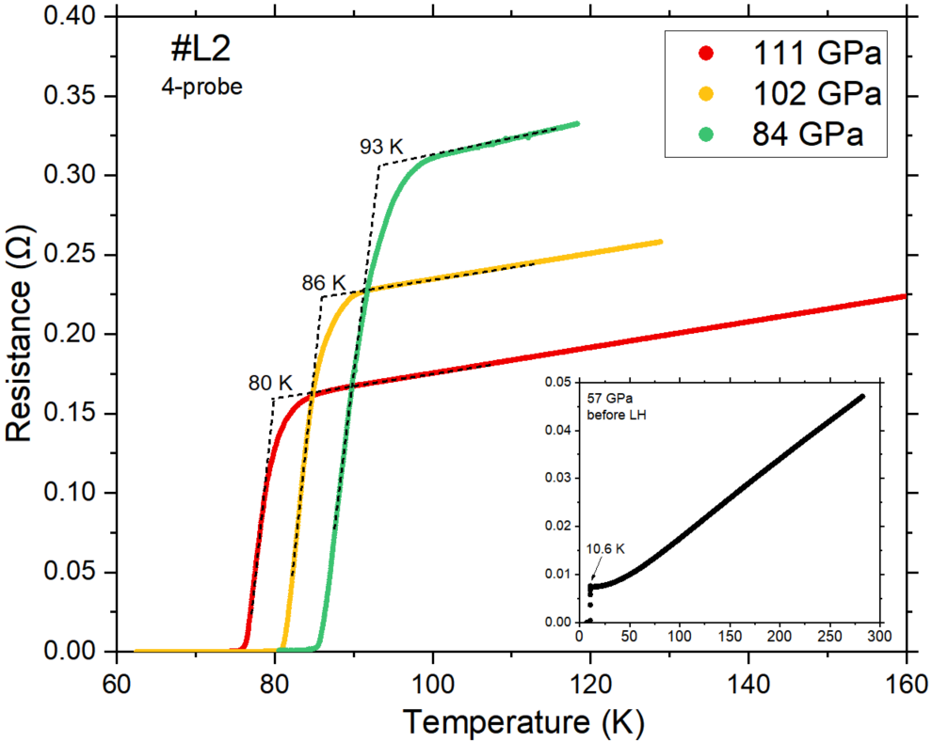
Fig. S34. Temperature dependence of the electrical resistance, measured using the four-probe method, showing the superconducting transitions of LaH_{x} in DAC #L2. Inset shows the superconducting transition of pure La at 57 GPa before the laser-heating.

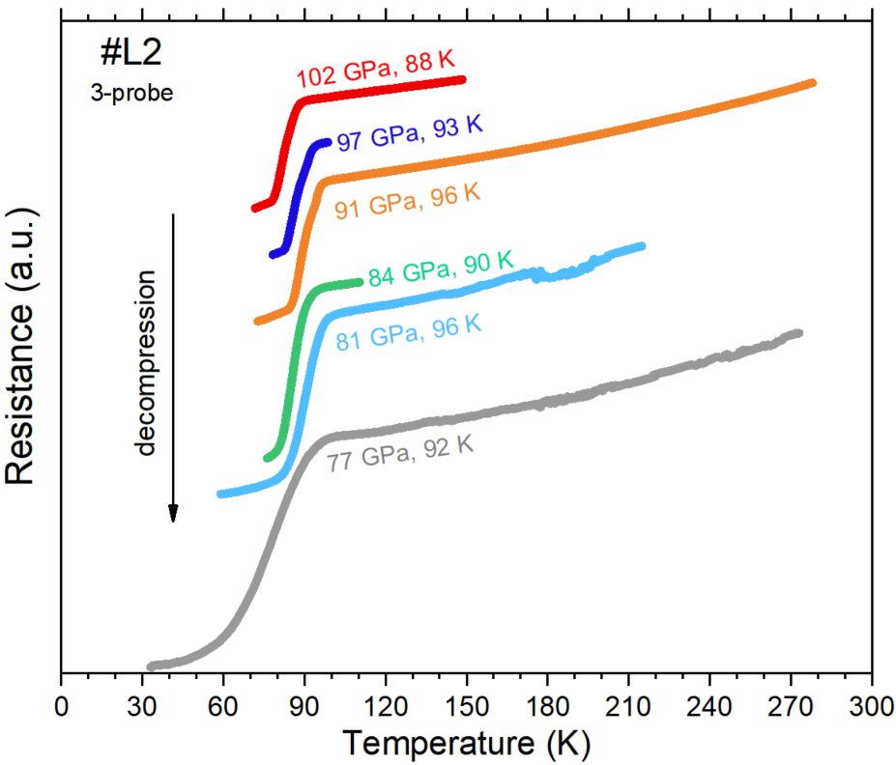
Fig. S35. Temperature dependence of the electrical resistance, measured using the three-probe method, showing the superconducting transitions of LaH_{x} in DAC #L2 during decompression.
Run #L3
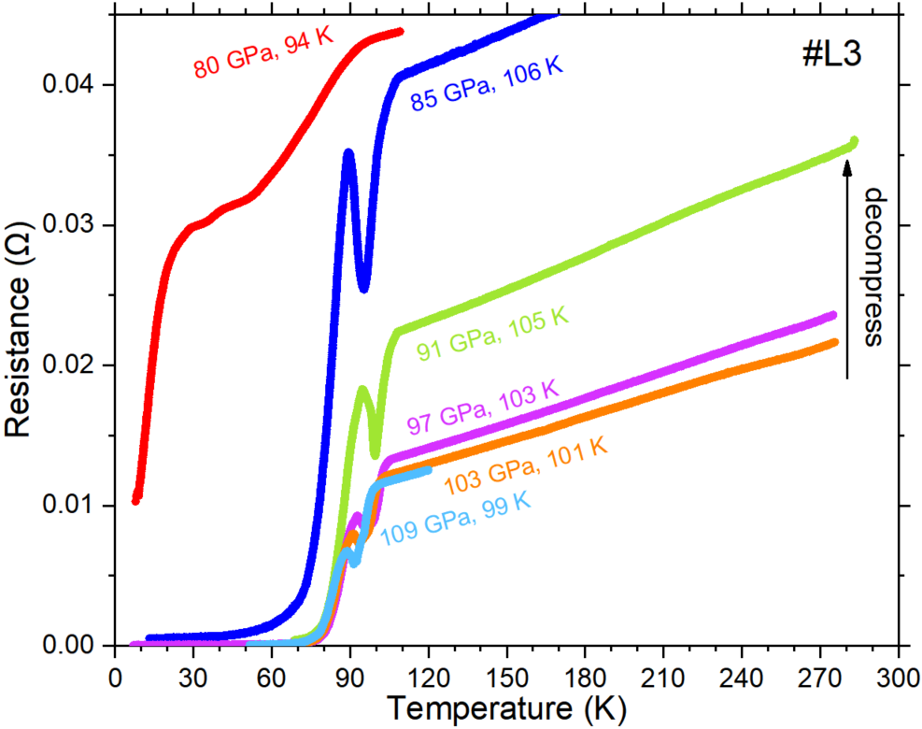
Fig. S36. Temperature dependence of the electrical resistance showing the superconducting transitions of LaH_{x} in DAC #L3.

Run #S
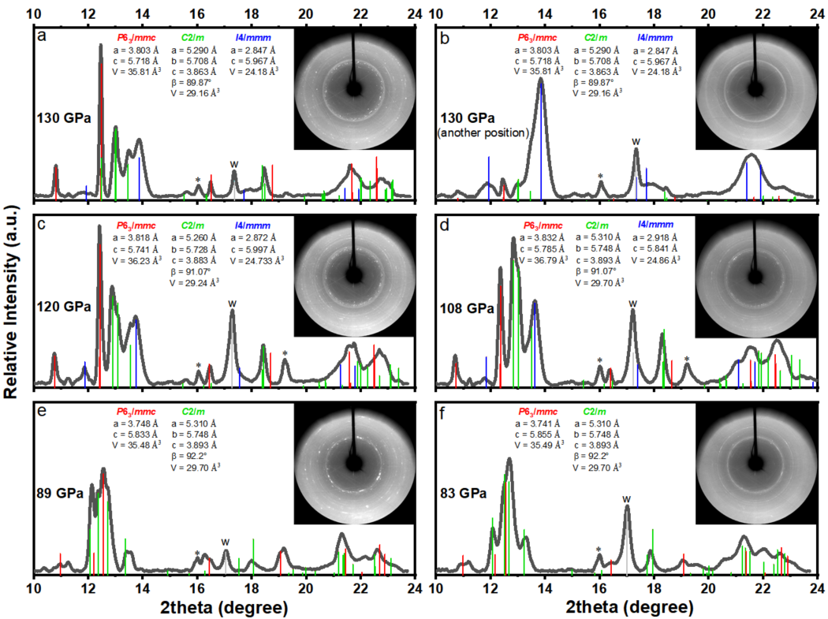
Fig. S37. Indexing of the synchrotron XRD data (λ = 0.6199 Å) for the sample in DAC #S during decompression. Insets show the XRD patterns.
Further discussions

Here are several points to distinguish the SC transition from binary hydrides. First, all the SEM+EDX, XRD, and R–T measurements revealed a good quality of the La–Ce alloy at ambient conditions. After the compression of the samples to a certain pressure, electrical measurements showed a sharp transition at a temperature obviously lower than T_{c} of pure La (Fig. S20 and S21)⁸. This indicates that the introduction of Ce atoms actually affects T_{c}. Second, the superconducting transitions in the La–Ce–H system are considered to be arising from the main phase of P6₃/mmc-(La,Ce)H₉₋₁₀, rather than C2/m-LaH₁₀¹⁶. Meanwhile, laser heating the sample at 152 GPa did not achieve as high T_{c} as that of LaH₁₀. Previously, Geballe et al. have detected the evolution of the XRD patterns during the decompression of Fm$\overline{3}$m-LaH₁₀ from 169 GPa to 27 GPa (Fig. S8 in Ref.¹⁷). We noticed that the main peak abnormally shifted to the higher angles at 121–109 GPa, and some new peaks emerged, which was characteristic of the decomposition and appearance of a new phase, possibly P6₃/mmc-LaH_{x}. This is not in accord with the nearly linear T_{c}–P trend of the current La–Ce–H system. Third, the synthesized compounds of the La–Ce–H system have much higher T_{c} than binary La–H and Ce–H phases in the same pressure range.

Table S2. Results of processing the dependence of electrical resistance on temperature according to the Bloch-Grüneisen formula for the cerium-lanthanum polyhydride (La,Ce)H_{9+x}. The resulting compound has a superconducting gap

DAC | Pressure, GPa | T_{D}, K | ~ω_{log}, K  (0.827×T_{D}) | λ | T_{C}, K (μ*=0.1) | Δ(0), meV
Cell 2 | 95 | 868 | 718 | 2.62 | 156 | 35.5
Cell 2 | 98 | 750 | 620 | 3.26 | 161 | 38.1
Cell 2 | 100 | 514 | 425 | 5.6* | 164 | 37
Cell 3 | 131 | 750 | 620 | 3.29 | 165 | 39.2
Cell 3 | 132 | 948 | 784 | 2.48 | 166 | 35.5
Cell 3 | 140 | 878 | 726 | 2.72 | 166 | 38.2
Cell 6 | 150 | 1026 | 848 | 2.6 | 187 | 42.7
Cell 6 | 156 | 1124 | 930 | 2.24 | 180 | 39.6
Cell 9 | 107 | 738 | 610 | 3.65 | 176 | 42.2
Cell 9 | 93 | 587 | 485 | 1.41 | 59** | 11.3
Cell 9 | 123 | 1107 | 915 | 2.27 | 179 | 39.5
Cell 9 | 113 | 662 | 547 | 4.42* | 182 | 43.4
theory
LaCeH₁₈ | 120 | ~704 | 582 | 3.16 | 159 | 38
La₃CeH₃₆ | 120 | ~827 | 684 | 2.16 | 131 | 28.8
* Probable phase transition
** Decomposition with losing hydrogen

Table S3. Results of processing the dependence of electrical resistance on temperature according to the Bloch-Grüneisen formula for the lanthanum polyhydrides LaH_{x}. Comparison of experimental and theoretical T_{C} allows us to estimate x < 9.
DAC | Pressure, GPa | T_{D}, K | ~ω_{log}, K  (0.827×T_{D}) | λ | T_{C}, K (μ*=0.1)
L1 | 129 | 546 | 451 | 3.11 | 115
L1 | 125 | 582 | 481 | 2.66 | 108
L1 | 121 | 504 | 417 | 2.54 | 90 ª
L1 | 118 | 470 | 389 | 2.58 | 85 ª
L1 | 110 | 516 | 427 | 2.41 | 88 ª
L1 | 103 | 532 | 440 | 2.42 | 91
L1 | 98 | 574 | 475 | 2.36 | 96
L1 | 95 | 732 | 605 | 1.95 | 103
L1 | 91 | 778 | 643 | 1.87 | 105
L1 | 87 | 834 | 690 | 1.75 | 106
L1 | 78 | 1040 | 860 | 1.38 ^{b} | 101
L2 | 111 | 446 | 369 | 2.60 | 81 ª
L2 | 102 | 302 | 250 | 4.64 ^{c} | 86
L2 | 84 | 472 | 390 | 2.86 | 93
L3 | 103 | 480 | 397 | 3.11 | 101 ª
L3 | 97 | 524 | 433 | 2.82 | 102
L3 | 91 | 514 | 425 | 3.03 | 106
L3 | 85 | 562 | 465 | 2.65 | 104
theory
P1-LaH₁₀ | 135 | 764 | 632 | 3.64 | 193
P6₃/mmc-LaH₉ | 120 | 447 | 370 | 4.73 | 150
ª Linear temperature dependence R(T)
^{b} Phase transition to stable phase with less hydrogen content
^{c} Vicinity of phase transition

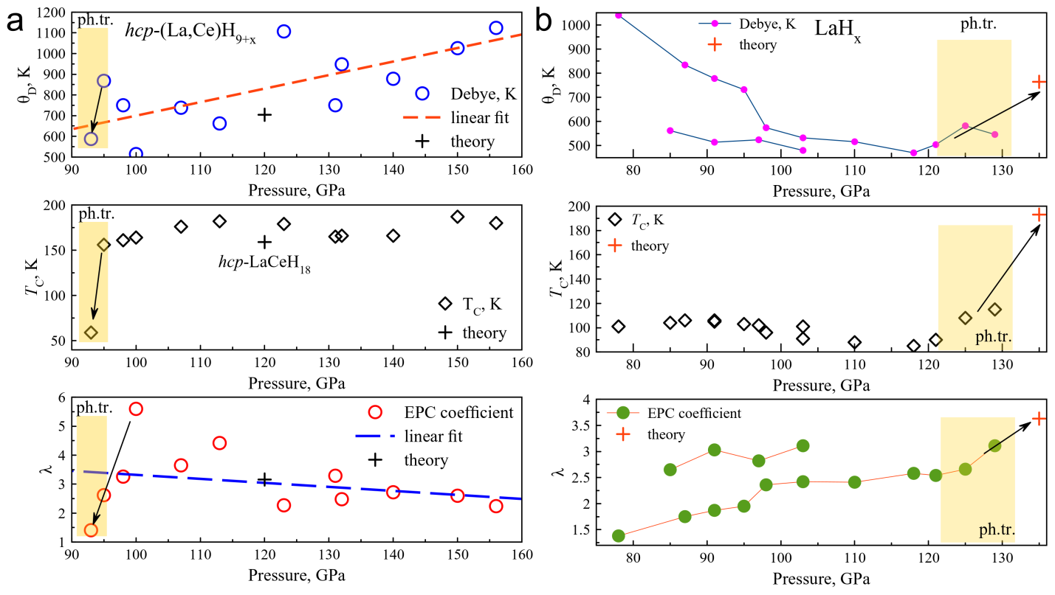
FIG. S38. Dependence of superconducting state parameters on pressure in (a) La-Ce ternary hydrides. Data obtained using Bloch-Grüneisen and Allen-Dynes formulas. The onset of phase transformations (“ph.tr.”) in Ce-La and LaH_{x} hydrides is highlighted by yellow strips. Simultaneous changes in all studied parameters are shown by arrows. “Theory” corresponds to QE calculations.

It is interesting that the dependence of the EPC parameter (λ) and the logarithmically averaged frequency (ω_{log}) are non-monotonic functions of pressure for the studied polyhydrides. It is generally assumed that the Debye temperature and ω_{log} will increase with increasing pressure. However, as Fig. S38b shows, this is not always the case. As the pressure increases, a phase transition to a more highly symmetric polyhydride modification may occur with a change in its stoichiometry. Such processes are usually accompanied by the appearance of "soft" phonon modes, a significant increase in the EPC coefficient, and a decrease in the average phonon energy.
In the cases studied, the phase transformations occur in the low-pressure interval of 90-100 GPa for Ce-La polyhydrides and in the high-pressure interval > 130 GPa for lanthanum hydrides. Simultaneous changes in all three parameters λ, T_{C}, ω_{log} and high values of λ correspond to these regions. In particular, for (La,Ce)H_{9+x} (Fig. S38a), an abnormally high λ > 5 is observed at 100 GPa, which rapidly decreases to ≈1.5 at the pressure interval around 15 GPa, simultaneously with a sharp fall in the critical temperature of almost 3 times and a decrease in Debye temperature. This speaks in favor of a phase transformation with the loss of some hydrogen.

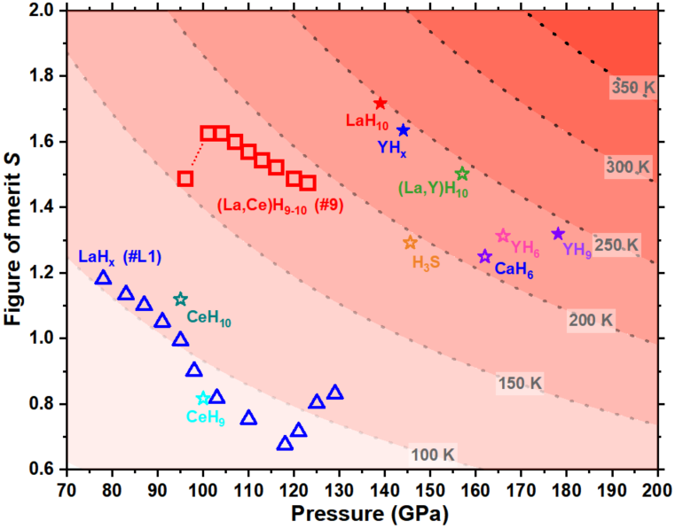
Fig. S39. S-P diagram of hcp-(La,Ce)H₉₋₁₀ and LaH_{x}, including the experimentally highest S value of the well-known superconducting polyhydrides^{16,18,19,20,21,22,23,24}. Solid symbols use the pressure scale of the hydrogen vibration. Dashed lines represent isotherms.
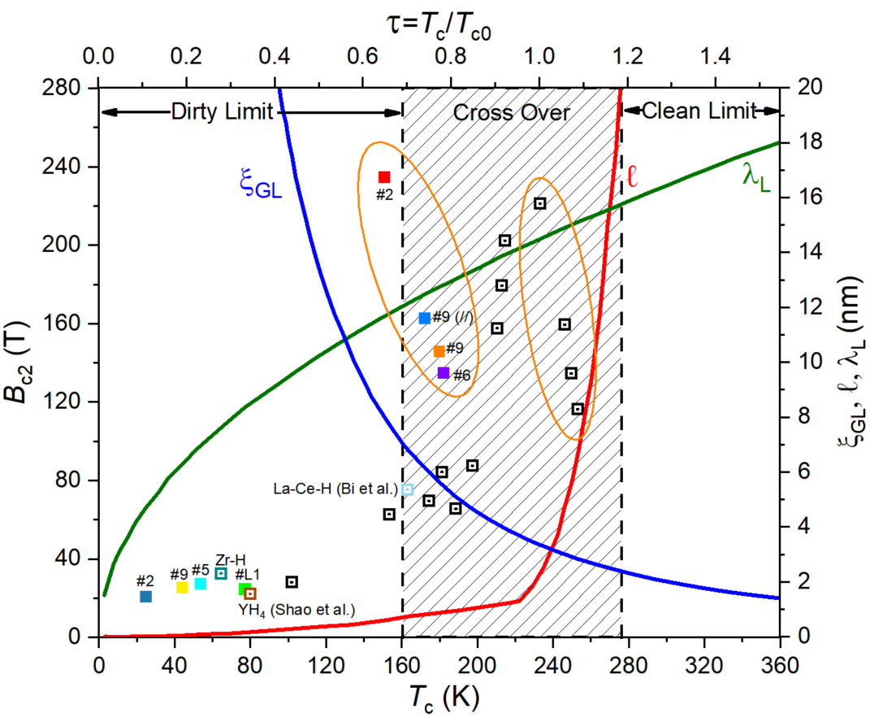
Fig. S40. The merged Fig. 1. (Various physical parameters from the GLAG theory applied to H-rich superconductors.) and Fig. 2. (The upper critical magnetic field B_{c2}) from Ref.²⁵, together with our data (colorful solid squares).

Theoretical calculations
The calculations of superconducting T_{C} were carried out using Quantum ESPRESSO (QE) package^{26,27}. The phonon frequencies and electron–phonon coupling (EPC) coefficients were computed using the density functional perturbation theory²⁸, employing the plane-wave pseudopotential method with a cutoff energy of 70-80 Ry, and the Perdew–Burke–Ernzerhof or exchange–correlation functionals^{28,29,30}. Within the optimized tetrahedron method³¹, we calculated the electron–phonon coupling coefficients λ and the Eliashberg functions via sampling of the first Brillouin zone by 12×12×8 k-points and 3×3×2 q-points meshes. To evaluate the density of states (DOS) and electron–phonon linewidths, a denser 16×16×12 k-mesh was used. PBE PAW pseudopotentials for Ce, La and H (pbe-spfn-kjpaw_psl) were used with a plane-wave basis set cutoff of 70 Ry for calculations of superconducting properties of (La,Ce)H₉. The k-space integration (electrons) was approximated by a summation over the 8×6×6 uniform grid in reciprocal space for the self-consistent cycles, the used supercell was up to La₃CeH₃₆. Dynamical matrices and electron–phonon linewidths were calculated on a uniform 4×3×3 grid in q-space. The harmonic approximation was used for all theoretical calculations. Therefore, the obtained electron-phonon interaction coefficients for lanthanum and lanthanum-cerium polyhydrides at low pressures may be overestimated.

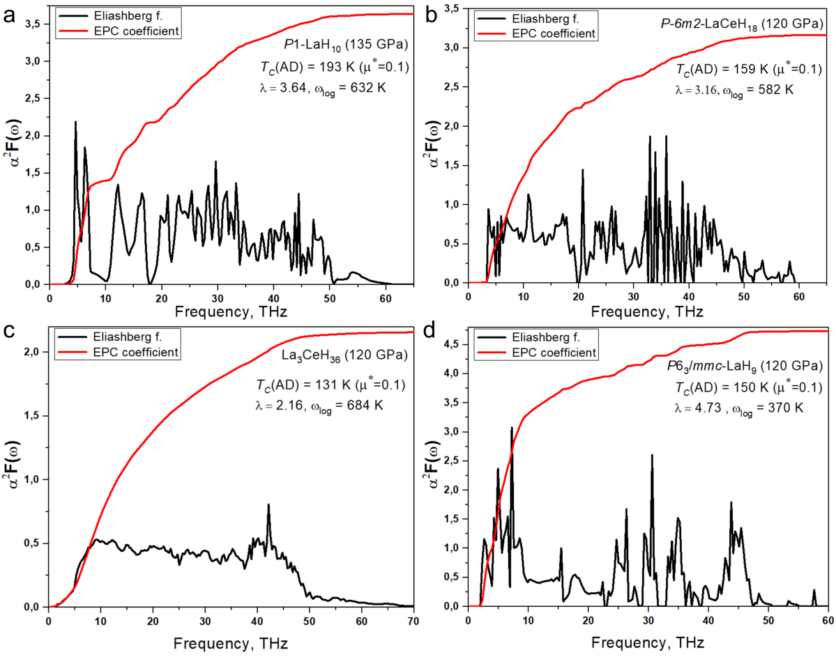
Fig. S41. Harmonic Eliashberg functions of studied La-Ce and La polyhydrides calculated within the tetrahedron method. Distorted (P1) LaH₁₀ at 135 GPa (a), P-6m2-LaCeH₁₈ at 120 GPa (b), hexagonal La₃CeH₃₆ at 120 GPa (c), and P6₃/mmc-LaH₉ at 120 GPa. Red curves correspond to integrated EPC coefficient λ(ω). In the harmonic approximation, most of the compounds studied are unstable (see also Fig. S43), so soft modes < 5 THz are excluded from the calculation.

The resulting Eliashberg functions require some discussion. As can be seen from Fig. S41d, the large values of the electron-phonon interaction coefficient (λ > 4.7) for hexagonal LaH₉ at 120 GPa indicate its dynamic instability. This is one of the reasons why we do not observe the formation of this compound in the experiment. However, various dopants can stabilize a hexagonal P6₃/mmc-XH₉ structure at this pressure. One of them is Ce, which forms a stable hexagonal CeH₉^{32,33,34}. Obviously, there is a certain critical concentration of cerium that stabilizes the hexagonal structure of XH₉. Both 25 at.% (this work) and 50 at.%³⁵ of cerium will definitely stabilize such a structure in the experiment. However, as we can see from Fig. S41c, the polyhydride with 25 at.% cerium has α²F(ω) characteristic of amorphous alloys and films (see for example^{36,37}), which indicates the beginning of destruction of the ordered hexagonal structure. As the cerium concentration decreases to the critical value, the stability of hexagonal (La,Ce)H₉ will decrease, while the electron-phonon interaction coefficient (λ) and the critical temperature of superconductivity (T_{C}) will increase until (La,Ce)H₉ decomposes. This explains why the critical temperature for La_{0.75}Ce_{0.25}H₉ is greater than for La_{0.5}Ce_{0.5}H₉. An additional factor is also the suppression of superconductivity due to spin-flipping scattering on the local magnetic moments of Ce atoms³⁸.

FIG. S42. Electronic properties of hexagonal La₃CeH₃₆ at 120 GPa calculated using VASP (PAW PBE) code. (a) Partial contribution of different orbitals (s, p, d, f) to the density of states. (b) Structural model of model of the described compound. (c) Band structure of La₃CeH₃₆. vHs can be seen near “C₂”. (d) Total electron density of states and the partial contribution of La, Ce and H atoms.

Note the relatively high contribution (0.17 states/eV/metal atom) of the f-electrons to the total density of states (DOS, 0.5 states/eV/metal atom), which results in a lower T_{C} than in pure P6₃/mmc-La₂H₁₈ (Fig. S42). The contribution to the DOS from hydrogen is significant (0.12 states/eV/metal atom) and is at a similar level as from La and Ce. There is a van Hove singularity (vHs) in the vicinity of k(C₂) at the Fermi level. It is noteworthy that the introduction of only 25 at.% Ce provides the same density of states as 75 at.% La. However, there is no profit from that due to the increased Cooper pair-breaking on a small magnetic moment of Ce atoms. In addition, we should say the DOS changes in the vicinity of the Fermi level (decreasing by 15% in the interval of 200 meV), which limits the application of the constant DOS approximation³⁹. Found values of the DOS and λ (experimental and theoretical) allow us to estimate the upper magnetic field μ₀H_{C2}(0)^{21,24} using an empirical formula (see Theoretical Methods), which has shown good results for many polyhydrides. We get μ₀H_{C2}(0) ~ 41-45 T (Table S3), much less than the experimental value (> 200 T), but quite close to the results of a similar investigation⁴⁰.
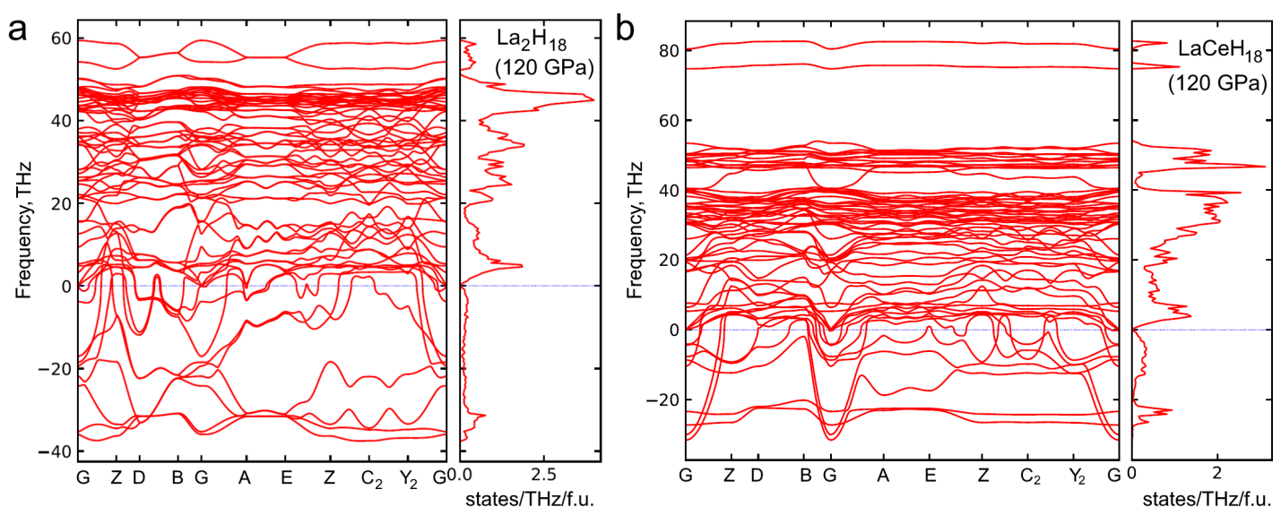
Fig. S43. Phonon band structure and density of states of distorted hexagonal (P6₃/mmc) La₂H₁₈ (a) and LaCeH₁₈ (b) at 120 GPa calculated within harmonic approximation (f.u. = La₂H₁₈ and LaCeH₁₈). Both compounds are dynamically unstable, but LaCeH₁₈ has shorter imaginary “tail” which allows us to say that cerium somewhat stabilizes the hexagonal XH₉ structure.

Many recent experimental studies of polyhydrides (e.g., LaH₁₀^{41,42}, LaYH₂₀⁴³, CeH₉³⁴, etc.) have shown that they are stable at much lower pressures than the dynamic stability criterion based on the harmonic approximation predicts. This serious discrepancy between the theoretical predictions and the experiment greatly devalues the harmonic calculations. We also investigated the applicability of Born's criteria^{44,45} for hexagonal and cubic crystals under static isotropic pressure P to our polyhydrides. Table S5 shows that all compounds (LaH₁₀, LaCeH₁₈ and La₃CeH₃₆) are mechanically stable except P6₃/mmc-LaH₉, for which two criteria are not met. However, the accuracy of the calculations performed (VASP code, PAW PBE) is insufficient to state unambiguously that the mechanical Born’s stability criteria are better than the harmonic phonon analysis.

Table S4. Parameters of the superconducting state of La-Ce and La polyhydrides calculated using the isotropic Migdal–Eliashberg equations (E)⁴⁶ and the Allen–Dynes formula (A–D)⁴⁷ with μ* = 0.15–0.1.
Pressure/compound | 120 GPa  hcp-LaCeH₁₈ | 120 GPa  hcp-La₃CeH₃₆ | 120 GPa  P6₃/mmc-La₂H₁₈ | 135 GPa  P1-LaH₁₀
λ | 3.16 | 2.16 | 4.73 | 3.64
ω_{log}, K | 582 | 684 | 370 | 632
ω₂, K | 987 | 1088 | 772 | 1037
α | 0.48-0.49 | 0.47-0.49 | 0.48-0.49 | 0.48-0.49
T_{C} (A–D), K | 146-159 | 117-131 | 141-150 | 179-193
T_{C} (E), K | 172-187 | 136-150 | 164-178 | 215-231
N(E_{F}), states/eV/metal* | 0.82 | 0.77 | 0.79 | 0.78
Δ(0), meV | 41.2-44.7 | 30.2-34.2 | 32.2-30 | 51-53.5
μ₀H_{C}(0), T | 57-59 | 41-45 | 45-44 | 67-68
ΔC/T_{C}, mJ/mol·K² | 17.8-13.7 | 17.1-16.9 | - | 10.6-4.14
γ, mJ/mol·K² | 8.05 | 5.7 | 10.7 | 8.5
R_{Δ} = 2Δ(0)/k_{B}T_{C} | 5.54 | 5.15-5.29 | 4.55-3.9 | 5.5-5.4
*Calculated using Quantum ESPRESSO code (pbe-spdn-kjpaw_psl pseudopotentials).

The calculation of the Debye temperature using elastic constants (Table S5) gives good agreement with the averaged experimental data for La₃CeH₃₆ (θ_{D}(exp) ≈ 810 K, see linear fit in Fig. S38a), but much worse for LaH₁₀ which indicates that the experimentally synthesized compound in DACs L1-L3 is not P1-LaH₁₀ and has a lower hydrogen content. Estimation of the average Fermi velocity V_{F} ~ 4.76 × 10⁵ m/s in hexagonal La₃CeH₃₆ at 120 GPa makes it possible to estimate the London penetration depth of (La,Ce)H₉ polyhydrides λ_{L} ~ 110 nm, coherence length ξ_{BCS} = 23 nm, and lower critical magnetic field μ₀H_{C1} = 0.09 T. The calculated Ginzburg–Landau parameter⁴⁸ is over 46, which is typical for type-II superconductors.

Table S5. Elastic and thermodynamic parameters of lanthanum-cerium and lanthanum polyhydrides.
Pressure/compound | 120 GPa  hcp-LaCeH₁₈ | 120 GPa  hcp-La₃CeH₃₆ | 120 GPa  P6₃/mmc-La₂H₁₈ | 135 GPa  P1-LaH₁₀
a, Å | 3.726 | 3.763 | 3.758 | 3.590
c, Å | 5.470 | 5.444 | 5.478 | 3.589
V_{DFT}, Å³ | 65.60 | 135.68 | 67.15 | 34.46
C₁₁, GPa | 517.9 | 629.9 | 461.7 | 532.1
C₁₂, GPa | 279.1 | 165.5 | 388.5 | 175.9
C₁₃, GPa | 204.7 | 180.3 | 186.1 | 198.3
C₂₂, GPa | 552.7 | 470.0 | 483.6 | 557.3
C₂₃, GPa | 195.6 | 167.8 | 162.6 | 234.7
C₃₃, GPa | 497.9 | 482.2 | 480.2 | 534.03
C₄₄, GPa | 66.8 | 130.6 | 13.3 | 211.1
C₅₅, GPa | 9.1 | 19.3 | 99.5 | 241.2
C₆₆, GPa | 119.4* | 81.6 | 108.2 | 252.0
C₁₁-|C₁₂| – P, GPa | 118.8 | 344.4 | -46.9 | 221.2**
C₃₃(C₁₁+C₁₂)-2C₁₃², GPa² | > 0 | > 0 | > 0 | > 0
С₄₄ – P/2, GPa | 6.8 | 70.6 | -46.7 | 143.6**
B, GPa | 322.6 | 282.0 | 305.6 | 314.8
G, GPa | 61.0 | 88.4 | 62.1 | 201.1
E, GPa | 172.1 | 238.4 | 172.9 | 497.3
Poisson ratio η | 0.41 | 0.36 | 0.41 | 0.24
Debye temperature θ_{D}, K | 637 | 761 | 642 | 1130
, K | 527 | 629 | 531 | 935
* Calculated as (C₁₁-C₁₂)/2 due to computational problems with convergence
** P = 135 GPa instead of 120 GPa.

Theoretical Methods
To calculate isotope coefficient α, the Allen-Dynes interpolation formulas were used:
, | (S1)
, | (S2)
where the last two correction terms are usually small (~0.01).
The superconducting transition temperature T_{C} was estimated by Allen-Dynes formula in the following form:
$$T_{C}=ω_{log}\frac{f_{1}f_{2}}{1.2}\exp\left(\frac{-1.04\left(1+λ\right)}{λ-μ^{*}-0.62λμ^{*}}\right),$$ |  | (S3)
where  $$f_{1}f_{2}=\sqrt[3]{1+{\left(\frac{λ}{2.46\left(1+3.8μ^{*}\right)}\right)}^{\frac{3}{2}}∙}\left(1-\frac{λ^{2}({1-ω}_{2}/ω_{log})}{λ^{2}+3.312{\left(1+6.3μ^{*}\right)}^{2}}\right),$$ | (S4)
The EPC constant λ, logarithmic average frequency ω_{log} and mean square frequency ω₂ were calculated as:
$$λ=\int_{0}^{ω_{max}}{\frac{2∙α^{2}F\left(ω\right)}{ω}dω},$$ | (S5)
$$ω_{log}=\exp\left(\frac{2}{λ}\int_{0}^{ω_{max}}{\frac{dω}{ω}α^{2}F\left(ω\right)\ln\left(ω\right)}\right),$$  $$ω_{2}=\sqrt{\frac{1}{λ}\int_{0}^{ω_{max}}{\left[\frac{2α^{2}F\left(ω\right)}{ω}\right]ω^{2}dω}}$$ |  | (S6)
where µ∗ is the Coulomb pseudopotential, for which we used widely accepted lower and upper bounds of 0.10 and 0.15.
The Sommerfeld parameter was found as
$γ=\frac{2}{3}π^{2}{k_{B}}^{2}N(0)(1+λ)$, | (S7)
where N(0) – is the total density of electronic states at the Fermi level per spin. It was used to estimate the upper critical magnetic field and superconducting gap using the known semiempirical equations of the BCS theory (see Ref. ⁴⁹, equations 4.1 and 5.11), working satisfactorily for T_{C}/ω_{log} < 0.25:
$$\frac{γ'{Т_{С}}^{2}}{(μ_{0}H_{C_{2}}(0))^{2}}=0.168\left[1-12.2\left({\left(\frac{T_{C}}{ω_{log}}\right)}^{2}\ln\left(\frac{ω_{log}}{3T_{C}}\right)\right)\right]$$ | (S8)
 | (S9)
where γ' = 2γ. Regarding formula (A8), the following remark should be made. The upper critical field by nature depends on the amount of impurities and defects in the sample, so it changes significantly from sample to sample. Only the lower limit for μ₀H_{C2}, which corresponds to an ideal crystal, can be estimated. However, we noticed that formula (S8), originally designed to calculate the thermodynamic critical field μ₀H_{C} of superconductors, also gives a good estimate of the upper critical field of hydrides if the full DOS expressed per mole of a hydride is used in the Sommerfeld parameter (γ'). In this case, μ₀H_{C2} is expressed in Tesla in formula (S8).
The lower critical magnetic field was calculated according to the Ginzburg-Landau theory⁵⁰
(S10)
where λ_{L} is the London penetration depth can be estimated by the formula
(S11)
here c - is the speed of light, e - is the electron charge, m_{e} - is the mass of an electron, and n_{e} - is an effective concentration of charge carriers expressed via the average Fermi velocity (V_{F}) in the Fermi-gas model:
(S12)
The average Fermi velocity can be estimated as
(S13)
where ξ is the coherence length calculated from the experimental upper critical magnetic field using the formula .
For processing the results of measurements of the critical temperatures in external magnetic fields we used the Werthamer-Helfand-Hohenberg (WHH) model simplified by Baumgartner et al.⁵¹
(S14)
The critical temperature of superconducting transition was calculated using the Matsubara-type linearized Eliashberg equations⁵²:
$$ℏω_{j}=π\left(2j+1\right)k_{B}T, j=0,±1, ±2, …$$ | (S15)
$$λ\left(ω_{i}-ω_{j}\right)=2\int_{0}^{∞}{\frac{ω⋅α^{2}F\left(ω\right)}{ω^{2}+{\left(ω_{i}-ω_{j}\right)}^{2}}dω}$$ | (S16)
$$Δ\left(ω=ω_{i},T\right)=Δ_{i}\left(T\right)==πk_{B}T\sum_{j}{\frac{\left[λ\left(ω_{i}-ω_{j}\right)-μ^{*}\right]}{ρ+\left|ℏω_{j}+πk_{B}T\sum_{k}{\left(sign ω_{k}\right)}⋅λ\left(ω_{i}-ω_{j}\right)\right|}}⋅Δ_{j}\left(T\right)$$ | (S17)
where T is the temperature in kelvins, μ* is the Coulomb pseudopotential, ω is the frequency in Hz, ρ(T) is a pair-breaking parameter, the function $λ\left(ω_{i}-ω_{j}\right)$ is related to an effective electron–electron interaction via the exchange of phonons ⁵³. The transition temperature can be found as the solution of the equation ρ(T_{C}) = 0, where ρ(T) is defined as max(ρ), provided that Δ(ω) is not a zero function of ω at a fixed temperature.
These equations can be rewritten in a matrix form as⁵⁴
$ρ\left(T\right)ψ_{m}=\sum_{n=0}^{N}{K_{\text{mn}}ψ_{n}}⇔ρ\left(T\right)\left(\begin{matrix}ψ_{1} \\ \text{...} \\ ψ_{N}\end{matrix}\right)=\left(\begin{matrix}K_{\text{11}} & \text{...} & K_{1N} \\ \text{...} & K_{\text{ii}} & \text{...} \\ K_{N1} & \text{...} & K_{\text{NN}}\end{matrix}\right)×\left(\begin{matrix}ψ_{1} \\ \text{...} \\ ψ_{N}\end{matrix}\right)$, | (S18)
where ψ_{n} relates to Δ(ω, T), and
$K_{\text{mn}}=F\left(m-n\right)+F\left(m+n+1\right)-2μ^{*}-δ_{\text{mn}}\left[2m+1+F\left(0\right)+2\sum_{l=1}^{m}{F\left(l\right)}\right]$,  $F\left(x\right)=F\left(x,T\right)=2\int_{0}^{ω\text{max}}{\frac{α^{2}F\left(ω\right)}{{\left(ℏω\right)}^{2}+{\left(2πk_{B}Tx\right)}^{2}}ℏωdω}$, | (S19)  (S20)
where δ_{nn} = 1 and δ_{nm} = 0 (n ≠ m) is a unit matrix. Now we can replace the equation ρ(T_{C}) = 0 with the vanishing of the maximum eigenvalue of the matrix K_{nm}: [ρ = max_eigenvalue(K_{nm}) = f(T), f(T_{C}) = 0].
In accordance with the Debye model^{55,56}, the Debye temperature (θ_{D}) and both sound velocities were calculated:
$$\begin{aligned}θ_{D}=\frac{h}{k_{B}}\sqrt[3]{\frac{9n_{f.u.}V_{f.u.}}{4π\left({v_{l}}^{-3}+2{v_{t}}^{-3}\right)}}=\frac{h\sqrt{N_{A}}}{k_{B}}\left\{\sqrt[3]{\frac{9n_{f.u.}}{4π}}⋅\frac{{V^{1/6}}_{f.u.}}{\sqrt{M}}⋅\frac{\sqrt{GB+\left(4/3\right)G^{2}}}{\sqrt[3]{2{\left(B+\left(4/3\right)G\right)}^{3/2}+G^{3/2}}}\right\}, \\ {v_{l}}^{-3}={\left(\frac{ρ}{B+\left(4G/3\right)}\right)}^{3/2}, \\ {v_{t}}^{-3}={\left(\frac{ρ}{G}\right)}^{3/2}, \\ \end{aligned}$$ | (S21)  (S22)  (S23)

References

1. Baer, B. J., Chang, M. E., Evans, W. J. Raman shift of stressed diamond anvils: Pressure calibration and culet geometry dependence. J. Appl. Phys. 104, 034504 (2008).
2. Akahama, Y., Kawamura, H. Pressure calibration of diamond anvil Raman gauge to 310GPa. J. Appl. Phys. 100, 043516 (2006).
3. Gao, C. et al. Accurate measurements of high pressure resistivity in a diamond anvil cell. Rev. Sci. Instrum. 76, 083912 (2005).
4. Prescher, C., Prakapenka, V. B. DIOPTAS: a program for reduction of two-dimensional X-ray diffraction data and data exploration. High Press. Res. 35, 223-230 (2015).
5. Petříček, V., Dušek, M., Palatinus, L. Crystallographic Computing System JANA2006: General features. Z. Kristallogr. Cryst. Mater. 229, 345-352 (2014).
6. Le Bail, A., Duroy, H., Fourquet, J. L. Ab-initio structure determination of LiSbWO6 by X-ray powder diffraction. Mater. Res. Bull. 23, 447-452 (1988).
7. King, E., Harris, I. R. High pressure resistance measurements of some lanthanum-cerium alloys. Journal of the Less Common Metals 27, 51-63 (1972).
8. Chen, W. et al. Superconductivity and equation of state of lanthanum at megabar pressures. Phys. Rev. B 102, (2020).
9. Bassett, W. A., Skalwold, E. A. Diamond cleavage: importance to high pressure research. High Press. Res. 37, 46-58 (2017).
10. Irifune, T., Kurio, A., Sakamoto, S., Inoue, T., Sumiya, H. Ultrahard polycrystalline diamond from graphite. Nature 421, 599-600 (2003).
11. Odake, S., Ohfuji, H., Okuchi, T., Kagi, H., Sumiya, H., Irifune, T. Pulsed laser processing of nano-polycrystalline diamond: A comparative study with single crystal diamond. Diamond Relat. Mater. 18, 877-880 (2009).
12. Nakamoto, Y., Sumiya, H., Matsuoka, T., Shimizu, K., Irifune, T., Ohishi, Y. Generation of Multi-Megabar Pressure Using Nano-Polycrystalline Diamond Anvils. Japanese Journal of Applied Physics 46, L640-L641 (2007).
13. Matsumoto, R. et al. Data-driven exploration for pressure-induced superconductors using diamond anvil cell with boron-doped diamond electrodes and undoped diamond insulating layer. High Press. Res. 40, 22-34 (2020).
14. Ohfuji, H., Okada, T., Yagi, T., Sumiya, H., Irifune, T. Application of nano-polycrystalline diamond to laser-heated diamond anvil cell experiments. High Press. Res. 30, 142-150 (2010).
15. Baldini, M. et al. High-pressure EXAFS measurements of crystalline Ge using nanocrystalline diamond anvils. Phys. Rev. B 84, 014111 (2011).
16. Sun, D. et al. High-temperature superconductivity on the verge of a structural instability in lanthanum superhydride. Nat. Commun. 12, (2021).
17. Geballe, Z. M. et al. Synthesis and Stability of Lanthanum Superhydrides. Angew. Chem. Int. Ed. 57, 688-692 (2018).
18. Chen, W. et al. High-Temperature Superconducting Phases in Cerium Superhydride with a Tc up to 115 K below a Pressure of 1 Megabar. Phys. Rev. Lett. 127, (2021).
19. Einaga, M. et al. Crystal structure of the superconducting phase of sulfur hydride. Nat. Phys. 12, 835-838 (2016).
20. Ma, L. et al. Experimental observation of superconductivity at 215 K in calcium superhydride under high pressures. arXiv pre-print server, (2021).
21. Troyan, I. A. et al. Anomalous High-Temperature Superconductivity in YH6. Adv. Mater. 33, 2006832 (2021).
22. Kong, P. et al. Superconductivity up to 243 K in the yttrium-hydrogen system under high pressure. Nat. Commun. 12, (2021).
23. Snider, E. et al. Synthesis of Yttrium Superhydride Superconductor with a Transition Temperature up to 262 K by Catalytic Hydrogenation at High Pressures. Phys. Rev. Lett. 126, 117003 (2021).
24. Semenok, D. V. et al. Superconductivity at 253 K in lanthanum–yttrium ternary hydrides. Mater. Today 48, 18-28 (2021).
25. Andrew, Keith, Salamat, A. Understanding Hydrogen Rich Superconductors: Importance of Effective Mass and Dirty Limit. arXiv pre-print server, (2022).
26. Giannozzi, P. et al. QUANTUM ESPRESSO: a modular and open-source software project for quantum simulations of materials. J. Phys. Condens. Matter 21, 395502 (2009).
27. Giannozzi, P. et al. Advanced capabilities for materials modelling with QUANTUM ESPRESSO. J. Phys. Condens. Matter 29, 465901 (2017).
28. Baroni, S., de Gironcoli, S., Dal Corso, A., Giannozzi, P. Phonons and related crystal properties from density-functional perturbation theory. Rev. Mod. Phys. 73, 515-562 (2001).
29. Hartwigsen, C., Goedecker, S., Hutter, J. Relativistic separable dual-space Gaussian pseudopotentials from H to Rn. Phys. Rev. B 58, 3641-3662 (1998).
30. Goedecker, S., Teter, M., Hutter, J. Separable dual-space Gaussian pseudopotentials. Phys. Rev. B 54, 1703-1710 (1996).
31. Kawamura, M., Gohda, Y., Tsuneyuki, S. Improved tetrahedron method for the Brillouin-zone integration applicable to response functions. Phys. Rev. B 89, 094515 (2014).
32. Salke, N. P. et al. Synthesis of clathrate cerium superhydride CeH9 at 80 GPa with anomalously short H-H distance. Nat. Commun. 10, 4453 (2019).
33. Li, X. et al. Polyhydride CeH9 with an atomic-like hydrogen clathrate structure. Nat. Commun. 10, 3461 (2019).
34. Chen, W. et al. High-Temperature Superconducting Phases in Cerium Superhydride with a Tc up to 115 K below a Pressure of 1 Megabar. Phys. Rev. Lett. 127, 117001 (2021).
35. Bi, J. et al. Efficient route to achieve superconductivity improvement via substitutional La-Ce alloy superhydride at high pressure. arXiv:2204.04623, (2022).
36. Bergmann, G. Amorphous metals and their superconductivity. Phys. Rep. 27, 159-185 (1976).
37. Garland, J. W., Bennemann, K. H., Mueller, F. M. Effect of Lattice Disorder on the Superconducting Transition Temperature. Phys. Rev. Lett. 21, 1315-1319 (1968).
38. Semenok, D. V. et al. Effect of paramagnetic impurities on superconductivity in polyhydrides: s-wave order parameter in Nd-doped LaH10. arXiv:2203.06500, (2022).
39. Sano, W., Koretsune, T., Tadano, T., Akashi, R., Arita, R. Effect of Van Hove singularities on high-${T}_{\mathrm{c}}$ superconductivity in ${\mathrm{H}}_{3}\mathrm{S}$. Phys. Rev. B 93, 094525 (2016).
40. JingkaiBi et al. Efficient route to achieve superconductivity improvement via substitutional La-Ce alloy superhydride at high pressure. Preprint at https://arxiv.org/abs/2204.04623, (2022).
41. Drozdov, A. P. et al. Superconductivity at 250 K in lanthanum hydride under high pressures. Nature 569, 528-531 (2019).
42. Somayazulu, M. et al. Evidence for Superconductivity above 260 K in Lanthanum Superhydride at Megabar Pressures. Phys. Rev. Lett. 122, 027001 (2019).
43. Semenok, D. V. et al. Superconductivity at 253 K in lanthanum-yttrium ternary hydrides. Materials Today 48, 18-28 (2021).
44. Mouhat, F., Coudert, F.-X. Necessary and sufficient elastic stability conditions in various crystal systems. Physical Review B 90, 224104 (2014).
45. Karki, B. B., Ackland, G. J., Crain, J. Elastic instabilities in crystals from<i>ab initio</i>stress - strain relations. Journal of Physics: Condensed Matter 9, 8579-8589 (1997).
46. Eliashberg, G. M. Interactions between Electrons and Lattice Vibrations in a Superconductor. JETP 11, 696–702 (1959).
47. Allen, P. B., Dynes, R. C. Transition temperature of strong-coupled superconductors reanalyzed. Phys. Rev. B 12, 905-922 (1975).
48. Ginzburg, V. L., Landau, L. D. On the Theory of superconductivity. Zh. Eksp. Teor. Fiz. 20, 1064-1082 (1950).
49. Carbotte, J. P. Properties of boson-exchange superconductors. Rev. Mod. Phys. 62, 1027-1157 (1990).
50. Ginzburg, V. L., Landau, L. D., Eksp., Z., Fiz., T. Collected Papers of L.D. Landau (Oxford: Pergamon Press, 1965) p. 546. (1965).
51. Baumgartner, T., Eisterer, M., Weber, H. W., Flükiger, R., Scheuerlein, C., Bottura, L. Effects of neutron irradiation on pinning force scaling in state-of-the-art Nb3Sn wires. Superconductor Science and Technology 27, 015005 (2013).
52. Eliashberg, G. M. Interactions between electrons and lattice vibrations in a superconductor. Sov. Phys. JETP 11, 696-702 (1959).
53. Bergmann, G., Rainer, D. The sensitivity of the transition temperature to changes in α2F(ω). Zeitschrift für Physik 263, 59-68 (1973).
54. Allen, P., Dynes, R. A computer program for numerical solution of the Eliashberg equation to find Tc. Technical Report 7 TCM/4/1974 (1974).
55. Debye, Peter. Zur Theorie der spezifischen Waerme. Annalen der Physik 39, 789-839 (1912).
56. Anderson, O. L. Determination and Some Uses of Isotropic Elastic Constants of Polycrystalline Aggregates Using Single-Crystal Data. In Physical Acoustics 3B, 43-95 (1965).

