Supplementary Material for

Cerebrospinal fluid lipoproteins inhibit α-synuclein aggregation by interacting with oligomeric species in seed amplification assays
Giovanni Bellomo^{1*}, Silvia Paciotti¹, Luis Concha-Marambio², Domenico Rizzo^{3,4}, Leonardo Gatticchi⁵, Linda Cerofolini^{3,6}, Stefano Giuntini³, Chiara Maria Giulia De Luca⁷, Yihua Ma², Carly M. Farris², Giuseppe Pieraccini⁸, Sara Bologna³, Marta Filidei¹, Enrico Ravera^{3,4,6}, Moreno Lelli^{3,4,6}, Fabio Moda⁷, Marco Fragai^{3,4,6}, Lucilla Parnetti¹ and Claudio Luchinat^{3,4,6*}.
¹Laboratory of Clinical Neurochemistry, Section of Neurology, Department of Medicine and Surgery, University of Perugia; Piazzale Lucio Severi 1/8, Perugia, 06132, Italy.
²R&D Unit, Amprion Inc., 11095 Flintkote Av., San Diego, San Diego, 92121, CA, USA
³Magnetic Resonance Center (CERM), University of Florence, Via Luigi Sacconi 6, Sesto Fiorentino, 50019, Italy.
⁴Department of Chemistry “Ugo Schiff”, University of Florence, Via della Lastruccia 3, Sesto Fiorentino, 50019, Italy.
⁵Section of Physiology and Biochemistry, Department of Medicine and Surgery, University of Perugia, Perugia, Piazzale Lucio Severi 1/8, Perugia, 06132, Italy.
⁶Consorzio Interuniversitario Risonanze Magnetiche Metallo Proteine (CIRMMP), Via Luigi Sacconi 6, Sesto Fiorentino, 50019, Italy.
⁷Fondazione IRCCS Istituto Neurologico Carlo Besta, Division of Neurology 5 and Neuropathology, Via Celoria 11, Milano, 20133, Italy.
⁸CISM Mass Spectrometry Centre, Department of Health Sciences, University of Florence, Viale Gaetano Pieraccini 6, Firenze, 50139 Italy.

*To whom correspondence may be addressed
Email: giovanni.bellomo@unipg.it, luchinat@cerm.unifi.it
This PDF file includes:

Supplementary Results
Figures S1 to S9
Tables S1 to S3
Supplementary References

Supplementary Results

Solution NMR experiments on CSF fractions
To clarify the molecular basis of the inhibition of α-syn aggregation by CSF, we titrated ¹⁵N isotopically enriched monomeric α-syn (1.44 mg/mL, 100 μM) with all the CSF fractions and evaluated the intensity changes in α-syn amide resonances by 2D ¹H-¹⁵N HSQC solution NMR spectra. Relevant intensity decreases were observed by titrating α-syn with whole CSF and with the <3 kDa fraction (Fig. S4A and S4B), while no relevant intensity decreases were detected for the other fractions (as an example, the results for the >100 kDa fraction are shown in Fig. S4C). However, the intensity decreases observed by titrating α-syn with whole CSF and with the <3 kDa fraction were accompanied by a shift in the position of the amide-proton of histidine-50 (for whole CSF Δ¹H = 0.042 ppm, Δ¹⁵N = 0.26 ppm). The resonance frequency of histidine-50 amide protons of α-syn is known to be particularly sensitive to pH changes, which also affect the chemical exchange between bulk water protons and amide protons, which in turn modulates the intensity of peaks in 2D ¹H-¹⁵N HSQC solution NMR spectra. To test whether CSF could produce such a pH change also in the presence of PBS, we performed pH measurements over-time on the whole CSF fraction (2/3 CSF + 1/3 PBS 3x) and in undiluted CSF. The results of these experiments are shown in Fig. S5: exposing CSF to air upon vigorous shaking caused a significant increase in pH both in the presence and absence of PBS. This effect had been reported previously (1, 2) and is produced by the loss of carbon dioxide from CSF (and the consequent displacement of the CO₂/HCO₃– equilibrium). This effect is likely responsible for the intensity decreases observed in HSQC spectra while titrating α-syn with whole CSF and with the <3 kDa fraction. It is also well known that the aggregation propensity of α-syn is strongly dependent on pH (3). For this reason, we interpreted the slight decrease in the maximum fluorescence signal observed for the <3 kDa fraction (main text Fig. 3B), as a possible effect of the pH increase due to the loss of CO₂, which could be significantly present both in this fraction and in the whole CSF sample (the other fractions were eluted multiple times with PBS).

Supplementary Figures

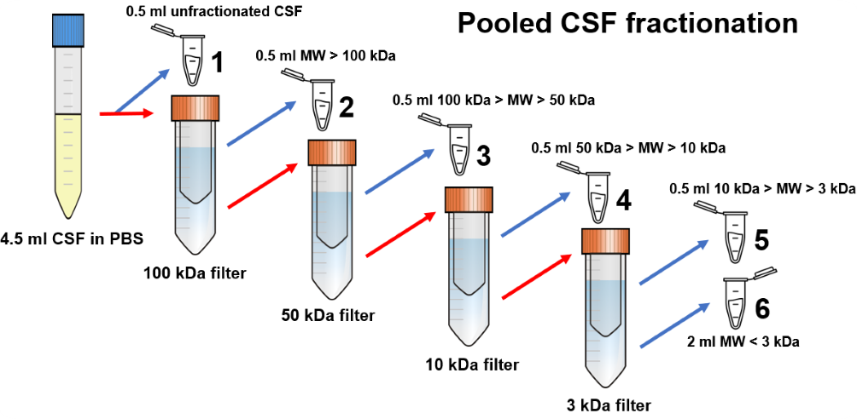

Fig. S1. Scheme of the CSF fractionation procedure. From a starting aliquot of 4.5 mL of CSF in PBS 1x, we collected 6 aliquots containing compounds of different molecular weight and froze them in liquid nitrogen. After every filtration with centrifugal filters, the flow-through of the filtered fraction was passed to a filter with smaller cutoff. Aliquots 2, 3, 4 and 5 were washed 2 times with PBS before storage, to dilute as much as possible compounds smaller than the cutoff value. The aliquots collected in this way contained the different constituents of the starting 4.5 mL of CSF in PBS with different concentration factors. The volume and the relative concentration factors (with respect to sample 1) of the aliquots depicted are summarized in Table S1.

Fig. S2. T₅₀ measured in Six different human CSF samples spiked with 20 fg of seeds. The measured T₅₀ parameters were globally different, as assessed by one-way analysis of variance (ANOVA) and Fisher’s LSD post-hoc test for mean comparisons. *0.01<p<0.05; **0.001<p<0.01: ***p<0.001.

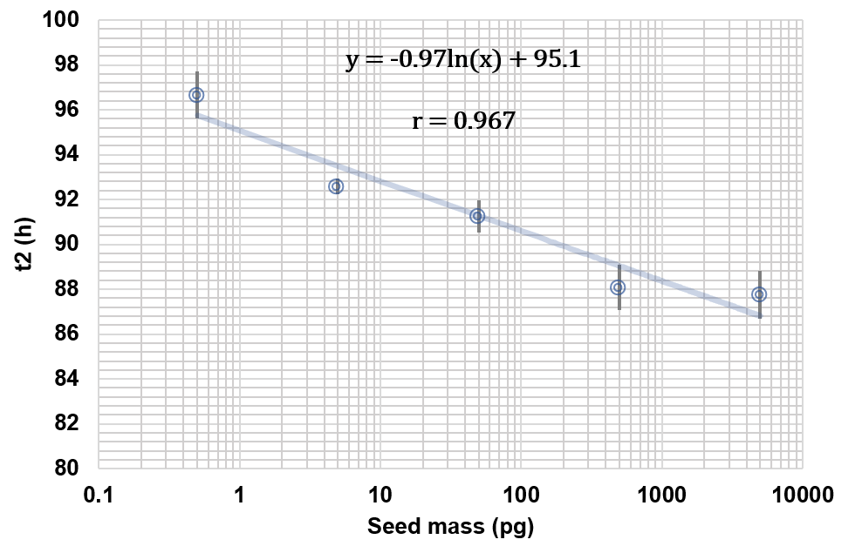

Fig. S3. Quantitative regression analysis of the seeded protein aggregation assay in the absence of human CSF. Measured t2 parameters for the seeded experiment vs the quantity of seeds added; the horizontal axis is displayed in log10 scale. The t2 values displayed result from the average of three replicates, error bars reflect the standard deviation of the mean value. The data were fitted with a natural log function, the correlation between t2 and the added seed masses was assessed by means of Pearson’s correlation coefficient (r).

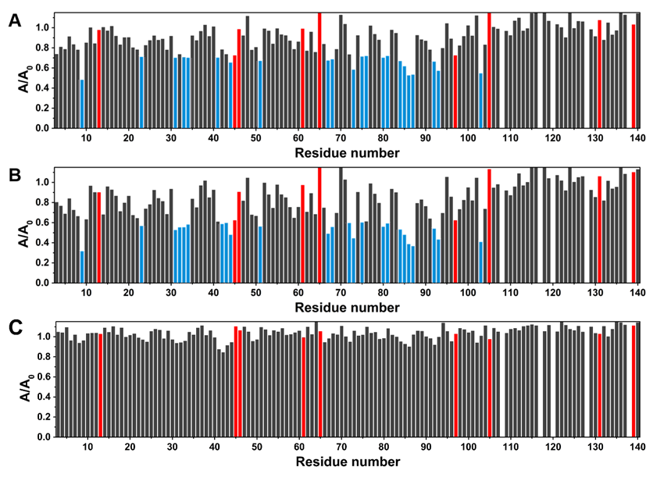

Fig. S4. NMR titrations of α-syn with CSF fractions. Intensity decreases of the signals of two-dimensional (2D) ¹⁵N–¹H HSQC experiments acquired at 950 MHz at T = 283 K on ¹⁵N labelled α-syn (100 μM) in PBS after the addition of: (A) whole pooled CSF in PBS, (B) < 3 kDa CSF fraction in PBS and (C) > 100 kDa CSF fraction in PBS. The residues experiencing the largest decreases in signal intensity (smaller by one or more standard deviations with respect to the average value) are highlighted in light blue. The intensity ratios corresponding to overlapping peaks are highlighted in red (their values were not considered in the calculation of the average decreases and standard deviations).

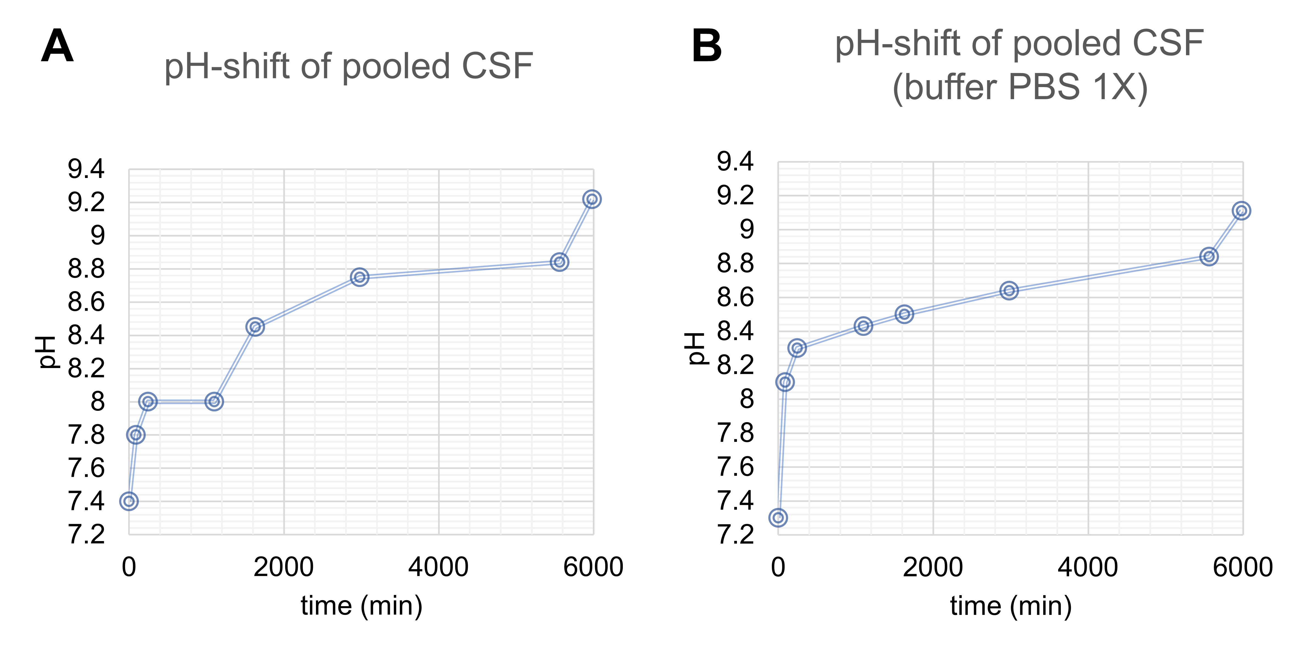

Fig. S5. CSF pH drift. The pH change due to the exposure of CSF to air was monitored over time in 500 μL of undiluted pooled CSF (A) and in the presence of PBS (400 μL CSF + 200 μL PBS 3x) in polypropylene vials with a Thermo Scientific Orion pH-meter equipped with a glass 6 mm diameter pHenomenal MIC 220 Micro electrode. Right before each measurement, the sample was vortexed for 20 sec and left open to air for another 20 sec.

Fig. S6. Different CSF fractions differently affect α-syn aggregation. Mean fitted t2 parameters of samples with 40 μl of PBS/CSF fractions. The values displayed result from the average of three replicates with error bars reflecting the SEM. For whole CSF and the >100 kDa fraction the total duration of the experiment is shown due to the absence of appreciable aggregation.
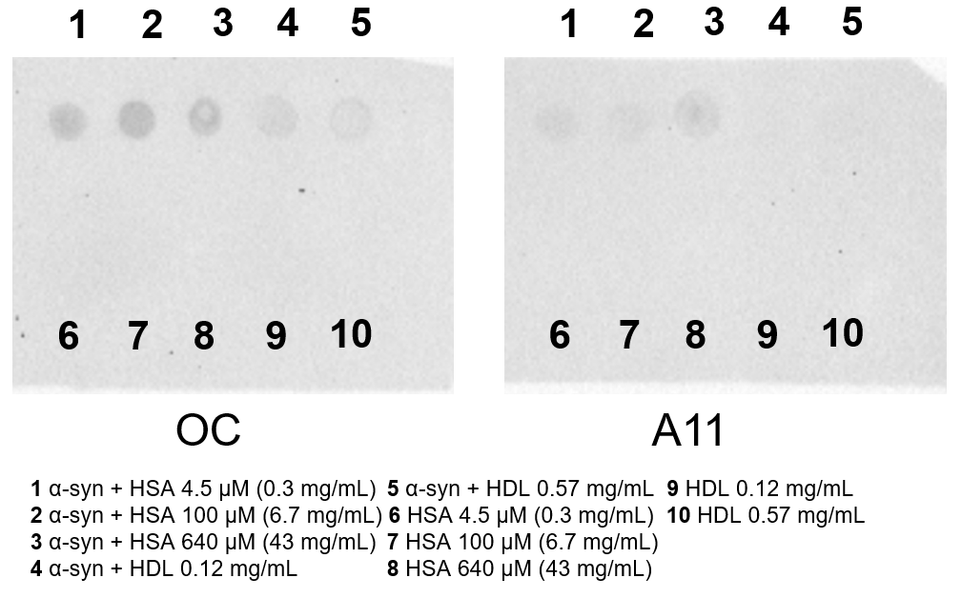

Fig. S7. Native image of the dot-blot assay. Native image of the dot-blot assay performed on the HSA and HDL containing samples with OC (detection of fibrillary oligomers) and A11 (detection of amorphous oligomers) conformational antibodies.

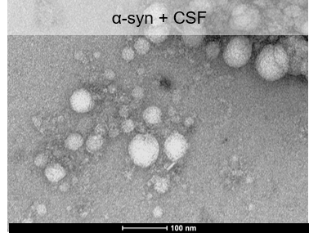

Fig. S8. Representative TEM images of α-syn incubated with CSF. Representative TEM images obtained by analyzing samples obtained by the co-incubation of α-syn 0.7 mg/mL at 37 °C with pooled human CSF (1:5 ratio with respect to total reaction volume). Samples were subjected to cycles of incubation (13 min) and shaking (double-orbital, 2 min) at 500 rpm.

Fig. S9. NMR titrations of α-syn with HDL, LDL and TTR. A) Intensity decreases of the signals of two-dimensional (2D) ¹⁵N–¹H HSQC experiments acquired at 950 MHz at T = 283 K on ¹⁵N labelled α-syn (100 μM) in PBS after the addition of 0.57 mg/mL serum-derived HDL. The intensity ratios corresponding to overlapping peaks are highlighted in red. B) Intensity decreases of the signals of two-dimensional (2D) ¹⁵N–¹H HSQC experiments acquired at 950 MHz at T = 283 K on ¹⁵N labelled α-syn (100 μM) in PBS after the addition of 1 mg/mL serum-derived LDL. C) Intensity decreases of the signals of two-dimensional (2D) ¹⁵N–¹H HSQC experiments acquired at 950 MHz at T = 283 K on ¹⁵N labelled α-syn (100 μM) in PBS after the addition of 3 mg/mL TTR.

Supplementary Tables

Table S1. Concentration factors and final volumes of the CSF fractions.
Sample number | MW range | Volume (mL) | Native concentration factor | Final concentration factor
1 | whole CSF | 0.5 | 1 | 1
2 | >100 kDa | 0.5 | 8 | 5
3 | 50-100 kDa | 0.5 | 7 | 5
4 | 10-50 kDa | 0.5 | 6 | 5
5 | 3-10 kDa | 0.5 | 5 | 5
6 | <3 kDa | 2 | 1 | 1

Table S2. Measured levels of the most abundant macromolecular CSF constituents by nLC-nESI HRMS/MS. Albumin was the most abundant protein in whole CSF at its native concentration and in all concentrated fractions, although its level was similar to the one of apolipoproteins (apolip.) in the > 100 kDA fraction. TTR was abundant in the 100-50 kDa fraction. Apolipoproteins were mostly present in the >100 kDa fraction but relevant quantities were also detected in the 100-50 kDa and 50-10 kDa fractions while PGDS was mostly present in the 50-10 kDa fraction. Table cells are colored according to the relative concentration (emPAI x MW, proportional to the protein concentration in mg/mL) of each analyte in each concentrated CSF fraction, from blue (most abundant), to white (low levels or not detected, n.d.), the highest value of each analyte is highlighted in bold. The overall dilution/concentration factors (with respect to whole CSF) of the samples depicted are summarized in Table 3 in the Materials and Methods section.

Sample | whole CSF | >100 kDa | 50-100 kDa | 50-10 kDa | 10-3 kDa | <3kDa
Albumin (MW x emPAI) | (520 ± 40) · 10⁴ | (220 ± 30) · 10⁴ | (1090 ± 130) · 10⁴ | (180 ± 130) · 10⁴ | (1.4 ± 0.4) · 10⁴ | n.d.
TTR (MW x emPAI) | (130 ± 40) · 10⁴ | (11 ± 4) · 10⁴ | (270 ± 100) · 10⁴ | (14 ± 1) · 10⁴ | n.d. | n.d.
apolip. (MW x emPAI) | (52 ± 15) · 10⁴ | (180 ± 10) · 10⁴ | (28 ± 6) · 10⁴ | (2.4 ± 0.6) · 10⁴ | n.d. | n.d.
PGDS (MW x emPAI) | (16 ± 4) · 10⁴ | (2.6 ± 1.6) · 10⁴ | (13 ± 2) · 10⁴ | (30 ± 14) · 10⁴ | n.d. | n.d.

Table S3. Mean fitted kinetic parameters and maximum fluorescence values (F_{max}) of the analyzed samples. Fitting was not possible for samples containing 0.3 and 1 mg/mL of HDL. Data are represented as mean ± SEM.
HDL (mg/mL) | F_{max}  (a.u.) | 2nd plateau | 1st plateau | 2nd inflection | 1st inflection
HDL (mg/mL) | F_{max}  (a.u.) | A2 (a.u.) | A1 (a.u.) | t2 (h) | t1 (h)
0 | (31 ± 6) ∙ 10³ | (27 ± 5) ∙ 10³ | (12 ± 1.2) ∙ 10² | 120 ± 11 | 39.1 ± 0.3
0.003 | (27 ± 4) ∙ 10³ | (22 ± 4) ∙ 10³ | (9.4 ± 1.7) ∙ 10² | 135 ± 9 | 29.6 ± 1.3
0.03 | (35 ± 3) ∙ 10³ | (28 ± 2) ∙ 10³ | (3.3 ± 0.7) ∙ 10² | 139 ± 7 | 30.2 ± 0.3
0.3 | (50 ± 2) ∙ 10 | n.d. | n.d. | > 215 | > 215
1 | (49 ± 3) ∙ 10 | n.d. | n.d. | > 215 | > 215

SI References

1. J. G. Cunniffe, S. Whitby-Strevens, M. H. Wilcox, Effect of pH changes in cerebrospinal fluid specimens on bacterial survival and antigen test results. J Clin Pathol 49, 249–253 (1996).
2. A. Fura, T. W. Harper, H. Zhang, L. Fung, W. C. Shyu, Shift in pH of biological fluids during storage and processing: effect on bioanalysis. Journal of Pharmaceutical and Biomedical Analysis 32, 513–522 (2003).
3. V. N. Uversky, J. Li, A. L. Fink, Evidence for a Partially Folded Intermediate in α-Synuclein Fibril Formation *. Journal of Biological Chemistry 276, 10737–10744 (2001).
4. V. E. Shevchik, G. Condemine, J. Robert-Baudouy, Characterization of DsbC, a periplasmic protein of Erwinia chrysanthemi and Escherichia coli with disulfide isomerase activity. The EMBO Journal 13, 2007–2012 (1994).
5. C. Huang, G. Ren, H. Zhou, C. Wang, A new method for purification of recombinant human α-synuclein in Escherichia coli. Protein Expression and Purification 42, 173–177 (2005).
6. G. Bellomo, et al., Dissecting the Interactions between Human Serum Albumin and α-Synuclein: New Insights on the Factors Influencing α-Synuclein Aggregation in Biological Fluids. J Phys Chem B 123, 4380–4386 (2019).
7. K. M. Pate, R. M. Murphy, Cerebrospinal Fluid Proteins as Regulators of Beta-amyloid Aggregation and Toxicity. Isr J Chem 57, 602–612 (2017).
8. E. R. Padayachee, et al., Cerebrospinal fluid-induced retardation of amyloid β aggregation correlates with Alzheimer’s disease and the APOE ε4 allele. Brain Res 1651, 11–16 (2016).
9. M. Shahnawaz, et al., Development of a Biochemical Diagnosis of Parkinson Disease by Detection of α-Synuclein Misfolded Aggregates in Cerebrospinal Fluid. JAMA Neurology 74, 163 (2017).
10. L. Concha-Marambio, M. Shahnawaz, C. Soto, Detection of Misfolded α-Synuclein Aggregates in Cerebrospinal Fluid by the Protein Misfolding Cyclic Amplification Platform. Methods in molecular biology (Clifton, N.J.) 1948, 35–44 (2019).
11. J. Adler, H. A. Scheidt, K. Lemmnitzer, M. Krueger, D. Huster, N-terminal lipid conjugation of amyloid β(1–40) leads to the formation of highly ordered N-terminally extended fibrils. Phys. Chem. Chem. Phys. 19, 1839–1846 (2017).
12. R. G. Morris, J. L. Evenden, B. J. Sahakian, T. W. Robbins, “Computer-aided assessment of dementia: Comparative studies of neuropsychological deficits in Alzheimer-type dementia and Parkinson’s disease” in Cognitive Neurochemistry, (Oxford University Press, 1987), pp. 21–36.
13. Y. Ishihama, et al., Exponentially modified protein abundance index (emPAI) for estimation of absolute protein amount in proteomics by the number of sequenced peptides per protein. Mol Cell Proteomics 4, 1265–1272 (2005).
14. K. Shinoda, M. Tomita, Y. Ishihama, emPAI Calc--for the estimation of protein abundance from large-scale identification data by liquid chromatography-tandem mass spectrometry. Bioinformatics 26, 576–577 (2010).

