Table S1 List of the 30 CMIP5 GCMs used in this study.
Model | Institution (Country) | Spatial resolution
ACCESS1-0 | Australian Research Council Centre of Excellence for Climate System Science (Australia) | 1.875° × 1.25°
ACCESS1-3 |  | 1.875° × 1.25°
CanESM2 | Canadian Centre for Climate Modelling and Analysis (Canada) | 2.8° × 2.8°
CMCC-CESM | The Centro Euro-Mediterraneo sui Cambiamenti Climatici (Italy) | 3.75° × 3.75°
CMCC-CM |  | 0.75° × 0.75°
CMCC-CMS |  | 1.875° × 1.875°
CNRM-CM5 | Centre National de Recherches Meteorologiques, Meteo-France (France) | 1.4° × 1.4°
CSIRO-Mk3-6-0 | Commonwealth Scientific and Industrial Research Organization (Australia) | 1.875° × 1.875°
FGOALS-g2 | Chines Academy of Sciences (China) | 2.8125° × 3°
FGOALS-s2 | Chines Academy of Sciences (China) | 2.8° × 1.8°
GFDL-CM3 | Geophysical Fluid Dynamics Laboratory  (USA) | 2.5° × 2.0°
GFDL-ESM2G | Geophysical Fluid Dynamics Laboratory  (USA) | 2.5° × 2.0°
GFDL-ESM2M | Geophysical Fluid Dynamics Laboratory  (USA) | 2.5° × 2.0°
GISS-E2-H | NASA Goddard Institute for Space Studies (USA) | 2.5° × 2.0°
GISS-E2-R | NASA Goddard Institute for Space Studies (USA) | 2.5° × 2.0°
HadGEM2-AO | Met Office Hadley Centre (UK) | 1.875° × 1.24°
HadGEM2-CC | Met Office Hadley Centre (UK)
HadGEM2-ES | Met Office Hadley Centre (UK)
INMCM4 | Institute for Numerical Mathematics  (Russia) | 1.4° × 1.4°
IPSL-CM5A-LR | Institut Pierre-Simon Laplace (France) | 3.75° × 1.875°
IPSL-CM5A-MR | Institut Pierre-Simon Laplace (France) | 2.5° × 1.25°
IPSL-CM5B-LR | Institut Pierre-Simon Laplace (France) | 3.75° × 1.875°
MIROC-ESM-CHEM | JAMSTEC, AORI, NIES, R-CCS (Japan) | 2.8° × 2.8°
MIROC-ESM | The Center for Climate System Research, the University of Tokyo, the Japan Agency for Marine Earth Science and Technology, and the national institute for environmental studies (Japan) | 2.8° × 2.8°
MIROC5 |  | 1.4° × 1.4°
MPI-ESM-LR | Max Planck Institute for Meteorology (Germany) | 1.875° × 1.875°
MPI-ESM-MR | Max Planck Institute for Meteorology (Germany) | 1.875° × 1.875°
MRI-CGCM3 | Meteorological Research Institute (Japan) | 1.125° × 1.125°
MRI-ESM1 | Meteorological Research Institute (Japan) | 1.125° × 1.125°
NorESM1-M | Norwegian Climate Centre (Norway) | 2.5° × 1.875°

Table S2 List of the 26 CMIP6 GCMs used in this study.
Model | Institution (Country) | Spatial resolution
ACCESS-CM2 | Australian Research Council Centre of Excellence for Climate System Science (Australia) | 1.875° × 1.25°
ACCESS-ESM1-5 |  | 1.875° × 1.24°
BCC-CSM2-MR | Beijing Climate Center, Meteorological Administration (China) | 1.125° × 1.1°
CAMS-CSM1-0 | Canadian Centre for Climate Modelling and Analysis (Canada) | 1.125° × 1.1°
CanESM5 | Canadian Centre for Climate Modelling and Analysis (Canada) | 2.8125° × 2.8°
CMCC-CM2-SR5 | The Centro Euro-Mediterraneo sui Cambiamenti Climatici (Italy) | 1.25° × 0.9°
CMCC-ESM2
EC-Earth3-CC | EC-Earth-Consortium Europe | 0.7° × 0.7°
EC-Earth3-Veg-LR | EC-Earth-Consortium Europe | 1.125° × 1.125°
EC-Earth3-Veg | EC-Earth-Consortium Europe | 0.7° × 0.7°
EC-Earth3 | EC-Earth-Consortium Europe | 0.7° × 0.7°
FGOALS-g3 | Institute of Atmospheric Physics (IAP), Chinese Academy of Sciences (CAS) (China) | 2° × 2.5°
GFDL-ESM4 | Geophysical Fluid Dynamics Laboratory (USA) | 1.25° × 1°
GFDL-CM4 | Geophysical Fluid Dynamics Laboratory (USA)
HadGEM3-GC31-MM | Met Office Hadley Centre (UK)
INM-CM4-8 | Institute of numerical mathematics (INM) of the  Russian Academy of Sciences (Russia) | 2° × 1.5°
INM-CM5-0 | Institute of numerical mathematics (INM) of the Russian Academy of Sciences (Russia) | 2° × 1.5°
IPSL-CM6A-LR | Institut Pierre-Simon Laplace (France) | 2.5° × 1.3°
KACE-1-0-G | National Institute of Meteorological Sciences (NIMS) and Korea Meteorological Administration (KMA) (Korea) | 1.875° × 1.25°
KIOST-ESM | Institute of Ocean Science and Technology (Korea)
MIROC6 | The Center for Climate System Research, the  University of Tokyo, the Japan Agency for Marine Earth Science and Technology, and the national institute for environmental studies (Japan) | 1.4° × 1.4°
MPI-ESM1-2-HR | Max Planck Institute for Meteorology (Germany) | 0.9° × 0.9°
MPI-ESM1-2-LR | Max Planck Institute for Meteorology (Germany) | 1.875° × 2°
MRI-ESM2-0 | Meteorological Research Institute (Japan) | 1.125° × 1.1°
NESM3 | China | 1.875° × 1.9°
NorESM2-MM | . Norwegian Climate Centre (Norway) | 1.25° × 0.9°

Table S3 List of CORDEX simulations used in this study.
RCM | Downscaled CMIP5 GCM
CLMcom-CCLM4-8-17 | CNRM-CERFACS-CNRM-CM5
 | ICHEC-EC-EARTH
 | MOHC-HadGEM2-ES
 | MPI-M-MPI-ESM-LR
DMI-HIRHAM5 | ICHEC-EC-EARTH
GERICS-REMO2009 | IPSL-IPSL-CM5A-LR
 | MIROC-MIROC5
 | MOHC-HadGEM2-ES
 | NOAA-GFDL-GFDL-ESM2G
ICTP-RegCM4-3 | MOHC-HadGEM2-ES
 | MPI-M-MPI-ESM-MR
KNMI-RACMO22T | ICHEC-EC-EARTH
 | MOHC-HadGEM2-ES
MPI-CSC-REMO2009 | ICHEC-EC-EARTH
 | MPI-M-MPI-ESM-LR
SMHI-RCA4 | CCCma-CanESM2
 | CNRM-CERFACS-CNRM-CM5
 | CSIRO-QCCCE-CSIRO-Mk3-6-0
 | ICHEC-EC-EARTH
 | IPSL-IPSL-CM5A-MR
 | MIROC-MIROC5
 | MOHC-HadGEM2-ES
 | MPI-M-MPI-ESM-LR
 | NCC-NorESM1-M
 | NOAA-GFDL-GFDL-ESM2M

Table S4 List of CORE simulations used in this study.
RCM | Downscaled CMIP5 GCM
CLMcom-KIT-CCLM5-0-15 | MOHC-HadGEM2-ES
 | MPI-M-MPI-ESM-LR
 | NCC-NorESM1-M
GERICS-REMO2015 | MOHC-HadGEM2-ES
 | MPI-M-MPI-ESM-LR
 | NCC-NorESM1-M
ICTP-RegCM4-7 | MOHC-HadGEM2-ES
 | MPI-M-MPI-ESM-LR
 | NCC-NorESM1-M

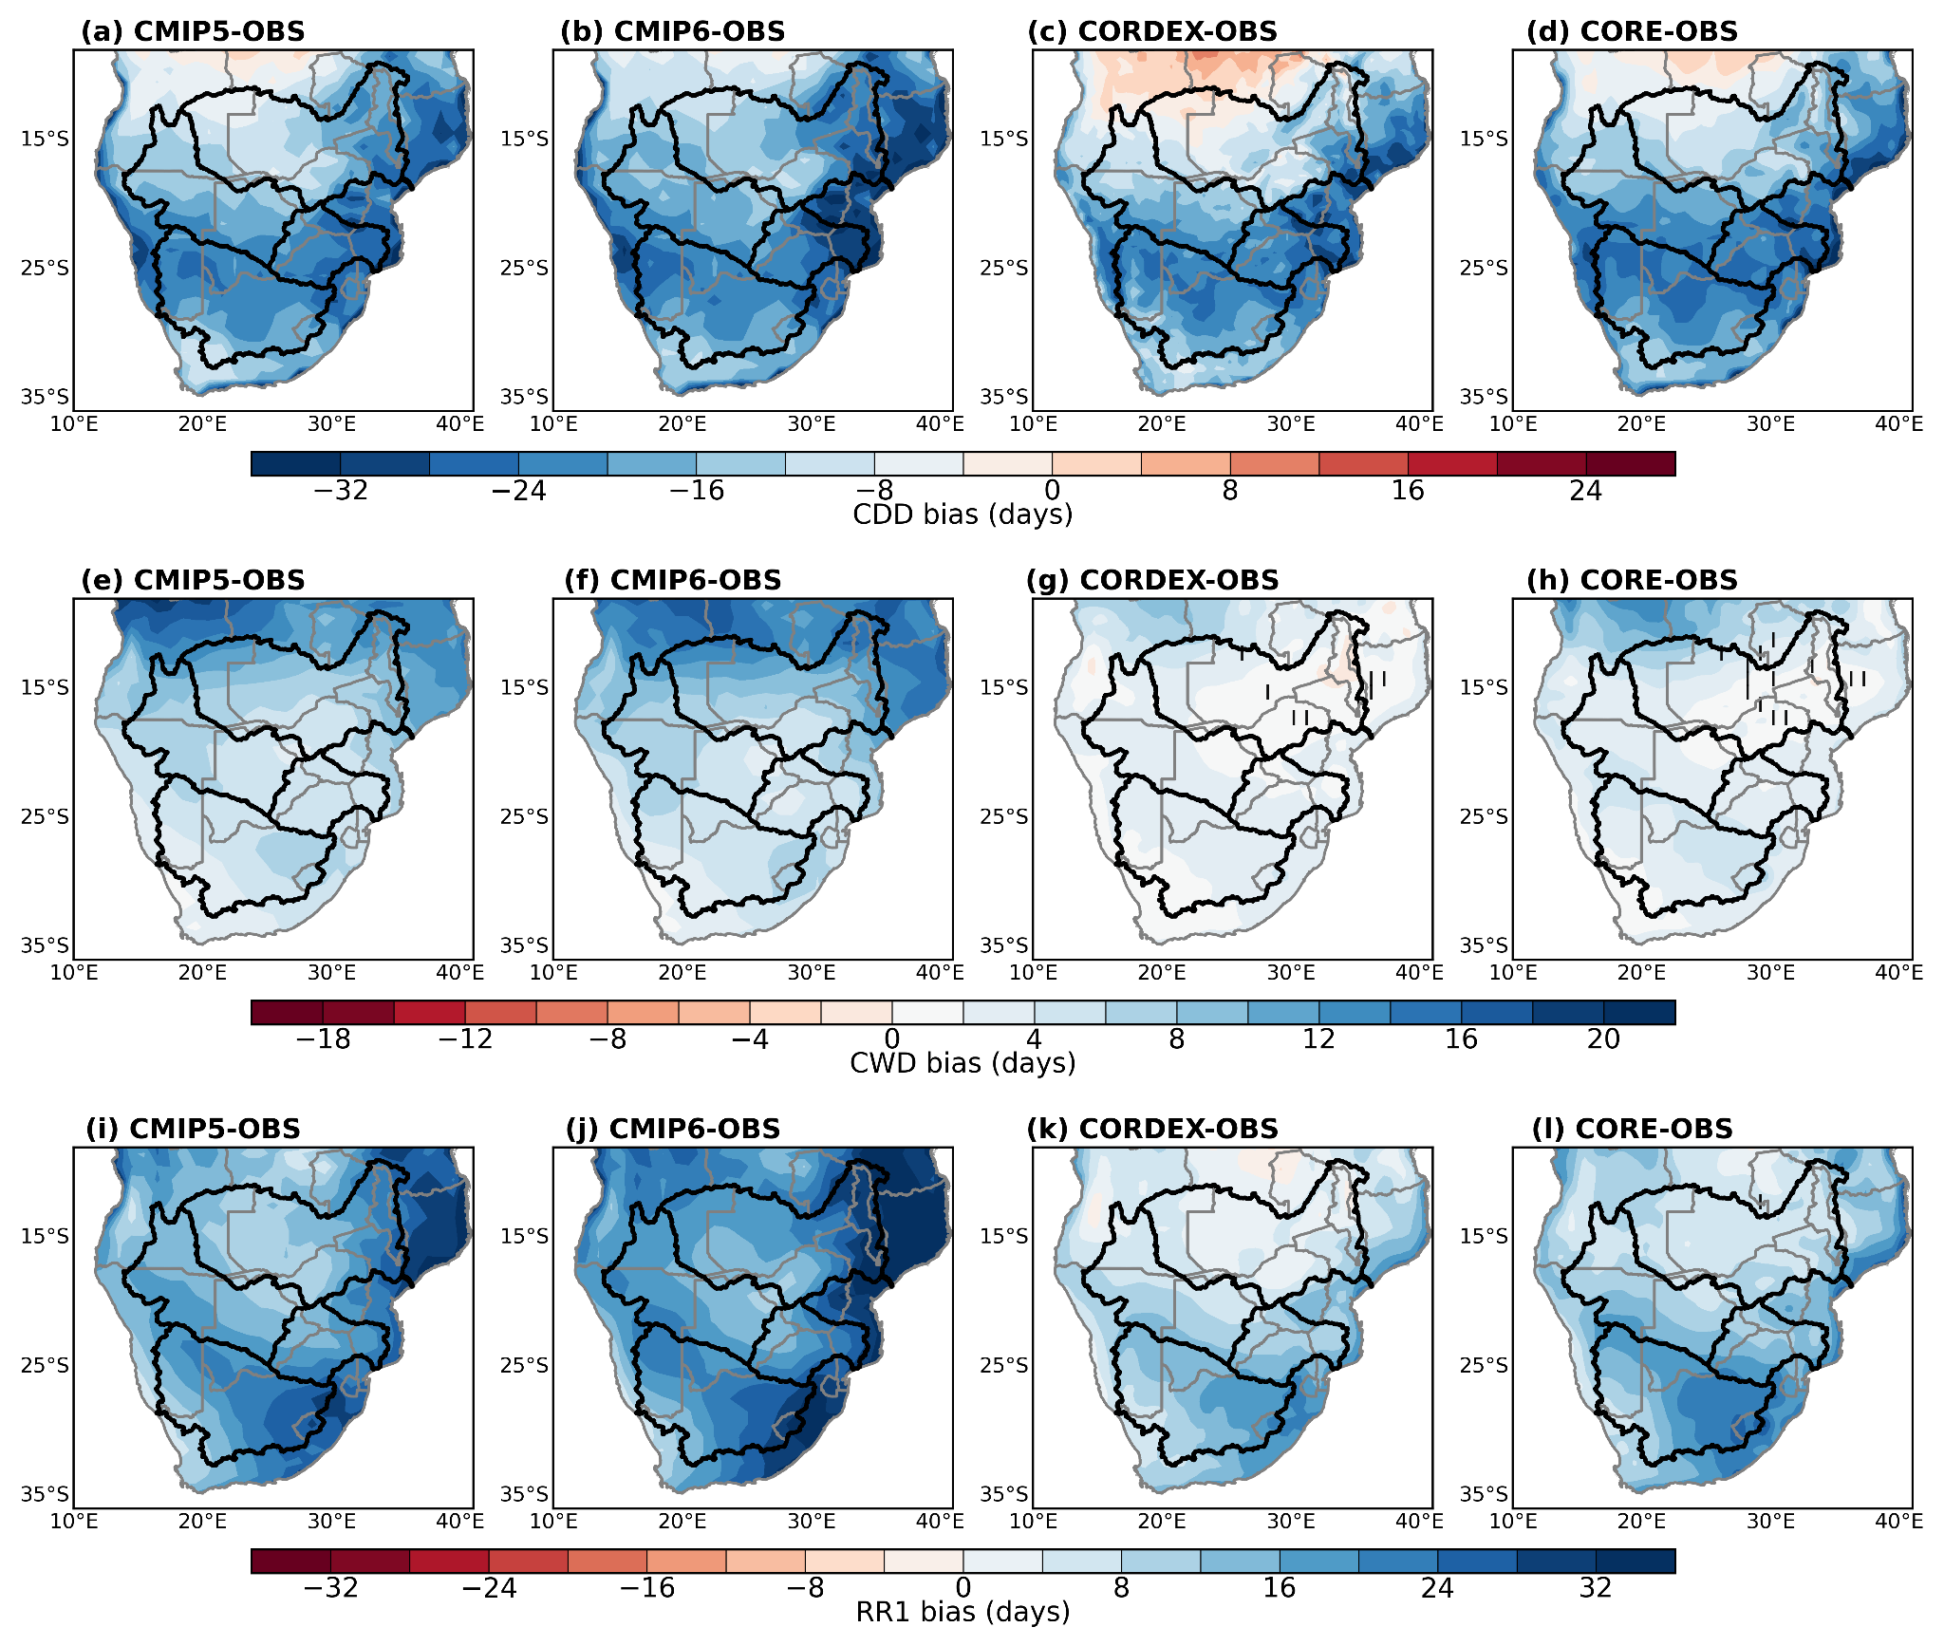
Fig. S1 The spatial distribution of biases of multi-model mean (MME minus OBSE ) for the period 1983–2005 March-April-May (MAM). From top to bottom are CDD (a-d), CWD (e-h) and RR1 (i–l). Areas with full colour are those where the bias is statistically significant. The regions where the bias is non-significant and uncertain are highlighted by vertical and horizontal lines, respectively.

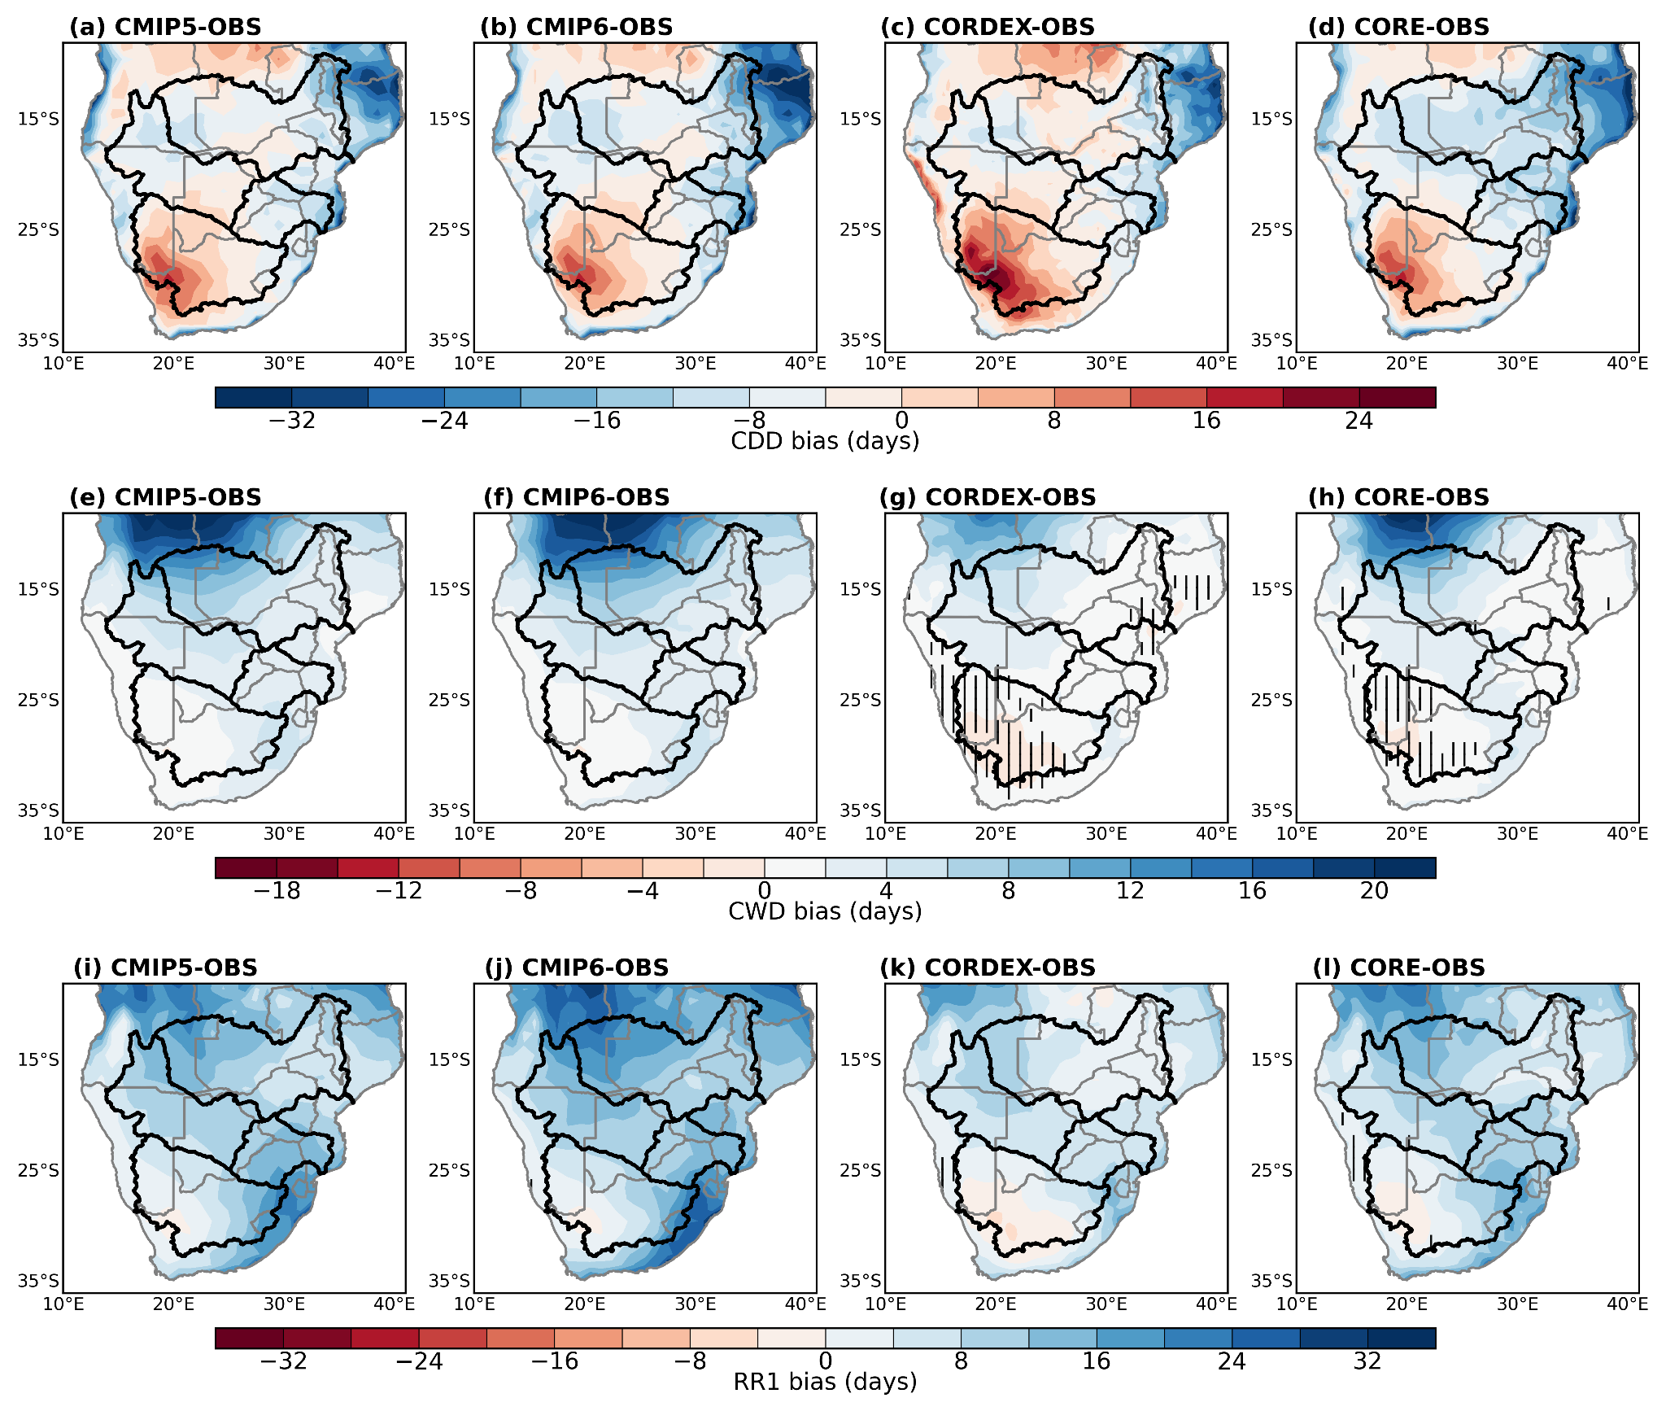
Fig. S2 The spatial distribution of biases of multi-model mean (MME minus OBSE ) for the period 1983–2005 during September-October-November (SON). From top to bottom are CDD (a-d), CWD (e-h) and RR1 (i–l). Areas with full colour are those where the bias is statistically significant. The regions where the bias is non-significant and uncertain are highlighted by vertical and horizontal lines, respectively.

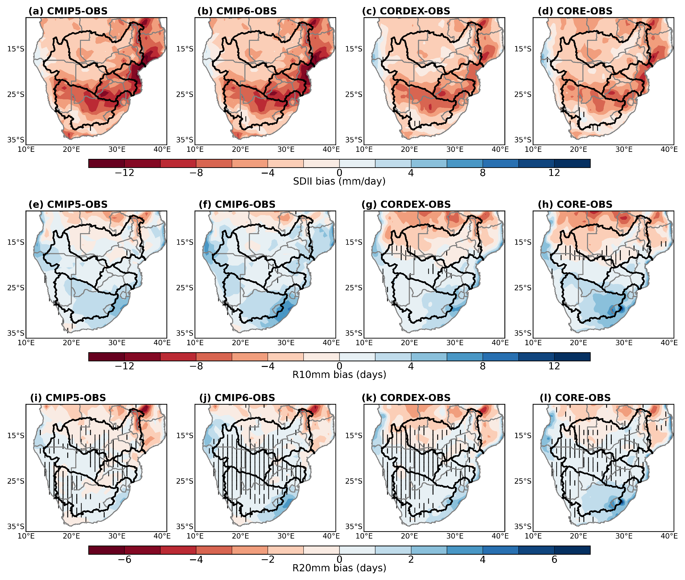
Fig. S3 The spatial distribution of biases of multi-model mean (MME minus OBSE ) for the period 1983–2005 during March-April-May (MAM). From top to bottom are R10mm (a-d), R20mm (e-h) and SDII (i–l). Areas with full colour are those where the bias is statistically significant. The regions where the bias is non-significant and uncertain are highlighted by vertical and horizontal lines, respectively.
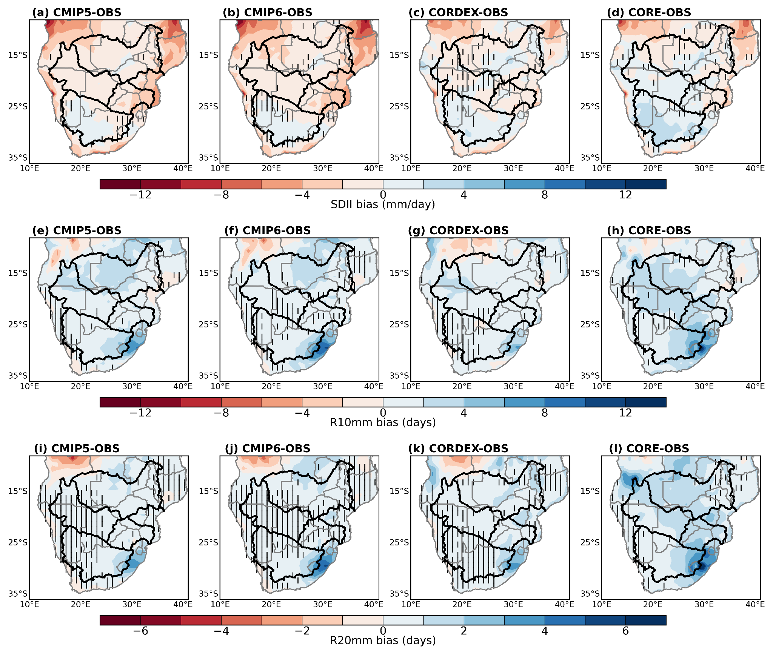
Fig. S4 The spatial distribution of biases of multi-model mean (MME minus OBSE ) for the period 1983–2005 during September-October-November (SON). From top to bottom are R10mm (a-d), R20mm (e-h) and SDII (i–l). Areas with full colour are those where the bias is statistically significant. The regions where the bias is non-significant and uncertain are highlighted by vertical and horizontal lines, respectively.
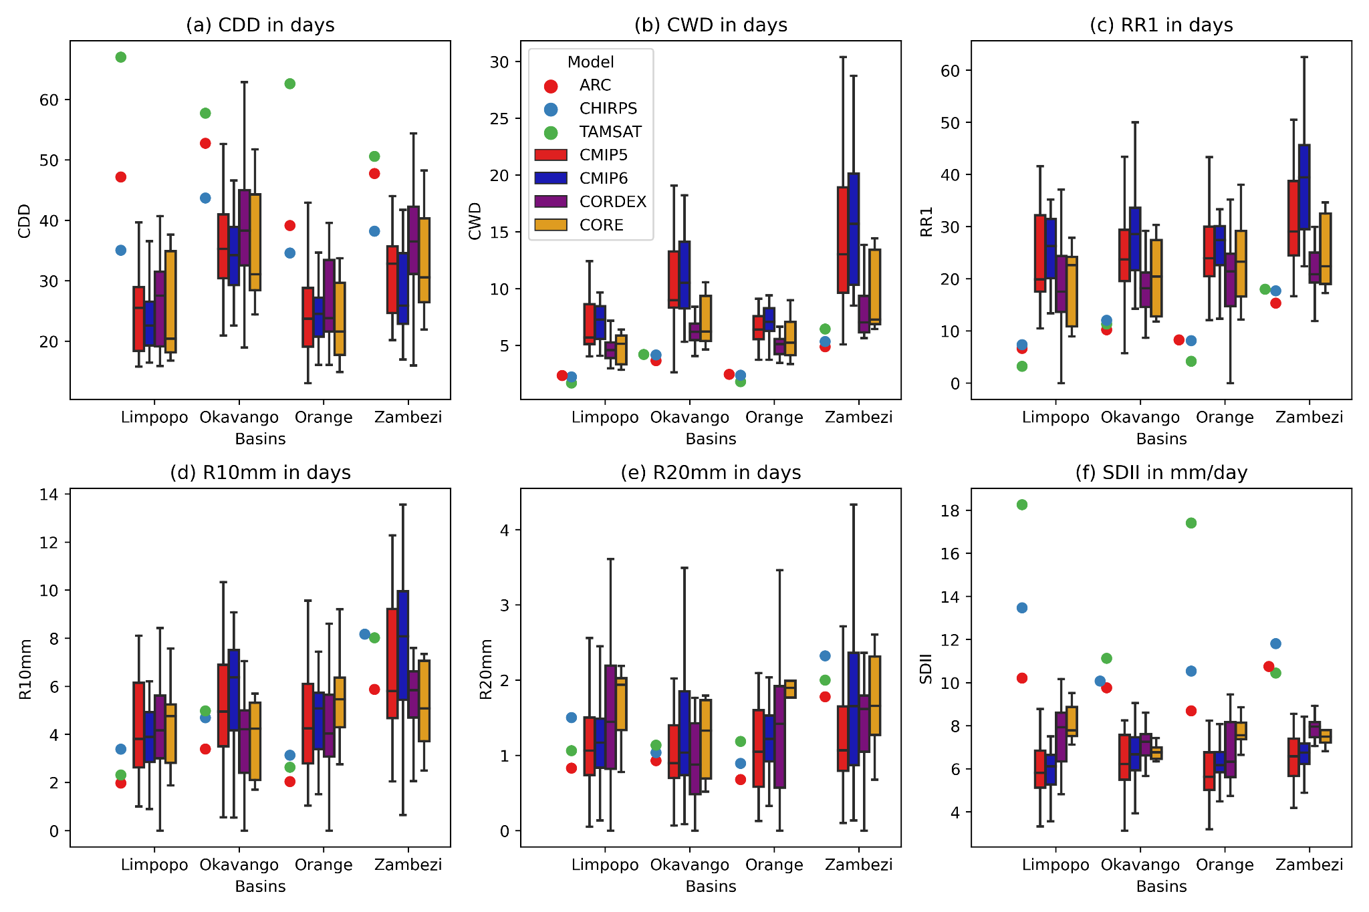
Fig. S5 Box-and-whisker plots for March-April-May (MAM) climatological (1983-2005) (a) CDD, (b) CWD, (c) RR1, (d) R10mm, (e) R20mm and (e) SDII for the Observations, CMIP5, CMIP6, CORDEX and CORE spatially averaged over the four basins shown in Fig.1. The boxes indicate the interquartile model spread (range between the 25th and 75th quantiles), the solid marks within the boxes show the observation and multi-model median and the whiskers indicate the total intermodel range.
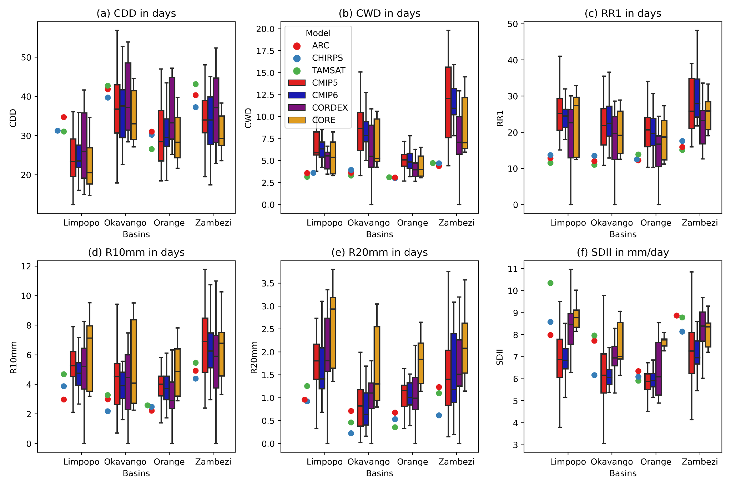
Fig. S6 Box-and-whisker plots for September-October-November (SON) climatological (1983-2005) (a) CDD, (b) CWD, (c) RR1, (d) R10mm, (e) R20mm and (e) SDII for the Observations, CMIP5, CMIP6, CORDEX and CORE spatially averaged over the four basins shown in Fig.1. The boxes indicate the interquartile model spread (range between the 25th and 75th quantiles), the solid marks within the boxes show the observation and multi-model median and the whiskers indicate the total intermodel range.
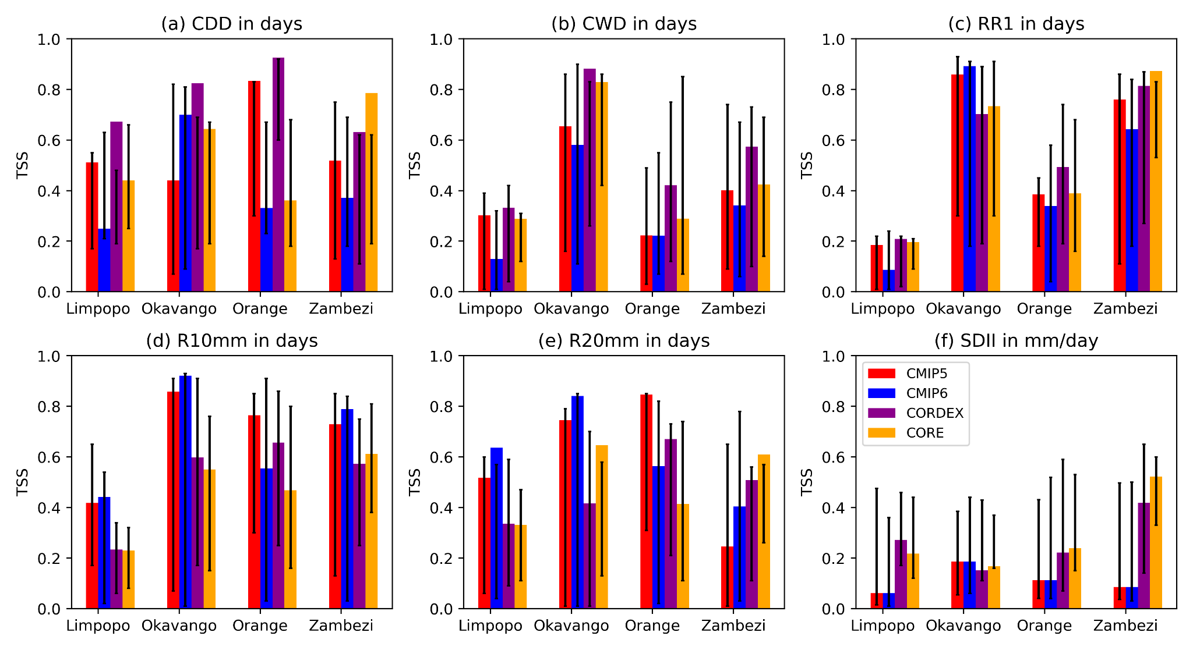
Fig. S7 Taylor skill scores (TSS) showing the performance of multi-model ensembles in simulating March-April-May (MAM) climatological (1983-2005) (a) CDD, (b) CWD, (c) RR1, (d) R10mm, (e) R20mm and (e) SDII, spatially averaged over the four major river basins of southern Africa. Error bars indicate intermodel range for each ensemble.
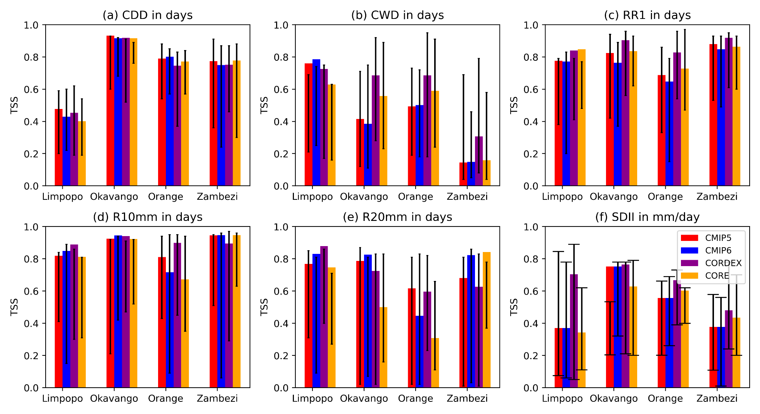
Fig. S8 Taylor skill scores (TSS) showing the performance of multi-model ensembles in simulating September-October-November (SON) climatological (1983-2005) (a) CDD, (b) CWD, (c) RR1, (d) R10mm, (e) R20mm and (e) SDII, spatially averaged over the four major river basins of southern Africa. Error bars indicate the intermodel range for each ensemble.
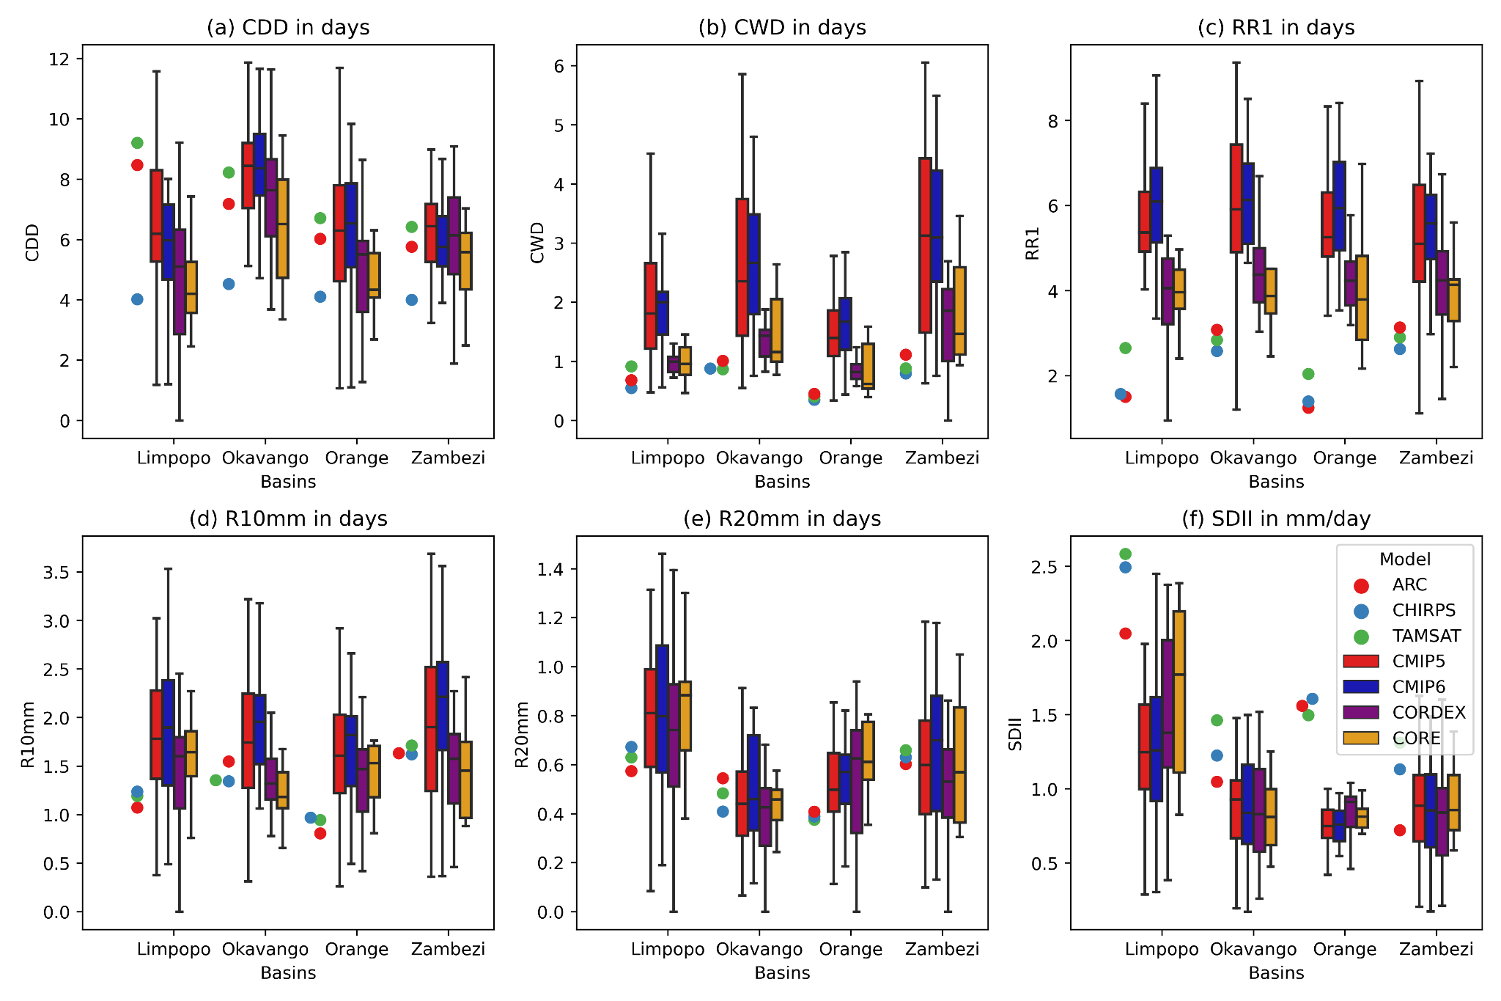
Fig. S9 Box-and-whisker plots for March-April-May (MAM) interannual variability (1983-2005) of (a) CDD, (b) CWD, (c) RR1, (d) R10mm, (e) R20mm and (e) SDII for the Observations, CMIP5, CMIP6, CORDEX and CORE spatially averaged over the four basins shown in Fig.1. The boxes indicate the interquartile model spread (range between the 25th and 75th quantiles), the solid marks within the boxes show the observation and multi-model median and the whiskers indicate the total intermodel range.
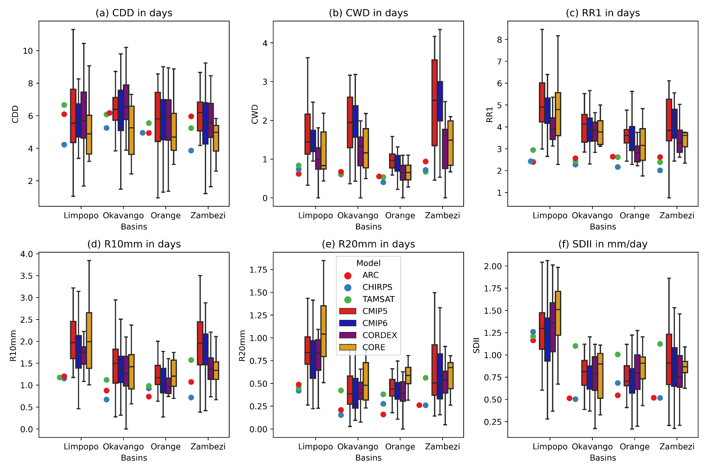
Fig. S10 Box-and-whisker plots for September-October-November (SON) interannual variability (1983-2005) of (a) CDD, (b) CWD, (c) RR1, (d) R10mm, (e) R20mm and (e) SDII for the Observations, CMIP5, CMIP6, CORDEX and CORE spatially averaged over the four basins shown in Fig.1. The boxes indicate the interquartile model spread (range between the 25th and 75th quantiles), the solid marks within the boxes show the observation and multi-model median and the whiskers indicate the total intermodel range.

