Engineering of Hole Transporting Interface by Incorporating the Atomic-Precision Ag₆ Nanoclusters for High-Efficiency Blue Perovskite Light-Emitting Diodes
Fujun Zhangª, Yanbo Gao*ª, Po Luª, Yuan Zhongª, Yue Liuª, Xinyu Baoª, Zehua, Xuª, Min Luª, Yanjie Wuª, Ping Chenª, Junhua Hu^{b}, Yu Zhangª, Zhennan, Wu*ª, Hongwei Song*ª, and Xue Bai*ª
ª State Key Laboratory of Integrated Optoelectronics, College of Electronic Science and Engineering, Jilin University, 2699 Qianjin Street, Changchun, 130012, China.
^{b} Key Laboratory of Materials Physics of Ministry of Education Department of Physics and Engineering, Zhengzhou University, Zhengzhou, 450052, China
E-mail: E-mail: gaoyanbo@jlu.edu.cn; wuzn@jlu.edu.cn; songhw@jlu.edu.cn; baix@jlu.edu.cn

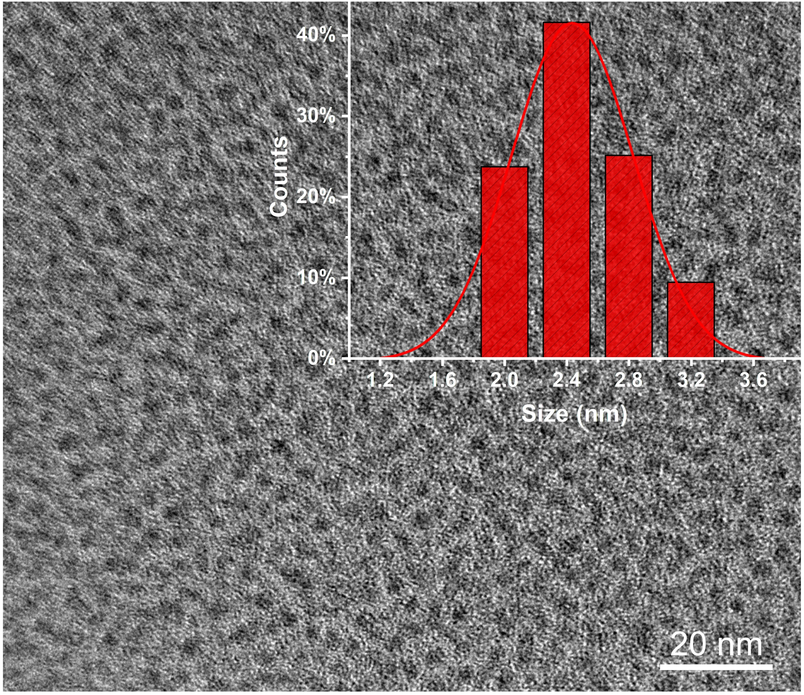
Fig. S1 the TEM of the Ag₆ NCs in CB (a) with the inset showing the size distribution.

Fig. S2 the Tauc-plot of the Ag₆ NCs and the inset picture is the PVK with the different concentrations of the Ag₆ NCs in CB solvent.

Fig. S3 the SEM and mapping images of the PVK film with the 20% Ag₆ NCs doping into.

Fig. S4 the XPS spectra of the PVK films with and without Ag₆ NCs.

Fig. S5 the evolution of EL spectra under increasing bias voltage from 4 V to 7 V of the modified device.

Fig. S6 the EL peaks at 7 V (a), the J-V-L curves (b) and the EQE-J curves (c) of the device with different contents Ag₆ NCs doping.

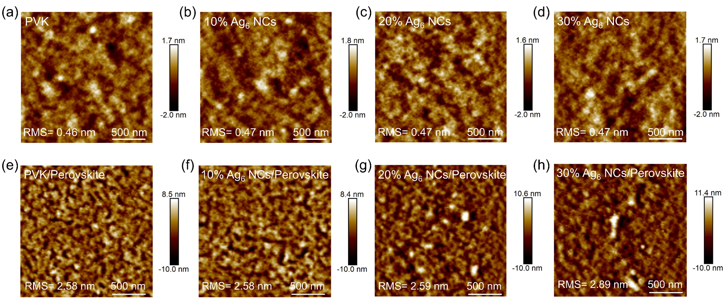
Fig. S7 AFM of the 0– 30% Ag₆ NCs doping into PVK films (a-d) and the perovskite films on different HTLs (e-h).

Fig. S8 the Tauc-plots of the PVK and PVK doped Ag₆ NCs films

Fig. S9 the absorbance intensity spectrum (a), Tauc-plot (c), and UPS spectra of the perovskite films (c).

Fig. S10 the GI-XRD of the PVK and 20%Ag₆ NCs modified PVK films.

Fig. S11 Surface potential images of PVK film and the 0– 30% Ag₆ NCs doping into PVK films (a-d).

Fig. S12 the J-V-L curves (a) and the EQE-J curves (b) of the device with different contents ligands doping into PVK as the HTL.

Fig. S13 the J-V-L curves (a) and the EQE-J curves (b) of the device with different contents Ag NPs doping into PVK as the HTL.

Fig. S14 the AFM of the PVK with the 0- 30% Ag NPs modified films.

