Support information
Computational Investigation of Functional Water Molecules Upon GPCR Bound to G protein or Arrestin
Jiaqi Hu¹ · Xianqiang Sun² · Zhengzhong Kang^{2,3} · Jianxin Cheng¹

Received: xx xxxx 2022 / Accepted: xx xxxx 2022
© The Author(s) 2022

* Jianxin Cheng
chengjx567@mail.ecust.edu.cn
* Zhengzhong Kang
kangzhzh2007@126.com
1 Jiangxi Provincial Key Laboratory of Drug Design and Evaluation, School of Pharmacy, Jiangxi Science & Technology Normal University, Nanchang, China
2 AutoDrug Biotech Co. Ltd, No. 58 XiangKe Rd., Pudong New Area, Shanghai, China
3 Department of Theoretical Chemistry and Biology, KTH Royal Institute of Technology, 10691, Stockholm, Sweden

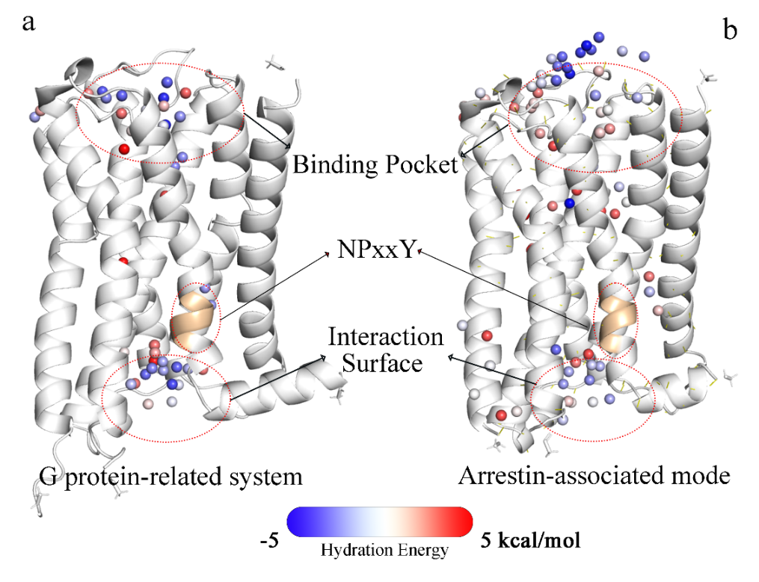
Figure S1. Hydration sites with thermodynamic signatures in M₂R under G protein and Arrestin pathway activation modes. Each hydration site is represented by a corresponding water molecule and shown as a sphere. The diversities of the hydration energy are illustrated with the colors on the spheres according to the spectrum bar shown in the bottom. (a) PDB ID: 6OIK. (b) PDB ID: 6U1N.

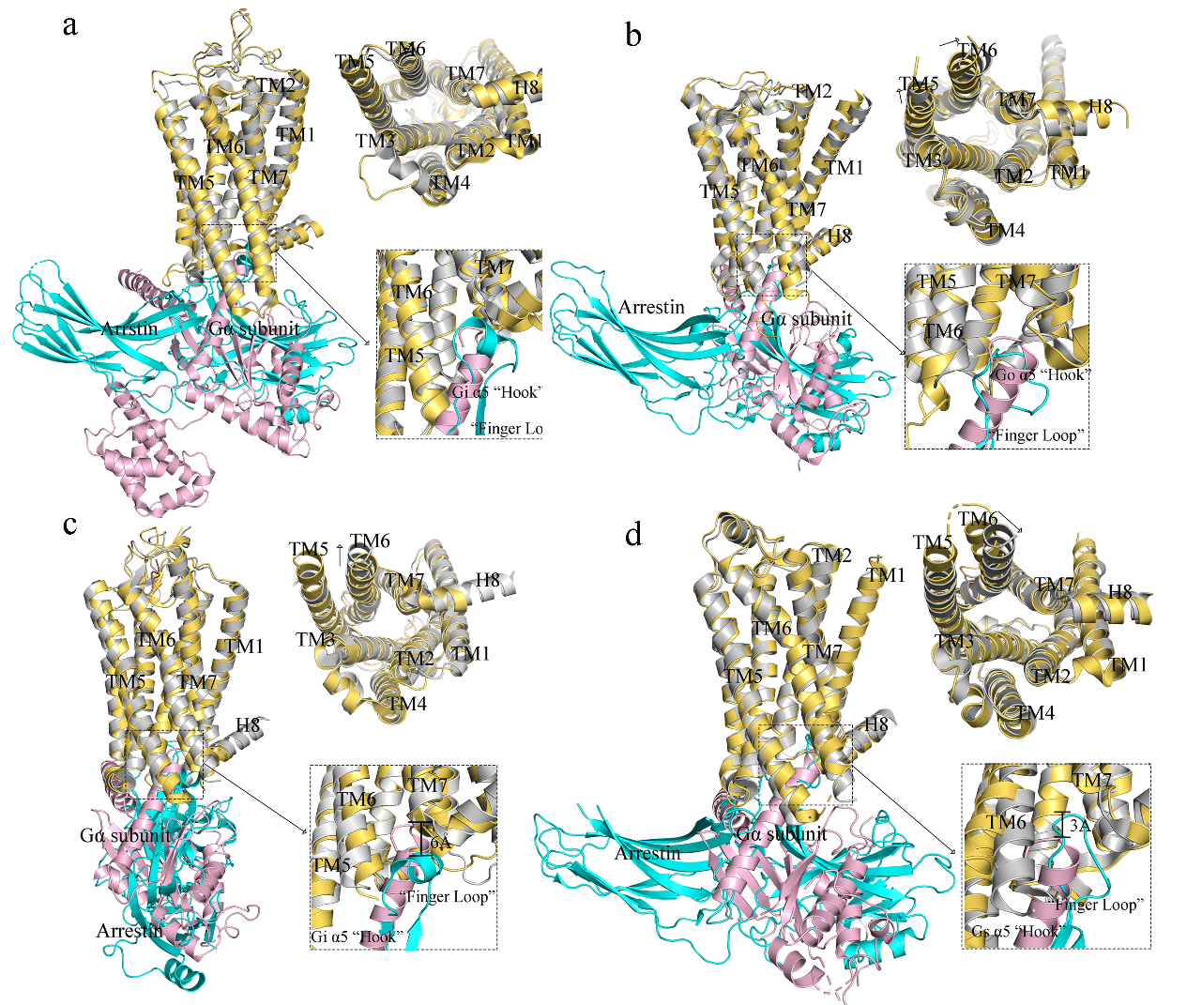
Figure S2. Superposed structures of GPCR-G protein and GPCR-Arrestin complexes. The GPCRs in the complexes are shown as cartoon and colored by orange and grey, respectively. G_{α} subunit, pink; Arrestin, cyan and G_{βγ} subunits omitted for clarity. The upper right picture is under a top view, and the bottom right picture shows the depth of insertion of the “Finger Loop” of Arrestin and the α5-helix into the TM bundle of GPCR. (a) Rhodopsin-G protein/Arrestin complexes. (b) M₂R-G protein/Arrestin complexes. (c) NTSR1-G protein/Arrestin complexes. (d) β₁AR-G protein/Arrestin complexes.

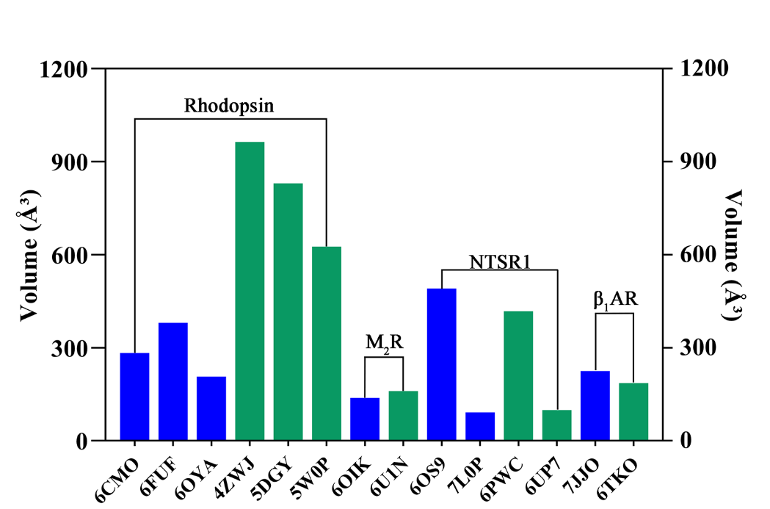
Figure S3. Volume of the helical bundle cavity in the interaction surface of GPCR-G protein/Arrestin. GPCR-G protein and GPCR-Arrestin complexes are shown in blue and green histograms, respectively. This part was calculated by POCASA 1.1 version. (http://altair.sci.hokudai.ac.jp/g6/service/pocasa/).

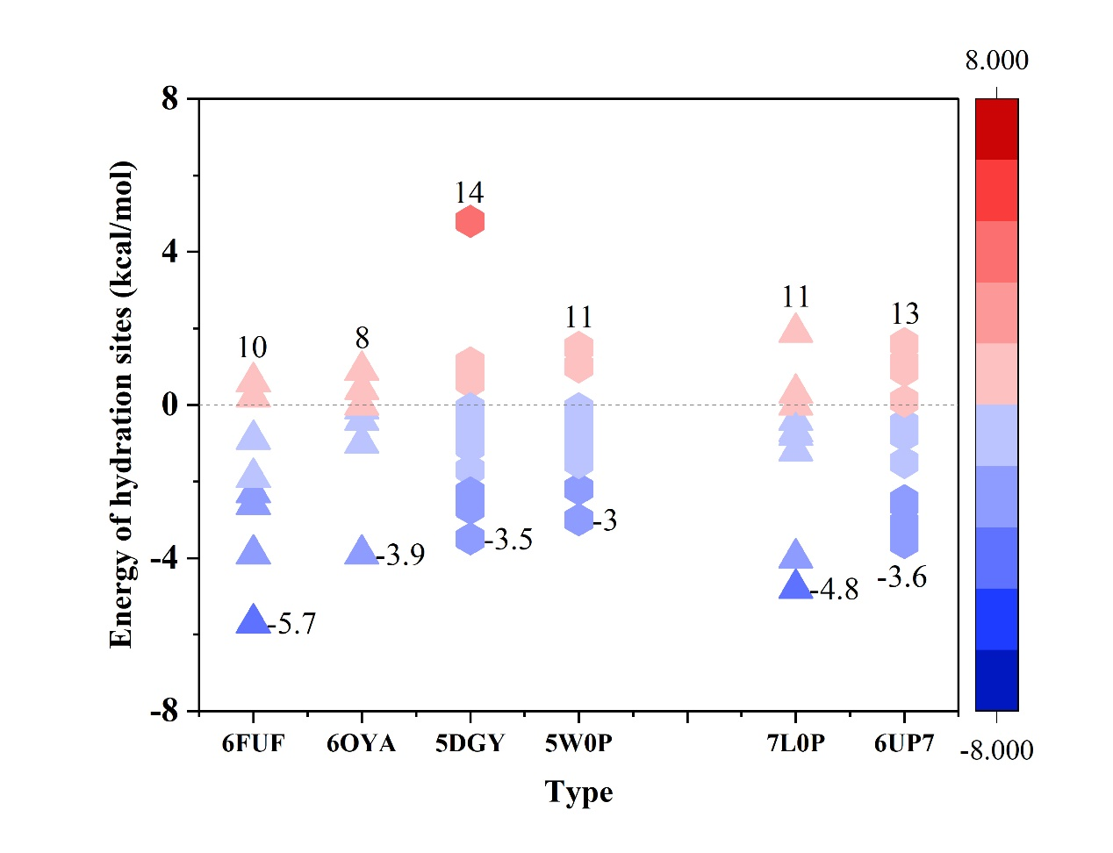
Figure S4. The energy of hydration sites and the number of hydration sites around the GPCR-G protein/Arrestin interaction surface. Rhodopsin: 6FUF, 6OYA, G protein-related; 5DGY, 5W0P, Arrestin-associated. NTSR1: 7L0P, G protein-related; 6UP7, Arrestin-associated. Triangles represent hydration sites in the G protein-related system, and hexagons represent hydration sites in the Arrestin-associated system.

Table S1. Basic information in the crystal structures of different GPCR-G proteins complexes.
PDB Code | Protein type | G protein type | Resolution (Å) | Release Year | Refs
6CMO | Rhodopsin | Gi | 3.12 | 2018 | [1]
6FUF | Rhodopsin | Go | 3.12 | 2018 | [2]
6OYA | Rhodopsin | Gt | 3.30 | 2019 | [3]
6OS9 | NTSR1 | Gi | 3.00 | 2019 | [4]
7L0P | NTSR1 | Gi | 4.10 | 2021 | [5]
7JJO | β₁AR | Gs | 2.60 | 2020 | [6]
6OIK | M₂R | Go | 3.60 | 2019 | [7]

Table S2. Basic information in the crystal structures of different GPCR-Arrestins complexes.
PDB Code | Protein type | Arrestin type | Resolution (Å) | Release Year | Refs
4ZWJ | Rhodopsin | Arrestin-1 | 3.30 | 2015 | [8]
5DGY | Rhodopsin | Arrestin-1 | 7.70 | 2016 | [9]
5W0P | Rhodopsin | Arrestin-1 | 3.01 | 2017 | [10]
6PWC | NTSR1 | β-arrestin-1 | 4.90 | 2019 | [11]
6UP7 | NTSR1 | β-arrestin-1 | 4.20 | 2020 | [12]
6TKO | β₁AR | β-arrestin-1 | 3.30 | 2020 | [13]
6U1N | M₂R | β-arrestin-1 | 4.00 | 2020 | [14]

Table S3. Basic information in the crystal structures of different apo-GPCR complexes.
PDB Code | Protein type | Resolution (Å) | Release Year | Refs
1U19 | Rhodopsin | 2.10 | 2004 | [15]
6Z66 | NTSR1 | 3.19 | 2021 | [16]
7BVQ | β₁AR | 2.50 | 2020 | [17]
3UON | M₂R | 3.00 | 2012 | [18]

Table S4. The number of water molecules and their distribution.
G protein-related system
PDB ID | 6CMO | 6FUF | 6OIK | 6OS9 | 6OYA | 7JJO | 7L0P | Total
Intracellular side | 28 | 21 | 16 | 20 | 16 | 18 | 16 | 135
Helical bundle | 48 | 16 | 11 | 9 | 9 | 14 | 13 | 120
Extracellular side | 44 | 38 | 22 | 32 | 21 | 13 | 33 | 203
Total | 119 | 75 | 49 | 61 | 46 | 45 | 62

Arrestin-associated mode
PDB ID | 4ZWJ | 5DGY | 5W0P | 6PWC | 6TKO | 6U1N | 6UP7 | Total
Intracellular side | 17 | 22 | 27 | 19 | 32 | 20 | 26 | 163
Helical bundle | 6 | 9 | 5 | 33 | 13 | 19 | 22 | 107
Extracellular side | 20 | 8 | 25 | 29 | 39 | 38 | 17 | 176
Total | 43 | 39 | 57 | 81 | 84 | 77 | 65

Table S5. The number of functional hydration sites and the residues with the lowest energy at the hydration site of the GPCR-G protein/Arrestin interaction surface (Energy↓ represents the hydration site with the lowest energy).
Type |  | Rhodopsin |  |  |  | NTSR1
State | Go |  | Gt | arr1 | arr1 | Gi | βarr1
PDB ID | 6FUF |  | 6OYA | 5DGY | 5W0P | 7L0P | 6UP7
Number | 9 |  | 5 | 9 | 9 | 4 | 1
Energy↓ | Wr43 |  | Wr21 | Wr22 | Wr31 | Wn18 | Wn9
Residues | R^{3.50}, N^{7.57} |  | R^{3.50} | R^{3.50} | R^{3.50}, N^{7.57} | E^{3.49} | R^{3.50}

Table S6. Composition of the conserved NPxxY motif.
GPCRs | N^{7.49} | P^{7.50} | X^{7.51} | X^{7.52} | Y^{7.53}
Rhodopsin | N | P | V | I | Y
NTSR1 | N | P | I | L | Y
M₂R | N | P | A | C | Y
β₁AR | N | P | I | I | Y

Table S7. The number of functional hydration sites and the residues interacted with hydration sites around the NPxxY motif.
Type | Rhodopsin |  |  |  | NTSR1
State |  | Go | Gt | arr1 |  | arr1 | Gi | βarr1
PDB ID |  | 6FUF | 6OYA | 5DGY |  | 5W0P | 6OS9 | 6PWC
Number |  | 2 | 2 | 2 |  | 1 | 3 | 3
Energy↓ |  | Wr45 | Wr23 | Wr27 |  | Wr34 | Wn34 | Wn49
Residues |  | Y^{7.53} | Y^{7.53} | Y^{7.53} |  | I^{7.52}, Y^{7.53} | Y^{7.53} | N^{7.49}

Table S8. Average conformation changes (dihedral: Benzene ring/ C_{α}, C_{β}, C₅) of Y^{7.53} in each system.
Type | Rhodopsin |  |  | NTSR1
State | Go | Gt | arr1 | arr1 | Gi | βarr1
PDB ID | 6FUF | 6OYA | 5DGY | 5W0P | 6OS9 | 6PWC
Dihedral | 88.31 | 83.60 | 84.43 | 84.89 | 61.64 | 68.24

Table S9. The number of functional hydration sites and the residues with the lowest energy at the hydration site of orthosteric pocket
Type | Rhodopsin
State | Go | Gt | Gi | arr1 | arr1 | arr1 | Inactive
PDB ID | 6FUF | 6OYA | 6CMO | 5DGY | 5W0P | 4ZWJ | 1U19
Number | 10 | 4 | 14 | 1 | 0 | 1 | 0
Energy↓ | Wr47 | Wr30 | Wr17 | Wr29 | - | Wr6 | -
Residue | E^{3.37}, H^{5.46} | E^{4.70}, C^{7.46} | E^{3.37} | C^{5.22}, E^{5.16}, K^{7.43} | - | C^{5.22}, E^{5.16}, K^{7.43} | -

Type | NTSR1
State | Gi | Gi | βarr1 | βarr1 | Inactive
PDB ID | 6OS9 | 7L0P | 6PWC | 6UP7 | 6Z66
Number | 18 | 13 | 12 | 10 | 15
Energy↓ | Wn12 | Wn7 | Wn2 | Wn17 | Wn70
Residue | R^{6.54} | R^{6.54} | R^{6.55} | R^{6.54}, Y^{7.31} | Y^{7.31}

References
- Kang YY, Kuybeda O, de Waal PW, Mukherjee S, Van Eps N, Dutka P, Zhou XE, Bartesaghi A, Erramilli S, Morizumi T, Gu X, Yin YT, Liu P, Jiang Y, Meng X, Zhao GP, Melcher K, Ernst OP, Kossiakoff AA, Subramaniam S, Xu HE (2018) Cryo-EM structure of human rhodopsin bound to an inhibitory G protein. Nature 558:553-558
- Tsai CJ, Pamula F, Nehme R, Muhle J, Weinert T, Flock T, Nogly P, Edwards PC, Carpenter B, Gruhl T, Ma P, Deupi X, Standfuss J, Tate CG, Schertler GFX (2018) Crystal structure of rhodopsin in complex with a mini-G(o) sheds light on the principles of G protein selectivity. Sci Adv 4:eaat7052
- Gao Y, Hu H, Ramachandran S, Erickson JW, Cerione RA, Skiniotis G (2019) Structures of the Rhodopsin-Transducin Complex: Insights into G-Protein Activation. Mol Cell 75:781-790
- Kato HE, Zhang Y, Hu HL, Suomivuori CM, Kadji FMN, Aoki J, Kumar KK, Fonseca R, Hilger D, Huang WJ, Latorraca NR, Inoue A, Dror RO, Kobilka BK, Skiniotis G (2019) Conformational transitions of a neurotensin receptor 1-G(i1) complex. Nature 572:80-85
- Zhang M, Gui M, Wang ZF, Gorgulla C, Yu JJ, Wu H, Sun ZYJ, Klenk C, Merklinger L, Morstein L, Hagn F, Pluckthun A, Brown A, Nasr ML, Wagner G (2021) Cryo-EM structure of an activated GPCR-G protein complex in lipid nanodiscs. Nat Struct Mol Biol 28:258-267
- Su MF, Zhu L, Zhang YX, Paknejad N, Dey R, Huang JY, Lee MY, Williams D, Jordan KD, Eng ET, Ernst OP, Meyerson JR, Hite RK, Walz T, Liu W, Huang XY (2020) Structural Basis of the Activation of Heterotrimeric Gs-Protein by Isoproterenol-Bound beta(1)-Adrenergic Receptor. Mol Cell 80:59-71
- Maeda S, Qu QH, Robertson MJ, Skiniotis G, Kobilka BK (2019) Structures of the M1 and M2 muscarinic acetylcholine receptor/G-protein complexes. Science 364:552-557
- Kang YY, Zhou XE, Gao X, He YZ, Liu W, Ishchenko A, Barty A, Sathish D, Yefanov O, Han GW, Xu QP, de Waal PW, Ke JY, Tan MHE, Zhang CH, Moeller A, West GM, Pascal BD, Van Eps N, Caro LN, Vishnivetskiy SA, Lee RJ, Suino-Powell KM, Gu X, Pal K, Ma JM, Zhi XY, Boutet S, Williams GJ, Messerschmidt M, Gati C, Zatsepin NA, Wang DJ, James D, Basu S, Roy-Chowdhury S, Conrad CE, Coe J, Liu HG, Lisova S, Kupitz C, Grotjohann I, Fromme R, Jiang Y, Tan MJ, Yang HY, Li J, Wang MT, Zheng Z, Li DF, Howe N, Zhao YM, Standfuss J, Diederichs K, Dong YH, Potter CS, Carragher B, Caffrey M, Jiang HL, Chapman HN, Spence JCH, Fromme P, Weierstall U, Ernst OP, Katritch V, Gurevich VV, Griffin PR Hubbell WL, Stevens RC, Cherezov V, Melcher K, Xu HE (2015) Crystal structure of rhodopsin bound to arrestin by femtosecond X-ray laser. Nature 523:561-567
- Zhou XE, Gao X, Barty A, Kang YY, He YZ, Liu W, Ishchenko A, White TA, Yefanov O, Han GW, Xu QP, de Waal PW, Suino-Powell KM, Boutet S, Williams GJ, Wang MT, Li DF, Caffrey M, Chapman HN, Spence JCH, Fromme P, Weierstall U, Stevens RC, Cherezov V, Melcher K, Xu HE (2016) X-ray laser diffraction for structure determination of the rhodopsin-arrestin complex. Sci Data 3:1-13
- Zhou XE, He YZ, de Waal PW, Gao X, Kang YY, Van Eps N, Yin YT, Pal K, Goswami D, White TA, Barty A, Latorraca NR, Chapman HN, Hubbell WL, Dror RO, Stevens RC, Cherezov V, Gurevich VV, Griffin PR, Ernst OP, Melcher K, Xu HE (2017) Identification of Phosphorylation Codes for Arrestin Recruitment by G Protein-Coupled Receptors. Cell 170:457-469
- Yin WC, Li ZH, Jin ML, Yin YL, de Waal PW, Pal K, Yin YT, Gao X, He YZ, Gao J, Wang XX, Zhang Y, Zhou H, Melcher K, Jiang Y, Cong Y, Zhou XE, Yu XK, Xu HE (2019) A complex structure of arrestin-2 bound to a G protein-coupled receptor. Cell Res 29:971-983
- Huang WJ, Masureel M, Qu QH, Janetzko J, Inoue A, Kato HE, Robertson MJ, Nguyen KC, Glenn JS, Skiniotis G, Kobilka BK (2020) Structure of the neurotensin receptor 1 in complex with beta-arrestin 1. Nature 579:303-308
- Lee Y, Warne T, Nehme R, Pandey S, Dwivedi-Agnihotri H, Chaturvedi M, Edwards PC, Garcia-Nafria J, Leslie AGW, Shukla AK, Tate CG (2020) Molecular basis of beta-arrestin coupling to formoterol-bound beta(1)-adrenoceptor. Nature 583:862-866
- Staus DP, Hu HL, Robertson MJ, Kleinhenz ALW, Wingler LM, Capel WD, Latorraca NR, Lefkowitz RJ, Skiniotis G (2020) Structure of the M2 muscarinic receptor-beta-arrestin complex in a lipid nanodisc. Nature 579:297-302
- Okada T, Sugihara M, Bondar AN, Elstner M, Entel P, Buss V (2004) The retinal conformation and its environment in rhodopsin in light of a new 2.2 angstrom crystal structure. J Mol Biol 342:571-583
- Deluigi M, Klipp A, Klenk C, Merklinger L, Eberle SA, Morstein L, Heine P, Mittl PRE, Ernst P, Kamenecka TM, He YJ, Vacca S, Egloff P, Honegger A, Pluckthun A (2021) Complexes of the neurotensin receptor 1 with small-molecule ligands reveal structural determinants of full, partial, and inverse agonism. Sci Adv 7:eabe5504
- Xu XY, Kaindl J, Clark MJ, Hubner H, Hirata K, Sunahara RK, Gmeiner P, Kobilka BK, Liu XY (2021) Binding pathway determines norepinephrine selectivity for the human beta(1)AR over beta(2)AR. Cell Res 31:569-579
- Haga K, Kruse AC, Asada H, Yurugi-Kobayashi T, Shiroishi M, Zhang C, Weis WI, Okada T, Kobilka BK, Haga T, Kobayashi T (2012) Structure of the human M2 muscarinic acetylcholine receptor bound to an antagonist. Nature 482:547-551

