Optical characteristics of type-II hexagonal shaped GaSb Quantum dots on GaAs synthesized using nanowire self-growth mechanism from Ga metal droplet

Min Baik^{1,2}, Ji-hoon Kyhm³, Hang-Kyu Kang^{1,2}, Kwang-Sik Jeong¹, Jong Su Kim⁴, Mann–Ho Cho^{1,}*, Jin Dong Song^{2,}*
¹ Department of Physics, Yonsei University, Seoul 03722, Korea
² Center of Opto-Electronic Convergence Systems, Korea Institute of Science and Technology, Seoul 02792, Korea
³ Quantum functional semiconductor research center, Dongguk University, Seoul 04620, Korea
⁴ Department of Physics, Yeungnam University, Gyeongsan 38541, Korea

Keywords: GaSb; Type-II band alignment; Self-growth; Photoluminescence; Droplet epitaxy; Nanowire
Supporting information

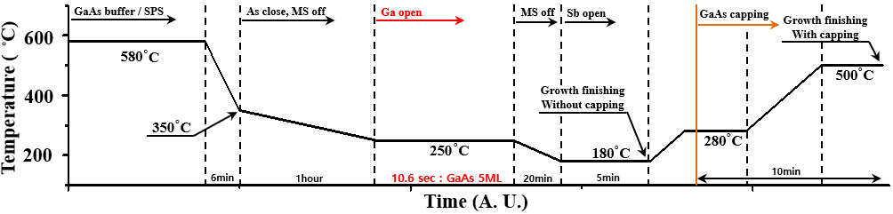
Figure S1. Growth process of GaSb QD on GaAs by Droplet epitaxy using Molecular Beam Epitaxy system

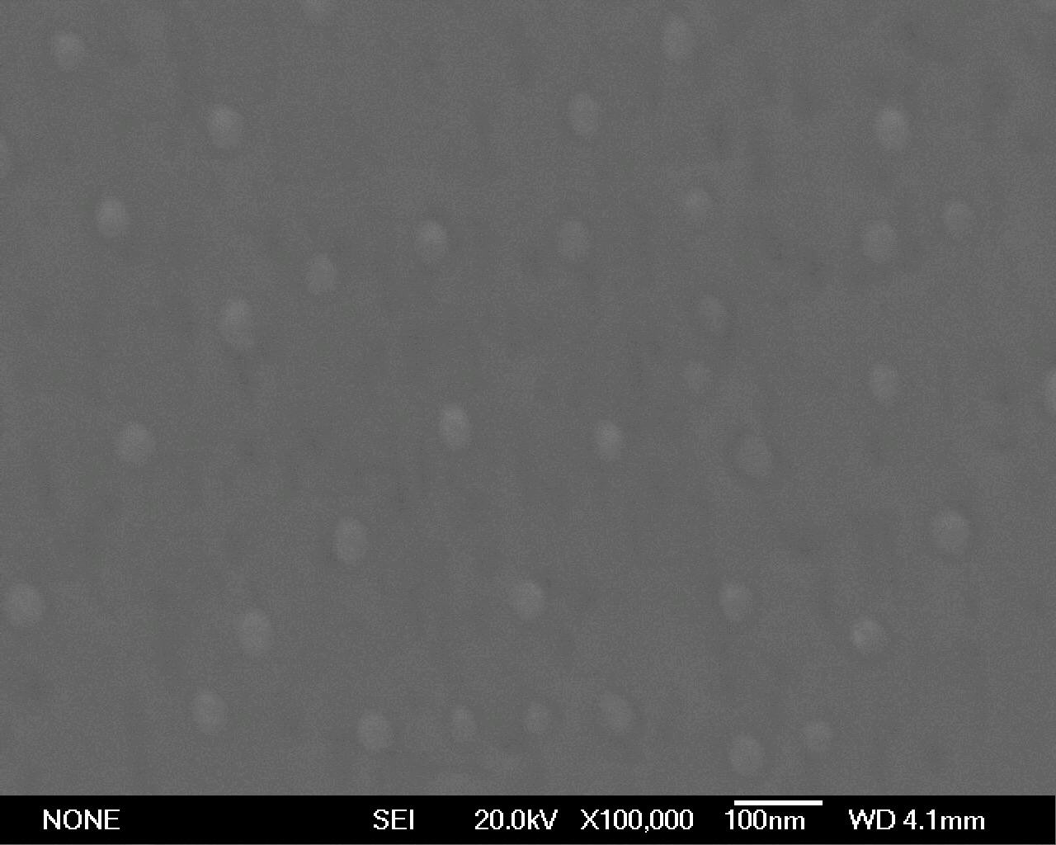
Figure S2. SEM top-view image of Ga droplets

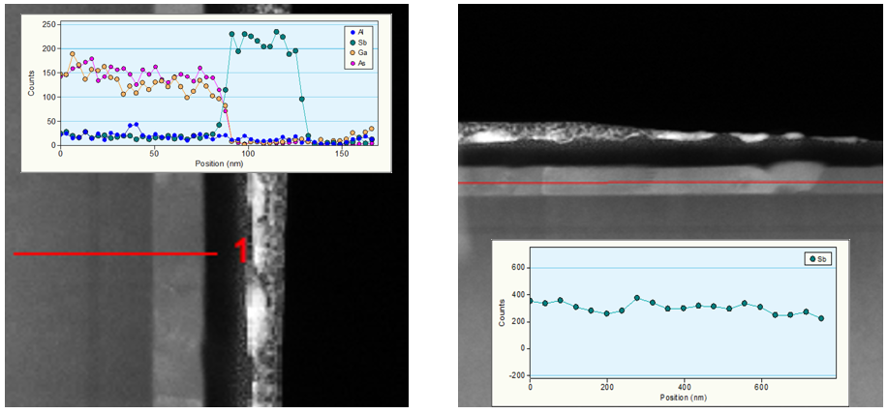
Figure S3. Cross-section images and EDX data of GaSb QD structure

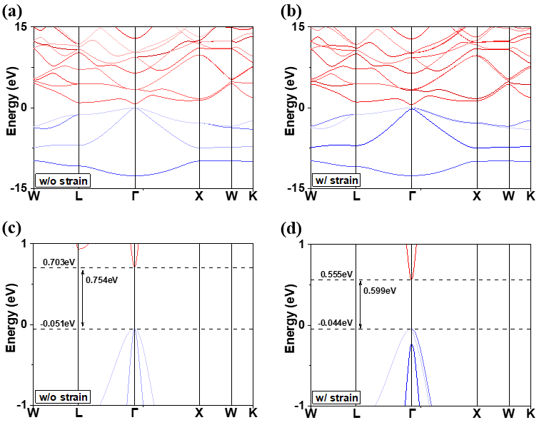
Figure S4. DFT calculation data of the GaSb band structure (a) without strain and (b) with a 1.8% strain along the [111] direction, and band gap of GaSb (c) without strain and (d) with a 1.8% strain along the [111] direction; the band gap is narrowed by strain along the [111] direction

