Table S1: Information on the gender, size, location of capture, and reference number of the snakes whose venom was used in this study
Species name | Common name | Reference number | Size/age | Gender | Location of capture
Dendroaspis angusticeps | Green mamba | BK17860  BK17861  BK17863 | Adult  Adult  Adult | Female  Male  Male | Lunga lunga  Lunga lunga  Lunga lunga
Dendroaspis polylepis | Black mamba | 15806  17651  17983 | Adult  Adult  Adult | Male  Female  Female | Arabuko Sokoke  Masai Mara  Busia
Bitis arietans | Puff adder | BK17190  BK17193  BK18081 | Adult  Adult  Adult | Male  Female  Female | Watamu  Kizingo  Arabuko Sokoke
Naja ashei | Large brown spitting cobra | BK16189  BK16648  BK17678 | Adult  Adult  Adult | Female  Female  Male | Watamu  Kilifi  Watamu
Naja haje | Egyptian cobra | BK11551  BK15139  BK16761 | Adult  Adult  Adult | Male  Male  Female | Naivasha  Kitengela  Naivasha
Naja pallida | Red spitting cobra | BK10739  BK13015  BK17394 | Adult  Adult  Adult | Female  Female  Male | Tsavo East (Kilalinda)  Tsavo East (Galana)  Tsavo East (Maungu)
Naja subfulva | Forest cobra | BK10293  BK17954  BK18019 | Adult  Adult  Adult | Male  Male  Female | Kakamega  Busia  Nandi

Table S2: Details on the antivenoms used in testing efficacy against the PLA₂ and brine shrimp lethality of Naja ashei venom
Brand | Manufacturer | Characteristics | Label claim
Snake Venom Antiserum African HIS  (Antivenom I) | Vins Bioproducts Limited,  Telangana, India | Lyophilized  Equine F(ab’)₂  Batch number: 07AS18001  Date of manufacture: 01/2018  Expiry date:12/2021 | Each ml has the capacity to neutralize 20 LD_{50’s} of the venoms of N. melanoleuca, N. nigricollis and 25 LD_{50’s} of the venoms of N. haje, D. polylepis, D. viridis, D. jamesoni, B. gabonica, B. arietans, and E. ocellatus
PAN AFRICA Inoserp®  (Antivenom II) | Veteria Labs SA de C.V  Juarez Colony, Mexico City,  Mexico | Lyophilized  Equine F(ab’)₂  Batch number: 9 IT06001  Date of manufacture: 06/2019  Expiry date:06/2022 | Each ml neutralizes 500DL₅₀ of the venom of E. ocellatus, B. arietans, N. nigricollis, D. polylepis and is recommended in the event of envenomation by E. ocellatus, E. leucogaster, E. pyramidum, B. arietans, B. rhinoceros, B. nascicornis, B. gabonica, D. polylepis, D. viridis, D. angusticeps, D. jamesoni, N. nigricollis, N. melanoleuca, N. haje, N. pallida, N. nubiae, N. katiensis, and N. senegalensis

Table S3: Absorbance values of serial dilutions of 2mg/ml of bovine serum albumin (standard), the venoms of B. arietans, D. angusticeps, D. polylepis, N. ashei, N. haje, N. pallida and two antivenoms commercially available in Kenya
Concentration (mg/ml) | Absorbance 1 | Absorbance 2 | Absorbance 3 | Mean
0.05 | 0.031 | 0.032 | 0.027 | 0.030±0.003
0.1 | 0.056 | 0.056 | 0.052 | 0.055±0.002
0.2 | 0.099 | 0.108 | 0.095 | 0.101±0.007
0.4 | 0.169 | 0.165 | 0.148 | 0.161±0.011
0.8 | 0.26 | 0.276 | 0.28 | 0.272±0.011
1.2 | 0.349 | 0.363 | 0.362 | 0.358±0.008
1.6 | 0.44 | 0.443 | 0.434 | 0.434±0.013
2 | 0.521 | 0.461 | 0.517 | 0.500±0.034
B. arietans | 0.175 | 0.176 | 0.174 | 0.175±0.001
D. angusticeps | 0.258 | 0.274 | 0.273 | 0.268±0.009
D. polylepis | 0.244 | 0.238 | 0.247 | 0.243±0.005
N. ashei | 0.213 | 0.223 | 0.208 | 0.215±0.008
N. haje | 0.209 | 0.237 | 0.234 | 0.227±0.015
N. pallida | 0.222 | 0.225 | 0.228 | 0.225±0.003
N. subfulva | 0.253 | 0.241 | 0.268 | 0.254±0.014
Indian antivenom | 0.162 | 0.164 | 0.154 | 0.160±0.005
Inoserp antivenom | 0.069 | 0.068 | 0.075 | 0.710±0.004

Table S4: Absorbance values used in the calculation of the neutralization capacity of antivenoms I and II against the svPLA₂ activity of N. ashei venom
Time | 0 minutes |  |  |  | 30 minutes |  |  |  | D
Sample | A₁ | A₂ | A₃ | Mean±SD | A₁ | A₂ | A₃ | Mean±SD
V only | 0.978 | 0.980 | 0.995 | 0.983±0.006 | 0.769 | 0.841 | 0.829 | 0.813±0.039 | 0.17
V+25µlAV₁ | 1.206 | 1.190 | 1.185 | 1.194±0.011 | 1.091 | 1.068 | 1.068 | 1.076±0.013 | 0.118
V+50µlAV₁ | 0.968 | 0.980 | 1.017 | 0.988±0.026 | 0.806 | 0.842 | 0.848 | 0.832±0.023 | 0.156
V+100µlAV₁ | 0.970 | 0.983 | 0.995 | 0.983±0.013 | 0.836 | 0.840 | 0.821 | 0.832±0.010 | 0.151
V+200µlAV₁ | 0.980 | 0.965 | 0.967 | 0.971±0.008 | 0.893 | 0.902 | 0.919 | 0.905±0.005 | 0.066
V+400µlAV₁ | 0.972 | 1.000 | 0.972 | 0.981±0.016 | 0.925 | 0.959 | 0.906 | 0.93±0.027 | 0.051
V+25µlAV₂ | 1.008 | 0.992 | 0.964 | 0.988±0.022 | 0.856 | 0.839 | 0.801 | 0.832±0.028 | 0.156
V+50µlAV₂ | 0.981 | 0.966 | 0.995 | 0.981±0.015 | 0.837 | 0.813 | 0.842 | 0.831±0.016 | 0.150
V+100µlAV₂ | 0.970 | 0.993 | 0.995 | 0.986±0.014 | 0.820 | 0.843 | 0.871 | 0.845±0.026 | 0.141
V+200µlAV₂ | 0.969 | 0.968 | 0.962 | 0.966±0.004 | 0.872 | 0.894 | 0.885 | 0.884±0.008 | 0.082
V+400µlAV₂ | 0.975 | 1.003 | 0.975 | 0.984±0.016 | 0.907 | 0.916 | 0.899 | 0.907±0.009 | 0.077
V: Venom; AV₁: Antivenom I; AV₂: Antivenom II; A₁: Absorbance 1; A₂: Absorbance 2; A₃: Absorbance 3; SD: Standard deviation; D: Difference in the mean absorbance
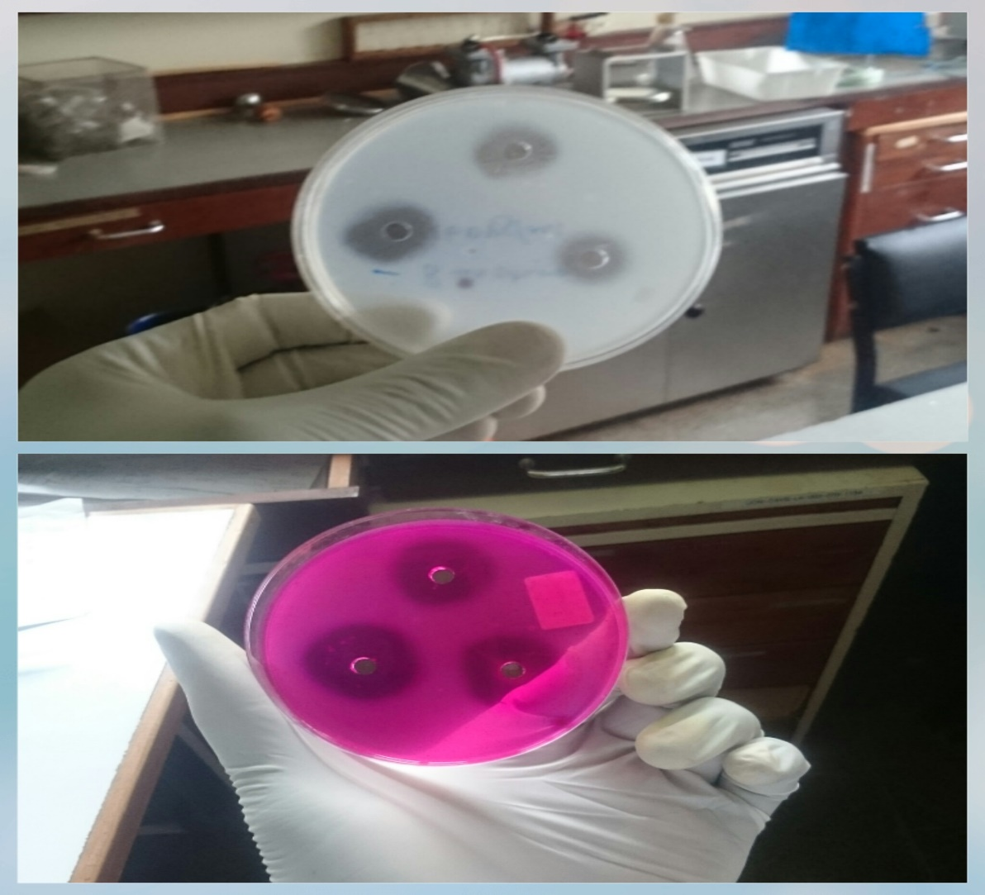
B
A
Figure S1: A. Visualization of venom-induced PLA₂ halos when Carbol Fuchsin stain is not used. B Visualization of the venom-induced PLA₂ halos when Carbol Fuchsin dye is used

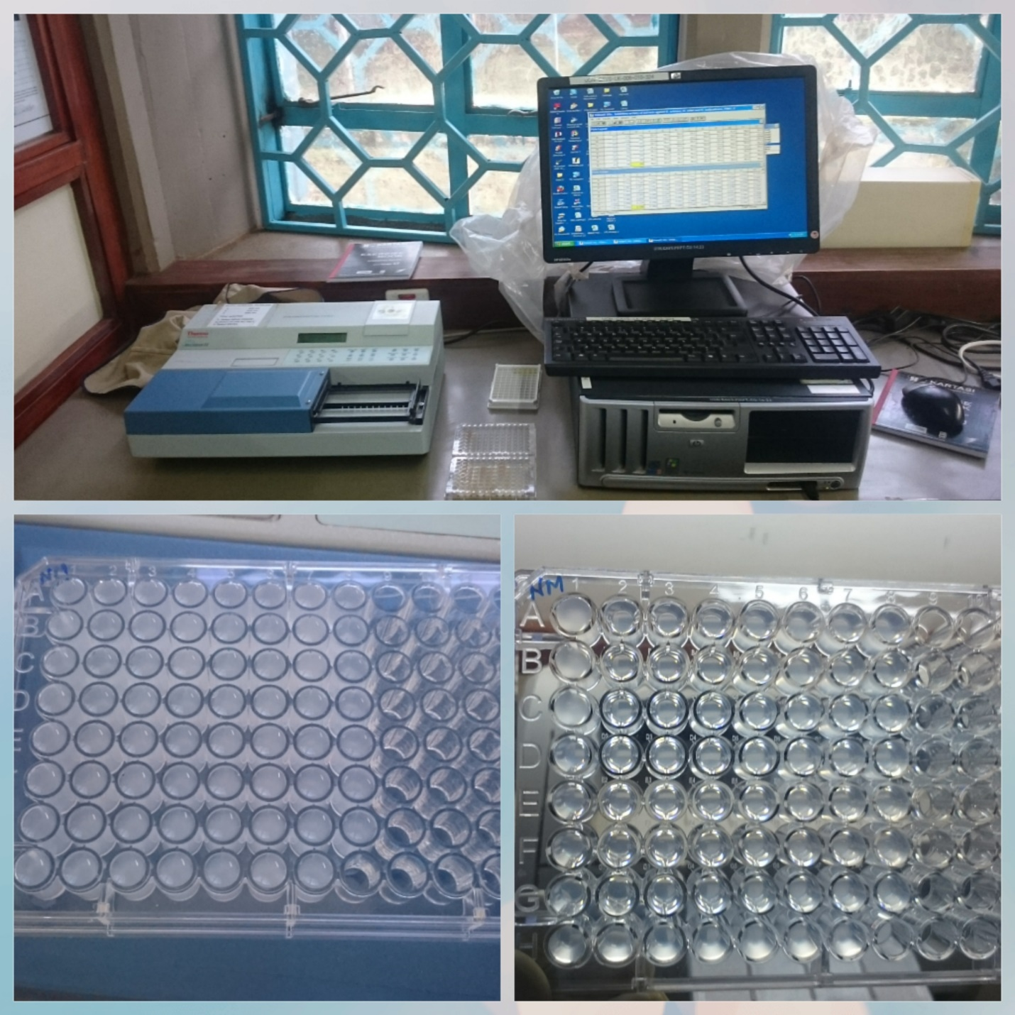
C
B
A
Figure S2: Experimental setup for evaluating the neutralization capacity of antivenoms I and II against the PLA₂ activity of N. ashei venom. A. Multi plate reader and a personal computer for recording the absorbance values. B. a 96-well ELISA plate before incubation of the venom+antivenom mixtures. C. a 96-well ELISA plate after incubation of the venom+antivenom mixtures
1

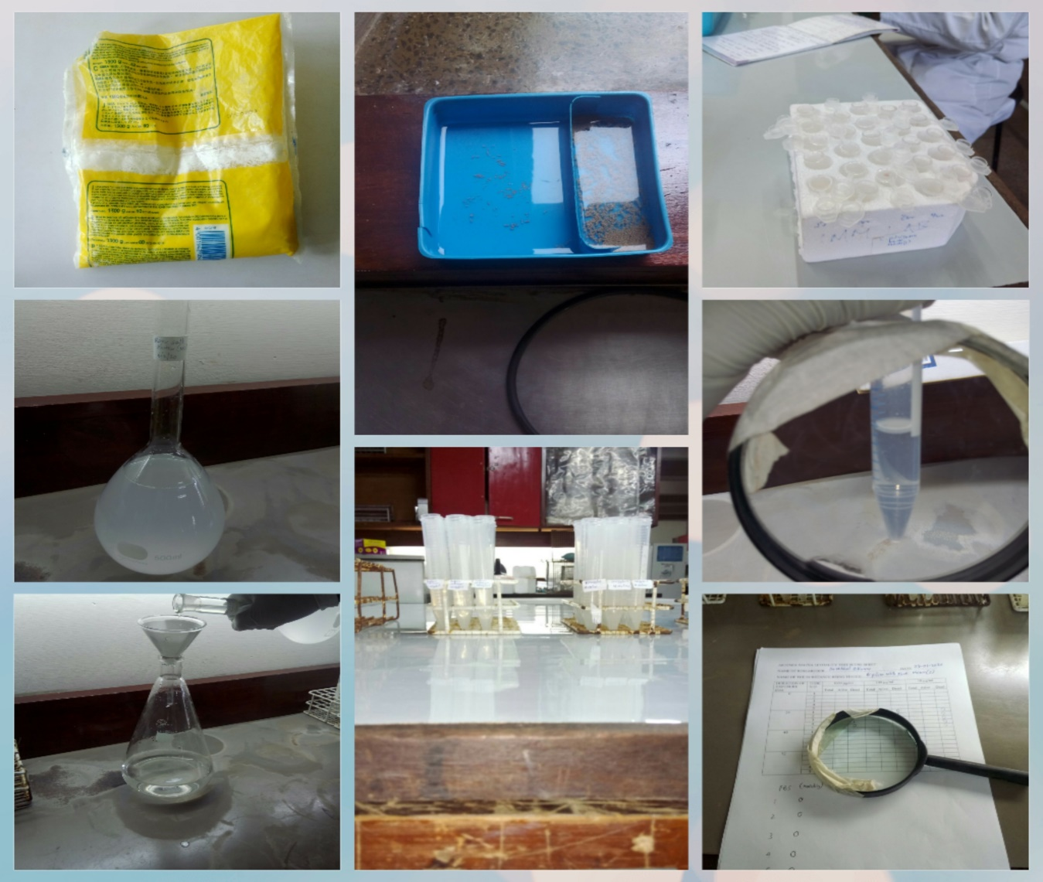
A
H
G
F
B
C
D
E
Figure S3: Experimental setup for the brine shrimp lethality assay. A. Marine salt. B. Marine salt solution before filtration. C. Marine salt solution after filtration. D. Hatching trough for the brine shrimp larvae. E. 5ml sample vials containing brine shrimp larvae. F. Eppendorf tubes for incubating venom+antivenom mixtures before discharging them in the sample vials. G. Counting the number of dead brine shrimp larvae using a magnifying glass. H. Recording the data from the assay.

Figure S4: Regression analysis of the log concentration-%mean response curve of serial dilutions of antivenom I mixed with a fixed dose of N. ashei venom

Figure S5: Regression analysis of the log concentration-%mean response curve of serial dilutions of antivenom II mixed with a fixed dose of N. ashei venom

