Supplementary Information
Potential future changes of climatic drivers for the European Spruce bark beetle outbreaks in Northern Baltic Sea area under CMIP5 projections
European Journal of Forest Research
Olli-Pekka Tikkanen*, School of Forest Sciences, University of Eastern Finland
Ilari Lehtonen, Finnish Meteorological Institute, Helsinki, Finland
*Corresponding author, E-mail: Olli-Pekka.Tikkanen@uef.fi

Fig S1 Thermal sums calculated from April-September historic weather data. Dots show annual values and undulating lines are 3-year moving averages.
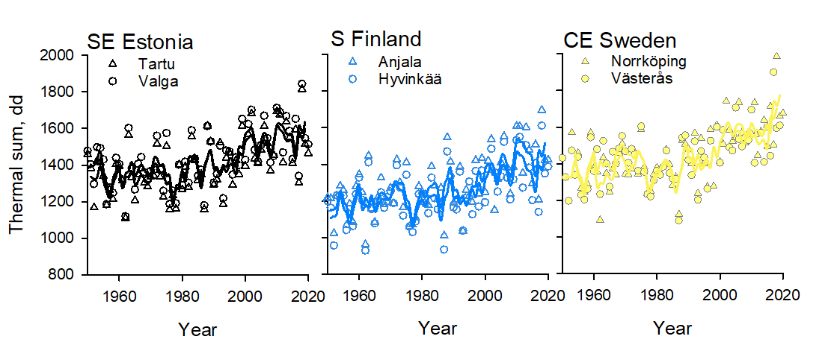

Fig S2 Hydrothermal index values calculated from historic weather data. Dots show annual values and undulating lines 3-year moving averages. Annual values of <1.5 indicate extremely dry years. Lows in moving average line indicate occurrence of multiannual drought periods

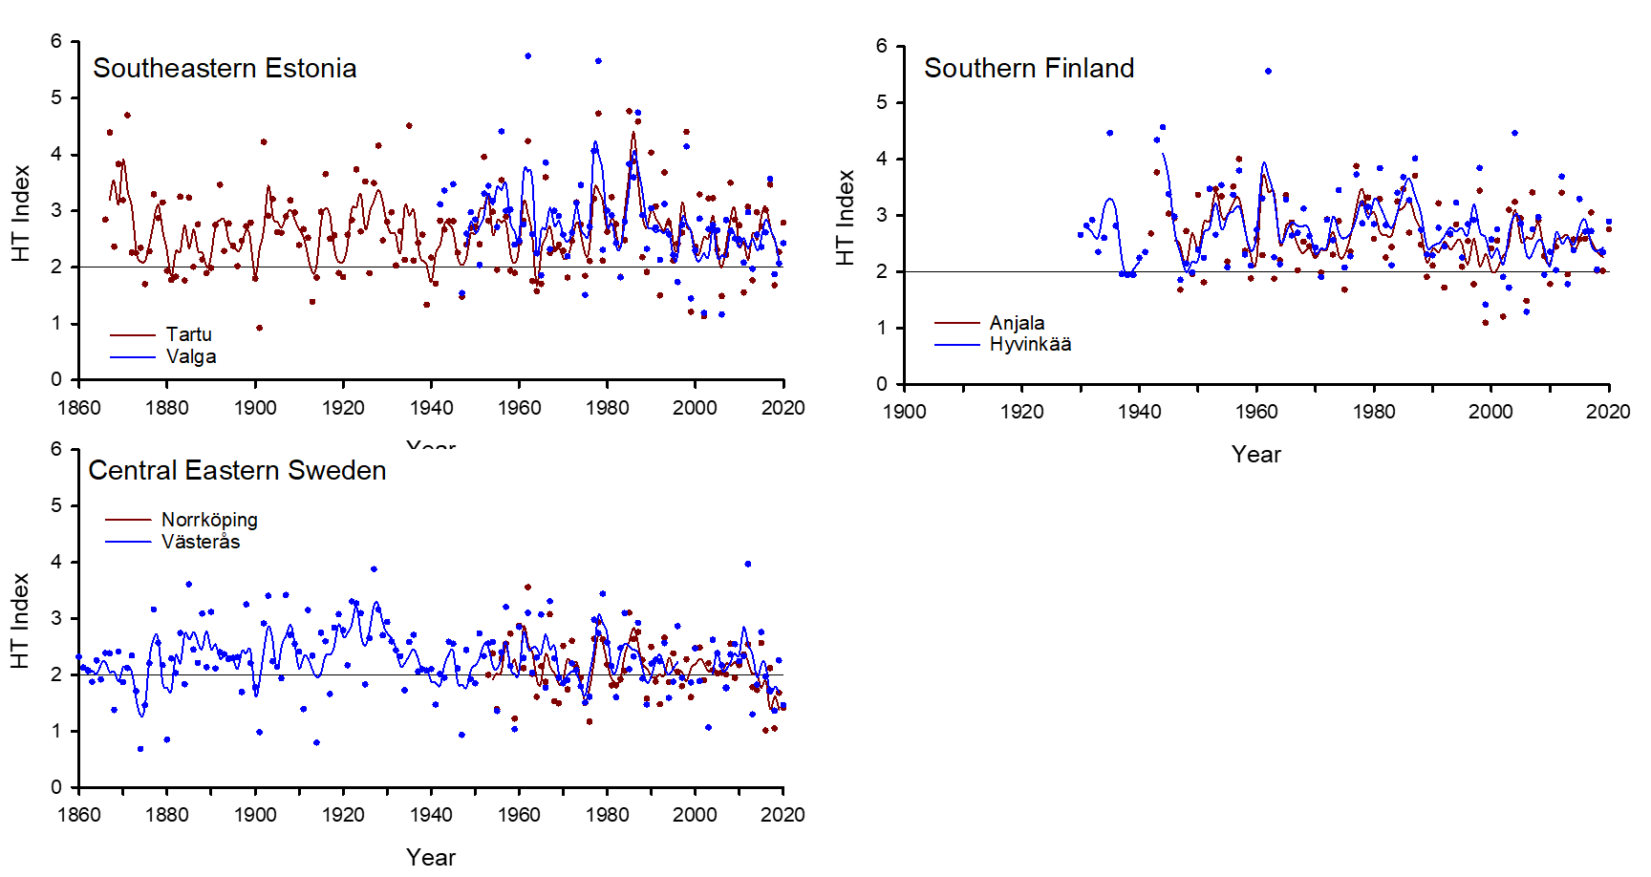

Fig S3 Precipitation (mm, April-October) of period 1900-2100 in Northern Baltic Sea area in A) RCP2.6, B) RCP4.5, and C) RCP8.5 climate change scenarios. Graph lines show 11-year moving averages calculated from the annual averages of 17 models in RCP 2.6 scenario, 23 models in RCP 4.5 scenario and 22 models in RCP 8.5 scenario. Locations of weather stations are shown in Fig 1 (see main article)

